**Using Patterns to Improve Localization of Design Decisions and Performance** -Princy Jain

**Introduction:**

This assignment mainly focuses on using patterns to improve design decisions and performance. I selected the part b of the given assignment, i.e., Sudoku Solver. The patterns implemented in this project are Template Pattern which we were supposed to use. Other than this I implemented Strategy Pattern.

**Flyweight pattern** is one of the [structural design patterns](https://www.geeksforgeeks.org/design-patterns-set-1-introduction/) as this pattern provides ways to decrease object count thus improving application required objects structure. Flyweight pattern is used when we need to create a large number of similar objects. One important feature of flyweight objects is that they are immutable. This means that they cannot be modified once they have been constructed.

**Factory method** is a [creational design pattern](https://www.geeksforgeeks.org/design-patterns-set-1-introduction/), i.e., related to object creation. In Factory pattern, we create object without exposing the creation logic to client and the client use the same common interface to create new type of object. Factory Method can be of two types: Simple Factory Method and Abstract Factory Method.

**Composite pattern** is a partitioning design pattern and describes a group of objects that is treated the same way as a single instance of the same type of object.

**Project Design:**

I started my project with the minimal shape library given by Professor. I created an Abstract Shape class and extended it to create all other shapes which include embedded image and composite image. Composite Image is the combination of all other images.

Patterns Applied:

Flyweight Pattern: It is used in Embedded Picture to check if the image exists or not. If not, then add the new one.

Composite Pattern: It is in creating the Composite Image.

Simple Factory: It used to add the objects of different shapes to the object pool.

Class Diagram:

Diagram with all the Relationships shown among the classes:

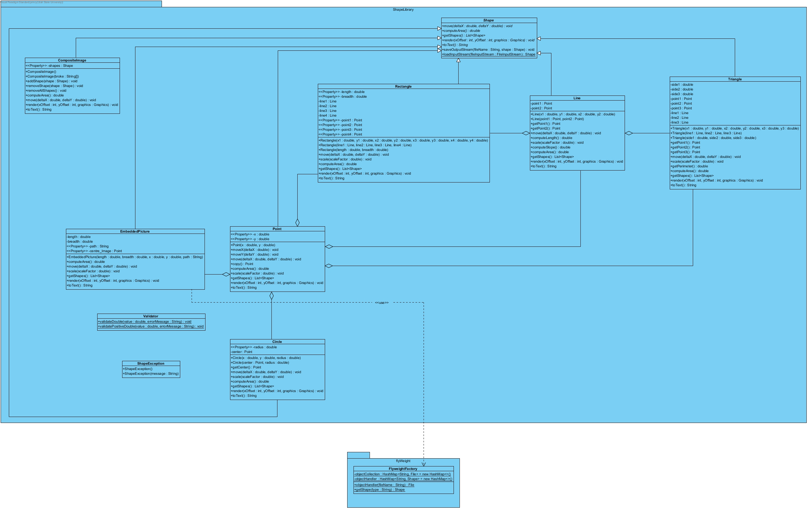

Generalized Class Diagram:

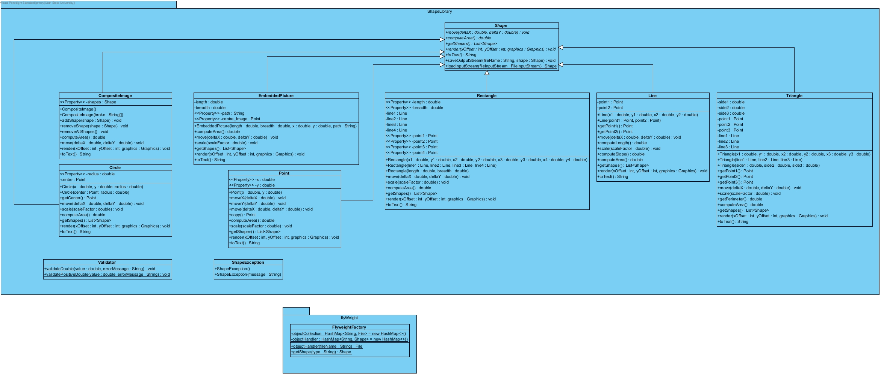

Interaction Diagram:

CompositeImage.AddShape

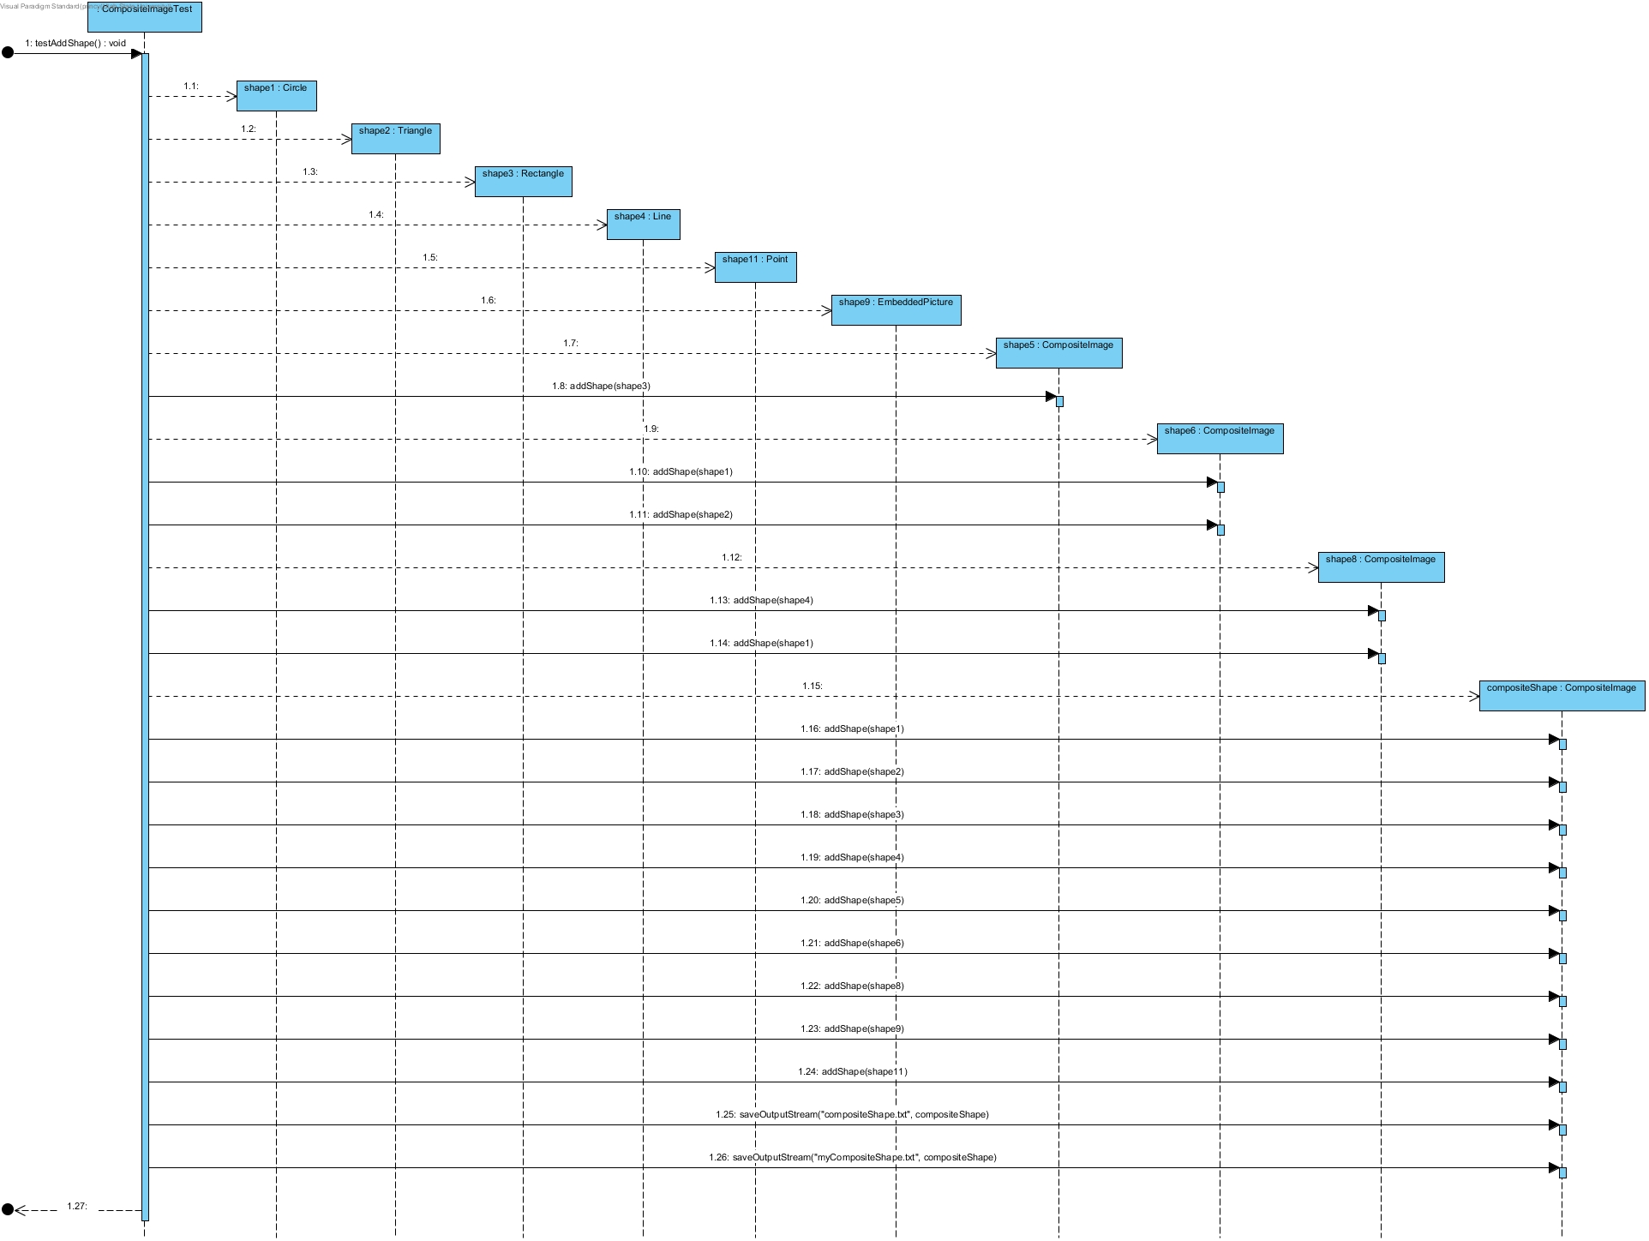

FlyweightFactoryTest:

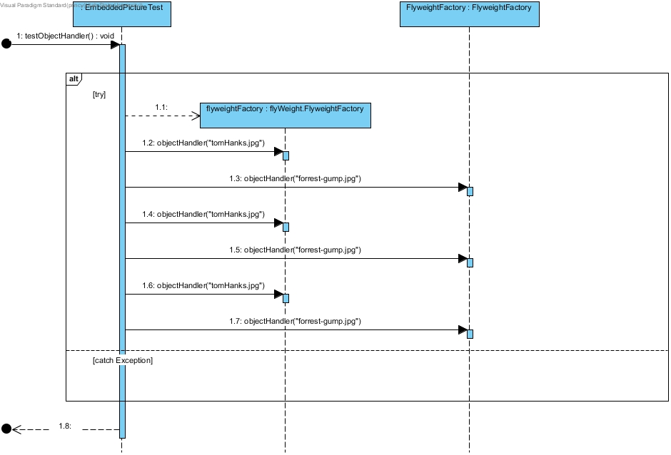

ShapeFactorySequence:

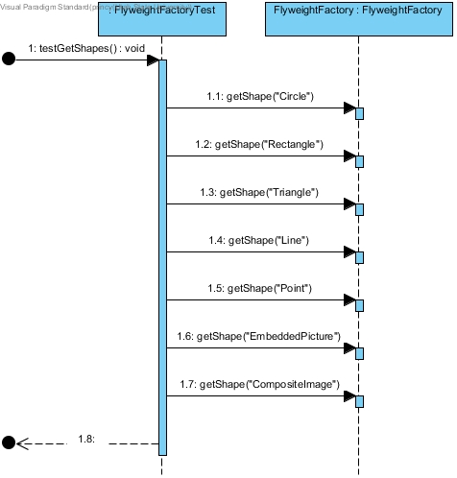

Insights Uncovered:

* I learned Unit Testing in a much better way this time.
* Composite Pattern
* Flyweight Pattern
* Simple Factory Method
* Learned Rendering which is super fun.