P P SAVANI UNIVERSITY
SCHOOL OF ENGINEERING
INTERNSHIP / UDP / TRAINING
FINAL PROJECT REPORT
(Hard-Bound Project Report Format)
Particular | Details
Project Title | PromptForm AI – An AI-Powered Intelligent Form Generation and Analytics Platform
Student Name | [STUDENT NAME]
Enrollment Number | [ENROLLMENT NUMBER]
Program / Branch | [B.Tech – Computer Engineering]
Semester | [SEMESTER]
Company / Organization | [COMPANY / ORGANIZATION NAME]
Department / Domain | Full-Stack Web Development / Applied Generative AI
Mentor (Company) | [COMPANY MENTOR NAME]
Mentor (Institute) | [INSTITUTE MENTOR NAME]
Academic Year | 2026–2027
CERTIFICATE
OF COMPLETION
This is to certify that
[STUDENT NAME]
Enrollment No.: [ENROLLMENT NUMBER]
of [B.Tech – Computer Engineering], [SEMESTER], has successfully completed the Internship / UDP / Training project titled
“PromptForm AI – An AI-Powered Intelligent Form Generation and Analytics Platform”
during the period from [START DATE] to [END DATE] at [COMPANY / ORGANIZATION NAME], under the guidance of [COMPANY MENTOR NAME] and [INSTITUTE MENTOR NAME].
The project work, final implementation, testing and validation, documentation, and demonstration were completed as required for the Internship / UDP / Training and found satisfactory.
Date of Issue: [DD / MM / YYYY]
________________________  Mentor (Company) | ________________________  Mentor (Institute)
DECLARATION
I hereby declare that this report is a consolidated and authentic record of the Internship / UDP / Training project work titled “PromptForm AI – An AI-Powered Intelligent Form Generation and Analytics Platform” carried out by me during the period [START DATE] to [END DATE] at [COMPANY / ORGANIZATION NAME]. All sources used have been appropriately acknowledged and cited.
I further declare that the work presented in this report has not been submitted, in part or in full, to any other university or institution for the award of any degree or diploma. Third-party libraries, frameworks, services and published works used in the project are listed in Chapter 15 (References) and cited in the text using the APA 7th Edition style.
Date: [DD / MM / YYYY]
Place: Surat, Gujarat
________________________
[STUDENT NAME]
Enrollment No.: [ENROLLMENT NUMBER]
ACKNOWLEDGEMENT
I express my sincere gratitude to [COMPANY / ORGANIZATION NAME] for giving me the opportunity to carry out the project “PromptForm AI – An AI-Powered Intelligent Form Generation and Analytics Platform” as part of my Internship / UDP / Training, and for providing the development environment, tools and real-world problem context that shaped this work.
I am deeply thankful to my company mentor, [COMPANY MENTOR NAME], for continuous technical guidance, code reviews and practical advice on architecture, deployment and product quality throughout the project. Their feedback during each progress review helped convert an initial prototype into a production-ready platform.
I am equally grateful to my institute mentor, [INSTITUTE MENTOR NAME], School of Engineering, P P Savani University, for academic supervision, for reviewing the four progress reports, and for valuable suggestions on documentation, testing methodology and report presentation.
I thank the Head of the Department, the faculty members of the School of Engineering and the Training and Placement cell of P P Savani University for the structured internship framework, timely evaluations and constant encouragement.
I also acknowledge the open-source communities behind Next.js, React, Express, Prisma, PostgreSQL and the Google Gemini API, whose documentation and tools made this project possible. Finally, I thank my family and friends for their patience, motivation and support during the entire internship period.
ABSTRACT / EXECUTIVE SUMMARY
Online forms are the most common way for organisations to collect registrations, feedback, quiz answers, patient intake details and survey data. Existing form builders such as Google Forms, Microsoft Forms, Typeform and Jotform require the author to add every field manually, choose input types, write options, configure validation and design the theme. For a typical 8–10 question form this takes 15–30 minutes and frequently produces inconsistent field types, missing validations and poor respondent experience. Paper forms that already exist in an organisation must also be retyped by hand.
This project presents PromptForm AI, a full-stack Software-as-a-Service (SaaS) platform that generates complete, editable and shareable web forms from a natural-language prompt or from an uploaded document (PDF, DOCX, spreadsheet or image). The objectives were to reduce form creation time to seconds, select correct field types and validations automatically, support quizzes with scoring and anti-cheat controls, and provide response analytics and team collaboration in one product.
The system follows a three-tier architecture developed in a TypeScript monorepo using an Agile, sprint-based methodology. The presentation tier is built with Next.js 15, React 19, Tailwind CSS and Zustand; the application tier is an Express 4 REST API secured by JWT authentication, bcrypt password hashing, Helmet, CORS and rate limiting; the data tier uses PostgreSQL through Prisma ORM with 16 relational models. Generation is handled by a hybrid engine: a deterministic rule-based “AIFormBrain” (intent, language, domain and industry detection, field intelligence, quiz engine and quality reviewer) combined with Google Gemini large language models through a five-model fallback chain with JSON-schema output.
The platform was verified with 50 automated test cases — 39 platform QA tests covering authentication, forms, submissions, teams, analytics and security, and 11 AI-generation tests covering text, quiz, survey, PDF and image inputs, credit limits and plan limits. All tests passed after nine defects identified during QA were fixed and re-verified. A form that takes about 20 minutes to build manually is produced by PromptForm AI in under 10 seconds, published immediately with a unique share link, and can be refined in a drag-and-drop visual builder.
The project demonstrates that combining deterministic domain rules with LLM generation yields reliable, structured output suitable for production use. The platform was deployed on Vercel (frontend) and Render (backend) with a managed PostgreSQL database, and it provides a strong foundation for future features such as payments, conditional-logic generation and multilingual voice input.
Keywords: Generative AI, Form Builder, Large Language Models, Google Gemini, Next.js, Express, Prisma ORM, PostgreSQL, SaaS, Prompt Engineering
TABLE OF CONTENTS
Chapter / Section No. | Title | Tentative Page
Preliminary Pages
 | Certificate | 2
 | Declaration | 3
 | Acknowledgement | 4
 | Abstract / Executive Summary | 5
 | Table of Contents | 7
 | List of Figures | 11
 | List of Tables | 13
 | List of Abbreviations / Acronyms | 15
Chapter 1 | Introduction | 17
1.1 | Background of the Project | 17
1.2 | Problem Statement | 17
1.3 | Need / Motivation | 18
1.4 | Objectives | 18
1.5 | Scope of the Project | 19
1.6 | Expected Outcomes vs Final Outcomes | 20
1.7 | Report Organization | 20
Chapter 2 | Organization / Internship / Training Profile | 22
2.1 | Organization / Company Overview | 22
2.2 | Department / Domain | 22
2.3 | Role and Responsibilities | 22
2.4 | Development / Work Environment | 23
2.5 | Internship Details | 23
Chapter 3 | Literature Review / Background Study | 25
3.1 | Domain Background | 25
3.2 | Existing Approaches / Related Work | 26
3.3 | Comparative Analysis | 26
3.4 | Research Gap / Project Justification | 27
Chapter 4 | Requirements Analysis and Project Scope | 28
4.1 | Functional Requirements | 28
4.2 | Non-Functional Requirements | 29
4.3 | Hardware Requirements (if applicable) | 30
4.4 | Software Requirements | 30
4.5 | Data / Dataset Requirements (if applicable) | 31
4.6 | Constraints and Assumptions | 31
Chapter 5 | Methodology and Project Planning | 33
5.1 | Final Development / Research Methodology | 33
5.2 | Project Workflow | 33
5.3 | Project Phases and Deliverables | 34
5.4 | Progress Report Consolidation | 34
5.5 | Project Schedule / Timeline | 35
Chapter 6 | System Analysis and Design | 36
6.1 | Existing System / Current Practice | 36
6.2 | Proposed System | 36
6.3 | System Architecture | 37
6.4 | Workflow / Process Flow | 37
6.5 | UML / Design Diagrams | 38
6.6 | Module-wise Design | 41
6.7 | Database / Data Design | 42
6.8 | Interface / UI Design (if applicable) | 43
Chapter 7 | Technology Stack and Development Environment | 45
7.1 | Programming Languages | 45
7.2 | Frameworks / Libraries / APIs | 45
7.3 | Database / Storage | 46
7.4 | Hardware / Cloud / Deployment Environment | 46
7.5 | Development Tools | 47
7.6 | Technology Selection Rationale | 47
Chapter 8 | System Implementation | 48
8.1 | Implementation Overview | 48
8.2 | Module / Feature 1 – AI Form Generator | 48
8.3 | Module / Feature 2 – Visual Form Builder | 49
8.4 | Module / Feature 3 – Responses, Quiz Engine and Analytics | 50
8.5 | Algorithm / Logic / Model Description | 51
8.6 | API / External Service Integration | 53
8.7 | Database Implementation | 54
8.8 | Security / Access Control (if applicable) | 54
8.9 | Integration of Modules | 55
Chapter 9 | Testing and Validation | 56
9.1 | Testing Strategy | 56
9.2 | Unit / Module Testing | 56
9.3 | Functional Testing | 57
9.4 | Integration Testing | 58
9.5 | System Testing | 59
9.6 | Performance Testing | 60
9.7 | User / Acceptance Testing | 60
9.8 | Experimental Validation (if applicable) | 61
9.9 | Defects / Bugs and Resolution | 61
9.10 | Final Validation Statement | 62
Chapter 10 | Results and Performance Analysis | 63
10.1 | Final Results | 63
10.6 | Results Discussion | 63
10.2 | Objective-wise Achievement | 64
10.3 | Performance Metrics | 64
10.4 | Comparative Results (if applicable) | 65
10.5 | Final Output Screenshots | 65
Chapter 11 | Challenges, Solutions and Improvements | 68
11.1 | Major Challenges | 68
11.2 | Technical Challenges | 68
11.3 | Process / Coordination Challenges | 69
11.5 | Lessons from Challenges | 69
11.4 | Improvements Made During Development | 69
Chapter 12 | Individual Contribution and Professional Learning | 71
12.1 | Individual Contribution | 71
12.2 | Technical Skills Acquired | 71
12.3 | Professional Skills Acquired | 72
12.4 | Major Learning Outcomes | 72
Chapter 13 | Limitations and Future Scope | 73
13.1 | Current Limitations | 73
13.2 | Future Scope | 73
13.3 | Scalability / Extension Opportunities | 74
Chapter 14 | Conclusion | 75
14.1 | Final Project Status | 75
Chapter 15 | References | 77
15.1 | References | 77
15.2 | Citation Requirements | 78
Chapter A | Appendices | 79
Appendix A | Progress Report 1 Summary | 79
Appendix B | Progress Report 2 Summary | 79
Appendix C | Progress Report 3 Summary | 79
Appendix D | Reporting 4 / Final Evaluation | 79
Appendix E | Additional Screenshots / Outputs | 80
Appendix F | Certificates / Internship Evidence | 85
Appendix G | Source Code / Repository / Deployment Evidence | 85
Appendix H | Mentor / Evaluator Remarks | 90
Chapter B | Final Hard-Bound Submission Checklist | 91
Chapter C | Formatting and Submission Guidelines | 92
LIST OF FIGURES
Figure No. | Title | Page
Figure 5.1 | Overall Project Workflow | 33
Figure 5.2 | Project Schedule (Gantt Chart) | 35
Figure 6.1 | Final System Architecture | 37
Figure 6.2 | Final Workflow / Process Flow | 38
Figure 6.3 | Major UML / ER / Design Diagram — Use Case Diagram | 39
Figure 6.4 | Data Flow Diagram (Level 1) | 39
Figure 6.5 | Class Diagram — AI Engine and Services | 40
Figure 6.6 | Sequence Diagram — AI Form Generation | 40
Figure 6.7 | Activity Diagram — Form Submission | 41
Figure 6.8 | ER Diagram / Database Schema | 41
Figure 6.9 | Major Interface / UI Design | 44
Figure 8.1 | Module 1 Implementation / Output | 49
Figure 8.2 | Module 2 Implementation / Output | 50
Figure 8.3 | Module 3 Implementation / Output | 51
Figure 8.4 | Authentication and Authorization Flow | 55
Figure 9.1 | Test Cases Passed by Suite | 62
Figure 10.1 | Final Output / Result Screenshot 1 (Workspace Overview Dashboard) | 66
Figure 10.2 | Final Output / Result Screenshot 2 (Public Responder) | 66
Figure 10.3 | Final Output / Result Screenshot 3 (Responses Ledger) | 67
Figure 10.4 | Final Output / Result Screenshot 4 (Template Marketplace) | 67
Figure A.1 | Supporting Evidence — Login Page | 80
Figure A.2 | Supporting Evidence — Form Creation Time Comparison | 80
Figure A.3 | Supporting Evidence — Registration Page | 81
Figure A.4 | Supporting Evidence — Pricing Plans | 81
Figure A.5 | Supporting Evidence — Forms Library | 82
Figure A.6 | Supporting Evidence — Workspace Analytics | 82
Figure A.7 | Supporting Evidence — Team Workspace | 83
Figure A.8 | Supporting Evidence — Account Settings | 83
Figure A.9 | Supporting Evidence — Billing and Credits | 84
Figure A.10 | Supporting Evidence — Module Architecture | 84
Figure A.11 | Supporting Evidence — Deployment Diagram | 85
Figure A.12 | Supporting Evidence — Landing Page (full length) | 89
LIST OF TABLES
Table No. | Title | Page
Table 1.1 | Expected outcomes compared with final outcomes | 20
Table 1.2 | Scope Matrix | 21
Table 2.1 | Internship details | 23
Table 3.1 | Review of existing approaches and related work | 26
Table 3.2 | Comparative analysis of existing approaches and the proposed project | 26
Table 4.1 | Functional requirements | 28
Table 4.2 | Non-functional requirements | 29
Table 4.3 | Hardware requirements | 30
Table 4.4 | Software requirements | 30
Table 4.5 | Data requirements | 31
Table 5.1 | Project phases and deliverables | 34
Table 5.2 | Progress report consolidation | 34
Table 5.3 | Project schedule – planned vs actual | 35
Table 6.1 | Module-wise design | 41
Table 6.2 | Database entities | 42
Table 7.1 | Programming languages | 45
Table 7.2 | Frameworks, libraries and APIs | 45
Table 7.3 | Database and storage | 46
Table 7.4 | Hardware, cloud and deployment environment | 46
Table 7.5 | Development tools | 47
Table 8.1 | API and external service integration | 53
Table 9.1 | Unit / module testing | 56
Table 9.2 | Functional testing (platform QA suite) | 57
Table 9.3 | Integration testing | 58
Table 9.4 | System testing (AI generator suite and end-to-end scenarios) | 59
Table 9.5 | Performance testing | 60
Table 9.6 | User acceptance testing | 60
Table 9.7 | Experimental validation of AI generation | 61
Table 9.8 | Defects identified and resolved | 61
Table 10.1 | Objective-wise achievement | 64
Table 10.2 | Performance metrics | 64
Table 10.3 | Comparative results with existing approaches | 65
Table 11.1 | Major challenges | 68
Table 11.2 | Improvements made during development | 69
Table 12.1 | Individual contribution | 71
Table 13.1 | Current limitations | 73
Table 14.1 | Final project status | 75
Table A.1 | Internship evidence checklist | 85
Table A.2 | Source code, repository and deployment evidence | 85
Table A.3 | Complete REST API endpoint catalogue | 86
Table A.4 | Mentor / evaluator remarks | 90
Table B.1 | Final hard-bound submission checklist | 91
LIST OF ABBREVIATIONS / ACRONYMS
Abbreviation | Full Form / Meaning
AI | Artificial Intelligence
API | Application Programming Interface
APA | American Psychological Association (citation style)
CDN | Content Delivery Network
CORS | Cross-Origin Resource Sharing
CRUD | Create, Read, Update, Delete
CSV | Comma-Separated Values
CSS | Cascading Style Sheets
DB | Database
DFD | Data Flow Diagram
DOCX | Microsoft Word Open XML Document
ER | Entity–Relationship
FR | Functional Requirement
HTML | HyperText Markup Language
HTTP(S) | HyperText Transfer Protocol (Secure)
IDE | Integrated Development Environment
JSON | JavaScript Object Notation
JWT | JSON Web Token
LLM | Large Language Model
MCQ | Multiple Choice Question
NFR | Non-Functional Requirement
NLP | Natural Language Processing
OCR | Optical Character Recognition
ORM | Object–Relational Mapping
PDF | Portable Document Format
QA | Quality Assurance
REST | Representational State Transfer
RTL | Right-to-Left (text direction)
SaaS | Software as a Service
SDLC | Software Development Life Cycle
SMTP | Simple Mail Transfer Protocol
SQL | Structured Query Language
SSR | Server-Side Rendering
UAT | User Acceptance Testing
UDP | University Defined Project
UI / UX | User Interface / User Experience
UML | Unified Modeling Language
URL | Uniform Resource Locator
UUID | Universally Unique Identifier
XLSX | Microsoft Excel Open XML Spreadsheet
CHAPTER 1

INTRODUCTION
This chapter consolidates the initial understanding from Reporting 1 and the final project context.

1.1 Background of the Project
Digital forms are the entry point of almost every data-driven process. Colleges collect admissions and feedback, hospitals collect patient intake information, companies run employee surveys and lead-capture campaigns, and trainers conduct quizzes and assessments — all through web forms. Form-building tools such as Google Forms, Microsoft Forms, Typeform and Jotform have made it easy to host a form online, but the authoring step has hardly changed in a decade: a person still has to think of every question, add each field one by one, pick an input type, type the options, decide which fields are mandatory, add validations and finally style the form.
At the same time, Generative Artificial Intelligence has matured rapidly. Large Language Models (LLMs) such as Google Gemini can understand an instruction written in plain English and return structured JSON that follows a supplied schema. Multimodal models can also read PDFs and images. This creates the opportunity to describe a form in one sentence — “Create a patient intake form for a dental clinic with contact details, medical history and appointment date” — and receive a complete, correctly typed, validated and themed form within seconds.
PromptForm AI was developed during the internship to exploit this opportunity. It is a full-stack SaaS web application in which users can generate forms from prompts or uploaded documents, refine them in a visual builder, publish them through a unique link, collect responses, run graded quizzes with anti-cheat controls, analyse results on dashboards and collaborate with team members. The project domain therefore spans full-stack web engineering, applied generative AI, database design and cloud deployment.

1.2 Problem Statement
The finalized problem statement is: “Creating high-quality online forms is a slow, manual and error-prone activity. Authors must design every field, choose input types and validations by hand, and re-type existing paper or PDF forms, while separate tools are needed for quizzes, analytics and collaboration. There is a need for a single platform that converts a natural-language description or an existing document into a complete, validated, shareable form in seconds, and supports the full life cycle of responses, analysis and teamwork.”
In Reporting 1 the problem was initially framed only as “generate a form from a prompt”. During requirement analysis and mentor reviews it evolved in three ways: (i) document digitisation (PDF, DOCX, XLSX and images) was added because many organisations already hold forms on paper; (ii) assessment use-cases required a quiz engine with scoring, timers and tab-switch detection; and (iii) the product had to be multi-user, so team workspaces, roles, invitations and activity logs were included. The problem therefore grew from a single AI feature into a complete form-management platform with AI at its core.

1.3 Need / Motivation
The practical need arises from the time cost and quality issues of manual form creation. In an informal timing exercise performed during Reporting 1, building a 10-field event registration form in a conventional builder took between 15 and 25 minutes, including choosing types for email, phone and date fields, adding dropdown options and making fields required. Mistakes such as using a plain text box for an email address, or forgetting to make the phone field mandatory, were common and only discovered after responses were collected.
There is also a technical motivation. LLM output is non-deterministic and may be malformed, so a production system cannot rely on it blindly. The project therefore explores a hybrid design in which deterministic, domain-aware rules plan and review the form while the LLM supplies natural wording and domain knowledge. This makes generation reliable, fast and usable even when the external AI service is slow or unavailable. Finally, small institutions and start-ups need an affordable all-in-one tool rather than separate subscriptions for forms, quizzes and analytics.

1.4 Objectives
The following clear and measurable objectives were defined and tracked through the four progress reports:
- Generate a complete, editable form (title, description, 5–15 typed questions, options, validations and theme) from a natural-language prompt in under 10 seconds on average.
- Digitise existing forms by extracting fields from uploaded PDF, DOCX, XLSX and image files.
- Support at least 10 field types (short text, long text, MCQ, checkbox, dropdown, rating, date, time, file upload, signature, payment) together with email, phone, name and number variants with automatic validation.
- Provide a visual drag-and-drop builder for editing questions, logic, theme, fonts and display mode (full page, wizard, chat).
- Publish forms instantly with a unique short share link and accept public, rate-limited submissions.
- Provide graded quizzes with points, negative marking, timers, shuffling and tab-switch (anti-cheat) detection.
- Provide per-form and workspace analytics (views, submissions, completion rate, device and country split, sentiment) and CSV/XLSX export.
- Enable team collaboration with workspaces, role-based access (admin / editor / viewer), e-mail invitations and activity logs.
- Secure the platform with JWT authentication, single active session, bcrypt hashing, Helmet headers, CORS whitelist and rate limiting.
- Validate the system with at least 40 automated test cases and deploy it on cloud infrastructure.

1.5 Scope of the Project
The project scope includes the design, implementation, testing and deployment of a responsive web application (frontend and backend), the AI generation engine, the relational database, the public form responder, analytics dashboards, team collaboration, subscription plans with AI credits and coupons, e-mail notifications and an admin panel. The deliverables are the source code in a TypeScript monorepo, the deployed application, automated test scripts, QA reports and this final report.
Native mobile applications, real payment-gateway settlement, offline form filling, on-premise LLM hosting and accessibility certification are out of scope for the current version and are discussed under future scope in Chapter 13. The scope matrix in Table 1.2 summarises the boundaries and constraints.

1.6 Expected Outcomes vs Final Outcomes
Table 1.1: Expected outcomes compared with final outcomes
Expected Outcome (Reporting 1) | Final Outcome (Reporting 4) | Status
Prompt-to-form generation using an LLM | Hybrid AIFormBrain + Gemini with 5-model fallback chain and JSON schema | Exceeded
Basic field types (text, MCQ, checkbox) | 11 core types plus email, phone, name, number, address, country variants | Exceeded
Simple form editor | Visual builder with undo/redo, theme editor, fonts, radius, display modes | Achieved
Shareable link | Unique short share ID, public responder with full / wizard / chat modes | Achieved
Response list | Responses table, print view, CSV/XLSX export, AI response analysis | Exceeded
Quiz support (planned as optional) | Quiz engine with points, negative marks, timer, shuffle, anti-cheat | Achieved
Document upload (not planned) | PDF, DOCX, XLSX and image digitisation | Added
Single-user application | Teams, roles, invites, collaborators, activity log, notifications | Exceeded
Local deployment | Cloud deployment on Vercel + Render + managed PostgreSQL | Achieved

1.7 Report Organization
The report is organised into fifteen chapters and appendices as follows:
- Chapter 1 – Introduction: background, problem statement, motivation, objectives and scope.
- Chapter 2 – Organization / Internship Profile: organization, domain, role, responsibilities and work environment.
- Chapter 3 – Literature Review: domain background, existing tools and research, comparison and research gap.
- Chapter 4 – Requirements Analysis: functional, non-functional, hardware, software and data requirements.
- Chapter 5 – Methodology and Project Planning: Agile methodology, workflow, phases, progress consolidation and schedule.
- Chapter 6 – System Analysis and Design: existing vs proposed system, architecture, UML, module and database design.
- Chapter 7 – Technology Stack: languages, frameworks, database, deployment platform, tools and selection rationale.
- Chapter 8 – System Implementation: major modules, AI algorithm, API integration, database, security and integration.
- Chapter 9 – Testing and Validation: strategy, unit, functional, integration, system, performance and acceptance testing, defects.
- Chapter 10 – Results and Performance Analysis: results, objective achievement, metrics, comparison and screenshots.
- Chapters 11–14: challenges, individual contribution, limitations and future scope, and conclusion.
- Chapter 15 – References followed by Appendices with progress report summaries, screenshots and repository evidence.
Table 1.2: Scope Matrix
In Scope | Out of Scope | Constraints
AI form generation from prompt and documents | Native Android / iOS apps | Gemini API quota and latency
Visual builder, themes, display modes | Real payment-gateway settlement | Free-tier cloud hosting (cold starts)
Public responder and submissions | Offline form filling | Internship duration of one semester
Quiz engine with anti-cheat | Self-hosted / fine-tuned LLM | Single developer with mentor reviews
Analytics, export, sentiment | WCAG accessibility certification | Browser support: modern evergreen browsers
Teams, roles, invites, notifications | Enterprise SSO (SAML) | E-mail delivery limits of SMTP provider
Plans, credits, coupons, admin panel | Multi-region data residency | PostgreSQL as the only data store

CHAPTER 2

ORGANIZATION / INTERNSHIP / TRAINING PROFILE

2.1 Organization / Company Overview
The internship was carried out at [COMPANY / ORGANIZATION NAME], a software development organisation that builds web and cloud applications for clients in education, healthcare, retail and services. The organisation follows modern engineering practices — Git-based version control, code reviews, continuous deployment to cloud platforms and Agile sprint planning — and increasingly integrates generative-AI capabilities into its products.
The organisation provided the problem context for PromptForm AI: many of its clients repeatedly request custom registration, feedback, quiz and intake forms, and building each form manually consumes developer and client time. An internal product that automates form creation and analysis was therefore identified as a high-value project suitable for an internship of one semester.

2.2 Department / Domain
The work was carried out in the Product Engineering / Web Development team, within the domain of full-stack web development and applied generative AI. The team is responsible for designing user-facing web applications, REST APIs, databases and their cloud deployment, and for evaluating new AI services for use in client products.
The working environment combined daily stand-up updates, weekly mentor reviews and fortnightly demonstrations. Tasks were tracked as user stories, code was maintained in a Git repository and every significant feature was demonstrated to the company mentor before being merged into the main branch.

2.3 Role and Responsibilities
The intern worked as a Full-Stack Developer (AI Integration) and was responsible for the complete life cycle of the project:
- Analysing requirements with the mentor and converting them into user stories and functional / non-functional requirements.
- Designing the system architecture, database schema (Prisma models) and REST API contract.
- Implementing the Next.js frontend: landing page, authentication, dashboard, AI generator, visual builder, templates, analytics, team, billing and public responder pages.
- Implementing the Express backend: routes, middlewares, services, the AIFormBrain engine and the Gemini integration.
- Implementing security controls — JWT, refresh tokens, single active session, bcrypt, Helmet, CORS and rate limits.
- Writing automated QA and AI-generation test scripts, logging defects and verifying fixes.
- Deploying the application to Vercel and Render, configuring environment variables and the managed database.
- Preparing progress reports, demonstrations and this final report.

2.4 Development / Work Environment
Development was carried out on a Windows 10 laptop using Visual Studio Code with TypeScript, ESLint and Prettier. Node.js 20+ and npm workspaces were used to manage a monorepo with three packages: frontend, backend and packages/shared. PostgreSQL ran locally (and through docker-compose together with Redis) during development, while production used a managed PostgreSQL instance. Git was used for version control with descriptive commits; the repository contains 66 commits at the time of writing. Postman and custom Node.js scripts were used for API testing, and the browser developer tools were used for UI debugging.

2.5 Internship Details
Table 2.1: Internship details
Particular | Details
Organization | [COMPANY / ORGANIZATION NAME]
Department / Team | Product Engineering – Web & AI
Role | Full-Stack Developer Intern (AI Integration)
Duration | [START DATE] to [END DATE]
Mode | [On-site / Hybrid / Remote]
Company Mentor | [COMPANY MENTOR NAME]
Institute Mentor | [INSTITUTE MENTOR NAME]
Project | PromptForm AI – AI-Powered Intelligent Form Generation and Analytics Platform
Primary Technologies | TypeScript, Next.js 15, React 19, Express 4, Prisma 5, PostgreSQL, Google Gemini API
Deliverables | Source code, deployed application, test reports, progress reports, final report

CHAPTER 3

LITERATURE REVIEW / BACKGROUND STUDY
This chapter consolidates the literature and research work recorded during the progress reports, and discusses its relevance instead of only listing sources.

3.1 Domain Background
Online form builders. Web forms are defined in HTML through input elements and validated on both client and server. Hosted builders abstract this into a graphical editor where each question is a component with a type, label, options and validation rules. Responses are stored in a database and presented as tables or charts. Usability research on web forms recommends clear labels, appropriate input types, inline validation and minimal required fields to reduce abandonment (Wroblewski, 2008).
Large Language Models. Transformer-based models (Vaswani et al., 2017) trained on large corpora can follow instructions and generate text. Instruction-tuned models such as Google Gemini accept a system instruction, a user prompt and optional files (images, PDFs) and can be constrained to emit JSON that conforms to a response schema. This makes them suitable for producing structured objects such as a form definition. However, LLMs may hallucinate, produce inconsistent types or exceed latency budgets, so production systems combine them with validation and fallbacks (Brown et al., 2020; Google, 2024).
Document understanding. Extracting fields from existing forms requires text extraction from PDFs (pdf-parse), Word documents (mammoth) and spreadsheets (SheetJS), and multimodal understanding for scanned images. Multimodal LLMs can read the image directly, avoiding a separate OCR pipeline.
Modern web architecture. React-based frameworks such as Next.js provide routing, server-side rendering and optimised builds, while Node.js/Express is a lightweight choice for JSON REST APIs. Object–relational mappers such as Prisma provide type-safe database access and migrations over PostgreSQL. Security guidance from OWASP recommends hashed passwords, short-lived tokens, secure headers, CORS restrictions and rate limiting for such APIs.

3.2 Existing Approaches / Related Work
Table 3.1: Review of existing approaches and related work
Source / Work | Focus | Approach | Key Finding | Relevance
Google Forms | General forms and quizzes | Manual GUI builder, Sheets export | Free and simple; no AI generation of whole forms, limited themes and analytics | Baseline for comparison and UX expectations
Typeform | Conversational forms | One-question-at-a-time UI, logic jumps | High completion rates, but manual authoring and costly plans | Inspired wizard and chat display modes
Jotform | Enterprise forms, PDFs | Templates, widgets, PDF editor | Large template library; templates still need manual editing | Inspired template marketplace
Microsoft Forms | Education / Office 365 | Manual builder, basic quizzes | Good quiz grading; tied to Microsoft ecosystem | Quiz scoring requirements
Vaswani et al. (2017) | Transformer architecture | Self-attention networks | Foundation of modern LLMs | Theoretical basis of the AI engine
Brown et al. (2020) | Few-shot LLMs (GPT-3) | Prompting without fine-tuning | LLMs perform new tasks from instructions/examples | Justifies prompt-based generation
Google Gemini API docs (2024) | Structured output | responseMimeType + responseSchema | Model can be forced to emit schema-valid JSON | Used directly for form JSON
Wroblewski (2008) | Web form design | Empirical UX guidelines | Correct input types and labels reduce errors | Rules in field intelligence engine
OWASP Top 10 (2021) | Web security | Risk catalogue | Broken access control and auth failures are top risks | Security design of the API

3.3 Comparative Analysis
Table 3.2: Comparative analysis of existing approaches and the proposed project
Parameter | Existing Approach | Proposed Project | Observation
Form creation | Manual, field by field | Prompt or document → full form in seconds | Major time saving
Field type selection | User chooses | Field intelligence engine infers type and validation | Fewer data-quality errors
Existing paper/PDF forms | Retyped manually | Uploaded and digitised | New capability
Quiz / assessment | Basic scoring | Points, negative marks, timer, shuffle, anti-cheat | Suitable for exams
Display modes | Usually one layout | Full page, wizard, chat | Better respondent UX
Analytics | Summary charts | Views, completion, devices, countries, sentiment, AI analysis | Richer insight
Collaboration | Share edit link | Teams, roles, invites, activity log, notifications | Controlled access
Reliability of AI | Not applicable | Rule engine + 5-model LLM fallback | Works under AI failure
Cost | Subscription per tool | Free tier + single Pro plan | Affordable for small users

3.4 Research Gap / Project Justification
The study shows that popular builders have matured in hosting and response collection but leave the core authoring task to the user. Some products have recently added AI “question suggestions”, yet these typically generate text only and still require manual selection of field types, validation and theming. None of the reviewed tools combines (a) whole-form generation from a prompt, (b) digitisation of existing documents, (c) graded quizzes with anti-cheat, (d) analytics with sentiment and (e) team collaboration in a single affordable platform.
Research on LLMs also highlights the gap between impressive demonstrations and reliable production behaviour: outputs must be structured, validated and available within a strict latency budget. PromptForm AI addresses this gap with a hybrid architecture in which a deterministic AIFormBrain plans, validates and reviews every form, and the LLM is used through schema-constrained JSON with a multi-model fallback chain. This justifies the project both as a useful product and as a practical study of dependable LLM integration.
CHAPTER 4

REQUIREMENTS ANALYSIS AND PROJECT SCOPE
Requirements were gathered through discussions with the company mentor, study of existing form tools (Chapter 3) and analysis of typical client form requests. They were prioritised using the MoSCoW technique and traced to implementation and test cases.

4.1 Functional Requirements
Table 4.1: Functional requirements
Req. ID | Requirement | Priority | Source / Basis | Status
FR-01 | User registration, login, logout, password reset and Google OAuth sign-in | Must | Mentor / SaaS norm | Done
FR-02 | Generate a complete form from a natural-language prompt | Must | Core problem | Done
FR-03 | Generate a form from an uploaded PDF, DOCX, XLSX or image | Should | Client feedback | Done
FR-04 | Edit questions, types, options, required flag, order and logic in a visual builder | Must | Core problem | Done
FR-05 | Customise theme colour, font, corner radius and display mode | Should | UX study | Done
FR-06 | Publish a form with a unique short share link; close or reopen it | Must | Core problem | Done
FR-07 | Accept public submissions with validation and response limits | Must | Core problem | Done
FR-08 | Create graded quizzes with points, negative marks, timer, shuffle and anti-cheat | Should | Education clients | Done
FR-09 | View responses, print them and export CSV / XLSX | Must | Mentor | Done
FR-10 | Per-form and workspace analytics with device, country and sentiment insights | Should | Mentor | Done
FR-11 | Template marketplace with live preview and “use template” | Could | Competitor study | Done
FR-12 | Teams with admin/editor/viewer roles, e-mail invitations and activity log | Should | Client feedback | Done
FR-13 | Form-level collaborators (editor / viewer) | Could | Mentor | Done
FR-14 | Free and Pro plans, AI credits, coupons and transaction receipts | Should | Business model | Done
FR-15 | Live in-app notifications and e-mail alerts for new responses | Could | UX study | Done
FR-16 | AI assistant chat to modify a form conversationally | Could | Innovation | Done
FR-17 | Admin panel to monitor users, coupons and platform metrics | Could | Mentor | Done

4.2 Non-Functional Requirements
Table 4.2: Non-functional requirements
Req. ID | Category | Requirement | Target / Measure | Status
NFR-01 | Performance | AI generation response time | < 10 s average, 45 s hard timeout | Met
NFR-02 | Performance | Standard API response time | < 500 ms for CRUD on local DB | Met
NFR-03 | Security | Password storage | bcrypt hash, min. 10 characters | Met
NFR-04 | Security | Authentication | JWT access + refresh, single active session | Met
NFR-05 | Security | Abuse protection | Rate limits: API 1000/15 min, AI 60/min, submit 60/min (prod) | Met
NFR-06 | Security | HTTP hardening | Helmet headers, CORS whitelist, 20 MB body limit | Met
NFR-07 | Reliability | AI availability | Fallback across 5 Gemini models + rule engine | Met
NFR-08 | Usability | Responsive UI | Usable from 360 px mobile to desktop; light/dark theme | Met
NFR-09 | Maintainability | Type safety and structure | TypeScript everywhere, layered routes/services | Met
NFR-10 | Scalability | Stateless API | JWT-based, horizontal scaling, indexed tables | Met
NFR-11 | Observability | Logging and health | Request logger, /health liveness & readiness | Met
NFR-12 | Portability | Deployment | Runs locally, in Docker and on Vercel/Render | Met

4.3 Hardware Requirements (if applicable)
Table 4.3: Hardware requirements
Component | Specification | Purpose | Availability
Development machine | Intel Core i5 / Ryzen 5, 8–16 GB RAM, SSD | Coding, local servers, builds | Available
Storage | ≥ 10 GB free (node_modules, DB, builds) | Dependencies and database | Available
Network | Broadband ≥ 10 Mbps | Gemini API, package install, deployment | Available
Server (production) | Render web service, 512 MB+ RAM | Express backend | Cloud
Database (production) | Managed PostgreSQL instance | Persistent data | Cloud
End-user device | Any modern browser on desktop / mobile | Using the application | User side

4.4 Software Requirements
Table 4.4: Software requirements
Software / Tool | Version | Purpose | Source / License
Node.js | 20.x / 24.x | JavaScript runtime for backend and tooling | MIT
TypeScript | 5.4+ | Typed language for all packages | Apache-2.0
Next.js | 15.x | React framework for the frontend | MIT
React / React DOM | 19 RC | UI library | MIT
Express | 4.19 | REST API framework | MIT
Prisma ORM | 5.12 | Database schema, migrations and client | Apache-2.0
PostgreSQL | 15/16 | Relational database | PostgreSQL License
Redis (optional) | 7.x | Cache / BullMQ queue | BSD
Google Gemini API | v1beta | LLM generation and document understanding | Commercial API
Visual Studio Code | Latest | IDE | MIT (Code-OSS)
Git / GitHub | 2.x | Version control and hosting | GPL-2.0 / SaaS
Docker / docker-compose | 24+ | Local PostgreSQL and Redis | Apache-2.0
Postman | Latest | API testing | Freeware
Vercel / Render | Cloud | Frontend and backend hosting | SaaS

4.5 Data / Dataset Requirements (if applicable)
PromptForm AI does not train its own machine-learning model, so no training dataset was required. The system relies on application data created by users and on curated domain knowledge embedded in the AIFormBrain rules. The data used during development and testing is summarised below.
Table 4.5: Data requirements
Data | Source | Type | Size / Records | Pre-processing | Purpose
Seed users and templates | prisma/seed.ts | Relational | 2 users, starter templates | Hashed passwords | Local development
Test prompts | QA scripts | Text | 11 AI scenarios | None | AI generation tests
Sample documents | Prepared PDF / image forms | PDF, PNG | Several files | Text extraction / base64 | Digitisation tests
Domain keyword lists | AIFormBrain modules | Rules | Healthcare, education, HR, events, surveys… | Normalisation | Domain detection
QA user accounts | Test runner | Relational | ~58 users in local DB | Generated per run | Auth / limits tests
Responses | Demo submissions | JSON | 16 demo responses | Zod validation | Analytics screenshots

4.6 Constraints and Assumptions
- API dependency: generation quality and latency depend on the Google Gemini API; quotas and occasional outages were assumed and handled with fallbacks.
- Hosting: free-tier cloud hosting introduces cold-start delays of several seconds on the first request after inactivity.
- Time: the project had to be completed within one internship semester with four progress reporting milestones.
- Team: a single developer implemented the system with weekly mentor reviews, so features were prioritised using MoSCoW.
- Assumption: users have a modern browser with JavaScript enabled and a stable Internet connection.
- Assumption: uploaded documents are legible and contain form-like content; heavily handwritten scans may produce partial results.
- Payments: the billing flow records plans, coupons and receipts but does not settle real money through a payment gateway.
CHAPTER 5

METHODOLOGY AND PROJECT PLANNING

5.1 Final Development / Research Methodology
The project followed an Agile, iterative and incremental methodology based on Scrum practices adapted for a single developer. Work was divided into two-week sprints. Each sprint began with planning (selecting user stories from the prioritised backlog), continued with design, implementation and testing, and ended with a demonstration to the company mentor and a short retrospective. Feedback from the demonstrations was added to the backlog, which is why features such as document digitisation and team collaboration were introduced after the first progress report.
Agile was preferred over the Waterfall model because the AI component involved uncertainty: prompt designs, model choices and the balance between rule-based and LLM generation could only be decided through experimentation. Short iterations allowed quick evaluation and course correction. The four university progress reports acted as major milestones (release reviews) on top of the sprint cycle.
For the AI component an experimental approach was used: candidate prompts and system instructions were evaluated against a fixed set of test prompts (medical intake, quiz, survey, event registration, job application). Outputs were checked for schema validity, correct field types, sensible option lists and latency, and the best configuration was retained. This led to the final hybrid design described in Chapter 8.

5.2 Project Workflow
The overall workflow of the project, from problem study to evaluation, is shown in Figure 5.1. Feedback from each reporting milestone flowed back into requirements and design.
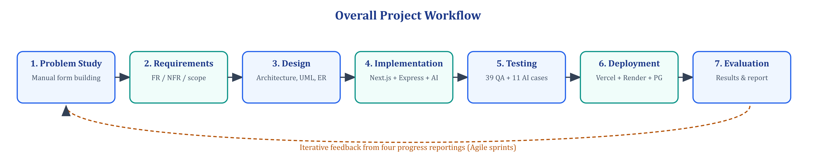
Figure 5.1: Overall Project Workflow

5.3 Project Phases and Deliverables
Table 5.1: Project phases and deliverables
Phase | Activities | Deliverables | Evidence / Status
1. Problem study | Study existing form tools, interview mentor, define problem and objectives | Problem statement, objectives | Reporting 1 – Completed
2. Requirements | FR/NFR, MoSCoW prioritisation, feasibility | Requirement specification | Chapter 4 – Completed
3. Design | Architecture, UML, ER model, API contract, UI wireframes | Design documents, Prisma schema | Reporting 2 – Completed
4. Core implementation | Auth, forms CRUD, builder, public responder | Working MVP | Reporting 2 – Completed
5. AI implementation | AIFormBrain, Gemini integration, document parsing, quiz engine | AI generation feature | Reporting 3 – Completed
6. Advanced features | Analytics, teams, notifications, billing, admin | Feature-complete product | Reporting 3 – Completed
7. Testing | QA suite, AI test suite, bug fixing, re-verification | QA reports (50 tests) | Reporting 3/4 – Completed
8. Deployment | Vercel, Render, managed PostgreSQL, env configuration | Live application | Reporting 4 – Completed
9. Documentation | Progress reports, final report, viva preparation | Final hard-bound report | Reporting 4 – Completed

5.4 Progress Report Consolidation
Table 5.2: Progress report consolidation
Progress Report | Primary Focus | Key Evidence | Final Report Chapters
Reporting 1 | Problem, objectives, methodology | Initial project definition | Ch. 1, Ch. 5, Ch. 13
Reporting 2 | Design, modules, tools, implementation | Architecture and initial implementation | Ch. 4, Ch. 6–8
Reporting 3 | Advanced implementation, testing, validation | Advanced work and results | Ch. 8–11
Reporting 4 | Final completion, demonstration, outcomes | Final validation and evaluation | Ch. 9–14

5.5 Project Schedule / Timeline
The planned and actual schedule (weeks relative to the internship start date) is given below and visualised as a Gantt chart in Figure 5.2. Minor slippage in the AI engine phase was absorbed by overlapping the testing phase with feature completion.
Table 5.3: Project schedule – planned vs actual
Task / Phase | Planned Start | Planned End | Actual Start | Actual End | Status
Problem study & literature | W1 | W2 | W1 | W2 | Completed
Requirement analysis | W2 | W3 | W2 | W3 | Completed
Architecture & UML design | W3 | W4 | W3 | W4 | Completed
Database schema (Prisma) | W4 | W5 | W4 | W5 | Completed
Auth & core APIs | W5 | W7 | W5 | W7 | Completed
AI engine (AIFormBrain + Gemini) | W6 | W9 | W6 | W10 | Completed (+1 week)
Builder, templates, public forms | W7 | W10 | W7 | W10 | Completed
Analytics, teams, notifications | W9 | W12 | W9 | W12 | Completed
Testing & bug fixing | W10 | W13 | W10 | W13 | Completed
Deployment (Vercel / Render) | W12 | W13 | W12 | W13 | Completed
Documentation & final report | W13 | W14 | W13 | W14 | Completed

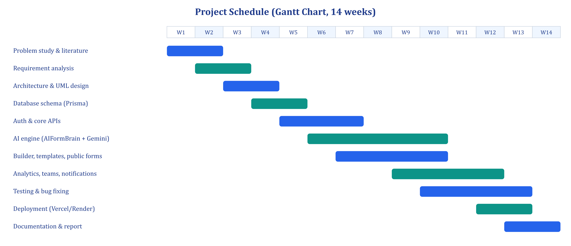
Figure 5.2: Project Schedule (Gantt Chart)
CHAPTER 6

SYSTEM ANALYSIS AND DESIGN

6.1 Existing System / Current Practice
In current practice a form author opens a hosted builder, creates an empty form and adds questions one at a time. For every question the author types a label, selects a type from a menu, types each option for choice questions, toggles the required flag and optionally adds validation such as an e-mail pattern. Themes are chosen from a small set of presets. If the organisation already has the form on paper or in a PDF, every field is re-typed. For assessments, correct answers and marks are entered manually for each question.
After publication, responses are viewed as a list or exported to a spreadsheet; deeper analysis such as completion rate, drop-off, device split or sentiment of text answers is either unavailable or requires external tools. Collaboration is usually limited to sharing an edit link, which gives full control to anyone holding it. The main weaknesses of the existing practice are therefore: high authoring time, inconsistent field types and validation, no digitisation of existing documents, limited quiz integrity controls, shallow analytics and coarse access control.

6.2 Proposed System
The proposed system, PromptForm AI, replaces manual authoring with AI generation while keeping the author in control. The author types a description or uploads a document; the backend validates the request, checks plan limits and AI credits, extracts text from documents, and runs the AIFormBrain pipeline, which detects intent, language, domain and industry, plans the fields with appropriate types and validations, and calls Gemini for natural wording. The quality reviewer corrects the result, which is saved as a published form with a unique share link and opened in the visual builder for refinement.
Respondents fill the form in full-page, wizard or chat mode. Submissions are validated on the server (required fields, password protection, response limits, anti-cheat flags) and stored together with browser metadata. Analytics events (views, starts, submissions, drop-outs) feed per-form and workspace dashboards, and the owner can export responses, ask the AI to analyse them, and receive notifications. Teams, roles and collaborators provide controlled access. The key advantages are speed, consistency of field types, digitisation, integrity of quizzes, richer analytics and secure collaboration.

6.3 System Architecture
PromptForm AI follows a three-tier client–server architecture (Figure 6.1). The presentation tier is a Next.js single-page experience; the application tier is an Express REST API composed of a gateway layer (security middleware), routers, the AIFormBrain engine and services; the data tier is PostgreSQL accessed through Prisma. External services include the Gemini API and an e-mail provider. The API is stateless — identity travels in a JWT — so it can be scaled horizontally.
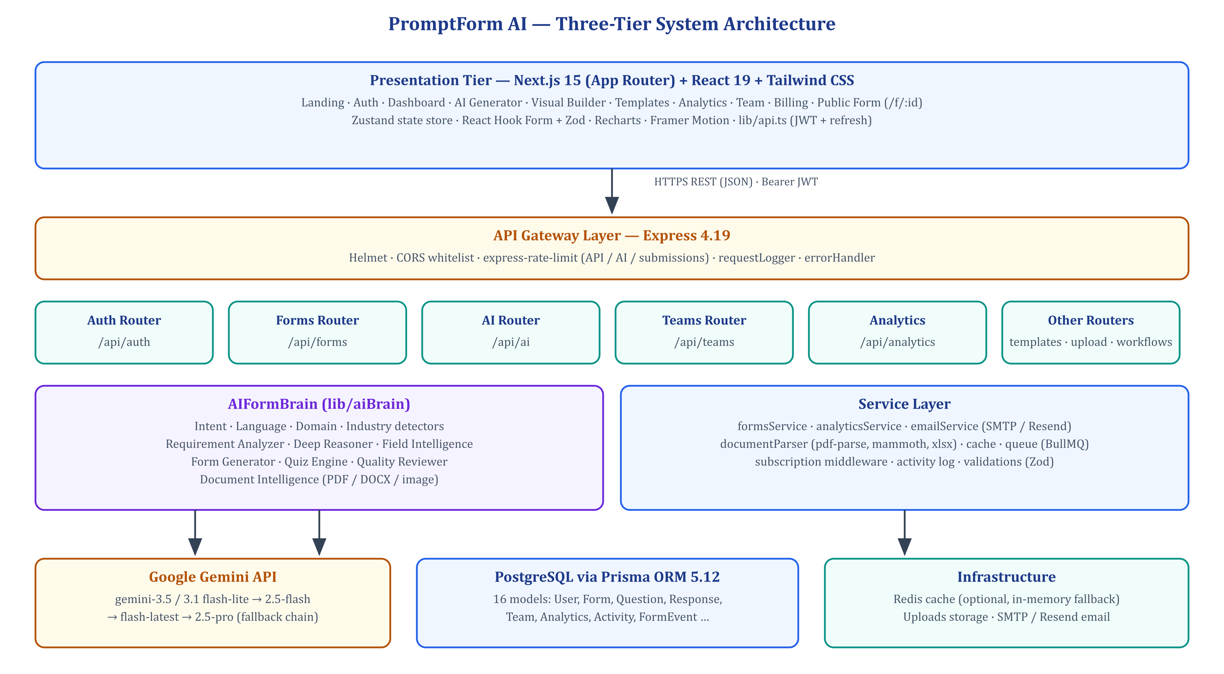
Figure 6.1: Final System Architecture

6.4 Workflow / Process Flow
The core process — turning a prompt or document into a published form — is shown in Figure 6.2. Each step either enriches the form definition or enforces a rule (credits, plan limits, schema validity) before the next step is executed.
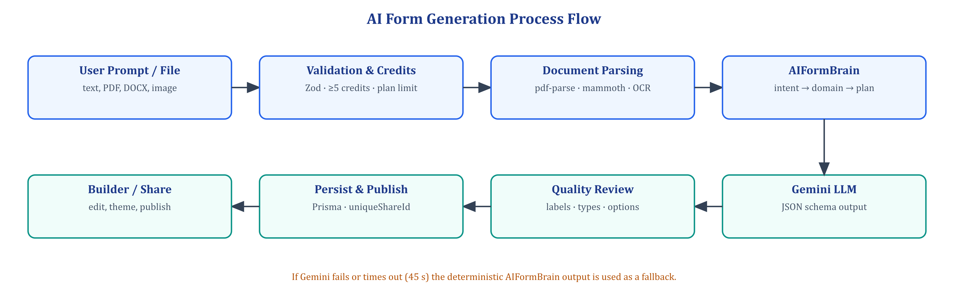
Figure 6.2: Final Workflow / Process Flow

6.5 UML / Design Diagrams
The design was documented using UML and structured-analysis diagrams: the use case diagram (Figure 6.3) identifies actors and their goals; the Level-1 data flow diagram (Figure 6.4) shows processes and data stores; the class diagram (Figure 6.5) shows the main engine and service classes; the sequence diagram (Figure 6.6) details AI generation; the activity diagram (Figure 6.7) describes form submission; and the ER diagram (Figure 6.8) presents the database schema.
- Use Case Diagram
- Class Diagram
- Sequence Diagram
- Activity Diagram
- ER Diagram / Database Schema
- Other domain-specific diagrams (Data Flow Diagram – Level 1)
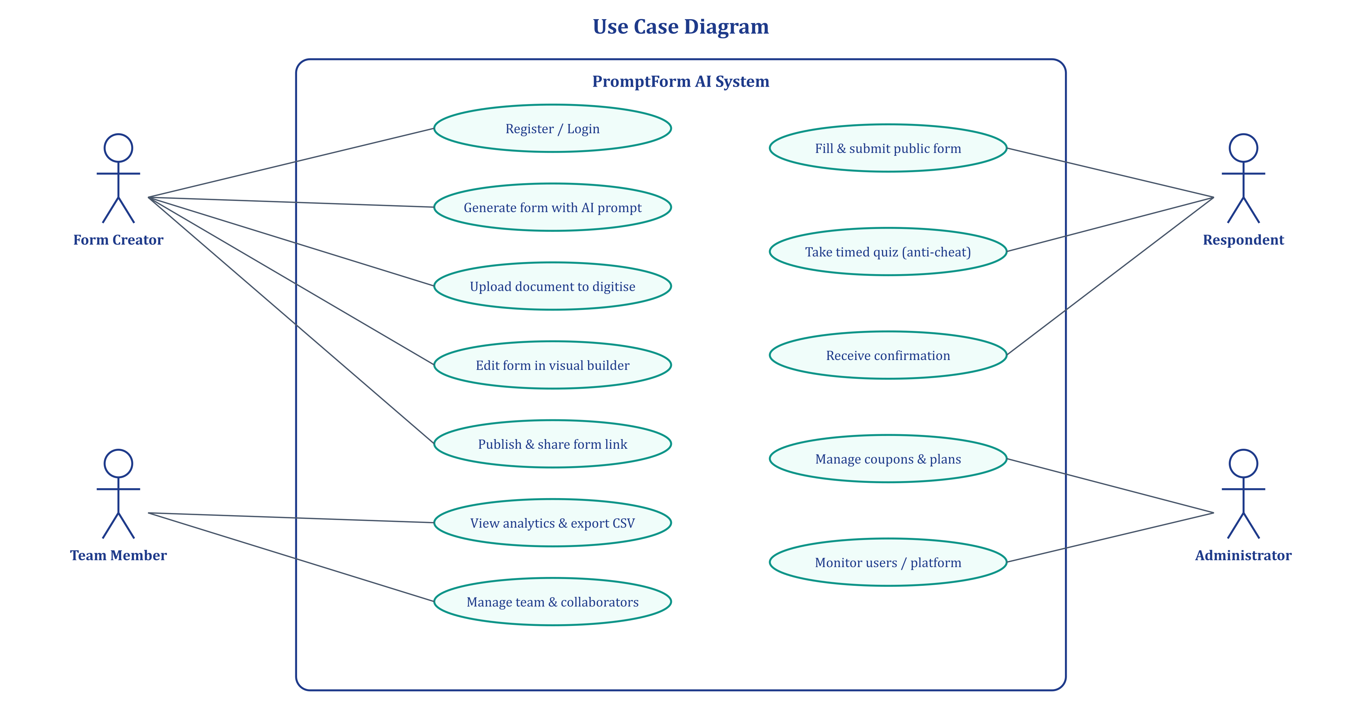
Figure 6.3: Major UML / ER / Design Diagram — Use Case Diagram
Four actors interact with the system. The Form Creator generates, edits, publishes and analyses forms; a Team Member collaborates on shared forms according to an assigned role; a Respondent fills public forms and quizzes without needing an account; and the Administrator manages plans, coupons and platform-level monitoring.
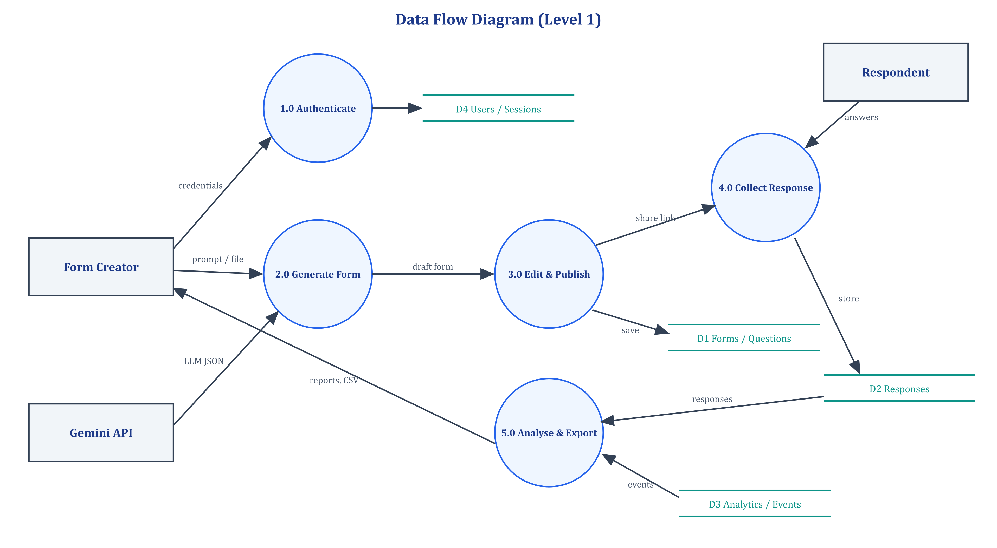
Figure 6.4: Data Flow Diagram (Level 1)
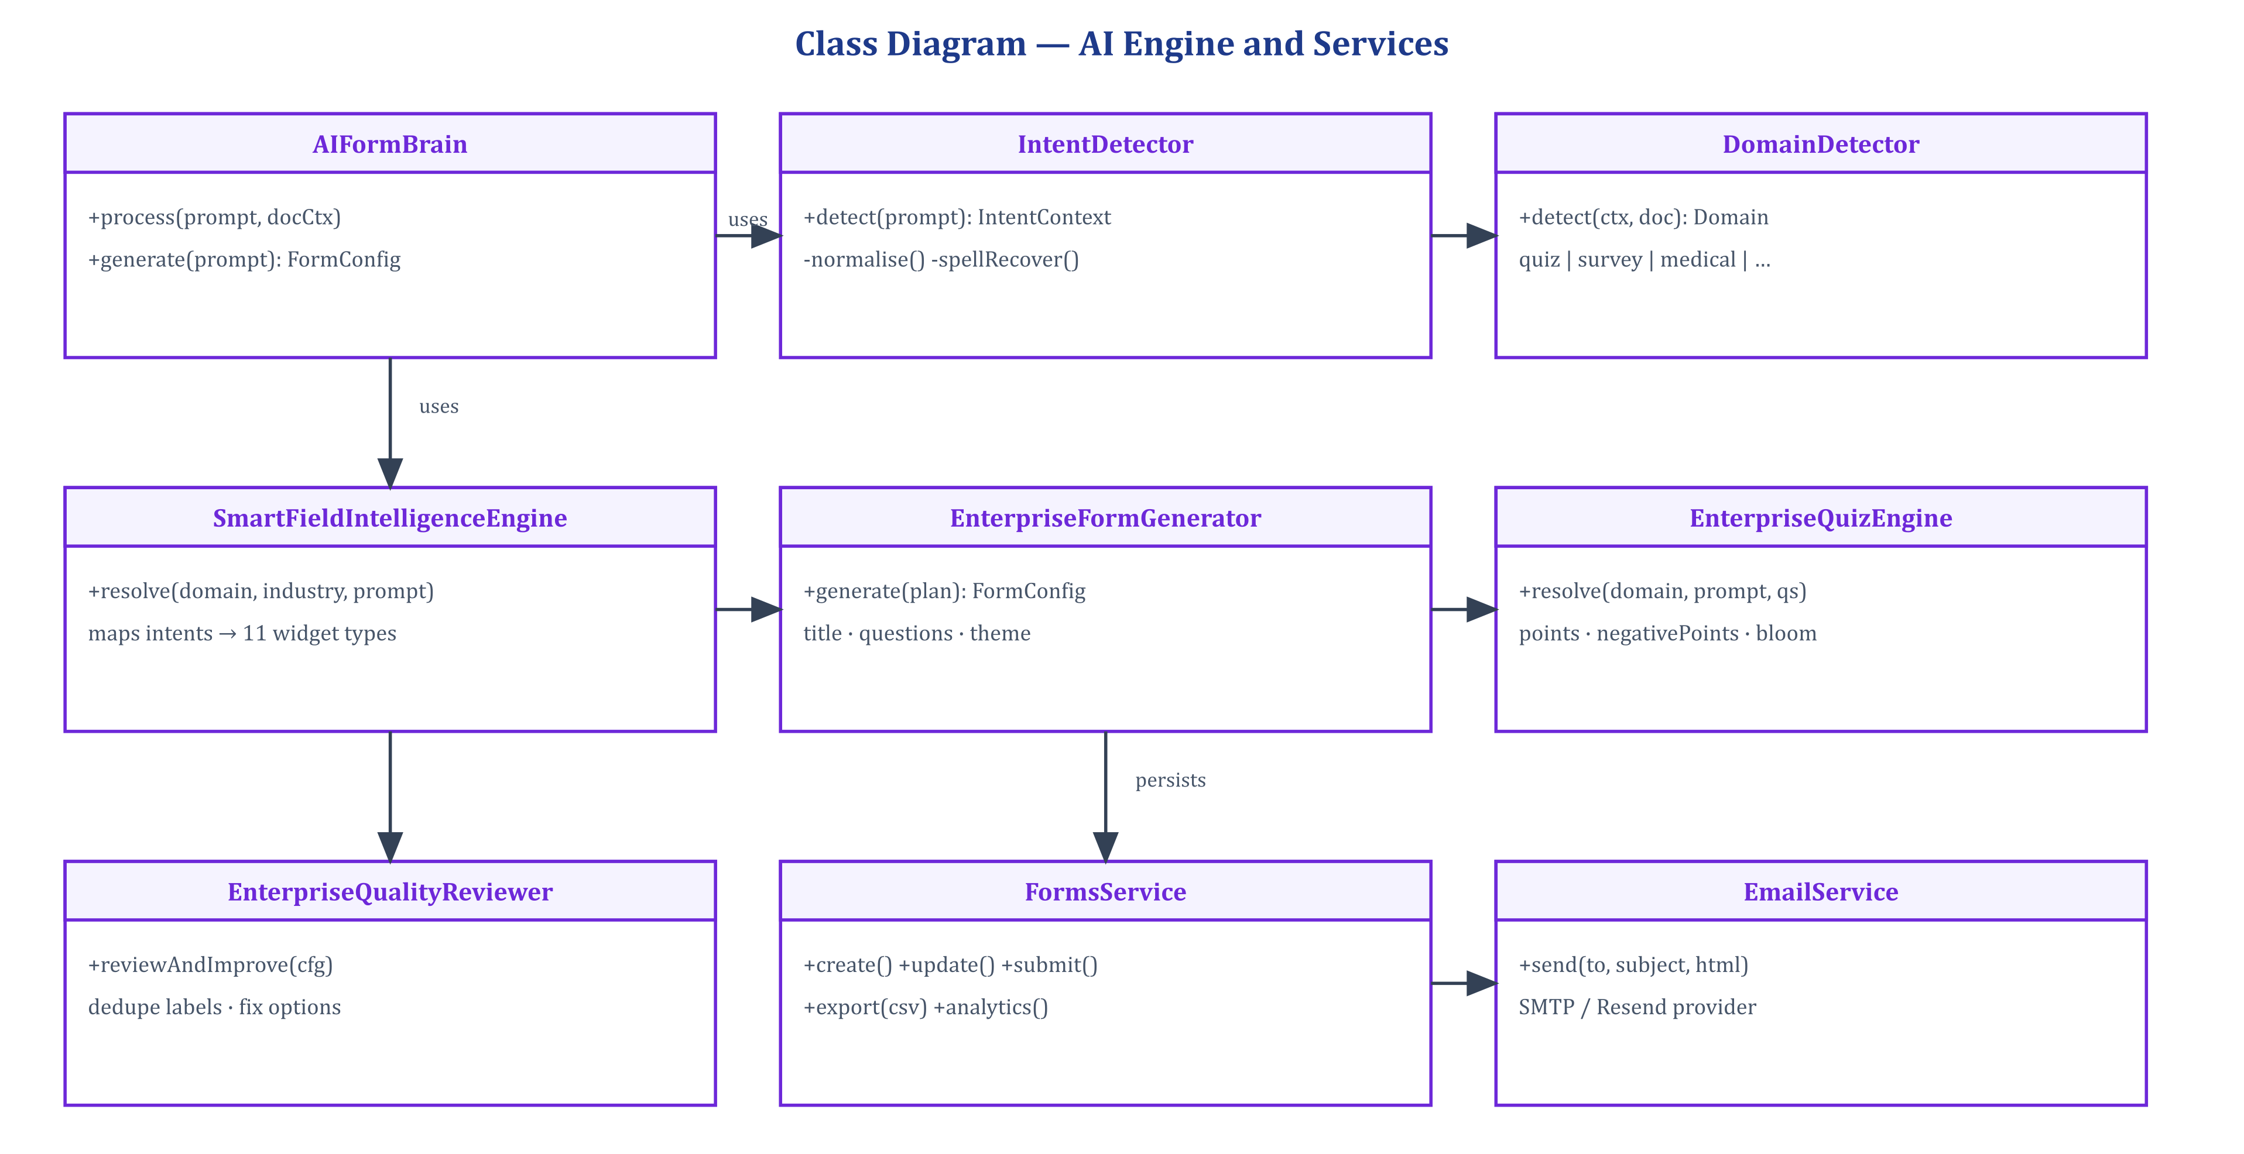
Figure 6.5: Class Diagram — AI Engine and Services
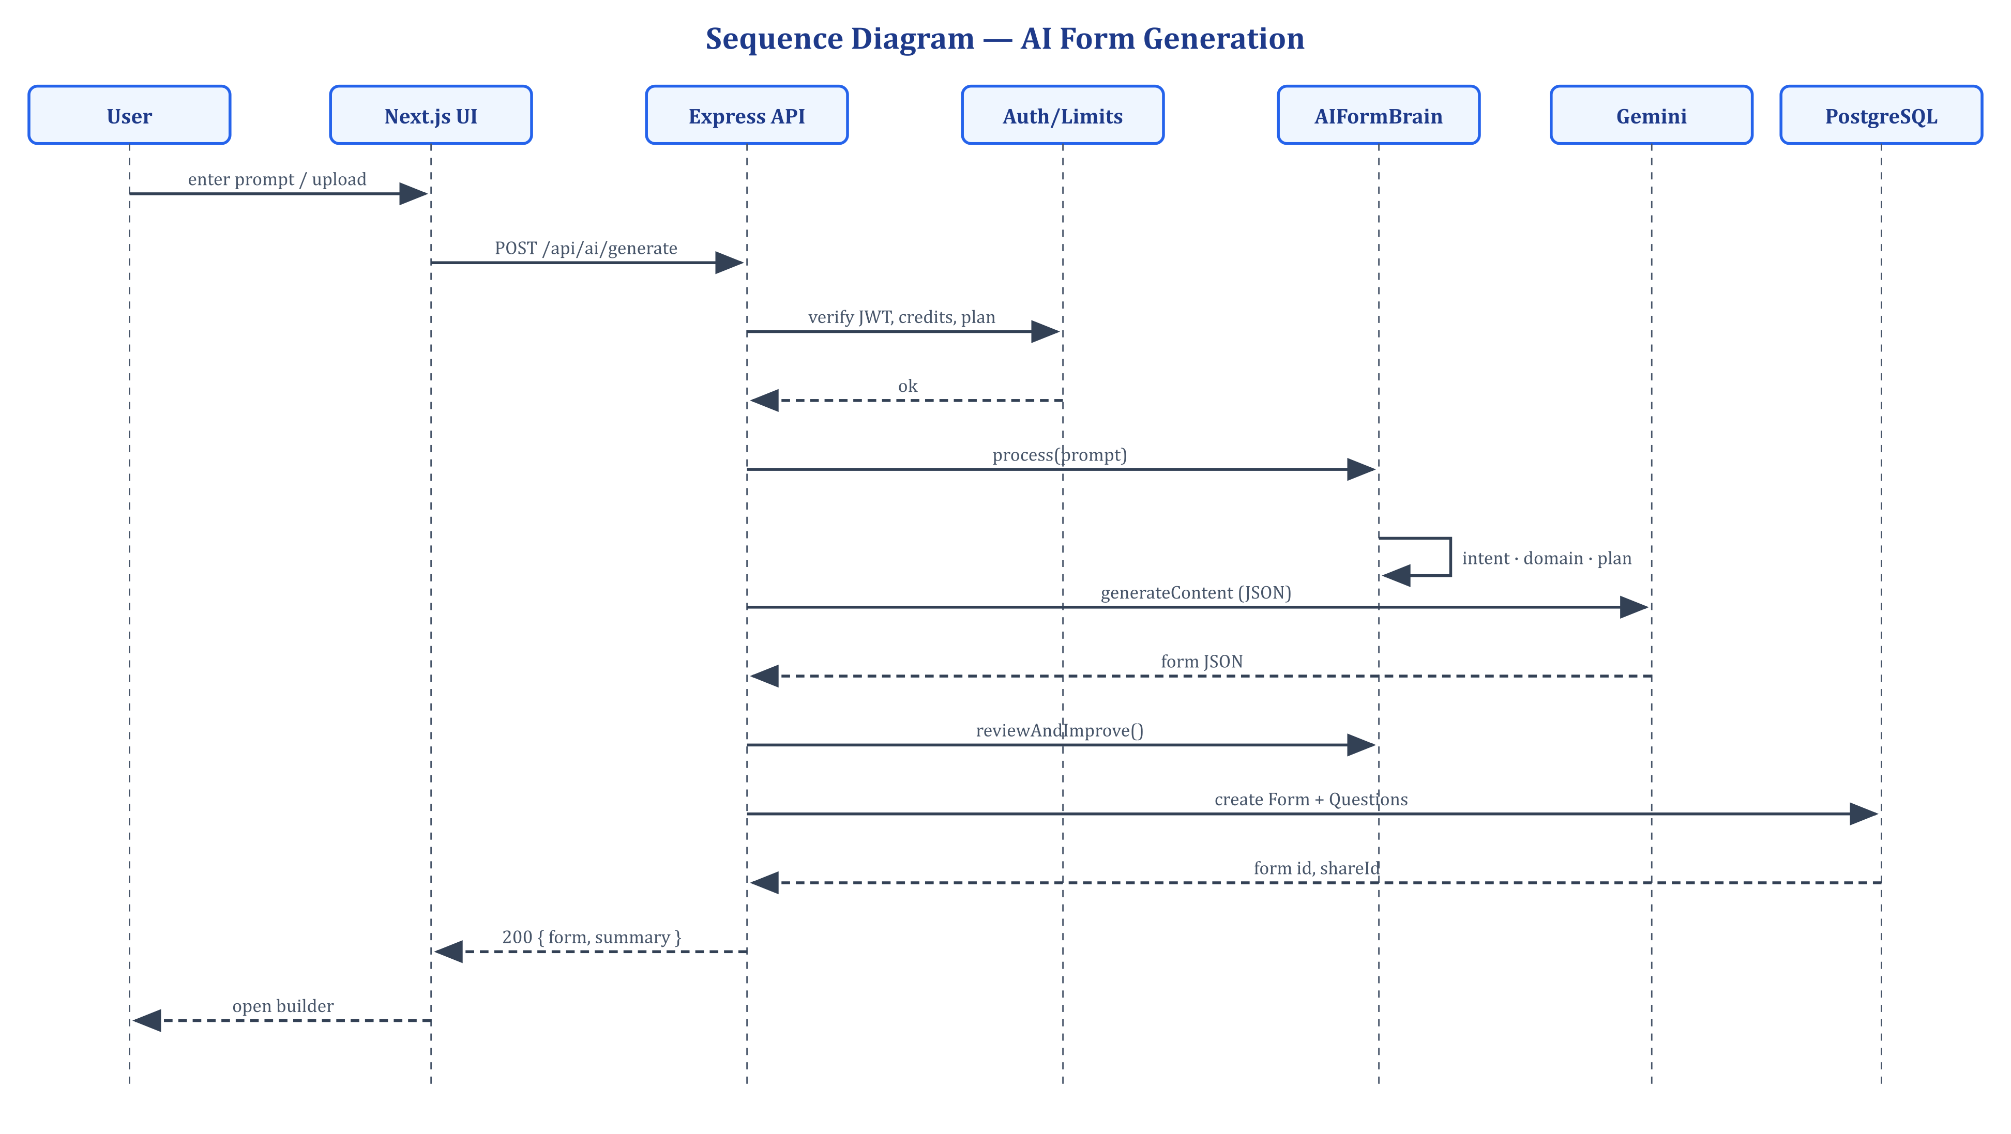
Figure 6.6: Sequence Diagram — AI Form Generation
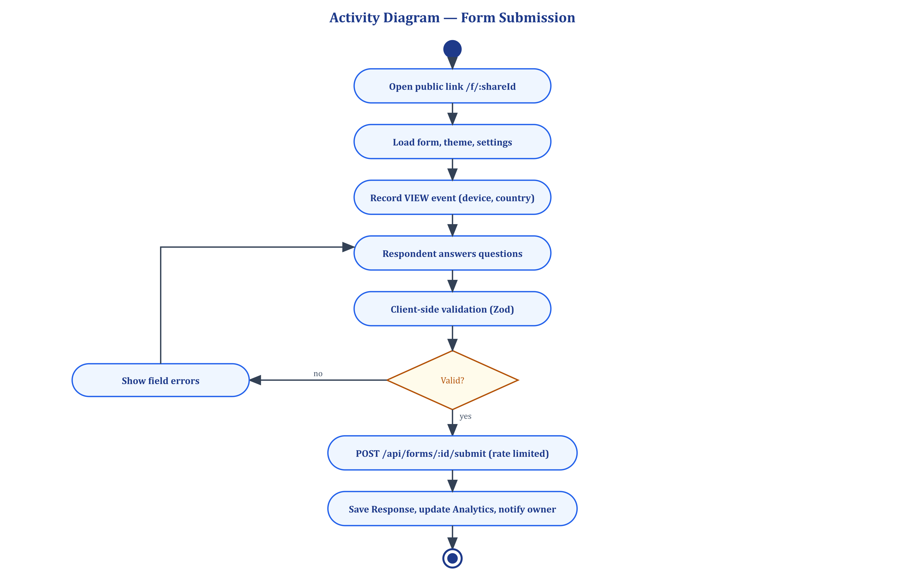
Figure 6.7: Activity Diagram — Form Submission
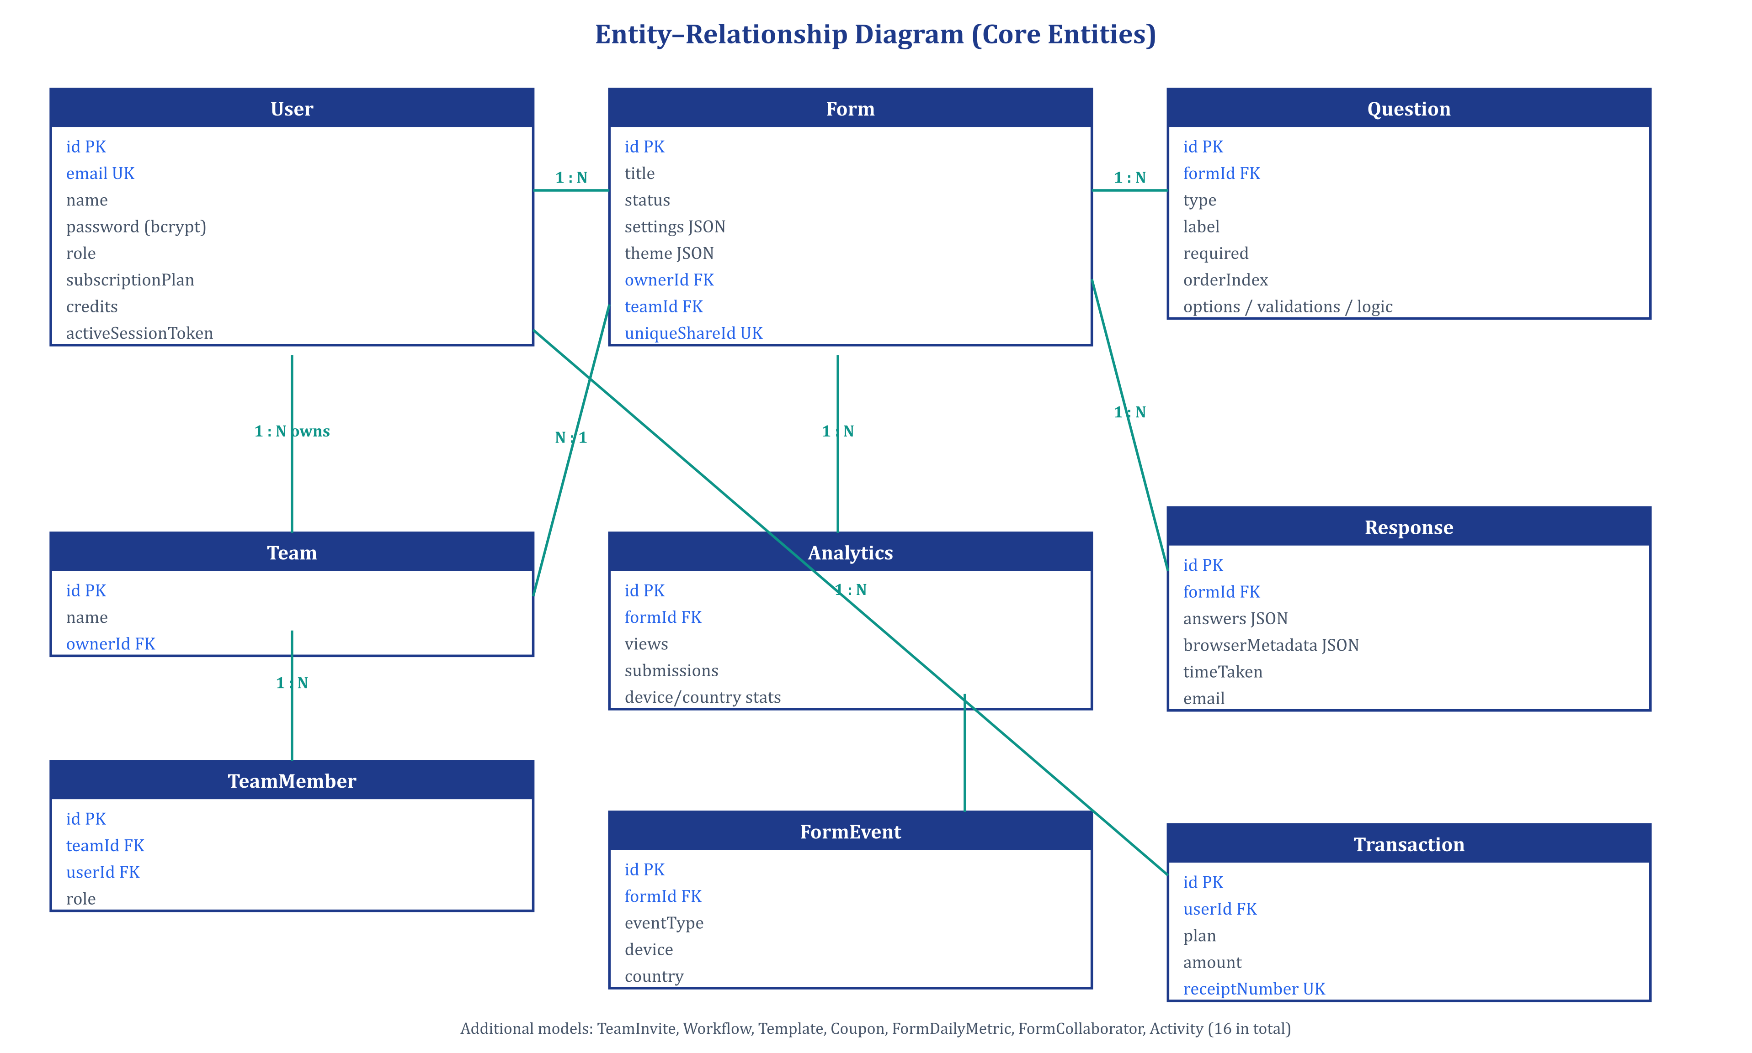
Figure 6.8: ER Diagram / Database Schema

6.6 Module-wise Design
Table 6.1: Module-wise design
Module | Purpose | Inputs | Processing | Outputs | Dependencies
Authentication | Identify users securely | Email, password, OAuth code | bcrypt verify, JWT issue, session token | Access/refresh tokens | User model, JWT
AI Generator | Create forms automatically | Prompt, file, options | Parsing, AIFormBrain, Gemini, review | Saved form + summary | Gemini, documentParser
Visual Builder | Edit forms | Form JSON, user edits | State store, undo/redo, PUT questions | Updated form | Forms API, Zustand
Templates | Start from ready forms | Template id | Clone structure into new form | New form | Template model
Public Responder | Collect answers | Share id, answers | Client + server validation, events | Response record | Forms submit API
Quiz Engine | Assessments | Graded questions, answers | Scoring, negative marks, timer, tab-switch | Score, flags, CSV | Response metadata
Analytics | Insight into performance | Events, responses | Aggregation, daily metrics, sentiment | Charts, KPIs | FormEvent, Analytics
Teams | Collaboration | Team, invites, roles | RBAC checks, invite tokens, activity log | Members, access | Team models, email
Billing | Plans and credits | Plan, coupon | Limit checks, discounts, receipts | Transaction | subscription middleware
Notifications | Inform owners | Submission, invite events | Live feed + e-mail dispatch | Alerts, e-mails | emailService

6.7 Database / Data Design
The relational schema contains 16 Prisma models. Flexible, form-specific structures (settings, theme, options, validations, logic, answers) are stored as PostgreSQL JSON columns, while identity and relationships use UUID keys, foreign keys with cascade rules, unique constraints and indexes on frequently filtered columns.
Table 6.2: Database entities
Entity / Table | Key Fields | Relationships | Purpose
User | id, email (unique), password, role, subscriptionPlan, credits, activeSessionToken | 1:N Form, Team, Transaction, Activity | Accounts and plans
Form | id, title, status, settings, theme, ownerId, teamId, uniqueShareId | N:1 User/Team; 1:N Question, Response | Form definition
Question | id, formId, type, label, required, orderIndex, options, validations, logic | N:1 Form | Form fields
Response | id, formId, answers, browserMetadata, timeTaken, email | N:1 Form | Submitted answers
Team / TeamMember | team id, name, ownerId; member role | N:M User via TeamMember | Workspaces and RBAC
TeamInvite | email, role, token (unique), status, expiresAt | N:1 Team | E-mail invitations
FormCollaborator | formId, userId, role (unique pair) | N:M Form–User | Per-form sharing
Analytics / FormDailyMetric | views, submissions, device/country stats, date | N:1 Form | Aggregated metrics
FormEvent | eventType, questionId, device, country | N:1 Form | Raw analytics events
Workflow | trigger, action, config, active | N:1 Form | Automation on submit
Template | title, category, structure | — | Template marketplace
Transaction / Coupon | plan, amount, receiptNumber; code, discountPercent | N:1 User | Billing records
Activity | action, targetTitle, details, metadata | N:1 User/Team/Form | Audit trail

6.8 Interface / UI Design (if applicable)
The interface follows a warm, minimal design language: a cream background, a brown primary accent, rounded cards, Inter typography and generous spacing, with a full dark mode through next-themes. Navigation in the authenticated area uses a top bar with Overview, Forms, AI Generator, Templates, Analytics, Team and Settings, plus search, theme toggle, notifications and profile menu. The builder uses a three-pane layout — field palette, live canvas and properties panel — so that every change is visible immediately.
The public landing page (Figure 6.9) introduces the product, demonstrates prompt-based generation and links to templates and pricing. All pages are responsive and were checked at mobile, tablet and desktop widths.
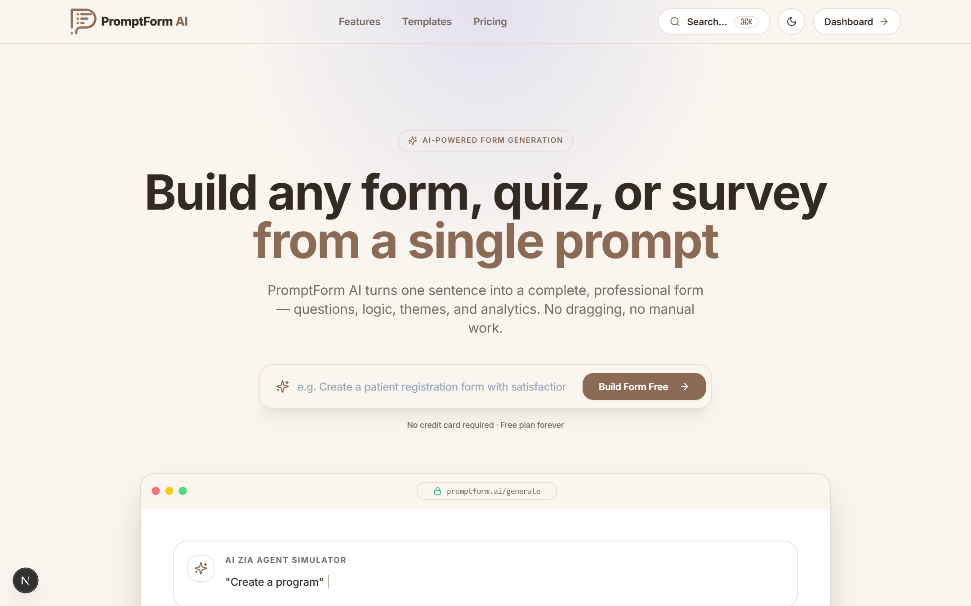
Figure 6.9: Major Interface / UI Design
CHAPTER 7

TECHNOLOGY STACK AND DEVELOPMENT ENVIRONMENT

7.1 Programming Languages
Table 7.1: Programming languages
Technology | Version | Purpose | Major Usage
TypeScript | 5.4 / 5.5 | Typed superset of JavaScript | All frontend, backend and shared code
JavaScript (ES2022) | Node 20+ | Scripts and tooling | dev orchestrator, QA scripts, build helpers
SQL (PostgreSQL dialect) | 15/16 | Database language | Generated by Prisma migrations, JSON queries
HTML5 / CSS3 | — | Markup and styling | Rendered by React, styled with Tailwind CSS
Prisma Schema Language | 5.12 | Data modelling | schema.prisma with 16 models

7.2 Frameworks / Libraries / APIs
Table 7.2: Frameworks, libraries and APIs
Tool / Framework / API | Version | Purpose | Usage
Next.js (App Router) | 15.5 | React framework | Routing for 29 pages, builds, dev server on port 4500
React / React DOM | 19 RC | UI rendering | Components, hooks
Tailwind CSS | 3.4 | Utility-first CSS | Design system, dark mode
Zustand | 5.0 | State management | Builder and session stores
React Hook Form + Zod | 7.53 / 3.23 | Forms and schemas | Client validation
Recharts | 3.10 | Charts | Analytics dashboards
Framer Motion, Lucide | 11 / 0.453 | Animation, icons | UI polish
Express | 4.19 | HTTP server | 73 REST routes
jsonwebtoken, bcryptjs | 9.0 / 2.4 | Auth | Tokens and password hashing
Helmet, cors, express-rate-limit | 7.1 / 2.8 / 7.2 | Security | Headers, origins, throttling
Multer | 1.4 | File upload | Documents and response files
pdf-parse, mammoth, xlsx | 2.4 / 1.12 / 0.18 | Document parsing | PDF, DOCX, spreadsheet text
Nodemailer / Resend | 10.0 | E-mail | Invites, notifications
BullMQ, redis | 5.79 / 4.6 | Queue and cache | Background jobs (optional)
geoip-lite, ua-parser-js | 2.0 / 2.0 | Analytics enrichment | Country and device detection
Google Gemini API | v1beta | LLM | Form generation, document reading, analysis, chat

7.3 Database / Storage
Table 7.3: Database and storage
Database / Storage | Version | Purpose | Data Managed
PostgreSQL | 15/16 | Primary relational store | Users, forms, questions, responses, teams, analytics, billing
Prisma Client | 5.12 | Type-safe ORM | Queries, transactions, migrations
Redis | 7 (optional) | Cache and queue backend | Cached lookups, job queue; in-memory fallback when disabled
Local file storage | — | Uploads directory | Files uploaded in responses and documents
Browser localStorage | — | Client session | Access/refresh tokens, theme preferences

7.4 Hardware / Cloud / Deployment Environment
Table 7.4: Hardware, cloud and deployment environment
Platform / Hardware | Specification | Purpose | Status
Developer laptop | Windows 10, 8–16 GB RAM, SSD | Development and testing | Used
Docker Compose | PostgreSQL + Redis containers | Local infrastructure | Used
Vercel | Next.js hosting with CDN | Frontend production | Deployed
Render | Node web service (render.yaml) | Backend production | Deployed
Managed PostgreSQL | Cloud database | Production data | Configured
Google AI Studio | Gemini API key | LLM access | Configured

7.5 Development Tools
Table 7.5: Development tools
Tool | Purpose | Usage
Visual Studio Code | IDE | Editing, debugging, integrated terminal
Git | Version control | 66 commits with descriptive messages on main branch
npm workspaces | Monorepo management | frontend, backend and packages/shared
nodemon + ts-node | Backend hot reload | npm run dev:backend
ESLint + Prettier | Code quality | Consistent formatting and linting
Prisma CLI / Studio | DB tooling | generate, migrate, seed, inspect data
Postman / custom Node scripts | API testing | Manual checks and automated QA runner
Chrome / Edge DevTools | Frontend debugging | Network, console, responsive checks

7.6 Technology Selection Rationale
TypeScript end-to-end was selected so that the same types and Zod schemas describe forms in the frontend, backend and shared package, catching mismatches at compile time. Next.js offers file-based routing, optimised production builds and first-class deployment on Vercel, and React 19 provides a modern component model. Tailwind CSS enabled a consistent design system and dark mode with little custom CSS.
Express was chosen for the API because it is minimal, mature and easy to compose with security middleware; it also makes streaming responses (AI chat) straightforward. PostgreSQL provides relational integrity for users, teams and billing together with JSON columns for flexible form definitions, and Prisma adds type-safe queries and migrations.
Google Gemini was selected as the LLM because it supports multimodal input (images and PDFs) in the same request, native JSON output with response schemas, a generous free tier and several model sizes that allow a cost/latency-aware fallback chain. Vercel and Render were selected for hosting because both deploy directly from Git, provide HTTPS by default and have free tiers suitable for an internship project.
CHAPTER 8

SYSTEM IMPLEMENTATION
Technical core of the report; consolidate Reporting 2, 3 and 4 implementation work.

8.1 Implementation Overview
The system is implemented as an npm-workspaces monorepo with three packages. frontend/ contains the Next.js application with 29 page routes (landing, auth, dashboard, AI generator, builder, templates, analytics, responses, team, settings, billing, admin, public form and others), reusable components (DashboardLayout, AssistantChat, notification panel, team components, UI primitives) and lib/api.ts, which wraps fetch with automatic token refresh. backend/ contains the Express server (index.ts), 8 routers exposing 73 routes, 4 middlewares, 3 services and the lib folder with the AIFormBrain engine, document parser, cache, queue and validation schemas. packages/shared/ holds shared types and schemas.
Development started with the database schema and authentication (Reporting 2), followed by forms CRUD, the builder and the public responder. The AI engine, document digitisation and quiz engine were implemented next (Reporting 3), followed by analytics, teams, notifications, billing and the admin panel. Reporting 4 concentrated on defect fixing, performance tuning, deployment and documentation. The three central modules are described in the following sections.

8.2 Module / Feature 1 – AI Form Generator
The AI generator is exposed as POST /api/ai/generate (and /generate-from-file). The route accepts a prompt, optional file (via Multer), desired question count and theme preferences. It first validates the input: prompts shorter than three characters return suggestions rather than an error, unauthenticated users can try generation in demo mode, and authenticated users must have at least 5 AI credits and must not exceed the free-plan limit of 5 active forms.
Uploaded documents are converted to text by documentParser (pdf-parse for PDF, mammoth for DOCX, SheetJS for spreadsheets), while images and PDFs are also passed to Gemini as inline base64 data for multimodal understanding. The AIFormBrain pipeline then produces a deterministic plan, Gemini produces natural wording through a JSON response schema, and the EnterpriseQualityReviewer merges and repairs the result. The form is saved as PUBLISHED with a unique share id, 5 credits are deducted and the response includes an “understanding summary” (topic, purpose, form type, difficulty, question count) that is shown to the user. The AI Generator page is shown in Figure 8.1.
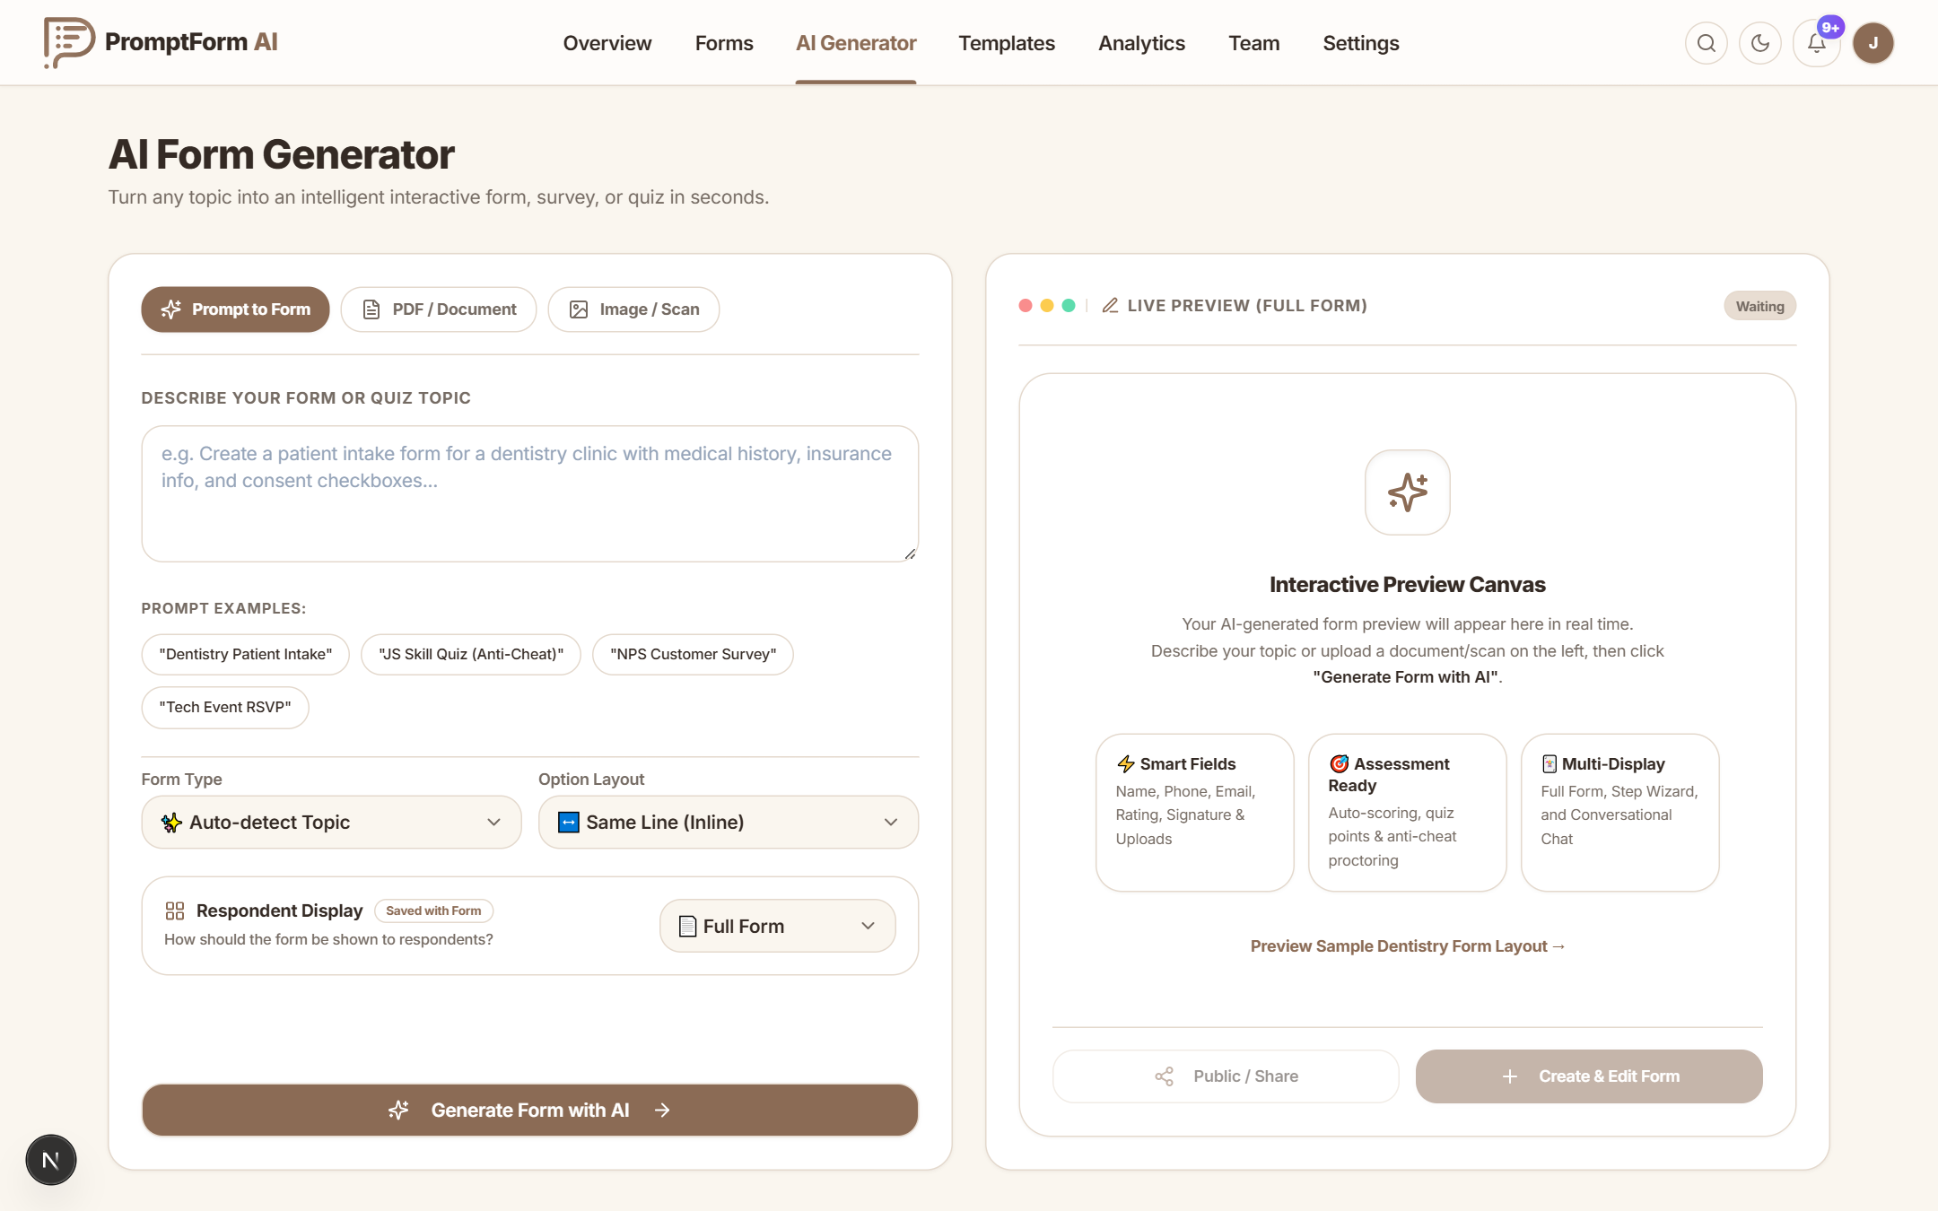
Figure 8.1: Module 1 Implementation / Output

8.3 Module / Feature 2 – Visual Form Builder
The builder (/builder/[id]) loads the form and renders a three-pane editor. The left palette groups field presets (Profile & Contact, Choices & Options, Advanced) such as Full Name, Email, Phone, Address, Country, Gender, Checkboxes, Radio, Agreement, Rating, Date, File Upload and Signature. The canvas shows the form exactly as respondents will see it; each question card supports duplicate, delete, reorder, logic and type badges. The right panel edits field properties (type, label, required, options, validation) and the live branding editor (accent colour, typography, corner radius, display mode).
State is held in a Zustand store with an undo/redo history. Saving calls PUT /api/forms/:id/questions, which upserts questions while preserving existing question UUIDs so that historical responses remain linked (a defect fixed during QA, see Section 9.9). Publish/share, preview, collaborators and close-form actions are available from the toolbar. Figure 8.2 shows the builder editing the AI-generated Patient Intake Form.
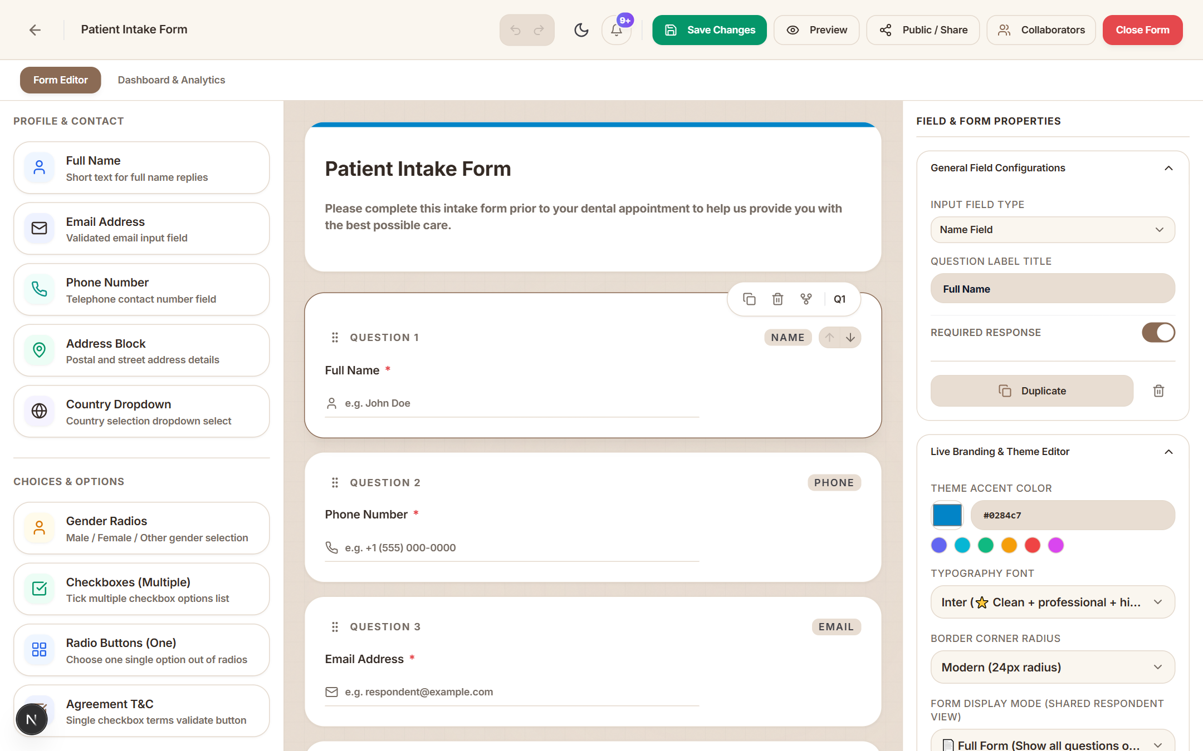
Figure 8.2: Module 2 Implementation / Output

8.4 Module / Feature 3 – Responses, Quiz Engine and Analytics
Public forms are served at /f/[shareId] in full, wizard or chat mode. The submit endpoint (POST /api/forms/:id/submit) is rate limited and validates answers with Zod, enforces required fields and form passwords on the server, applies response limits and auto-closes forms when the limit is reached. For quizzes, the EnterpriseQuizEngine attaches correct answers, points, negative points, difficulty and Bloom’s taxonomy level to each question; the client enforces a timer and counts tab switches, and submissions exceeding the threshold are flagged in browserMetadata. Scores are calculated with weighted marks and exported to CSV for leaderboards.
Every view, start, submission and drop-out is recorded as a FormEvent with device (ua-parser-js) and country (geoip-lite). The analyticsService aggregates these into FormDailyMetric rows and the per-form dashboard (Figure 8.3) presents views, submissions, completion rate, average time, historical trends, device distribution, top locations and an AI sentiment summary of text answers.
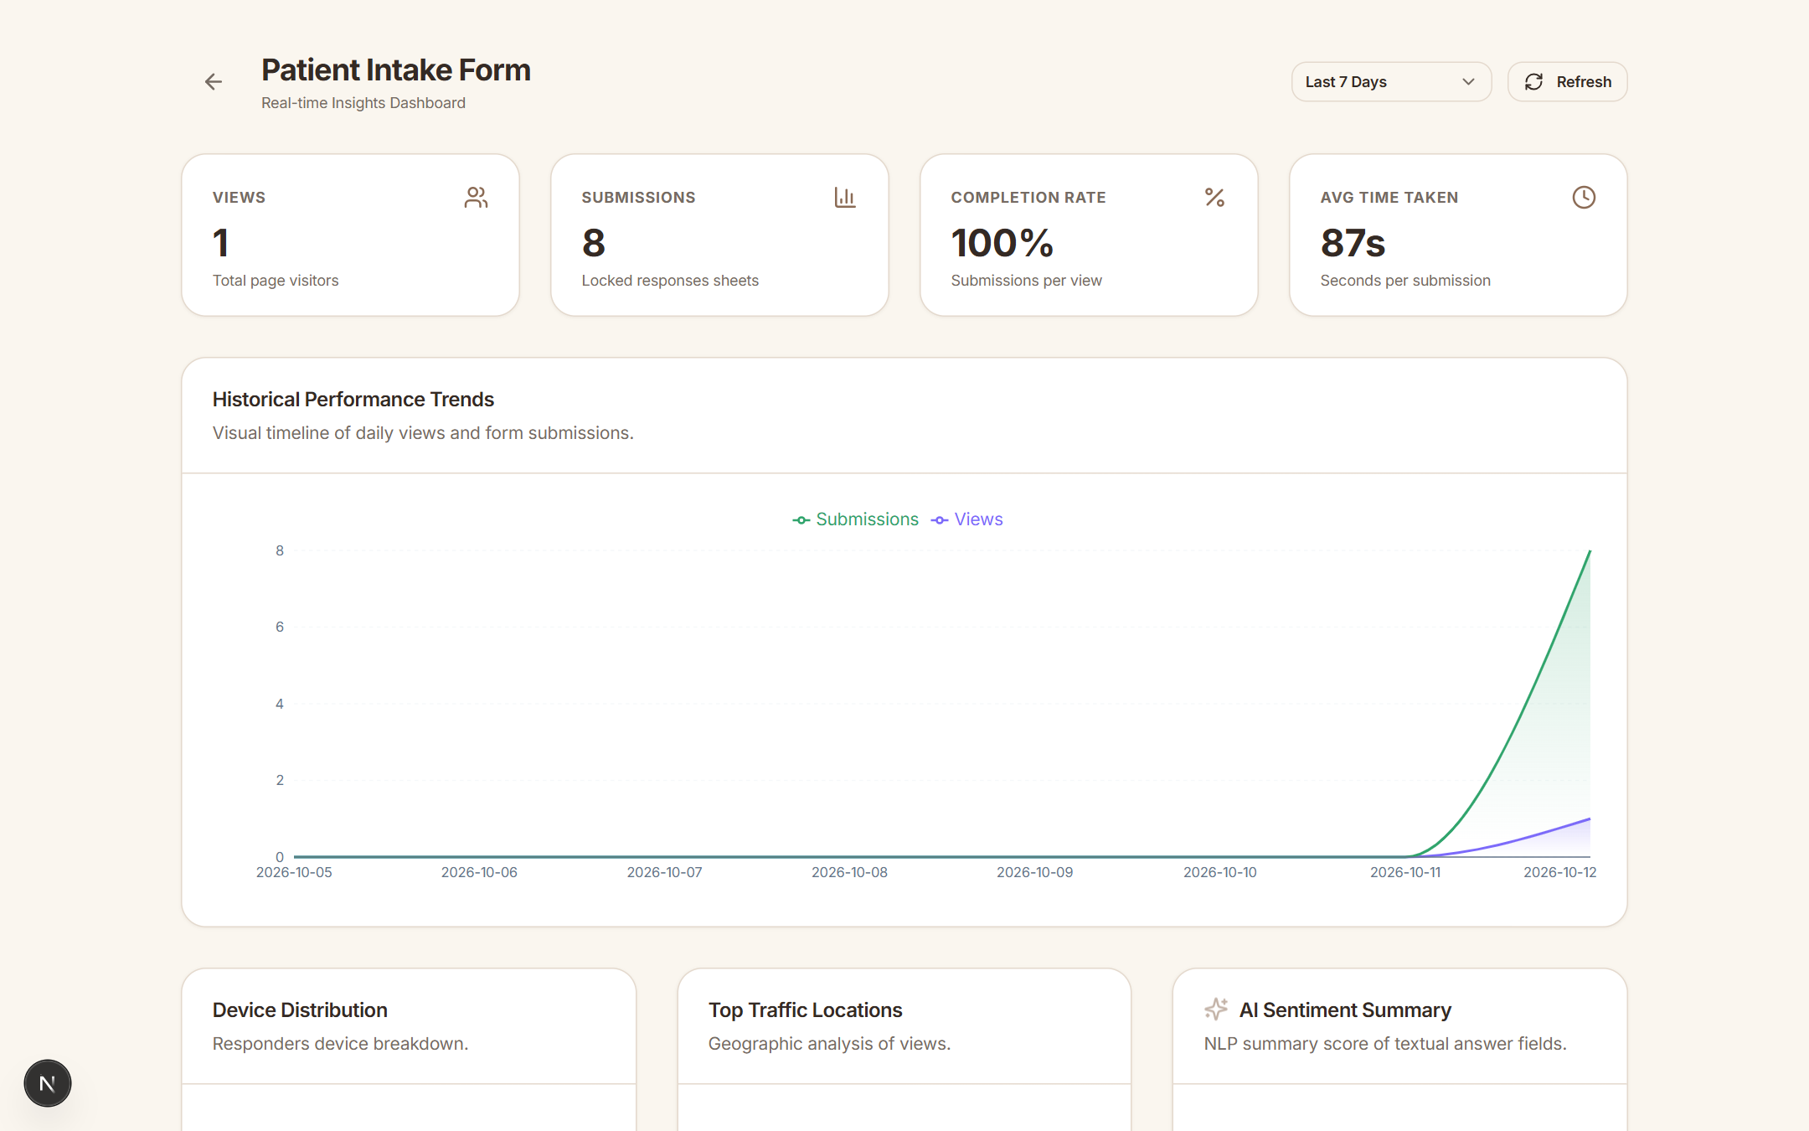
Figure 8.3: Module 3 Implementation / Output

8.5 Algorithm / Logic / Model Description
The heart of the system is the hybrid generation algorithm implemented in backend/src/lib/aiBrain. Its steps are:
- Intent detection: normalise the prompt (lower-case, spelling and phonetic recovery), extract the requested action (create quiz, survey, registration…), desired question count and constraints.
- Language detection: identify the language and right-to-left scripts so the theme can set rtl = true.
- Domain and industry detection: score the prompt and any document context against keyword dictionaries for domains (quiz, survey, medical, education, HR, events, feedback, contact…) and industries (healthcare, dentistry, hospitality, education…).
- Requirement analysis and deep reasoning: derive mandatory fields for the domain (e.g. patient name, date of birth and allergies for medical intake) and recommended settings (collect e-mails, response limits).
- Smart field intelligence: map each planned field to one of the widget types and attach validations — e-mail pattern, phone pattern, numeric ranges, date pickers, file size and type limits.
- Form generation: assemble title, description, ordered questions and an HSL-harmonised theme.
- Quiz enrichment: for quiz, survey and medical domains, the quiz engine adds options, correct answers, explanations, points, negative points and difficulty, and enables shuffle, anti-cheat and a 600-second timer for quizzes.
- LLM generation: the prompt, the plan and a system instruction are sent to Gemini with responseMimeType = application/json and a response schema. Models are tried in order (gemini-3.5-flash-lite → gemini-3.1-flash-lite → gemini-2.5-flash → gemini-flash-latest → gemini-2.5-pro) with a 45-second timeout each; invalid-key errors stop immediately, and if inline file data is rejected the request is retried as text only.
- Quality review: EnterpriseQualityReviewer removes duplicate labels, fixes types that conflict with labels (e.g. an “Email” field typed as short text), ensures choice questions have at least two options and normalises ordering. If every model fails, the deterministic plan from steps 1–7 is returned, so the user always receives a usable form.
export class AIFormBrain {
static process(prompt: string, documentContext?: string) {
let context = IntentDetector.detect(prompt);
context = LanguageDetector.detect(context);
const domain = DomainDetector.detect(context, documentContext);
const industry = IndustryDetector.detect(domain, context.normalizedPrompt);
const requirements = RequirementAnalyzer.analyze(context, domain);
const reasoning = DeepReasoner.reason(domain, requirements);
const plan = SmartFieldIntelligenceEngine.resolve(domain, industry,
context.normalizedPrompt, documentContext);
const formConfig = EnterpriseFormGenerator.generate(plan);
if (domain === 'quiz' || domain === 'survey' || domain === 'medical') {
const assessment = EnterpriseQuizEngine.resolve(domain,
context.normalizedPrompt, formConfig.questions);
/* merge points, answers, difficulty; enable anti-cheat, timer */
}
formConfig.settings = { ...formConfig.settings, ...reasoning.recommendedSettings };
formConfig.theme.rtl = context.isRtl;
return EnterpriseQualityReviewer.reviewAndImprove(formConfig);
}
}
Listing 8.1: Excerpt of the AIFormBrain pipeline (backend/src/lib/aiBrain/index.ts)
An abridged example of the response returned by the generator for the prompt “Patient intake form for a dental clinic with contact details, medical history and appointment date” is shown in Listing 8.2. The understanding summary is displayed to the user, and the form is immediately available at its share link.
{
"message": "Form generated successfully using PromptForm AI engine.",
"understandingSummary": {
"topic": "Dentistry Clinic", "purpose": "Lead Generation & Communication Inquiry",
"formType": "Contact Form", "difficulty": "Intermediate", "questionCount": 6
},
"form": {
"title": "Patient Intake Form", "status": "PUBLISHED", "uniqueShareId": "f5nmxd",
"settings": { "collect_emails": true, "anti_cheat_detection": false, "timer_limit": 0 },
"theme": { "primary_color": "#0284c7", "background_color": "#f0f9ff", "font_family": "Inter" },
"questions": [
{ "type": "name", "label": "Full Name", "required": true },
{ "type": "phone", "label": "Phone Number", "required": true },
{ "type": "email", "label": "Email Address", "required": true },
{ "type": "mcq", "label": "...", "options": ["...", "..."] },
{ "type": "checkbox", "label": "...", "options": ["...", "..."] },
{ "type": "short_text", "label": "..." }
]
}
}
Listing 8.2: Abridged generator response for the dental intake prompt

8.6 API / External Service Integration
Table 8.1: API and external service integration
API / Service | Purpose | Input | Output | Authentication | Status
POST /api/ai/generate | Generate form | Prompt / file | Form + summary | Optional JWT | Working
POST /api/ai/chat-stream | AI assistant edits | Message, form | Streamed reply | JWT + plan | Working
POST /api/ai/analyze-response(s) | AI insight / sentiment | Responses | Analysis JSON | JWT + plan | Working
/api/auth/* | Register, login, refresh, logout, OAuth, coupons | Credentials | Tokens, profile | Public / JWT | Working
/api/forms/* | CRUD, questions, collaborators, submit, export, notifications | Form JSON | Form, CSV | JWT / public submit | Working
/api/teams/* | Teams, members, invites, activity | Team data | Team JSON | JWT + RBAC | Working
/api/analytics/* | Workspace and form metrics, events | Form id, events | Metrics | JWT / public events | Working
Google Gemini generateContent | LLM generation | Prompt, schema, inline file | JSON text | API key | Working
Google OAuth 2.0 | Social login | Auth code | Profile | Client id/secret | Working
Gmail SMTP / Resend | Transactional e-mail | Recipient, HTML | Message id / status | App password / API key | Working

8.7 Database Implementation
The schema is defined in backend/prisma/schema.prisma and applied with prisma migrate; prisma generate produces a typed client used through a single shared instance (lib/db.ts). UUID primary keys avoid enumeration of records. Foreign keys use onDelete: Cascade so that deleting a form removes its questions, responses, events and analytics, while a deleted team sets Form.teamId to null instead of deleting forms. Composite unique constraints prevent duplicate team membership and duplicate collaborators, and indexes on ownerId, teamId, formId, token, email and (formId, eventType, createdAt) keep dashboard queries fast.
JSON columns store flexible structures: Form.settings (collect_emails, limit_responses, password, shuffle_questions, timer_limit, anti_cheat_detection, display_mode), Form.theme, Question.options/validations/logic and Response.answers/browserMetadata. Multi-step operations such as accepting a team invitation (verify token, create membership, mark invite accepted) run inside Prisma transactions to remain atomic. A seed script creates an admin and a demo user and starter templates for development.

8.8 Security / Access Control (if applicable)
Security was implemented in layers following OWASP recommendations; the authentication flow is shown in Figure 8.4.
- Password security: minimum 10 characters, hashed with bcrypt (cost 10); passwords are never returned by the API.
- Token-based authentication: short-lived JWT access tokens and refresh tokens; the client refreshes automatically on 401.
- Single active session: every login stores a new activeSessionToken; tokens carrying an older session id are rejected with SESSION_MISMATCH, and logout clears the session.
- Authorisation: authMiddleware for protected routes, subscriptionMiddleware for plan limits and credits, and role checks (owner / admin / editor / viewer) for team and collaborator actions.
- HTTP hardening: Helmet security headers, CORS restricted to known frontend origins, JSON body limit of 20 MB.
- Abuse protection: rate limits of 1000 requests per 15 minutes for the API, 60 per minute for AI routes and 60 per minute for submissions in production.
- Input validation: Zod schemas on request bodies, server-side required-field and password enforcement on submissions, upload type/size restrictions.
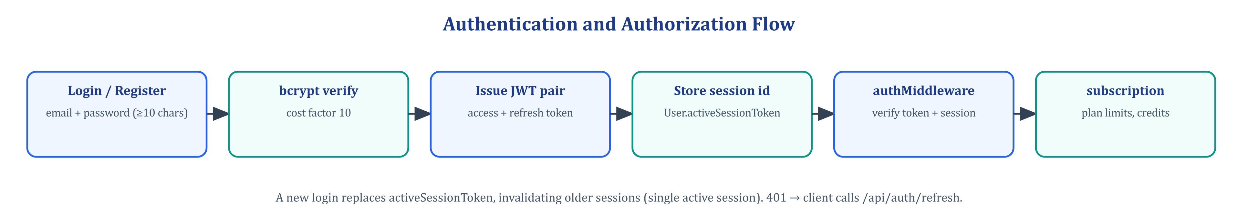
Figure 8.4: Authentication and Authorization Flow
// Enforce single active session & invalidation on logout
if (!user.activeSessionToken || user.activeSessionToken !== decoded.sessionToken) {
return res.status(401).json({
error: 'SESSION_MISMATCH',
message: 'You have been logged out because your account is active on another device.'
});
}

const aiGenerationLimiter = rateLimit({ windowMs: 60 * 1000, max: 60 });
app.use('/api/ai', aiGenerationLimiter);
Listing 8.3: Session enforcement (middlewares/auth.ts) and AI rate limiting (index.ts)

8.9 Integration of Modules
Modules are integrated through the REST API and shared types. The frontend lib/api.ts attaches the bearer token, retries once after refreshing an expired token and normalises errors, so every page uses the same integration path. On the backend, routers delegate to services (formsService, analyticsService, emailService) and to the AIFormBrain, while cross-cutting concerns — authentication, plan limits, logging and error handling — are applied as Express middleware in a fixed order: Helmet → CORS → request logger → body parsers → rate limiters → routers → 404 → error handler.
Events connect otherwise independent modules: a submission creates a Response, records a FormEvent, updates analytics, writes an Activity entry, raises a live notification for the owner and, if configured, triggers a Workflow (e-mail or webhook). Team invitations integrate the teams module with the e-mail service and the authentication module: an invite token survives sign-up or login, the invitee e-mail is verified and membership is created atomically. A bootstrap sequence at server start validates environment variables, database connectivity, the uploads directory and route registration, and exposes /health, /health/liveness and /health/readiness endpoints for the hosting platform.
CHAPTER 9

TESTING AND VALIDATION

9.1 Testing Strategy
Testing combined manual exploratory testing during development with automated black-box API test suites executed against a running backend and real PostgreSQL database. The automated platform QA suite (backend/src/scripts/runTests.ts, executed with npm run test) contains 39 test cases across nine suites: Auth, Billing, Builder, Runner, Quiz, Analytics, Team, AI and Workflows. The AI generator suite contains 11 cases covering text, quiz, survey, PDF and image generation, question-count control, credit and plan limits, publication status and display-mode persistence. Results were written to qa_test_report.json and ai_generator_qa_report.json.
Each test specifies an input, the expected HTTP status or behaviour and the observed result. Defects discovered in the first run were logged, fixed and re-verified; these appear with status “Pass (fix verified)”. Positive, negative and boundary cases were included (e.g. weak passwords, duplicate e-mails, 3 credits remaining, 6th form on the free plan). UI behaviour was validated manually in Chrome and Edge at desktop and mobile widths, and user acceptance testing was carried out with the mentor and peers.

9.2 Unit / Module Testing
Table 9.1: Unit / module testing
Test ID | Module / Function | Input | Expected | Actual | Status
UT-01 | IntentDetector.detect | “quiz on photosynthesis 5 questions” | domain quiz, count 5 | quiz, 5 | Pass
UT-02 | DomainDetector | Dental patient intake prompt | medical / dentistry | medical, dentistry | Pass
UT-03 | Field intelligence | Label “Email Address” | type email + pattern | email | Pass
UT-04 | Field intelligence | Label “Phone Number” | type phone | phone | Pass
UT-05 | Quality reviewer | MCQ with one option | ≥ 2 options | options filled | Pass
UT-06 | LanguageDetector | Arabic prompt | rtl = true | true | Pass
UT-07 | titleSanitizer | Prompt with “create a form for…” | Clean title | Clean title | Pass
UT-08 | documentParser | Sample PDF | Extracted text | Text returned | Pass
UT-09 | Zod submit schema | Missing user_agent | Validation error | 400 details | Pass
UT-10 | Gemini fallback | First model unavailable | Next model used | Fallback used | Pass

9.3 Functional Testing
Table 9.2: Functional testing (platform QA suite)
Test ID | Functionality | Expected | Actual | Status
AUTH-01 | User Registration (Valid Data) | 201 | 201 | Pass
AUTH-01-NEG | Registration Rejection on Weak Password (<10 chars) | 400 | 400 | Pass
AUTH-01-DUP | Registration Duplicate Email Guard | 400 | 400 | Pass
AUTH-02 | User Login & JWT Grant | 200 | 200 | Pass
AUTH-02-NEG | Login Rejection on Wrong Password | 400 | 400 | Pass
AUTH-03 | Single Active Session Enforcement | 401 SESSION_MISMATCH | 401 | Pass
AUTH-04 | Refresh Token Grant & Rotation | 200 | 200 | Pass
AUTH-05 | Logout Session Token Invalidation | 401 Unauthorized | 401 | Pass (fix verified)
AUTH-06 | Google OAuth Sign-In Simulation | 200 | 200 | Pass
BILL-01 | Free Plan 5-Form Creation Ceiling | 403 LIMIT_REACHED | 403 | Pass
BILL-02 | Slot Recovery upon Form Deletion | 201 | 201 | Pass
BILL-03 | Upgrade to PRO Plan & Limit Removal | 201 | 201 | Pass
BILL-04 | Enterprise Plan Recognition & Bypass | 201 Created | 201 | Pass (fix verified)
BILL-05 | Promo Coupon Validation & Discount Grant | 200 (Valid) / 404 (Invalid) | 200 | Pass
BILL-06 | User Transaction & Receipt Audit Trail | 200 | 200 | Pass
BLD-01 | Form Creation & Retrieval by UUID | 200 | 200 | Pass
BLD-02 | Bulk Question Insertion with Validations & Types | 200 | 200 | Pass
BLD-03 | Question UUID Preservation on Save | Question IDs preserved | 200 | Pass (fix verified)
BLD-04 | Conditional Logic JSONB Storage | 200 | 200 | Pass

9.4 Integration Testing
Table 9.3: Integration testing
Test ID | Integrated Components | Expected | Actual | Status
RUN-01 | Public Resolution via uniqueShareId (Unauthenticated) | 200 | 200 | Pass
RUN-02 | Server-Side Form Password Enforcement | 403 without password, 201 with password | 403 | Pass (fix verified)
RUN-03 | Server-Side Required Fields Validation | 400 on empty, 201 on provided | 400 | Pass (fix verified)
RUN-04 | Single Submission Constraint (limit_responses) | 400 | 400 | Pass
RUN-05 | Form Response Limit & Auto-Close | 400 CLOSED | 400 | Pass
RUN-06 | Anti-Cheat Tab-Switch Tracking & Flagging | 201 with flagged metadata | 201 | Pass
RUN-07 | Public Form Anonymous File Upload | 201 Created | 201 | Pass (fix verified)
QUIZ-01 | Quiz Form Setup with Graded Questions | 201 | 201 | Pass
QUIZ-02 | Quiz Responses CSV Export & Weighted Score Calculation | 200 text/csv | 200 | Pass
QUIZ-03 | Historical Response Preservation Across Form Updates | Historical answers preserved in CSV | 200 | Pass (fix verified)
ANL-01 | Public View & Form Interaction Event Registration | 200 | 200 | Pass
ANL-02 | Workspace Analytics Metrics & Time-Series Trends | 200 | 200 | Pass
ANL-03 | Form-Specific Metrics Funnel & Dropout Analysis | 200 | 200 | Pass
TEAM-01 | Workspace Team Creation & Member Invitation (Editor) | 201 | 201 | Pass
TEAM-02 | RBAC Enforcement: Viewer Blocked from Modifying Form | 403 Forbidden | 403 | Pass
TEAM-03 | Team Owner Removal Protection Guard | 400 | 400 | Pass
TEAM-04 | Team Rename (PUT) & Delete (DELETE) Endpoints | 200 OK | 200 | Pass (fix verified)
WORKFLOW-01 | Workflow Dispatch & Execution on Form Submit | 201 Created and dispatched | 201 | Pass (fix verified)

9.5 System Testing
Table 9.4: System testing (AI generator suite and end-to-end scenarios)
Test ID | Scenario | Expected | Actual | Status
AI-01 | AI Form Generation (Cognitive Brain Fallback) | 200 | 200 | Pass
AI-02 | AI Credit Balance Enforcement (<5 credits required) | 403 Insufficient credits | 403 | Pass
AI-GEN-01 | Text Prompt Form Generation (Medical Intake) | 200 OK with form and 5 credits deducted | Form "Dentistry Patient Knowledge Quiz" created with 5 questions. Credits deducted: 100 … | Pass
AI-GEN-02 | Quiz Form Generation with Anti-Cheat & Graded Validations | 200 OK with anti_cheat_detection=true and graded validations | Quiz generated with 5 questions. Anti-cheat enabled: true. Graded questions confirmed. | Pass
AI-GEN-03 | Customer Survey Generation with Rating Scales | 200 OK with rating widget field | Survey generated with 5 questions including rating widgets. | Pass
AI-GEN-04 | PDF / Document Upload Form Generation | 200 OK with parsed form | Generated form from PDF: "Extract Fields Dentistry Form" with 5 questions. | Pass
AI-GEN-05 | Image / Scan Upload Form Generation | 200 OK with generated form | Generated form from Image: "Education Event Registration & RSVP" with 10 questions. | Pass
AI-GEN-06 | Question Count Configuration (3 questions target) | 200 OK with around 3 questions | Form generated with 3 questions (target: 3). | Pass
AI-GEN-07 | Insufficient Credit Balance Guard (< 5 credits) | 403 Forbidden with Insufficient Credits message | Blocked generation when credits=3 with HTTP 403: "Insufficient credits. AI generation re… | Pass
AI-GEN-08 | Short Prompt Suggester / Guard (<3 chars) | 200 with suggestions or 400 validation error | Prompt "<3 chars" returned status='suggest' with suggestions: ["Product Review Form","Em… | Pass
AI-GEN-09 | Free Plan 5-Form Ceiling Enforcement on AI Generation | 403 Forbidden (LIMIT_REACHED) | subscriptionMiddleware properly blocked 6th AI form creation with HTTP 403: "Free plan l… | Pass
AI-GEN-10 | AI Generated Form Initial Status & Share Link Audit | Form created as PUBLISHED with uniqueShareId for immediate sharing | FIX VERIFIED: AI forms are created with status="PUBLISHED" and uniqueShareId="l7nm3s"! P… | Pass
AI-GEN-11 | Display Mode (Full / Wizard / Chat) Persistence via PATCH /forms/:id | 200 OK with settings.display_mode updated via PATCH | FIX VERIFIED: Endpoint PATCH /api/forms/:id successfully supported! display_mode="wizard… | Pass

9.6 Performance Testing
Table 9.5: Performance testing
Parameter | Condition | Target | Observed | Status
AI generation (text prompt) | Gemini flash-lite, warm server | < 10 s | ≈ 4–9 s | Met
AI generation (document) | PDF / image upload | < 15 s | ≈ 8–14 s | Met
Fallback generation | Gemini unavailable | < 1 s | < 300 ms (rule engine) | Met
Form CRUD API | Local PostgreSQL | < 500 ms | ≈ 40–200 ms | Met
Public form load | Share link, warm | < 2 s | ≈ 1 s | Met
Submission API | Valid payload | < 500 ms | ≈ 100–250 ms | Met
Rate limiter | > 60 AI requests / min | HTTP 429 | 429 returned | Met
Cold start (Render free tier) | After 15 min idle | — | ≈ 30–50 s first request | Known limitation

9.7 User / Acceptance Testing
Table 9.6: User acceptance testing
Scenario | Evaluator | Expected | Observed | Feedback / Status
Create event registration form from a prompt | Company mentor | Usable form in seconds | Generated in ≈ 6 s with correct types | Accepted
Digitise a scanned feedback form | Company mentor | Fields match paper form | Most fields matched; minor label edits | Accepted
Conduct a 10-question quiz | Peer students (5) | Timer, scoring, anti-cheat | Worked; tab switches flagged | Accepted
Edit theme and publish | Peer students | Intuitive builder | Completed without help | Accepted
Invite team member as viewer | Institute mentor | Viewer cannot edit | Edit blocked (403) | Accepted
View analytics and export CSV | Company mentor | Correct counts and file | Counts matched; CSV opened in Excel | Accepted
Use on mobile phone | Peer students | Responsive pages | Responsive; wizard mode preferred | Accepted

9.8 Experimental Validation (if applicable)
Table 9.7: Experimental validation of AI generation
Experiment | Conditions | Result | Interpretation
LLM only vs hybrid | Same 11 prompts, schema output | Hybrid fixed wrong types and missing options | Rule review improves reliability
Model fallback chain | Primary model disabled | Generation still succeeded | Resilient to model outages
Question-count control | Target 3 questions | Exactly 3 generated | Count constraint respected
Multimodal input | Image of registration form | 10 questions extracted | Image understanding usable
Short / vague prompts | < 3 characters | Suggestions returned | Graceful guidance instead of error

9.9 Defects / Bugs and Resolution
Table 9.8: Defects identified and resolved
Issue ID | Problem | Severity | Root Cause | Resolution | Final Status
AUTH-05 | Token still valid after logout | High | Session not cleared on logout | Clear activeSessionToken on logout; middleware compares session id | Closed
BILL-04 | Enterprise plan hit free limits | Medium | Plan check only recognised “pro” | Treat all paid plans as unlimited in subscription config | Closed
BLD-03 | Question IDs regenerated on save | High | Delete-and-recreate on update | Upsert questions preserving UUIDs | Closed
RUN-02 | Form password checked only in UI | High | No server check | Enforce password on submit endpoint (403) | Closed
RUN-03 | Required fields bypassable via API | High | Client-only validation | Server-side required validation (400) | Closed
RUN-07 | Anonymous file upload rejected | Medium | Upload route required auth | Allow public upload for public forms with limits | Closed
QUIZ-03 | Old answers lost in CSV after edits | Medium | Export keyed by current questions | Preserve historical answers in export | Closed
TEAM-04 | Team rename/delete missing | Low | Endpoints not implemented | Added PUT and DELETE /api/teams/:id | Closed
WF-01 | Workflows not dispatched | Medium | Submit did not call workflow runner | Dispatch active workflows after submit | Closed
AI-GEN-10 | AI forms created as DRAFT | Medium | Default status | Create AI forms as PUBLISHED with share id | Closed
UI-NOTIF | Notification panel under page content | Low | z-index / stacking context | Flex layout, viewport-bounded panel, Escape to close | Closed

9.10 Final Validation Statement
All 39 platform QA test cases and all 11 AI-generation test cases passed in the final run (50/50), including the nine defects that were fixed and re-verified (Figure 9.1). Functional, integration, system, performance and acceptance testing confirm that PromptForm AI meets the functional requirements FR-01 to FR-17 and the non-functional targets listed in Chapter 4, with the single known limitation of cold-start latency on the free hosting tier. The system is therefore validated as complete and ready for demonstration and use.
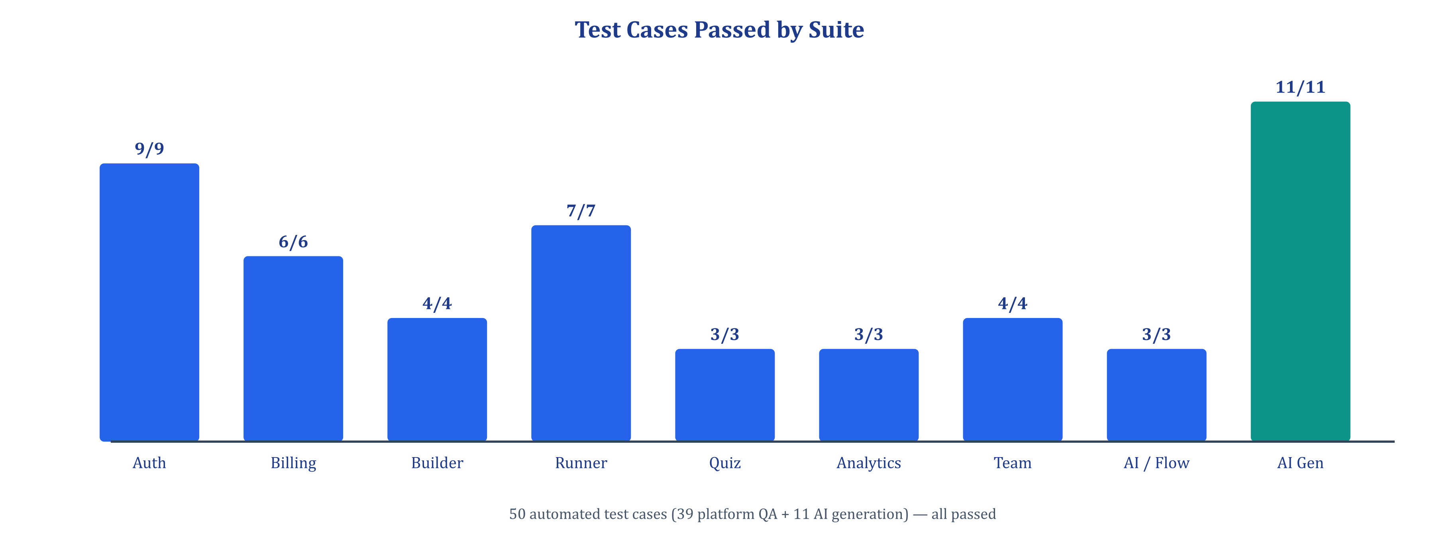
Figure 9.1: Test Cases Passed by Suite
CHAPTER 10

RESULTS AND PERFORMANCE ANALYSIS

10.1 Final Results
The final outcome of the project is a working, deployed SaaS platform. A user can register, describe a form in one sentence or upload a document, and within seconds receive a published form with a short share link (for example /f/f5nmxd), correctly typed fields, validations and a harmonised theme. During the final demonstration the prompt “Patient intake form for a dental clinic with contact details, medical history and appointment date” produced a six-question Patient Intake Form with name, phone, e-mail, choice and checkbox fields, and the prompt “Customer satisfaction survey for a restaurant” produced a six-question Restaurant Dining Experience Form with multiple-choice and long-text feedback questions.
The forms were edited in the builder, opened through the public link and filled by sample respondents; the dashboard immediately reflected 8 submissions per form with a 100% completion rate and an average time of 87 seconds, and the responses ledger listed each submission with time taken, tab switches and flag status. All 50 automated test cases passed. The application runs locally through a single command (node dev.js) and in production on Vercel and Render.

10.6 Results Discussion
The results confirm the central hypothesis of the project: combining deterministic domain rules with schema-constrained LLM generation produces forms that are both fast to create and reliable enough for real use. The most visible gain is time — form creation dropped from tens of minutes to seconds — but the quality gain is equally important. Because the field intelligence engine and quality reviewer enforce types and validations, AI-generated forms contained correctly typed e-mail and phone fields and complete option lists, which are frequent sources of error in manually built forms.
The fallback design proved valuable in practice. During development the Gemini API occasionally returned quota or availability errors; in those cases the next model in the chain or the rule-based plan was used, so the user never saw a failed generation. The security fixes found during QA (server-side password and required-field enforcement, session invalidation on logout) show the value of testing at the API level rather than only through the UI.
Two limitations were observed. First, the first request after inactivity on the free hosting tier suffers a cold start of around 30–50 seconds, which affects perceived performance but not functionality. Second, documents with heavy handwriting or complex multi-column layouts can produce partially correct field lists that need manual correction in the builder. Both are discussed further in Chapter 13.

10.2 Objective-wise Achievement
Table 10.1: Objective-wise achievement
Objective | Achievement / Evidence | Status
O1 – Prompt to form in < 10 s | Average 4–9 s; AI-GEN-01 to 03 passed | Achieved
O2 – Digitise documents | PDF, DOCX, XLSX, image; AI-GEN-04, 05 passed | Achieved
O3 – ≥ 10 field types with validation | 11 core types + contact variants; BLD-02 passed | Achieved
O4 – Visual builder | Three-pane builder with undo/redo and theme editor (Figure 8.2) | Achieved
O5 – Instant publish and share | Unique share id; RUN-01, AI-GEN-10 passed | Achieved
O6 – Graded quizzes with anti-cheat | QUIZ-01 to 03, RUN-06 passed | Achieved
O7 – Analytics and export | Dashboards, CSV export; ANL-01 to 03 passed | Achieved
O8 – Team collaboration | Roles, invites, RBAC; TEAM-01 to 04 passed | Achieved
O9 – Security controls | JWT, single session, bcrypt, Helmet, CORS, rate limits; AUTH suite passed | Achieved
O10 – ≥ 40 tests and cloud deployment | 50 tests passed; Vercel + Render deployment | Achieved

10.3 Performance Metrics
Table 10.2: Performance metrics
Parameter / Metric | Target | Final Result | Difference / Improvement | Status
Form creation time (10 fields) | < 60 s | ≈ 8 s (text), ≈ 12 s (document) | ≈ 99% less than ≈ 20 min manual | Met
AI generation success rate | ≥ 95% | 100% (11/11 AI tests) | Fallback ensures a form is always returned | Met
Automated test pass rate | 100% | 50 / 50 | 9 defects fixed and verified | Met
Correct field-type inference | ≥ 90% | All typed contact fields correct in tests | Quality reviewer repairs conflicts | Met
CRUD API latency | < 500 ms | ≈ 40–200 ms | 2.5–12× better than target | Met
Submission latency | < 500 ms | ≈ 100–250 ms | Within target | Met
Pages implemented | 20 | 29 routes | +9 pages | Exceeded
REST endpoints | 50 | 73 routes | +23 endpoints | Exceeded

10.4 Comparative Results (if applicable)
Indicative timings for producing a ready-to-share 8–10 field form were measured during the project (manual builder vs PromptForm AI); the comparison is summarised in the table below and charted in Appendix E.
Table 10.3: Comparative results with existing approaches
Method / System | Metric 1: Creation Time | Metric 2: Field-type Errors | Metric 3: Document Import | Observation
Manual builder (Google Forms) | ≈ 15–25 min | Common (manual choice) | Not supported | Baseline
Template-based (Jotform) | ≈ 5–8 min | Fewer, needs edits | Separate PDF tool | Faster but still manual
PromptForm AI – text prompt | ≈ 8 s | Rare (auto-typed) | — | Fastest, consistent
PromptForm AI – document | ≈ 12 s | Rare | PDF, DOCX, XLSX, image | Unique capability

10.5 Final Output Screenshots
The following screenshots were captured from the running application with the demo account and demonstrate the main outputs of the system.
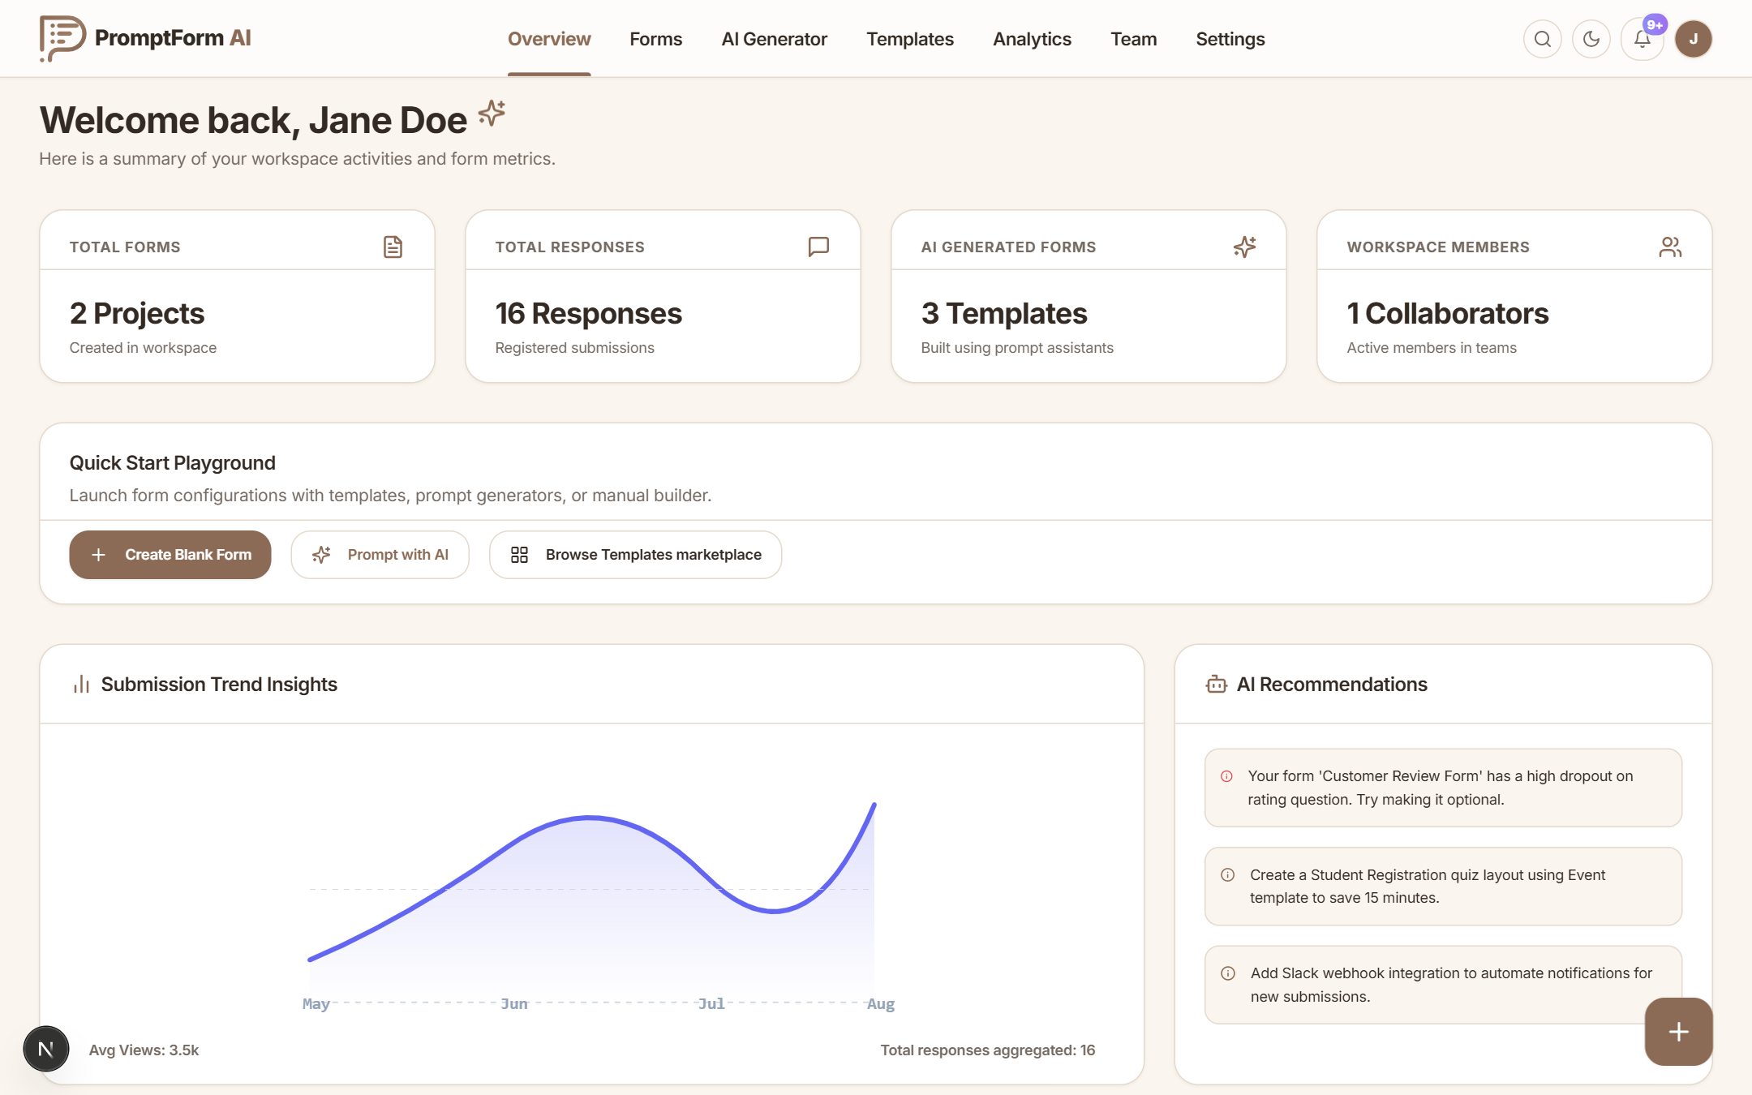
Figure 10.1: Final Output / Result Screenshot 1 (Workspace Overview Dashboard)
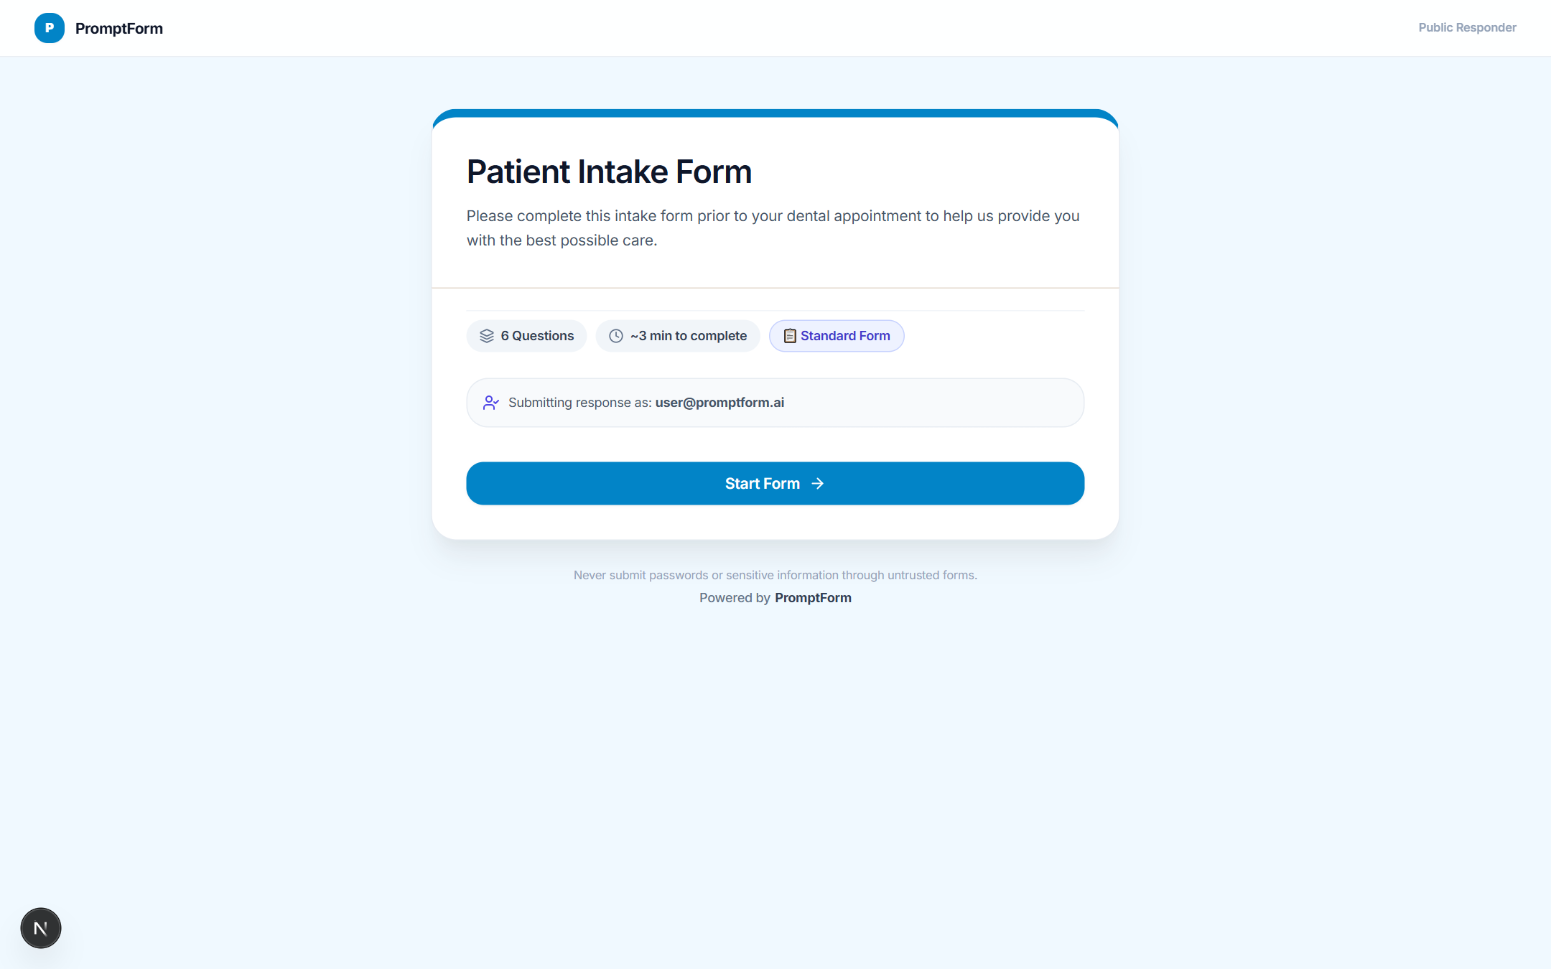
Figure 10.2: Final Output / Result Screenshot 2 (Public Responder)
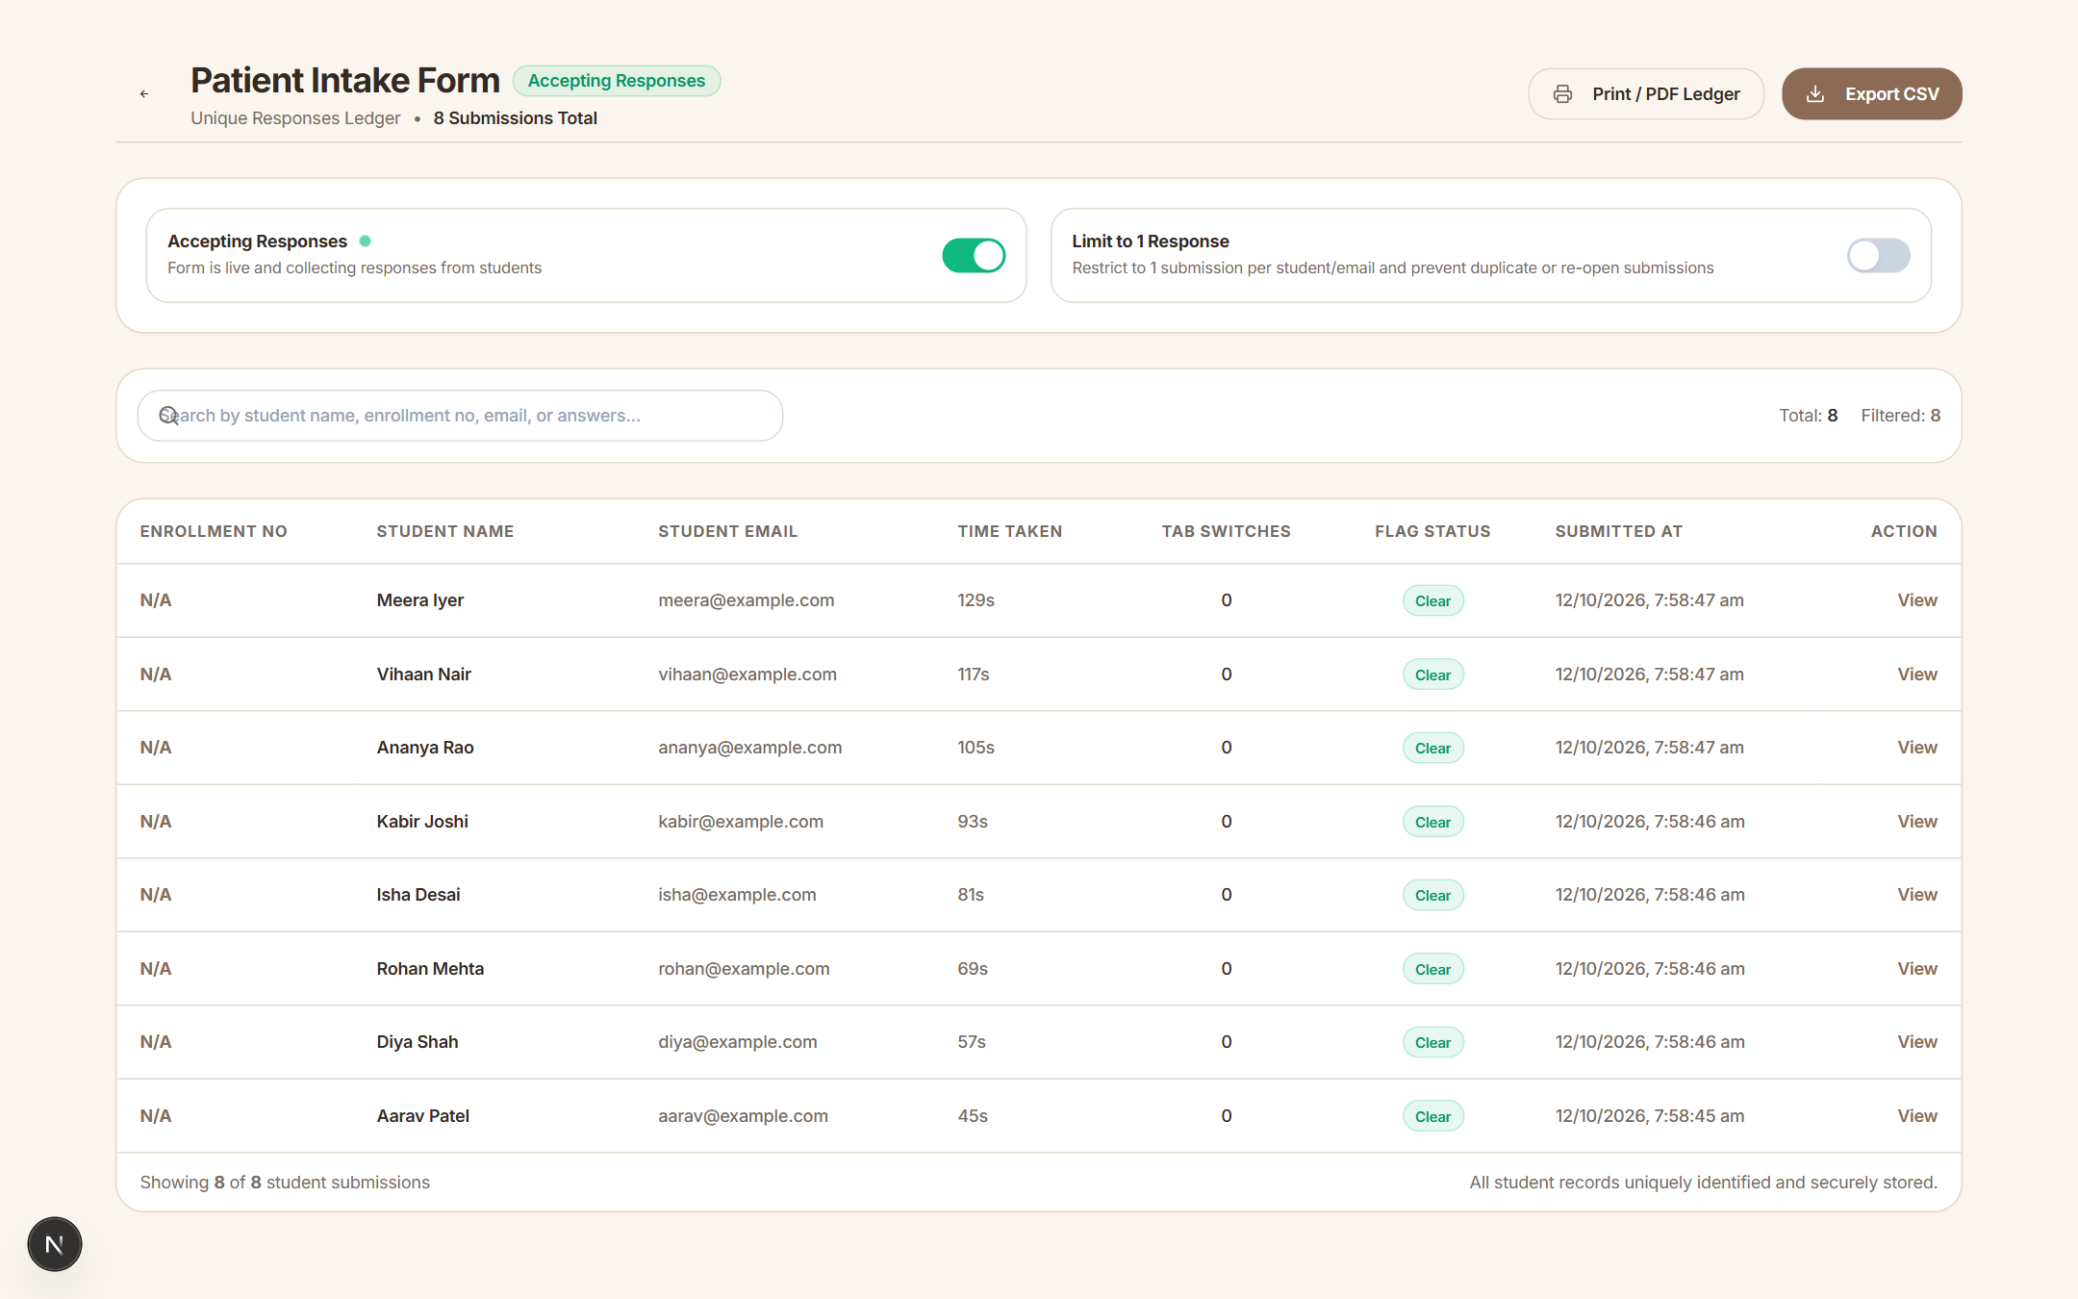
Figure 10.3: Final Output / Result Screenshot 3 (Responses Ledger)
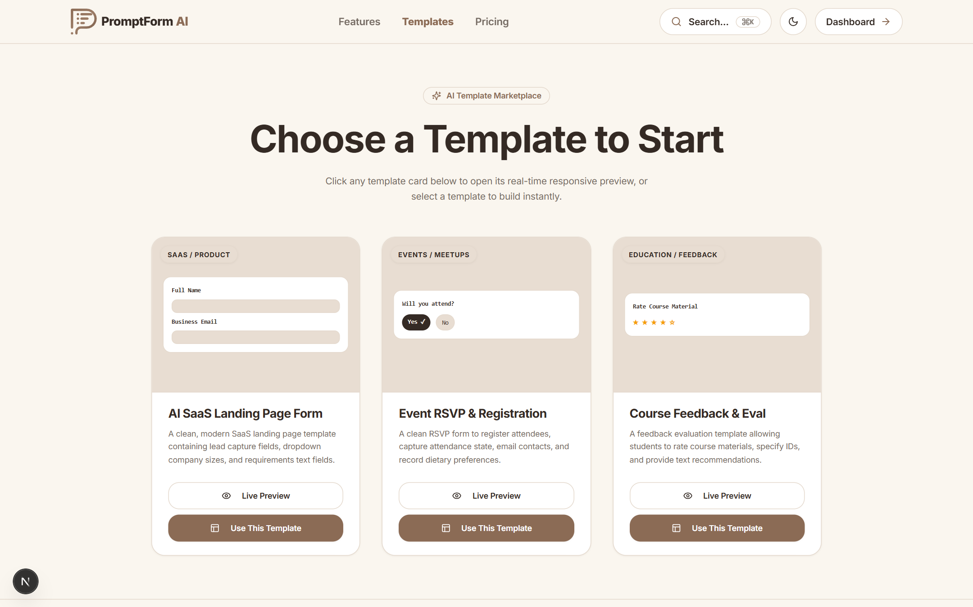
Figure 10.4: Final Output / Result Screenshot 4 (Template Marketplace)
CHAPTER 11

CHALLENGES, SOLUTIONS AND IMPROVEMENTS

11.1 Major Challenges
Table 11.1: Major challenges
Challenge | Phase | Impact | Solution | Final Outcome
Malformed or inconsistent LLM output | AI engine | Broken forms, wrong types | JSON response schema + quality reviewer | Consistent output
Gemini quota / model unavailability | AI engine | Failed generations | 5-model fallback chain + rule-based plan | Always returns a form
Long AI latency | AI engine | Poor UX | Flash-lite models first, 45 s timeout, progress UI | ≈ 4–9 s typical
Question IDs lost on save | Builder | Responses detached | Upsert with preserved UUIDs | History intact
Client-only validation | Testing | Security bypass | Server-side enforcement | Verified fix
Team invite flow across sign-up | Teams | Invites lost | Persist pending invite, verify e-mail, atomic membership | Reliable invites
Prisma client / port conflicts | Deployment | Server crashes | postinstall prisma generate, explicit PORT handling | Stable startup
E-mail deliverability | Notifications | Silent failures | Resend provider with SMTP fallback, domain checks | Honest delivery status

11.2 Technical Challenges
The most significant technical challenge was making LLM output dependable. Early prototypes asked the model for “a form in JSON” and parsed the text; responses sometimes contained markdown fences, missing fields, unsupported types or choice questions without options. The solution was to request native JSON with a response schema, validate the result, and pass it through the quality reviewer, which repairs types based on labels and fills missing options. Prompts were also enriched with the deterministic plan so that the model refines a sensible structure instead of inventing one from scratch.
A second challenge was multimodal document handling. Some models rejected certain inline file types, and large files increased latency. The implementation normalises MIME types, extracts text locally first (pdf-parse, mammoth, SheetJS) and, if a model rejects inline data, retries the request with text only. A third challenge was keeping analytics queries fast as events grew; this was addressed with a composite index on (formId, eventType, createdAt) and pre-aggregated FormDailyMetric rows.

11.3 Process / Coordination Challenges
Scope growth was the main process challenge: mentor feedback added document digitisation, quizzes and team collaboration to the original plan. MoSCoW prioritisation and sprint planning kept the work manageable — “must” features were completed first and “could” features were scheduled only after the core was stable. Coordinating reviews with two mentors (company and institute) required concise weekly demonstrations and written progress summaries, which later formed the basis of the four progress reports and this final report.

11.5 Lessons from Challenges
The challenges taught that AI features must be engineered like any other external dependency: with schemas, validation, timeouts, retries and a fallback path. They also showed that security must be enforced on the server, because API-level tests found issues that were invisible in the UI. Finally, regular demonstrations and a prioritised backlog proved essential for controlling scope while still incorporating valuable feedback.

11.4 Improvements Made During Development
Table 11.2: Improvements made during development
Improvement | Reason | Implementation | Impact
Hybrid AI engine | LLM-only output unreliable | AIFormBrain plan + Gemini + reviewer | Reliable, fast generation
Display modes | Long forms tiring on mobile | Full / wizard / chat responder | Better completion
Understanding summary | Users unsure what AI understood | Topic, purpose, type, difficulty shown | Transparency
Single active session | Shared-account abuse | Session token in JWT and DB | Stronger security
Live notifications | Owners missed responses | Notification panel + e-mail | Faster follow-up
Health endpoints & bootstrap checks | Opaque deployment failures | /health, readiness, env/DB validation | Easier operations
Notification panel polish | Layering and overflow bugs | Flex layout, viewport bounds, Escape to close | Usable on mobile

CHAPTER 12

INDIVIDUAL CONTRIBUTION AND PROFESSIONAL LEARNING

12.1 Individual Contribution
This was an individual internship project; all modules were designed, implemented, tested and deployed by the student under the guidance of the company and institute mentors.
Table 12.1: Individual contribution
Student | Module / Task | Contribution | Evidence | % Contribution
[STUDENT NAME] | Requirements & design | FR/NFR, architecture, UML, ER schema | Ch. 4, 6 | 100%
[STUDENT NAME] | Frontend | 29 Next.js pages, components, API client | frontend/src | 100%
[STUDENT NAME] | Backend & security | 73 routes, middlewares, services | backend/src | 100%
[STUDENT NAME] | AI engine | AIFormBrain, Gemini integration, document parsing | lib/aiBrain | 100%
[STUDENT NAME] | Testing | 50 automated tests, defect fixing | QA JSON reports | 100%
[STUDENT NAME] | Deployment & documentation | Vercel/Render, reports | render.yaml, this report | 100%

12.2 Technical Skills Acquired
- Programming / Development: advanced TypeScript, React 19 hooks and component design, Node.js and Express middleware patterns.
- Frameworks / Libraries: Next.js App Router, Tailwind CSS, Zustand, React Hook Form, Zod, Recharts, Prisma.
- Database / Data Handling: relational modelling, JSON columns, indexes, cascades, transactions and migrations in PostgreSQL.
- Testing / Debugging: API-level black-box test automation, defect triage, reproducing and verifying fixes.
- Deployment / Cloud: Vercel and Render deployment, environment configuration, health checks, Docker Compose.
- Domain-specific skills: prompt engineering, structured LLM output, multimodal document understanding and fallback design.

12.3 Professional Skills Acquired
- Communication: presenting progress to technical and academic mentors and explaining design trade-offs.
- Teamwork / Collaboration: incorporating reviewer feedback and following organisational coding conventions.
- Time Management: sprint planning and MoSCoW prioritisation within a fixed internship timeline.
- Problem Solving: diagnosing failures across frontend, backend, database and external services.
- Documentation: writing progress reports, test reports and this consolidated final report.
- Presentation / Technical Explanation: live demonstrations of AI generation, analytics and security features.

12.4 Major Learning Outcomes
The internship provided end-to-end experience of building a production-style product: translating a business problem into requirements, designing a scalable architecture, implementing a large TypeScript codebase, integrating an external AI service, securing it, testing it systematically and deploying it to the cloud. The most important learning was how to use generative AI responsibly in software — not as a black box, but as one component surrounded by validation, deterministic rules and graceful degradation.
The project also strengthened professional habits: writing meaningful commit messages, keeping the main branch deployable, documenting decisions and measuring results instead of relying on impressions. These outcomes directly support future work as a full-stack or AI application engineer.
CHAPTER 13

LIMITATIONS AND FUTURE SCOPE

13.1 Current Limitations
Table 13.1: Current limitations
Limitation | Reason | Impact | Possible Improvement
Dependence on Gemini API | Third-party LLM | Quota / outage reduces wording quality | Add second provider, caching, self-hosted model
Cold start on free hosting | Render free tier sleeps | 30–50 s first request | Paid instance or keep-alive pings
No real payment settlement | Out of scope | Plans recorded but not charged | Integrate Razorpay / Stripe
Handwritten / complex documents | Model limits | Partial field extraction | Dedicated OCR and layout analysis
Conditional logic not auto-generated | Complexity | Logic set manually | Generate branching rules from prompt
Default JWT secret fallback in code | Developer convenience | Risk if env not set | Fail fast when JWT_SECRET missing
Web-only client | Time constraint | No offline use | PWA / native apps

13.2 Future Scope
- Payment gateway integration (Razorpay / Stripe) with subscriptions, invoices and paid forms.
- AI-generated conditional logic, calculated fields and multi-page sections.
- Voice-to-form and multilingual generation with automatic translation of published forms.
- Integrations with Google Sheets, Slack, Microsoft Teams, Zapier and webhooks with retry queues.
- Advanced quiz proctoring (webcam snapshots, full-screen enforcement) and certificate generation.
- Accessibility (WCAG 2.2 AA) audit and improvements, including screen-reader optimised responder.
- Progressive Web App with offline response capture and later synchronisation.

13.3 Scalability / Extension Opportunities
Because the API is stateless and authenticated with JWTs, it can be scaled horizontally behind a load balancer. The existing Redis and BullMQ integration can move AI generation, e-mail sending and analytics aggregation into background workers, keeping request latency low under load. PostgreSQL read replicas and partitioning of the FormEvent table by month would support high-volume analytics, and a CDN already serves the frontend globally.
The modular AIFormBrain allows new domains and industries to be added as rule modules without changing the API, and the provider-agnostic generation function can be extended to other LLMs. Multi-tenant enterprise features — SSO, audit export, data residency and custom domains for public forms — are natural extensions of the current team and activity models.
CHAPTER 14

CONCLUSION
The project began with a simple observation: building online forms is slow, repetitive and error-prone, and existing tools leave the entire authoring effort to the user. The objective was to create a platform that turns a natural-language description or an existing document into a complete, validated and shareable form in seconds, and that supports the rest of the form life cycle — responses, quizzes, analytics and collaboration.
An Agile methodology with two-week sprints and four progress milestones guided the work. Requirements were captured as 17 functional and 12 non-functional requirements, and the system was designed as a three-tier architecture documented with use case, data flow, class, sequence, activity, deployment and ER diagrams. The implementation — a TypeScript monorepo with a Next.js 15 frontend, an Express REST API with 73 routes, PostgreSQL through Prisma with 16 models, and a hybrid AIFormBrain + Google Gemini engine — delivers prompt and document based generation, a visual builder, public responders in three display modes, a quiz engine with anti-cheat, analytics, teams, billing, notifications and an admin panel.
Testing with 50 automated cases, all passing after nine defects were fixed and verified, together with performance measurements and acceptance testing by mentors and peers, confirms that the objectives were achieved. Form creation time fell from roughly 20 minutes to under 10 seconds while field-type accuracy improved. The final achievement is a deployed, secure and extensible product that demonstrates how generative AI can be integrated reliably into real software, and that provides a strong foundation for payments, conditional logic generation and multilingual features in the future.

14.1 Final Project Status
Table 14.1: Final project status
Area | Final Status | Evidence / Remarks
Requirements | Complete | FR-01 to FR-17 and NFR-01 to NFR-12 implemented
Design | Complete | Architecture, UML and ER diagrams (Chapter 6)
Implementation | Complete | Frontend, backend, AI engine, database (Chapter 8)
Testing | Complete | 50/50 automated tests passed (Chapter 9)
Deployment | Complete | Vercel (frontend), Render (backend), managed PostgreSQL
Documentation | Complete | Four progress reports and this final report
Demonstration | Complete | Live demonstration to company and institute mentors

CHAPTER 15

REFERENCES
References are consistent with the progress reports and follow the APA 7th Edition style. Every listed source was used and is cited in the text. The references include:
- Research papers / journal articles
- Books
- Official documentation
- Technical websites
- Standards
- APIs / libraries
- Software documentation

15.1 References
[1] Brown, T., Mann, B., Ryder, N., Subbiah, M., Kaplan, J. D., Dhariwal, P., … Amodei, D. (2020). Language models are few-shot learners. Advances in Neural Information Processing Systems, 33, 1877–1901.
[2] Vaswani, A., Shazeer, N., Parmar, N., Uszkoreit, J., Jones, L., Gomez, A. N., Kaiser, Ł., & Polosukhin, I. (2017). Attention is all you need. Advances in Neural Information Processing Systems, 30, 5998–6008.
[3] Wroblewski, L. (2008). Web form design: Filling in the blanks. Rosenfeld Media.
[4] Sommerville, I. (2016). Software engineering (10th ed.). Pearson.
[5] Pressman, R. S., & Maxim, B. R. (2020). Software engineering: A practitioner’s approach (9th ed.). McGraw-Hill Education.
[6] OWASP Foundation. (2021). OWASP Top 10: 2021. https://owasp.org/Top10/
[7] Google. (2024). Gemini API documentation: Generate structured output. Google AI for Developers. https://ai.google.dev/gemini-api/docs/structured-output
[8] Vercel. (2024). Next.js documentation (App Router). https://nextjs.org/docs
[9] Prisma Data. (2024). Prisma ORM documentation. https://www.prisma.io/docs
[10] OpenJS Foundation. (2024). Express 4.x API reference. https://expressjs.com/en/4x/api.html
[11] The PostgreSQL Global Development Group. (2024). PostgreSQL documentation. https://www.postgresql.org/docs/
[12] Jones, M., Bradley, J., & Sakimura, N. (2015). JSON Web Token (JWT) (RFC 7519). Internet Engineering Task Force. https://doi.org/10.17487/RFC7519
[13] Meta Open Source. (2024). React documentation. https://react.dev/
[14] Schwaber, K., & Sutherland, J. (2020). The Scrum guide. https://scrumguides.org/

15.2 Citation Requirements
- Sources are cited in the text where external ideas, methods or technical information are used (e.g. Vaswani et al., 2017; Brown et al., 2020; Wroblewski, 2008; OWASP, 2021; Google, 2024).
- No fake, unrelated or unused references are included.
- Primary, official and reliable academic and technical sources are preferred.
- One consistent citation style (APA 7th Edition) is maintained.
CHAPTER A

APPENDICES

Appendix A – Progress Report 1 Summary
Reporting 1 covered problem identification and planning. The student studied existing form builders (Google Forms, Typeform, Jotform, Microsoft Forms), measured manual form creation time, and defined the problem statement and ten objectives. An Agile methodology was selected, the technology stack (Next.js, Express, PostgreSQL, Prisma, Gemini) was proposed, and a 14-week schedule was prepared. Mentor feedback recommended adding document upload and assessment support, which were added to the backlog.

Appendix B – Progress Report 2 Summary
Reporting 2 covered design and initial implementation. The three-tier architecture, UML diagrams and the Prisma schema were finalised. The monorepo was set up with frontend, backend and shared packages. Authentication (register, login, JWT, refresh, Google OAuth), forms CRUD, the first version of the visual builder, the public responder and the template marketplace were implemented and demonstrated. The first AI generation prototype using Gemini was also shown.

Appendix C – Progress Report 3 Summary
Reporting 3 covered advanced implementation, testing and validation. The AIFormBrain hybrid engine, multi-model fallback, document digitisation, quiz engine with anti-cheat, analytics dashboards, teams with RBAC and invitations, billing with credits and coupons, notifications and the admin panel were completed. The 39-case platform QA suite and the 11-case AI suite were executed; nine defects were logged and fixed.

Appendix D – Reporting 4 / Final Evaluation
Reporting 4 covered final completion and evaluation. All defects were re-verified (50/50 tests passing), performance was measured, the notification panel and team invite flow were polished, e-mail delivery was improved with the Resend provider, and the application was deployed to Vercel and Render with a managed PostgreSQL database. The system was demonstrated end-to-end to the mentors and the final report was prepared.

Appendix E – Additional Screenshots / Outputs
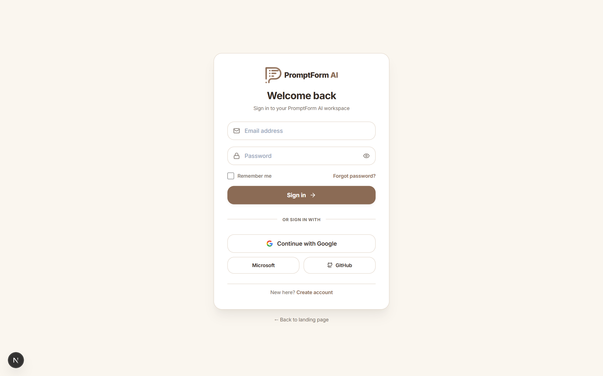
Figure A.1: Supporting Evidence — Login Page
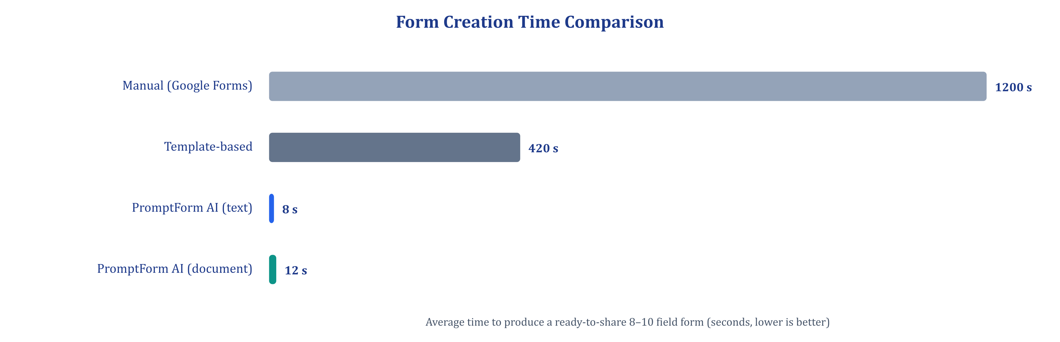
Figure A.2: Supporting Evidence — Form Creation Time Comparison
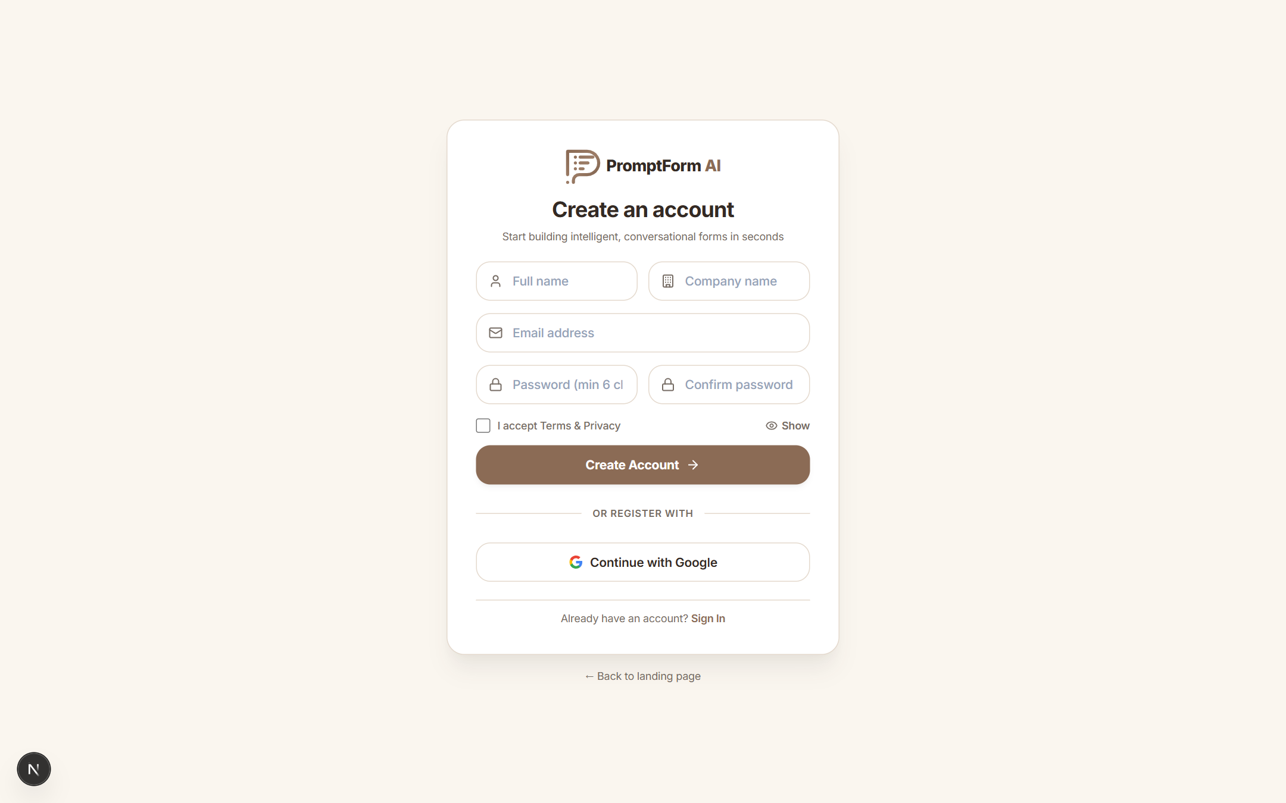
Figure A.3: Supporting Evidence — Registration Page
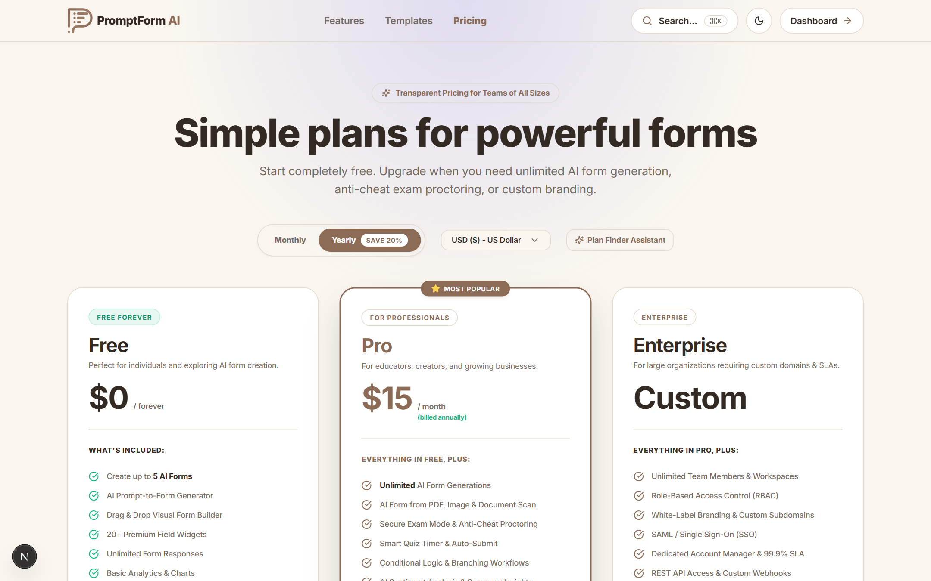
Figure A.4: Supporting Evidence — Pricing Plans
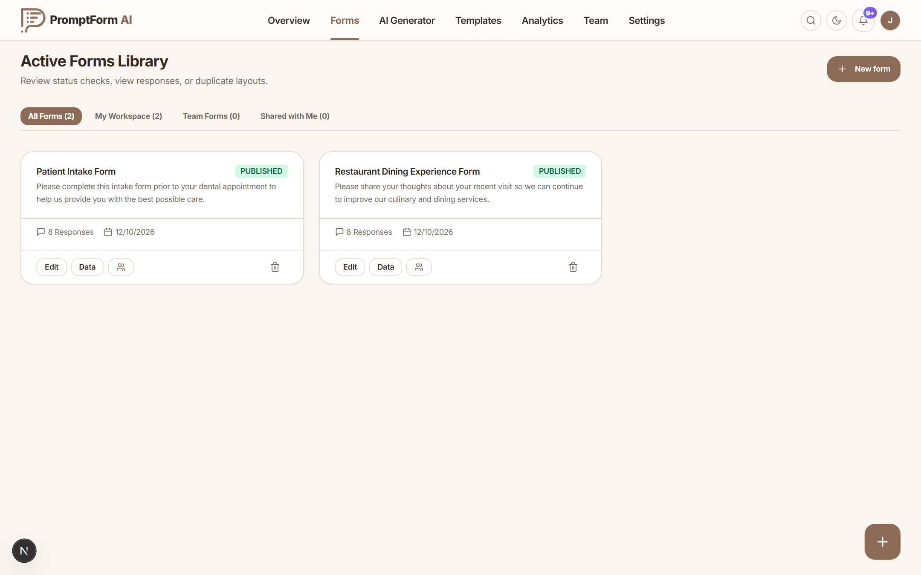
Figure A.5: Supporting Evidence — Forms Library
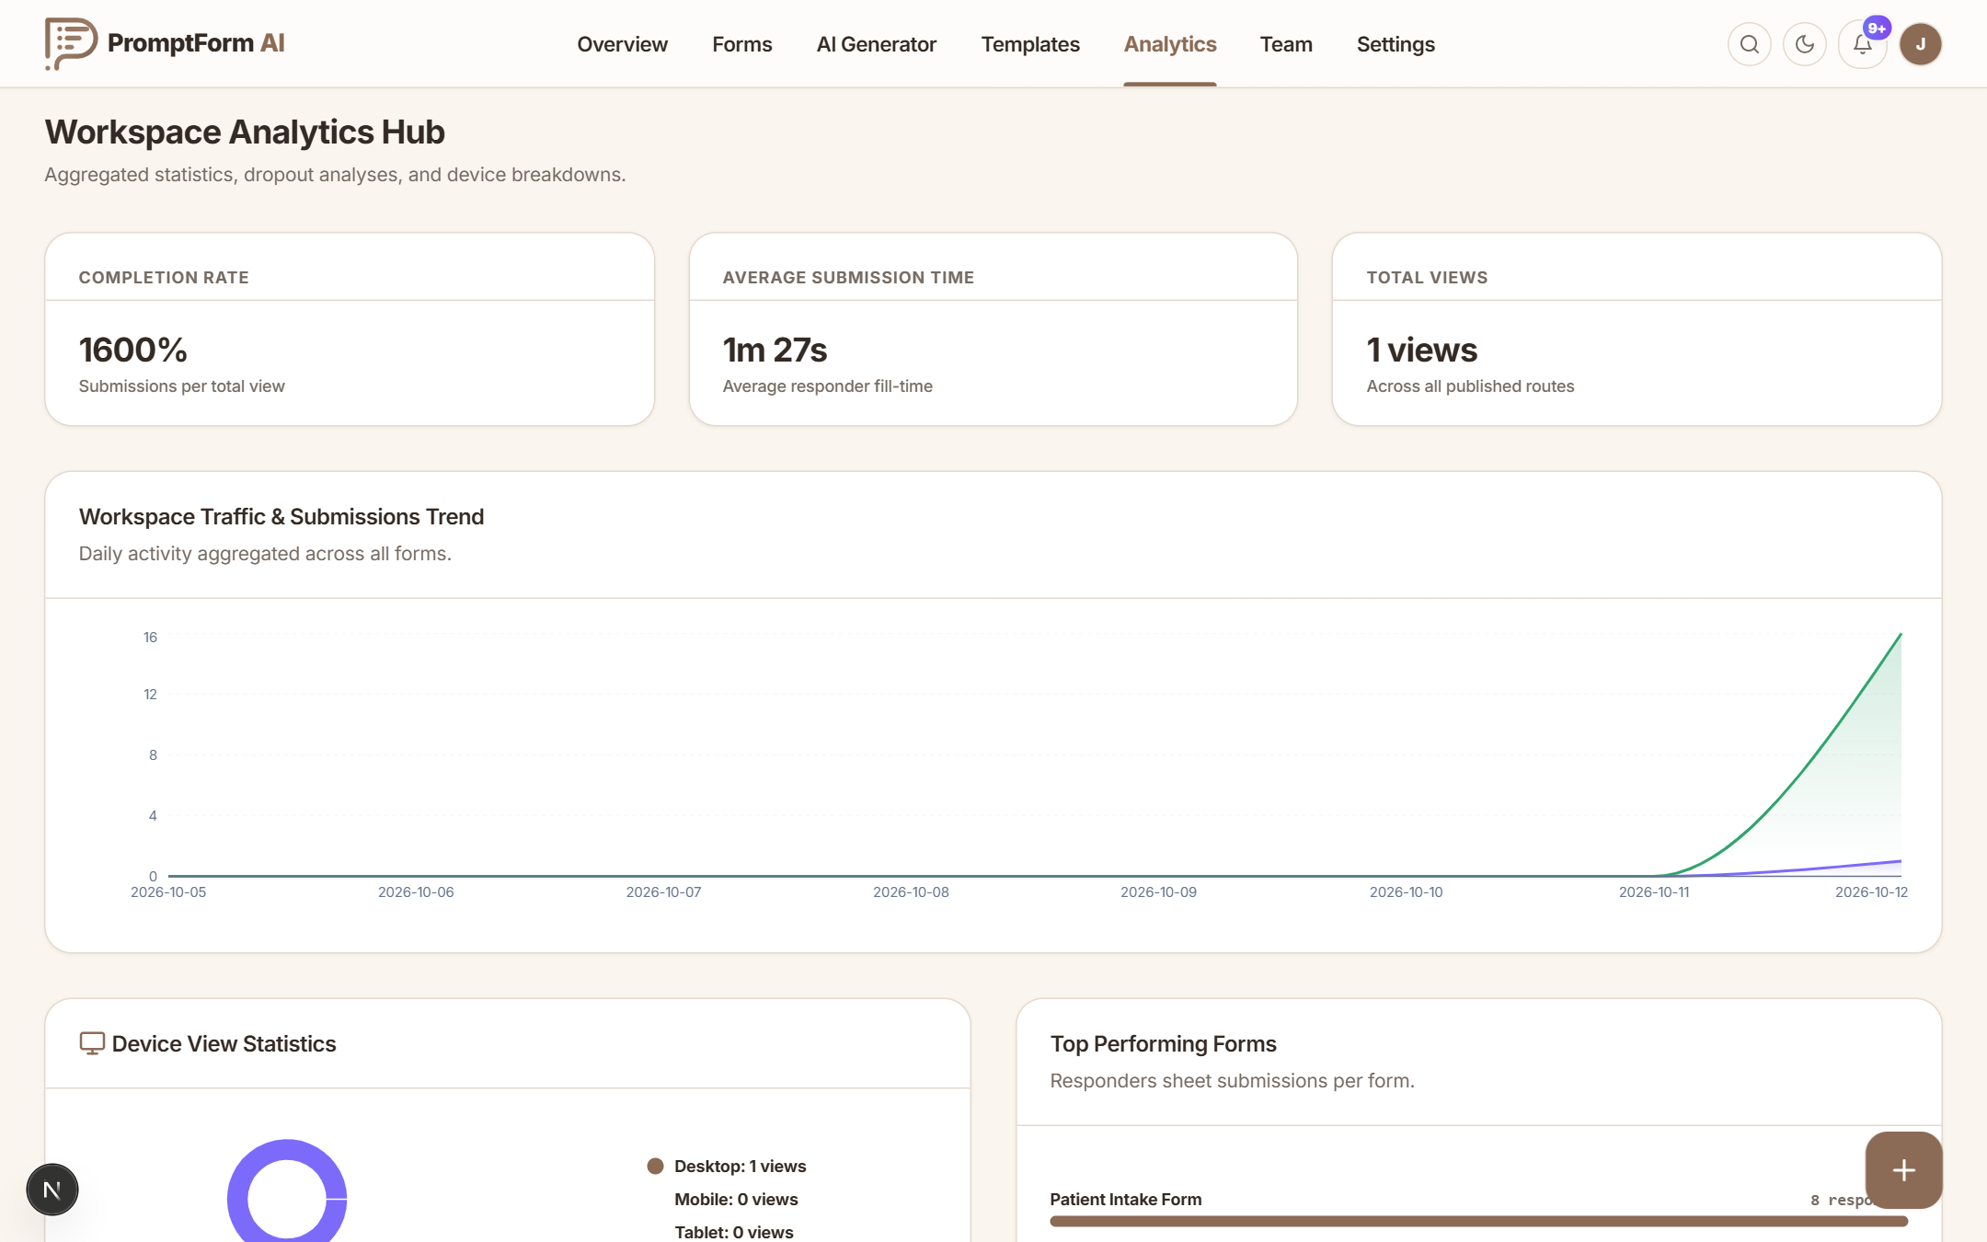
Figure A.6: Supporting Evidence — Workspace Analytics
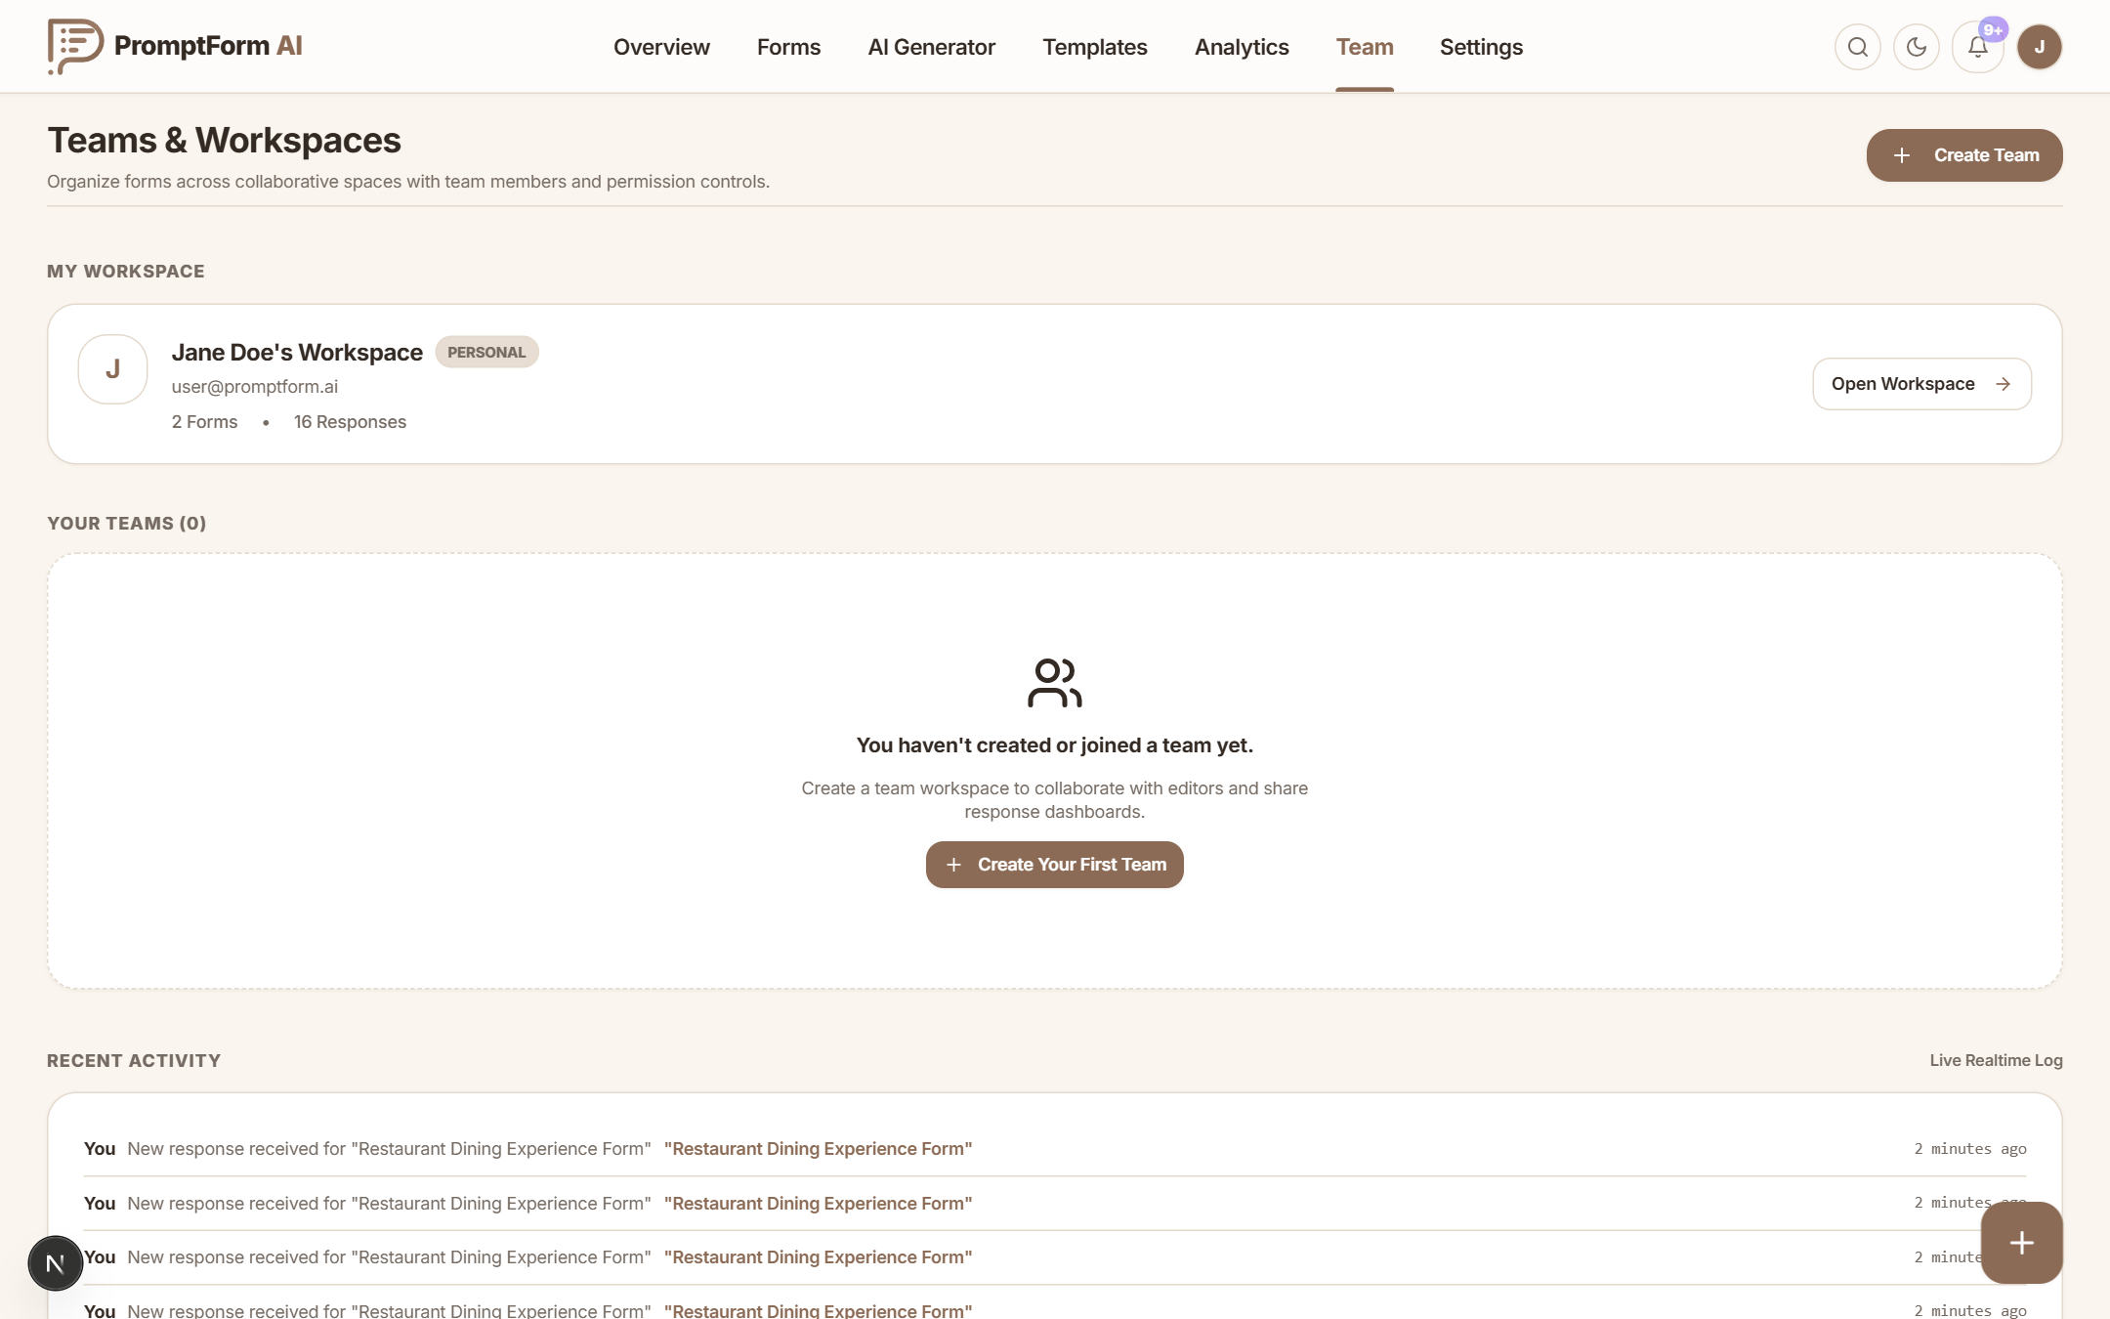
Figure A.7: Supporting Evidence — Team Workspace
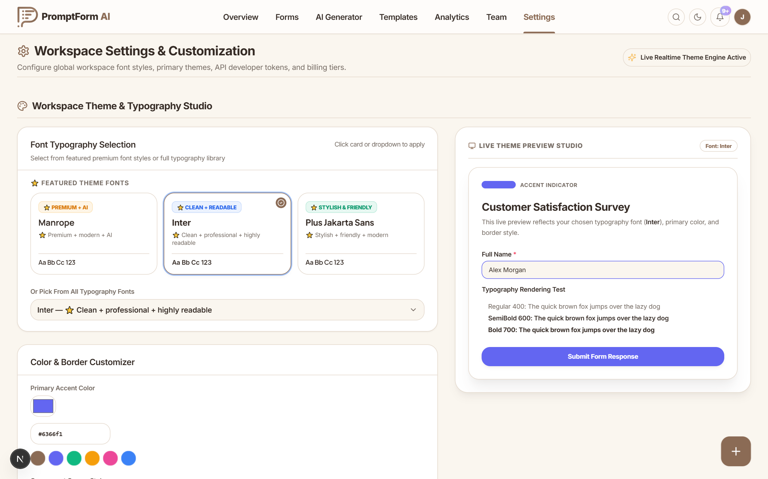
Figure A.8: Supporting Evidence — Account Settings
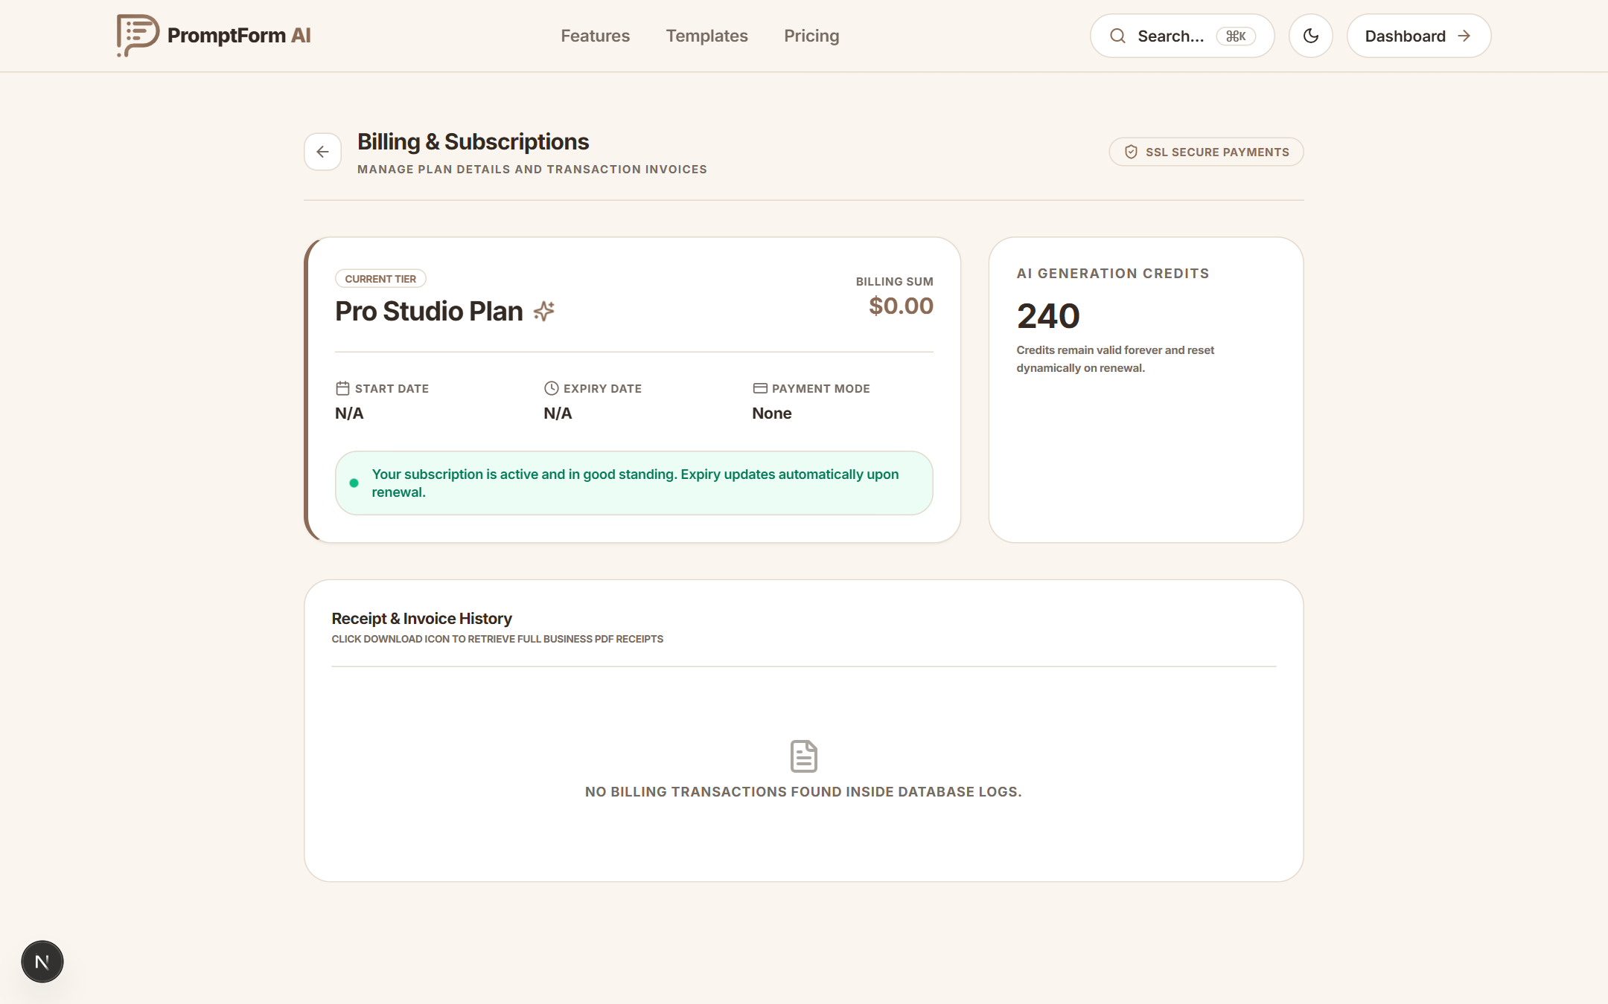
Figure A.9: Supporting Evidence — Billing and Credits
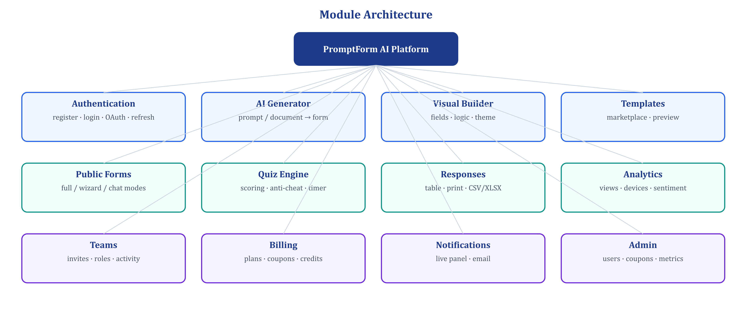
Figure A.10: Supporting Evidence — Module Architecture
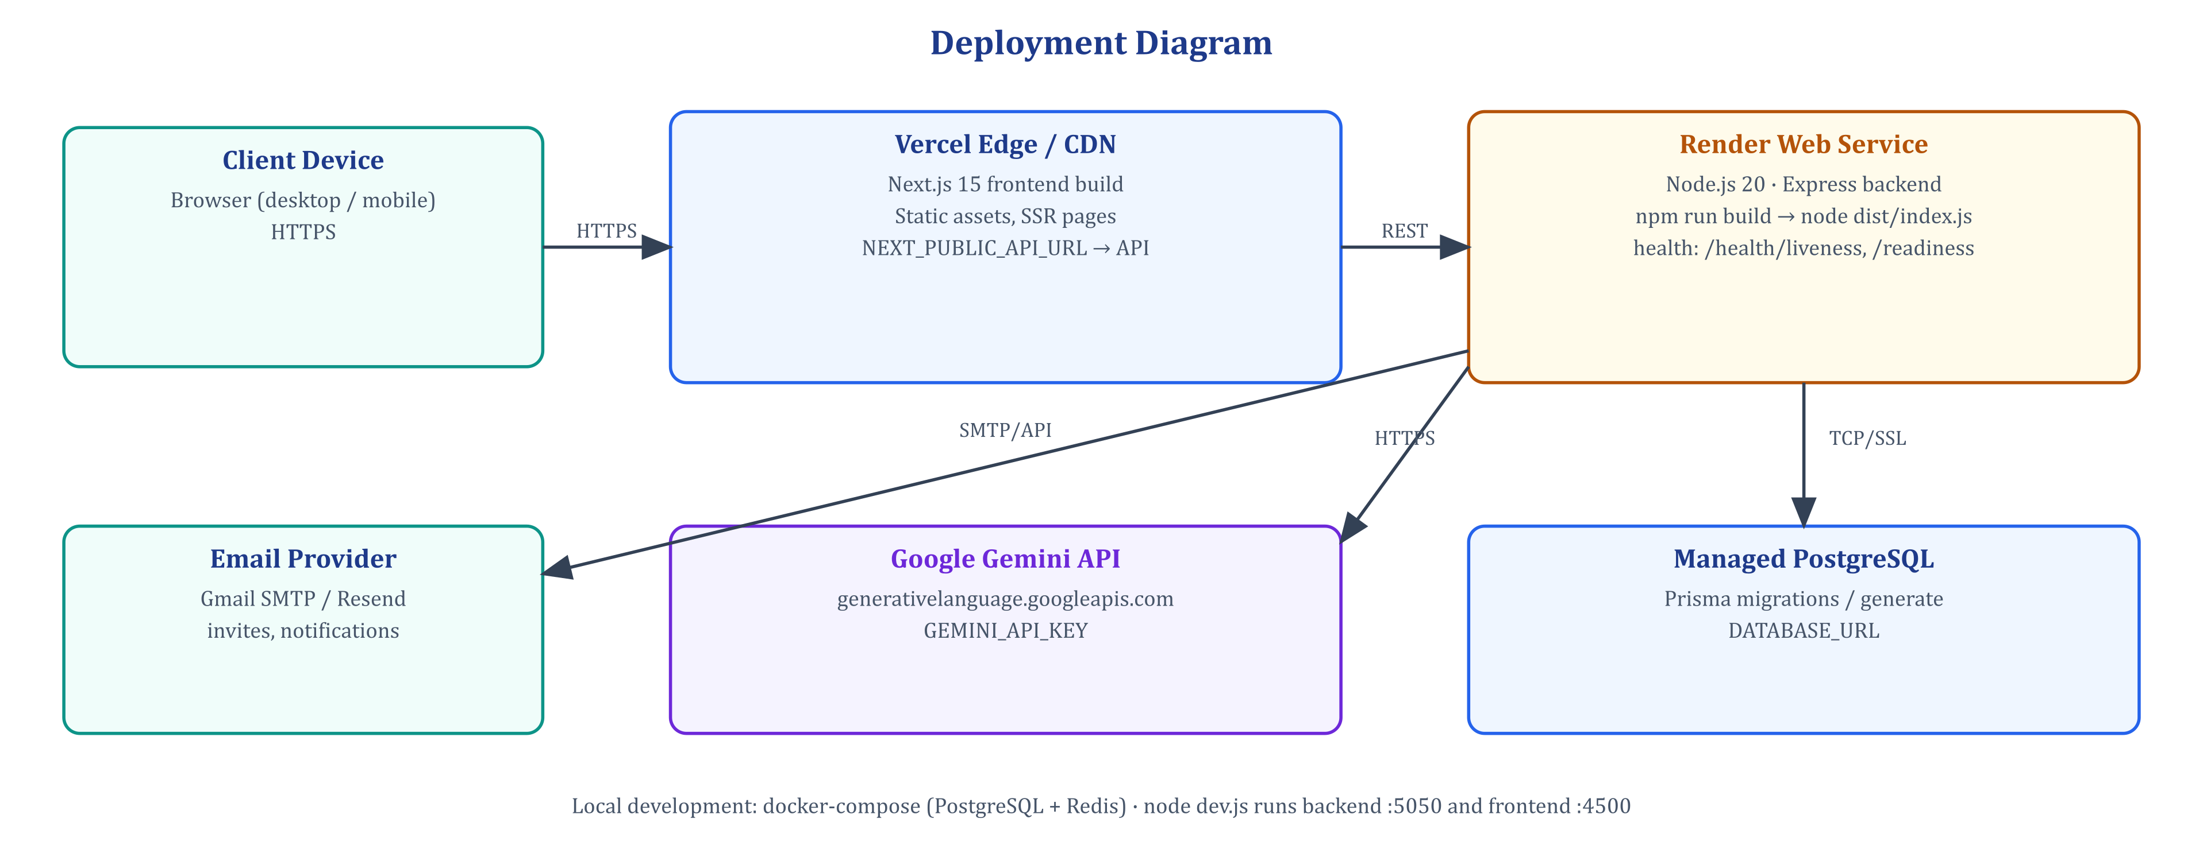
Figure A.11: Supporting Evidence — Deployment Diagram

Appendix F – Certificates / Internship Evidence
Attach the internship offer letter, internship completion certificate issued by [COMPANY / ORGANIZATION NAME], attendance / timesheet records and any training certificates on the following pages before hard binding.
Table A.1: Internship evidence checklist
Document | Issued By | Attached
Internship offer / joining letter | [COMPANY / ORGANIZATION NAME] | [Yes / No]
Internship completion certificate | [COMPANY / ORGANIZATION NAME] | [Yes / No]
Attendance / timesheet | Company mentor | [Yes / No]
Progress report evaluations (1–4) | Institute mentor | [Yes / No]

Appendix G – Source Code / Repository / Deployment Evidence
Table A.2: Source code, repository and deployment evidence
Item | Link / Location | Description | Remarks
Source repository | [Git repository URL] | TypeScript monorepo (main branch, 66 commits) | Private / shared with mentor
Frontend app | https://frontend-tau-nine-n8hxn4thl0.vercel.app | Next.js frontend on Vercel | Deployed
Backend API | https://promptform-api.onrender.com | Express API on Render (render.yaml) | Deployed
Database schema | backend/prisma/schema.prisma | 16 Prisma models | —
AI engine | backend/src/lib/aiBrain/ | AIFormBrain modules | —
Test suites | backend/src/scripts/runTests.ts | Automated QA runner | 50/50 passed
QA reports | qa_test_report.json, ai_generator_qa_report.json | Test evidence | —
Local run | node dev.js | Backend :5050, frontend :4500 | docker-compose for DB

The complete REST API surface registered by the backend at start-up (73 routes, as reported by the bootstrap sequence) is catalogued below as repository evidence.
Table A.3: Complete REST API endpoint catalogue
Method | Endpoint | Purpose | Access
GET | /api/auth/google, /google/callback | Google OAuth sign-in | Public
POST | /api/auth/register | Create account (bcrypt, min. 10 chars) | Public
POST | /api/auth/login | Issue access + refresh token, new session | Public
POST | /api/auth/reset-password | Reset password | Public
GET | /api/auth/me, /profile | Current user profile | JWT
POST | /api/auth/upgrade | Upgrade plan, record transaction | JWT
POST | /api/auth/refresh | Rotate tokens | Refresh token
GET | /api/auth/transactions | Receipts / audit trail | JWT
POST | /api/auth/logout | Invalidate active session | JWT
GET / POST | /api/auth/coupons | List / create coupons | Admin
DELETE | /api/auth/coupons/:id | Delete coupon | Admin
POST | /api/auth/coupons/validate | Validate promo code | JWT
GET / POST | /api/forms | List / create forms | JWT
GET | /api/forms/notifications/live | Live notification feed | JWT
POST | /api/forms/notifications/live/read-all, /:id/read | Mark notifications read | JWT
DELETE | /api/forms/notifications/live, /:id | Clear notifications | JWT
POST | /api/forms/notifications/live/test, /test-email | Send test notification / e-mail | JWT
GET | /api/forms/notifications/live/email-status/:messageId | E-mail delivery status | JWT
GET | /api/forms/collaborations/shared-with-me | Forms shared with user | JWT
GET | /api/forms/:id | Get form (owner or public by share id) | JWT / Public
PUT / PATCH | /api/forms/:id | Update form, settings (deep merge) | JWT + role
PUT | /api/forms/:id/questions | Upsert questions (UUIDs preserved) | JWT + role
DELETE | /api/forms/:id | Delete form (cascade) | Owner
GET / POST | /api/forms/:id/collaborators | List / add collaborators | Owner
PUT / DELETE | /api/forms/:id/collaborators/:collaboratorId | Change role / remove | Owner
POST | /api/forms/:id/submit | Public submission (rate limited) | Public
GET | /api/forms/:id/responses | List responses | JWT + role
GET | /api/forms/:id/export | CSV export with scores | JWT + role
POST | /api/ai/generate, /generate-from-file | AI form generation | Optional JWT
POST | /api/ai/analyze-sentiment | Sentiment of text answers | JWT + plan
POST | /api/ai/analyze-response | AI response insights | JWT + plan
POST | /api/ai/chat-stream | Streaming AI assistant | JWT + plan
POST | /api/upload | File upload (documents, answers) | Public / JWT
GET | /api/teams/activity/recent | Recent activity across teams | JWT
GET / POST | /api/teams | List / create teams | JWT
GET | /api/teams/invitations/verify/:token | Verify invite token | Public
POST | /api/teams/invitations/accept/:token | Accept invite (atomic) | JWT
GET | /api/teams/:id, /:id/forms, /:id/activity | Team details, forms, activity | Member
GET / DELETE | /api/teams/:id/invitations[/:inviteId] | List / revoke invitations | Team admin
POST | /api/teams/:id/members | Invite member | Team admin
PUT / DELETE | /api/teams/:id/members/:memberId | Change role / remove member | Team admin
PUT / DELETE | /api/teams/:id | Rename / delete team | Owner
GET | /api/workflows/form/:formId | List workflows of a form | JWT
POST / PUT / DELETE | /api/workflows[/:id] | Manage workflows | JWT
GET | /api/analytics/workspace | Workspace KPIs and trends | JWT
GET | /api/analytics/form/:formId | Form metrics and funnel | JWT
POST | /api/analytics/form/:formId/view, /event | Record view / event | Public
GET / POST | /api/templates[/:id] | Template marketplace | Public / JWT
GET | /health, /health/liveness, /health/readiness | Health checks | Public

Selected source excerpts that are referenced in the report are reproduced below; the complete code is available in the repository.
for (const model of candidateModels) { // flash-lite → flash → pro
const payload = {
contents: [...history, { role: 'user', parts: currentParts }],
generationConfig: { responseMimeType: 'application/json',
...(responseSchema ? { responseSchema } : {}) },
systemInstruction: { parts: [{ text: systemInstruction }] },
};
const controller = new AbortController();
const timeoutId = setTimeout(() => controller.abort(), 45000);
try {
const res = await fetch(`${GEMINI_URL}/${model}:generateContent?key=${apiKey}`,
{ method: 'POST', headers: { 'Content-Type': 'application/json' },
body: JSON.stringify(payload), signal: controller.signal });
if (!res.ok) { /* invalid key → stop; inline data rejected → retry text-only;
otherwise continue with next model */ continue; }
return JSON.parse(await extractText(res));
} finally { clearTimeout(timeoutId); }
}
// all models failed → caller falls back to AIFormBrain.process(prompt)
Listing G.1: Gemini call with model fallback chain (backend/src/routes/ai.ts, simplified)
const apiLimiter = rateLimit({ windowMs: 15 * 60 * 1000, max: 1000 });
app.use('/api/', apiLimiter);
const submissionLimiter = rateLimit({ windowMs: 60 * 1000,
max: process.env.NODE_ENV === 'production' ? 60 : 1000 });
app.use('/api/forms/:id/submit', submissionLimiter);

app.use('/api/auth', authRouter); app.use('/api/forms', formsRouter);
app.use('/api/ai', aiRouter); app.use('/api/upload', uploadRouter);
app.use('/api/teams', teamsRouter); app.use('/api/workflows', workflowsRouter);
app.use('/api/analytics', analyticsRouter);
app.use('/api/templates', templatesRouter);
app.use(errorHandler);
Listing G.2: Router mounting and rate limiting (backend/src/index.ts)
model Form {
id String @id @default(uuid())
title String
status String @default("DRAFT") // DRAFT | PUBLISHED | CLOSED
settings Json // collect_emails, password, timer_limit, anti_cheat …
theme Json // primary_color, background_color, font_family
ownerId String
owner User @relation("UserForms", fields: [ownerId],
references: [id], onDelete: Cascade)
teamId String?
uniqueShareId String? @unique
questions Question[]
responses Response[]
events FormEvent[]
@@index([ownerId])
@@index([teamId])
}
Listing G.3: Form model (backend/prisma/schema.prisma, abridged)
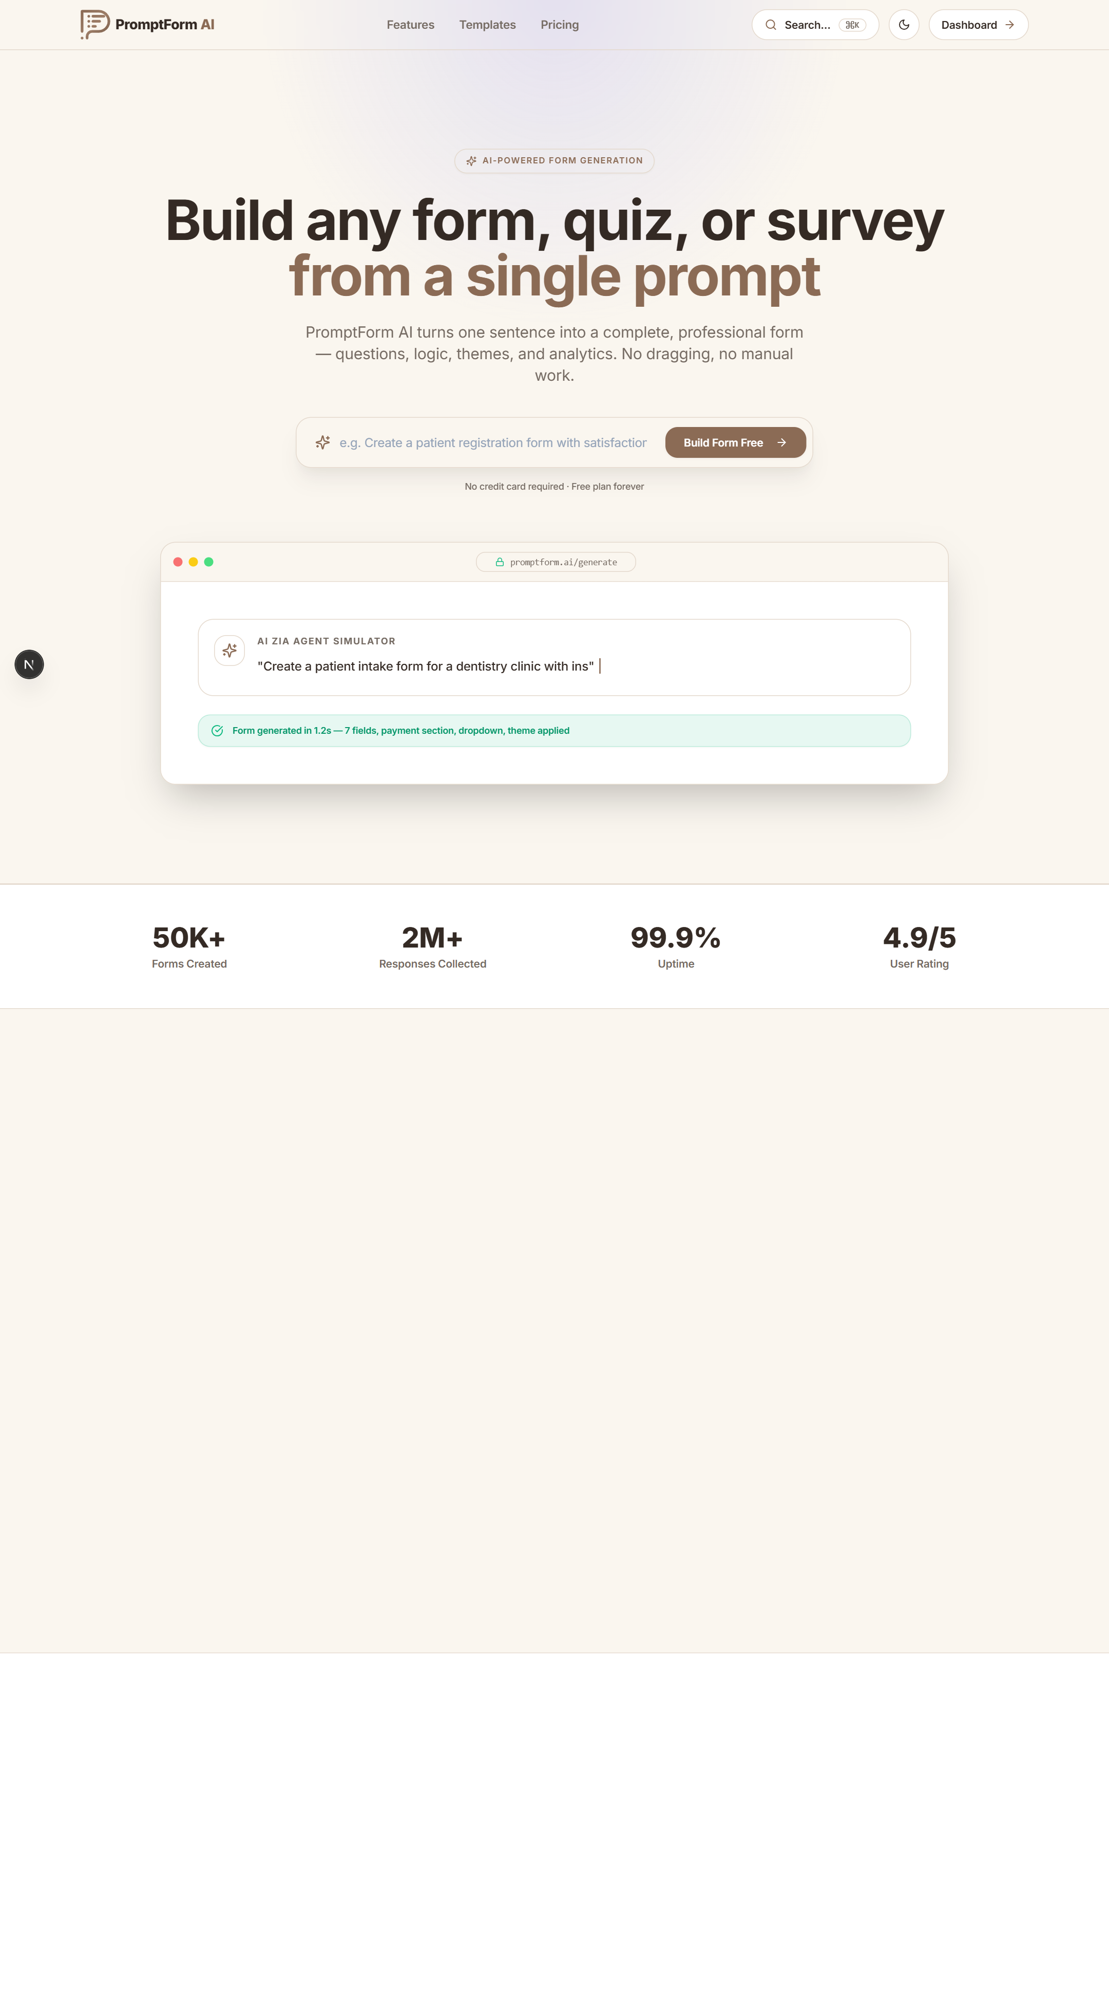
Figure A.12: Supporting Evidence — Landing Page (full length)

Appendix H – Mentor / Evaluator Remarks
Table A.4: Mentor / evaluator remarks
Evaluator | Remarks | Signature / Date
Mentor (Company)
[COMPANY MENTOR NAME]
Mentor (Institute)
[INSTITUTE MENTOR NAME]
External Evaluator

CHAPTER B

FINAL HARD-BOUND SUBMISSION CHECKLIST
Table B.1: Final hard-bound submission checklist
Check | Requirement | Status / Remarks
☑ | Cover page | Included
☑ | Certificate | Included – signatures pending
☑ | Declaration | Included – signature pending
☑ | Acknowledgement | Included
☑ | Abstract / Executive Summary | Included with keywords
☑ | Table of Contents updated | Page references updated
☑ | List of Figures updated | Included
☑ | List of Tables updated | Included
☑ | All chapters completed | Chapters 1–15
☑ | Figures/diagrams captioned and referenced | Chapter-wise numbering
☑ | Tables captioned and referenced | Chapter-wise numbering
☑ | Testing evidence | Chapter 9, Appendix G
☑ | Final results and performance analysis | Chapter 10
☑ | APA 7th references | Chapter 15
☑ | Appendices/supporting evidence | Appendices A–H
☐ | Mentor/Institute evaluation and signatures | To be completed before binding

CHAPTER C

FORMATTING AND SUBMISSION GUIDELINES
- Paper size: A4.
- Body font: Cambria, 12 pt; headings should be consistent.
- Line spacing: 1.5 for body text; single spacing may be used in tables, captions and references where appropriate.
- Margins: approximately 1 inch left/right/top and 0.75 inch bottom; institutional binding rules may override these values.
- Body text should be justified.
- Start each chapter on a new page.
- Number figures and tables chapter-wise, e.g., Figure 6.1 and Table 9.1.
- Provide meaningful captions and refer to every important figure/table in the text.
- Use genuine, readable screenshots and high-resolution architecture/UML/workflow diagrams.
- Do not paste complete source code into the main report; use important excerpts and/or appendices/repository evidence.
- Where a section is not applicable, write 'Not Applicable' rather than leaving it blank.
- The hard-bound report must be a consolidated final document, not four progress reports pasted together.
- Update the Table of Contents, List of Figures and List of Tables before printing and hard binding.
- Ensure consistent project title, module names, technology names, terminology and numbering throughout.

