**ASSIGNMENT 1**

**Design a web page of your resume with all formatting tags.**

**HTML CODE:**

<!DOCTYPE html>

<html lang="en">

<head>

<meta charset="UTF-8">

<meta name="viewport" content="width=device-width, initial-scale=1.0">

<title>Document</title>

</head>

<body Bgcolor=#242424 >

<font color=#f5f5f5>

<center>

<img src="./assets/passport photo.jpg" width=400px alt=""/>

<h1>Priyanshu Sharma</h1>

<h2>Student of <i><u>MSI</u></i></h2>

<marquee><pre><font color=red><h2>- Learn - Learn - Learn - Learn - Learn - Learn - Learn - Learn - Learn - Learn - Learn - Learn - Learn - Learn - Learn - Learn - Learn - Learn - Learn - Learn - Learn - Learn - Learn - Learn - Learn - Learn - Learn - Learn - Learn - Learn - Learn - Learn - Learn - Learn - Learn - Learn - Learn - Learn - Learn - Learn - Learn - Learn - Learn - Learn - Learn - Learn - Learn - Learn - Learn - Learn - Learn - Learn - Learn - Learn - Learn - Learn - Learn - Learn - Learn - Learn - Learn - Learn - Learn - Learn - Learn - Learn - Learn - Learn - Learn - Learn - Learn - Learn - Learn - Learn - Learn - Learn - Learn - Learn - Learn - Learn - Learn - Learn - Learn - Learn - Learn - Learn - Learn - Learn - Learn - Learn - Learn - Learn - Learn - Learn - Learn - Learn - Learn -<h2></font></pre></marquee>

<br>

<br>

<center>

<hr>

<table border="">

</tr>

<br>

<tr>

<td><h2>Profile <h2></td>

<td><br>I am a dedicated and proactive BCA (Bachelor of Computer Applications) student at MSI College, committed to developing strong technical skills and a comprehensive understanding of computer applications. With a solid foundation in programming, software development, and problem-solving, I am eager to contribute my knowledge and enthusiasm to dynamic projects and professional environments. My academic journey has equipped me with practical experience and a collaborative mindset, preparing me to tackle challenges and drive innovation in the field of information technology.<br>. </td>

</tr>

<br>

<tr>

<td><center> <h2><pre>Social Media <pre></h2><center></td>

<td>

<ul>

<h2>

<li><a href="#">Instagram</a></li>

<li><a href="#">LinkedIn</a></li>

<li><a href="#">Twitter</a></li>

<li><a href="#">Whatsapp</a></li>

</h2>

</ul>

</td>

</tr>

<tr>

<td><h2>Hobbies</h2></td>

<td>

<ul>

<h2>

<li><a href="#">Instagram</a></li>

<li><a href="#">LinkedIn</a></li>

<li><a href="#">Twitter</a></li>

<li><a href="#">Whatsapp</a></li>

</h2>

</ul>

</td>

</tr>

<tr>

<td><h2>Education</h2></td>

<td>

<ul>

<h2>

<li>Completed higer Education from <a href="davbistupur.org">D.A.V Bistupur</a></li>

<li>Persuing BCA from MSI</li>

</h2>

</ul>

</td>

</tr>

</table>

</font>

</body>

</html>

**Output:**

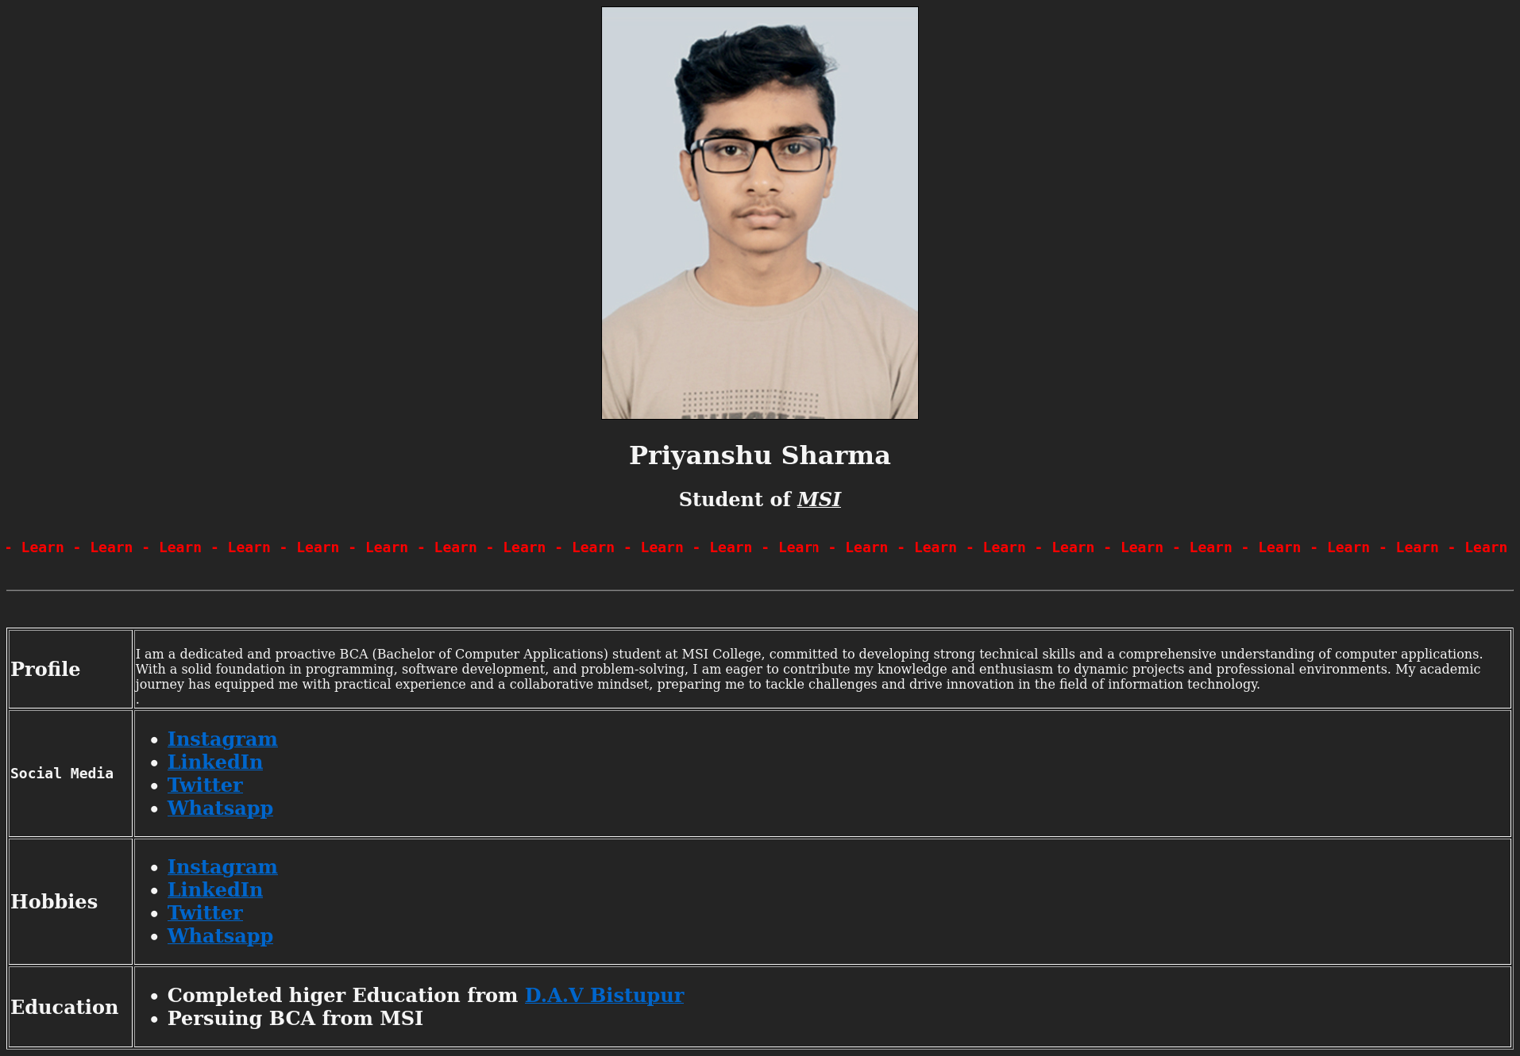

**ASSIGNMENT 2**

**Design a web page to display types of list in HTML.**

**HTML CODE:**

<!DOCTYPE html>

<html>

<head>

<title>Learning Web Development</title>

</head>

<body>

<h1>Learning Web Development</h1>

<ol type="I">

<li>Background Skills</li>

<ol type="A">

<li>Unix Commands</li>

<li>Vim Text Editor</li>

</ol>

<li>HTML</li>

<ol type="A">

<li>Minimal Page</li>

<li>Headings</li>

<li>Tags</li>

<li>Lists

<ol type="i">

<li>Unordered</li>

<li>Ordered</li>

<li>Definition</li>

<li>Nested</li>

</ol>

</li>

<li>Links

<ol type=i>

<li>Absolute</li>

<li>Relative</li>

</ol>

</li>

<li>Images</li>

</ol>

<li>CSS</li>

<ol type=A>

<li>Anatomy</li>

<li>Basic Selectors

<ol type=i>

<li>Elements</li>

<li>Class</li>

<li>ID</li>

<li>Group</li>

</ol>

</li>

<li>The DOM</li>

<li>Advanced Selectors

<li>Box Model</li>

</li>

</ol>

<li>Programming</li>

<ol type=A>

<li>JavaScript</li>

<li>Python</li>

</ol>

<li>Database</li>

<ol type=A>

<li>Flat File</li>

<li>Relational</li>

</ol>

</ol>

</body>

</html>

**Output:**

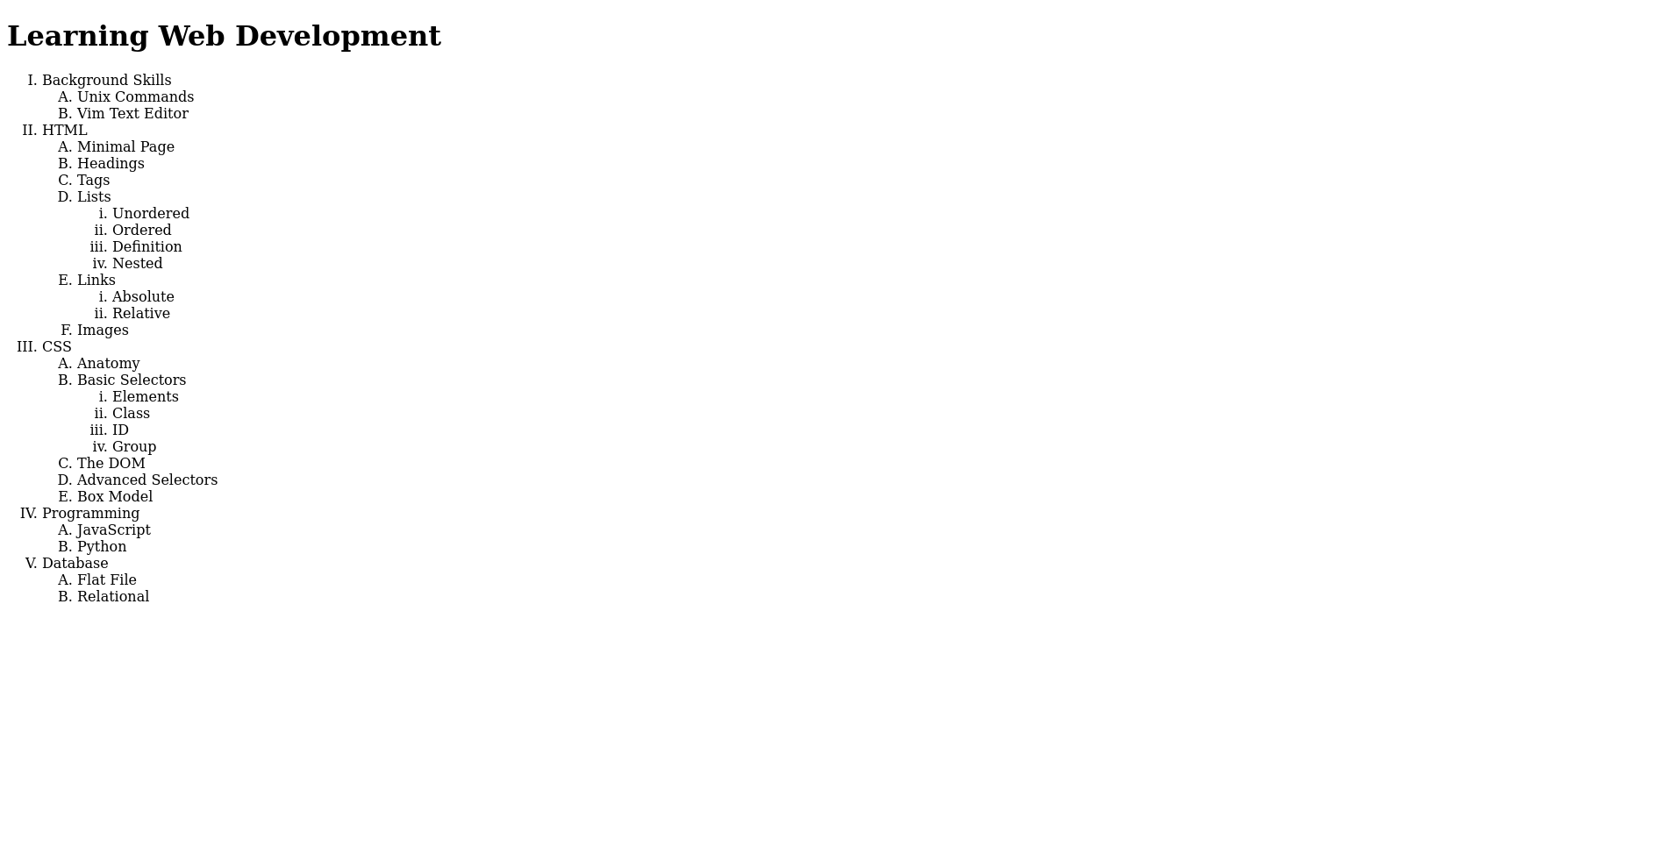

**ASSIGNMENT 3**

**Write HTML code to display time table and current month calendar.**

**HTML CODE:**

<!DOCTYPE html>

<html>

<head>

<title>BCA-1 Sem Timetable</title>

</head>

<body>

<h1>Class Time Table</h1>

<table border="" width="100%" border="1" cellspacing="0" cellpadding="10">

<tr>

<th colspan=3>BCA -1 Sem(Sec -A) Room:204</th>

<th colspan=5>Class Coordinator: Dr. Nidhi Jolly</th>

</tr>

<tr>

<th>Day/Time</th>

<th>11:00-12:00</th>

<th>12:00-1:00</th>

<th>1:00-2:00</th>

<th rowspan=6>BREAK</th>

<th>2:30-3:30</th>

<th>3:30-4:30</th>

<th>4:30-5:30</th>

</tr>

<tr>

<th>Monday</th>

<td>UI</td>

<td colspan=2>CLab 1(MS-G1)/FIT Lab 4(SPC-G2)</td>

<td>C</td>

<td>Math</td>

<td>WT</td>

</tr>

<tr>

<th>Tuesday</th>

<td>C</td>

<td>Math</td>

<td>WT</td>

<td>C</td>

<td>Math</td>

<td>Remidial</td>

<tr>

<th>Wednesday</th>

<td>FIT</td>

<td colspan=2>WT Lab 4(AR-G2)/FIT Lab 1(SPC-G1)</td>

<td>C</td>

<td>Math</td>

<td>Remedial</td>

</tr>

<tr>

<th>Thursday</th>

<td>Math</td>

<td>WS</td>

<td>FIT</td>

<td>WT</td>

<td colspan=2>CLab 1(NF2-G1)/FIT Lab 4(SPC-G2)</td>

</tr>

<tr>

<th>Friday</th>

<td>C</td>

<td>FIT</td>

<td>WT</td>

<td>WS</td>

<td colspan=2>CLab 1(NF2-G2)/WT Lab 4(AR-G1)</td>

</tr>

<tr>

<th>Day/Time</th>

<th>8:00-9:00</th>

<th>9:00-10:00</th>

<th>10:00-11:00</th>

<th>11:00-12:00</th>

<th>12:00-1:00</th>

<th>1:00-2:00</th>

</tr>

<tr>

<th>Saturday</th>

<td colspan=2>CLab 6(MS-G2)/SPC Lab 8(SPC-G1)</td>

<td colspan=2>Math-Bridge (Room 209)</td>

<td>Library</td>

</tr>

</table>

<br>

<br>

<br>

<h1>September 2024 Calendar</h1>

<table cellpadding=15 style="text-align=center;">

<thead>

<tr>

<th><font color=red>Sun</font></th>

<th>Mon</th>

<th>Tue</th>

<th>Wed</th>

<th>Thu</th>

<th>Fri</th>

<th>Sat</th>

</tr>

</thead>

<tbody>

<!-- Empty cells for days before September 1 -->

<tr>

<td>1</td>

<td>2</td>

<td>3</td>

<td>4</td>

<td>5</td>

<td>6</td>

<td>7</td>

</tr>

<tr>

<td>8</td>

<td>9</td>

<td>10</td>

<td>11</td>

<td>12</td>

<td>13</td>

<td>14</td>

</tr>

<tr>

<td>15</td>

<td>16</td>

<td>17</td>

<td>18</td>

<td>19</td>

<td>20</td>

<td>21</td>

</tr>

<tr>

<td>22</td>

<td>23</td>

<td>24</td>

<td>25</td>

<td>26</td>

<td>27</td>

<td>28</td>

</tr>

<tr>

<td>29</td>

<td>30</td>

</tr>

</tbody>

</table>

</body>

</html>

**Output:**

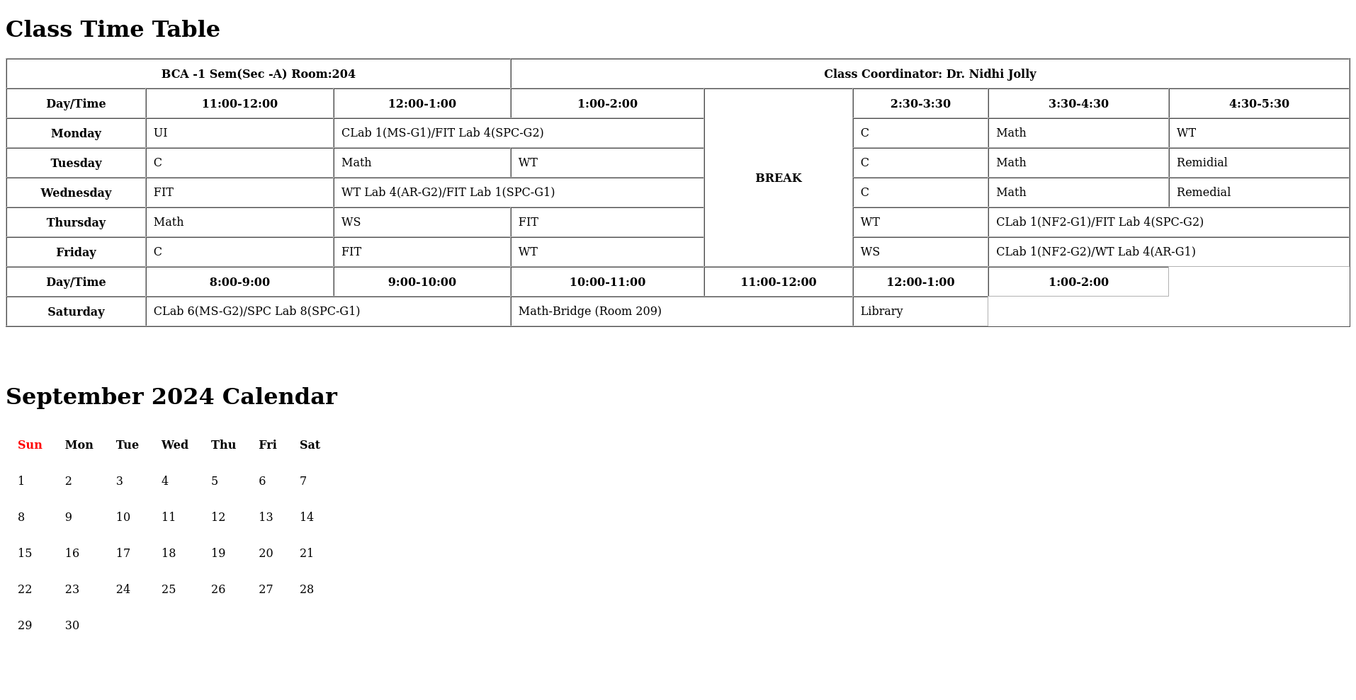

**ASSIGNMENT 4**

**4. Write HTML code to create hyperlinks with all 3 assignments.**

<!DOCTYPE html>

<html lang="en">

<head>

<meta charset="UTF-8">

<meta name="viewport" content="width=device-width, initial-scale=1.0">

<title>Document</title>

</head>

<body>

<h1>Web Technology</h1>

<ul>

<li>8th September 2024</li>

<ul>

<li><a href="./list.html">List</a></li>

<li><a href="./resume.html">Resume</a></li>

<li><a href="./table.html">Table</a></li>

</ul>

<li>9th September 2024</li>

<ul>

<li><a href="intermediateform.html">intermediate form</a></li>

<li><a href="hardform.html">hard form</a></li>

</ul>

<li>11th September 2024</li>

<ul>

<li><a href="bookmarks.html">Bookmarks</a></li>

<li><a href="imagemaps.html">Image Maps</a></li>

</ul>

</ul>

</body>

</html>

**Output:**

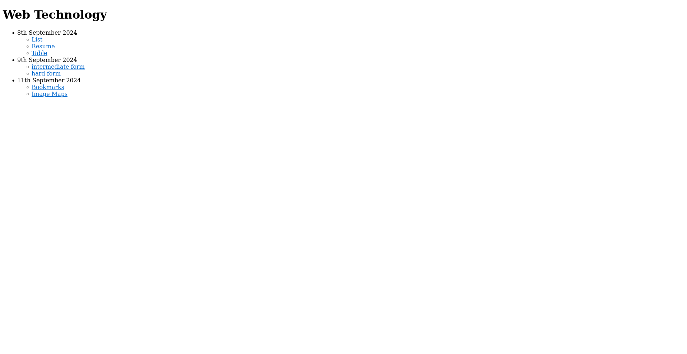

**ASSIGNMENT 5**

**5.** **⁠Design a web page for student registration form.**

<!DOCTYPE html>

<html>

<head>

<title>Student Registration Form</title>

</head>

<body bgColor=#6b5acd>

<font color=white>

<form>

<h2>STUDENT REGISTRATION FORM</h2>

<label for="firstName">FIRST NAME:</label>

<input type="text" id="firstName" name="firstName" maxlength="30"><br><br>

<label for="lastName">LAST NAME:</label>

<input type="text" id="lastName" name="lastName" maxlength="30"><br><br>

<label for="dateOfBirth">DATE OF BIRTH:</label>

<input type="date" id="dateOfBirth" name="dateOfBirth"><br><br>

<label for="email">EMAIL ID:</label>

<input type="email" id="email" name="email"><br><br>

<label for="mobileNumber">MOBILE NUMBER:</label>

<input type="number" id="mobileNumber" name="mobileNumber" maxlength="10"><br><br>

<label>GENDER:</label>

<input type="radio" name="gender" value="male"> Male

<input type="radio" name="gender" value="female"> Female<br><br>

<label for="address">ADDRESS:</label>

<textarea id="address" name="address"></textarea><br><br>

<label for="city">CITY:</label>

<input type="text" id="city" name="city" maxlength="30"><br><br>

<label for="pincode">PIN CODE:</label>

<input type="number" id="pincode" name="pincode" maxlength="6"><br><br>

<label for="state">STATE:</label>

<input type="text" id="state" name="state" maxlength="30"><br><br>

<label>COUNTRY:</label>

<input type="text" id="country" name="country" value="India" disabled><br><br>

<label>HOBBIES:</label>

<input type="checkbox" name="hobbies" value="drawing"> Drawing

<input type="checkbox" name="hobbies" value="singing"> Singing

<input type="checkbox" name="hobbies" value="dancing"> Dancing

<input type="checkbox" name="hobbies" value="sketching"> Sketching

<input type="checkbox" name="hobbies" value="others"> Others<br><br>

<label>QUALIFICATION</label>

<table>

<tr>

<th>S1.No.</th>

<th>Examination</th>

<th>Board</th>

<th>Percentage</th>

<th>Year of Passing</th>

</tr>

<tr>

<td>1</td>

<td>Class X</td>

<td><input type="text" maxlength="10"></td>

<td><input type="text" maxlength="5"></td>

<td><input type="number" min="1900" max="2024"></td>

</tr>

<tr>

<td>2</td>

<td>Class XII</td>

<td><input type="text" maxlength="10"></td>

<td><input type="text" maxlength="5"></td>

<td><input type="number" min="1900" max="2024"></td>

</tr>

<tr>

<td>3</td>

<td>Graduation</td>

<td><input type="text" maxlength="10"></td>

<td><input type="text" maxlength="5"></td>

<td><input type="number" min="1900" max="2024"></td>

</tr>

<tr>

<td>4</td>

<td>Masters</td>

<td><input type="text" maxlength="10"></td>

<td><input type="text" maxlength="5"></td>

<td><input type="number" min="1900" max="2024"></td>

</tr>

</table><br><br>

<h2>COURSES APPLIED FOR</h2>

<input type="radio" name="courses" value="bca"> BCA

<input type="radio" name="courses" value="bcom"> B.Com

<input type="radio" name="courses" value="bsc"> B.Sc

<input type="radio" name="courses" value="ba"> B.A<br><br>

<input type="submit" value="Submit">

<input type="reset" value="Reset">

</form>

</font>

</body>

</html>

**Output:**

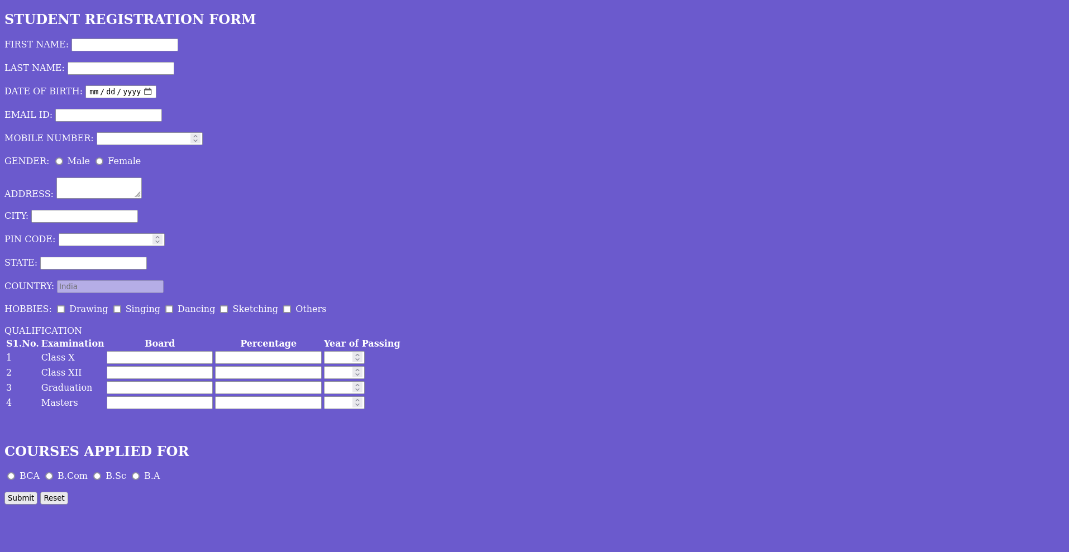

**ASSIGNMENT 6**

⁠6**. Design a web page of image map with all three types of shape.**

<!DOCTYPE html>

<html lang="en">

<meta charset="UTF-8">

<meta name="viewport" content="width=device-width, initial-scale=1.0">

<title>Image Maps</title>

</head>

<body>

<img src="https://rukminim2.flixcart.com/image/850/1000/poster/x/m/e/delhi-map-pp-20-s-03-pp20s03-small-original-imae8p3rntwzpmx4.jpeg?q=90&crop=false" alt="delhimap" usemap="#map">

<map name="#map">

<area shape="rectangle" coords="520,220,575,275" href="https://en.wikipedia.org/wiki/India_Gate" alt="">

<area shape="circle" coords="490,210,25" href="https://en.wikipedia.org/wiki/Chandni_Chowk" alt="">

<area shape="poly" coords="450,325,500,400,400,400" href="https://en.wikipedia.org/wiki/Vasant_Kunj" alt="">

</map>

</body>

</html>

**Output:**

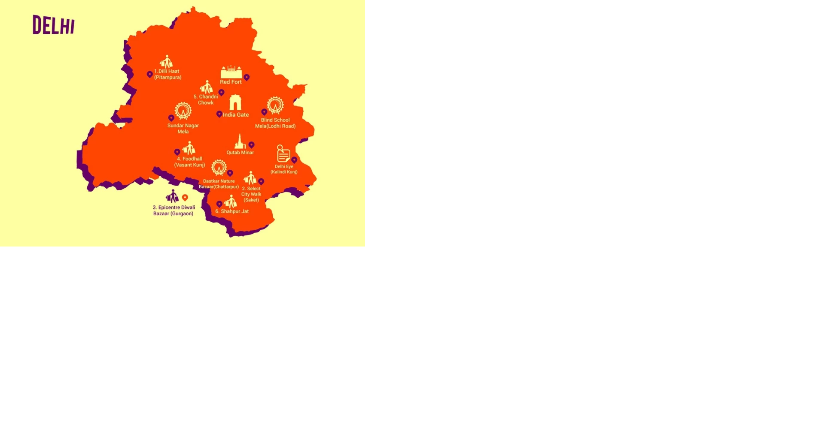

**ASSIGNMENT 7**

**Design a web page for 7 book mark.**

**HTML CODE:-**

<!DOCTYPE html>

<html lang="en">

<head>

<meta charset="UTF-8">

<meta name="viewport" content="width=device-width, initial-scale=1.0">

<title>Bookmarks</title>

</head>

<body>

<a href="#bottom" id="top">Go to Bottom</a>

<h1>Top 6 Programming Languages</h1>

<ol>

<li><a href="#python">Python</a></li>

<li><a href="#javascript">JavaScript</a></li>

<li><a href="#java">Java</a></li>

<li><a href="#csharp">C#</a></li>

<li><a href="#ruby">Ruby</a></li>

<li><a href="#swift">Swift</a></li>

<li><a href="#go">Go</a></li>

<li><a href="#php">PHP</a></li>

</ol>

<h1 id="python">Python</h1>

<p>Python is a versatile, high-level programming language that emphasizes readability and simplicity. Created by Guido van Rossum and first released in 1991, Python has grown into one of the most popular languages due to its clean syntax and ease of learning. It supports multiple programming paradigms, including procedural, object-oriented, and functional programming. Python’s extensive standard library provides modules and tools for everything from file I/O to internet protocols. Its dynamic typing and automatic memory management make it a preferred choice for rapid application development. Python is widely used in web development, data analysis, machine learning, and scientific computing. Frameworks like Django and Flask facilitate web application development, while libraries such as Pandas and NumPy are essential for data analysis and numerical computations. Python’s active community and broad support ensure that it remains a top choice for developers across various domains.</p>

<h1 id="javascript">JavaScript</h1>

<p>JavaScript, a high-level, interpreted programming language, is fundamental to modern web development. Originally developed by Brendan Eich at Netscape and introduced in 1995, JavaScript enables interactive features and dynamic content on web pages. It has evolved from a simple client-side scripting language into a powerful tool for both client-side and server-side development. The language's event-driven, non-blocking I/O model, coupled with its asynchronous capabilities through promises and async/await, makes it suitable for building scalable applications. JavaScript's ecosystem includes a wide range of frameworks and libraries, such as React, Angular, and Vue.js, which simplify and expedite the development of complex user interfaces. Additionally, with Node.js, JavaScript can be used on the server side to create fast and efficient server applications. Its versatility and extensive community support contribute to its ongoing relevance and widespread use in both web and mobile development.</p>

<h1 id="java">Java</h1>

<p>Java is a class-based, object-oriented programming language designed for cross-platform compatibility through the use of the Java Virtual Machine (JVM). Developed by Sun Microsystems and released in 1995, Java was designed with the principle of "write once, run anywhere" in mind, allowing code to be executed on any device with a compatible JVM. This makes Java highly portable and a popular choice for enterprise-level applications, web services, and mobile applications on the Android platform. Java’s syntax is similar to C++, but it eliminates some of the more complex features, such as pointers, making it easier to learn and use. The language supports multithreading, allowing concurrent execution of tasks, which enhances performance in complex applications. Java’s robustness, security features, and extensive libraries and frameworks, such as Spring and Hibernate, make it a preferred choice for large-scale systems and high-performance applications across various industries.</p>

<h1 id="csharp">C#</h1>

<p>C# (pronounced C-sharp) is a modern, object-oriented programming language developed by Microsoft as part of its .NET framework. Introduced in 2000, C# was designed to be simple, modern, and versatile, making it suitable for a wide range of applications, from web and desktop to mobile and gaming. The language incorporates features from various programming paradigms, including object-oriented and component-oriented programming. C# supports strong type checking, garbage collection, and exception handling, contributing to its reliability and ease of use. The language’s syntax is similar to C++ and Java, which eases the transition for developers familiar with those languages. C# is commonly used with the .NET platform for developing enterprise applications, web services, and Windows applications. Additionally, C# is a popular choice for game development using the Unity engine, where its performance and ease of integration with various systems are highly valued. Its rich feature set and strong integration with Microsoft’s ecosystem make it a powerful tool for developers.</p>

<h1 id="ruby">Ruby</h1>

<p>Ruby is an open-source, high-level programming language known for its elegant and human-readable syntax. Created by Yukihiro Matsumoto and released in 1995, Ruby emphasizes simplicity and productivity, with an emphasis on making programming a more enjoyable experience. The language supports multiple programming paradigms, including procedural, object-oriented, and functional programming. Ruby’s syntax is designed to be intuitive and easy to read, reducing the complexity of coding tasks. It is particularly renowned for its association with the Ruby on Rails framework, which revolutionized web development by introducing convention over configuration, enabling rapid application development. Ruby on Rails provides a structured approach to web application development, offering a range of tools and libraries to streamline the process. Ruby’s focus on developer happiness, along with its strong community support, makes it a popular choice for startups and developers seeking to build web applications quickly and efficiently.</p>

<h1 id="swift">Swift</h1>

<p>Swift is a powerful, open-source programming language developed by Apple for building applications across its ecosystem, including iOS, macOS, watchOS, and tvOS. Released in 2014, Swift was designed to be a more modern and safer alternative to Objective-C. It combines the best features of modern programming languages with performance-oriented capabilities, making it easier for developers to write clean, maintainable, and efficient code. Swift’s syntax is expressive and concise, reducing the amount of boilerplate code and making development faster and more intuitive. The language includes features such as optional types, type inference, and pattern matching, which enhance code safety and reduce the likelihood of runtime errors. Swift’s strong performance is achieved through its LLVM-based compiler, which optimizes code at compile time. The language is supported by a rich set of libraries and frameworks, including SwiftUI for building user interfaces and Combine for reactive programming, making it a versatile choice for developing high-quality applications for Apple platforms.</p>

<h1 id="go">Go</h1>

<p>Go, also known as Golang, is an open-source programming language created by Google, known for its simplicity, efficiency, and strong support for concurrent programming. Released in 2009, Go was designed to address the shortcomings of other programming languages in terms of performance and ease of use. Its clean syntax and static typing provide a balance between simplicity and robustness, making it easy to learn and use for various types of applications. Go’s standout feature is its built-in support for concurrency, achieved through goroutines and channels, which allows developers to write efficient and scalable concurrent programs. The language’s focus on simplicity is reflected in its minimalistic design, which avoids unnecessary complexity and promotes clear, readable code. Go’s performance is enhanced by its fast compilation times and efficient execution, making it ideal for developing high-performance server-side applications, cloud services, and distributed systems. Its growing ecosystem of libraries and tools, along with strong community support, contributes to its increasing popularity among developers.</p>

<h1 id="php">PHP</h1>

<p>PHP (Hypertext Preprocessor) is a widely-used, open-source scripting language specifically designed for web development. First released in 1995 by Rasmus Lerdorf, PHP allows developers to embed code directly into HTML, creating dynamic and interactive web pages. Its server-side scripting capabilities enable the creation of complex web applications by interacting with databases, handling sessions, and managing form submissions. PHP’s ease of integration with various databases, including MySQL and PostgreSQL, makes it a popular choice for building data-driven websites and applications. Over the years, PHP has evolved with the introduction of frameworks such as Laravel and Symfony, which offer advanced features and improved security practices. PHP’s simplicity and versatility are complemented by a large community of developers who contribute to its rich ecosystem of libraries, tools, and documentation. Its widespread use and continuous development ensure that PHP remains a relevant and effective language for server-side web development.</p>

<a href="#top" id="bottom">Go to top</a>

</body>

</html>

**Output:**

