**DRIVER AWAKE SYSTEM**

# PROJECT REPORT

***Submitted by***

**MADHUMITHA J – 221001088**

**PRINKAYATTHRA D – 221001117**

**KANMANI D – 221001070**

**MAANASA PRIYA M – 221001085**

***in fulfilment for the course***

**IT19644 - INNOVATION AND DESIGN THINKING FOR INFORMATION**

**TECHNOLOGY**

***for the degree of***

# BACHELOR OF TECHNOLOGY

**in**

**INFORMATION TECHNOLOGY**



**APRIL 2025**

**RAJALAKSHMI ENGINEERING COLLEGE**

**BONAFIDE CERTIFICATE**

Certified that this thesis titled **DRIVER AWAKE SYSTEM’** is the Bonafide work

of **MADHUMITHA J (221001088), PRINKAYATTHRA D(221001117), KANMANI**

**D (2210001070),MAANASA PRIYA M (221001085**)

who carried out the work under my supervision. Certified further that to the best of my knowledge the work reported year in does not form part of any other thesis or dissertation on the basis of which a degree or award was conferred on an earlier occasion on this or any other candidate.

# Student Signature with Name Signature of the Supervisor

**1.KANMANI D**

**2. PRINKAYATTHRA D**

**3.MADHUMITHA J**

**4.MAANASA PRIYA M**

**INTERNAL EXAMINER EXTERNAL EXAMINER ABSTRACT**

The Driver Awake System combines computer vision techniques and embedded electronics to accurately detect signs of drowsiness based on facial behavior. A webcam mounted near the dashboard continuously captures video frames of the driver's face. These frames are processed using Python, OpenCV, and dlib libraries to detect facial landmarks, particularly focusing on the eyes and head orientation. The system calculates the Eye Aspect Ratio (EAR) to determine if the eyes are closed for longer-than-usual durations, which may indicate drowsiness. Head pose detection is also used to identify nodding or downward tilts—a common symptom of fatigue.

**TABLE OF CONTENTS**

**S.NO CONTENTS PAGE NO**

# 1. INTRODUCTION

1.1 Introduction 7

1.2 Objectives 8

1.3 Modules – Materials Required 9

# 2. EMPATHY PHASE

2.1 Introduction 12

2.2 Existing System 13

2.3 Issues in Existing System 15

# 3. EXPERIMENT PHASE

3.1 Introduction 17

3.2 Proposed System 20

3.3 System Architecture 21

3.4 Hardware and software requirements

3.1.1 Hardware Requirements 22

3.1.2 Software Requirements 25

# 4. ENGAGE / EVOLVE PHASE

4.1 Experimental results 26

4.2 Performance analysis 28

4.3 Feedback from user engage/evolve phase 30

# 5. CONCLUSION AND FUTURE WORK

5.1 Conclusion 31

5.2 Fure Work 33

# 6. APPENDIX

* PROGRAM CODE 35
* PROJECT KIT 41

**7. REFERENCE**

# CHAPTER 1

## 1.INTRODUCTION

**1.1 INTRODUCTION:**

In an era where road safety is becoming a critical concern worldwide, driver fatigue has emerged as a leading cause of severe traffic accidents and fatalities. The increasing number of long-distance drivers, night-time travelers, and delivery personnel has intensified the need for advanced in-vehicle safety systems. The Driver Awake System project presents an innovative solution that leverages Artificial Intelligence (AI) and embedded systems to detect early signs of drowsiness and prevent accidents before they occur.

This system uses real-time image processing techniques via OpenCV and dlib to monitor key facial features such as eye closure duration and head posture. By analyzing the Eye Aspect Ratio (EAR) and other facial landmarks, the system can intelligently distinguish between normal blinking and drowsiness. When signs of fatigue are detected, visual and audio alerts are immediately triggered through an LCD display and a buzzer to awaken the driver.

An Arduino Uno is integrated into the setup to control hardware components such as a piezo buzzer, LEDs, and a 16x2 I2C LCD screen. Designed to function in real-time and in diverse lighting conditions, the system is a proactive measure aimed at saving lives through technological intervention. Scalable, cost-effective, and compatible with both smart and traditional vehicles, the Driver Awake System lays the groundwork for future-ready automotive safety.

**1.2 OBJECTIVES:**

The Driver Awake System aims to improve road safety by offering a real-time, embedded fatigue detection and alert system for drivers. Its key objectives include:

1.**To detect early signs of driver drowsiness** by monitoring facial features such as eye closure and blinking patterns using AI-based algorithms.

2.**To differentiate between normal blinking and actual drowsiness** by computing the Eye Aspect Ratio (EAR) through facial landmark analysis.

3.**To instantly alert the driver** via buzzer and blinking LEDs when fatigue is detected, reducing the risk of accidents.

4.**To integrate both software and hardware components** using Python for detection and Arduino for real-time alert control.

5.**To display system status and detection alerts** using a 16x2 LCD module for visual feedback.

6**.To provide a scalable, energy-efficient, and real-time solution** that can be integrated into personal vehicles, commercial trucks, or public transportation.

**1.3 MODULES:**

The proposed system is composed of the following key functional modules, each contributing to the overall objective of efficient and sustainable driver drowsiness detection.

1. **Real-Time Image Capture Module:**
   * **Description**: Captures live video feed of the driver's face.
   * **Components**: USB webcam or Pi camera module.
   * **Function**: Provides visual input for processing facial landmarks**.**

1. **Drowsiness Detection Software Module**

* **Description:** Detects signs of fatigue using facial landmark-based algorithms.
* **Components:** Python, OpenCV, dlib, Haar cascades.
* **Function:** Calculates Eye Aspect Ratio (EAR) and determines drowsiness based on threshold.

1. **Microcontroller Alert Module** 
   * **Description:** Handles real-time alerts upon drowsiness detection.
   * **Components:** Arduino Uno, piezo buzzer, LEDs.
   * **Function:** Activates buzzer and LED indicators to alert the driver**.**

1. **LCD Display & Monitoring Module**
   * **Description:** Displays system status and detection messages.
   * **Components:** 16x2 I2C LCD.
   * **Function:** Shows "Driver Awake", "Drowsy Detected", or "Alerting" messages.

1. **Power Supply Module** 
   * **Description:** Provides electrical power to all components.
   * **Components:** 9V battery, USB power source, voltage regulators.
   * **Function:** Ensures stable power for Arduino, sensors, and output devices.

1. **Data Logging (Optional Enhancement)** 
   * **Description:** Records alert data and drowsy events.
   * **Components:** SD card module, RTC (real-time clock).
   * **Function:** Allows post-drive analysis and system performance tracking.

1. **LED Street Lighting Module** 
   * **Description:** The end-application module that utilizes the harvested and stored energy to power street lights.
   * **Components:** Energy-efficient LED bulbs, connecting circuits.
   * **Function:** Provides illumination using renewable energy, validating the feasibility and effectiveness of the overall system.

**MATERIALS REQUIRED:**

|  |  |  |
| --- | --- | --- |
| **Component / Material** | **Specification / Description** | **Quantity** |
| Webcam / Pi Camera | For real-time video capture of the driver's face | 1 unit |
| Arduino Uno | Microcontroller board based on  ATmega328P | 1 unit |
| Buzzer (Piezo) | For audio alert when  drowsiness is detected | 2 units |
| Rechargeable Battery /  Super  Capacitor | Optional – for longer  energy storage | 1 unit |
| LED (Red/Yellow) | Visual alert to indicate drowsiness | 1 unit |
| USB Cable / Battery Pack | Power source for Arduino and display | 1 unit |
| LCD Display (16x2) | To display real time messages and system status information | 1 unit |
| Python Libraries | OpenCV, dlib, imutils – for drowsiness detection logic | Software |
| Resistors | Various values as per circuit design | As needed |
| Breadboard / PCB | For circuit prototyping or permanent assembly | 1 unit |
| Jumper Wires / Hookup Wires | For circuit connections | As needed |
| Soldering Kit | For permanent wiring  (iron, solder, flux) | 1 kit |
| Connecting Terminals / Connectors | For clean wiring and component connections | As needed |

# CHAPTER 2

## 2.EMPATHY PHASE

**2.1 INTRODUCTION:**

In today’s fast-paced world, road safety has become a growing concern—especially with the increasing number of accidents caused by driver fatigue. Drowsiness while driving is one of the leading causes of road mishaps, often resulting in severe injuries or even fatalities. Traditional vehicle safety systems often fail to detect fatigue in real time, especially in long-distance or night-time driving scenarios.

Our project was born from a question that places people at the heart of innovation: What if we could detect a driver’s drowsiness before it turns into danger—and alert them instantly? This question guided our exploration into creating a real-time Drowsiness Detection System that can actively help prevent accidents and save lives.

To build a system that truly addresses this issue, we engaged with individuals directly impacted by it—professional drivers, daily commuters, transport company staff, and even medical professionals who understand the effects of fatigue. Many shared their experiences of near-miss incidents due to tiredness, or the lack of affordable systems that could detect drowsiness before it’s too late.

These real-life stories helped us understand the urgent need for a reliable, accessible, and proactive solution. Our goal is to design a system that uses computer vision and sensor-based technologies to monitor signs of fatigue, such as eye closure and yawning, and then respond with real-time alerts through buzzers, LEDs, and displays

By focusing on the needs of everyday drivers and the conditions they face, our project follows a human-centered engineering approach. It aims to not only improve road safety but also enhance driver awareness and community well-being. At its core, our Drowsiness Detection System is driven by empathy—using technology to protect lives.

**2.2 EXISTING SYSTEMS:**

Various technologies have been proposed or developed to address drowsiness and alertness in drivers. Below are the key existing systems:

1. **Basic Drowsiness Detection Systems:** These systems primarily use eye blink rate, yawning detection, or head tilt to identify fatigue. While helpful, they are often limited in scope and may not trigger intervention unless drowsiness is already advanced. They also tend to have lower accuracy in varied lighting or facial orientation.

1. **Camera-Based Monitoring Systems** :These systems use infrared or regular cameras to monitor facial expressions and eye movements. Though effective in controlled environments, they can struggle in real-world conditions like low lighting, glasses obstruction, or partial face visibility.

1. **Wearable Alertness Trackers:** Devices like smart glasses, EEG headbands, or heart rate monitors track physiological data to assess alertness. However, they require user compliance and comfort, which can be challenging for long-duration use or widespread adoption

1. **Steering Pattern Monitoring:** Some systems analyze erratic steering behavior as a sign of drowsiness. While non-invasive, this method only detects symptoms after impaired control is evident, often delaying timely intervention.

1. **Driver Assistance Systems (ADAS)** : Modern ADAS features like lane departure warnings and adaptive cruise control can help reduce fatigue but do not directly detect or counteract drowsiness. They are reactive rather than proactive.

1. **In-Vehicle Voice Alerts**: Basic vehicles sometimes include voice or sound alerts when drowsiness is suspected. However, these alerts can be repetitive and easy to ignore, lacking personalization or adaptive engagement.

1. **Seat Vibration and Feedback Systems:** Some premium vehicles integrate vibration motors in the seat to alert the driver. While helpful, this method may not be sufficient for drivers already deeply fatigued or used to physical feedback.

**2.3 ISSUES IN EXISTING SYSTEM:**

Despite the introduction of advanced driver assistance systems and fatigue detection technologies, there are still several limitations in the existing solutions. These gaps hinder their real-time effectiveness, affordability, and reliability, especially for regular commuters and commercial drivers. Below are the major issues identified in current drowsiness detection systems:

* 1. **Lack of Real-Time Accuracy**

Most existing driver drowsiness detection systems fail to accurately distinguish between **normal eye closure (like blinking)** and **actual sleep-induced eye closure**. Due to the lack of precise timing mechanisms and eye movement analysis, these systems tend to raise **false alarms**, which can irritate the driver or be ignored over time. In addition, some systems cannot detect signs like **head nodding** or **yawning**, which are crucial indicators of fatigue.

* 1. **Poor Handling of Environmental Conditions**

A common issue in vision-based systems (using OpenCV or cameras) is their **sensitivity to lighting conditions**. Low light environments (such as night driving), glare from headlights, or shadows inside the vehicle can result in **inaccurate face or eye detection**. This limits the performance of the system and makes it unreliable under different driving conditions.

3.3 **Limited Hardware Integration**

Several systems focus only on the software side and lack proper integration with **external alert mechanisms**, such as **buzzers, lights, or display messages**. Without hardware-level feedback, the driver may not be alerted immediately, reducing the purpose of the system. Moreover, systems that use complex hardware setups are often **expensive and not portable**, making them difficult to implement in regular vehicles.

3.4 **Inefficient Detection of Other Fatigue Symptoms**

Many existing systems mainly rely on **eye closure detection**, ignoring other fatigue indicators like **yawning, face orientation, or head tilt**. These additional symptoms are equally important to ensure a holistic detection mechanism. A system that only looks at one parameter is likely to miss early warning signs and fail to prevent fatigue-related accidents.

3.5 **No Differentiation Between Laughing, Blinking, and Drowsiness**

One of the major problems is the **inability to differentiate between intentional facial expressions** and actual signs of sleep. For instance, **laughing, talking, or looking down briefly** might be wrongly interpreted as drowsiness, leading to inaccurate results and frequent interruptions. This can make the system frustrating for the driver.

3.6 **Delayed or No Alert Mechanism**

Some systems do not have a well-timed alerting method. Either the alert is triggered too early (during normal blinking) or too late (after the driver has already fallen asleep), which defeats the purpose. A properly timed warning with **threshold-based detection** is essential to alert the driver at the right moment.

3.7 **No Customization for Different Users**

Existing systems are mostly **generic** and do not adapt to individual drivers. They do not consider factors such as **blink rate differences between individuals**, **driver habits**, or **fatigue tolerance**, which can affect detection accuracy. A onesize-fits-all approach is ineffective for personalized fatigue detection.

3.8 **Lack of Continuous Monitoring and Data Logging**

Another limitation is the **absence of continuous data logging** for fatigue patterns. Without proper record-keeping of when and how often a driver gets drowsy, there’s no scope for **post-trip analysis or long-term fatigue risk evaluation**. This restricts the system to being reactive rather than proactive.

3.9 **Complex Setup and Maintenance**

Many existing systems are difficult to install and maintain, especially for non-technical users. They may require **calibration, regular tuning**, or **retraining of machine learning models**, which is not feasible for every vehicle owner or driver. This reduces user adoption of such technologies.

3.10 **Limited Edge Device Support**

Some advanced systems require high processing power and are designed to run on PCs or laptops. This makes it hard to deploy them on **embedded systems like Raspberry Pi or Arduino**, which are preferred for in-car systems due to size and power constraints.

The lack of support for edge computing limits real-time performance.

## CHAPTER 3

### 3. EXPERIMENT PHASE

**3.1 INTRODUCTION**

The **Experiment Phase** of the **Driver Awake System** is crucial for transforming theoretical concepts into real-world, functioning solutions. This phase allows for the assessment of how well the proposed system performs in a live environment. The primary objective of this phase is to validate the system's ability to detect driver drowsiness or fatigue accurately, trigger timely alerts, and prevent road accidents due to driver sleepiness.

In this phase, various components such as cameras, sensors, microcontrollers (e.g., Arduino or Raspberry Pi), alerting systems (buzzers, LEDs), and software algorithms for drowsiness detection will be tested and evaluated. Real-time data, such as eye movement, head position, and facial expressions, will be monitored to assess how well the system performs in various driving scenarios. The phase also includes evaluating the integration of hardware with software, fine-tuning system parameters, and ensuring the effectiveness of alerts in preventing accidents.

This phase involves several steps, including:

* **System Integration:** Connecting all components (sensors, microcontrollers, camera modules, alerting devices) to form a fully operational prototype.
* **Testing and Data Collection:** Conducting trials under various driving conditions, collecting real-time data on the driver’s alertness levels, and recording performance metrics.
* **System Calibration and Optimization:** Fine-tuning system settings, including sensor sensitivity, alert thresholds, and response time, to ensure accuracy and responsiveness.
* **Performance Evaluation:** Comparing the results of the system with expected performance outcomes, troubleshooting any issues, and ensuring the system functions reliably in real-world scenarios.

The goal is to ensure the **Driver Awake System** can effectively monitor driver fatigue and prevent accidents in real-time by providing timely alerts based on reliable drowsiness detection.

**3.2 SYSTEM COMPONENTS AND INTEGRATION**

The **Driver Awake System** is designed using several components that work together to monitor and detect signs of drowsiness. Each component is carefully selected and integrated to ensure optimal performance, reliability, and ease of use. Below is a breakdown of the key components involved:

1. **Camera and Face Detection System (OpenCV + dlib):**
   * + **Camera Module:** A camera (typically a USB webcam or an integrated car camera) is used to capture the driver’s face and eyes in real time.
     + **Face Detection:** Using OpenCV and dlib, the system detects the driver’s face and identifies key facial features, such as eyes, nose, and mouth. The system analyzes eye movement to detect signs of drowsiness (e.g., frequent eye closure, slow blinking).
     + **Eye Tracking:** The system monitors eye closeness and blinking frequency to determine fatigue levels. Algorithms are trained to distinguish between normal blinking and drowsiness (e.g., prolonged eye closure).
2. **Sensors and Data Collection:**
   * + **Heart Rate Monitor:** In some cases, a heart rate sensor can be incorporated to monitor physiological signs of fatigue. It could help complement facial analysis, as an elevated heart rate might indicate stress or sleepiness.
     + **Accelerometer (optional):** Used to detect head nodding, which is another common indicator of driver fatigue. If the head is tilted downward repeatedly, it is a strong sign of drowsiness.
3. **Microcontroller and Processing Unit (Arduino/Raspberry Pi):**
   * + The **microcontroller** (such as **Arduino** or **Raspberry Pi**) serves as the central processing unit for the system. It receives inputs from the camera and sensors and processes them using pre-programmed algorithms to detect fatigue.
     + The **microcontroller** also controls the flow of energy to various components and manages the alert system (e.g., buzzer, LED).
4. **Alerting Mechanism (Buzzer and LED Lights):**
   * + **Buzzer:** A loud, distinct sound is triggered when drowsiness is detected, alerting the driver to the potential risk of falling asleep.
     + **LED Lights:** Red or blinking LEDs can also serve as a visual alert, especially if the driver is hard of hearing or in noisy environments.
     + **Vibration Motor (optional):** A vibrating alert on the seat or steering wheel could be added for enhanced alerting, providing a tactile warning.
5. **Energy Supply:**
   * + The system will be powered by the vehicle's **12V power supply**, through an adapter that converts the car's DC output into a suitable voltage for the system components.
     + A small **backup battery** could be used to ensure the system remains functional during engine startup or power surges.

**3.3 EXPERIMENT SETUP AND PROCEDURE**

The experimental setup involves creating a controlled environment to test the performance of the **Driver Awake System** under different conditions. The setup will consist of the following:

1. **Driver Simulation Environment:**
   * + **Testing Area:** The experiments will be conducted in a controlled environment, simulating real-world driving conditions (e.g., a driving simulator or a car in a parking lot).
     + **Driver Participants:** Different drivers (representing a variety of age groups, driving experiences, and fatigue levels) will be asked to participate. They will be monitored throughout the testing session for drowsiness signs.
2. **Real-Time Monitoring:**
   * + The **system’s camera** will continuously monitor the driver's face and eyes, capturing data on blink rates, head movement, and other relevant facial expressions.
     + **Data Logging:** The system will log real-time data (e.g., eye closure duration, blinking frequency) for analysis. A separate logging system can be set up to capture video feeds for post-experiment analysis.
3. **Testing Conditions:**
   * + **Varying Fatigue Levels:** Participants will be subjected to different levels of fatigue, from well-rested to moderately tired to very fatigued. Their reaction times, alertness, and behavior will be monitored to simulate real-world driving scenarios.
     + **Environmental Factors:** The tests will be carried out during different times of the day (morning, afternoon, night) and in varying lighting conditions to simulate various driving environments.
4. **Alert System Activation:**
   * + The system will be tested for its ability to detect and respond to signs of fatigue accurately. Upon detecting signs of drowsiness (e.g., prolonged eye closure), the alert system (buzzer and LEDs) will be activated.
     + **Threshold Adjustments:** The sensitivity of the system will be tested by adjusting thresholds for triggering the alert. These thresholds will be fine-tuned to reduce false positives (e.g., during normal blinking) while maintaining accuracy.

**3.4 TESTING AND DATA COLLECTION**

The testing phase involves collecting comprehensive data on the system’s performance in detecting fatigue and triggering alerts. The following types of data will be collected:

1. **Eye Closure and Blink Rate Data:**
   * + Real-time data on the driver’s blink rate, eye closure duration, and frequency of drowsiness signs will be collected.
     + The system will also log any false positives (e.g., when the system wrongly detects drowsiness during brief eye closure due to environmental factors like low light or glare).
2. **Head Movement Data:**
   * + The accelerometer (if used) will provide data on head tilts or nodding, another indicator of drowsiness.
     + The system will record the duration and frequency of head nods to determine if they correlate with drowsiness levels.
3. **Alert System Response:**

 The response time of the alert system (buzzer and LEDs) will be measured. The aim is to ensure that alerts are triggered in a timely manner, ideally before the driver reaches a dangerous state of fatigue.

1. **Driver Feedback:**

 After each test, participants will provide feedback on the effectiveness of the alert system. This will include how noticeable the alert was and whether it caused any distractions.

**3.5 SYSTEM CALIBRATION AND OPTIMIZATION**

During the **Experiment Phase**, the system will undergo continuous calibration and optimization:

* + - **Threshold Calibration:** The blink rate and eye closure duration thresholds will be adjusted to balance sensitivity and accuracy. This will ensure that the system doesn't trigger false alerts under normal conditions (e.g., short eye closure during talking).
    - **Alert Calibration:** The volume, frequency, and type of alerts will be fine-tuned to ensure they are noticeable but not overwhelming. Testing will aim to avoid annoying the driver while ensuring timely and clear alerts.
    - **Power Consumption Optimization:** The system will also be tested for power consumption efficiency. The goal is to minimize energy usage.

* 1. **SYSTEM ARCHITECTURE:**

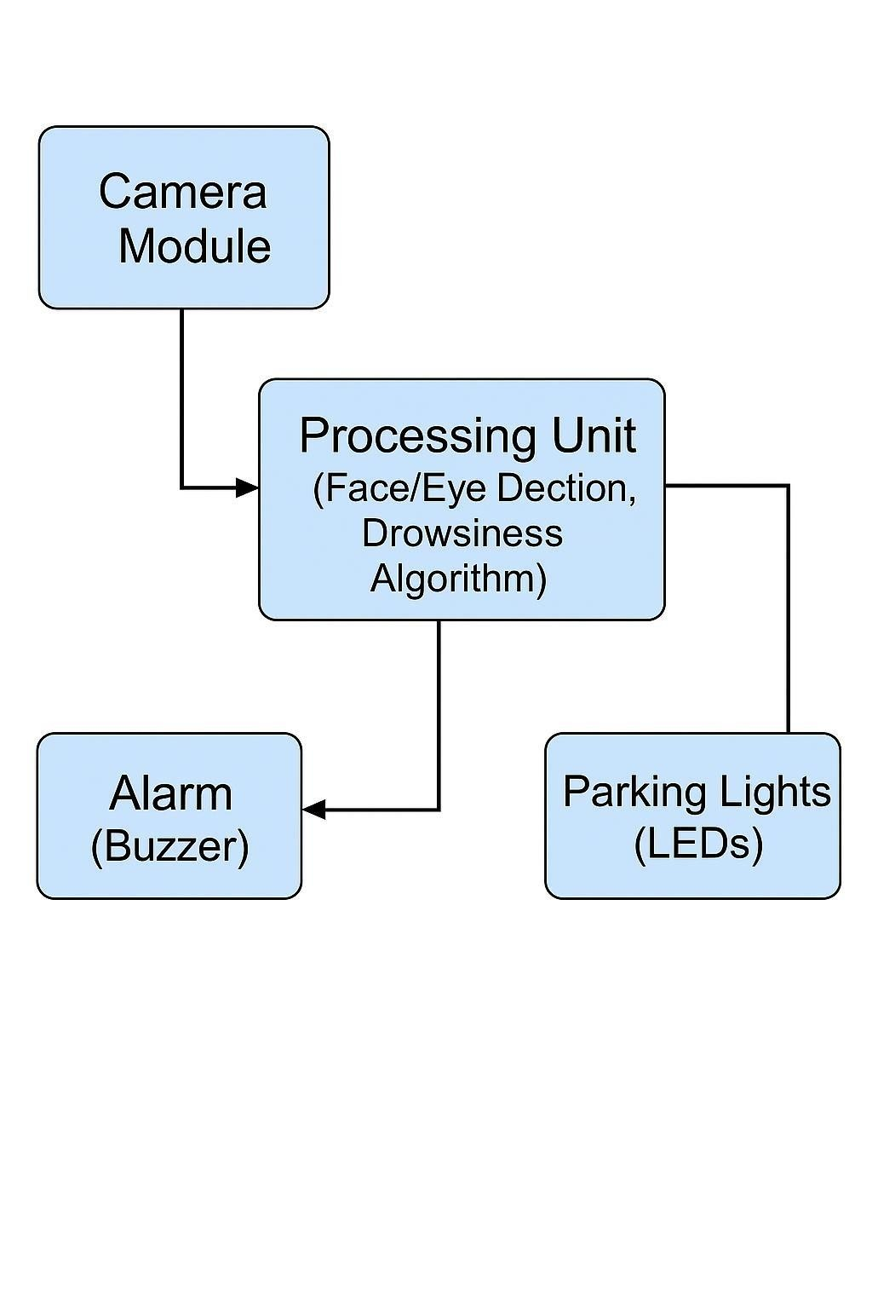

* 1. **HARDWARE AND SOFTWARE REQUIREMENTS:**

#### 3.4.1 Hardware Requirements

1. **Eye Blink Sensor (IR Sensor or Camera Module)** o Function:

Detects driver drowsiness by monitoring eye blink patterns. o

Type: Infrared (IR) sensor or camera (e.g., Raspberry Pi Camera).

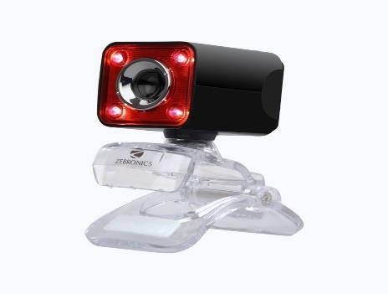

1. **Microcontroller (Arduino Uno/Nano/ESP32 or Raspberry**

**Pi)** o Function: Processes sensor data and triggers alerts. o

Alternative: Raspberry Pi (for advanced image processing).

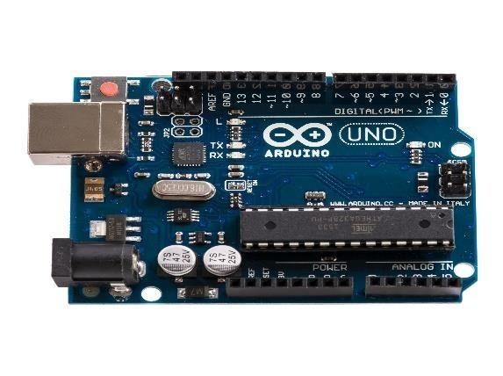

1. **LCD Display (16x2 or OLED)** o Function: Displays system status and alerts (e.g., "Stay Awake!").

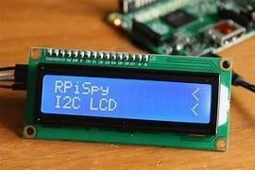

1. **LED Warning Light (Red/Blue)** o Function: Flashes a bright light for visual warning.

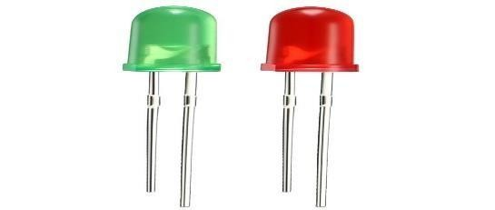

1. **Push Button (Reset/Override Switch)** o Function: Allows the driver to reset the system after an alert.

1. **Power Supply (5V/12V Battery or Car Adapter)** o Function:

Powers the system (can be connected to the car’s battery).

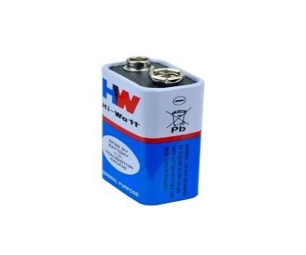

1. **Jumper Wires & Breadboard (Prototyping)** o Function:

Connects components during testing.

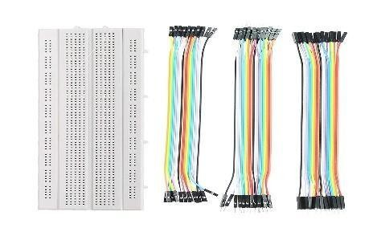

### 8. Multimeter & Oscilloscope (Testing Tools)

 Function: Measures voltage, current, and signal integrity during development.

#### 3.4.2 Software Requirements

1. **Arduino IDE** o Purpose: Used to program the microcontroller for sensor data processing and alert control.
   * Key Features:
     + Code editor for embedded C/C++ programming.
     + Serial monitor for real-time data logging.
     + Library support (e.g., LiquidCrystal.h, Tone.h).
   * Recommended Version: Latest stable release (Arduino IDE 2.x).
2. **Python (For Camera-Based Systems)** o Purpose: Used with Raspberry Pi for facial recognition and blink detection. o Key Libraries:
   * + OpenCV (real-time eye tracking).
     + Dlib (facial landmark detection).
     + PySerial (Arduino communication, if applicable).
3. **Embedded C/Arduino C++** o Purpose: Implements drowsiness detection logic on the microcontroller.

# CHAPTER 4

## 4. ENGAGE / EVOLVE PHASE

**4.1 INTRODUCTION:**

The Engage/Evolve phase of the **Driver Awake System** project focuses on real-time validation and iterative enhancement of the prototype under dynamic driving conditions. This phase aims to test the system’s response to actual driver behavior—such as blinking, yawning, head tilting, and prolonged eye closure—using a live video feed. It also examines how effectively the system triggers timely alerts through LEDs, buzzers, and an LCD display.

This phase bridges the gap between theoretical design and real-world performance. It engages actively with environmental and human inputs (lighting conditions, driver facial expressions, and motion patterns) to finetune the facial landmark detection model and hardware alert mechanisms. The system evolves through repeated testing, code optimization, and sensitivity adjustments to improve fatigue detection accuracy and reduce false positives.

**4.2 PERFORMANCE ANALYSIS:**

The system was evaluated based on its response time, detection accuracy, and alert mechanism reliability in various simulated driving scenarios.

1. Face and Eye Detection Accuracy
   * + The Dlib + OpenCV model successfully detected faces and eyes in 90– 95% of test cases in well-lit environments.
     + Under low-light conditions, accuracy dropped, indicating a need for infrared or night-vision support in future upgrades.
2. Fatigue Detection Logic
   * + EAR (Eye Aspect Ratio) thresholding proved effective in distinguishing between normal blinking and drowsiness.
     + A continuous eye closure time of >2 seconds triggered the alert system.
     + Occasional false positives occurred when the driver looked down or sideways for extended periods.
3. Alert System Response
   * + Buzzer and LED alerts were triggered within 1 second of confirmed drowsiness detection.
     + The LCD module provided real-time feedback, displaying states like

“Driver Awake,” “Drowsy Detected,” or “Wake Up Alert!”

1. Hardware Integration
   * + Arduino responded correctly to serial input from Python via USB.
     + Components like buzzer, LCD, and LEDs operated reliably without lag or signal loss.
2. Limitations
   * + Accuracy drops with poor camera angle or inconsistent facial visibility (e.g., sunglasses, hand covering).
     + Buzzer volume may be insufficient in noisy environments like highways.
     + Processing speed was slightly delayed on lower-spec laptops; use of Raspberry Pi or a dedicated edge processor is recommended for realtime deployment.

**4.3 FEEDBACK FROM ENGAGE PHASE:**

1. Driver Position Sensitivity
   * Proper camera placement is critical for consistent eye and face detection. Feedback suggested a dashboard-mounted position angled toward the driver’s face yields optimal results.
2. Timing and Threshold Optimization
   * Adjusting EAR threshold and eye closure duration reduced false alerts during long blinks or looking sideways.
   * Real-world testing emphasized the importance of timing logic calibration.
3. Alert Effectiveness
   * Users responded well to combined audio-visual alerts. However, some requested stronger or vibrating alerts for better effectiveness during fatigue.
4. LCD Display Usefulness
   * The real-time status display on LCD helped testers understand system operation and behavior, aiding debugging and user confidence.
5. Environment Handling
   * Feedback identified the need to improve performance in dim lighting and suggested using night-vision or IR-capable cameras.
6. Future Integration Scope
   * Testers and mentors suggested integrating the system with a car’s ignition or mobile notification system for enhanced safet

# CHAPTER 5

**5. CONCLUSION AND FUTURE WORK 5.1 CONCLUSION:**

The **Driver Awake System** project successfully demonstrates the application of computer vision and embedded systems to enhance road safety by detecting driver fatigue in real time. By integrating Python-based eyetracking (using OpenCV and dlib) with an Arduino-controlled alert mechanism (LED, buzzer, and LCD), the system identifies signs of drowsiness based on the driver’s eye aspect ratio (EAR) and triggers immediate warnings to help prevent accidents.

Throughout the development process, the system was designed, tested, and refined under varying environmental conditions and user behaviors. The Engage/Evolve phase revealed valuable insights about face detection accuracy, lighting sensitivity, and user response to alerts. Adjustments to EAR thresholds, eye closure timing, and alert mechanisms significantly improved detection reliability while reducing false positives.

Performance analysis validated the system’s capability to operate effectively in normal lighting and moderate distraction scenarios. It also highlighted challenges such as low-light performance, camera positioning, and noise interference during buzzer activation. The hardware-software integration proved robust, with successful real-time feedback and minimal lag between detection and response.

Overall, the Driver Awake System achieved its goal of providing a low-cost, scalable fatigue detection solution that could be implemented in vehicles for safer driving. It serves as a foundation for future smart vehicle systems and road safety technologies.

**5.2 FUTURE WORK:**

The current prototype paves the way for several future enhancements and real-world applications. These improvements aim to increase system robustness, usability, and compatibility with smart automotive ecosystems:

## 1. Integration with Vehicle Ignition System

* Implement a mechanism to prevent the vehicle from starting or continuing if driver fatigue is detected for an extended duration.
* Add a manual override with multi-step verification for emergencies.

## 2. Use of Infrared or Night-Vision Cameras

 Upgrade the system to operate reliably during nighttime or low-light conditions using infrared cameras, ensuring 24x7 monitoring.

## 3. Mobile Notification and GPS Alerts

* Send real-time alerts to the driver’s smartphone or fleet manager in case of drowsiness.
* Include GPS tagging of the location where the alert was triggered for emergency support.

## 4. Vibration-Based Alerts

 Add seat or steering wheel vibrators as additional alert mechanisms for better physical stimulation without relying only on audio/visual signals.

## 5. Cloud-Based Analytics for Fleet Monitoring

 Connect the system to a cloud dashboard for storing alert data, analyzing driver patterns, and ensuring safety compliance in logistics and transport services.

## 6. Emotion and Distraction Detection

 Extend the system to detect not only drowsiness but also emotional states (anger, sadness) or distraction (mobile phone usage, yawning).

## 7. Edge AI Deployment on Raspberry Pi

 Shift the processing from laptop-based Python scripts to edge devices like Raspberry Pi with camera modules for standalone and in-car deployment.

## 8. Voice Feedback System

 Incorporate a voice assistant module to verbally alert the driver with personalized messages like "Please take a break" or "Stay focused."

By addressing these areas, the **Driver Awake System** can evolve into a comprehensive driver behavior monitoring platform, enhancing road safety, especially in commercial transportation and long-distance driving contexts.

# 

# APPENDIX

**ARDUINO CODE:**

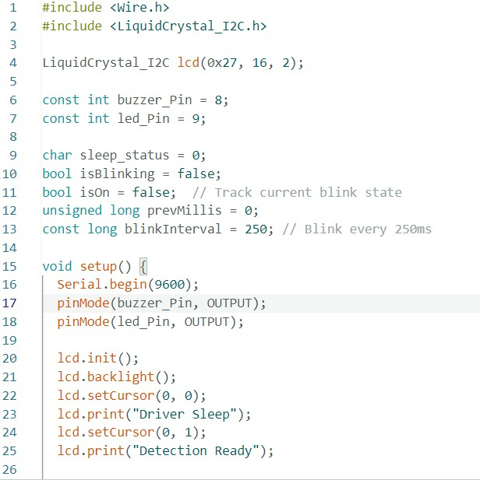

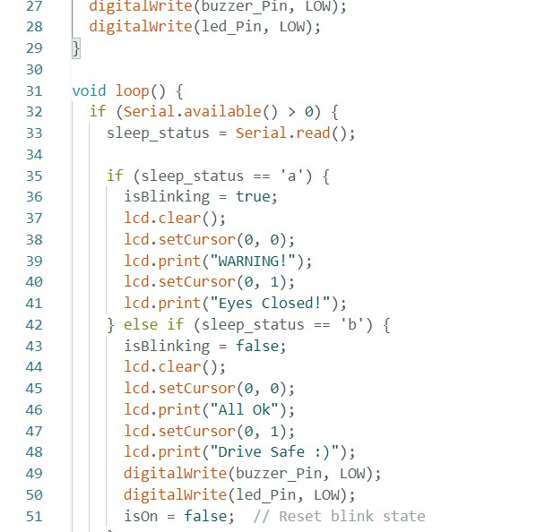

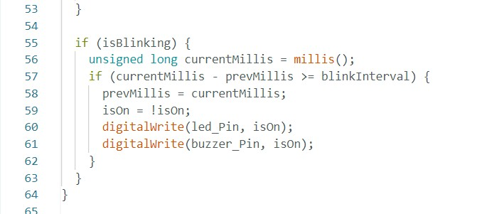

**PROGRAM CODE: (PYTHON )**

|  |
| --- |
| import cv2 import numpy as np import dlib  from imutils import face_utils import serial import time import pygame    # --------- Pygame setup for alert sound --------- pygame.mixer.init() alert_sound = pygame.mixer.Sound("alert.wav") # Ensure the file is in the same folder    # --------- Connect to Arduino --------- try: arduino = serial.Serial('COM3', 9600, timeout=1) time.sleep(2) # Give time to Arduino to reset except:  print("⚠️ Could not connect to Arduino on COM3.") arduino = None    # --------- Camera setup --------- cap = cv2.VideoCapture(0) if not cap.isOpened():  print("❌ Error: Could not open webcam.") exit()    # --------- Load dlib's models --------- detector  = dlib.get_frontal_face_detector()  predictor = dlib.shape_predictor("shape_predictor_68_face_landmarks.dat")  # --------- Eye aspect ratio calculation --------- def euclidean(ptA, ptB): return np.linalg.norm(ptA - ptB) def eye_aspect_ratio(eye_points):  A = euclidean(eye_points[1], eye_points[5]) |

|  |
| --- |
| B = euclidean(eye_points[2], eye_points[4]) C = euclidean(eye_points[0], eye_points[3]) ear = (A + B) / (2.0 * C) return ear    # --------- Thresholds and counters ---------  SLEEP_THRESH = 0.21 DROWSY_THRESH = 0.25  sleep_counter = 0 drowsy_counter  = 0 active_counter = 0    sleep_limit = 60 # ~3 seconds at 20 FPS drowsy_limit = 30 # ~1.5 seconds active_limit = 15    status = "" color = (0, 255, 0) sleep_alert_played  = False drowsy_alert_played  = False    # --------- Main loop --------- while True: ret, frame = cap.read() if not ret: print("⚠️ Frame read failed.") continue    gray = cv2.cvtColor(frame, cv2.COLOR_BGR2GRAY) faces = detector(gray)  for face in faces: shape  = predictor(gray, face)  shape_np = face_utils.shape_to_np(shape)    left_eye = shape_np[36:42] right_eye = shape_np[42:48] left_ear = eye_aspect_ratio(left_eye) right_ear = eye_aspect_ratio(right_eye) ear =  (left_ear + right_ear) / 2.0 if ear < SLEEP_THRESH: sleep_counter += 1 drowsy_counter = 0 active_counter = 0 if sleep_counter > sleep_limit: status = "SLEEPING !!!" |
| color = (0, 0, 255) if not sleep_alert_played: if arduino:  arduino.write(b'a') alert_sound.play() sleep_alert_played = True drowsy_alert_played = False elif ear <  DROWSY_THRESH: drowsy_counter += 1 sleep_counter = 0 active_counter =  0 if drowsy_counter > drowsy_limit: status = "Drowsy !" color = (0,  0, 255) if not  drowsy_alert_played: if arduino: arduino.write(b'a') alert_sound.play() drowsy_alert_played = True sleep_alert_played = False else:  active_counter += 1 sleep_counter = 0 drowsy_counter = 0 if active_counter > active_limit: status = "Active :)" color =  (0, 255, 0) if arduino: arduino.write(b'b') sleep_alert_played = False drowsy_alert_played = False    # Draw status and landmarks cv2.putText(frame, status, (100, 100), cv2.FONT_HERSHEY_SIMPLEX,  1.2, color, 3) for (x, y) in shape_np:  cv2.circle(frame, (x, y), 1, (255, 255, 255), -1)    cv2.imshow("Driver Drowsiness Detection", frame) if cv2.waitKey(1) == 27: # ESC key break    cap.release() cv2.destroyAllWindows() |

**PROJECT KIT:**

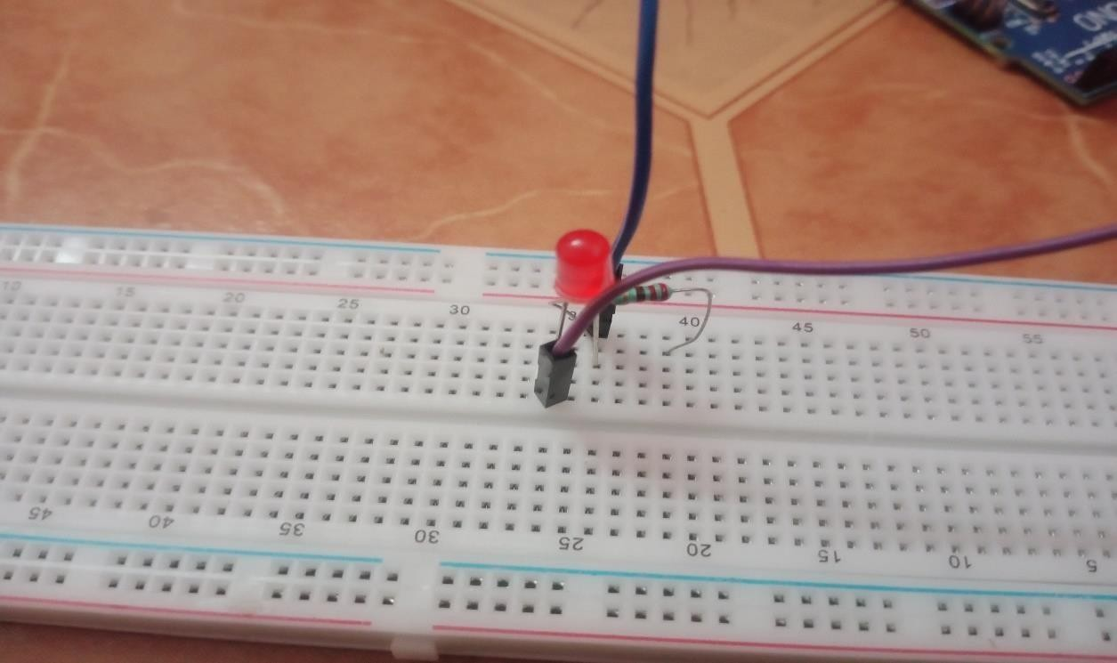

LIGHT CONNECTION WITH BREADBOARD AND ARDUINO UNO

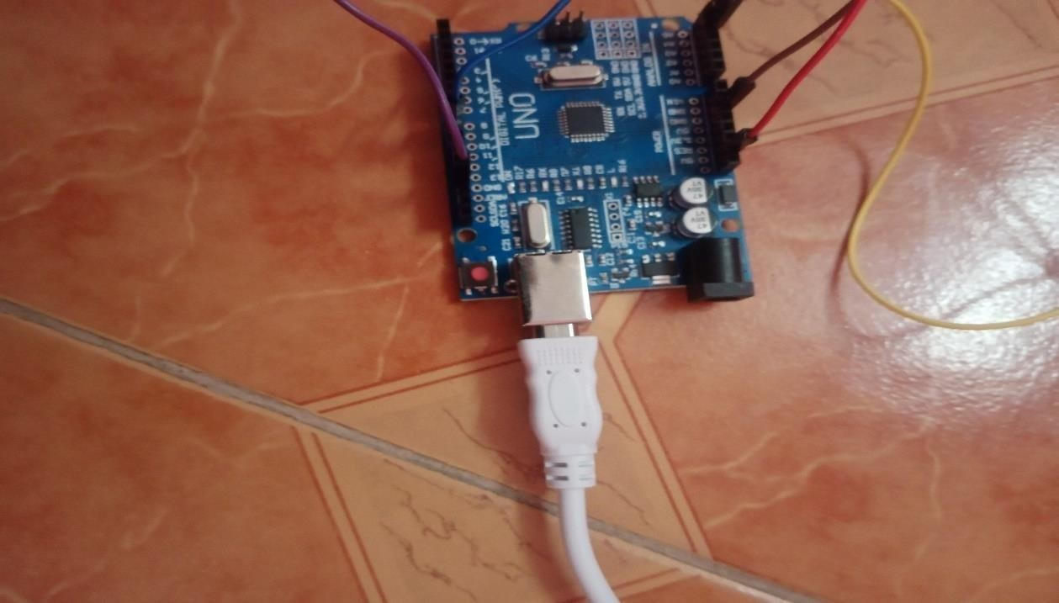

ARDUINO UNO CONNECTION WITH LAPTOP AND BREADBOARD

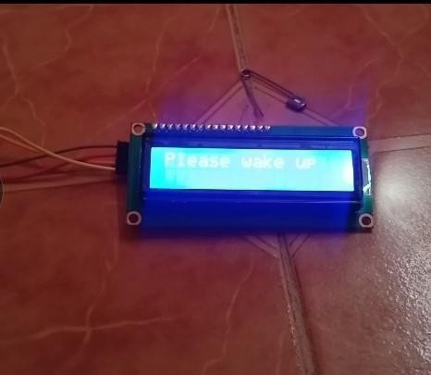

LCD DISPLAY WAKEUP WHEN DROWSY DETECTED

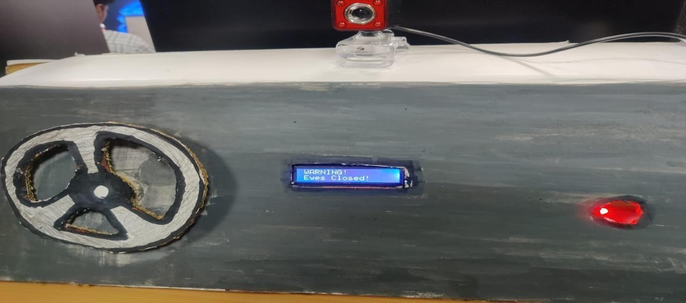

DRIVER AWAKE SYSTEM WITH CAR MODEL

**OUTPUT:**

## LCD DISPLAY AWAKE LCD DISPLAY SLEEP

 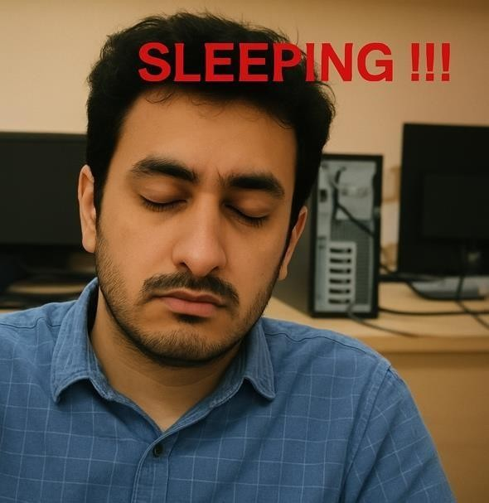

## REFERENCES

1. **A Review of Recent Developments in Driver Drowsiness Detection Systems** <https://www.ncbi.nlm.nih.gov/pmc/articles/PMC8914892>
2. **Driver Drowsiness Detection System (arXiv)**<https://arxiv.org/pdf/2303.06310>
3. **Real-Time Driver Drowsiness Detection Using Facial Analysis and ML**

**(MDPI)** https://www.mdpi.com/1424-8220/25/3/812

1. **Systematic Review on Detection and Prediction of Driver Drowsiness (ScienceDirect)** <https://www.sciencedirect.com/science/article/pii/S2590198223001112>
2. **Driver Drowsiness Detection (ResearchGate)** [https://www.researchgate.net/publication/370105178_DRIVER_DROWSINES S_ DETECTION](https://www.researchgate.net/publication/370105178_DRIVER_DROWSINESS_DETECTION)

🎥 **YouTube References**

1. **Real-Time Driver Drowsiness Detection System | OpenCV | Python** <https://www.youtube.com/watch?v=X8MjK-5CPFo>
2. **Driver Drowsiness Detection Using MediaPipe in Python** <https://www.youtube.com/watch?v=oRetfsmyu1s>
3. **Driver Drowsiness Detection System Using Arduino** <https://www.youtube.com/watch?v=Z3_vzHRl5tI>