**HTML**

<!DOCTYPE html>  
<html>  
<head>  
<title>Page Title</title>  
</head>  
<body>  
  
<h1>My First Heading</h1>  
<p>My first paragraph.</p>  
  
</body>  
</html>

Example Explained

* The <!DOCTYPE html> declaration defines that this document is an HTML5 document
* The <html> element is the root element of an HTML page
* The <head> element contains meta information about the HTML page
* The <title> element specifies a title for the HTML page (which is shown in the browser's title bar or in the page's tab)
* The <body> element defines the document's body, and is a container for all the visible contents, such as headings, paragraphs, images, hyperlinks, tables, lists, etc.
* The <h1> element defines a large heading
* The <p> element defines a paragraph

Elements: contents placed inside a start and end tag.

URL 🡪 ABSOLUTE , RELATIVE

TAGS:

<html> <title> <head> <body> <h1>….<h6> <a href=’’> <br> <p> <img src=’’ alt=’’ width=’’ height=’’> <hr> <b> <strong> <i> <em> <mark> <small> <del> <ins> <sub> <sup> <blockquote> <q> <abbr title=’’> <address> <cite> <bdo dir=’ltr’ or dir=’rtl’> <link rel=’stylesheet’ href=’’>

ATTRIBUTES : att=’value’

Href=url, src=path, alt=txt, width=px, height=px, style=’cssproperty:cssvalue;’, title=tooltip, target=_self(same tab) _blank(new tab) _parent(parent frame) _top(full body of window)

<!—comments-->

CSS

CSS Syntax

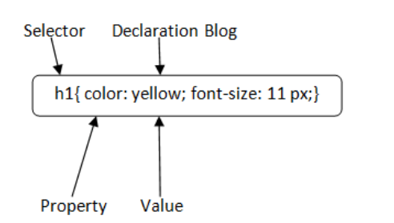

# CSS Selector

1. CSS Element Selector
2. CSS Id Selector
3. CSS Class Selector
4. CSS Universal Selector
5. CSS Group Selector

# CSS Background

1. background-color
2. background-image
3. background-repeat
4. background-attachment
5. background-position

# CSS Border

* border-style
* border-color
* border-width
* border-radius

15-8=7

//////////////////////////////////////////////////////////////////////////////////////////////////

The word **cascading** means that a style applied to a parent element will also apply to all children elements within the parent. So, if you set the color of the body text to "blue", all headings, paragraphs, and other text elements within the body will also get the same color (unless you specify something else)!

* **Inline** - by using the style attribute inside HTML elements
* **Internal** - by using a <style> element in the <head> section
* **External** - by using a <link> element to link to an external CSS file

Margin:, (space b/w content and margin)Padding:, Font-size:, Color:, Background-color:, border:, Font-family:, font-size:, text-align:,

<https://www.w3schools.com/colors/colors_names.asp>

RGB HEX HSL

REFER OBJECTS BY, ELEMENT #id ID=’id’ OR .class CLASS=’class’

Anchor tag link colors

<style>  
a:link {  
  color: green;  
  background-color: transparent;  
  text-decoration: none;  
}  
  
a:visited {  
  color: pink;  
  background-color: transparent;  
  text-decoration: none;  
}  
  
a:hover {  
  color: red;  
  background-color: transparent;  
  text-decoration: underline;  
}  
  
a:active {  
  color: yellow;  
  background-color: transparent;  
  text-decoration: underline;  
}  
</style>

<style>  
a:link, a:visited {  
  background-color: #f44336;  
  color: white;  
  padding: 15px 25px;  
  text-align: center;  
  text-decoration: none;  
  display: inline-block;  
}  
  
a:hover, a:active {  
  background-color: red;  
}  
</style>