**INTERNET**  
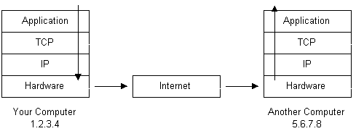

A line or connection between Computers/ Serverss

1960- ARPANET – Internet

IP address, ISP, Packets, Routers.

**World Wide Web (WWW / W3)**

Sir Tim Berners Lee, Father of World Wide Web

1991, info.cern.ch

Hyperlinks

**Networking Technologies:**

TCP – Transmission Control Protocol  
DNS- Domain Name Service  
IP address- Internet Protocol

**WEB (1994):**

A Network of servers, ready to be accessed.

WEB has no owner  
WEB-hosts (Hosting Companies): Provide space for setting web applications  
WEB Registrars: Provide Domain Name or WEB address  
WEB Access: ISP – Internet Service Providers

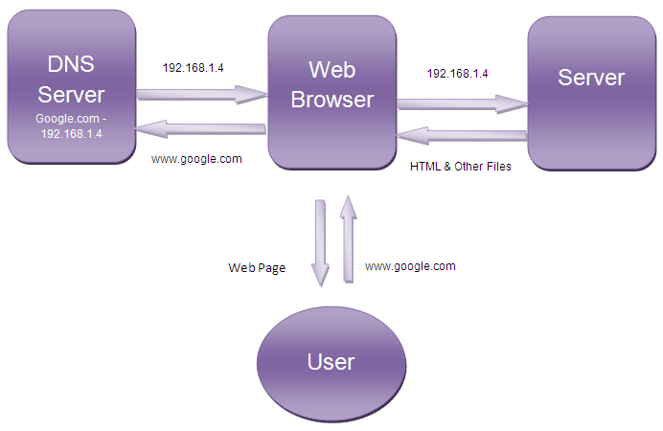

**WEB languages:**

HTML, JavaScript, etc

**WEB Browsers (Translators):**

Chrome, EDGE, Firefox, Safari, etc

**WEB 2.0 (2004) –Interactive Webpages**

WEB 1.0 (read only)

JavaScript, HTML 5, CSS 3

Cookies and Sessions

**WEB 3.0 ?**

**WEB Technologies**

Languages  
Visualitzation  
Libraries and Frameworks  
Testing Frameworks  
PHP Frameworks  
Python Frameworks  
.NET  
Java Frameworks  
DBMS  
Cloud Services  
Back-end  
Front-end  
Ajax  
Restful-API  
Micro-Services  
Containerization  
Repositories  
Dashboards  
**FRONT-END:**Visualization  
Design  
Markup  
Styling  
Bootstrap  
Animation  
UI ,UX

**BACK-END:**

Backend Programming Language  
Backend Framework  
Package Manager

**Frameworks and Micro-frameworks**

**Database- SQL based or No-SQL**

**Request-Response Cycle**

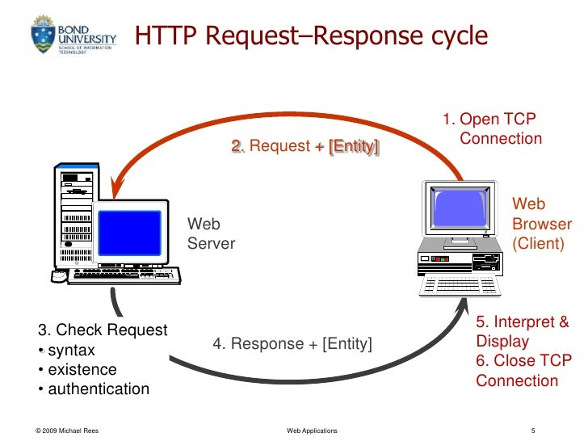

Request: GET [www.hello.wld/earth](http://www.hello.wld/earth)  
 type domain_name url_path  
 CONTENT

**Request types:**

GET  
POST  
DELETE  
PUT  
PATCH  
HEAD

**API: Application Programming Interface**

Requests and Responses

***REST- Representational State Transfer***

API + REST = REST API  
REST API, Graphql, RPC

**WEB SERVICES:**

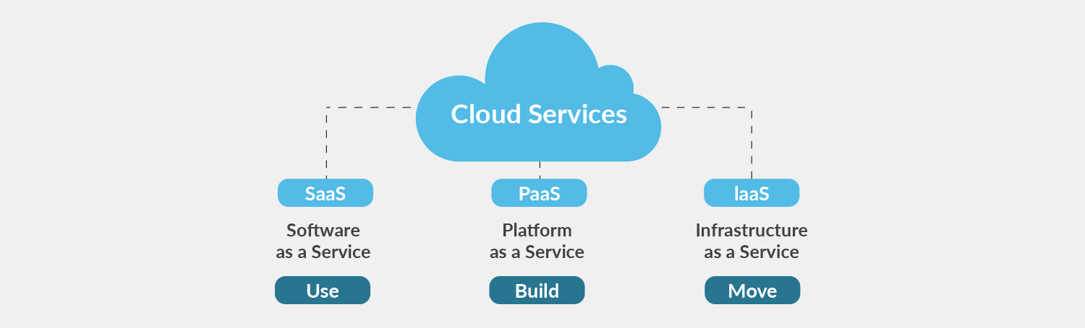

**IaaS : Infrastructure as a Service**

Cloud services, VM, Load Balancer

**PaaS: Platform as a Service**

Microservices, Order, Payments, email, etc

**SaaS: Software as a Service**

Blob storage, Search Database, Primary Storage, CDN, analytical Storage, Chache