In reference to your proposed microcontroller application study, design the schematic diagram, pictorial diagram, computations, and C++ program. Simulate and take a video recording on the functional operation of the system
This simple simulation system features a set of buttons, different color LEDs, resistors, 1 buzzer and an Arduino Uno Board. The 5 buttons represents the 5 sensors that will be used in the system, namely; Temperature (DS18B20), Humidity (DHT22), Smoke (MQ-2), Gas (MQ-9), Oxygen (ZE03-O2). These buttons will be represented by a set of LEDs and 1 buzzer. If the temperature button is pressed, a red colored LED will light and the buzzer will go high (there will be different frequency per button (sensors) just for categorization). Lastly, there will be a main button wherein if pressed, will light up all the LEDs and turn on the buzzer (which signify that all sensor sensed a change in the environment). Below is the representation of the simulation logic:
Buttons | Simulated Sensor | LED Color | Buzzer Tone
Button 1 | Temperature (DS18B20) | Red | 1000hz
Button 2 | Humidity (DHT22) | Blue | 800hz
Button 3 | Smoke (MQ-2) | White | 1200hz
Button 4 | Gas (MQ-9) | Yellow | 900hz
Button 5 | Oxygen (ZE03-O2) | Green | 2000hz
Button 6 | All sensor | All LEDs | Default

Below are the pin connection of the various components to the Arduino Uno R3:
Component | Arduino Pin
Temperature Button | 2
Humidity Button | 3
Smoke Button | 4
Gas Button | 5
Oxygen Button | 6
Main Button | 7
Temperature LED (Red) | 8
Humidity LED (Blue) | 9
Smoke LED (White) | 10
Gas LED (Yellow) | 11
Oxygen LED (Green) | 12

The following information are the computations for the necessary components (resistor). Using the formula R=Vsupply-Vled/I (required current of LED). We have calculated the necessary resistor value per led:
LED Color | V_{LED} | I | Computed R | Nearest Value
Red | 2.0V | 0.02A | (5 V – 2 V)/0.02 A = 150 Ω | 180 Ω or 220 Ω
Yellow | 2.1V | 0.02A | (5 – 2.1)/0.02 = 145 Ω | 180 Ω or 220 Ω
Green | 2.2V | 0.02A | (5 – 2.2)/0.02 = 140 Ω | 180 Ω or 220 Ω
Blue | 3.2V | 0.02A | (5 – 3.2)/0.02 = 90 Ω | 180 Ω or 220 Ω
White | 3.0V | 0.02A | (5 – 3.0)/0.02 = 100 Ω | 180 Ω or 220 Ω

The following is the respective pictorial and schematic diagram of the aforementioned circuit:
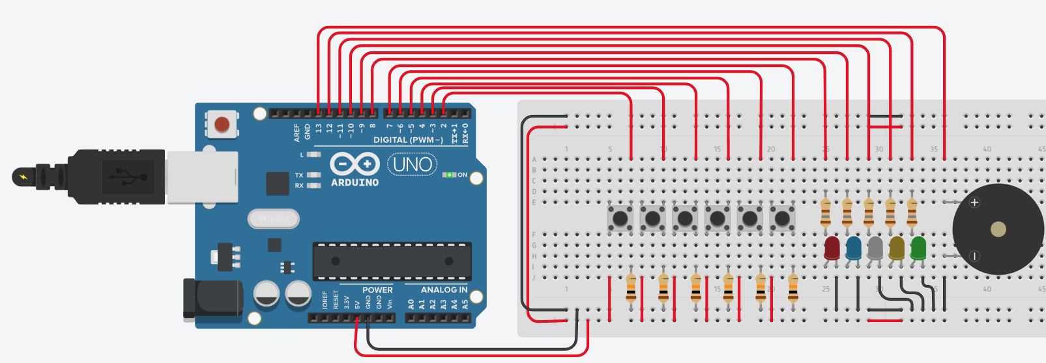
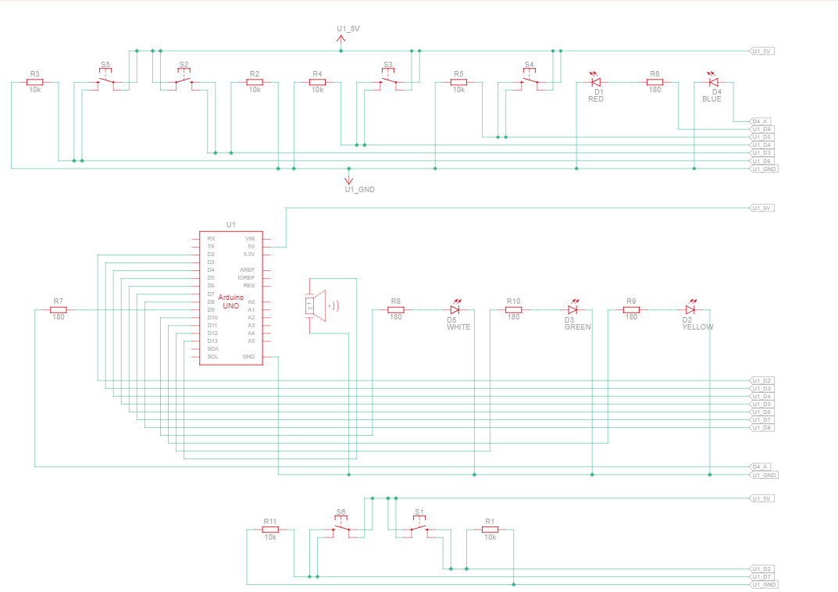

The following is the code of the aforementioned circuit:
// Define pins
const int buttonPins[5] = {2, 3, 4, 5, 6}; // Sensor buttons
const int ledPins[5] = {8, 9, 10, 11, 12}; // Sensor LEDs
const int mainButton = 7; // Main alarm button
const int buzzer = 13; // Single buzzer

// Frequencies for each sensor
const int frequencies[5] = {1000, 800, 1200, 900, 700};

void setup() {
for (int i = 0; i < 5; i++) {
pinMode(buttonPins[i], INPUT);
pinMode(ledPins[i], OUTPUT);
}
pinMode(mainButton, INPUT);
pinMode(buzzer, OUTPUT);
}

void loop() {
// Main alarm button pressed?
if (digitalRead(mainButton) == HIGH) {
activateAllAlarms();
} else {
bool anyActive = false;

// Check each "sensor"
for (int i = 0; i < 5; i++) {
if (digitalRead(buttonPins[i]) == HIGH) {
digitalWrite(ledPins[i], HIGH);
tone(buzzer, frequencies[i]); // Each has unique tone
anyActive = true;
delay(100); // Small delay for clarity
} else {
digitalWrite(ledPins[i], LOW);
}
}

// Turn off buzzer if no buttons are pressed
if (!anyActive) {
noTone(buzzer);
}
}
}

// Main alarm function
void activateAllAlarms() {
// Turn all LEDs ON
for (int i = 0; i < 5; i++) {
digitalWrite(ledPins[i], HIGH);
}

// Strong general alarm sound
tone(buzzer, 2000);
delay(1000);

// Turn everything OFF
for (int i = 0; i < 5; i++) {
digitalWrite(ledPins[i], LOW);
}
noTone(buzzer);
}

