  - SIMULATION REPORT

Simulation Results and Analysis
  - Researcher and Author
Howida Gharib Saad El Din Selim
  - Research Project Version 0.2 - Validated Draft
  - 2026-08-29

Common setup
- Simulator: LTspice 26.0.2 for Windows.
- Device model: PTM 65-nm bulk CMOS beta model released 22 February 2006.
- Nominal condition: 1.2 V, 27 C, 125 MHz, 10 fF per observed output.
- NMOS: L=65 nm, W=120 nm.
- PMOS: L=65 nm, W=240 nm.
- Input edge time: 20 ps.
- XOR transient maximum timestep: 2 ps.
- Encoder transient maximum timestep: 20 ps.
- Power: average of `-V(VDD)*I(VSUP)` over the documented steady-state window.
- Delay: 50%-to-50%; `tpd=(tpLH+tpHL)/2`.
- Extended encoder delay endpoint: overall parity P0.

Sweeps
The experiment set uses independent one-factor sweeps around the nominal condition: VDD = 0.6, 0.8, 1.0, 1.2 V; temperature = -20, 27, 85 C; load = 1, 5, 10, 20 fF; frequency = 25, 125, 200 MHz. A redundant full Cartesian product is intentionally avoided.

Functional criteria
For the automated operating map, a measured point is considered functionally acceptable when VOH is at least 0.8 VDD, VOL is at most 0.2 VDD, and propagation delay is less than half the input period. This is an explicit study criterion, not a claim that it is a foundry-qualified noise-margin specification.

Traceability
Every generated netlist and log has an experiment ID. The manifest is `data/experiments.json`; raw LTspice logs stay next to their circuits; parsed results are in `data/processed/results.csv`; web data are in `thesis/data/results.json`.

Nominal Comparison
Architecture | Power (uW) | Delay (ps) | PDP (fJ) | Swing (V) | Transistors | Status
CMOS | 27.0237 | 344.947 | 9.3217 | 1.2064 | 264 | Pass
FSGDI | 2.5502 | 429.062 | 1.0942 | 1.2135 | 132 | Pass
HYBRID_A | 25.8367 | 278.783 | 7.2029 | 1.2039 | 220 | Pass
HYBRID_B | 11.2029 | 215.846 | 2.4181 | 1.2042 | 152 | Pass

Hybrid-B reduces nominal power by 58.54%, delay by 37.43%, PDP by 74.06%, and transistor count by 42.42% relative to CMOS.
FS-GDI has the lowest nominal power (2.550 uW) and PDP (1.094 fJ), but its P0 path is slower than CMOS.
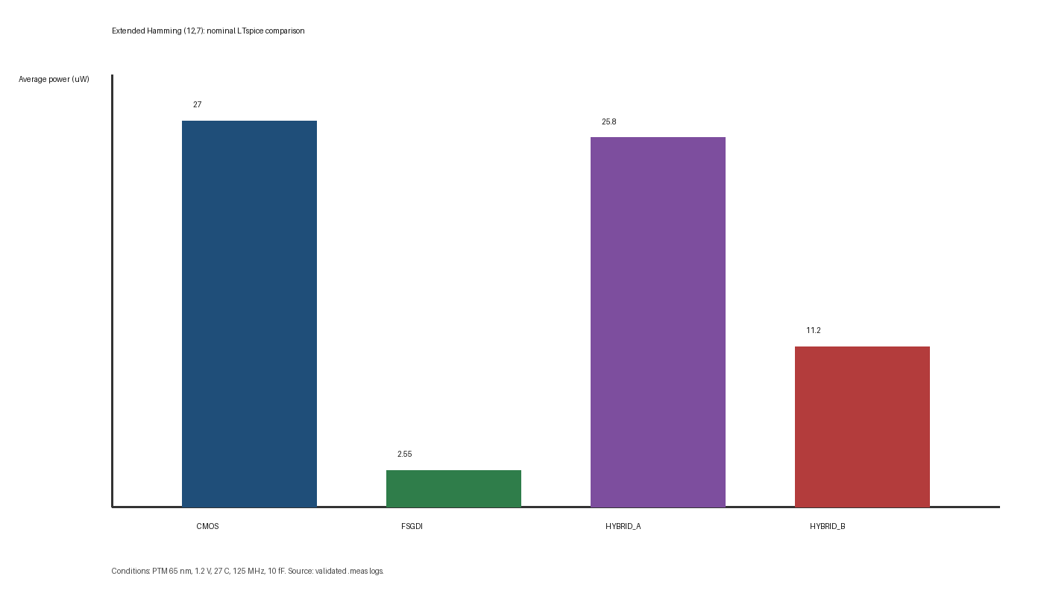
Figure 8.1. Nominal average power.
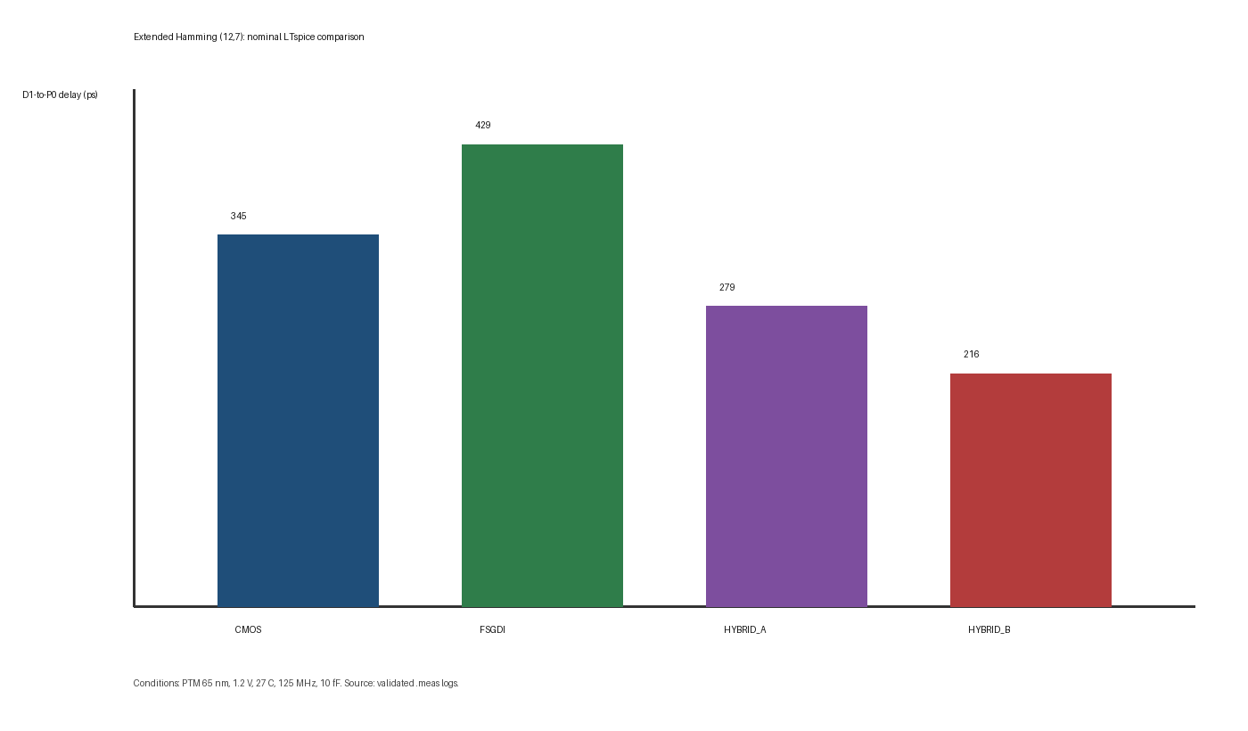
Figure 8.2. Nominal D1-to-P0 delay.
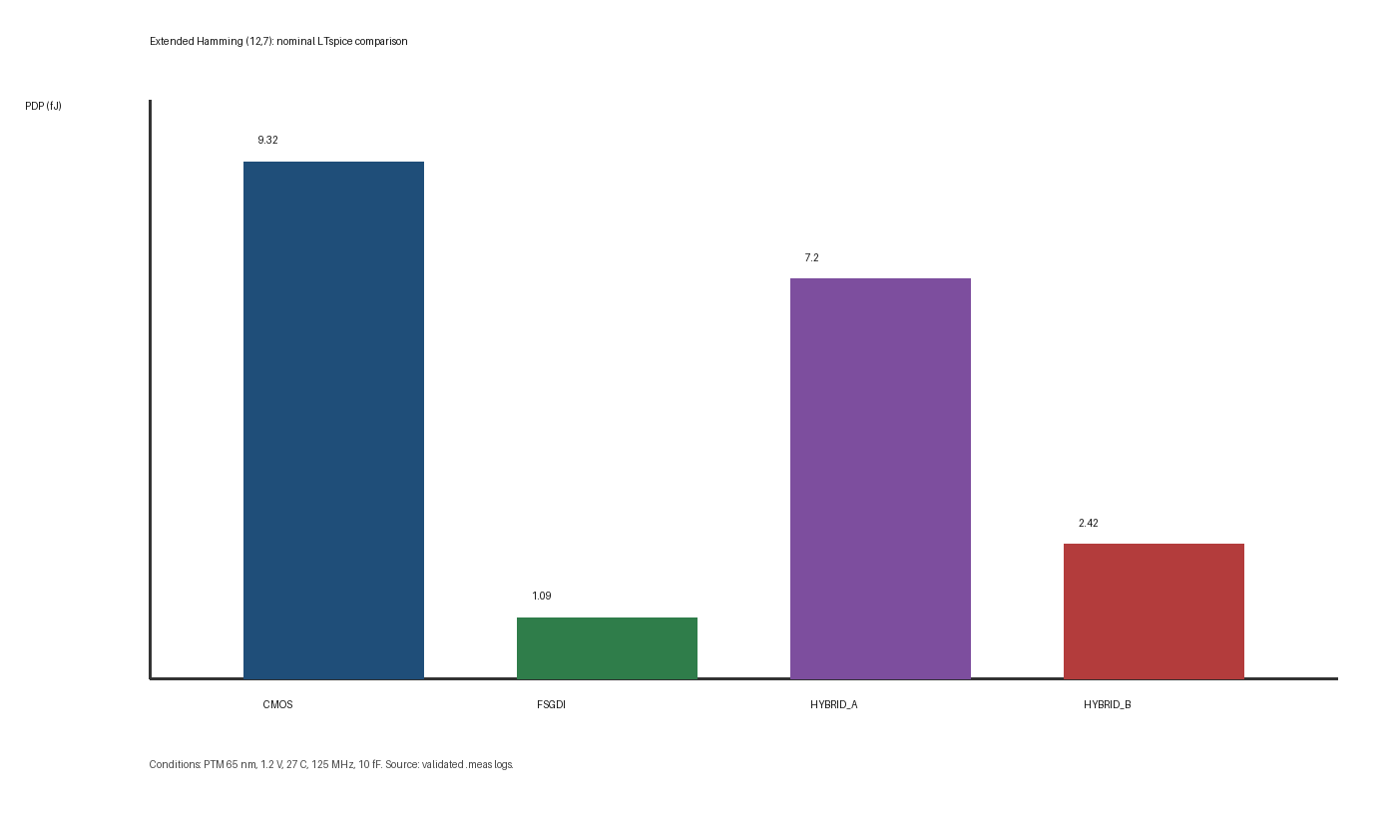
Figure 8.3. Nominal power-delay product.
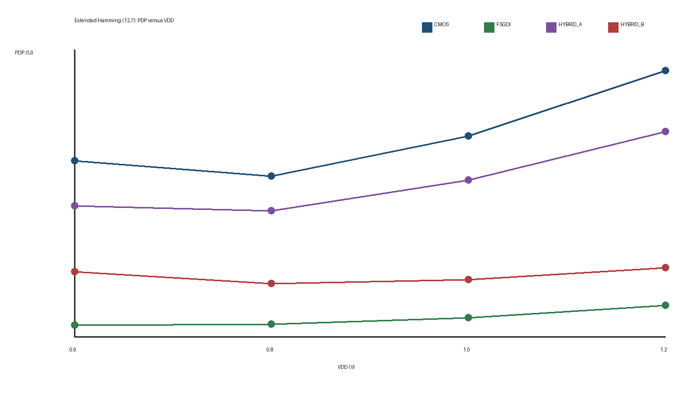
Figure 8.4. PDP versus supply voltage.

