  - WORKING THESIS DRAFT

Design and Robustness Analysis of a Low-Power Hybrid FS-GDI/CMOS Extended Hamming (12,7) Encoder
  - Researcher and Author
Howida Gharib Saad El Din Selim
  - Research Project Version 0.2 - Validated Draft
  - 2026-08-29

Abstract
This working thesis draft evaluates CMOS, GDI, FS-GDI, and hybrid FS-GDI/CMOS implementations of Hamming (11,7) and extended Hamming (12,7). The baseline paper is independently audited, SEC-DED logic is exhaustively verified, and 121 LTspice experiments are executed with a predictive 65-nm PTM model. Of these, 118 measurement sets pass automated validation and three low-load cases are rejected for excessive overshoot. Hybrid-B provides the lowest measured D1-to-P0 delay at the nominal condition, whereas FS-GDI retains the lowest simulated power and PDP.

Abbreviations
Abbreviation | Meaning
CMOS | Complementary metal-oxide-semiconductor
GDI | Gate diffusion input
FS-GDI | Full-swing gate diffusion input
PDP | Power-delay product
PTM | Predictive technology model
SEC-DED | Single-error correction, double-error detection

Chapter 1 - Introduction
Low-power error-control hardware is dominated by XOR networks. Device count alone does not establish useful operation because pass-transistor degradation, output load, restoration overhead, and cascade depth can change the power-delay trade-off.

Chapter 2 - Literature Survey
Hamming established the coding theory; Morgenshtein and co-authors established GDI and later FS-GDI. Recent ECC work addresses SEC-DED and stronger adjacent-error codes. Extended Hamming and GDI are therefore not new by themselves.

Chapter 3 - Theoretical Background
P1 = D1 XOR D2 XOR D4 XOR D5 XOR D7
P2 = D1 XOR D3 XOR D4 XOR D6 XOR D7
P4 = D2 XOR D3 XOR D4; P8 = D5 XOR D6 XOR D7
P0 = D1 XOR ... XOR D7 XOR P1 XOR P2 XOR P4 XOR P8

Chapter 4 - Baseline Reproduction
Architecture | Power (uW) | Delay (ps) | PDP (fJ) | Swing (V) | Transistors | Status
CMOS | 12.0805 | 164.049 | 1.9818 | 1.2077 | 144 | Pass
GDI | 0.7756 | 16089.790 | 12.4793 | 1.2043 | 48 | Fail
FSGDI | 0.5029 | 139.363 | 0.0701 | 1.2053 | 72 | Pass

Chapter 5 - Extended Hamming (12,7)
The extended architecture adds a ten-XOR overall-parity path to the twelve-XOR Hamming network.

Hybrid-B Architecture Summary
- Data inputs D1 through D7 feed FS-GDI XOR parity networks.
- The overall parity path adds P0 for SEC-DED detection.
- CMOS restoration is applied only to externally observed parity outputs.
- Hybrid-B is a speed-oriented restoration compromise, not a universal energy optimum.

Chapter 7 - LTspice Simulation Methodology
Parameter | Value
Simulator | LTspice 26.0.2
Model | PTM 65-nm bulk CMOS beta
Nominal | 1.2 V, 27 C, 125 MHz, 10 fF
Sizing | NMOS 120/65 nm; PMOS 240/65 nm
Delay | 50%-to-50%; D1-to-P0 for EH127
Power | AVG(-V(VDD)*I(VSUP))
Sweeps | VDD, temperature, load, and frequency independently

Chapter 8 - Results and Robustness Analysis
Exhaustive verification covered 128 data words, 1536 single-bit cases, and 8448 double-bit cases. All passed.
Architecture | Power (uW) | Delay (ps) | PDP (fJ) | Swing (V) | Transistors | Status
CMOS | 27.0237 | 344.947 | 9.3217 | 1.2064 | 264 | Pass
FSGDI | 2.5502 | 429.062 | 1.0942 | 1.2135 | 132 | Pass
HYBRID_A | 25.8367 | 278.783 | 7.2029 | 1.2039 | 220 | Pass
HYBRID_B | 11.2029 | 215.846 | 2.4181 | 1.2042 | 152 | Pass

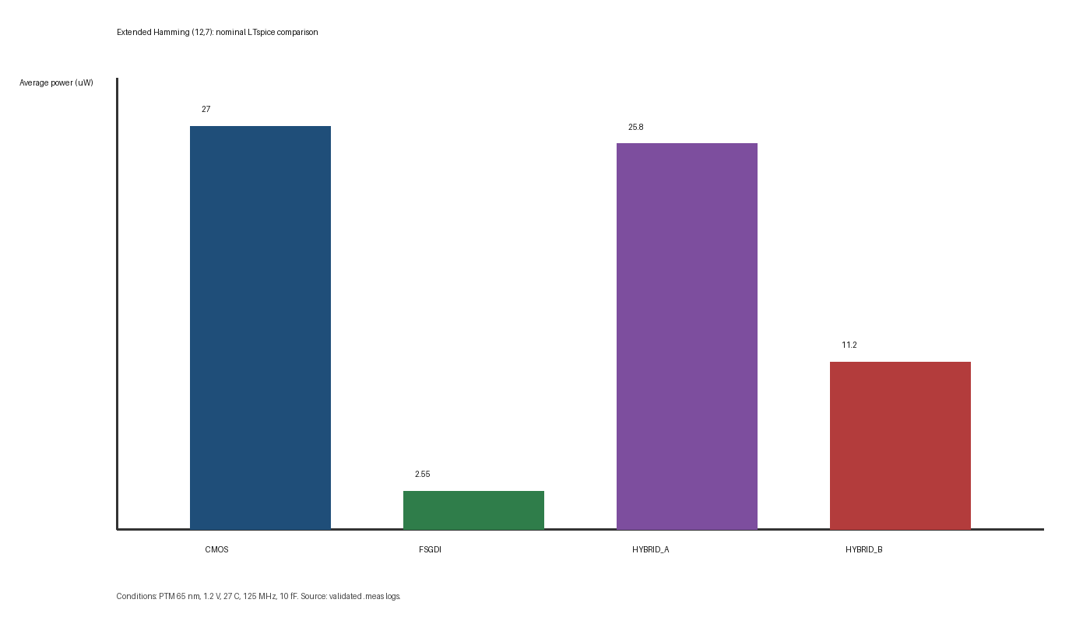
Figure 8.1. Nominal average power.
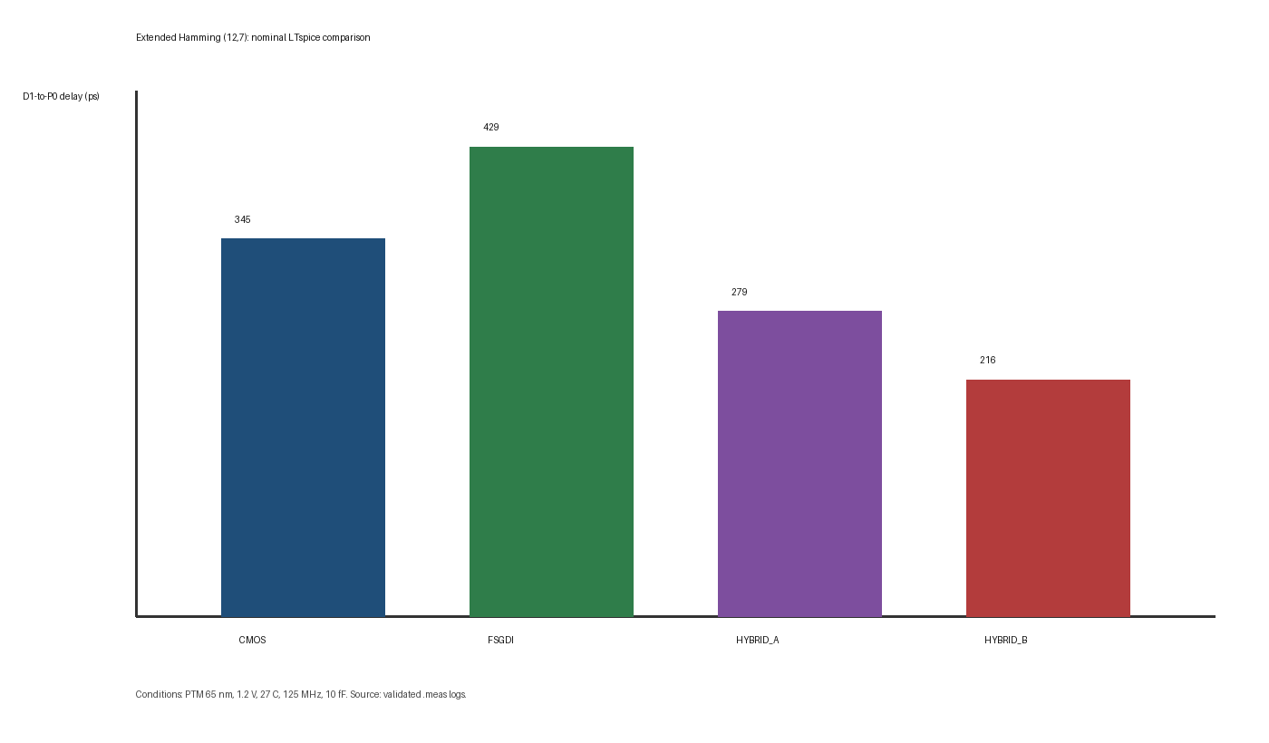
Figure 8.2. Nominal D1-to-P0 delay.
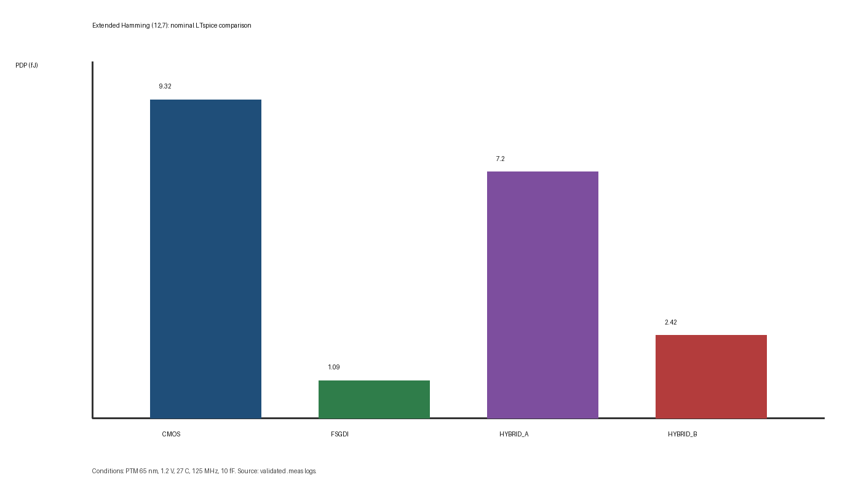
Figure 8.3. Nominal power-delay product.
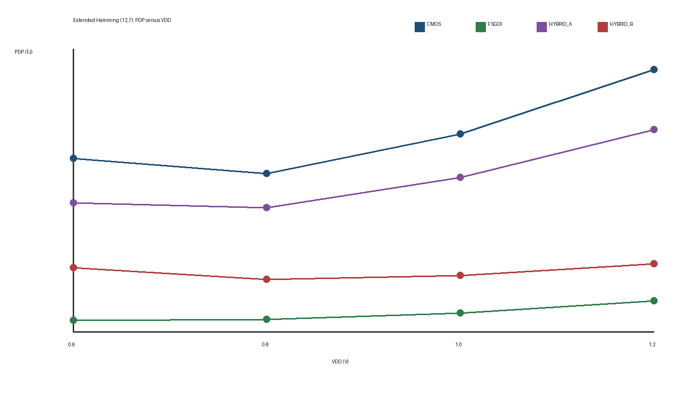
Figure 8.4. PDP versus supply voltage.

Chapter 9 - Discussion
At nominal conditions, Hybrid-B uses 11.203 uW and has a D1-to-P0 delay of 215.846 ps. Relative to CMOS, this is 58.54% lower power and 37.43% lower delay. FS-GDI uses only 2.550 uW but has a longer P0 path.

Chapter 10 - Conclusions and Future Work
Hybrid-B is supported as a speed-oriented selective-restoration candidate, not as a universal energy optimum. Future work requires supervisor review, an independent foundry-PDK or second-simulator cross-check, post-layout parasitics, and a lower-voltage boundary search.

References
[1] R. W. Hamming, 'Error Detecting and Error Correcting Codes,' Bell System Technical Journal, vol. 29, no. 2, pp. 147-160, 1950.
[2] A. Morgenshtein, A. Fish, and I. A. Wagner, 'Gate-Diffusion Input (GDI): A Power-Efficient Method for Digital Combinatorial Circuits,' IEEE TVLSI, 2002.
[3] A. Morgenshtein et al., 'Full-Swing Gate Diffusion Input Logic - Case-Study of Low-Power CLA Adder Design,' Integration, 2014.
[4] M. A. M. El-Bendary and O. El-Badry, 'FS-GDI Based Area Efficient Hamming (11,7) Encoding,' International Journal of Electronics, 2024.

