a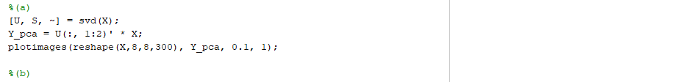

The analytic forms to LDA is

$$-0.4289x+8.6491y-1.3464=0$$

$$-0.0084x+4.2779y+2.6426=0$$

$$0.4205x-4.3712y+3.9890=0$$

The analytic forms to QDA is

The error rate is 0.0733

f

Yes. We can augment every $x$ by adding ${x_{i}}^{2}$ to the vector and follow the exact same process in part (e) to perform QDA. Since the QDA in part (c) has different dimension and $δ(x)$. It is not identical to the QDA in c.