23BD1A052B

G ROHAN RAO

EXAMPLE PROBLEMS

1. The writeprog1.c program is a simple C program executed inside a Docker container running Ubuntu. It utilizes the write() system call to print "Rohan" to the terminal. The program is compiled using GCC and then executed within the Linux environment inside the container.

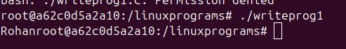

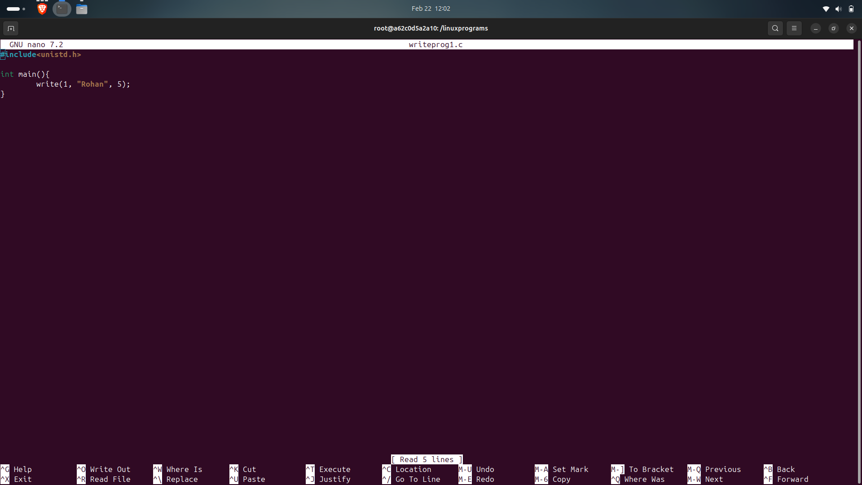

### The writeprog2.c program is a simple C program executed inside a Docker container running Ubuntu. It combines the write() system call to output "Hello Rohan" and printf() to display a numerical value. After compiling with GCC, the program is run inside the Linux environment, printing "Hello Rohan" followed by "Value of n is 5".

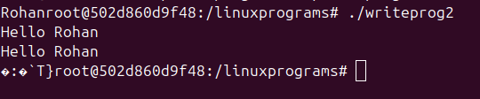

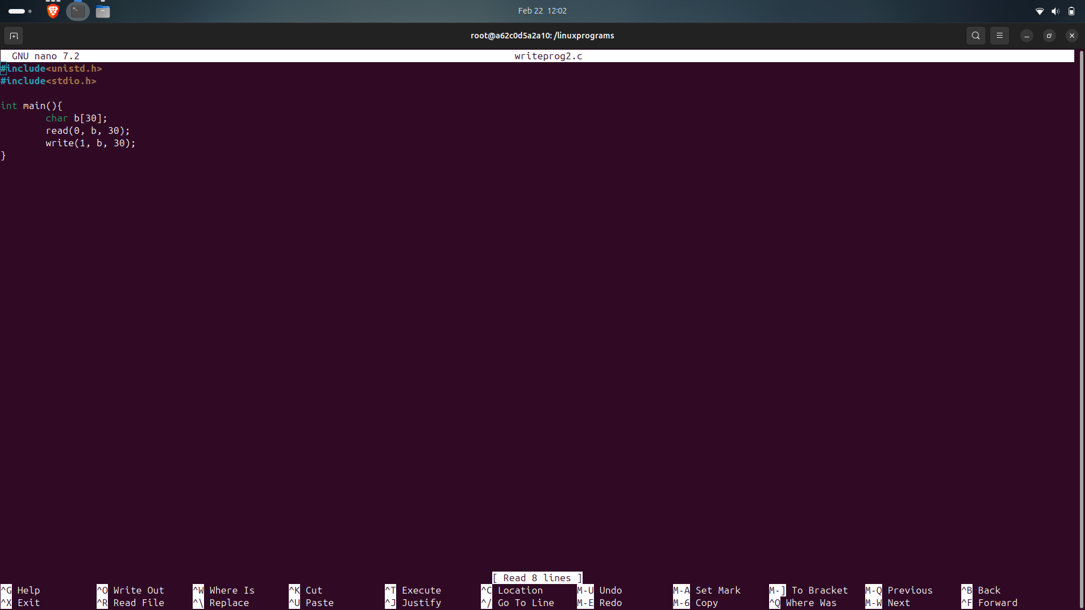

1. The readwriteprog.c program is a simple C program that reads input (using the read() function) and writes output using write(). When executed inside a Docker container running Ubuntu, it processes user input and prints the message "Hello Rohan". The program is compiled using GCC and then executed within the Linux environment.

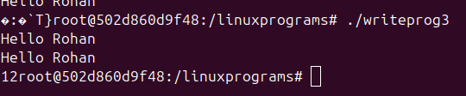

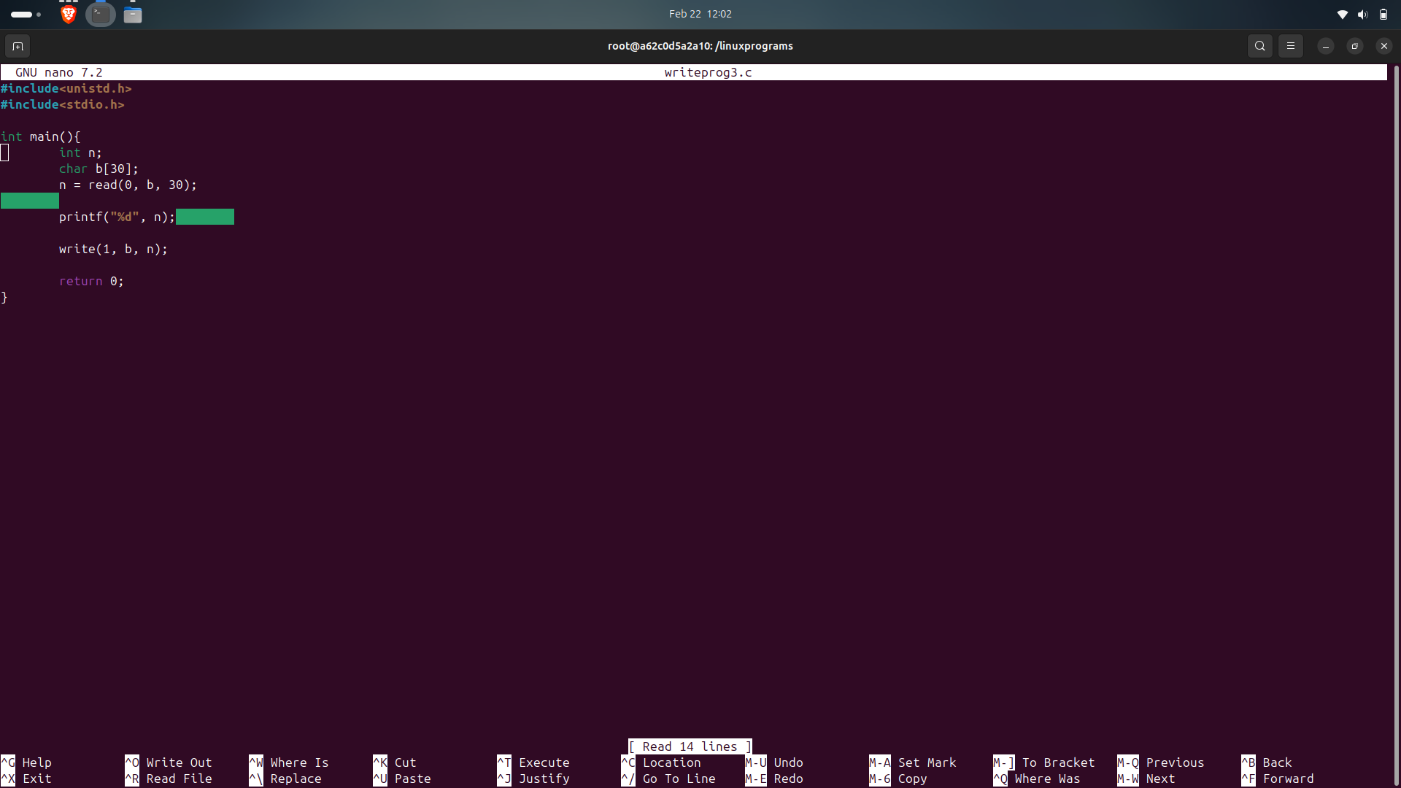

1. The readwritel.c program is a C application that reads input and writes output inside a Docker container running Ubuntu. It uses the read() and write() system calls to process text. When executed, the program outputs "Hello", “Value of n is 5”, indicating it handles both input and formatted output. The program is compiled using GCC and run within the Linux environment.

