将字符串转化为有效的表达式并求值：

＃1 自己写映射函数

from functools import reduce

//这只是将字符串转换为数字，可以在char2num()添加识别运算符号，在fn()识别运算

def str2int(s):

def fn(x, y):

return x \* 10 + y

def char2num(s):

return {'0': 0, '1': 1, '2': 2, '3': 3, '4': 4, '5': 5, '6': 6, '7': 7, '8': 8, '9': 9}[s]

return reduce(fn, map(char2num, s))

＃2 系统内置函数eval()

>>> a="[[1,3,5,],[54,77,4],['sf']]"

>>> eval(a)

[[1, 3, 5], [54, 77, 4], ['sf']]

>>> a={1:'a',3:'f',3+6:'y'}

>>> a[9]

'y'

>>> a="{1:'a',3:'f',3+6:'y'}"

>>> eval(a)

{1: 'a', 3: 'f', 9: 'y'}

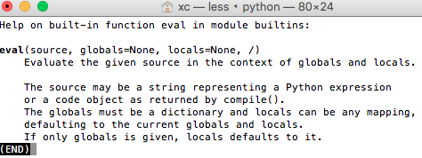

eval() 处理json

http://www.th7.cn/Program/Python/201607/918539.shtml