MAR ATHANASIOS COLLEGE FOR ADVANCED STUDIES, TIRUVALLA
(MACFAST)
(Affiliated to Mahatma Gandhi University, Kottayam)

MACFAST (AUTONOMOUS)

MCACP106 DATABASE TECHNOLOGY LAB ( MYSQL & MONGODB )

Department of Computer Applications
Mar Athanasios College for Advanced Studies, Tiruvalla (MACFAST)
Kerala, India, Pin-689101
www.macfast.org www.macfast.ac.in

MAR ATHANASIOS COLLEGE FOR ADVANCED STUDIES, TIRUVALLA
(MACFAST)
(Affiliated to Mahatma Gandhi University, Kottayam)

MACFAST (AUTONOMOUS)

MCACP106 DATABASE TECHNOLOGY LAB ( MYSQL & MONGODB )

Name : REJOSH P REJI
Register No : 253242210263
Semester : 1
Subject : Database Technology Lab (Mysql & Mongodb)
Certified that this is a Bonafide record of the practical work done by
Mr. REJOSH P REJI Reg.No: 253242210263 in the Department of Computer Applications
during 2025-2027 at Mar Athanasios College for Advanced Studies,Tiruvalla ((MACFAST) Autonomous).

Faculty in Charge Head of the Department

Examiners
1………………………………..
2………………………………..

INDEX
SL.NO | DATE | NAME OF PROGRAM | PAGE NO
1 | 12/09/2025 | Creating tables and inserting values | 4
2 | 16/09/2025 | Modifying the table structure | 7
3 | 19/09/2025 | Insertion and updation of records | 10
4 | 07/10/2025 | Demonstrating data retrieval and joining multiple tables:  - Basic Queries  - Demonstrating the use of UNION,  INTERSECT, EXCEPT/MINUS.  - Nested Queries  - Correlated Nested Query  - Aggregate Operators  - Set Comparison Operators | 16
5 | 28/10/2025 | Demonstrating GROUP BY & HAVING Clause | 27
6 | 05/11/2025 | Number, String & Date Functions | 29
7 | 19/11/2025 | VIEWS | 37
8 | 27/11/2025 | Mongodb | 39

- CREATING TABLES AND INSERTING VALUES

- Create table customer with following fields:

COLUMN NAME | TYPE | REMARKS
cid | Integer
fname | varchar(10)
lname | varchar(50)
age | Integer
gender | varchar(5) | Should allow only F or M
state | varchar(30)
pincode | Integer

OUTPUT:
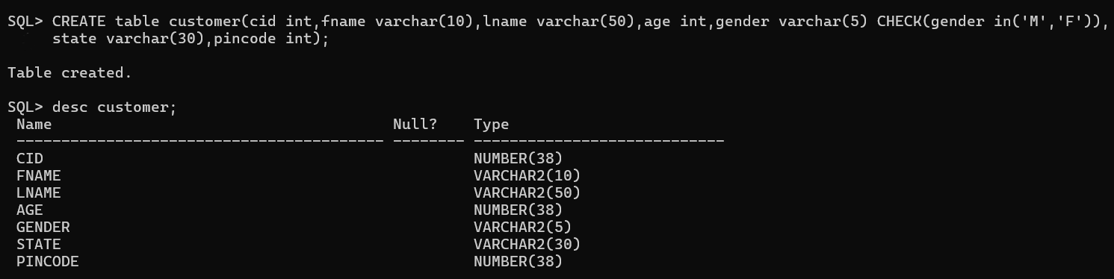

- Create table sailors with following fields:

COLUMN NAME | TYPE | REMARKS
sid | Integer | PRIMARY KEY
sname | varchar(20)
rating | Integer
age | Integer

OUTPUT: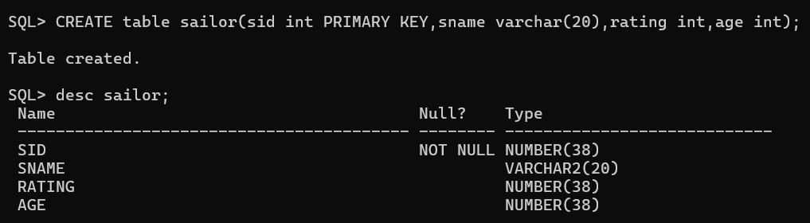
- Create table boats with following fields:

COLUMN NAME | TYPE | REMARKS
bid | Integer | PRIMARY KEY
bname | varchar(20)
color | varchar(20)

OUTPUT:
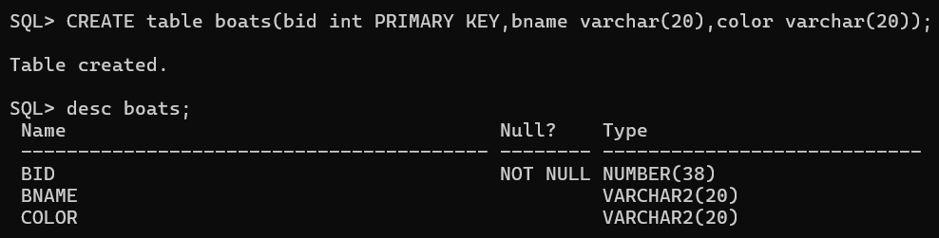
- Create table reserves with following fields:

COLUMN NAME | TYPE | REMARKS
sid | Integer | PK,FK
bid | Integer | PK,FK
day | date

OUTPUT:
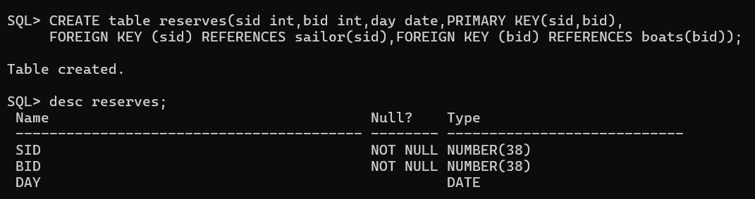

- Display the description of customer table.
OUTPUT:


- MODIFYING THE TABLE STRUCTURE

- Rename the table sailor to sailors.
OUTPUT:
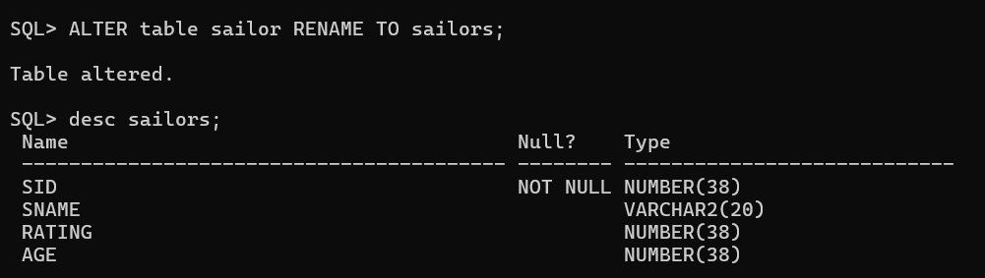

- Rename the field pincode in customer table to pin.
OUTPUT:
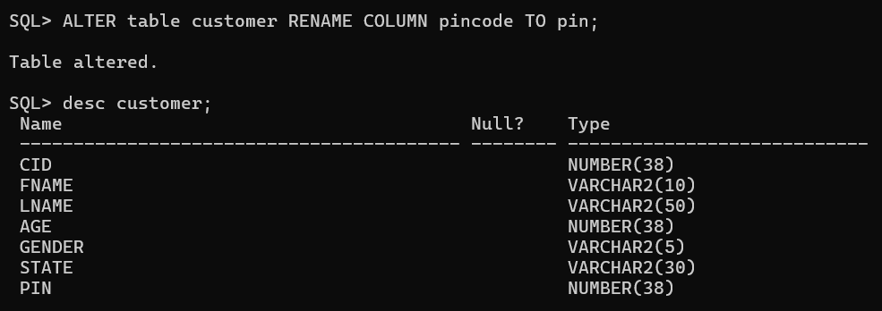

- Add a new column DOB to customer table.
OUTPUT:
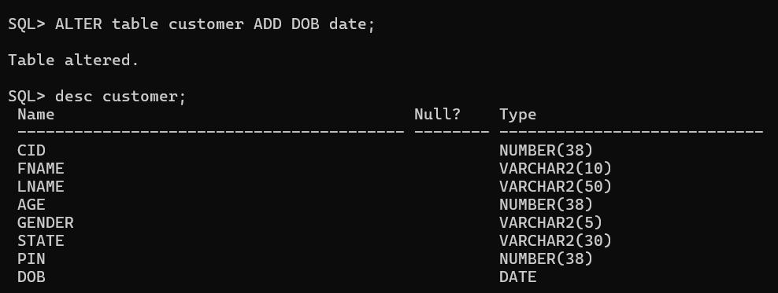

- Change the size of fname column to varchar(20)
OUTPUT:
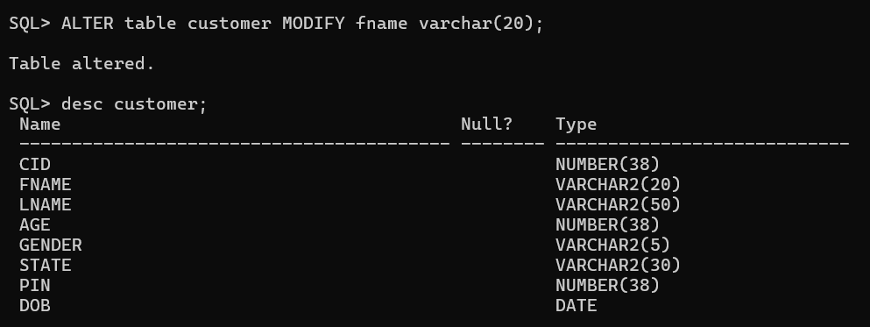

- Add a constraint to the DOB field of customer table which allows only dates greater than
’01-JAN-1980’.
OUTPUT:
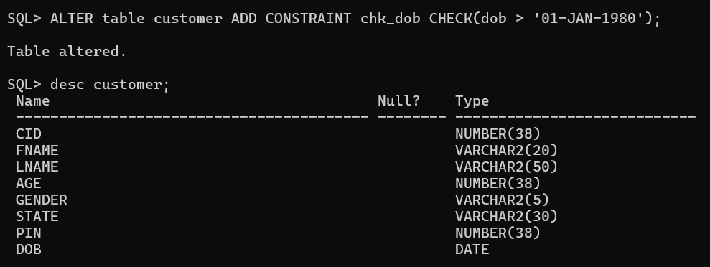

- INSERTION AND UPDATION OF RECORDS

- Insert records into customer table.
OUTPUT:
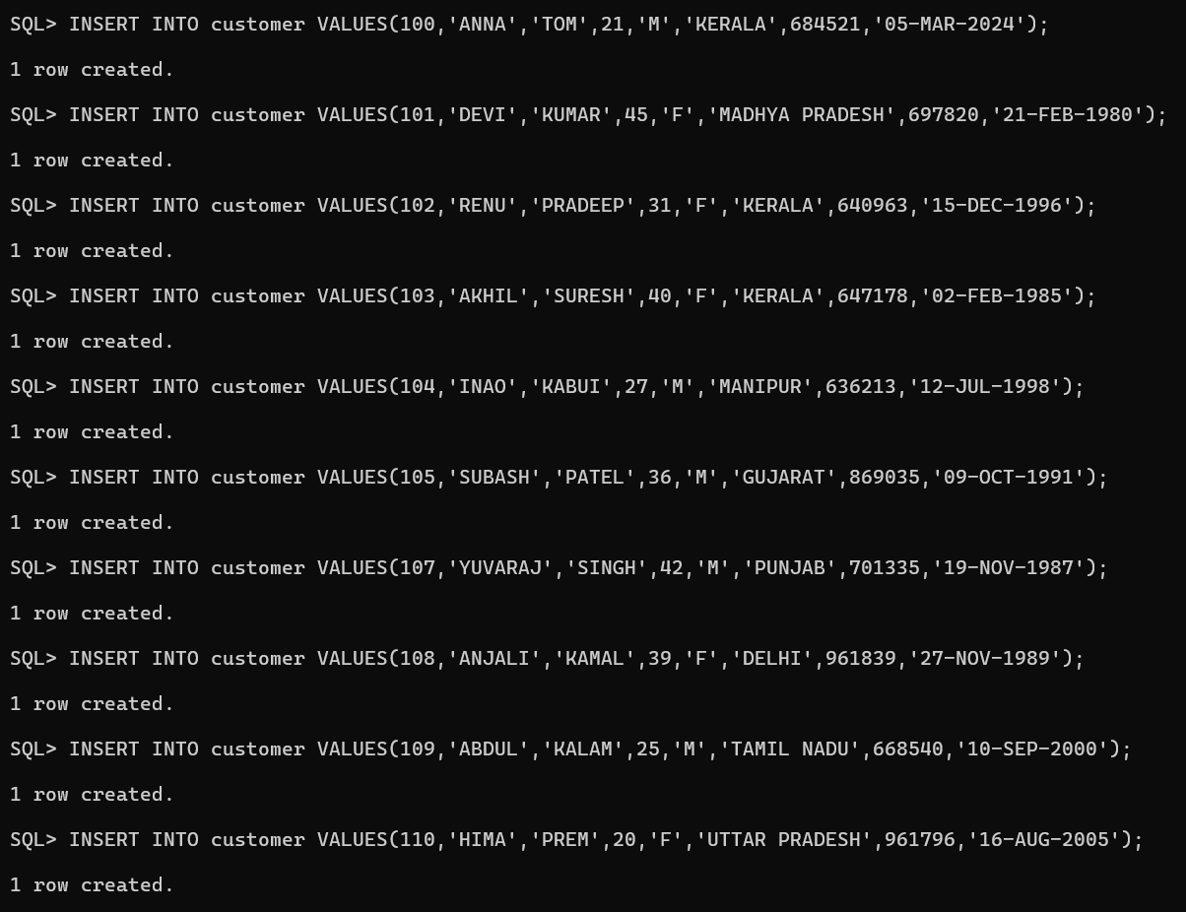

- List all the contents of customer table.
OUTPUT:
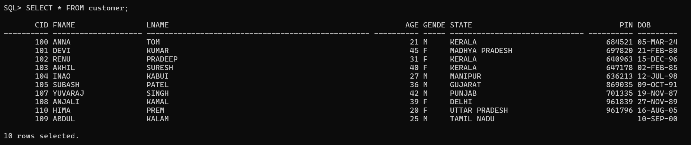

- Retrieve the full names of all customers, the output should be titled “CUSTOMER LIST”.
OUTPUT:
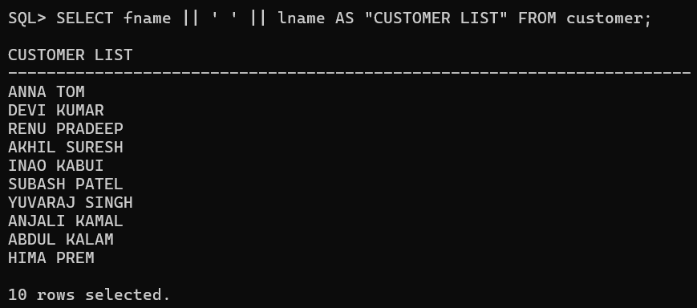

- Retrieve First name and last name of customer from Kerala.
OUTPUT:
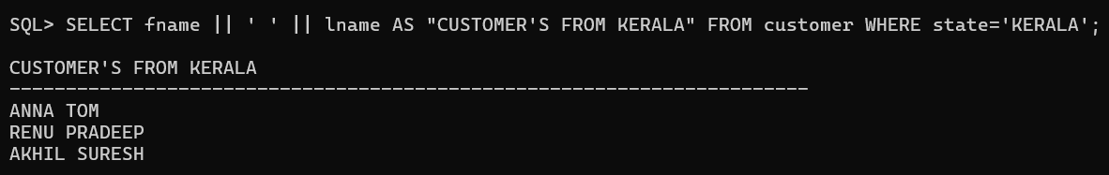

- Retrieve the names of customers for whom pincode is missing.
OUTPUT:
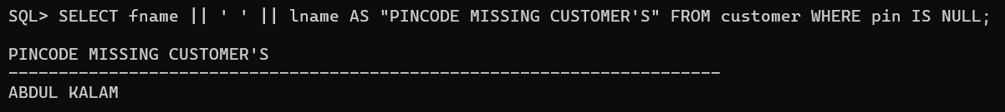

- Retrieve the name of state from which customers are there.
OUTPUT:
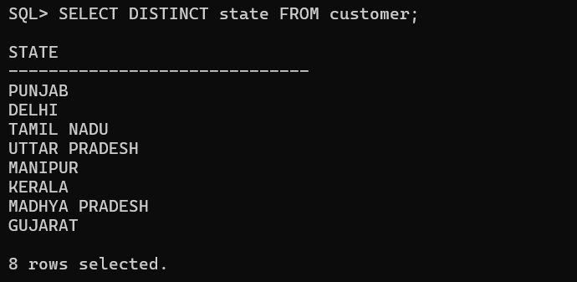

- Retrieve the name and corresponding state of north Indian Customers.
OUTPUT:
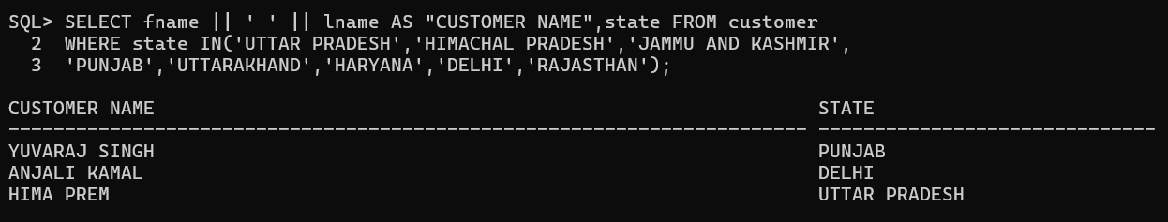

- Select fname & lname ,state as customer list from customer where state=’Manipur’ or state=’Gujarat’.
OUTPUT:
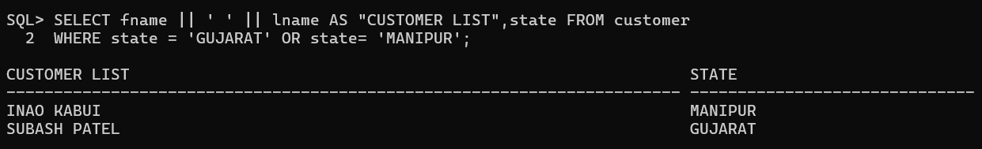

- Retrieve customer information in decending order of state.
OUTPUT:
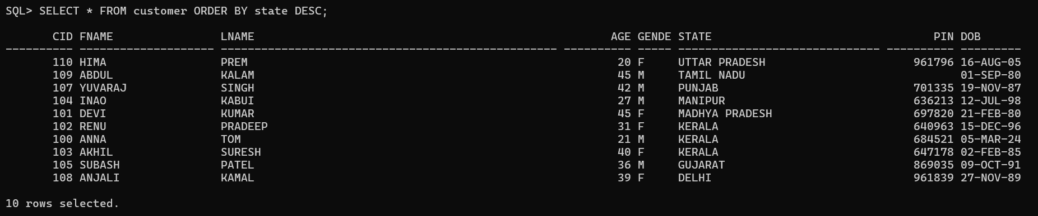

- Retrieve customer information in alphabetical order of there names.
OUTPUT:
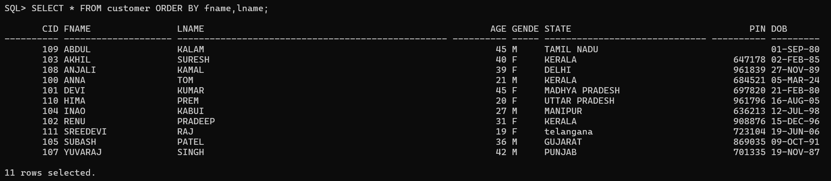

- Retrieve the names of customers from kerala whose pincode information is available.
OUTPUT:
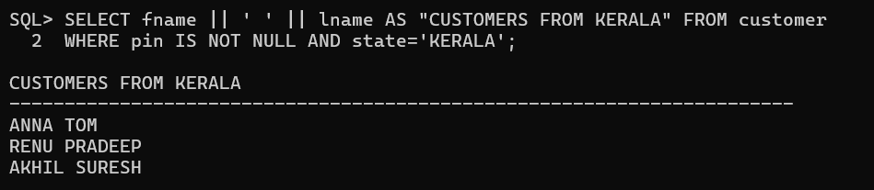

- Select the names of all customers whose firstname contains the word ‘devi’.
OUTPUT:
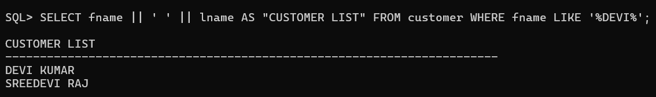

- Select the names of all customers whose names begin with ‘s’ or ’r’.
OUTPUT:
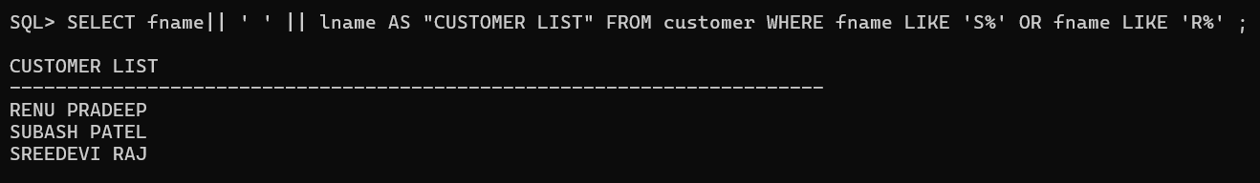

- Retrieve the names and age of all customers having cid greater than 103 and below 106.
OUTPUT:
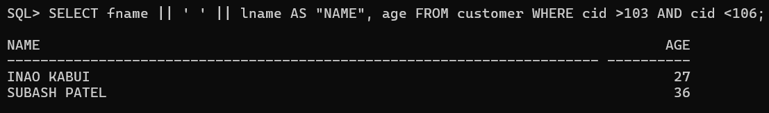

- Set the pincode as ‘908876’ for ‘renu’.
OUTPUT:
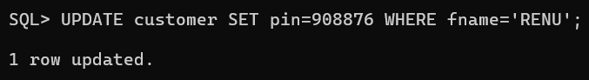

- Retrieve the names of customers who are born after 01-JAN-1990.
OUTPUT:
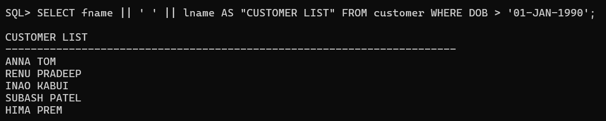

- DEMONSTRATING DATA RETRIEVAL AND JOINING MULTIPLE TABLES

- List the contents of sailors table.
OUTPUT:
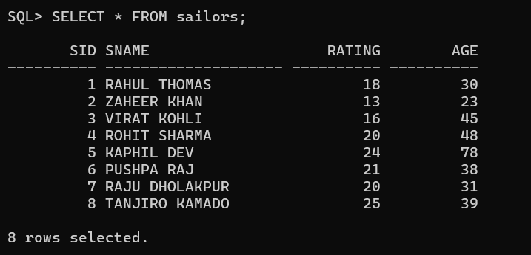
- List the contents of boats table.
OUTPUT:
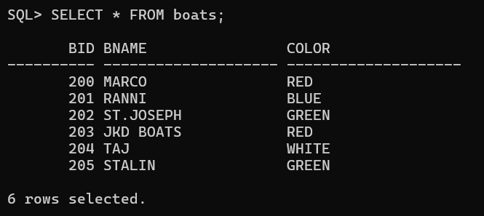
- List the contents of Reserves table.
OUTPUT:
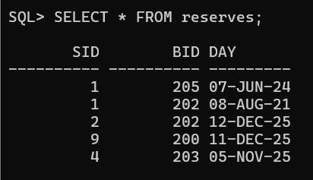
- BASIC QUERIES

- Find the names and ages of all sailors.
OUTPUT:
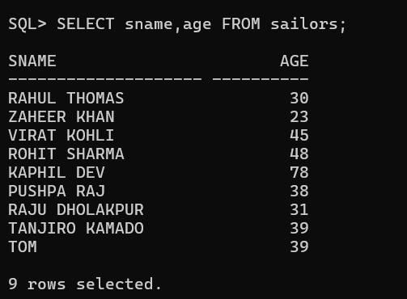
- Retrieve the names and incremented ratings of all sailors(incremented rating=rating+5). The output should be headlined as ‘new rating’.
OUTPUT:
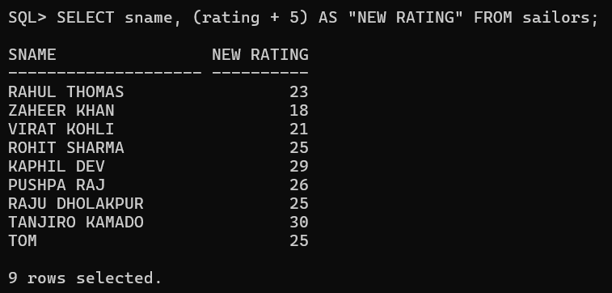
- Find the names of sailors who have reserved boat 202.
OUTPUT:
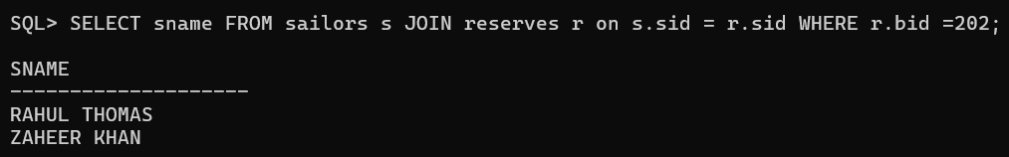

- Find the names of sailors who reserved a red boat.
OUTPUT:
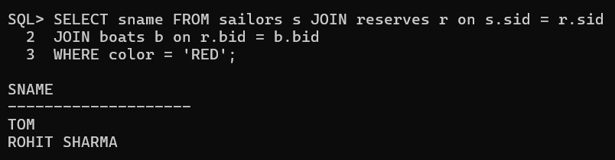

- Find the colors of boats reserved by tom.
OUTPUT:
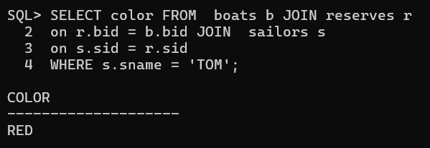

- Find the names of sailors who have reserved at least one boat.
OUTPUT:
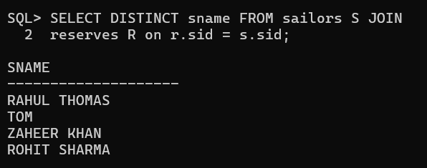

- Compute the names and incremented ratings of all sailors who have sailed two different boats on the same day(incremented rating=rating+1),The incremented rating should appear in the output as ‘newrating’.
OUTPUT:
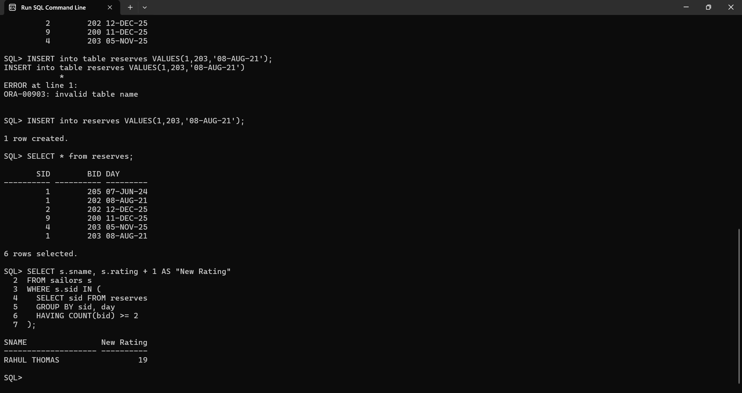

- Find the names of sailors who have reserved a red or a green boat.
OUTPUT:
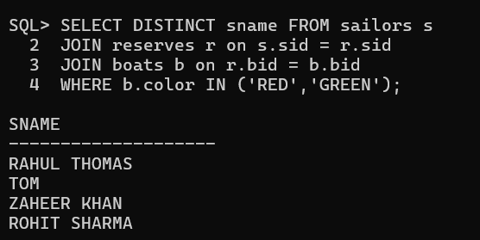

- DEMONSTRATING THE USE OF UNION , INTERSECT, EXCEPT / MINUS

1. Find the names of all sailors who have reserved a red or a green boat.
OUTPUT:
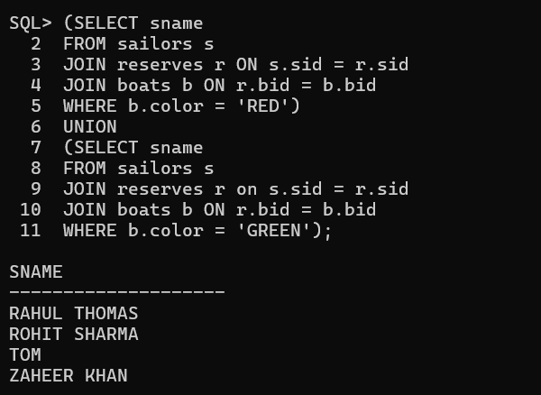

2. Find the names of all sailors who have reserved both red and green boats.
OUTPUT:
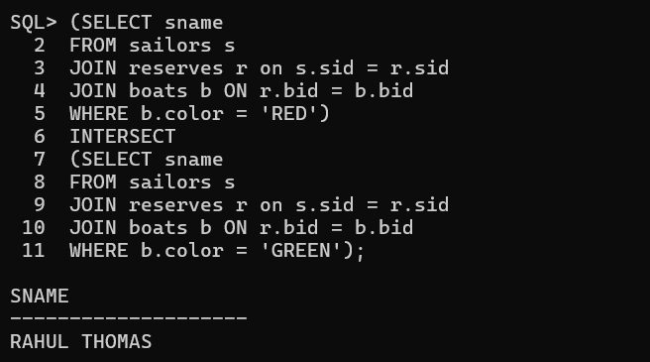

- Find the names of all sailors who have reserved a red boat but not a green boat.
OUTPUT:
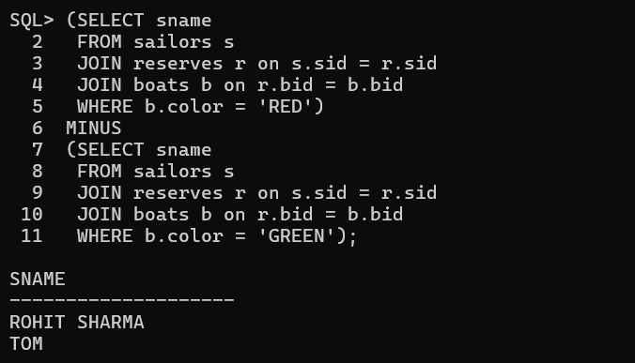

- NESTED QUERIES
1. Find the names of sailors who have reserved a boat
OUTPUT:
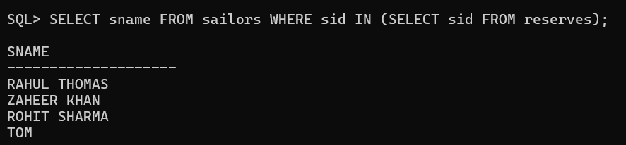
2. Display names of sailors who have reserved a red boat
OUTPUT:
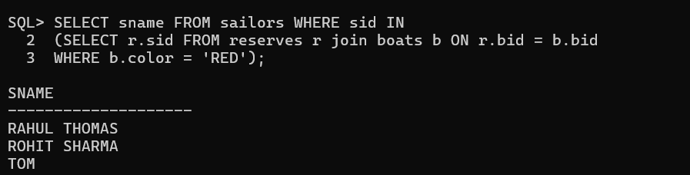
3. Display sid and names of sailors who have not reserved a green boat.
OUTPUT:
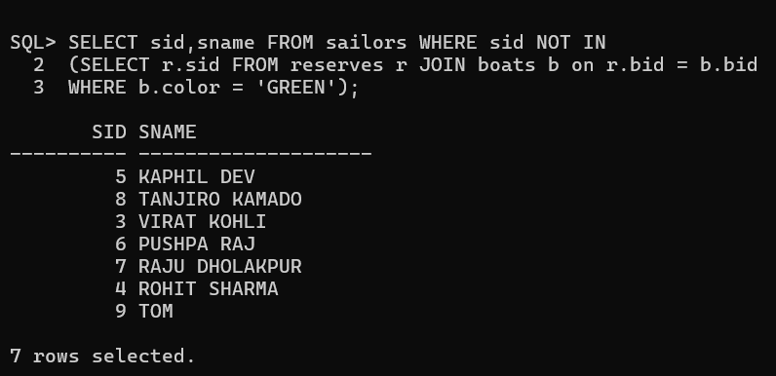

- CORRELATED NESTED QUERY
1. Find the names of all sailors who have reserved atleast one boat.
OUTPUT:
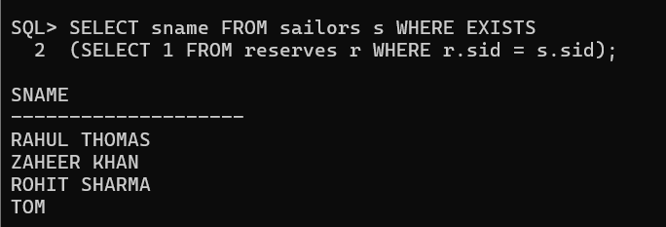

2. Find the names of all sailors who have reserved boat number 201
OUTPUT:
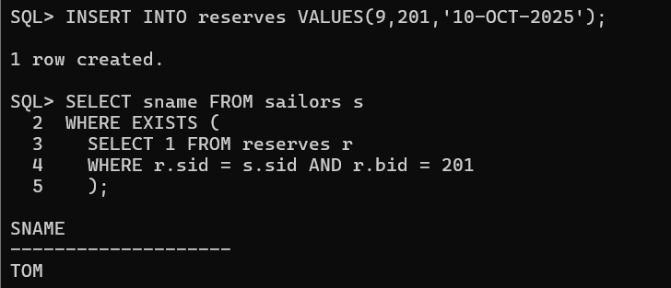\

- AGGREGATE OPERATORS
1. Find the average rating of all sailors
OUTPUT:
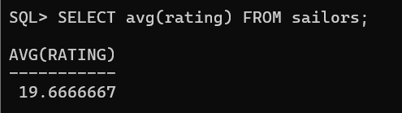
2. Retrieve the total number of sailors.
OUTPUT:
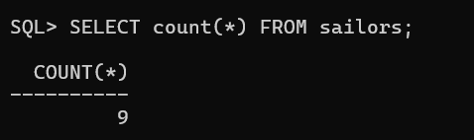

3. Find the average age of all sailors with a rating of 20.
OUTPUT:
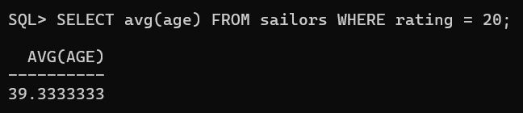
4. Find the names and age of oldest sailors.
OUTPUT:
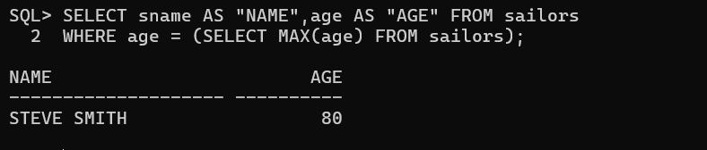
5. Find the names of sailors who are older than the oldest sailor with rating of 24.
OUTPUT:
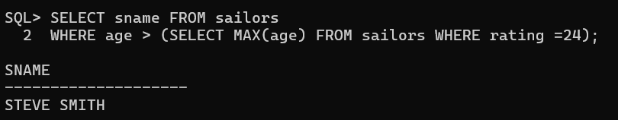

- SET COMPARISON OPERATORS
1. Find the sailors whose rating is better than some sailor called tom.
OUTPUT:
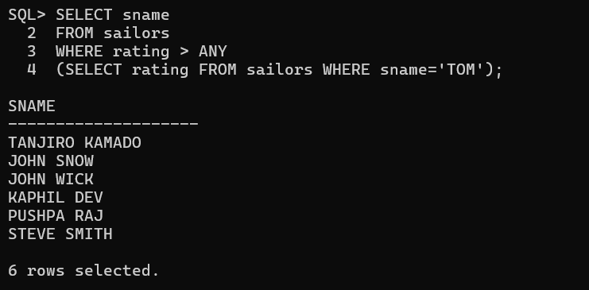

2. Find the sailors whose rating is better than every sailor called Rion.
OUTPUT:
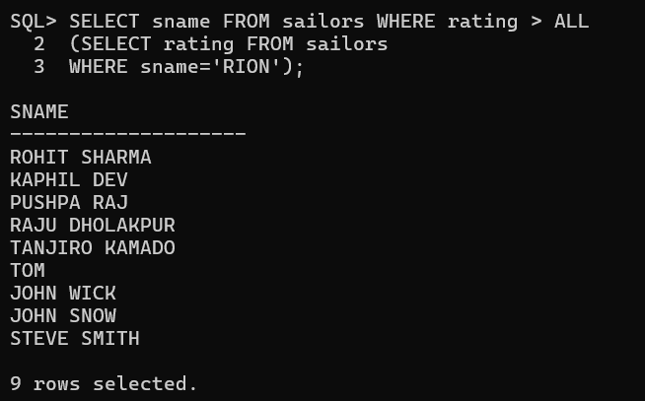

3. Find the sailors with highest rating.
OUTPUT:
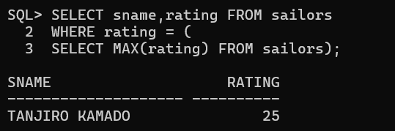

- DEMONSTRATING GROUP BY AND HAVING CLAUSE
1. Retrieve the number of reservations for each boat
OUTPUT:
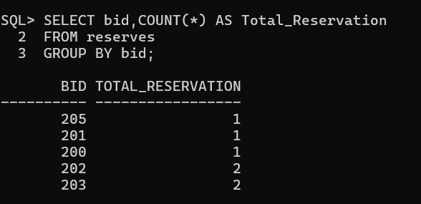
2. Find the age of the youngest sailor for each rating level
OUTPUT:
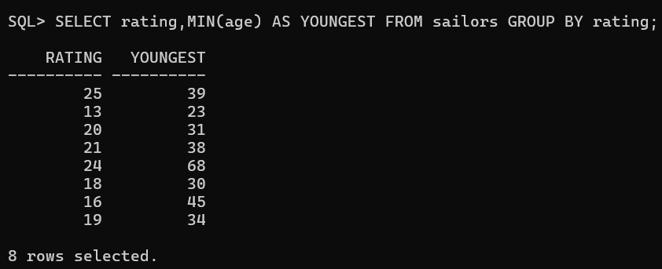
3. Find the age of the youngest sailor for each rating level with atleast 2 sailors with that rating
OUTPUT:
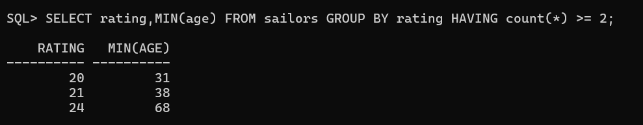
4. Find the age of the youngest sailors who is eligible to vote (atleast 18 years old) for each rating level with atleast two such sailors.
OUTPUT:
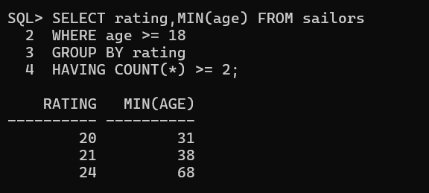

- NUMBER ,STRING AND DATE FUNCTIONS
1. Write queries to demonstrate numeric function like:
a) Abs
OUTPUT:
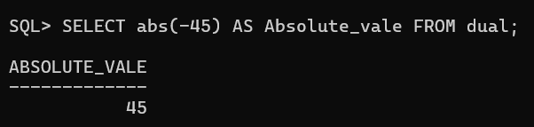

b) ceil
OUTPUT:
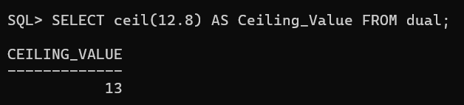

c) Floor
OUTPUT:
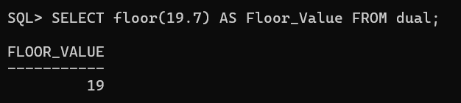

d) Trunc
OUTPUT:
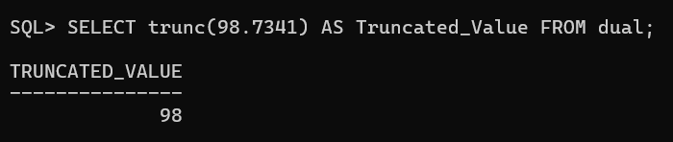

e) mod
OUTPUT:
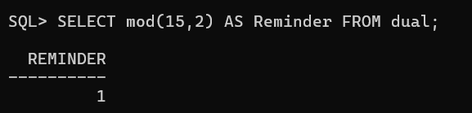

f) power
OUTPUT:
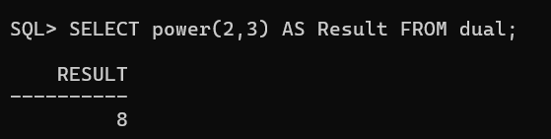

g) Sqrt
OUTPUT:
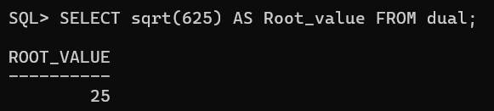

h) round
OUTPUT:
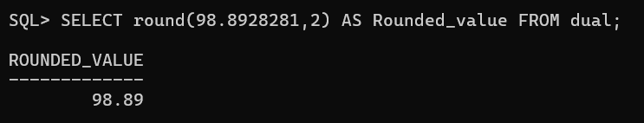

i) log
OUTPUT:
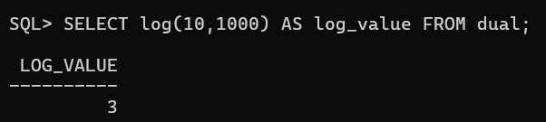

j) sign
OUTPUT:
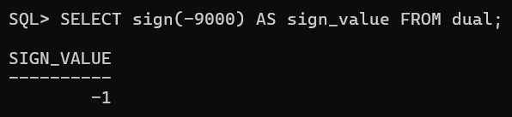
k) least
OUTPUT:
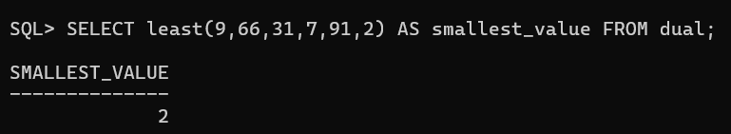

l) Greatest
OUTPUT:
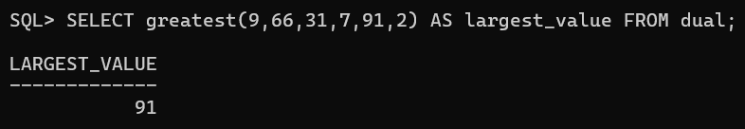

2. Write queries to demonstrate string functions
a) lower
OUTPUT:
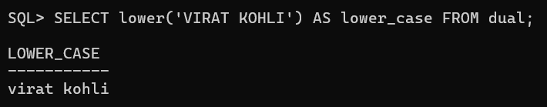
b) upper
OUTPUT:
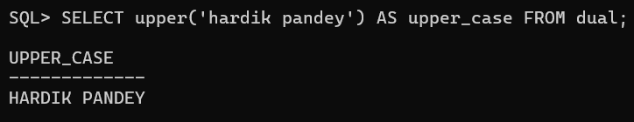

c) ltrim
OUTPUT:
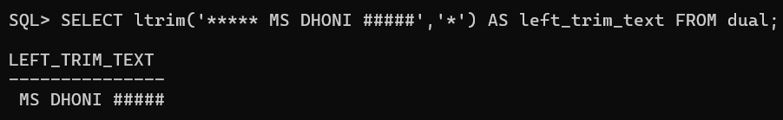

d) rtrim
OUTPUT:
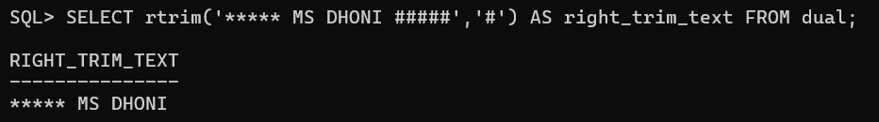

e) length
OUTPUT:
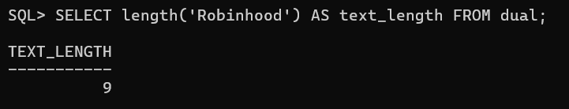

f) instr
OUTPUT:
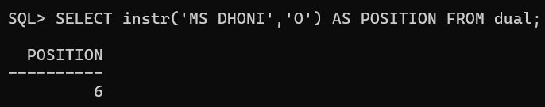

g) substr
OUTPUT:
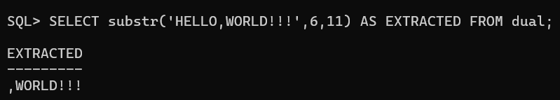

h) initcap
OUTPUT:
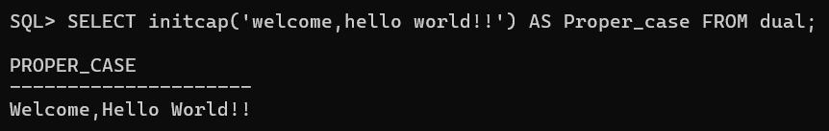

i) ASCII
OUTPUT:
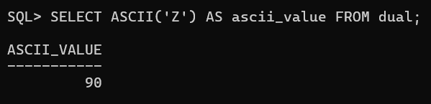

j) chr
OUTPUT:
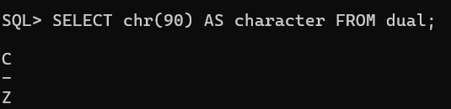

3. Write the queries to demonstrate date functions like
a) sysdate
OUTPUT:
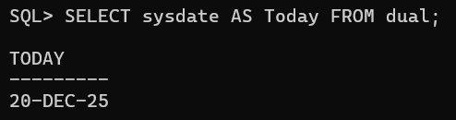

b) Add-months
OUTPUT:
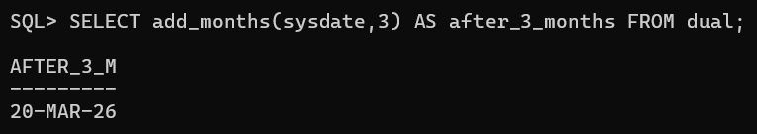

c) Last-day
OUTPUT:
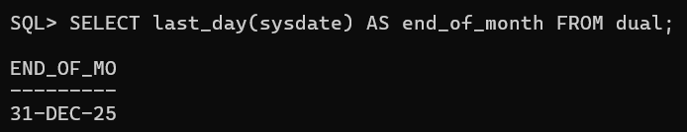

d) Months-between
OUTPUT:
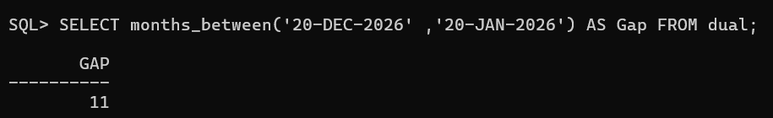
e) Next-day
OUTPUT:
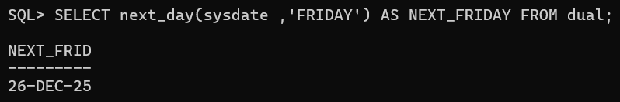

f) trun
OUTPUT:
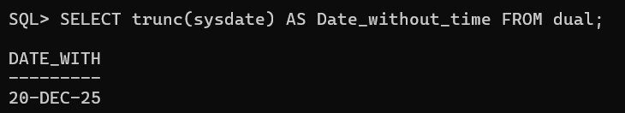

g) extract
OUTPUT:
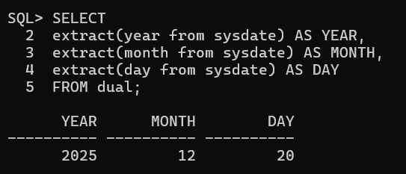

- VIEWS
- Create a view v1 that contains the name and rating of all sailors.
OUTPUT:
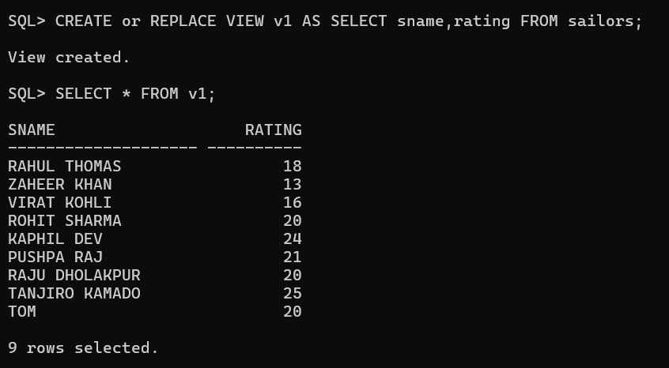

- Update the view so that rating is incremented by 1 for all who have rating of 24.
OUTPUT:
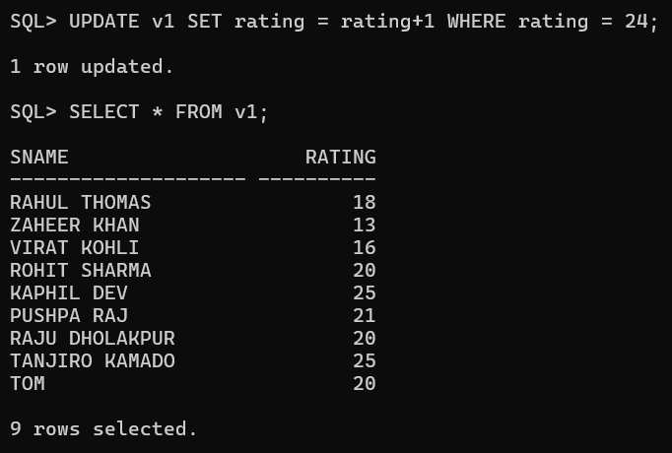
- Create a non updatable view that contains only the boated and boat name.
OUTPUT:
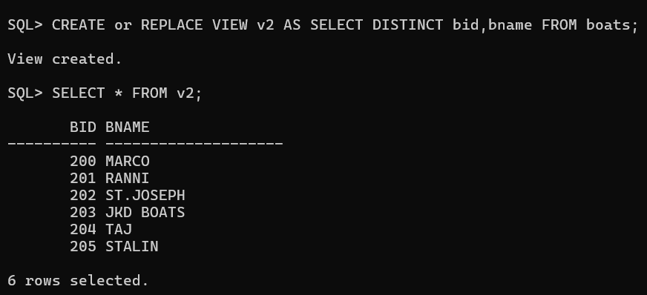

- MONGODB

- ) COMMANDS

- To create a DB
OUTPUT:
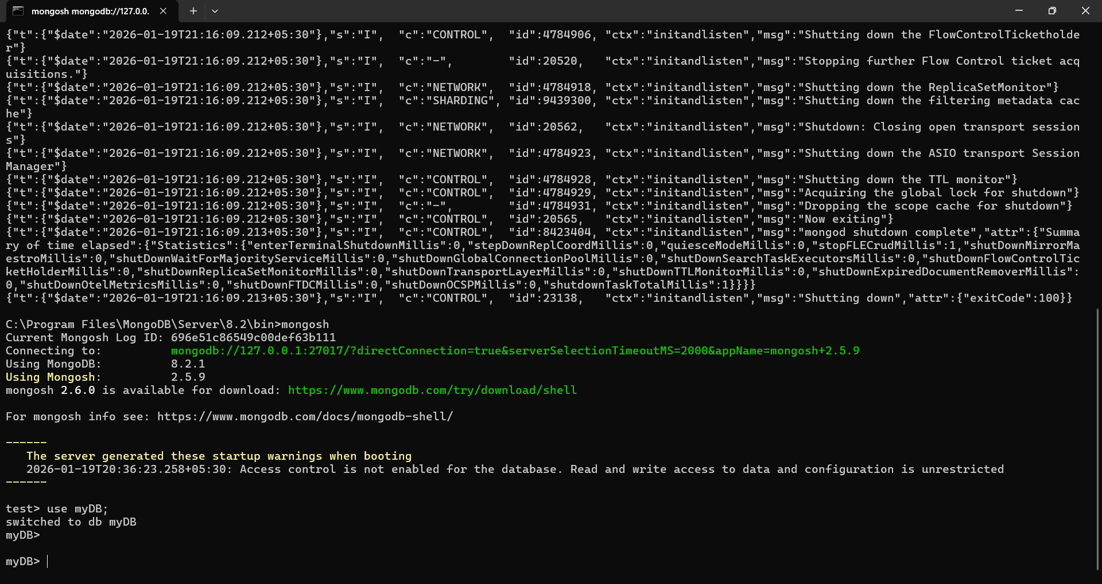

- To confirm the existence of DB
OUTPUT:
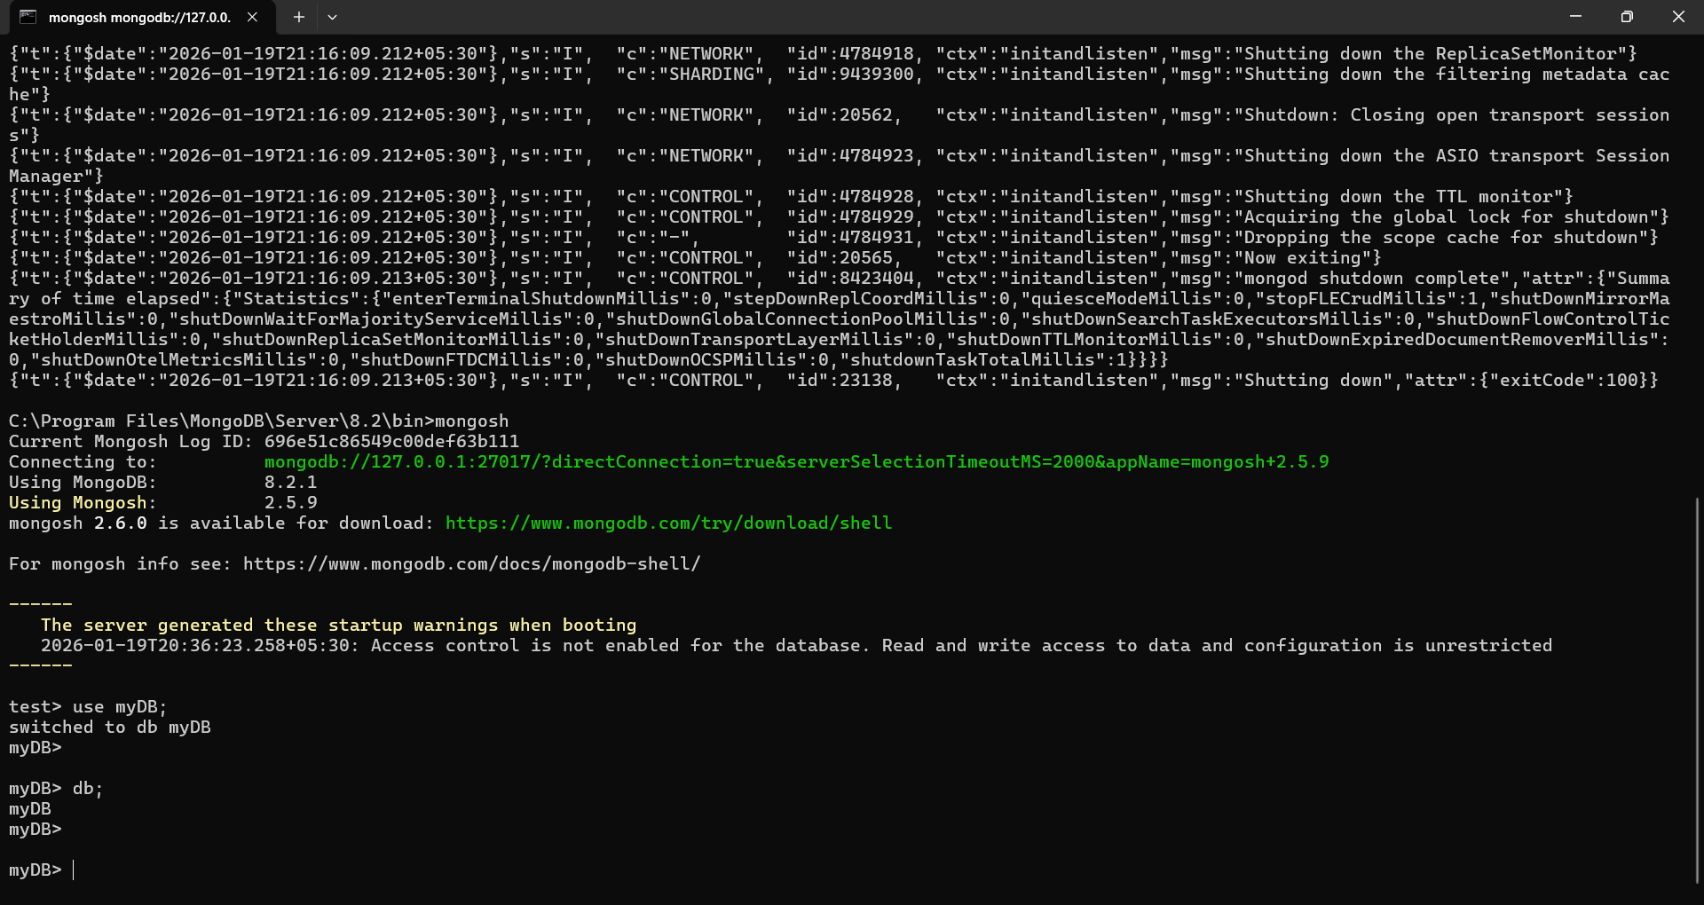

- To get a list of all DBs
OUTPUT:
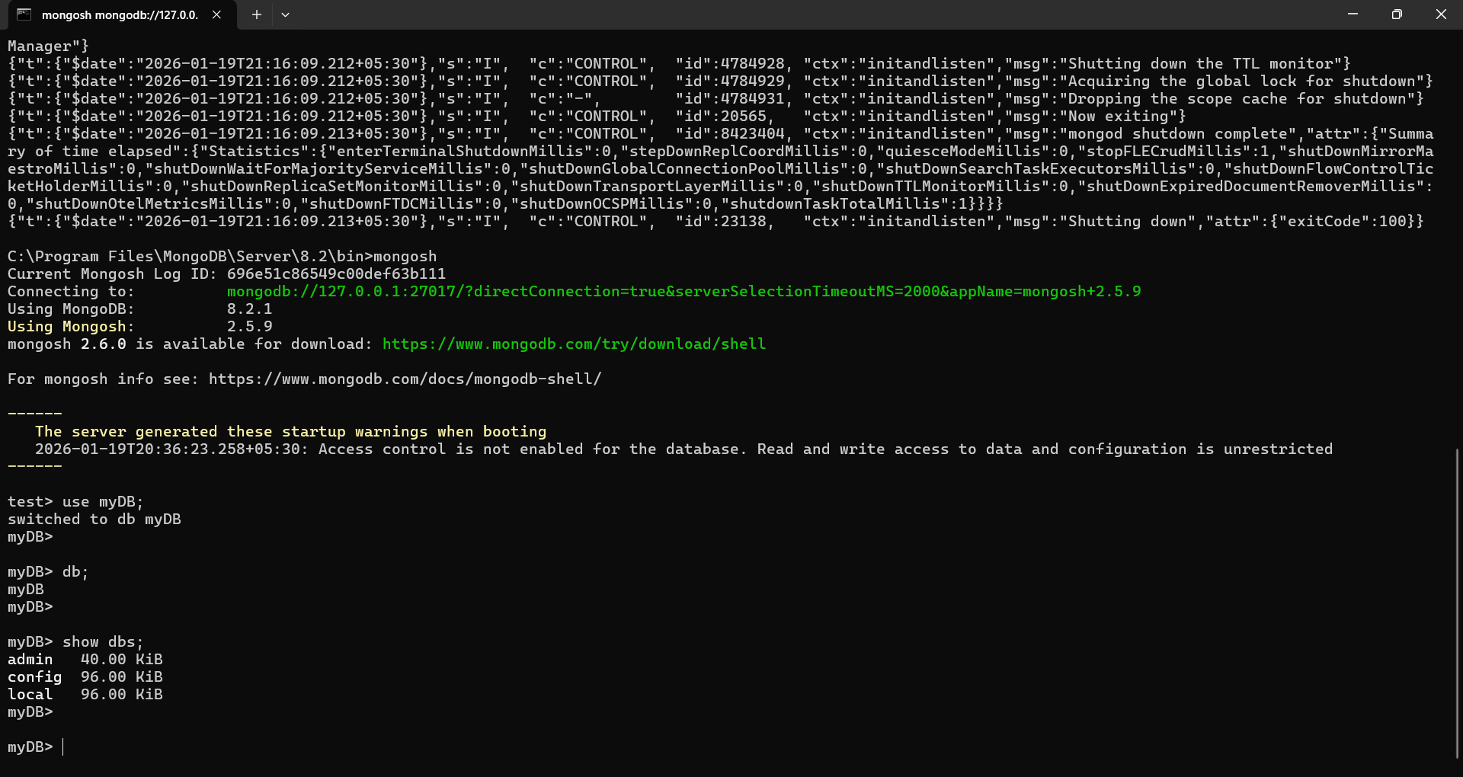

- To Drop a DB
OUTPUT:
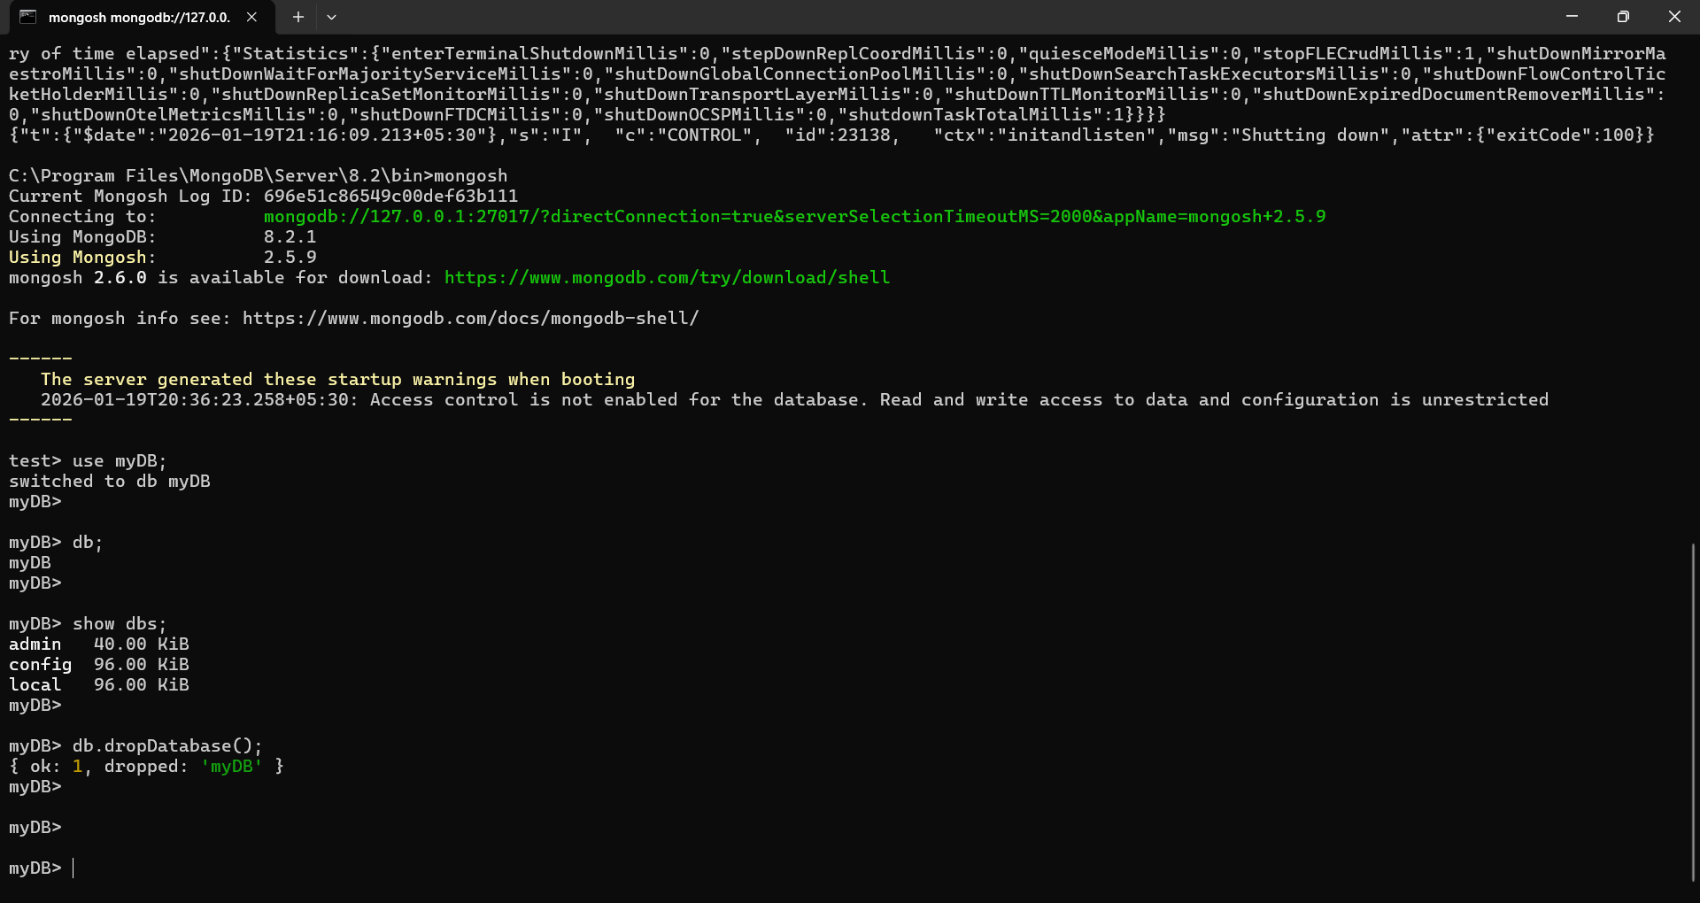

- To switch to a new DB
OUTPUT:
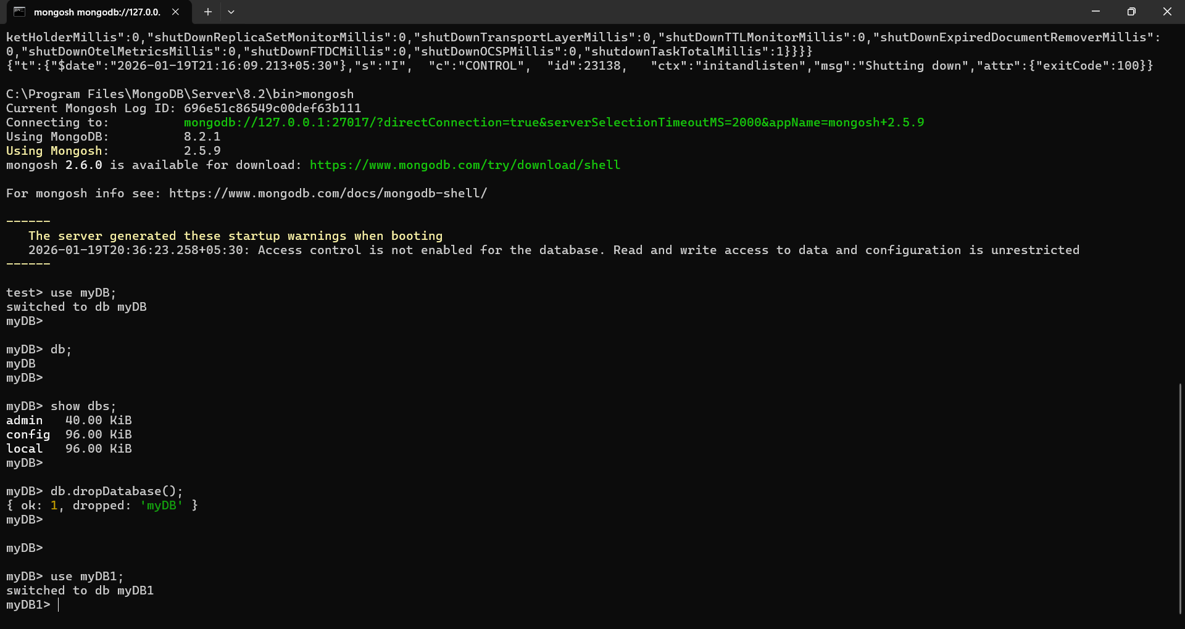

- To display statistics
OUTPUT:
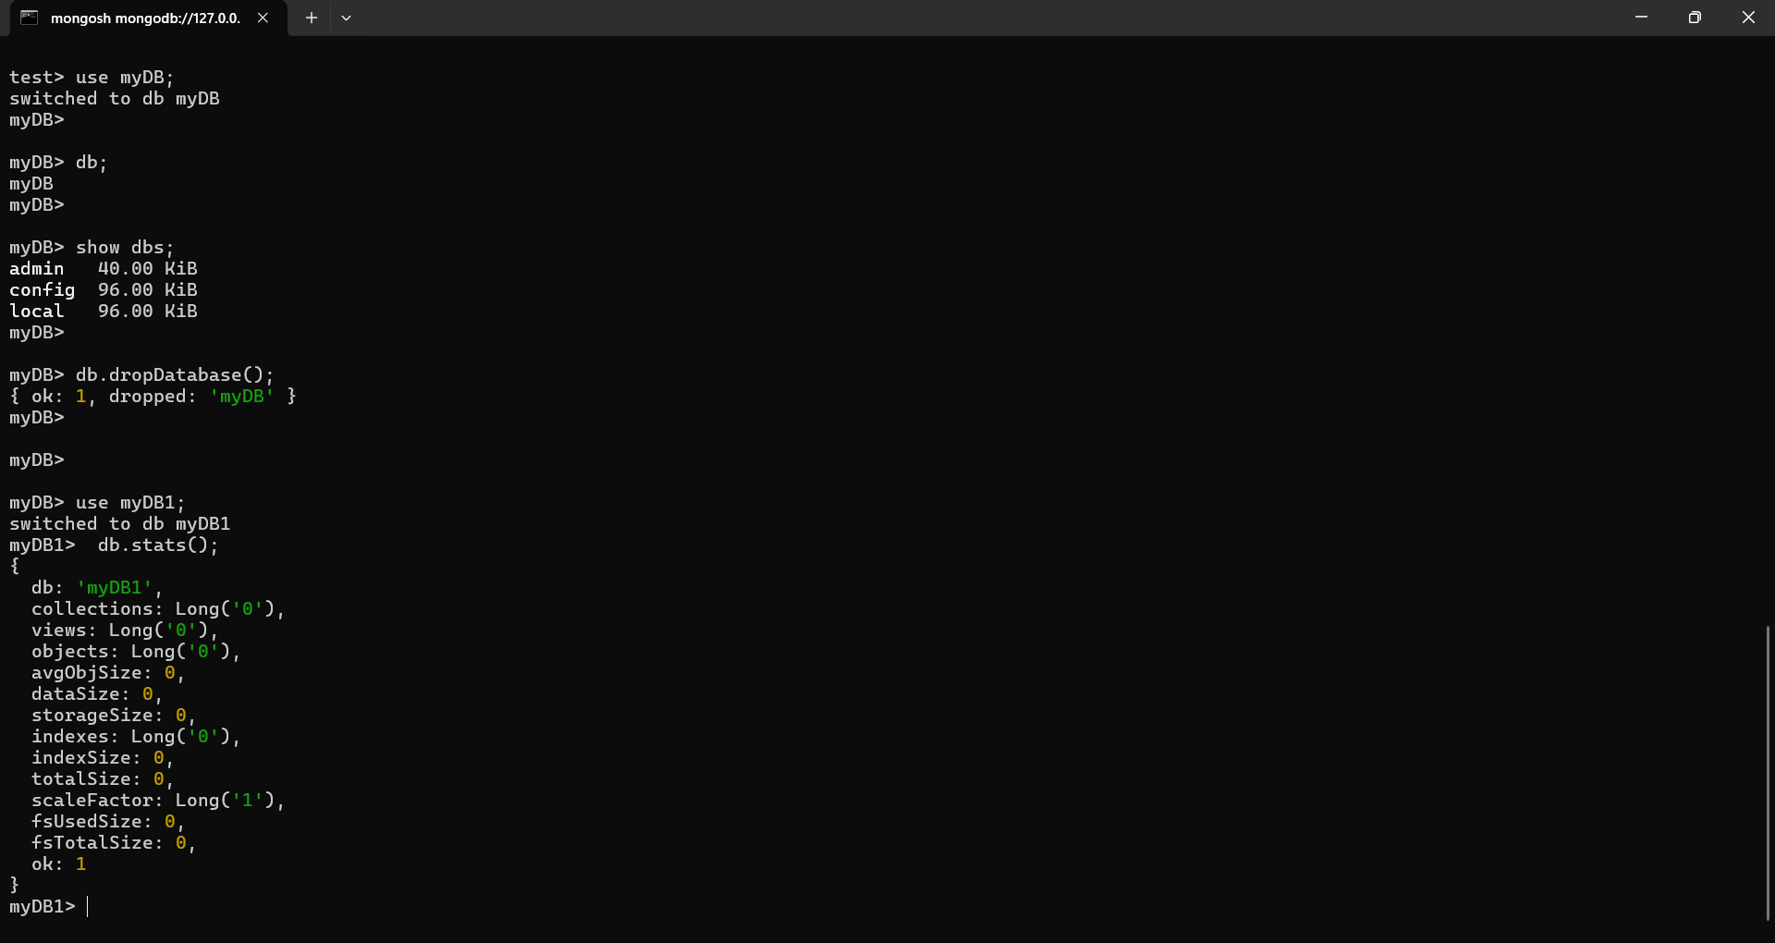

- Create a collection and perform various operations.

- db.createCollection(“Person”);
OUTPUT:
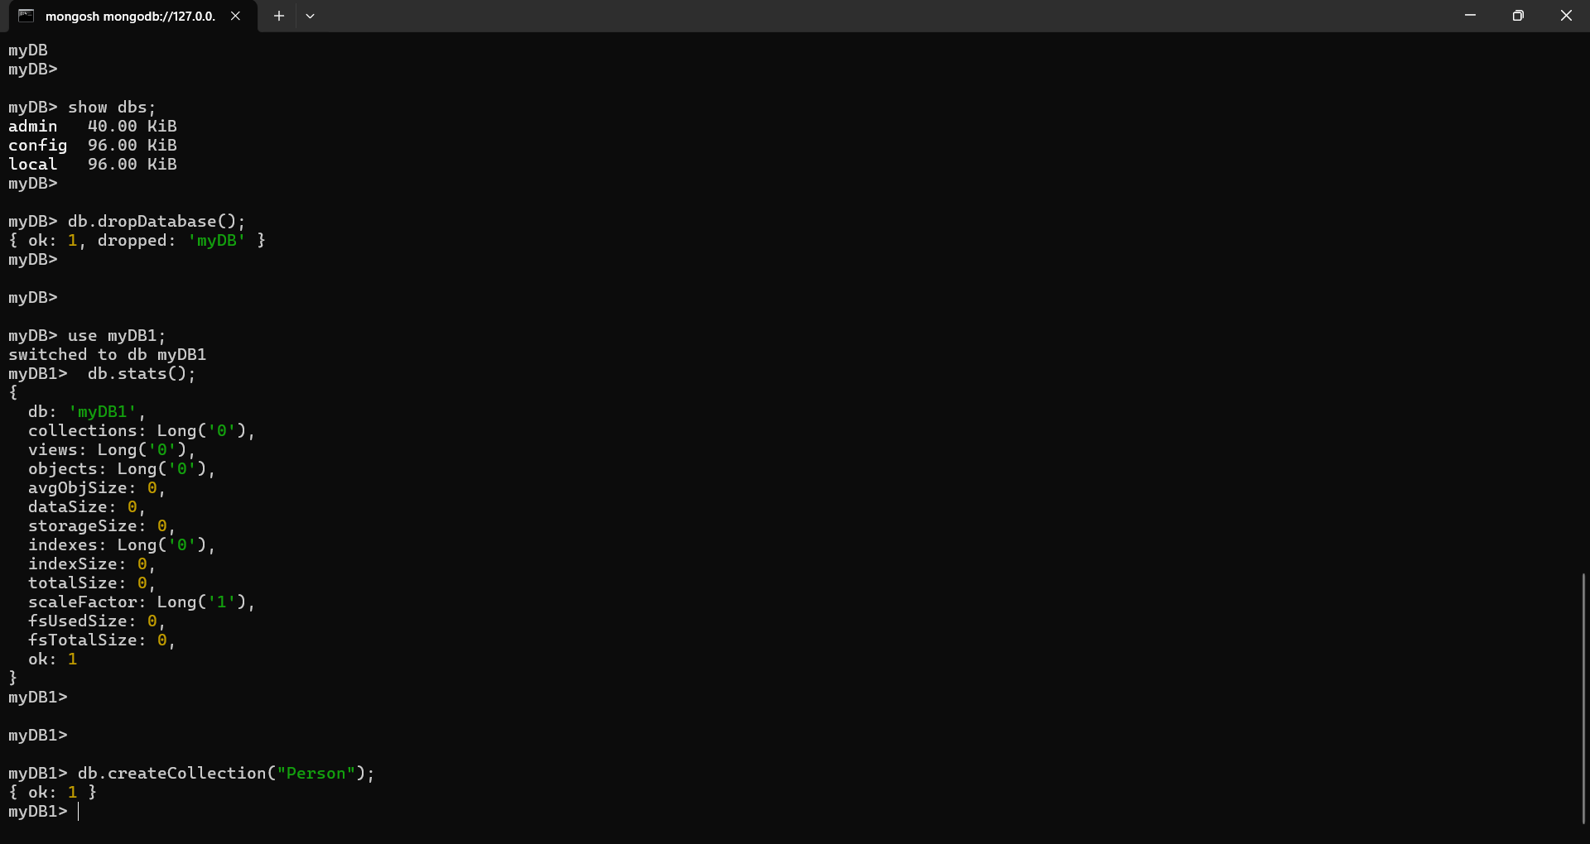

- db.student.insert({_id:1, StudName: "Anju", Grade: "VII", Hobbies: "Reading"})
OUTPUT:
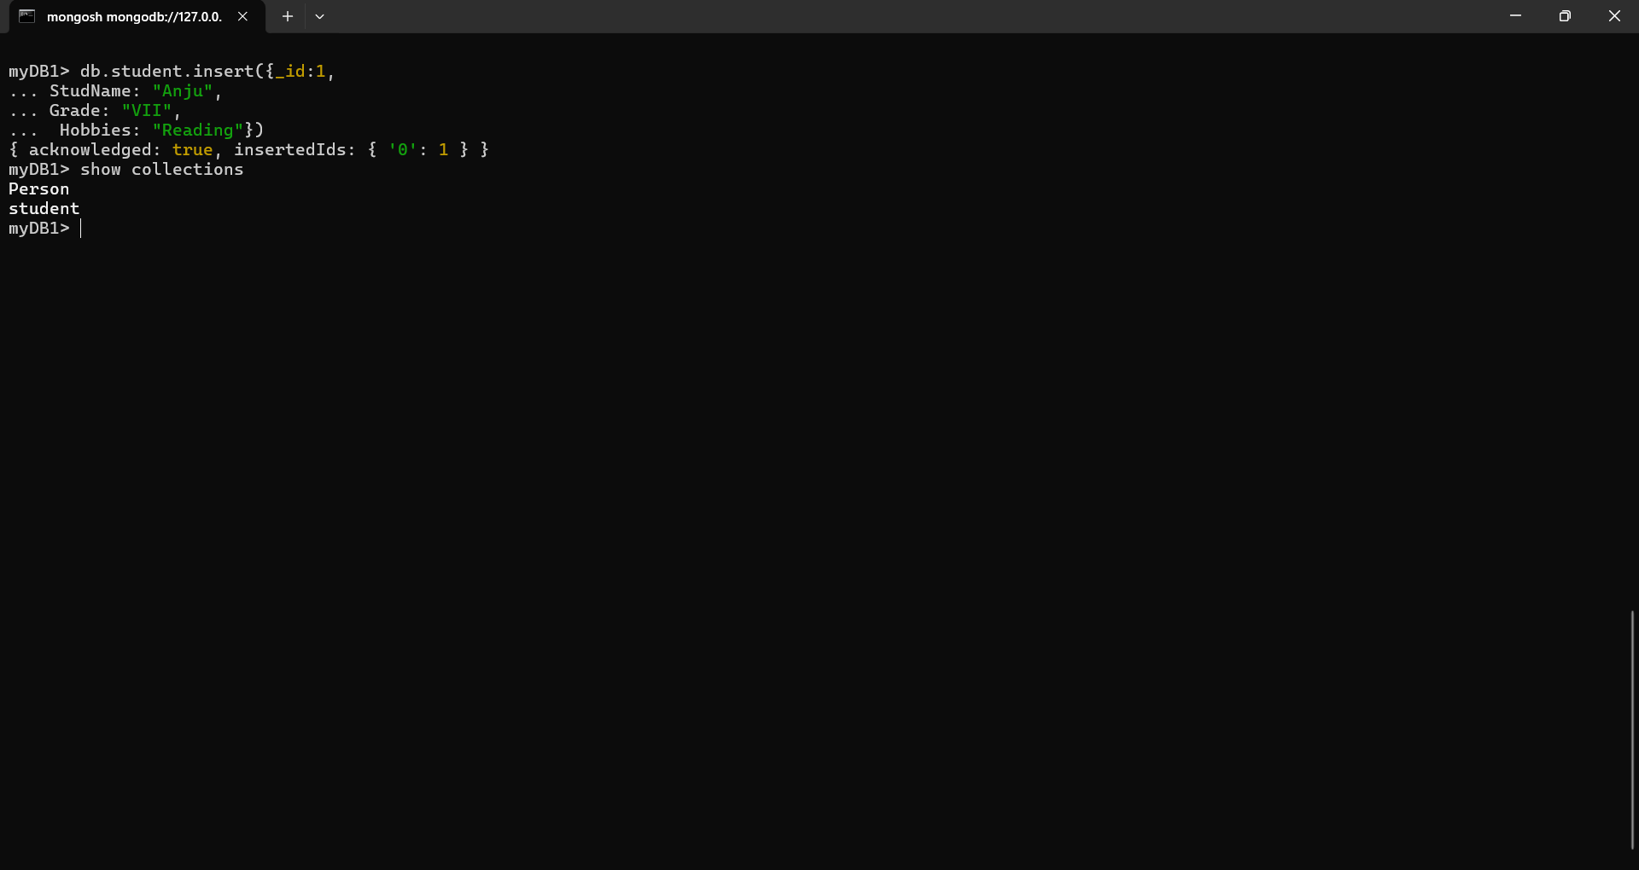

- show collections
OUTPUT:


- db.students.find();
OUTPUT:
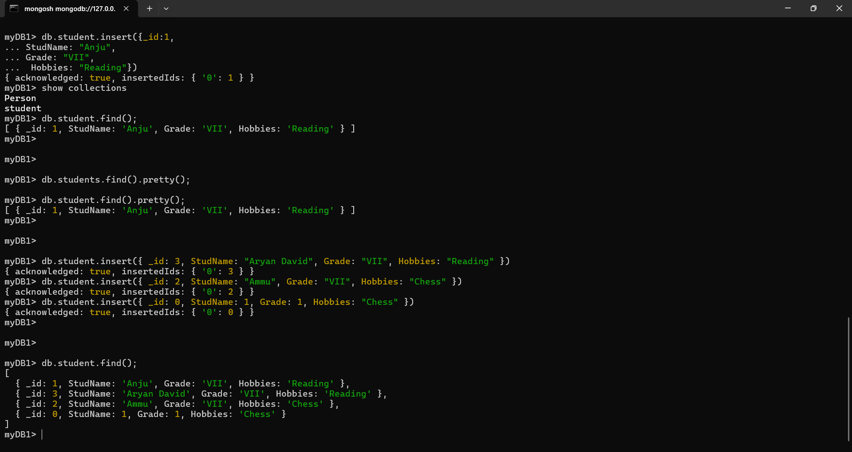

- db.students.find().pretty();
OUTPUT:
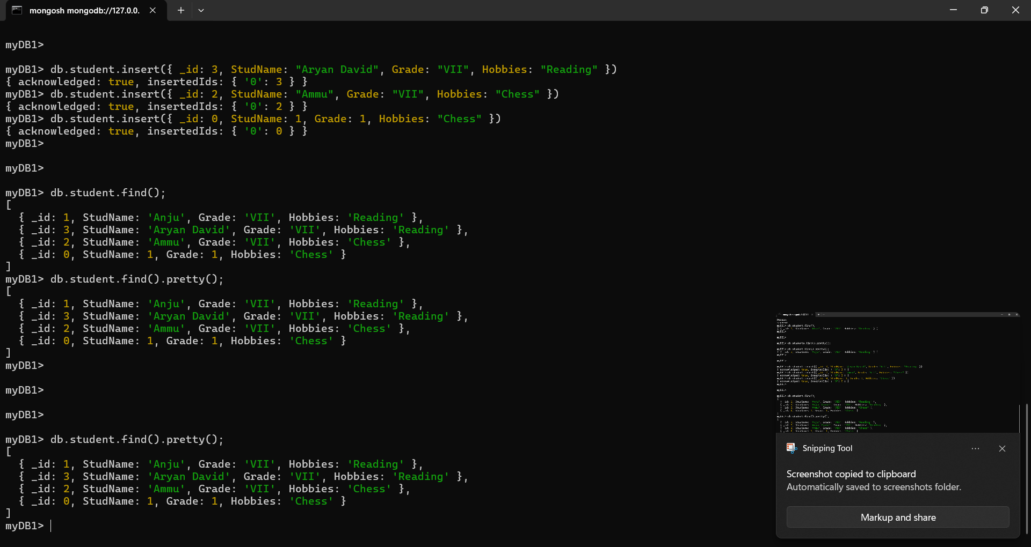

- db.Students.update({_id:3, StudName:"Aryan David", Grade: "VII"},{$set:{Hobbies: "Skating"}},{upsert:false});
OUTPUT:
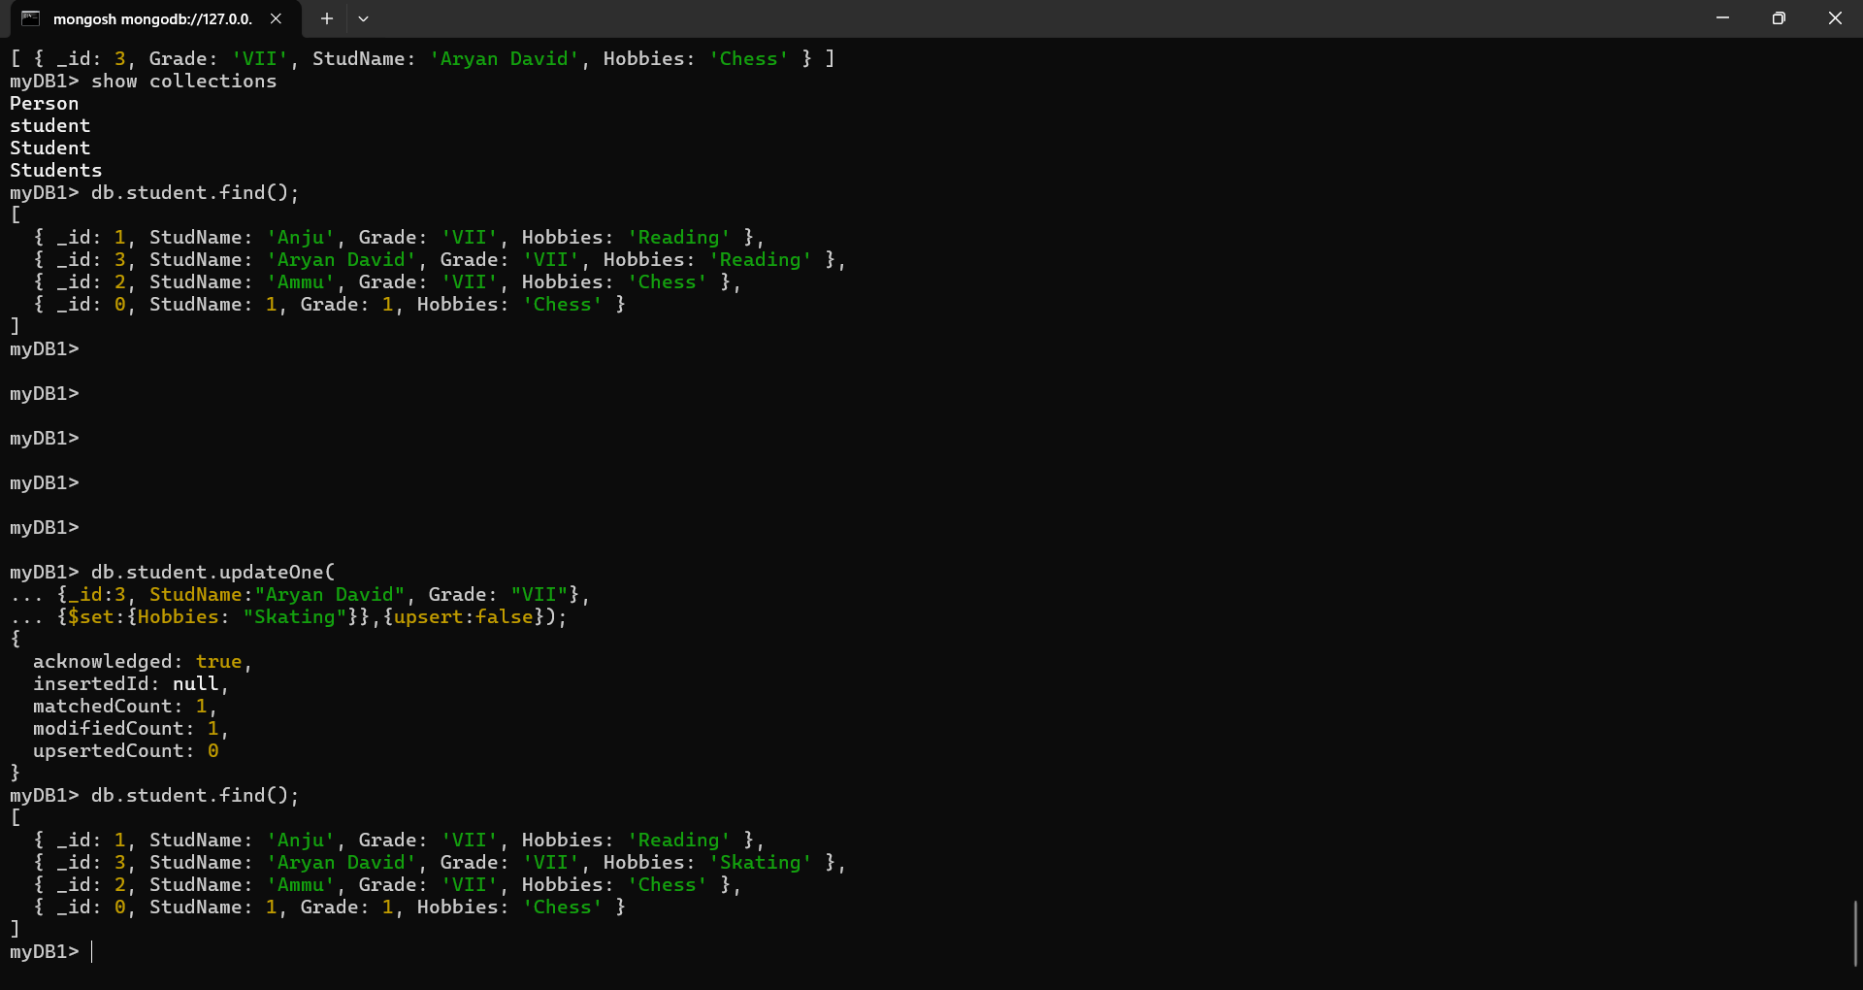

- db.Students.update({_id:3, StudName:"Aryan David", Grade: "VII"},{$set:{Hobbies: “Chess"}},{upsert:true});
OUTPUT:
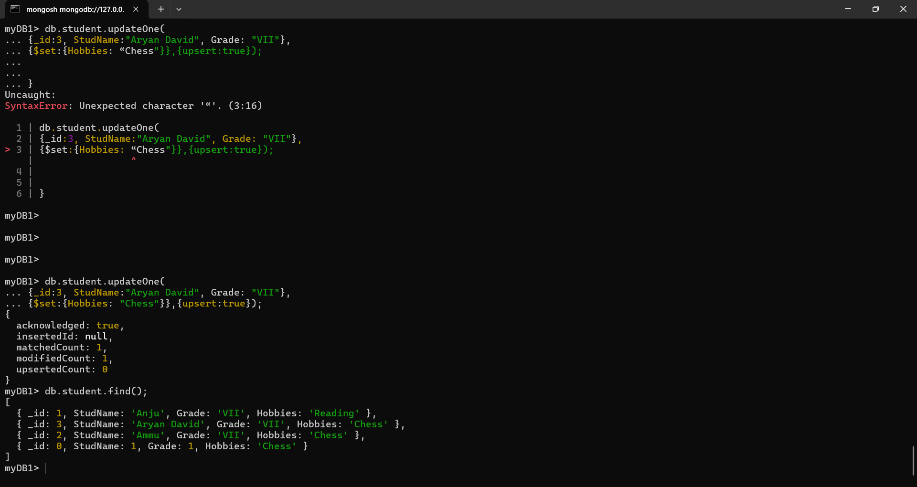

- db.Students.find({_id:3});
OUTPUT:
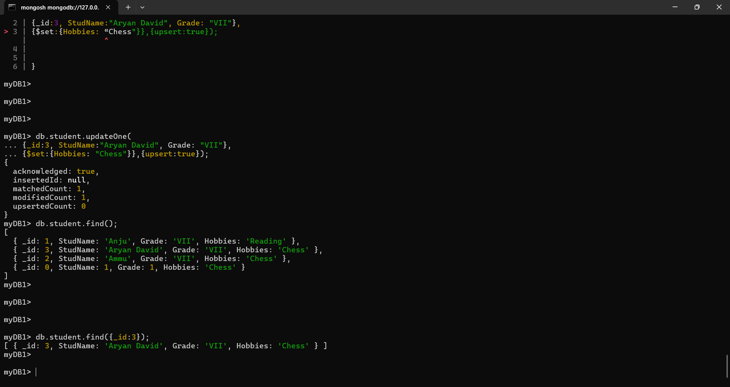

- db.Students.find({Grade: “VII”});
OUTPUT:
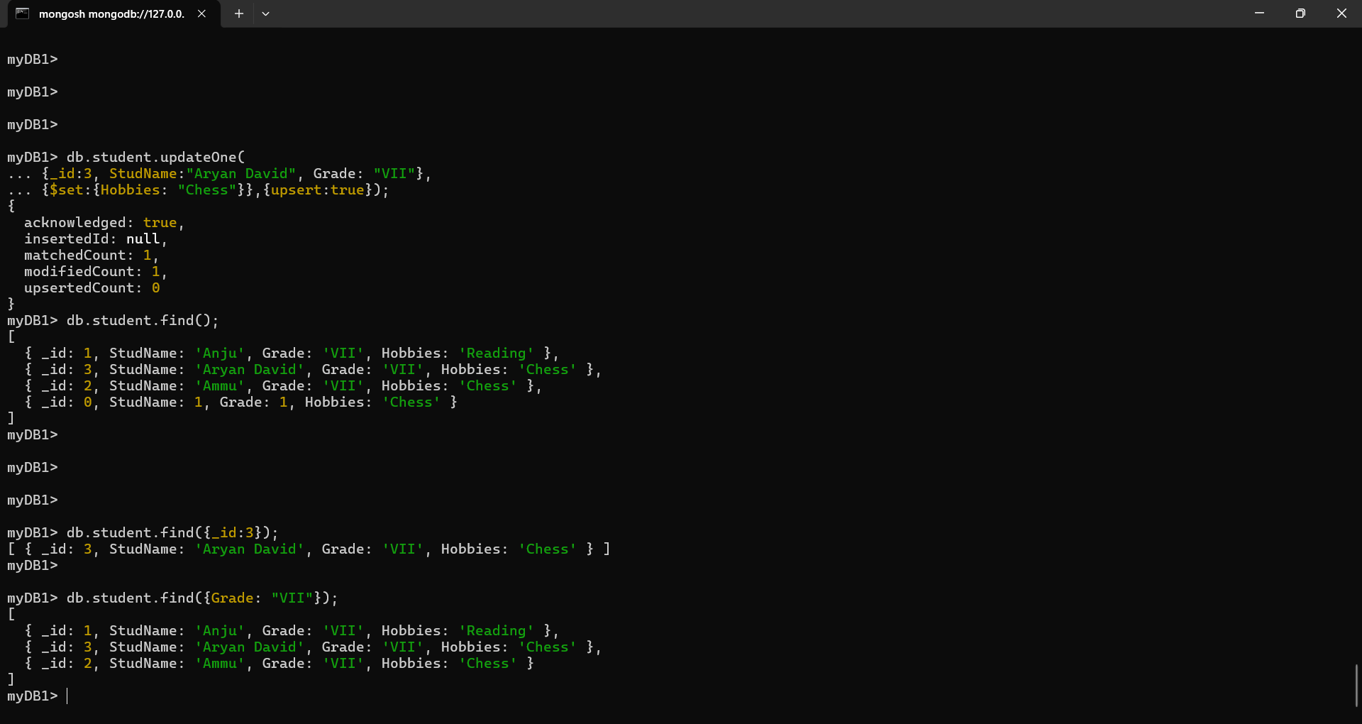

- db.Students.find({StudName:"Ammu"})
OUTPUT:
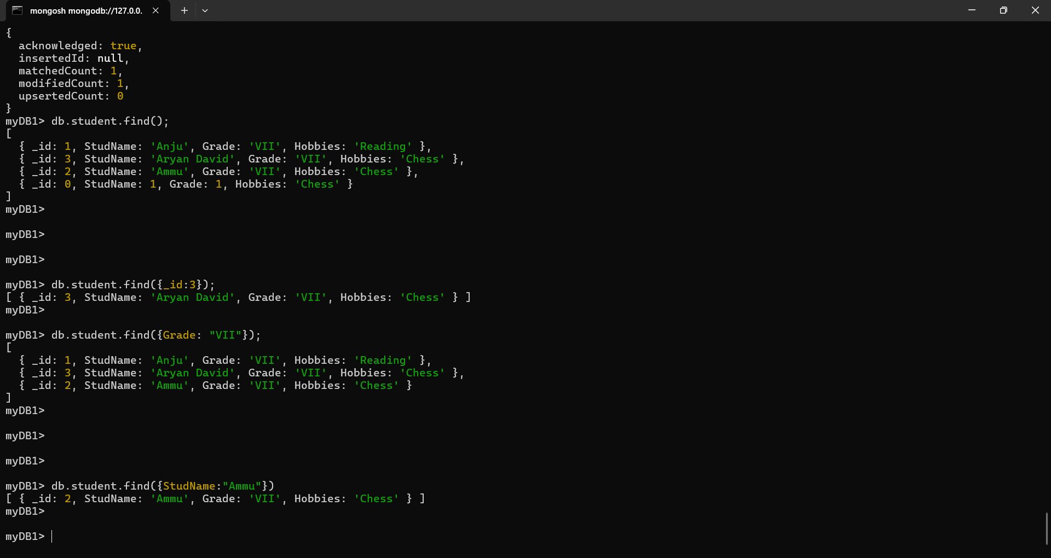

- db.Students.find({},{StudName:1,Grade:1});
OUTPUT:
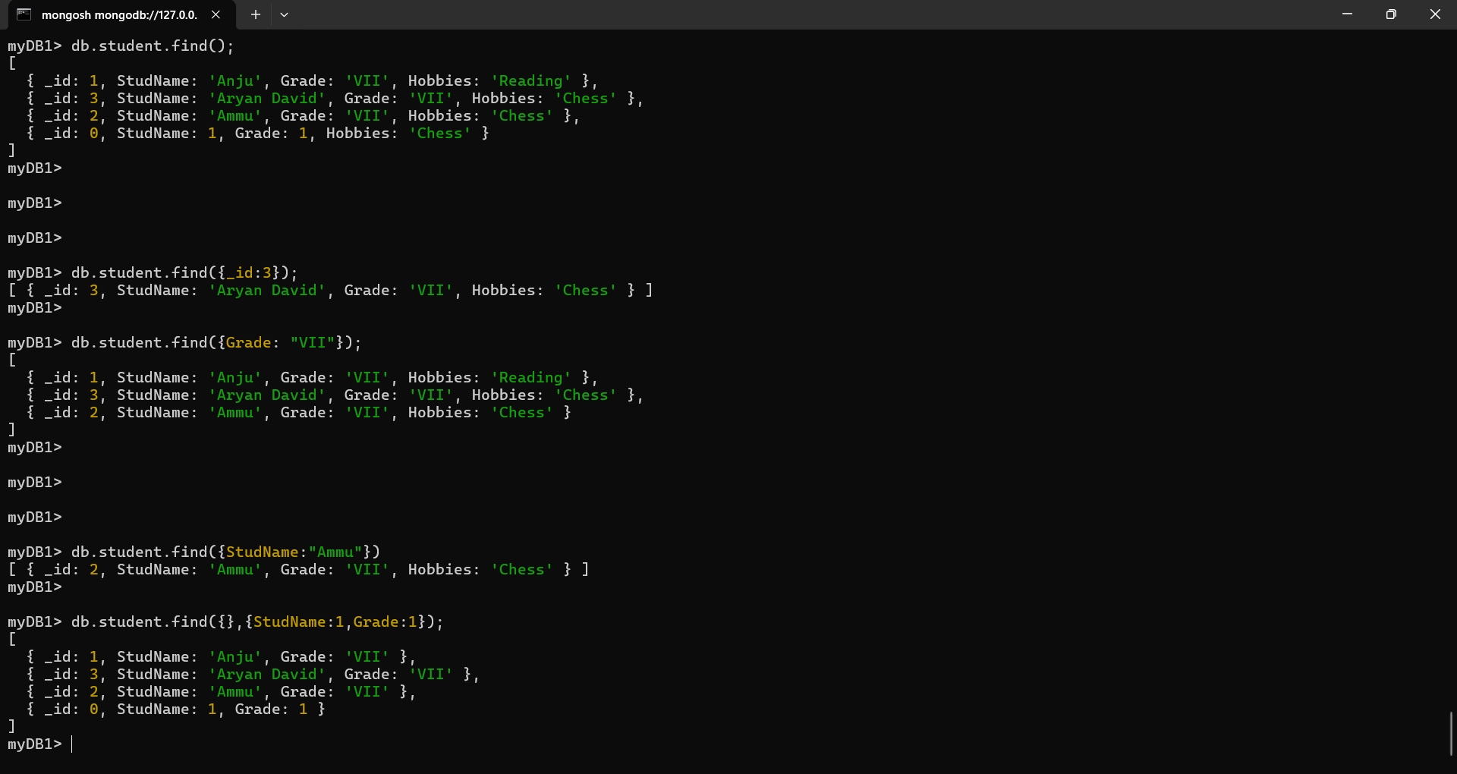

- db.Students.find({},{StudName:1,Grade:1,_id:0});
OUTPUT:
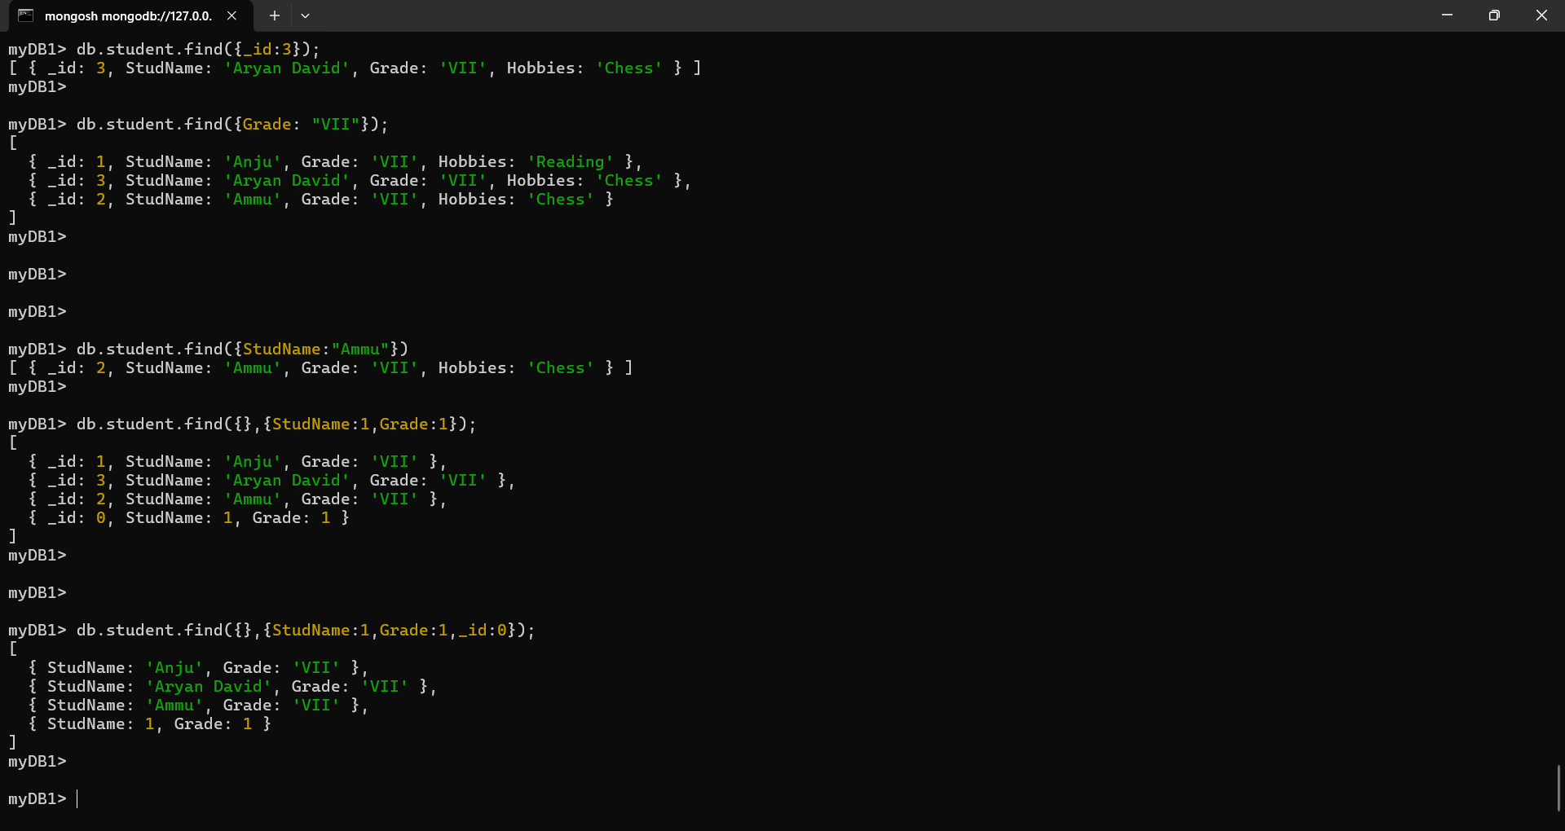

- db.Students.find({Grade:"VII"}).pretty().limit(2);
OUTPUT:
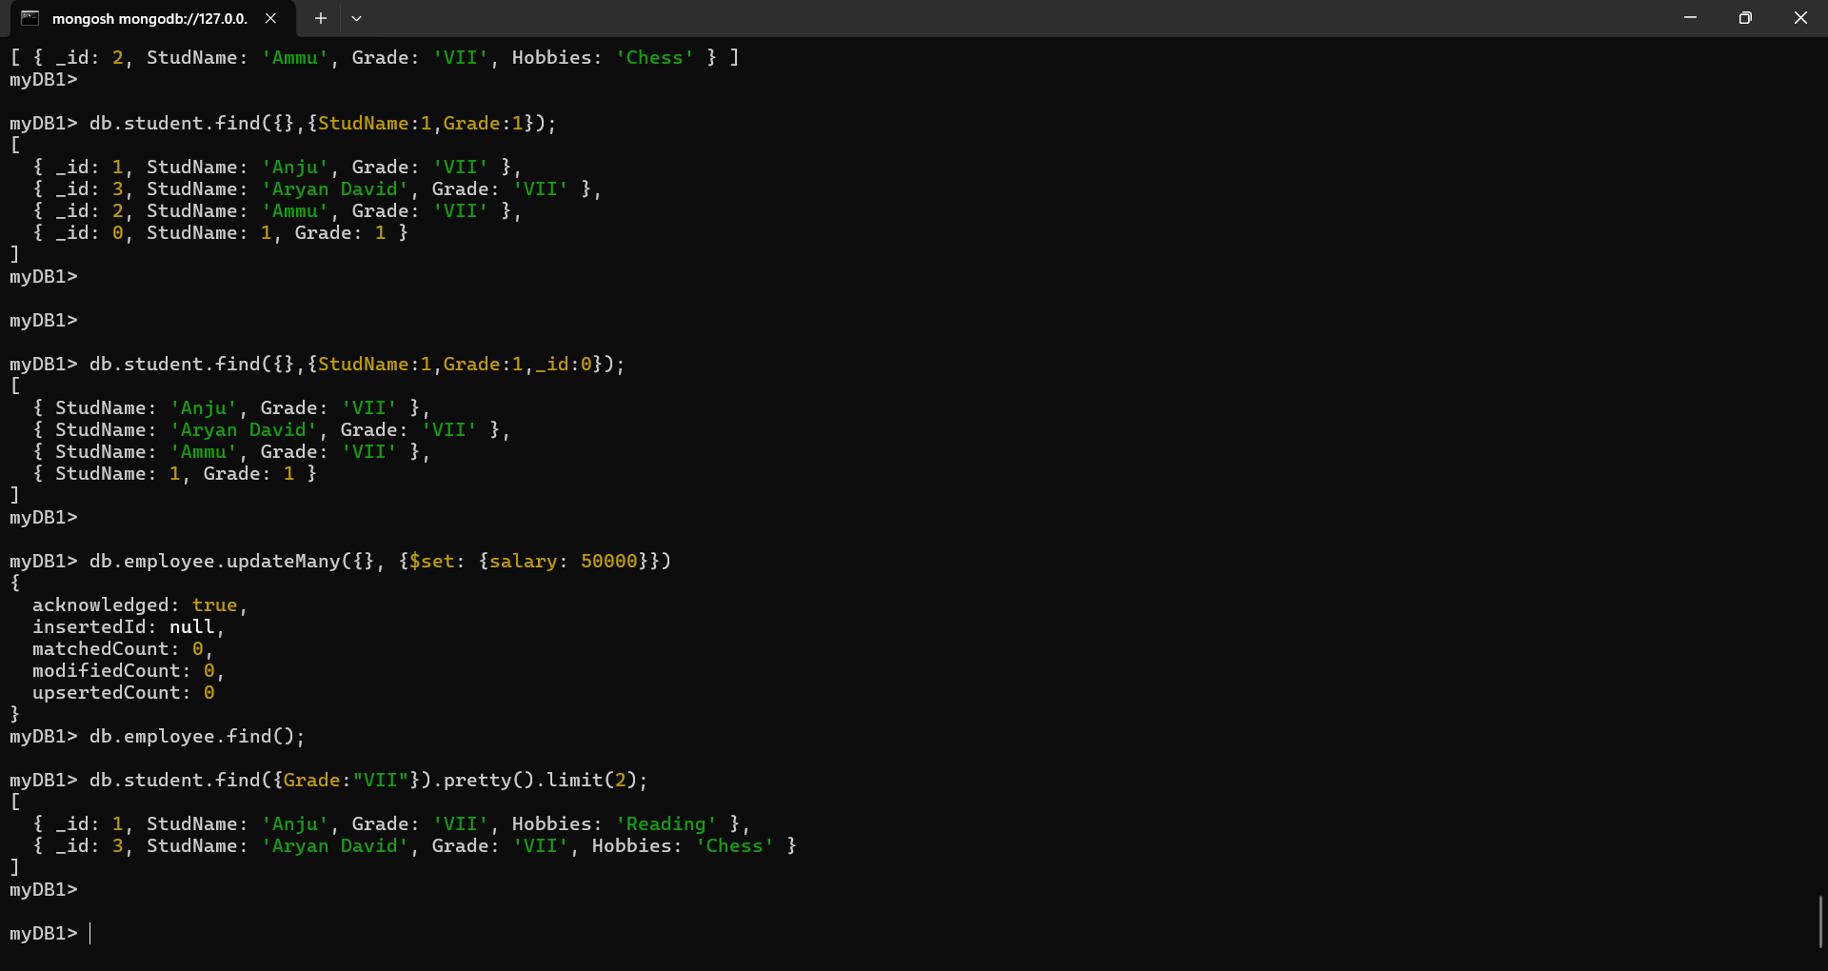

- db.employee.updateMany({}, {$set: {salary: 50000}})
OUTPUT:
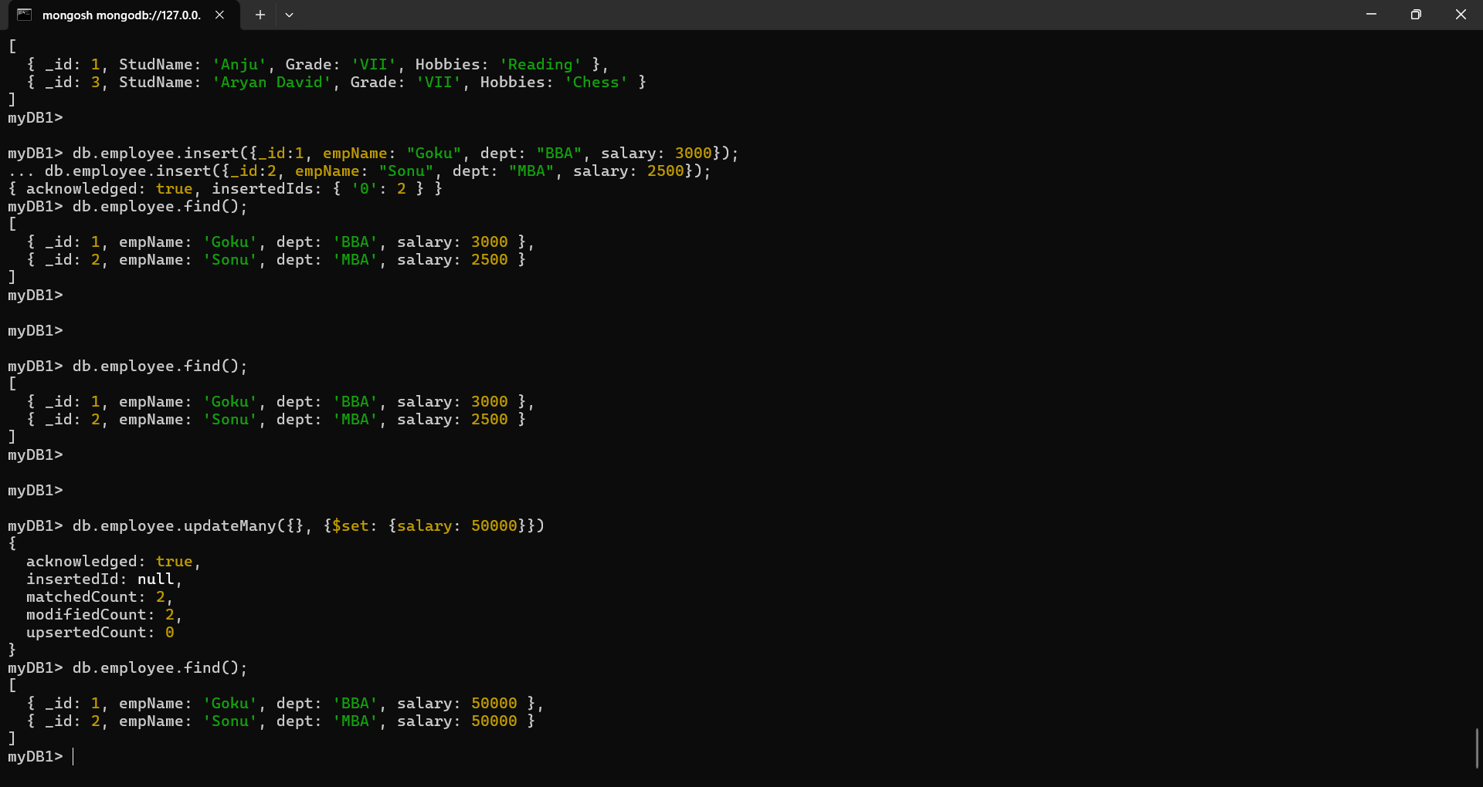

- MongoDB Queries

- Create a collection and insert documents into it using insertOne() and insertMany()

- Switch to (or create) a database
OUTPUT:
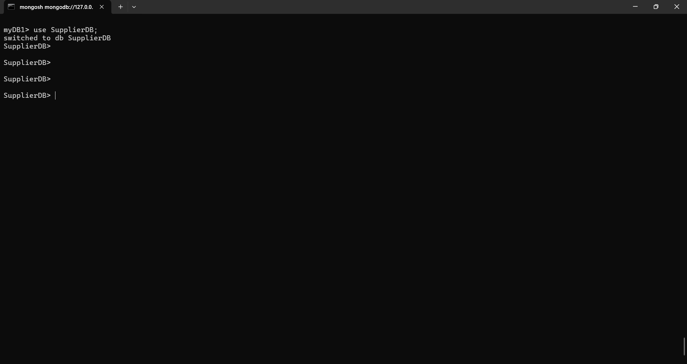

- Create a collection named "suppliers" and insert documents
- Insert one document
OUTPUT:
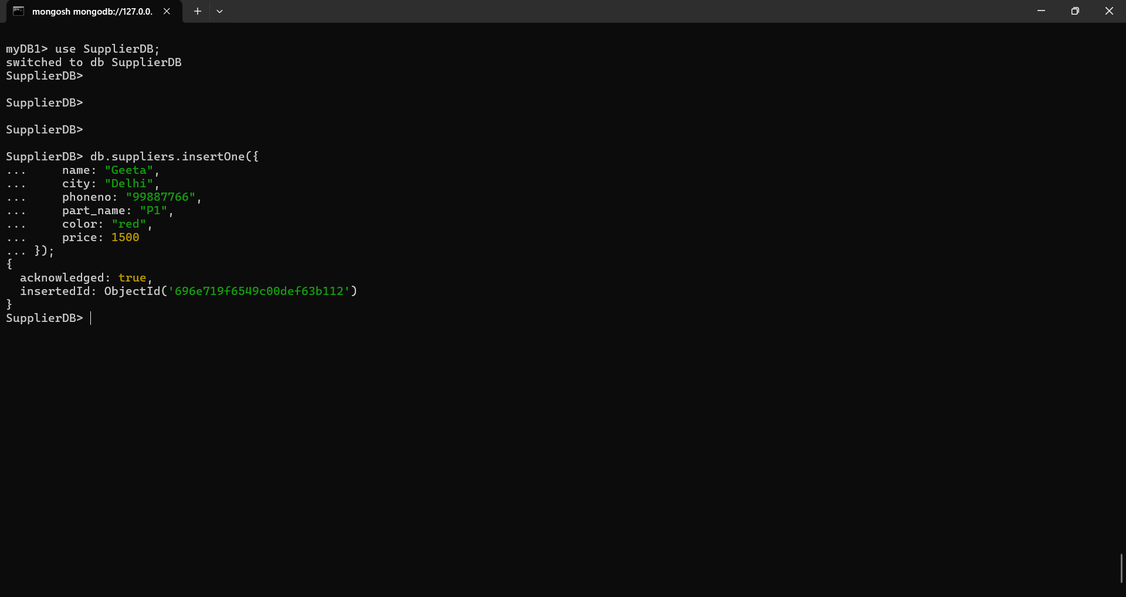

- Insert many documents
OUTPUT:

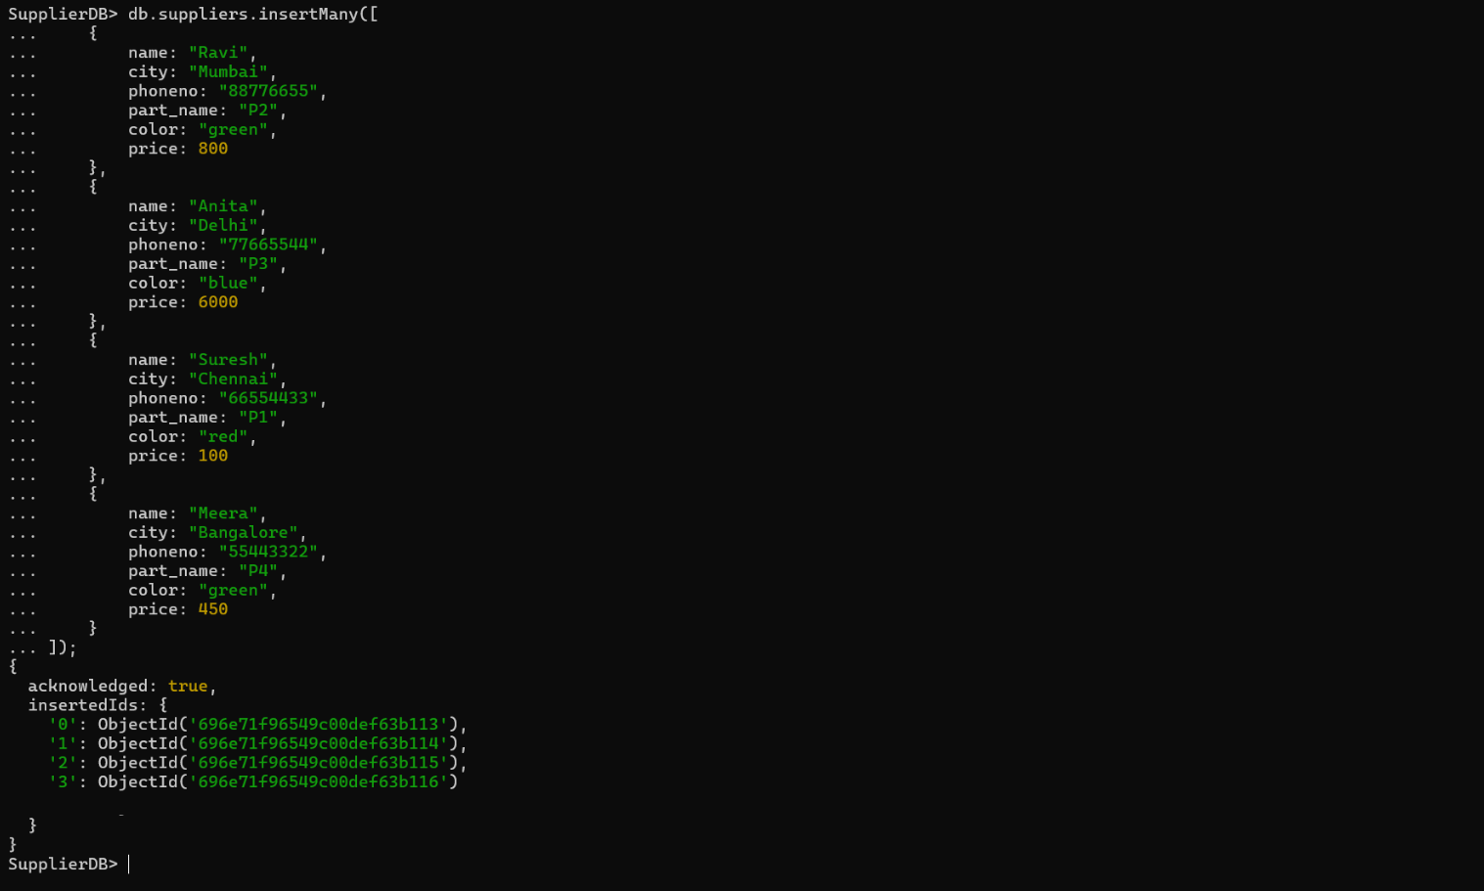

- Find the count of all suppliers
OUTPUT:
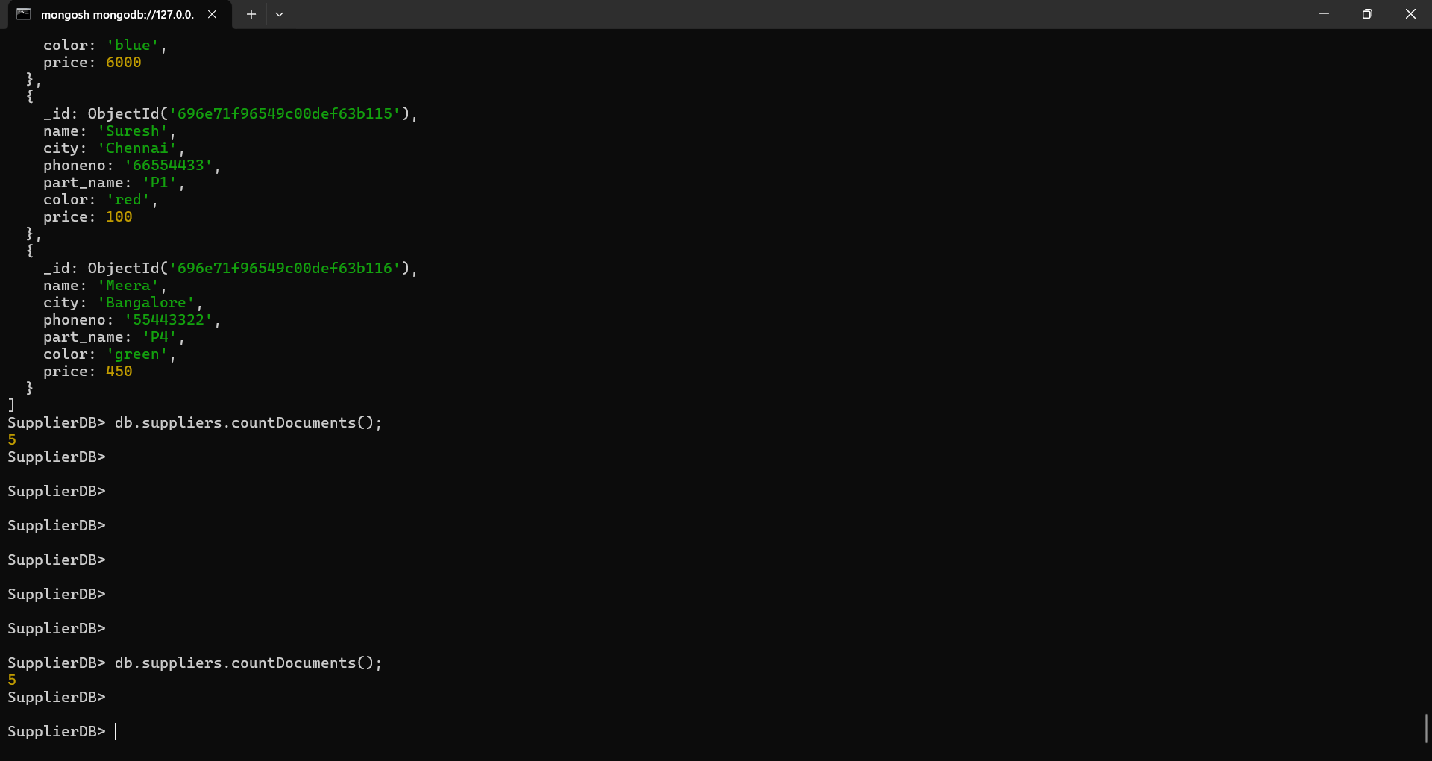

- Select all documents in collection
OUTPUT:
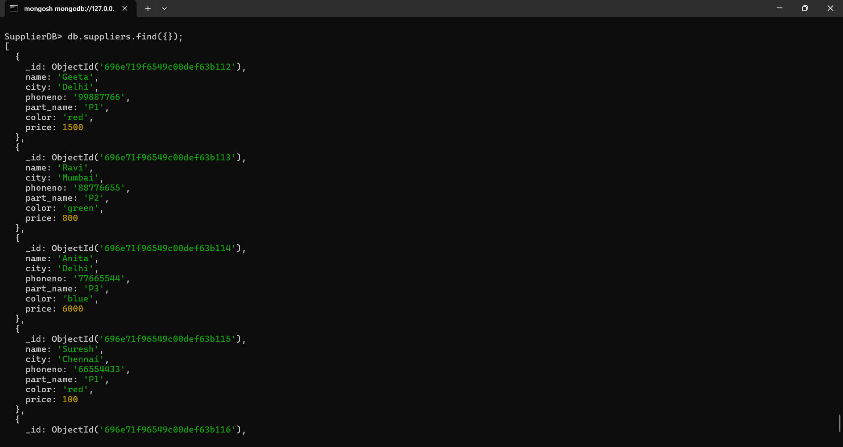
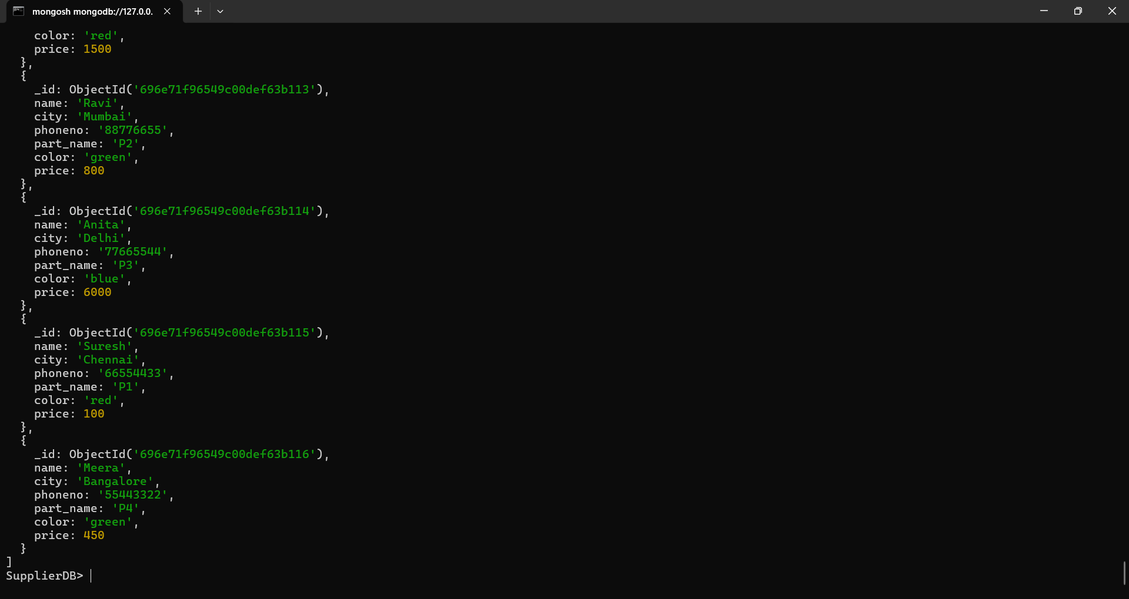

- Find all records that have city = ‘Delhi’
OUTPUT: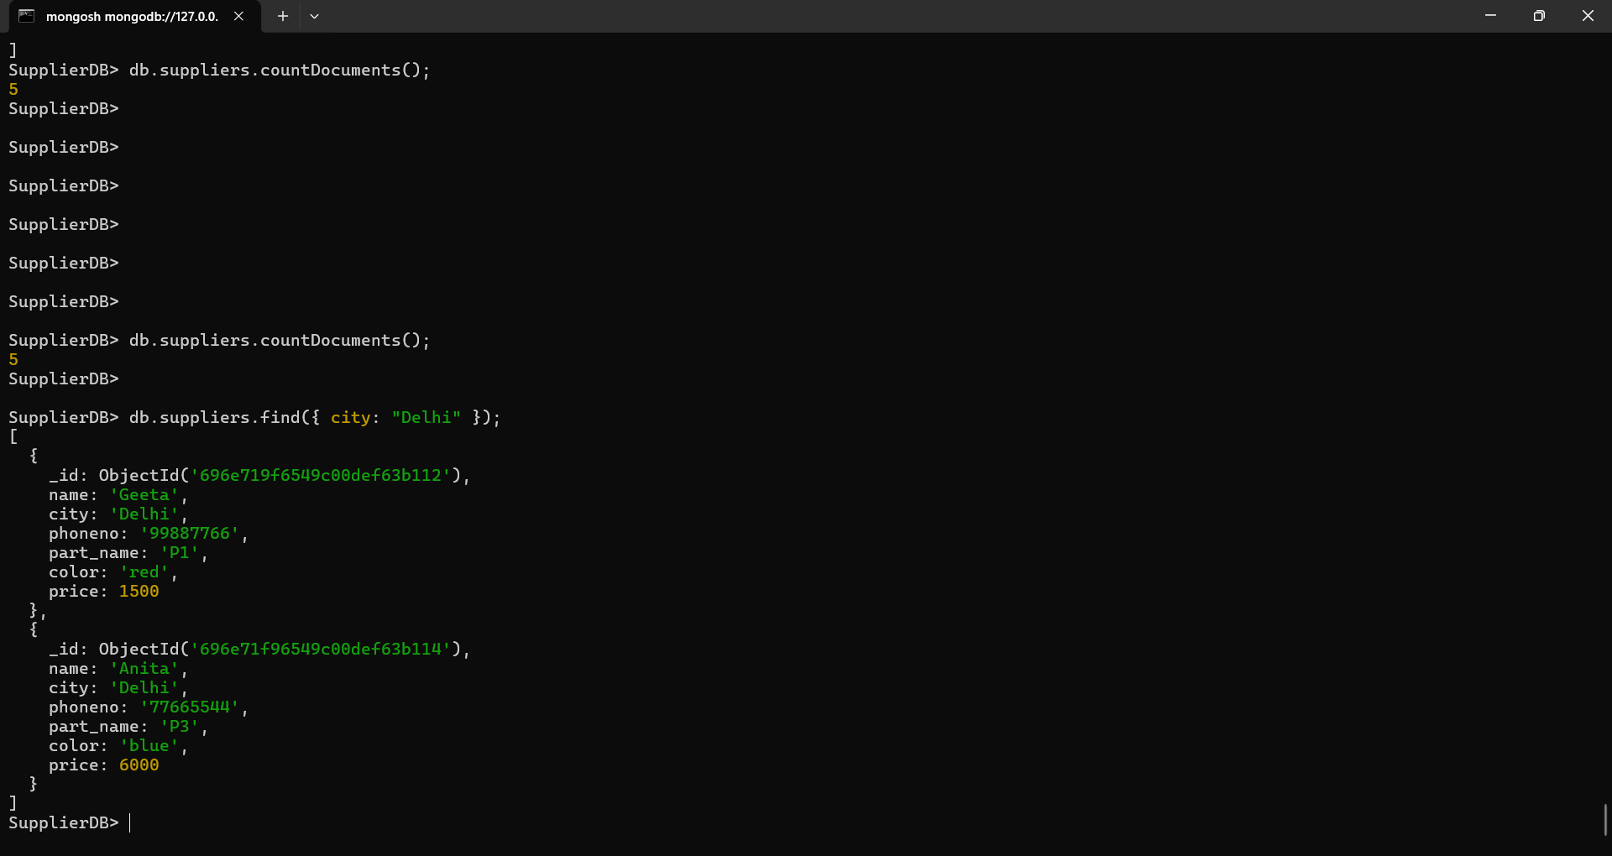
5. Retrieve all documents that have color equal to ‘red’ or ‘green’
OUTPUT:
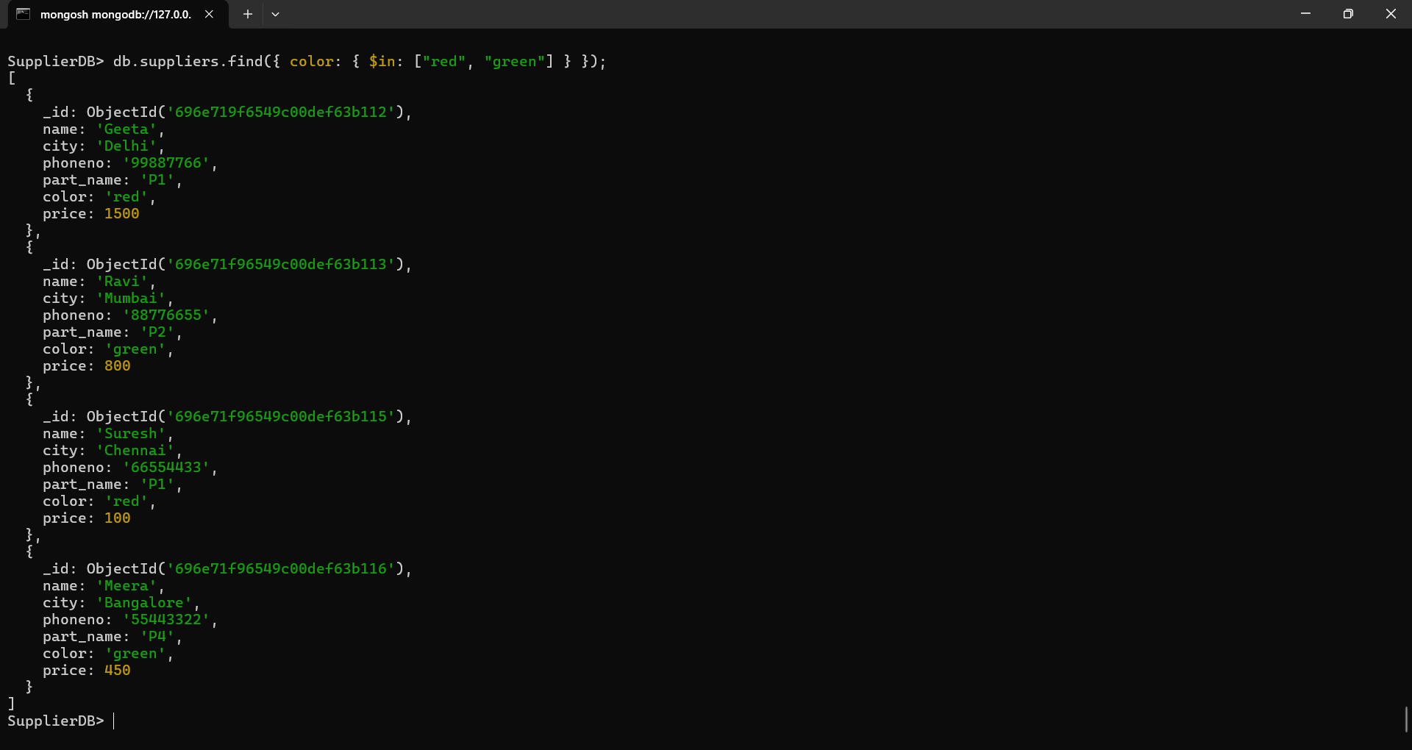

6. Retrieve all documents where part_name is ‘P1’ or price is less than 200.
OUTPUT:
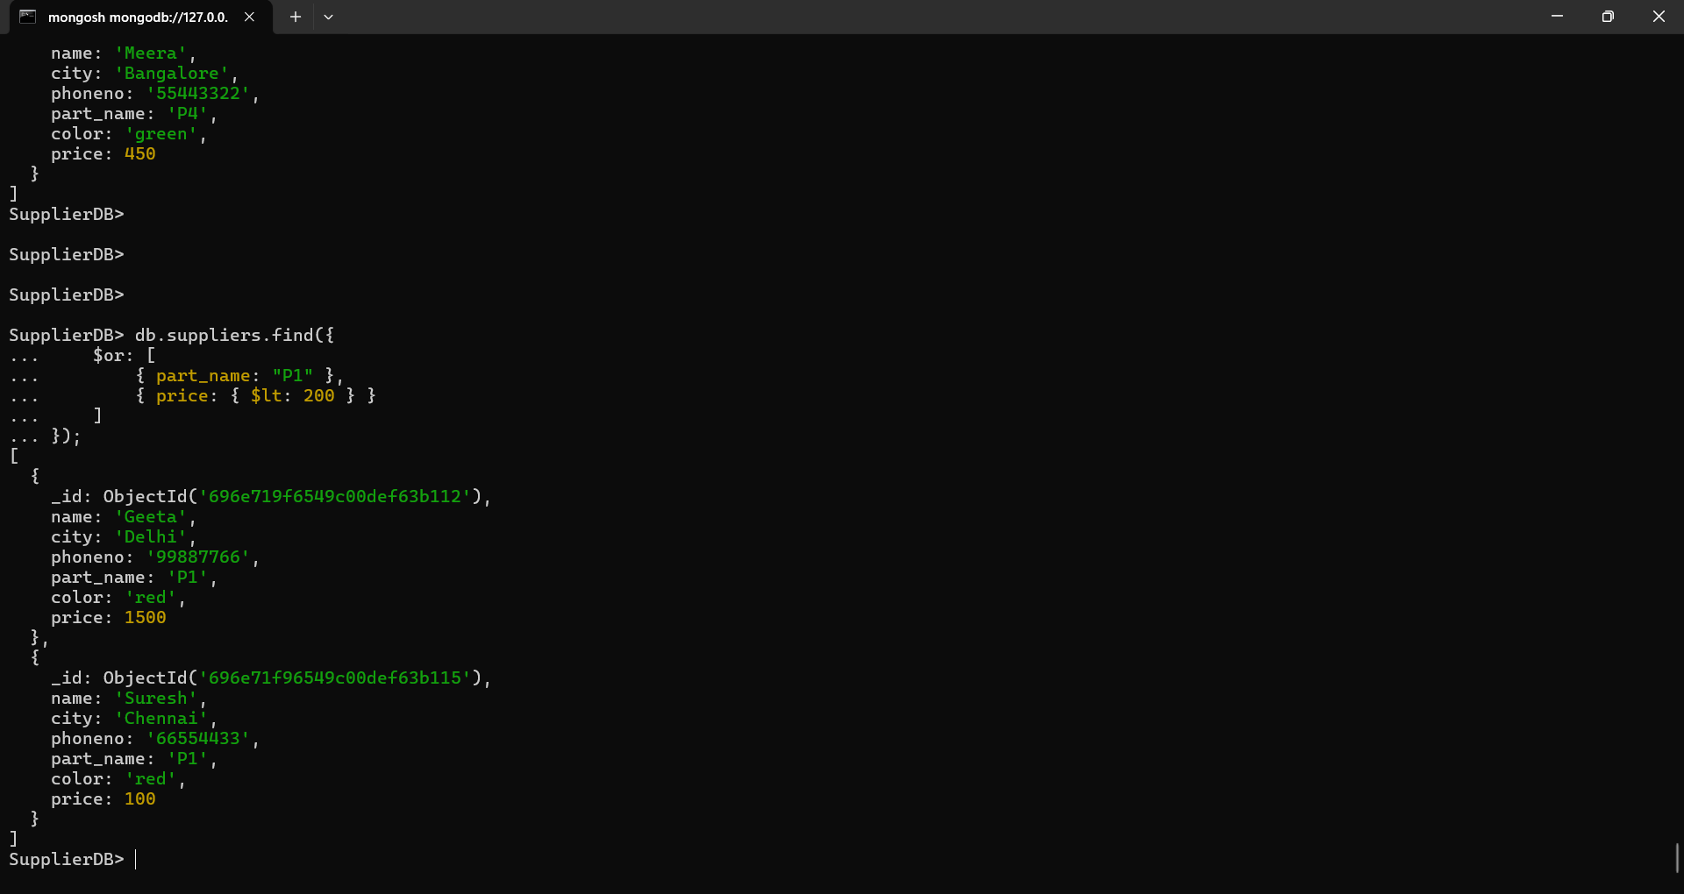

7. Update the record of ‘Geeta’ ,set city = ‘Bombay’ and phoneno = ‘11223344’
OUTPUT:
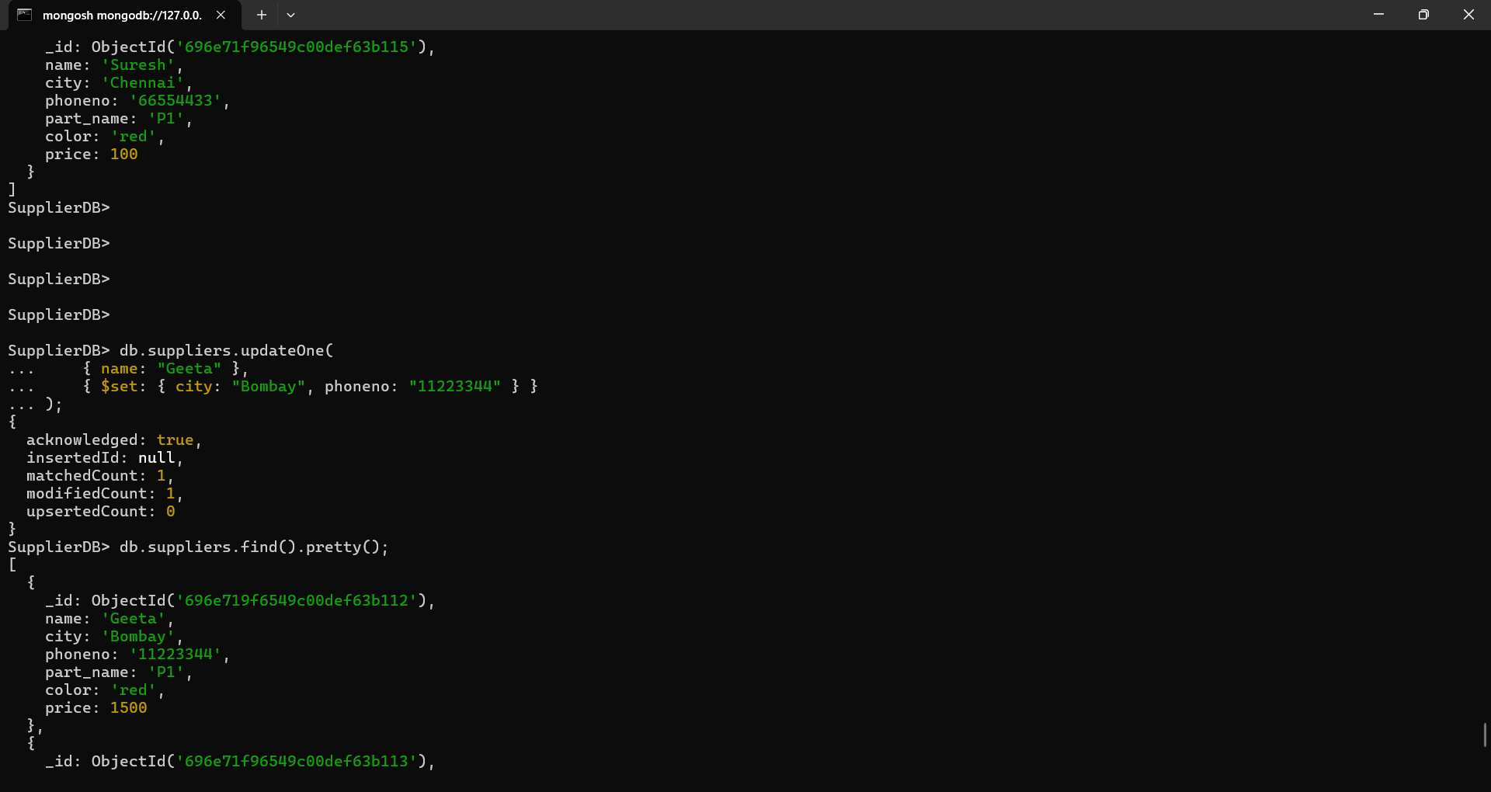

8. Delete all records where price is greater than 5000
OUTPUT:
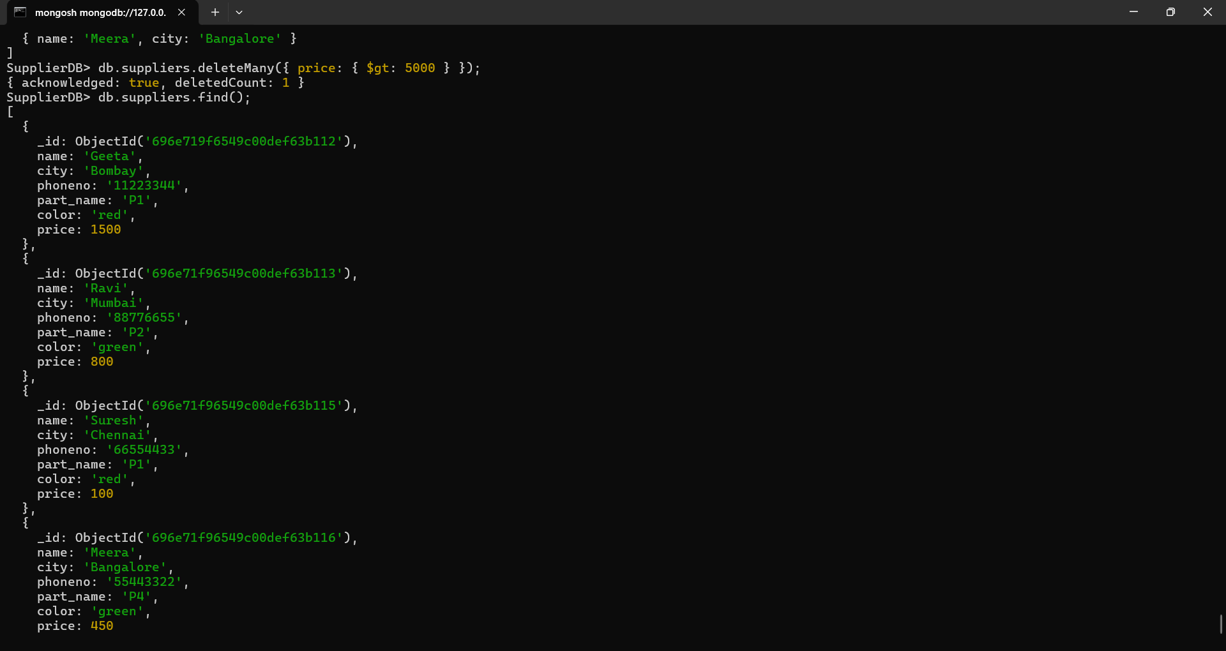
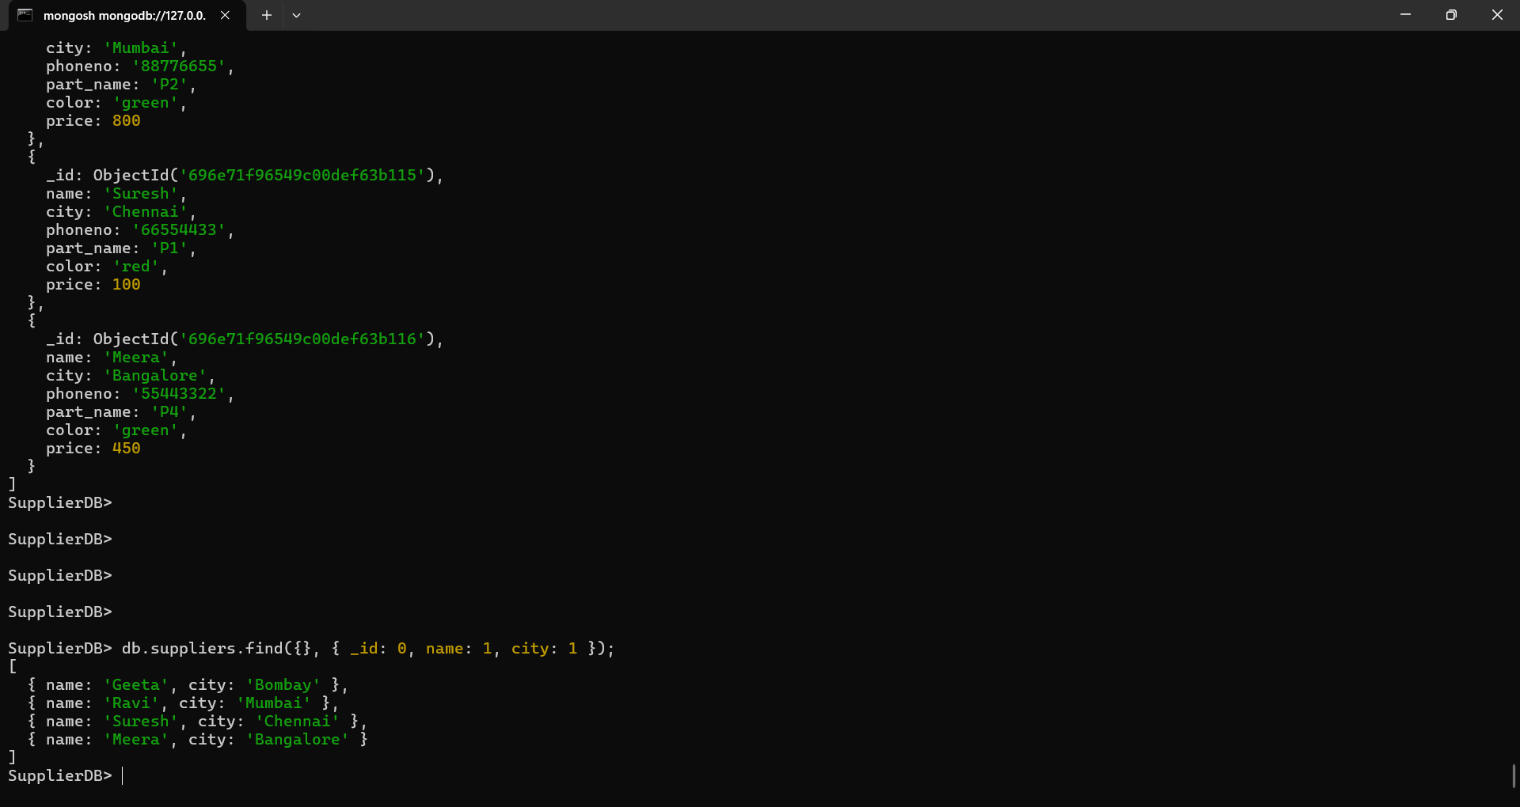
9. Display only the name and city of the supplier
OUTPUT:


10. Sort all suppliers on city and display only the first two records.
OUTPUT:
