MAR ATHANASIOS COLLEGE FOR ADVANCED STUDIES, TIRUVALLA
(MACFAST)
(Affiliated to Mahatma Gandhi University, Kottayam)


MACFAST

MCA CP 107 SOFTWARE DEVELOPMENT LAB-I (C PROGRAMMING) &
C PROJECT

Department of Computer Applications
Mar Athanasios College for Advanced Studies, Tiruvalla (MACFAST)
Kerala, India, Pin-689101
www.macfast.org www.macfast.ac.in

MAR ATHANASIOS COLLEGE FOR ADVANCED STUDIES, TIRUVALLA
(MACFAST)
(Affiliated to Mahatma Gandhi University, Kottayam)

MACFAST
MCA CP 107 SOFTWARE DEVELOPMENT LAB-I (C PROGRAMMING)
& C PROJECT

Name : PRINTO MATHEW
Register No :
Semester : 1
Subject :
Certified that this is a Bonafide record of the practical work done by
Mr. /Ms. ………………………………… Reg.No: ….………………………… in the Department of
Computer Applications during 2025-2027 at Mar Athanasios College for Advanced Studies,
Tiruvalla (MACFAST).

Faculty in Charge Head of the Department

Examiners
1………………………………..
2………………………………..

INDEX

SL.NO | DATE | NAME OF PROGRAM | PAGE NO
1 | 01/10/2025
2

DATE:
PROGRAM – 1
AIM : Program to find the absolute value of a number using the conditional operator.

SOURCE CODE

#include<stdio.h>
#include<conio.h>
void main()
{
int num, absvalue;
clrscr();
printf("Enter a number\n");
scanf("%d",&num);

absvalue = (num < 0)? -num:num;

printf("%d is an absolute value",absvalue);
getch();
}

OUTPUT :
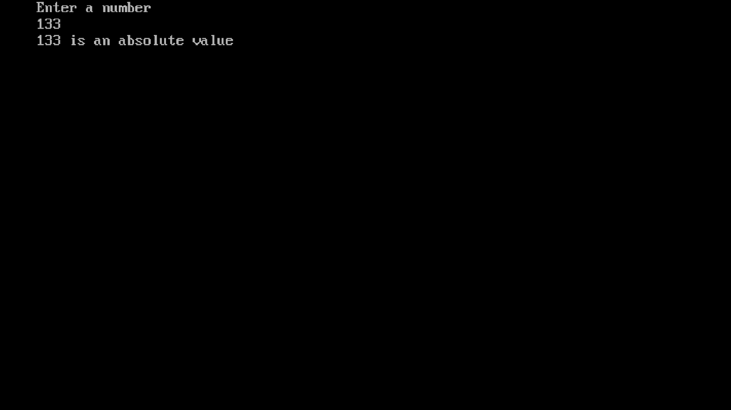

PROGRAM – 2
AIM : Program to check whether the given number is odd or even.

SOURCE CODE
#include <stdio.h>
#include <conio.h>
void main()
{
int a;
clrscr();
printf("Enter a Number\n");
scanf("%d",&a);

if(a%2==0)
{
printf("%d is an even number",a);
}
else
{
printf("%d is an odd number",a);
}

getch();
}

OUTPUT
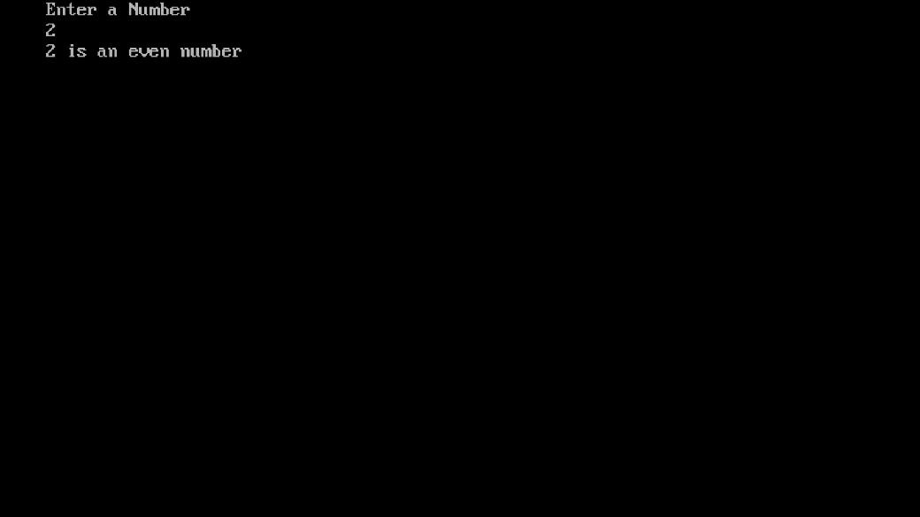
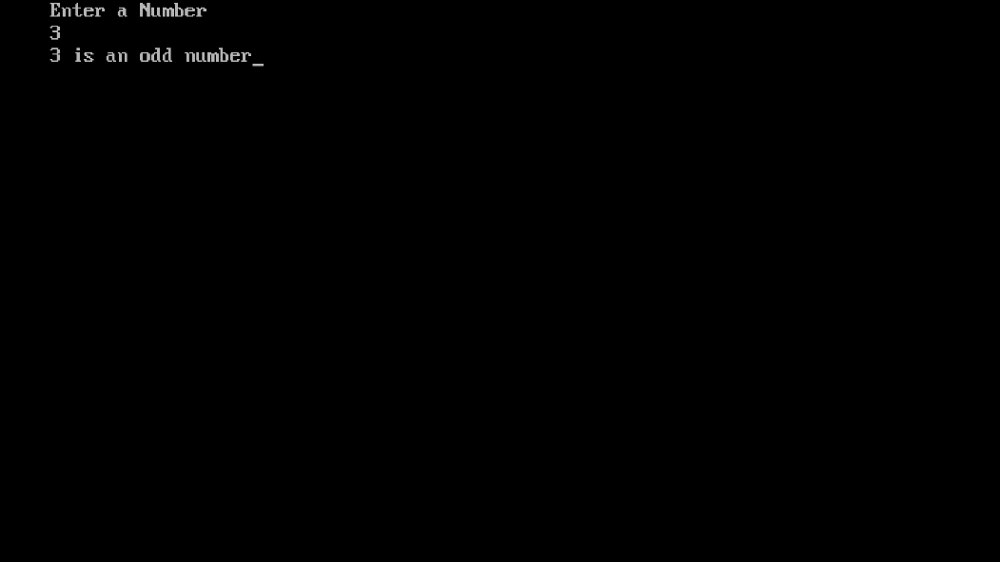
PROGRAM – 3
AIM : Program to calculate the simple interest.

SOURCE CODE
#include<stdio.h>
#include<conio.h>
void main()
{
float P,T,SI,R;
clrscr();
printf("Enter Your initail Amount:\n");
scanf("%f",&P);
printf("Enter Rate of interest:\n");
scanf("%f",&R);
printf("Enter Time (in years):\n");
scanf("%f",&T);

SI =(P*R*T)/100;
printf("Your interest: %f",SI);

getch();
}

OUTPUT
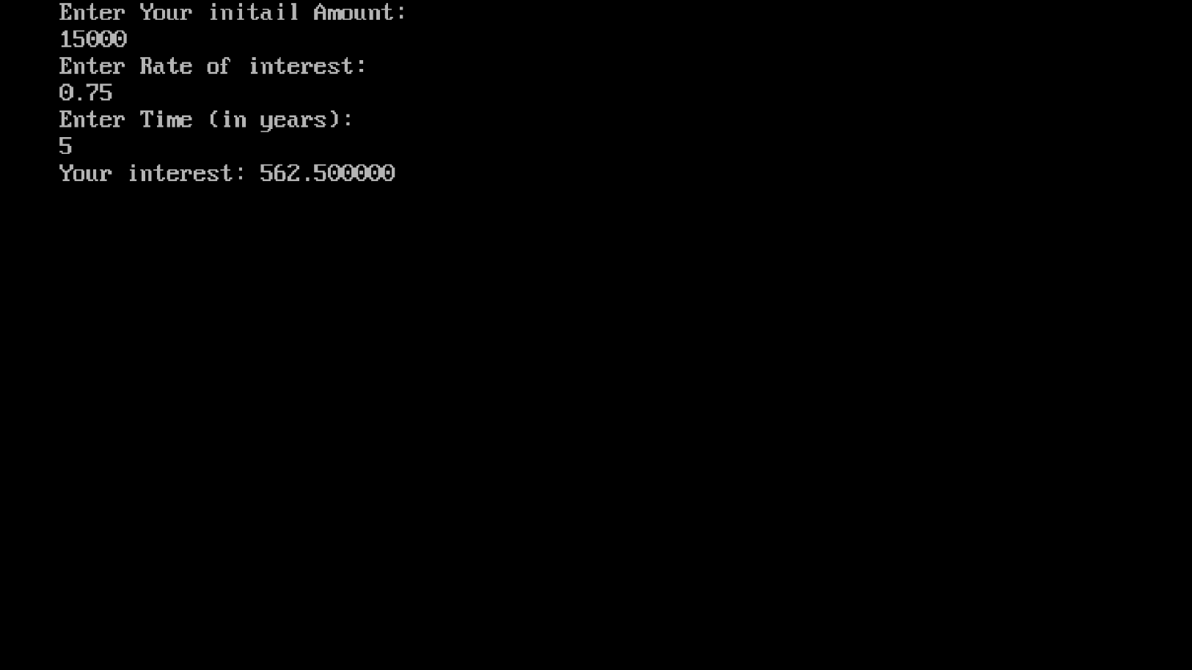
PROGRAM – 4
AIM : Program to interchange the values of 2 variables (swapping).

SOURCE CODE
OUTPUT

PROGRAM – 5
AIM : Program to check whether a year is leap year or not.

SOURCE CODE
OUTPUT

PROGRAM – 6
AIM : Program to calculate the area and perimeter of a circle.
SOURCE CODE
OUTPUT

PROGRAM – 7
AIM : Program to accept temperature in Fahrenheit and convert it to degree Celsius.
SOURCE CODE
OUTPUT

PROGRAM – 8
AIM : Program to find the lowest of three numbers using the nested if concept.
SOURCE CODE
OUTPUT

PROGRAM – 9
AIM : Program to implement the arithmetic operations using switch.

SOURCE CODE
OUTPUT

PROGRAM – 10
AIM : Program to convert decimal number to different bases using switch.

SOURCE CODE
OUTPUT

PROGRAM – 11
AIM : Program to find total and average of 5 marks of a student.
SOURCE CODE
OUTPUT

PROGRAM – 12
AIM : Program to find factorial of a number.
SOURCE CODE
OUTPUT

PROGRAM – 13
AIM : Program to find reverse of a number using while loop.

SOURCE CODE
OUTPUT

PROGRAM – 14
AIM : Program to generate sum of N natural numbers and their squares.
SOURCE CODE
OUTPUT

PROGRAM – 15
AIM : Program to find the occurrences of a digit in a number.
SOURCE CODE
OUTPUT

PROGRAM – 16
AIM : Program to check whether a number is palindrome or not.

SOURCE CODE
OUTPUT

PROGRAM – 17
AIM : Program to print Fibonacci series up to a particular number.

SOURCE CODE
OUTPUT

PROGRAM – 18
AIM : Program to check whether a number is Armstrong or not.

SOURCE CODE
OUTPUT

PROGRAM – 19
AIM : Program to print prime numbers within a given range.
SOURCE CODE
OUTPUT

PROGRAM – 20
AIM : Program to find root of a quadratic equation.

SOURCE CODE
OUTPUT

PROGRAM – 21
AIM : Program to print multiplication table of a number using for loop.
SOURCE CODE
OUTPUT

PROGRAM – 22
AIM : Program to read marks of a student and find their grade according to the mark using else…if ladder.

SOURCE CODE
OUTPUT

PROGRAM – 23
AIM : An electric power distribution company charges its domestic consumers as follows:
CONSUMPTION UNITS | RATE OF CHARGE
0 - 200 | Rs. 0.50 per unit
201 - 400 | Rs. 100 plus Rs. 0.65 per unit excess of 200
401 - 600 | Rs. 230 plus Rs. 0.80 per unit excess of 400
601 and above | Rs. 390 plus Rs. 1.00 per unit excess of 600

Read the customer number and power consumed and prints the amount to be paid by the customer.
SOURCE CODE
OUTPUT

PROGRAM – 24
AIM : Program to find sum of series 1! +2! + 3! …. N! Using functions.

SOURCE CODE
OUTPUT

PROGRAM – 25
AIM : Program to find factorial of a number using recursion.

SOURCE CODE
OUTPUT

PROGRAM – 26
AIM : Program to display alphabet A to Z using loops.

SOURCE CODE
OUTPUT

PROGRAM – 27
AIM : Program to print the pattern
*
* *
* * *
* * * *

SOURCE CODE
OUTPUT

PROGRAM – 28
AIM : Program to read an array of n numbers; find the largest among them and display using functions.

SOURCE CODE
OUTPUT

PROGRAM – 29
AIM : Program to find the sum of two matrices using function.

SOURCE CODE
OUTPUT

PROGRAM – 30
AIM : Program to find the transpose of a matrix using function.

SOURCE CODE
OUTPUT

PROGRAM – 31
AIM : Program to search an element in an array using linear search.

SOURCE CODE
OUTPUT

PROGRAM – 32
AIM : Program to search an element in an array using binary search.

SOURCE CODE
OUTPUT

PROGRAM – 33
AIM : Program to sort N elements in an array using bubble sort.

SOURCE CODE
OUTPUT

PROGRAM – 34
AIM : Program to perform various string handling functions.

SOURCE CODE
OUTPUT

PROGRAM – 35
AIM : Program to read a string and check whether it is palindrome or not.

SOURCE CODE
OUTPUT

PROGRAM – 36
AIM : Program to find the length of a string without using the string handling function strlen().

SOURCE CODE
OUTPUT

PROGRAM – 37
AIM : Program to copy one string to another without using the string handling function.

SOURCE CODE
OUTPUT

PROGRAM – 38
AIM : Program to concatenate one string to another without using the string handling function.

SOURCE CODE
OUTPUT

PROGRAM – 39
AIM : Program to compare two strings without using string handling function.

SOURCE CODE
OUTPUT

PROGRAM – 40
AIM : Program to sort N strings.

SOURCE CODE
OUTPUT

PROGRAM – 41
AIM : Program to swap two numbers using call by value and call by reference.

SOURCE CODE
OUTPUT

PROGRAM – 42
AIM : Program to perform matrix multiplication using pointers.

SOURCE CODE
OUTPUT

PROGRAM – 43
AIM : Program to read a string and calculate the number of vowels in it.

SOURCE CODE
OUTPUT

PROGRAM – 44
AIM : Program to read the personal data (name, address, phone no etc…) of N people and search the details of a particular person using structures and functions.

SOURCE CODE
OUTPUT

PROGRAM – 45
AIM : Program to read and display the contents of a file.

SOURCE CODE
OUTPUT

PROGRAM – 46
AIM : Program to copy one file to another using command line argument.

SOURCE CODE
OUTPUT

PROGRAM – 47
AIM : Program to count the number of words and number of lines in a file using command line argument.

SOURCE CODE
OUTPUT

PROGRAM – 48
AIM : Program to count the number of lower case, upper case and special characters in a file.

SOURCE CODE
OUTPUT

PROGRAM – 49
AIM : Create an employee file, read and display the details on console.

SOURCE CODE
OUTPUT

PROGRAM – 50
AIM : Program to find the mismatch of opening and closing brackets in a file.
SOURCE CODE
OUTPUT

PROGRAM – 51
AIM : Project - Banking Management System

SOURCE CODE
OUTPUT

