MAR ATHANASIOS COLLEGE FOR ADVANCED STUDIES, TIRUVALLA
(MACFAST)

(Affiliated to Mahatma Gandhi University, Kottayam)


MACFAST (AUTONOMOUS)

MCACP107 SOFTWARE DEVELOPMENT LAB-I(C PROGRAMMING)
& C PROJECT

Department of Computer Applications
Mar Athanasios College for Advanced Studies, Tiruvalla
(MACFAST) AUTONOMOUS
Kerala, India, Pin-689101
www.macfast.org www.macfast.ac.in
MAR ATHANASIOS COLLEGE FOR ADVANCED STUDIES, TIRUVALLA
(MACFAST)

(Affiliated to Mahatma Gandhi University, Kottayam)



MACFAST (AUTONOMOUS)

MCACP107 SOFTWARE DEVELOPMENT LAB-I(C PROGRAMMING)
& C PROJECT

Name : PRINTO MATHEW
Register No : 253242210258
Semester : 1
Subject : Software Development Lab-1 (C programming)

Certified that this is a bonafide record of the practical work done by Mr. PRINTO MATHEW Reg.No: 253242210258 in the Department of Computer Applications during 2025-2027 at Mar Athanasios College for Advanced Studies, Tiruvalla ((MACFAST) Autonomous).

Faculty in Charge Head of the Department

Examiners

1……………………………………

2…………………………………….

SL.NO | DATE | NAME OF PROGRAM | PAGE NO
1 | 20/08/2025 | Absolute value of a number using the conditional operator | 7
2 | 20/08/2025 | Check whether the given number is odd or even | 9
3 | 20/08/2025 | Calculate the simple interest. | 11
4 | 25/08/2025 | Swapping of 2 variables | 13
5 | 29/08/2025 | Check whether a year is leap year or not | 15
6 | 29/08/2025 | Calculate the area and perimeter of a circle | 17
7 | 02/09/2025 | Fahrenheit to Celsius Conversion | 19
8 | 02/09/2025 | Smallest among of three numbers using the nested if | 21
9 | 08/09/2025 | Arithmetic operations using switch. | 23
10 | 08/09/2025 | Decimal to base conversion using switch. | 27
11 | 11/09/2025 | Total and average of marks | 35
12 | 11/09/2025 | Factorial of a number | 39
13 | 16/09/2025 | Reverse of a number using while loop | 41
14 | 16/09/2025 | Sum of N natural numbers and their squares | 43
15 | 16/09/2025 | Occurrences of a digit in a number | 45
16 | 19/09/2025 | Check whether a number is palindrome or not | 47
17 | 22/09/2025 | Fibonacci series | 49
18 | 22/09/2025 | Check whether a number is Armstrong or not | 51
19 | 25/09/2025 | Prime numbers within a given range | 53
20 | 25/09/2025 | Root of a quadratic equation | 55
21 | 03/10/2025 | Multiplication table of a number using for loop | 57
22 | 03/10/2025 | Student grade calculation | 59
INDEX

SL.NO | DATE | NAME OF PROGRAM | PAGE NO
23 | 06/10/2025 | Electricity bill calculation | 63
24 | 06/10/2025 | Sum of factorial series using functions | 67
25 | 06/10/2025 | Factorial of a number using recursion | 69
26 | 13/10/2025 | Display alphabet A to Z using loops | 71
27 | 13/10/2025 | Program to print the pattern | 73
28 | 17/10/2025 | Largest element in an array using functions | 75
29 | 17/10/2025 | Sum of two matrices using function | 77
30 | 17/10/2025 | Transpose of a matrix using function | 79
31 | 22/10/2025 | Linear search | 81
32 | 24/10/2025 | Binary search | 83
33 | 03/11/2025 | Bubble sort | 87
34 | 07/11/2025 | String handling operations | 89
35 | 10/11/2025 | Check whether a string is palindrome or not. | 93
36 | 14/11/2025 | String length without strlen() | 95
37 | 14/11/2025 | String copy without strcpy() | 97
38 | 17/11/2025 | String concatenation without strcat() | 99
39 | 19/11/2025 | String comparison without strcmp() | 101
40 | 21/11/2025 | Sorting of strings | 103
41 | 21/11/2025 | Call by value and call by reference | 105
42 | 25/11/2025 | Matrix multiplication using pointers | 107
43 | 28/11/2025 | Vowel count in a string | 111
44 | 01/12/2025 | Personal data using structures | 113

SL.NO | DATE | NAME OF PROGRAM | PAGE NO
45 | 04/12/2025 | File read and display | 117
46 | 08/12/2025 | File copy using command line arguments | 119
47 | 10/12/2025 | Count words and lines in a file | 123
48 | 12/12/2025 | Count character types in a file | 127
49 | 16/12/2025 | Employee file creation and display | 129
50 | 18/12/2025 | Mismatch of brackets in a file | 133
51 | 13/12/2025 | Project – BANKING MANAGEMENT SYSTEM | 137

OUTPUT

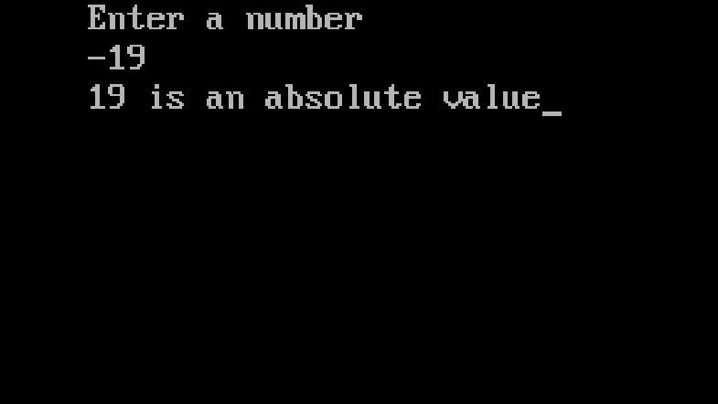

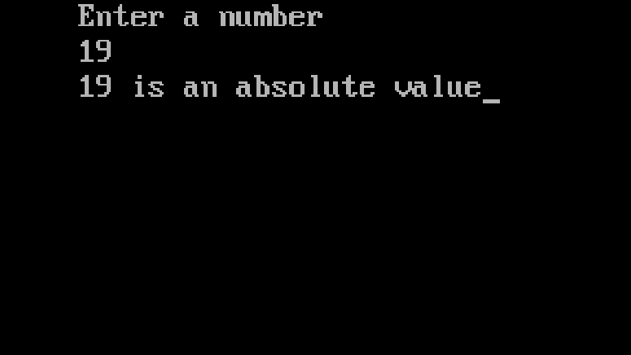

PROGRAM – 1

AIM : Program to find the absolute value using conditional operator.

SOURCE CODE:

#include<stdio.h>
#include<conio.h>
void main()
{
int num, absvalue;
clrscr();
printf("Enter a number\n");
scanf("%d",&num);
absvalue = (num < 0)? -num:num;
printf("%d is an absolute value",absvalue);

getch();
}

OUTPUT

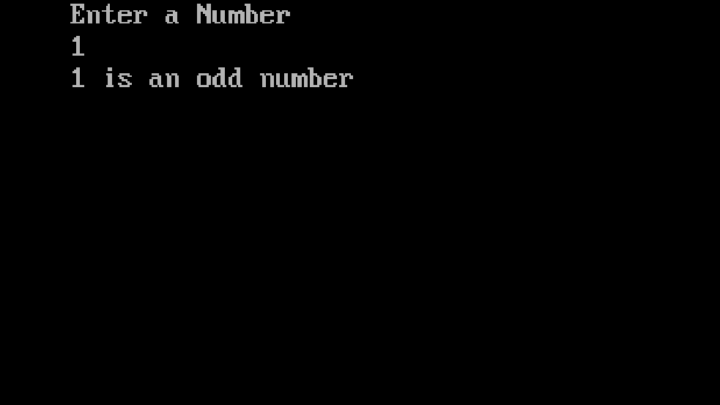

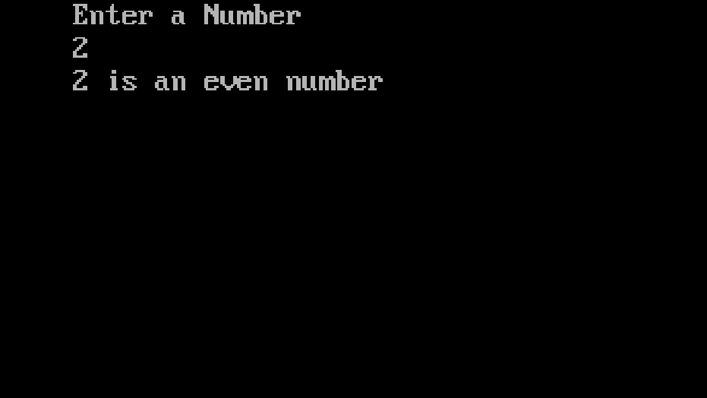

PROGRAM – 2

AIM : Program to check whether the given number is odd or even.

SOURCE CODE:

#include <stdio.h>
#include <conio.h>
void main()
{
int a;
clrscr();
printf("Enter a Number\n");
scanf("%d",&a);

if(a%2==0)
{
printf("%d is an even number",a);
}
else
{
printf("%d is an odd number",a);
}
getch();
}

OUTPUT

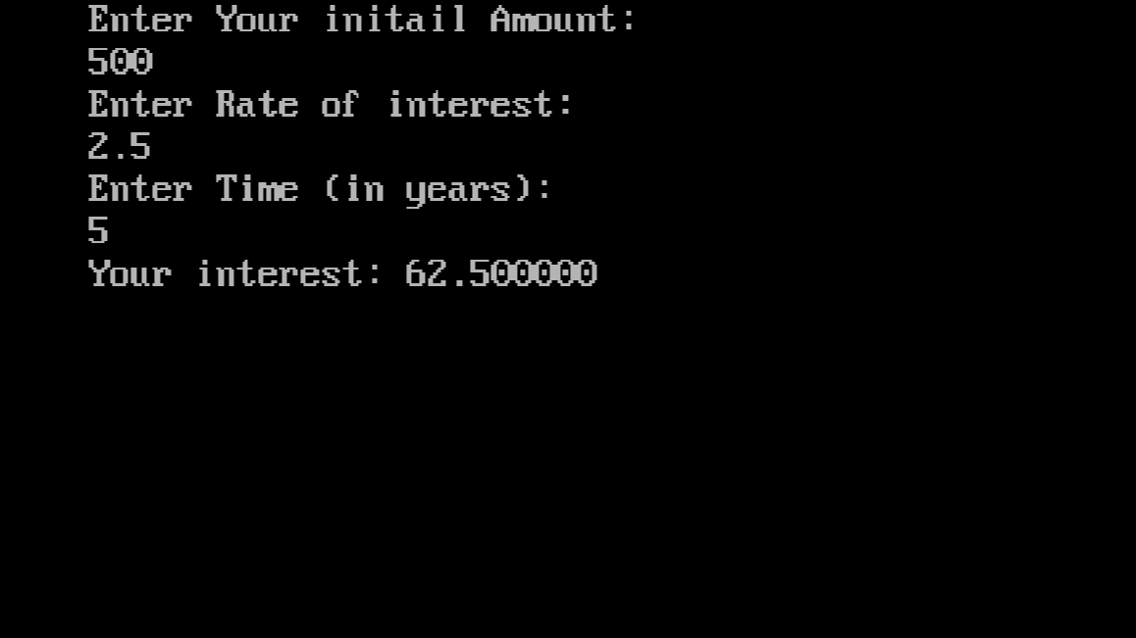

PROGRAM – 3

AIM : Program to find simple interest.

SOURCE CODE:

#include<stdio.h>
#include<conio.h>
void main()
{
float P,T,SI,R;
clrscr();
printf("Enter Your initail Amount:\n");
scanf("%f",&P);
printf("Enter Rate of interest:\n");
scanf("%f",&R);
printf("Enter Time (in years):\n");
scanf("%f",&T);
SI =(P*R*T)/100;
printf("Your interest: %f",SI);
getch();
}

OUTPUT

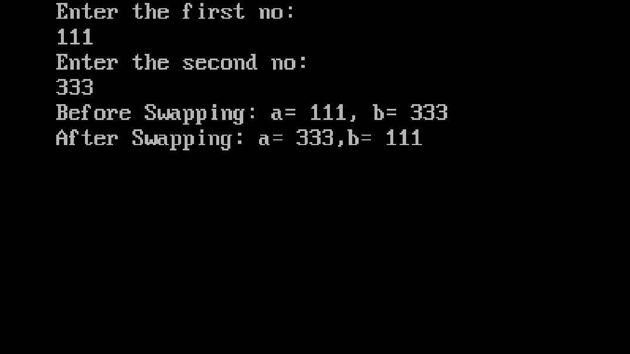

PROGRAM – 4

AIM : Program to interchange the value of 2 variables (swapping).

SOURCE CODE:

#include<stdio.h>
#include<conio.h>
void main()
{
int a,b,temp=0;
clrscr();
printf("Enter the first no:\n");
scanf("%d",&a);
printf("Enter the second no: \n");
scanf("%d",&b);
printf("Before Swapping: a= %d, b= %d\n",a,b);
temp =a;
a=b;
b=temp;
printf("After Swapping: a= %d,b= %d",a,b);
getch();
}

OUTPUT

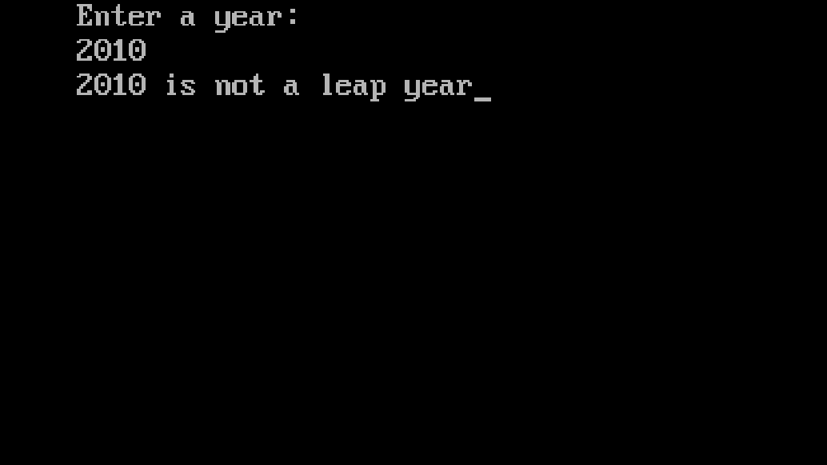

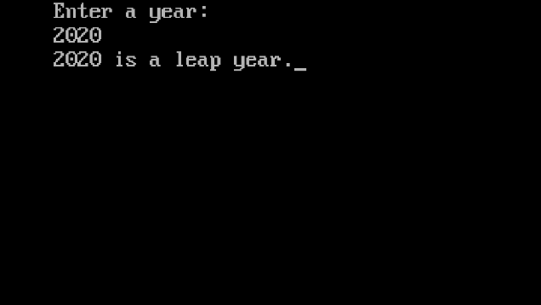

PROGRAM – 5

AIM : Program to check whether a year is a leap year or not.

SOURCE CODE:

#include<stdio.h>
#include<conio.h>
void main()
{
int year;
clrscr();
printf("Enter a year:\n");
scanf("%d",&year);
if((year % 4 == 0) || (year % 400 == 0))
{
printf("%d is a leap year.",year);
}
else{
printf("%d is not a leap year");
}
getch();
}

OUTPUT

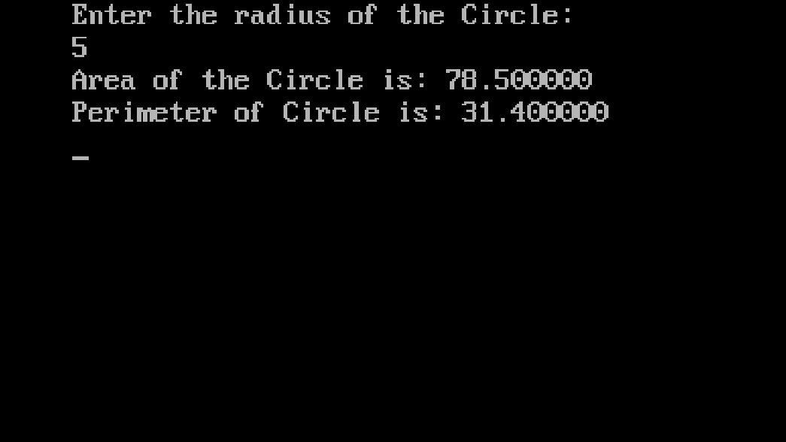

PROGRAM – 6

AIM : Program to calculate the area and perimeter of a circle.

SOURCE CODE:

#include<stdio.h>
#include<conio.h>
#define PI 3.14
void main()
{
float r,perimeter,area;
clrscr();
printf("Enter the radius of the Circle:\n");
scanf("%f",&r);
area = PI * r * r;
perimeter = 2 * PI *r;
printf("Area of the Circle is: %f\n",area);
printf("Perimeter of Circle is: %f\n",perimeter);
getch();
}

OUTPUT

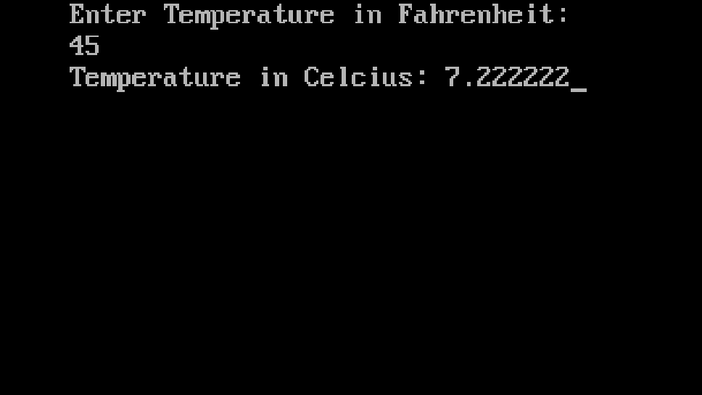

PROGRAM – 7

AIM : Program to accept Temperature in Fahrenheit and convert it to degree celcius.

SOURCE CODE:

#include<stdio.h>
#include<conio.h>
void main()
{
float f,c;
clrscr();
printf("Enter Temperature in Fahrenheit:\n");
scanf("%f",&f);
c = ((f - 32) * 5.0) / 9.0;
printf("Temperature in Celcius: %f",c);
getch();
}

OUTPUT

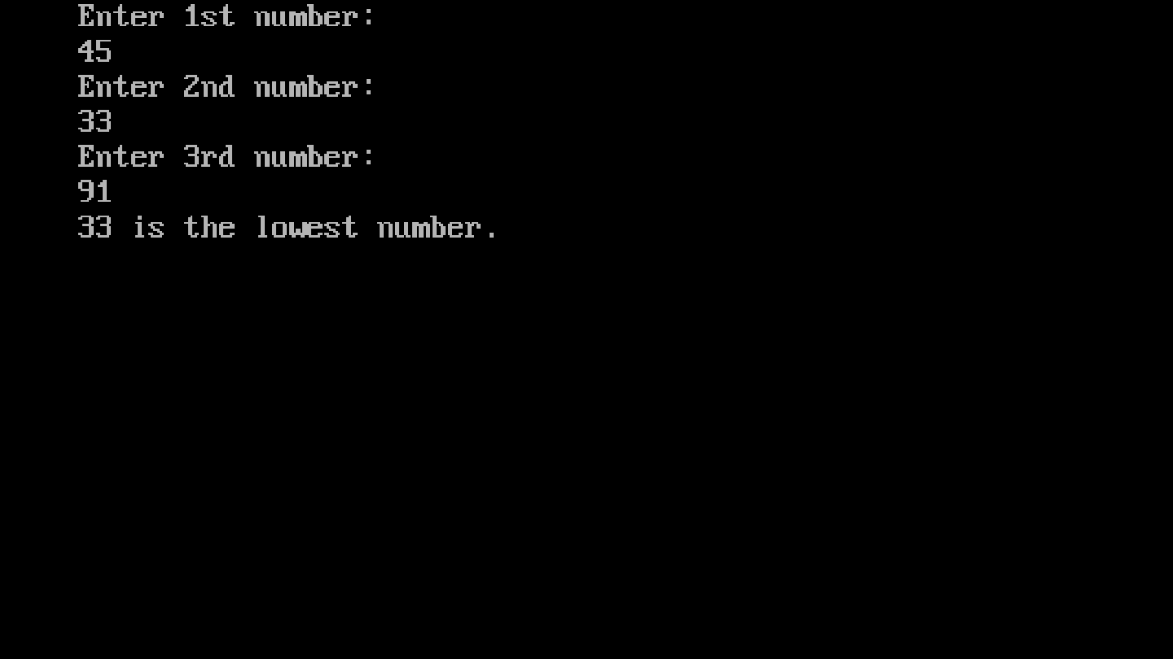

PROGRAM – 8

AIM : Program to find the lowest of 3 numbers using nested if statement.

SOURCE CODE:

#include <stdio.h>
#include <conio.h>
void main()
{
int low, first, second, third;
clrscr();
printf("Enter 1st number:\n");
scanf("%d", &first);
printf("Enter 2nd number:\n");
scanf("%d", &second);
printf("Enter 3rd number:\n");
scanf("%d", &third);
if (first < second)
{
if (first < third)
low = first;
else
low = third;
}
else
{
if (second < third)
low = second;
else
low = third;
}
printf("%d is the lowest number.", low);
getch();
}
OUTPUT

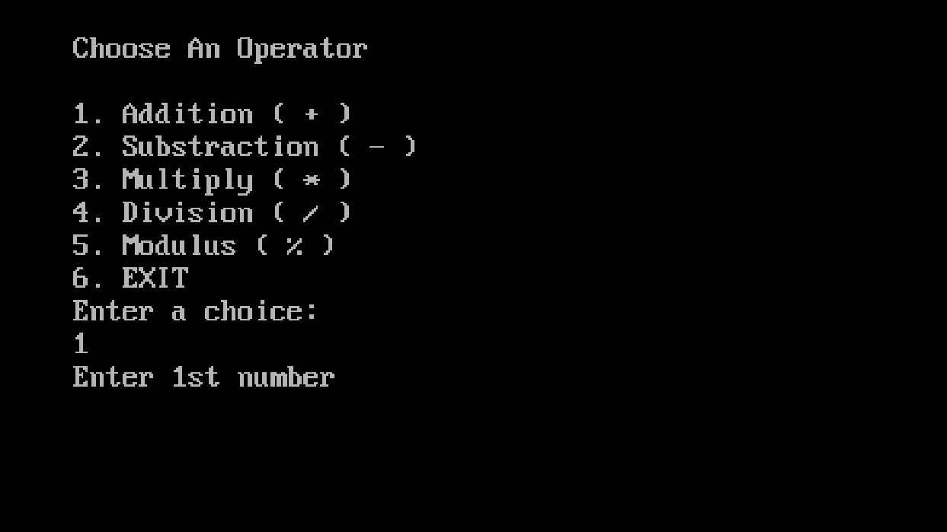

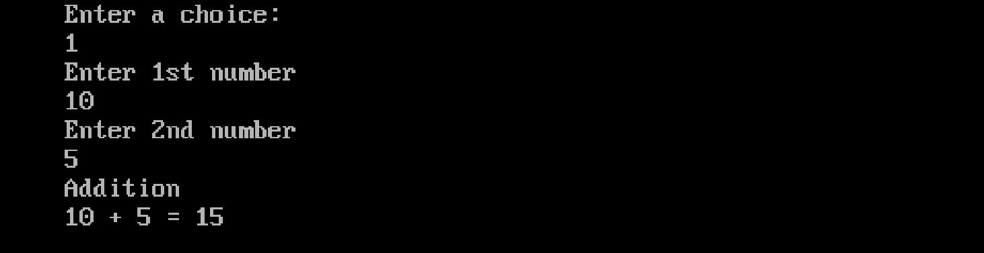

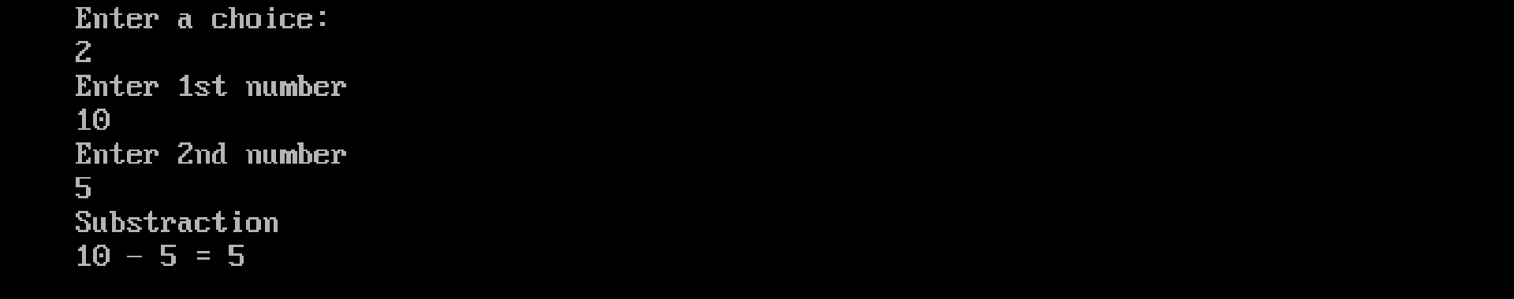

PROGRAM – 9

AIM : Program to implement arithematic operation using switch.

SOURCE CODE:

#include<stdio.h>
#include<conio.h>
#include<stdlib.h>
void main()
{
int choice;
int a,b,sum,product,subtract;
float div,mod;
clrscr();
while(1)
{
printf("\n");
printf("Choose An Operator \n\n");
printf("1. Addition ( + )\n");
printf("2. Substraction ( - )\n");
printf("3. Multiply ( * )\n");
printf("4. Division ( / )\n");
printf("5. Modulus ( % )\n");
printf("6. EXIT \n");
printf("Enter a choice: \n");
scanf("%d",&choice);
if (choice == 6){
exit(0);
}
printf("Enter 1st number\n");
scanf("%d",&a);
printf("Enter 2nd number\n");
scanf("%d",&b);
switch(choice){
OUTPUT

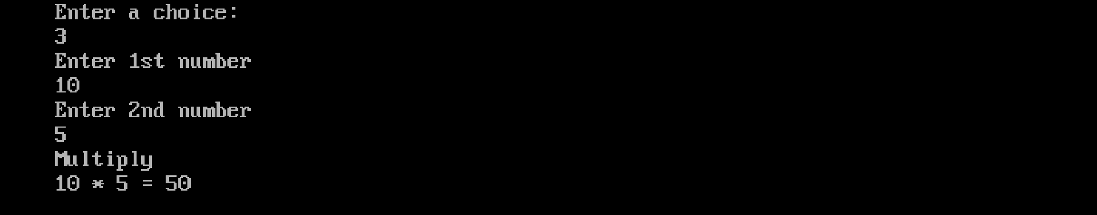

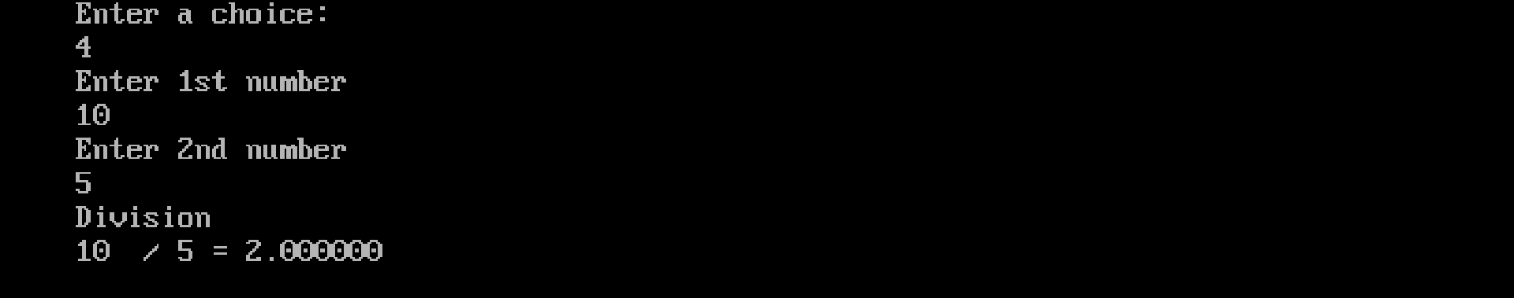

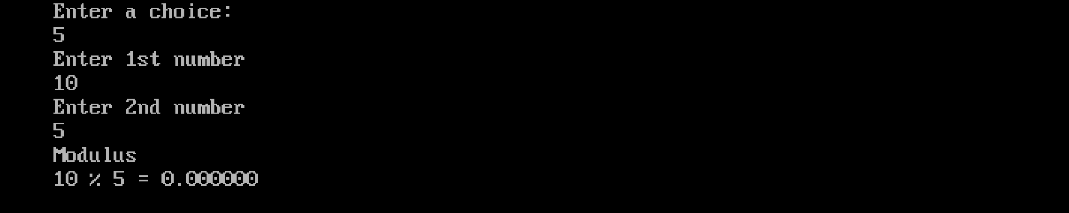

case 1:
printf("Addition\n");
sum = a + b;
printf("%d + %d = %d",a,b,sum);
break;
case 2:
printf("Substraction\n");
subtract = a - b;
printf("%d - %d = %d",a,b,subtract);
break;
case 3:
printf("Multiply\n");
product = a * b;
printf("%d * %d = %d",a,b,product);
break;
case 4:
printf("Division\n");
div = a / b;
printf("%d / %d = %f",a,b,div);
break;
case 5:
printf("Modulus\n");
mod = a % b;
printf("%d %% %d = %f",a,b,mod);
break;
default:
printf("Invalid Input");
}
}
getch();
}

OUTPUT

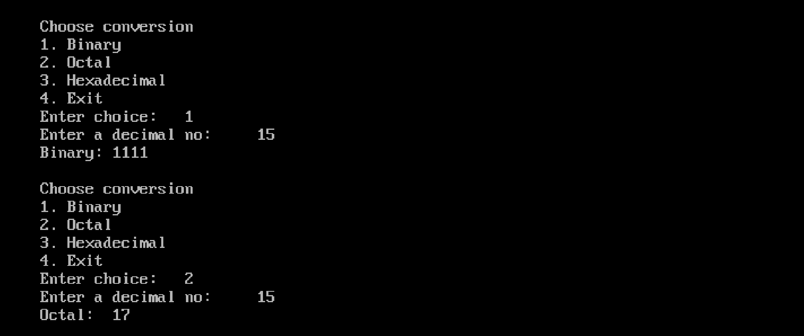



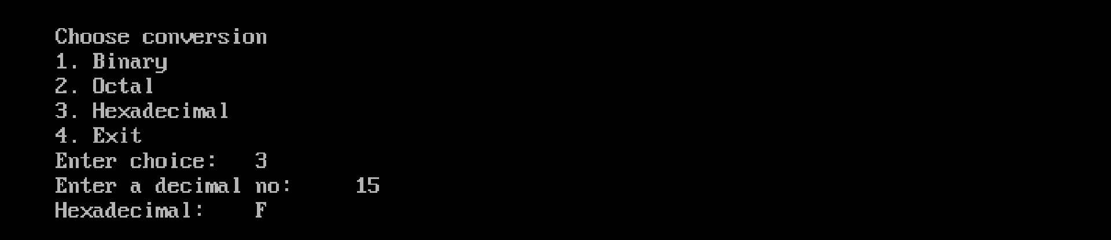

PROGRAM – 10

AIM : Program to convert decimal numbers to different bases using switch.

SOURCE CODE:

#include<stdio.h>
#include<stdlib.h>
void contobin(int num);
void contooct(int num);
void contohexa(int num);
int main()
{
int num, choice;
clrscr();
while (1)
{
printf("\nChoose conversion\n");
printf("1. Binary\n");
printf("2. Octal\n");
printf("3. Hexadecimal\n");
printf("4. Exit\n");
printf("Enter choice:\t");
scanf("%d", &choice);
if(choice != 4){
printf("\Enter a decimal no:\t");
scanf("%d",&num);
}
switch (choice)
{
case 1:
contobin(num);
break;

case 2:
contooct(num);
break;

case 3:
contohexa(num);
break;

case 4:
exit(0);

default:
printf("Invalid choice\n");
}
printf("\n");
}

return 0;
}

void contobin(int num)
{
int bin[32], i = 0, j;

if (num == 0)
{
printf("Binary:\t0\n");
return;
}
while (num > 0)
{
bin[i++] = num % 2;
num /= 2;
}

printf("Binary:\t");
for (j = i - 1; j >= 0; j--)
printf("%d", bin[j]);
}

void contooct(int num)
{
int oct[32], i = 0, j;
if (num == 0)
{
printf("Octal:\t0\n");
return;
}
while (num > 0)
{
oct[i++] = num % 8;
num /= 8;
}
printf("Octal:\t");
for (j = i - 1; j >= 0; j--)
printf("%d", oct[j]);
}

void contohexa(int num)
{
char hex[32];
int i = 0, j, rem;
if (num == 0)
{
printf("Hexadecimal:\t0\n");
return;
}
while (num > 0)
{

rem = num % 16;
hex[i++] = (rem < 10) ? rem + '0' : (rem - 10) + 'A';
num /= 16;
}
printf("Hexadecimal:\t");
for (j = i - 1; j >= 0; j--)
printf("%c", hex[j]);
}

OUTPUT

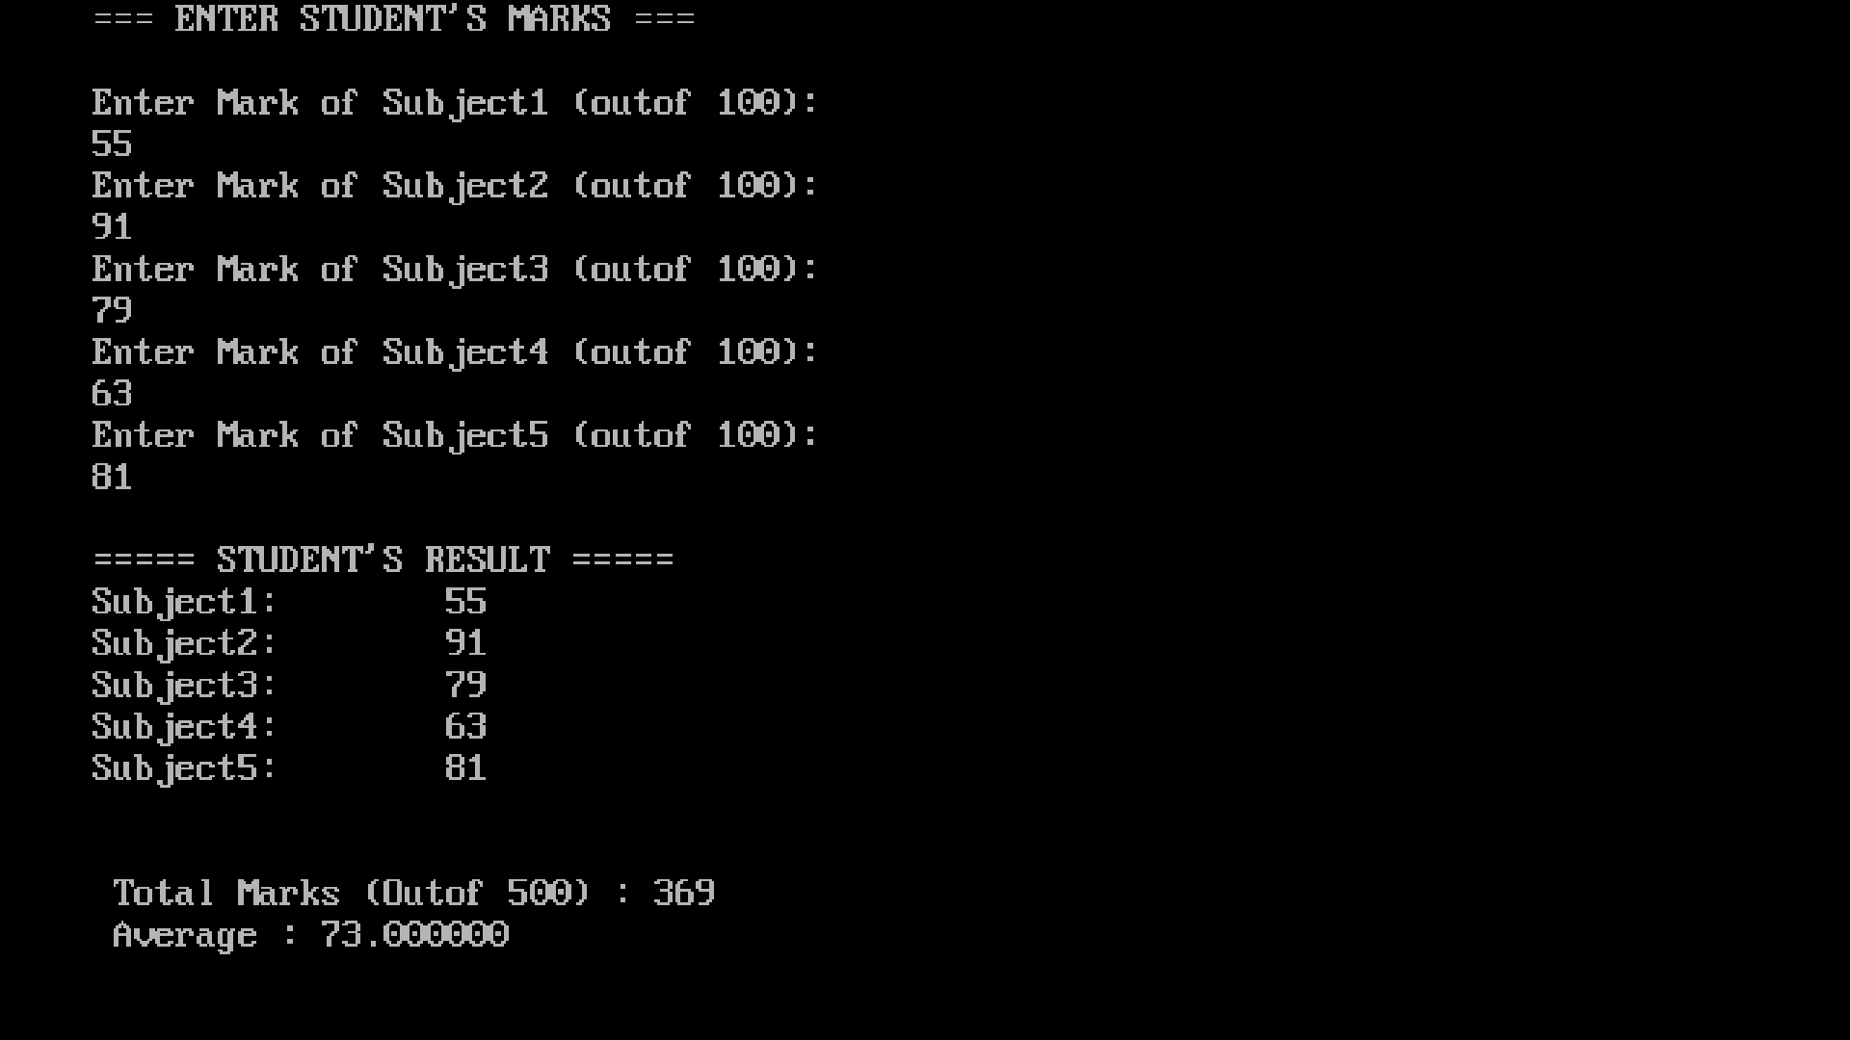

PROGRAM – 11

AIM : Program to find total and avrage of 5 marks of student.

SOURCE CODE:

#include<stdio.h>
#include<conio.h>
void main()
{
int sum;
char name[20];
float avg;
int mark1,mark2,mark3,mark4,mark5;
clrscr();
printf("=== ENTER STUDENT'S MARKS ===\n\n");
printf("Enter Mark of Subject1 (outof 100):\n");
scanf("%d",&mark1);
printf("Enter Mark of Subject2 (outof 100): \n");
scanf("%d",&mark2);
printf("Enter Mark of Subject3 (outof 100): \n");
scanf("%d",&mark3);
printf("Enter Mark of Subject4 (outof 100): \n");
scanf("%d",&mark4);
printf("Enter Mark of Subject5 (outof 100): \n");
scanf("%d",&mark5);
sum = mark1+mark2+mark3+mark4+mark5;
avg = (mark1+mark2+mark3+mark4+mark5)/5;
printf("\n");
printf("===== STUDENT'S RESULT =====\n");
printf("Subject1:\t %d\n",mark1);
printf("Subject2:\t %d\n",mark2);
printf("Subject3:\t %d\n",mark3);
printf("Subject4:\t %d\n",mark4);

printf("Subject5:\t %d\n",mark5);
printf("\n");
printf("\n Total Marks (Outof 500) : %d",sum);
printf("\n Average : %f",avg);
getch();
}

OUTPUT

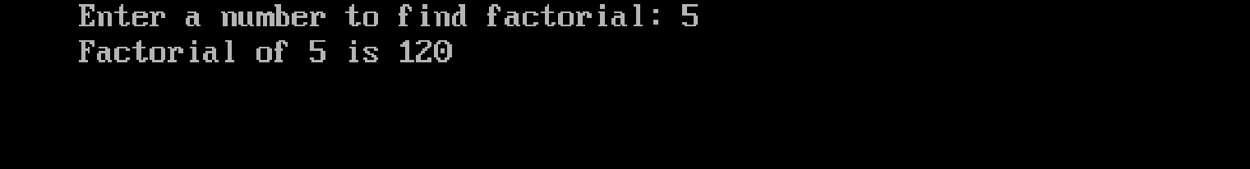

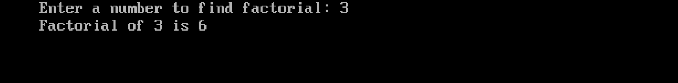

PROGRAM – 12

AIM : Program to find factorial of a number.

SOURCE CODE:

#include<stdio.h>
#include<conio.h>
void main()
{
int i,n,f=1;
clrscr();
printf("Enter a number to find factorial: ");
scanf("%d",&n);

for(i=1;i<=n;i++)
{
f = f * i;
}
printf("Factorial of %d is %d",n,f);
getch();
}

OUTPUT

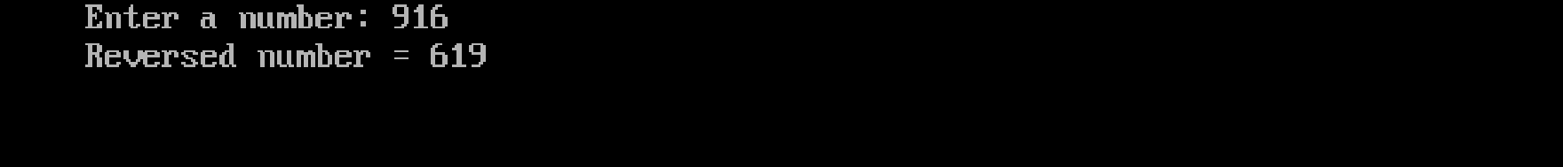

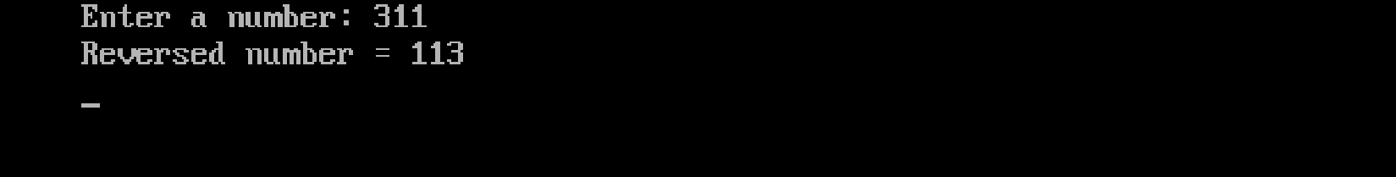

PROGRAM – 13

AIM : Program to find reverse of a number using while loop.

SOURCE CODE:
#include <stdio.h>
#include <conio.h>
void main()
{
int num, reversed = 0, remainder;
printf("Enter a number: ");
scanf("%d", &num);
while (num != 0)
{
remainder = num % 10;
reversed = reversed * 10 + remainder;
num = num / 10;
}
printf("Reversed number = %d\n", reversed);
getch();
}

OUTPUT

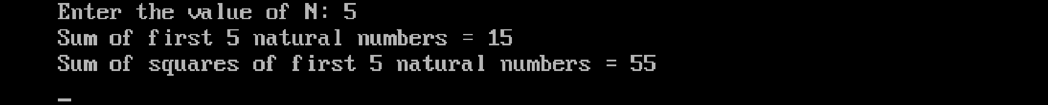

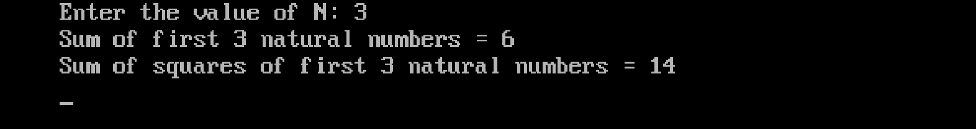

PROGRAM – 14

AIM : Program to generate sum of N natural numbers and their squares

SOURCE CODE:

#include <stdio.h>
#include <conio.h>
void main() {
int n, i;
int sum = 0, squareSum = 0;
clrscr();
printf("Enter the value of N: ");
scanf("%d", &n);

for (i = 1; i <= n; i++) {
sum += i;
squareSum += i * i;
}
printf("Sum of first %d natural numbers = %d\n", n, sum);
printf("Sum of squares of first %d natural numbers = %d\n", n, squareSum);
getch();
}

OUTPUT

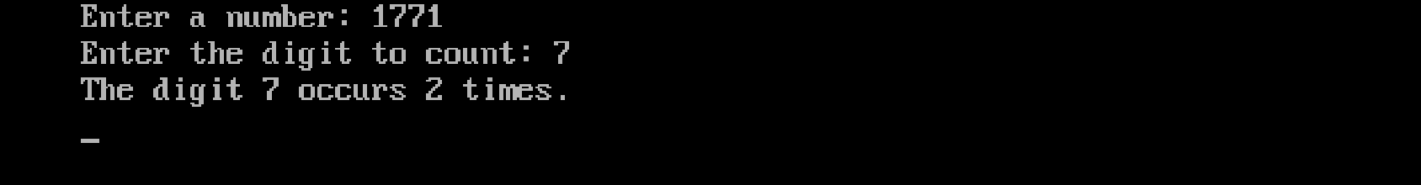

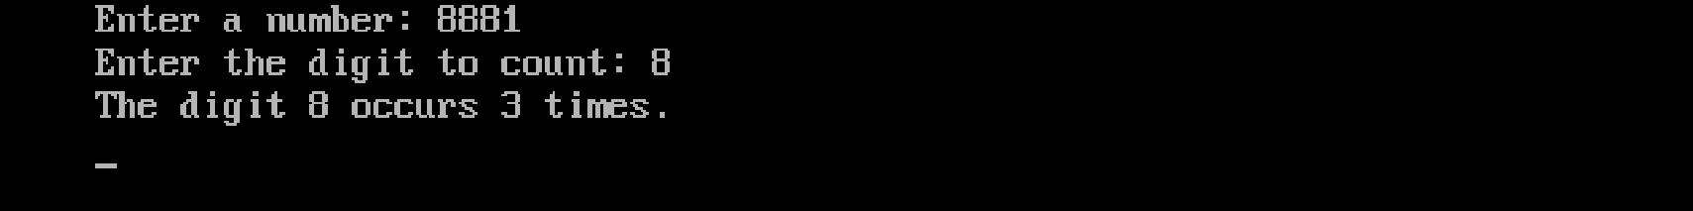

PROGRAM – 15

AIM : Program to find the occurrences of a digit in a number

SOURCE CODE:

#include <stdio.h>
#include <conio.h>
void main() {
int num, digit, count = 0, remainder;
clrscr();
printf("Enter a number: ");
scanf("%d", &num);
printf("Enter the digit to count: ");
scanf("%d", &digit);
while (num != 0) {
remainder = num % 10;
if (remainder == digit)
{
count++;
}
num = num / 10;
}
printf("The digit %d occurs %d times.\n", digit, count);
getch();
}

OUTPUT

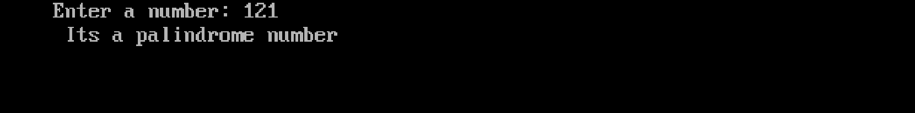

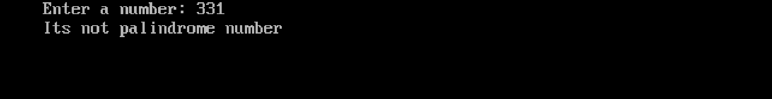

PROGRAM – 16

AIM : Program to check whether a number is palindrome or not.

SOURCE CODE:

#include<stdio.h>
#include<conio.h>
void main()
{
int num,rev=0,rem,temp;
clrscr();
printf("Enter a number: ");
scanf("%d",&num);
temp = num;
while(num > 0)
{
rem = num % 10;
rev = rev * 10 + rem;
num = num /10;
}
if(temp == rev)
printf("palindrome",temp);
else
printf(" not palindrome \n",temp);
getch();
}

OUTPUT

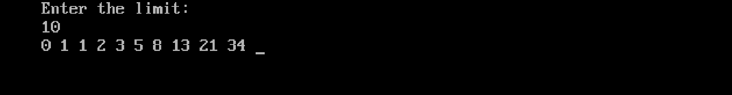
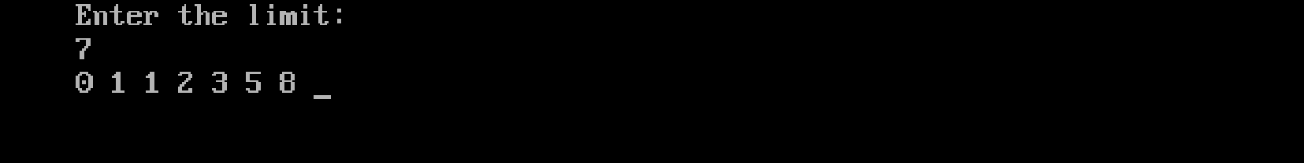

PROGRAM – 17

AIM : Program to print Fibonacci series up to a particular number.

SOURCE CODE:

#include<stdio.h>
#include<conio.h>
void main()
{
int n,i,nextTerm;
int a = 0, b = 1;
printf("Enter the limit: \n");
scanf("%d",&n);
printf("%d %d ",a,b);
for(i = 2; i < n; i++){
nextTerm = a + b;
printf("%d ",nextTerm);
a = b;
b = nextTerm;
}
getch();
}

OUTPUT

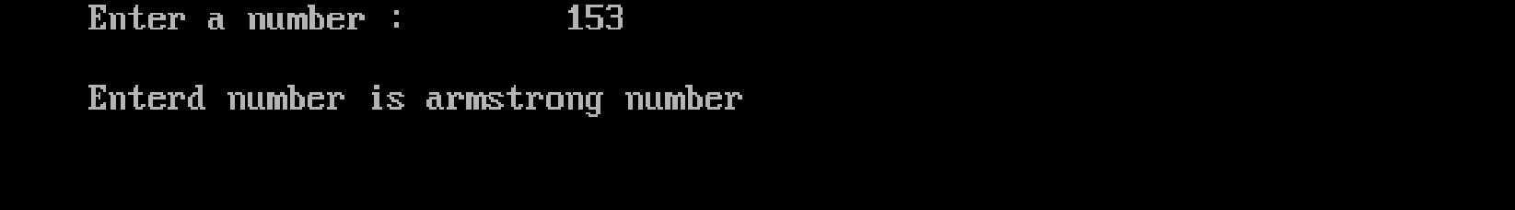

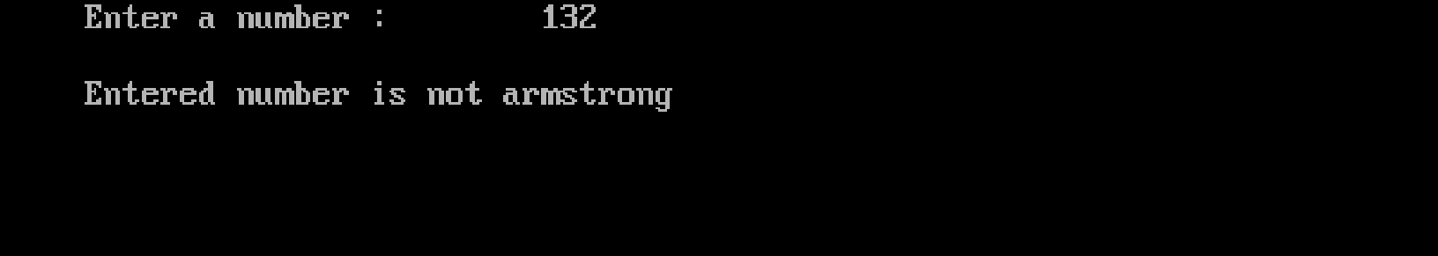

PROGRAM – 18

AIM : Program to check whether a number is Armstrong or not.

SOURCE CODE:

#include<stdio.h>
#include<conio.h>
void main()
{
int num,rem,arm=0,cpy;
clrscr();
printf("Enter a number : \t");
scanf("%d",&num);
cpy=num;
while(num>0)
{
rem=num%10;
arm=arm+(rem*rem*rem);
num=num/10;
}
if(arm==cpy)
printf("Enterd number is armstrong number");
else
printf("Entered number is not armstrong");
getch();
}

OUTPUT

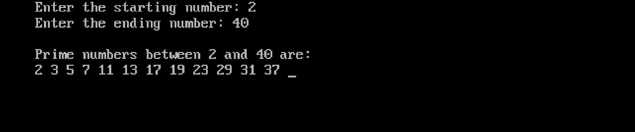

PROGRAM – 19

AIM : Program to print prime numbers within a given range.

SOURCE CODE:

#include<stdio.h>
#include<conio.h>
void main()
{
int start, end, i, j, flag;
clrscr();
printf("Enter the starting number: ");
scanf("%d", &start);
printf("Enter the ending number: ");
scanf("%d", &end);
printf("\nPrime numbers between %d and %d are:\n", start, end);
for(i = start; i <= end; i++)
{
if(i < 2)
continue;
flag = 0;
for(j = 2; j <= i/2; j++)
{
if(i % j == 0)
{
flag = 1;
break;
}
}
if(flag == 0)
printf("%d ", i);
}
getch();
}
OUTPUT

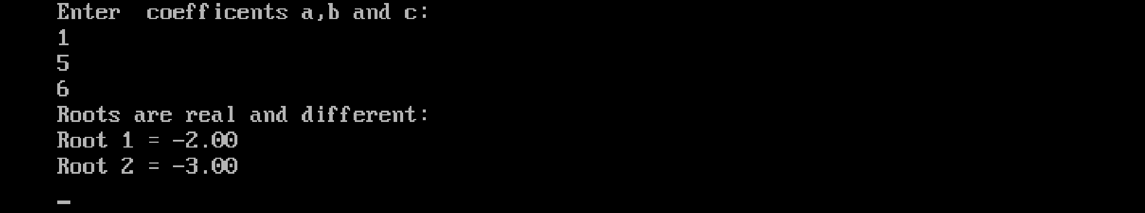
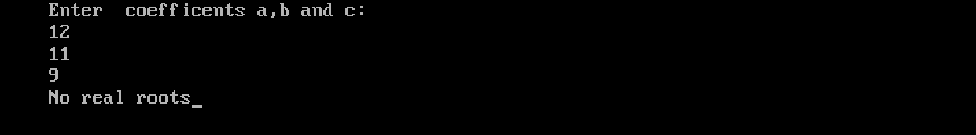

PROGRAM – 20

AIM : Program to find root of a quadratic equation.

SOURCE CODE:

#include<stdio.h>
#include<conio.h>
#include<math.h>
void main()
{
float a,b,c,discri,root1,root2;
clrscr();
printf("Enter coefficents a,b and c: \n");
scanf("%f %f %f",&a,&b,&c);
discri = (b * b) - (4 * a * c);
if(discri >= 0)
{
root1 = ( -b + sqrt(discri)) / (2 * a);
root2 = ( -b - sqrt(discri)) / (2 * a);
printf("Roots are real and different: \n");
printf("Root 1 = %.2f\n",root1);
printf("Root 2 = %.2f\n",root2);
}
else{
printf("No real roots");
}
getch();
}

OUTPUT

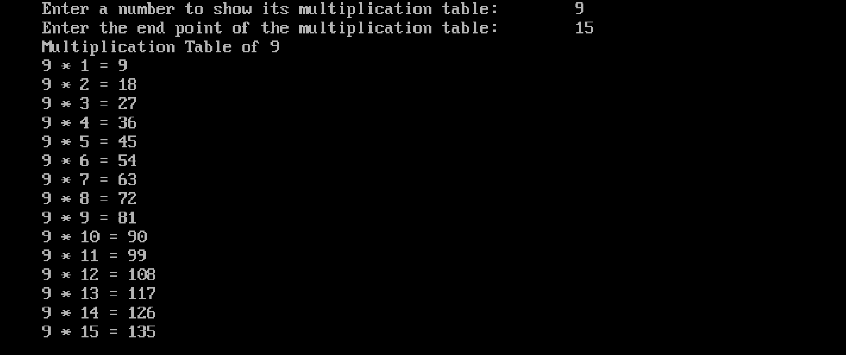

PROGRAM – 21

AIM : Program to print multiplication table of a number using for loop.

SOURCE CODE:

#include<stdio.h>
#include<conio.h>
void main()
{
int num,limit,i,m;
clrscr();
printf("Enter a number to show its multiplication table.");
scanf("%d",&num);
printf("Enter the end point of the multiplication table.");
scanf("%d",&limit);
printf("Multiplication Table of %d",num);
for(i=1;i<=limit;i++)
{
m = num * i;
printf("%d * %d = %d",num,i,m);
}
getch();
}

OUTPUT

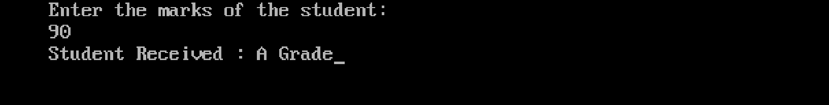

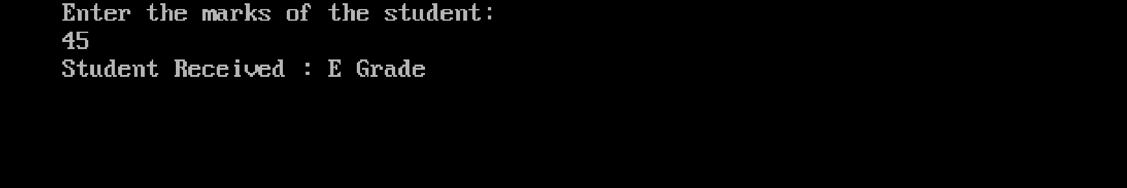

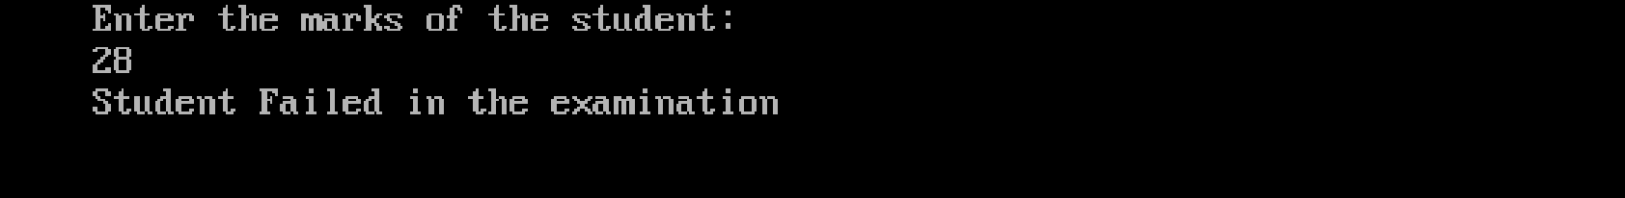

PROGRAM – 22

AIM: Program to read marks of a student and find their grade according to the mark using else…if ladder.

SOURCE CODE:

#include<stdio.h>
#include<conio.h>
void main()
{
int marks;
clrscr();
printf("Enter the marks of the student:\n");
scanf("%d",&marks);
if(marks <= 100)
{
if(marks >= 90 && marks <= 100)
{
printf("Student Received : A Grade");
}
else if(marks >= 80 && marks < 90)
{
printf("Student Received : B Grade");
}
else if(marks >= 70 && marks < 80)
{
printf("Student Received : C Grade");
}
else if(marks >= 60 && marks < 70)
{
printf("Student Received : D Grade");
}
else if(marks >= 35 && marks < 60)
{

printf("Student Received : E Grade");
}
else
{
printf("Student Failed in the examination \n");
}
}
else{
printf("Marks is outof 100.\n Please enter marks within 100");
}

getch();
}

OUTPUT

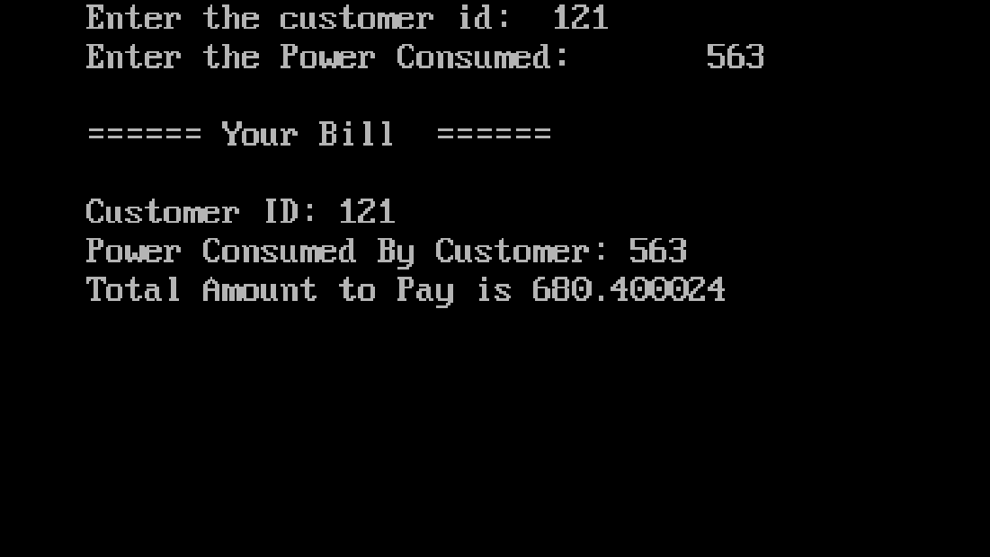

PROGRAM – 23

AIM : An electric power distribution company charges its domestic consumer as follows:

CONSUMMPTION UNITS | RATE OF CHARGE
0 - 200 | Rs: 0.50 per unit
201 - 400 | Rs: 100 plus Rs: 0.65 per unit excess of 200
401 - 600 | Rs: 230 plus Rs: 0.80 per unit excess of 400
601 and above | Rs: 390 plus Rs: 1.00 per unit excess of 600

Read the customer number and power consumed and prints the amount to be paid by the customer.

SOURCE CODE:

#include<stdio.h>
#include<conio.h>
void main()
{
int cust_no,units;
float amount;
clrscr();
printf("Enter the customer id: \t");
scanf("%d",&cust_no);
printf("Enter the Power Consumed: \t");
scanf("%d",&units);
if(units > 0 && units <= 200)
{
amount = units * 0.50;
}
else if(units >= 201 && units <= 400)
{
amount = (units * 0.65) + 100;
}
else if(units >=401 && units <= 600)

{
amount = (units * 0.80) + 230;
}
else if(units >=601)
{
amount = (units * 1.00) + 390;
}
else
{
printf("Invalid Input ");
}
printf("\n");
printf("====== Your Bill ======");
printf("\n");
printf("\nCustomer ID: %d",cust_no);
printf("\nPower Consumed By Customer: %d",units);
printf("\nTotal Amount to Pay is %f",amount);
getch();
}

OUTPUT

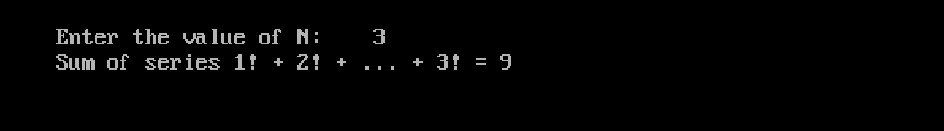

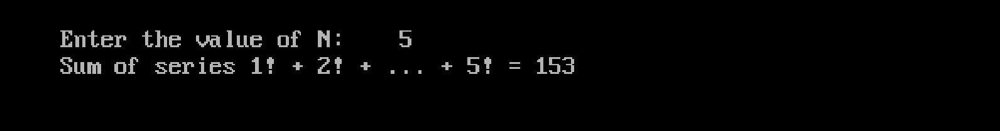

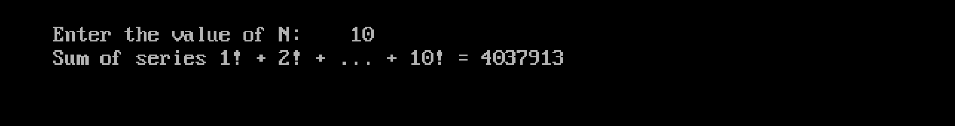

PROGRAM – 24

AIM : Program to find sum of series 1! + 2! + 3! ...... N! Using Function.

SOURCE CODE:

#include<stdio.h>
#include<conio.h>
long factorial(int n) {
long long fact = 1;
int i;
for (i = 1; i <= n; i++) {
fact = fact * i;
}
return fact;
}
long sumOfSeries(int N) {
long sum = 0;
int i;
for (i = 1; i <= N; i++) {
sum += factorial(i);
}
return sum;
}
void main() {
int N;
long result;
clrscr();
printf("\n");
printf("Enter the value of N:\t ");
scanf("%d", &N);
result = sumOfSeries(N);
printf("Sum of series 1! + 2! + ... + %d! = %lld\n", N, result);
getch();
}

OUTPUT

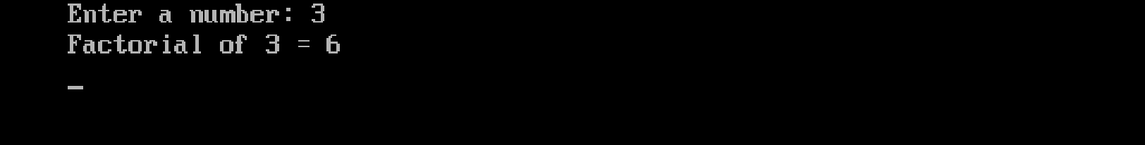

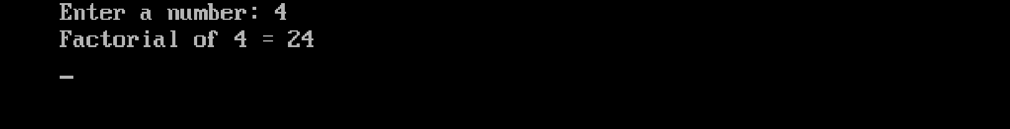

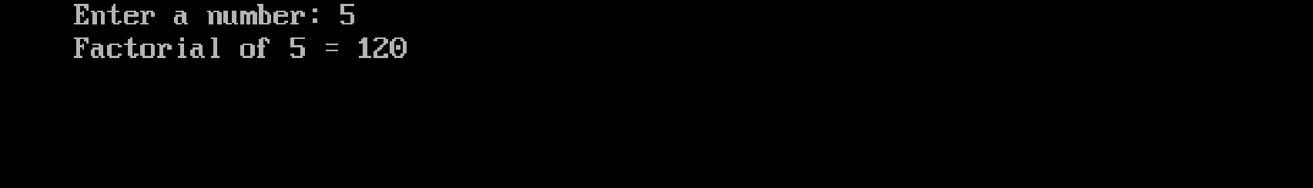

PROGRAM – 25

AIM : Program to find factorial of a number using recursion.

SOURCE CODE:

#include <stdio.h>
#include <conio.h>
long factorial(int n) {
if (n == 0 || n == 1) {
return 1;
}
return n * factorial(n - 1);
}
void main() {
int num;
clrscr();
printf("Enter a number: ");
scanf("%d", &num);
if (num < 0) {
printf("Factorial of negative numbers is not defined.\n");
} else {
printf("Factorial of %d = %lld\n", num, factorial(num));
}
getch();
}

OUTPUT

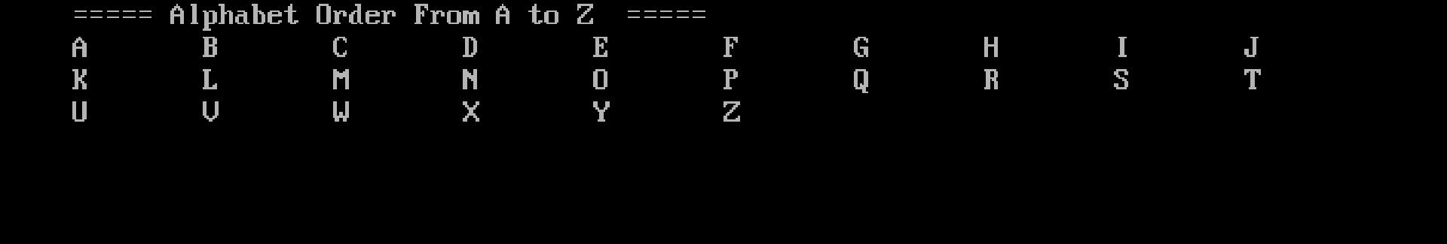

PROGRAM – 26

AIM : Program to display alphabet A to Z using loops.

SOURCE CODE:

#include<stdio.h>
#include<conio.h>
void main()
{
char i;
clrscr();
printf("===== Alphabet Order From A to Z =====\n");
for(i='A';i<='Z';i++)
{
printf("%c\t",i);
}
getch();
}

OUTPUT

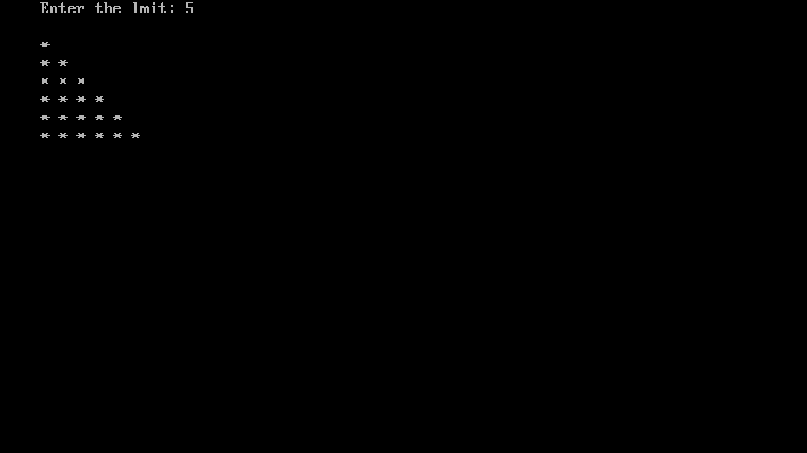
PROGRAM – 27

AIM : Program to print the pattern.

*
* *
* * *
* * * *

SOURCE CODE:

#include<stdio.h>
#include<conio.h>
void main()
{
int i,j,n;
clrscr();
printf("Enter the lmit:\t");
scanf("%d",&n);
printf("\n");
for(i=0;i<=n;i++)
{
for(j=0;j<=i;j++)
{
printf("* ");
}
printf("\n");
}
getch();
}

OUTPUT

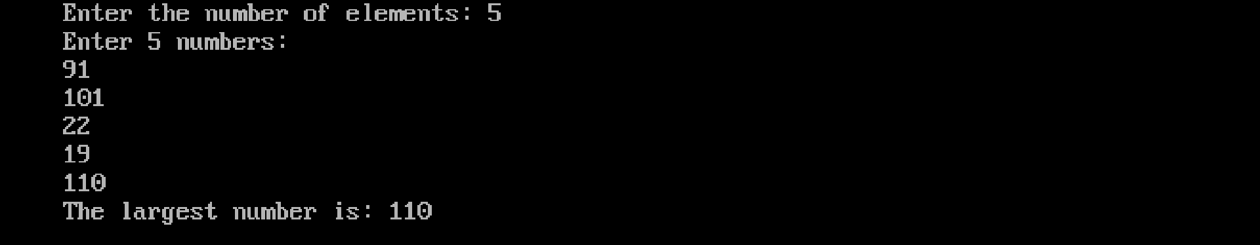
PROGRAM – 28

AIM : Program to read an array of n numbers; find the largest amoung them and display using functions.

SOURCE CODE:

#include <stdio.h>
#include <conio.h>
int findLargest(int arr[], int n) {
int i, max = arr[0];
for (i = 1; i < n; i++) {
if (arr[i] > max) {
max = arr[i];
}
}
return max;
}
void main() {
int n, i;
printf("Enter the number of elements: ");
scanf("%d", &n);
int arr[n];
printf("Enter %d numbers:\n", n);
for (i = 0; i < n; i++) {
scanf("%d", &arr[i]);
}
int largest = findLargest(arr, n);
printf("The largest number is: %d\n", largest);
getch();
}

OUTPUT

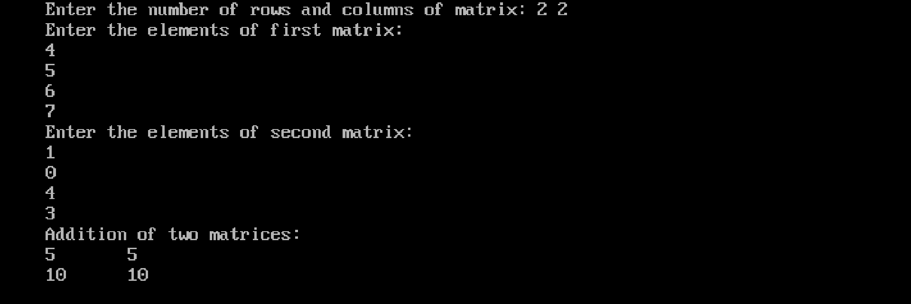

PROGRAM – 29

AIM: Program to find the sum of two matrices using function.

SOURCE CODE:

#include<stdio.h>
#include<conio.h>
void addition(int r,int c,int a[10][10],int b[10][10]);
void main() {
int r, c, a[10][10], b[10][10],i, j;
printf("Enter the number of rows and columns of matrix: ");
scanf("%d %d",&r,&c);
printf("Enter the elements of first matrix:\n");
for (i = 0; i < r; i++)
for (j = 0; j < c; j++)
scanf("%d", &a[i][j]);
printf("Enter the elements of second matrix:\n");
for (i = 0; i < r; i++)
for (j = 0; j < c; j++)
scanf("%d", &b[i][j]);
addition(r,c,a,b);
getch();
}
void addition(int r,int c,int a[10][10],int b[10][10])
{ int add[10][10],i,j;
for (i = 0; i < r; i++)
for (j = 0; j < c; j++)
add[i][j] = a[i][j] + b[i][j];
printf("Addition of two matrices: \n");
for (i = 0; i < r; i++){
for (j = 0; j < c; j++)
printf("%d\t", add[i][j]);
printf("\n");
}
OUTPUT

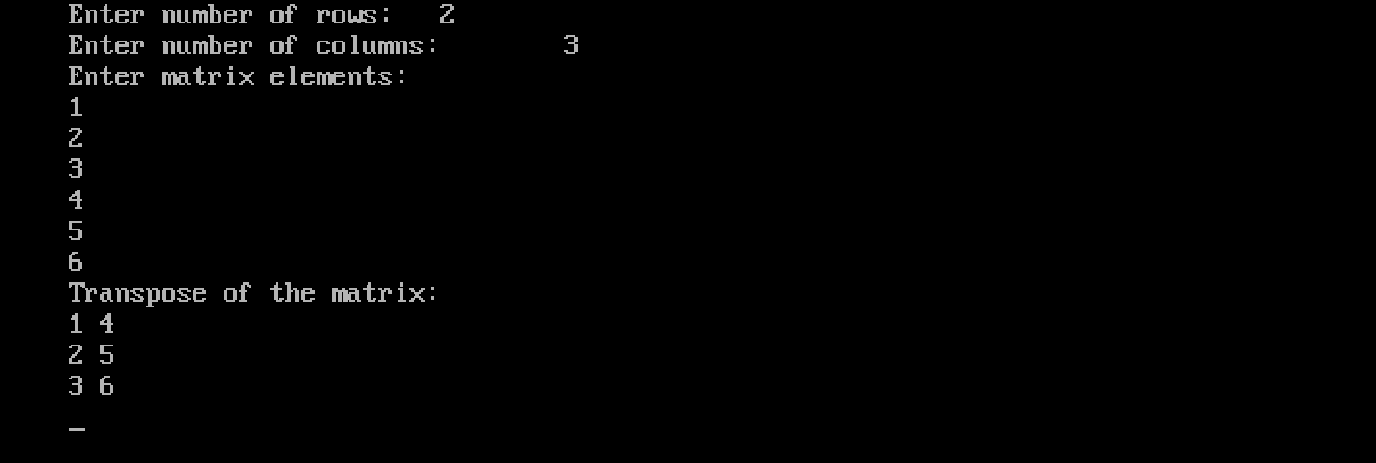

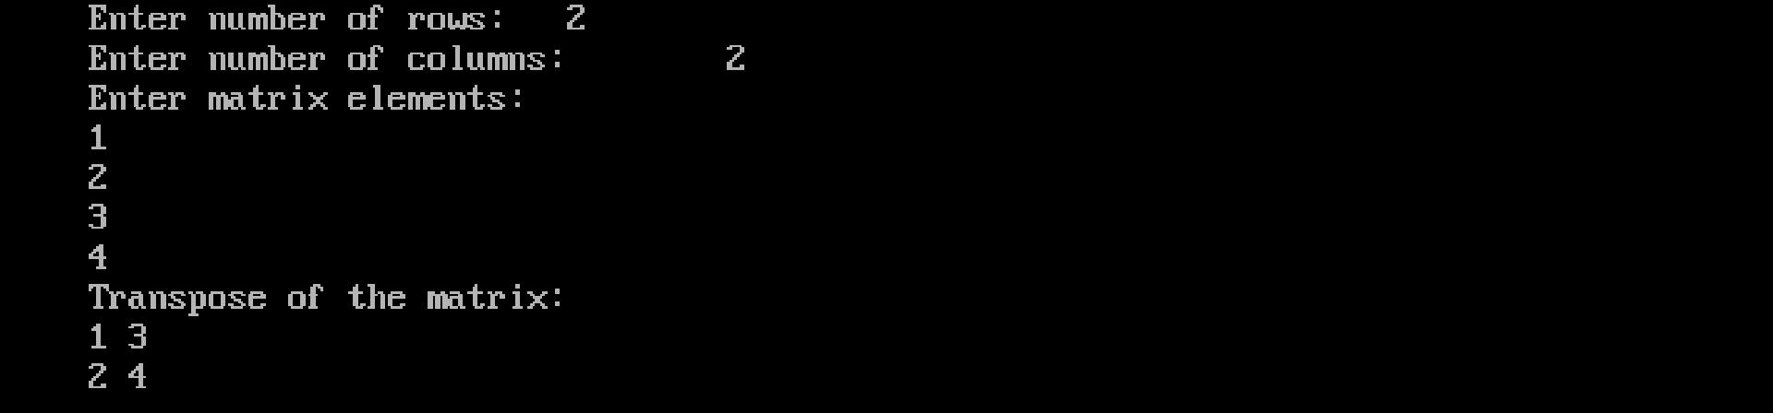

PROGRAM – 30

AIM: Program to find the transpose of a matrix using function.

SOURCE CODE:

#include<stdio.h>
#include<conio.h>
void transpose(int a[10][10], int r, int c) {
int t[10][10], i, j;
for(i = 0; i < r; i++) {
for(j = 0; j < c; j++) {
t[j][i] = a[i][j];
} }
printf("Transpose of the matrix:\n");
for(i = 0; i < c; i++) {
for(j = 0; j < r; j++) {
printf("%d ", t[i][j]);
}
printf("\n");
}}
void main() {
int a[10][10], r, c, i, j;
printf("Enter number of rows: \t");
scanf("%d", &r);
printf("Enter number of columns: \t");
scanf("%d", &c);
printf("Enter matrix elements:\n");
for(i = 0; i < r; i++) {
for(j = 0; j < c; j++) {
scanf("%d", &a[i][j]);
} }
transpose(a, r, c);
getch();
}
OUTPUT

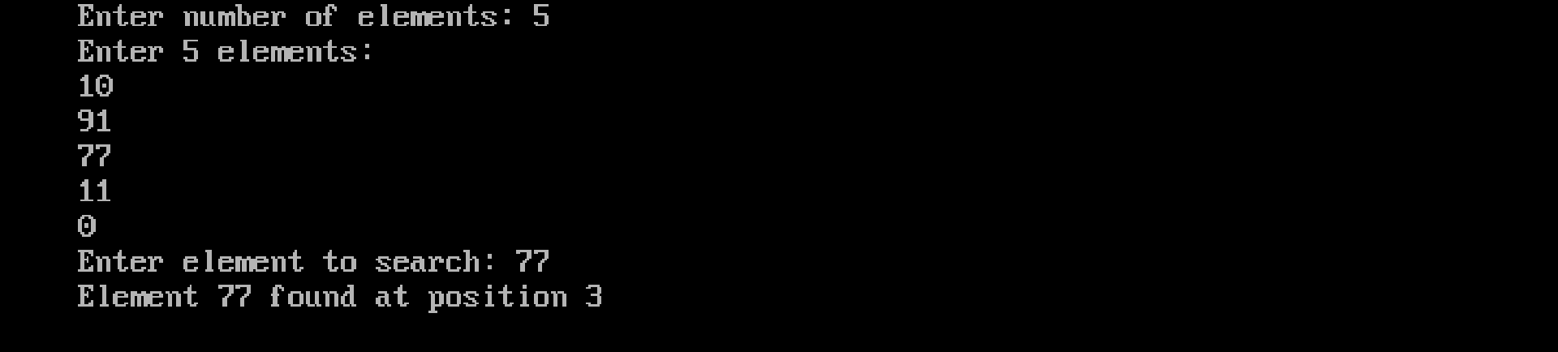

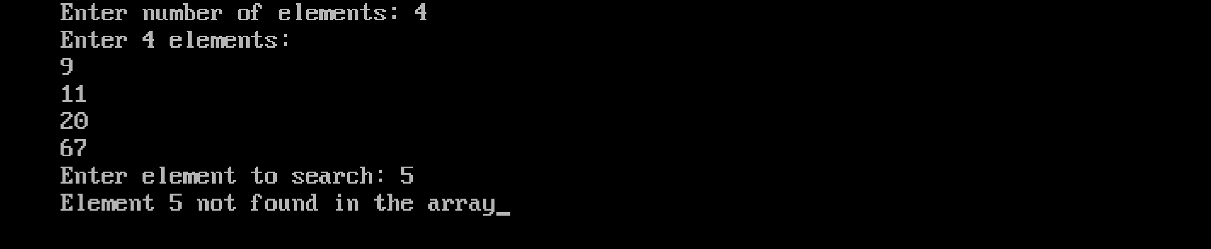

PROGRAM – 31

AIM: Program to search an element in an array using linear search.

SOURCE CODE:

#include<stdio.h>
#include<conio.h>
void main()
{
int a[50], n, key, i, found = 0;
printf("Enter number of elements: ");
scanf("%d", &n);
printf("Enter %d elements:\n", n);
for (i = 0; i < n; i++)
{
scanf("%d", &a[i]);
}
printf("Enter element to search: ");
scanf("%d", &key);
for (i = 0; i < n; i++)
{
if (a[i] == key)
{
printf("Element %d found at position %d", key, i + 1);
found = 1;
break;
}
}
if (found == 0)
printf("Element %d not found in the array", key);
getch();
}

OUTPUT

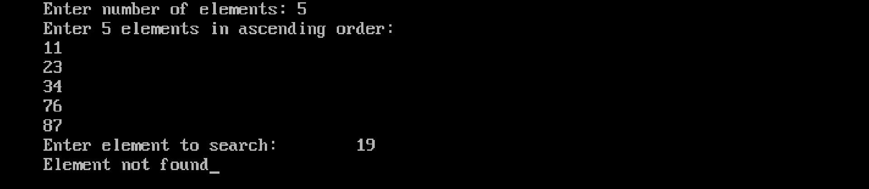

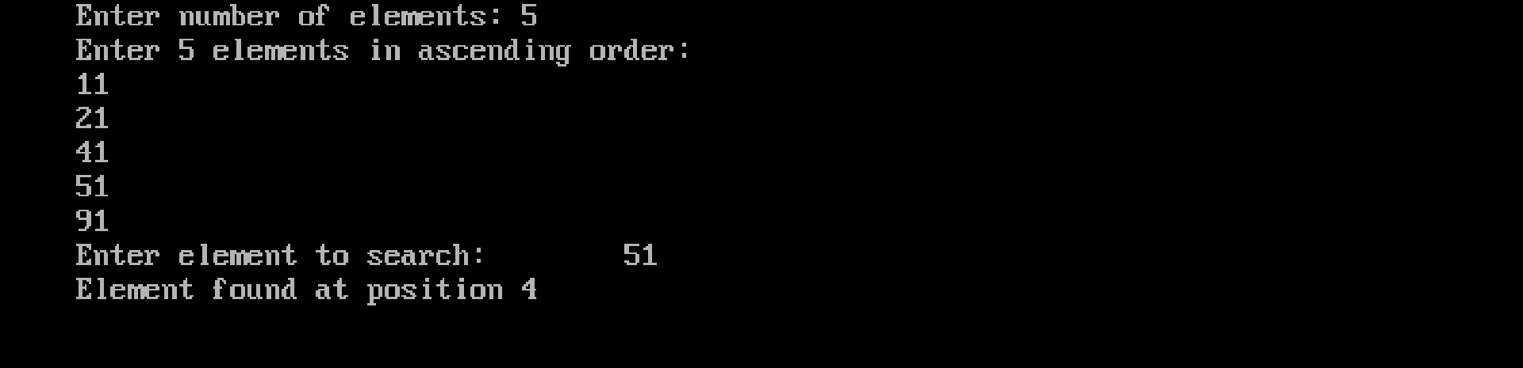

PROGRAM – 32

AIM: Program to search an element in an array using binary search.

SOURCE CODE:

#include<stdio.h>
#include<conio.h>
void main()
{
int a[20],n,i,key;
int low = 0,high,mid,found = 0;
clrscr();
printf("Enter number of elements: ");
scanf("%d",&n);
printf("Enter %d elements in ascending order: \n",n);
for(i=0;i<n;i++)
{
scanf("%d",&a[i]);
}
printf("Enter element to search: \t");
scanf("%d",&key);
high = n -1;
while(low <= high)
{
mid = (low + high)/2;
if(a[mid] == key)
{
found = 1;
break;
}
else if(key < a[mid])
{
high = mid - 1;
}

else {
low = mid + 1;
}
}
if(found == 1)
{
printf("Element found at position %d",mid + 1);
}
else
{
printf("Element not found");
}
getch();
}

OUTPUT

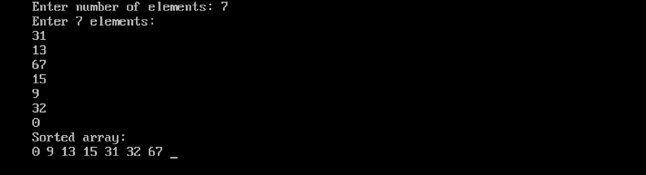

PROGRAM – 33

AIM : Program to sort N elements in an array using bubble sort.

SOURCE CODE:

#include<stdio.h>
#include<conio.h>
void main() {
int a[50], n, i, j, temp;
printf("Enter number of elements: ");
scanf("%d", &n);
printf("Enter %d elements:\n", n);
for(i = 0; i < n; i++) {
scanf("%d", &a[i]);
}

for(i = 0; i < n - 1; i++) {
for(j = 0; j < n - i - 1; j++) {
if(a[j] > a[j + 1]) {
temp = a[j];
a[j] = a[j + 1];
a[j + 1] = temp;
}
}
}
printf("Sorted array:\n");
for(i = 0; i < n; i++) {
printf("%d ", a[i]);
}
getch();
}

OUTPUT

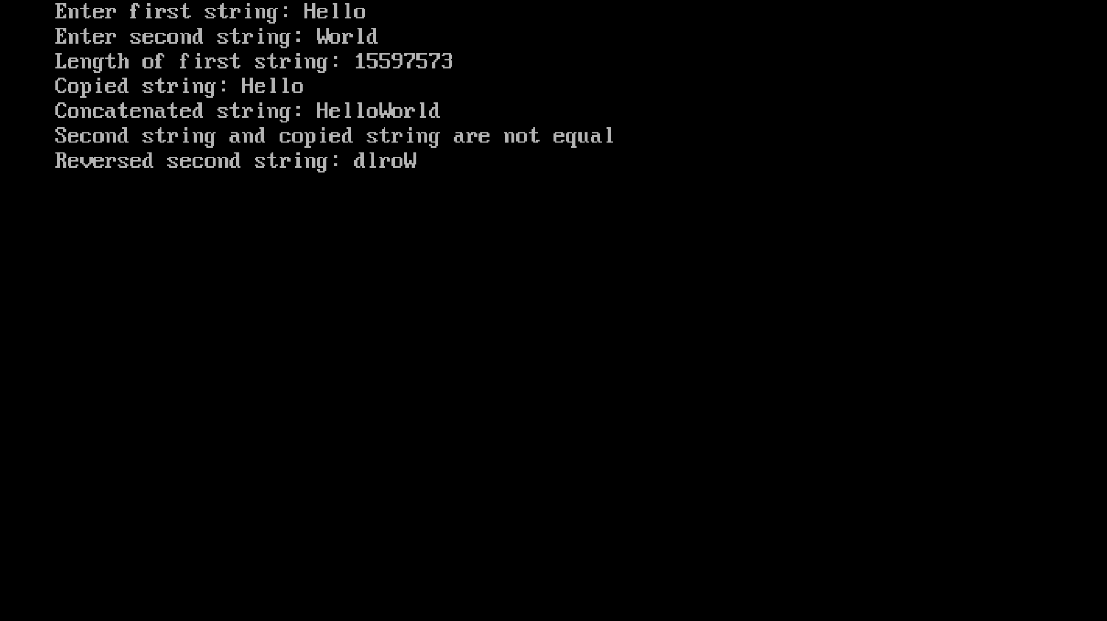

PROGRAM – 34

AIM : Program to perform various string handling functions.

SOURCE CODE:

#include <stdio.h>
#include <string.h>
void main()
{
char str1[50], str2[50], str3[50];
int cmp;
printf("Enter first string: ");
scanf("%s", str1);
printf("Enter second string: ");
scanf("%s", str2);

// 1. Length of string
printf("Length of first string: %lu\n", strlen(str1));

// 2. Copy string
strcpy(str3, str1);
printf("Copied string: %s\n", str3);

// 3. Concatenate strings
strcat(str1, str2);
printf("Concatenated string: %s\n", str1);

// 4. Compare strings
cmp = strcmp(str2, str3);
if (cmp == 0)
printf("Second string and copied string are equal\n");
else
printf("Second string and copied string are not equal\n");

// 5. Reverse string (Turbo C)
strrev(str2);
printf("Reversed second string: %s\n", str2);
getch();
}

OUTPUT

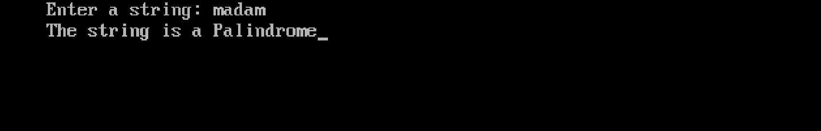

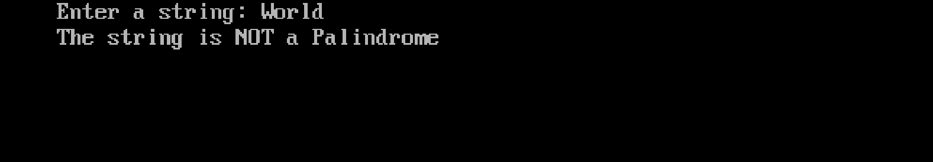

PROGRAM – 35

AIM : Program to read a string and check whether it is palindrome or not.

SOURCE CODE:

#include<stdio.h>
#include<string.h>
void main()
{
char str[100];
int i, len, flag = 0;
clrscr();
printf("Enter a string: ");
scanf("%s", str);
len = strlen(str);
for (i = 0; i < len / 2; i++)
{
if (str[i] != str[len - i - 1])
{
flag = 1;
break;
}
}
if (flag == 0)
printf("The string is a Palindrome");
else
printf("The string is NOT a Palindrome");
getch();
}

OUTPUT

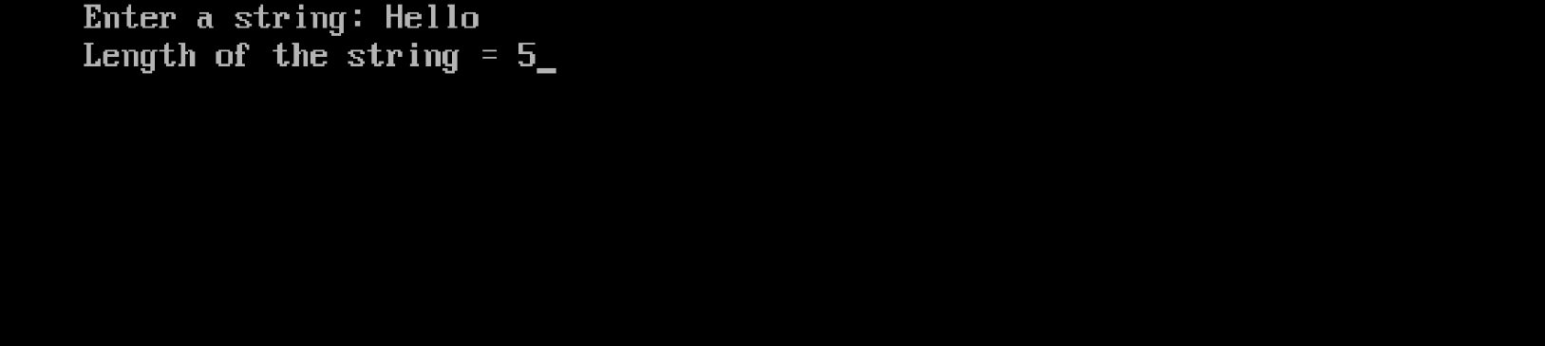

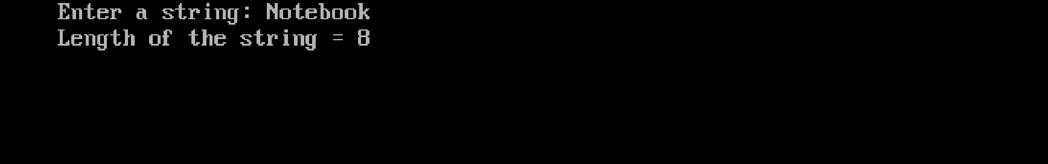

PROGRAM – 36

AIM : Program to find the length of a string without using the string handling function strlen().

SOURCE CODE:

#include<stdio.h>
#include<conio.h>
void main()
{
char str[100];
int length = 0;
clrscr();
printf("Enter a string: ");
scanf("%s", str);
while (str[length] != '\0')
{
length++;
}
printf("Length of the string = %d", length);
getch();
}

OUTPUT

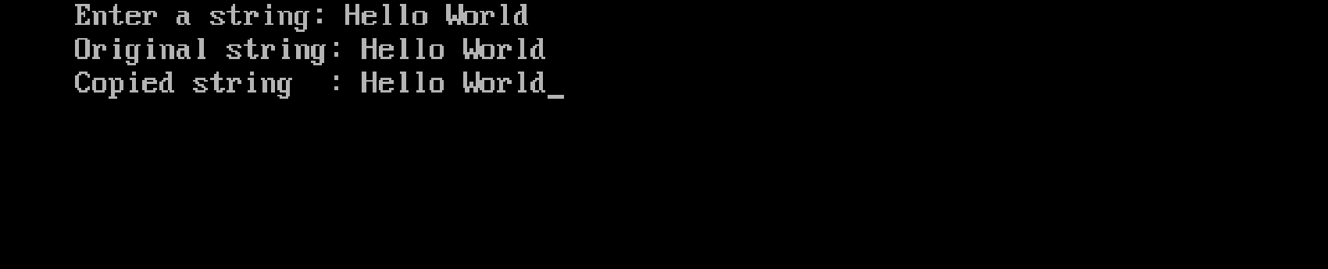

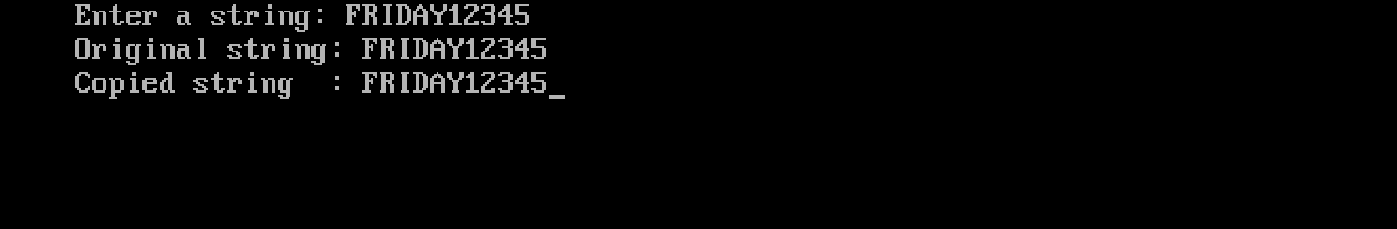

PROGRAM – 37

AIM : Program to copy one string to another without using string handling function.

SOURCE CODE:

#include<stdio.h>
#include<conio.h>
void main() {
char str1[100], str2[100];
int i = 0;
printf("Enter a string: ");
gets(str1);

while(str1[i] != '\0') {
str2[i] = str1[i];
i++;
}
str2[i] = '\0';
printf("Original string: %s\n", str1);
printf("Copied string : %s", str2);
getch();
}

OUTPUT

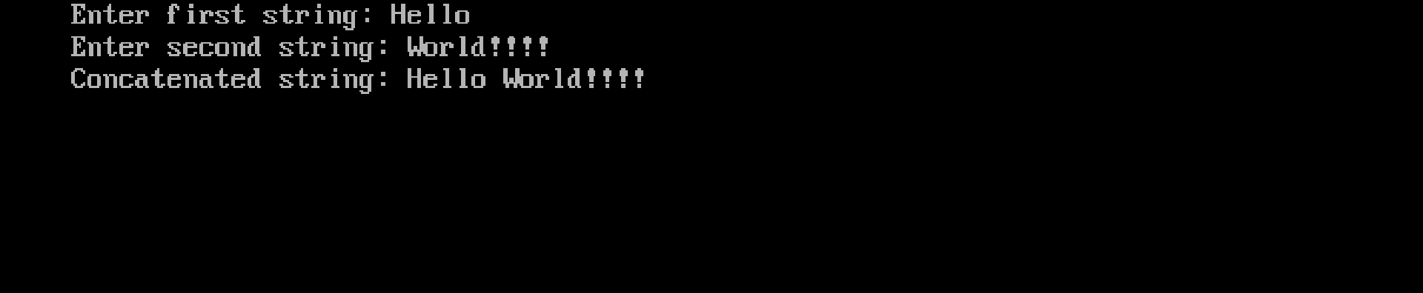

PROGRAM – 38

AIM : Program to concatenate one string to another without using the string handling function.

SOURCE CODE:

#include<stdio.h>
#include<conio.h>
void main()
{
char str1[100], str2[100];
int i = 0, j = 0;
printf("Enter first string: ");
gets(str1); // For Turbo C++
printf("Enter second string: ");
gets(str2);

while(str1[i] != '\0') {
i++;
}
while(str2[j] != '\0') {
str1[i] = str2[j];
i++;
j++;
}
str1[i] = '\0';
printf("Concatenated string: %s", str1);
getch();
}

OUTPUT

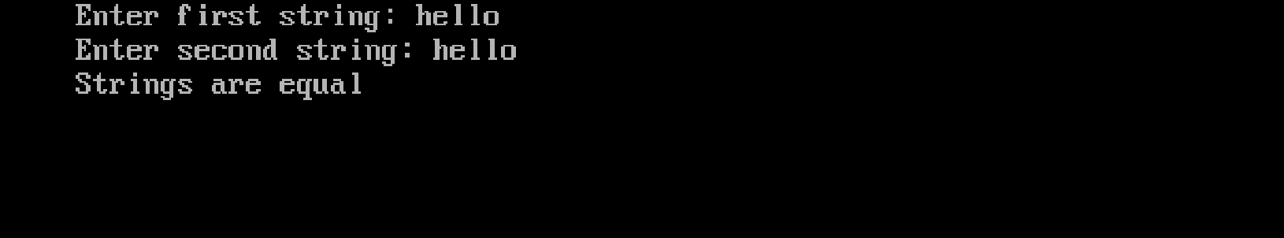

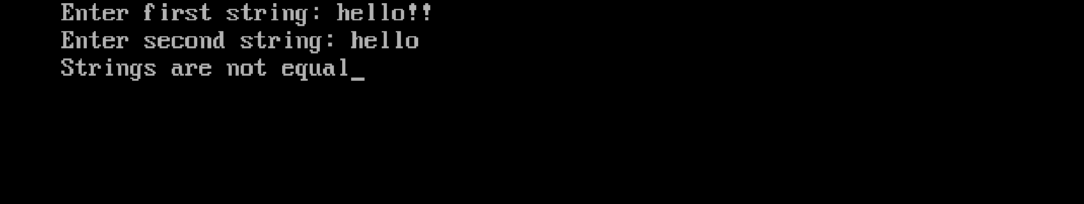

PROGRAM – 39

AIM : Program to compare two strings without using string handling function.

SOURCE CODE:

#include<stdio.h>
#include<conio.h>
void main() {
char str1[100], str2[100];
int i = 0, flag = 0;
clrscr();
printf("Enter first string: ");
gets(str1);
printf("Enter second string: ");
gets(str2);
while(str1[i] != '\0' && str2[i] != '\0') {
if(str1[i] != str2[i]) {
flag = 1;
break;
}
i++;
}
if(str1[i] != str2[i])
flag = 1;
if(flag == 0)
printf("Strings are equal");
else
printf("Strings are not equal");
getch();
}

OUTPUT

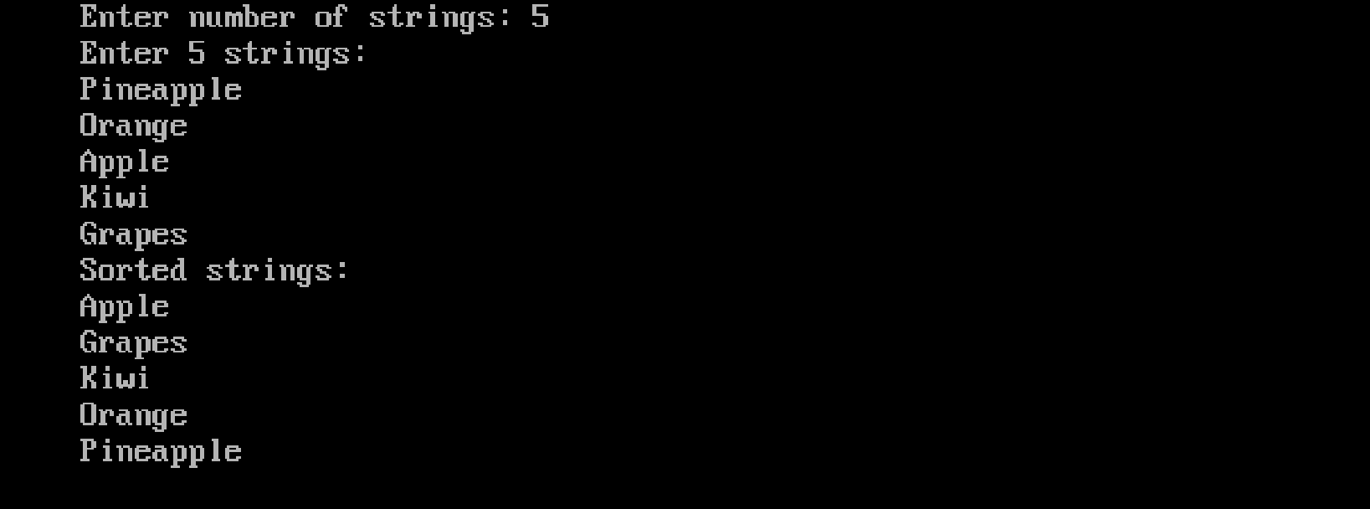

PROGRAM – 40

AIM : Program to sort N strings.

SOURCE CODE:

#include <stdio.h>
#include <string.h>
void main() {
char str[20][50], temp[50];
int n, i, j;
clrscr();
printf("Enter number of strings: ");
scanf("%d", &n);
printf("Enter %d strings:\n", n);
for(i = 0; i < n; i++) {
scanf("%s", str[i]);
}
for(i = 0; i < n - 1; i++) {
for(j = i + 1; j < n; j++) {
if(strcmp(str[i], str[j]) > 0) {
strcpy(temp, str[i]);
strcpy(str[i], str[j]);
strcpy(str[j], temp);
}
}
}
printf("Sorted strings:\n");
for(i = 0; i < n; i++) {
printf("%s\n", str[i]);
}
getch();
}

OUTPUT

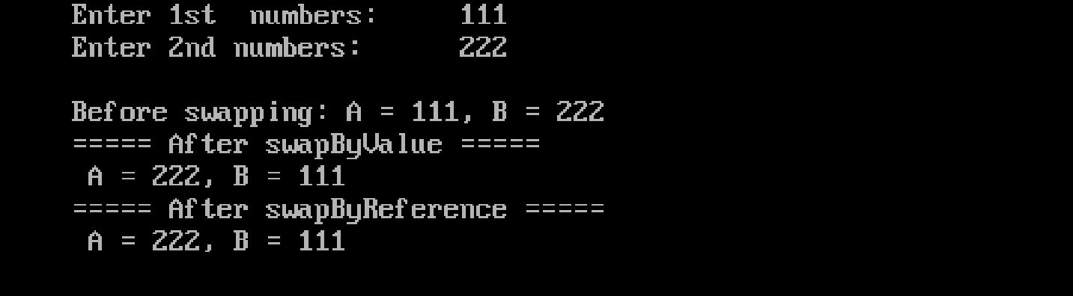

PROGRAM – 41

AIM : Program to swap two numbers using call by value and call by reference.

SOURCE CODE:

#include<stdio.h>
#include<conio.h>
int swapByValue(int a, int b)
{
int temp = a;
a = b;
b = temp;
printf("===== After swapByValue =====\n A = %d, B = %d\n", a, b);
}
void swapByReference(int *a, int *b)
{
int temp = *a;
*a = *b;
*b = temp;
printf("===== After swapByReference =====\n A = %d, B = %d\n", *a, *b);
}
void main()
{
int a, b;
clrscr();
printf("Enter 1st numbers: \t");
scanf("%d", &a);
printf("Enter 2nd numbers: \t");
scanf("%d",&b);
printf("\nBefore swapping: A = %d, B = %d\n", a, b);
swapByValue(a, b);
swapByReference(&a, &b);
getch();
}
OUTPUT

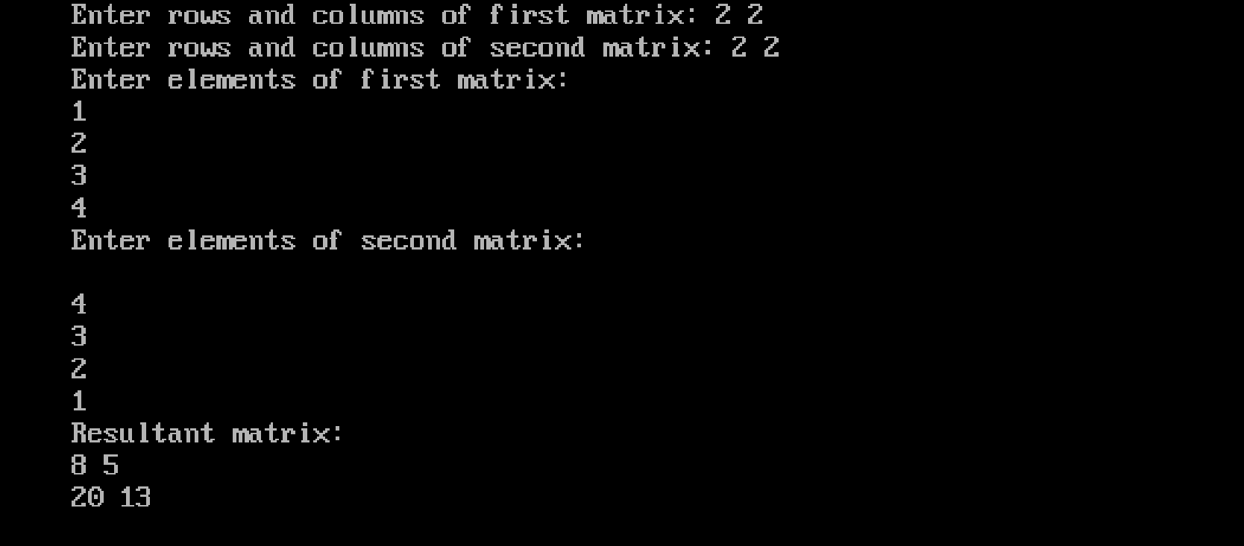

PROGRAM – 42

AIM : Program to perform matrix multiplication using pointers.

SOURCE CODE:

#include<stdio.h>
#include<conio.h>
void main() {
int a[10][10], b[10][10], c[10][10];
int r1, c1, r2, c2;
int i, j, k;
printf("Enter rows and columns of first matrix: ");
scanf("%d %d", &r1, &c1);
printf("Enter rows and columns of second matrix: ");
scanf("%d %d", &r2, &c2);

// Matrix multiplication condition
if(c1 != r2) {
printf("Matrix multiplication not possible");
return 0;
}
printf("Enter elements of first matrix:\n");
for(i = 0; i < r1; i++) {
for(j = 0; j < c1; j++) {
scanf("%d", (*(a + i) + j)); // pointer access
}
}

printf("Enter elements of second matrix:\n");
for(i = 0; i < r2; i++) {
for(j = 0; j < c2; j++) {
scanf("%d", (*(b + i) + j)); // pointer access
}
}

// Matrix multiplication logic
for(i = 0; i < r1; i++) {
for(j = 0; j < c2; j++) {
*(*(c + i) + j) = 0;
for(k = 0; k < c1; k++) {
*(*(c + i) + j) +=
(*(*(a + i) + k)) * (*(*(b + k) + j));
}
}
}
printf("Resultant matrix:\n");
for(i = 0; i < r1; i++) {
for(j = 0; j < c2; j++) {
printf("%d ", *(*(c + i) + j));
}
printf("\n");
}
getch();
}

OUTPUT

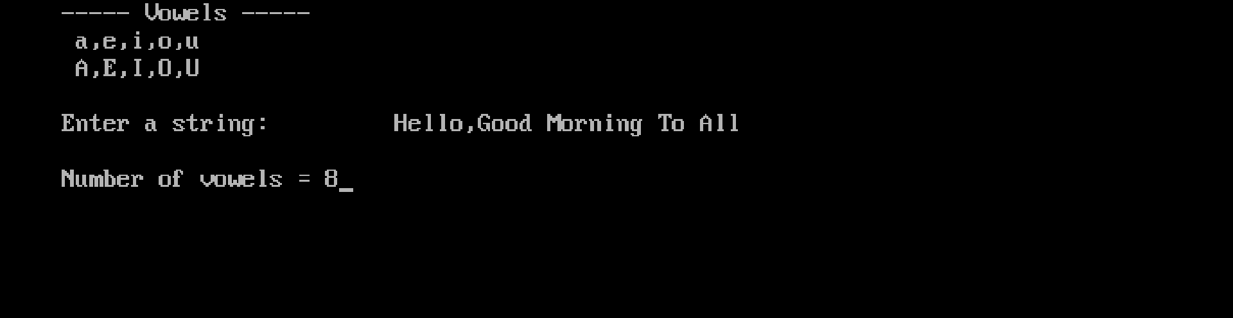
PROGRAM – 43

AIM : Program to read a string and calculate the number of vowels in it.

SOURCE CODE:

#include<stdio.h>
#include<conio.h>
void main()
{
char str[100];
int i, count = 0;
printf("----- Vowels -----\n a,e,i,o,u\n A,E,I,O,U\n");
printf("\n");
printf("Enter a string: \t");
gets(str);

for(i = 0; str[i] != '\0'; i++) {
if(str[i] == 'a' || str[i] == 'e' || str[i] == 'i' ||
str[i] == 'o' || str[i] == 'u' ||
str[i] == 'A' || str[i] == 'E' || str[i] == 'I' ||
str[i] == 'O' || str[i] == 'U') {
count++;
}
}
printf("\n");
printf("Number of vowels = %d", count);
getch();
}

OUTPUT

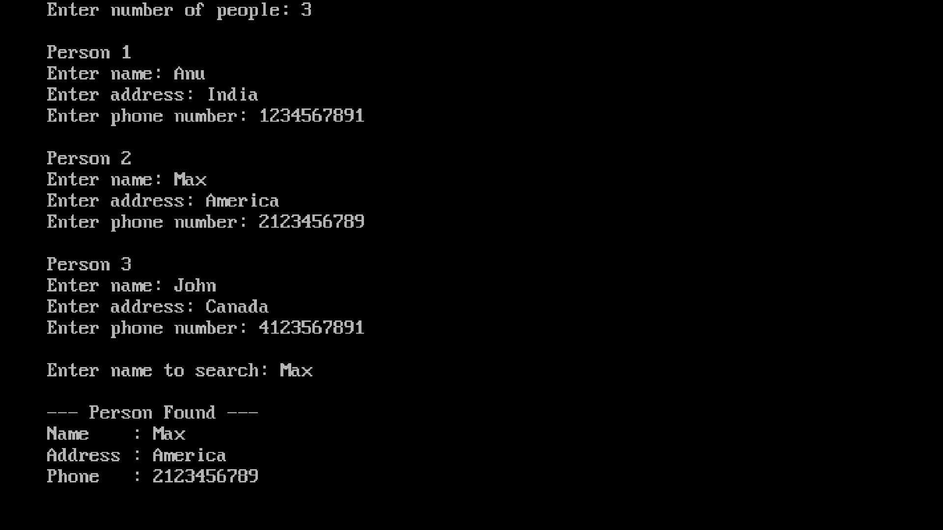

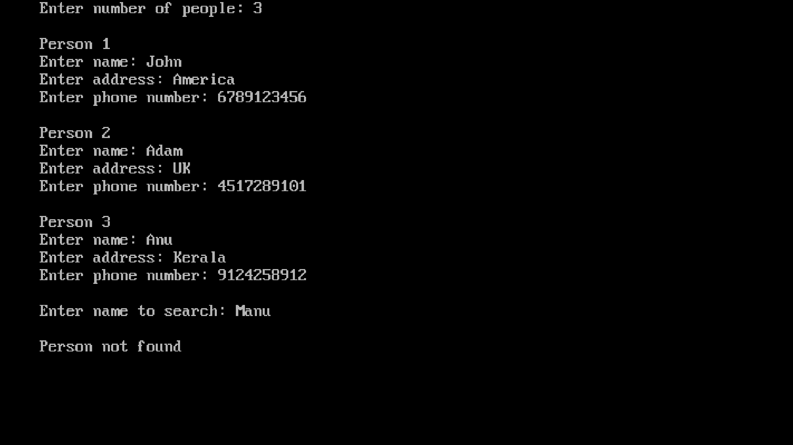

PROGRAM – 44

AIM : Program to read the personal data (name, address, phone no etc…) of N people and search the details of a particular person using structures and functions

SOURCE CODE:

#include<stdio.h>
#include<conio.h>
#include<string.h>

struct person {
char name[50];
char address[100];
char phone[15];
};

void readData(struct person p[], int n)
{
int i;
for(i = 0; i < n; i++)
{
printf("\nPerson %d\n", i + 1);
printf("Enter name: ");
gets(p[i].name);
printf("Enter address: ");
gets(p[i].address);
printf("Enter phone number: ");
gets(p[i].phone);
}
}

void searchData(struct person p[], int n)
{
char searchName[50];
int i, found = 0;
printf("\nEnter name to search: ");
gets(searchName);
for(i = 0; i < n; i++)
{
if(strcmp(p[i].name, searchName) == 0)
{
printf("\n--- Person Found ---\n");
printf("Name : %s\n", p[i].name);
printf("Address : %s\n", p[i].address);
printf("Phone : %s\n", p[i].phone);
found = 1;
break;
}
}
if(found == 0)
printf("\nPerson not found");
}
void main() {
struct person p[20];
int n;
printf("Enter number of people: ");
scanf("%d", &n);
getchar();
readData(p, n);
searchData(p, n);
getch();
}

OUTPUT

Create a file “prgm45.txt” and enter the content.

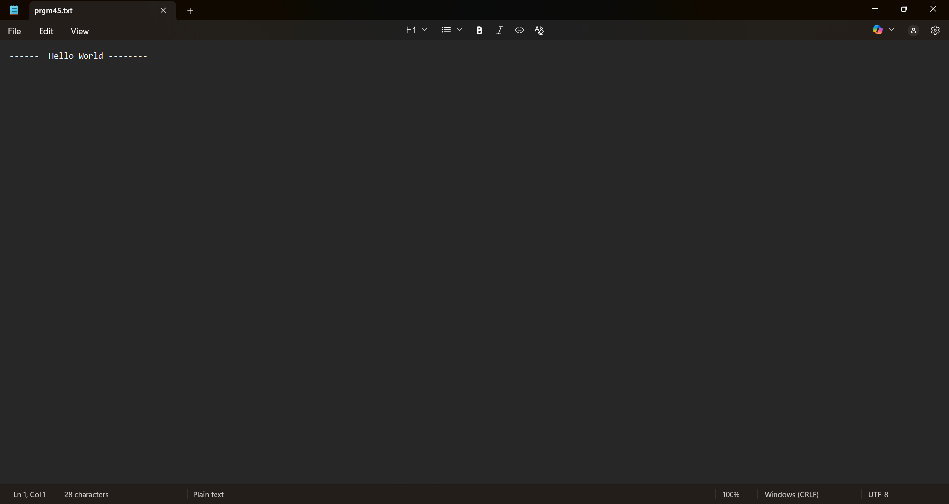

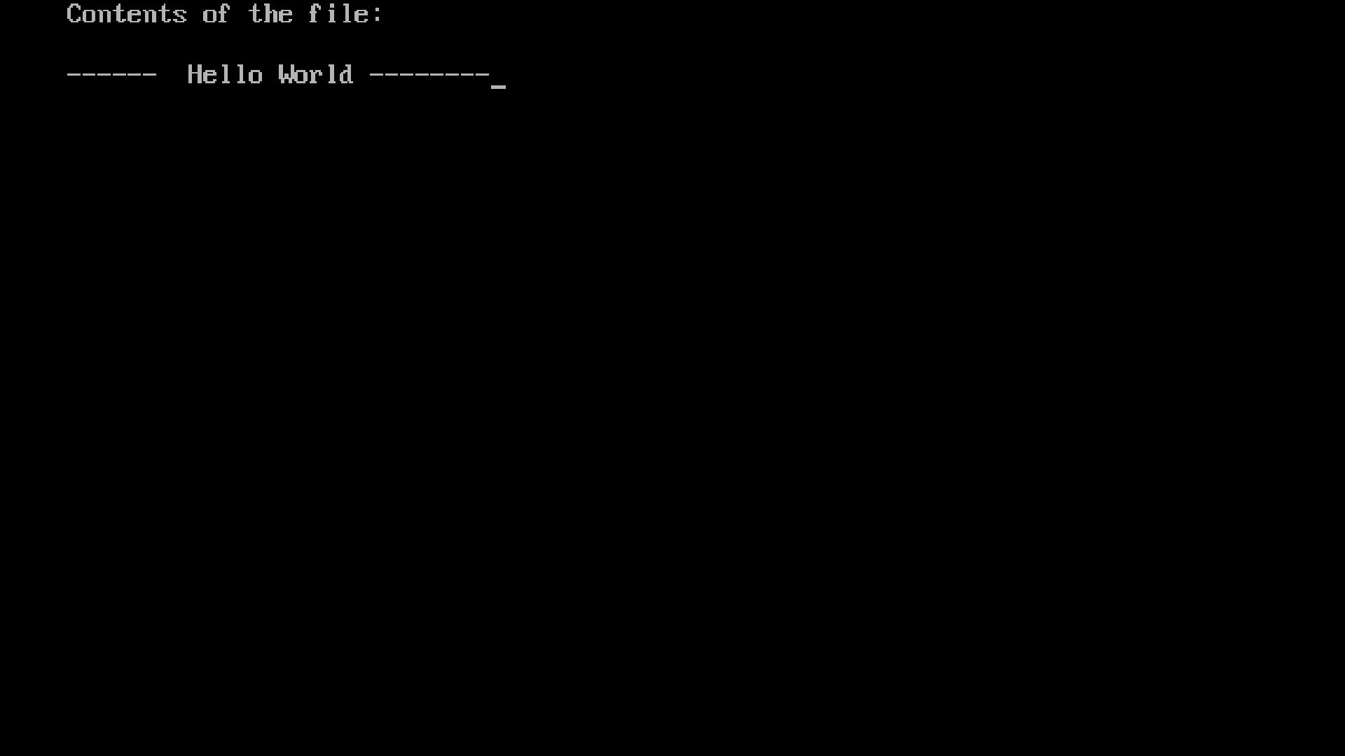

PROGRAM – 45

AIM : Program to read and display the contents of a file.

SOURCE CODE:

#include <stdio.h>
#include <conio.h>
void main() {
FILE *fp;
char ch;
clrscr();

fp = fopen("prgm45.txt", "r");

if(fp == NULL) {
printf("File not found or cannot be opened");
getch();
return;
}
printf("Contents of the file:\n\n");
while((ch = fgetc(fp)) != EOF) {
printf("%c", ch);
}
fclose(fp);
getch();
}

OUTPUT

Create two files “source.txt” & “destination.txt”.
Enter contents in “source.txt” & leave “destination.txt” as an empty file.

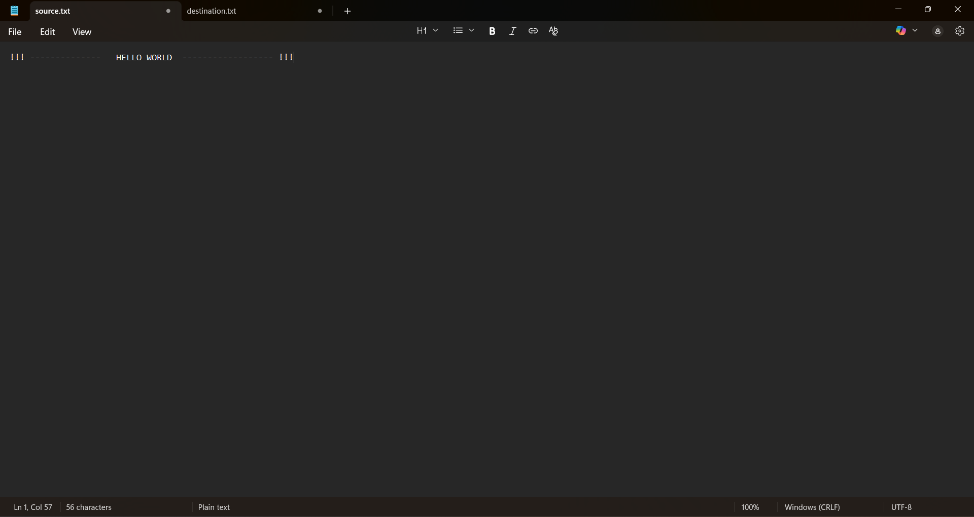

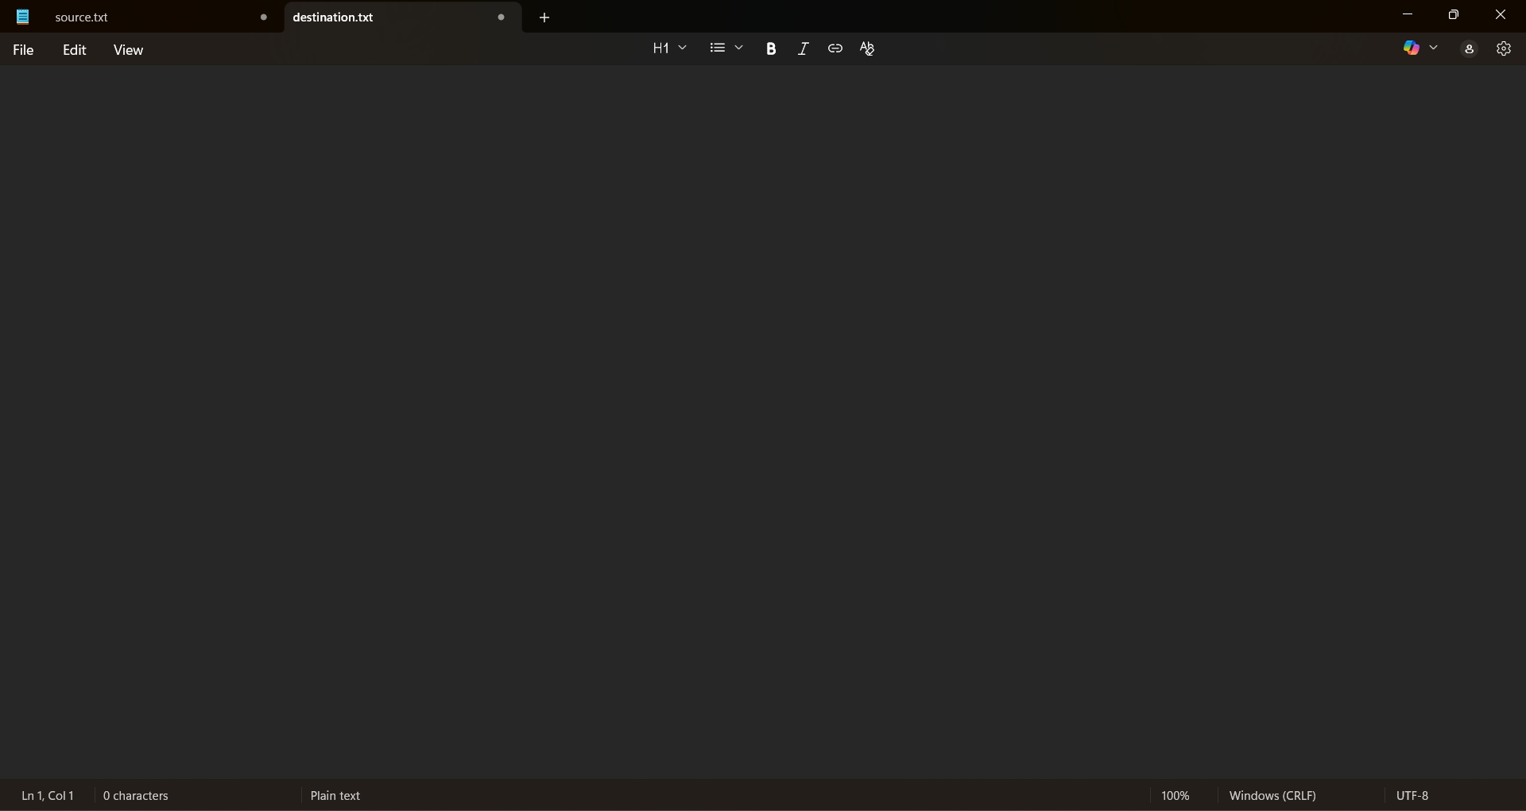

PROGRAM – 46

AIM : Program to copy one file to another using command line argument.

SOURCE CODE:

#include <stdio.h>
#include <conio.h>
void main(int argc, char *argv[]) {
FILE *fs, *ft;
char ch;
if(argc != 3) {
printf("Usage: copy source_file destination_file");
return 0;
}
fs = fopen(argv[1], "r");
if(fs == NULL) {
printf("Source file cannot be opened");
return 0;
}
ft = fopen(argv[2], "w");
if(ft == NULL) {
printf("Destination file cannot be created");
fclose(fs);
return 0;
}
while((ch = fgetc(fs)) != EOF) {
fputc(ch, ft);
}

OUTPUT

Open terminal from where the program is stored, type “gcc progrm46.c -o copy” in terminal.
Then, type “copy source.txt destination.txt”.
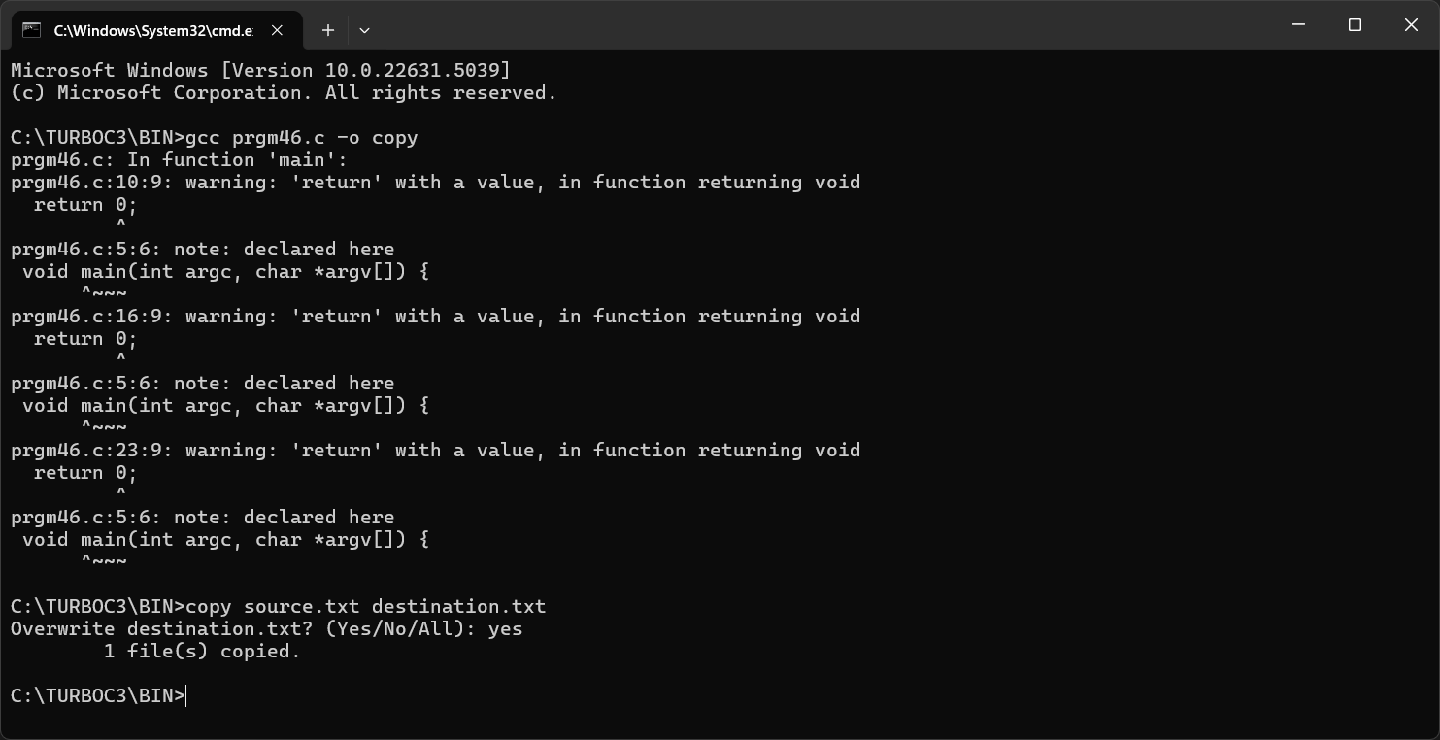

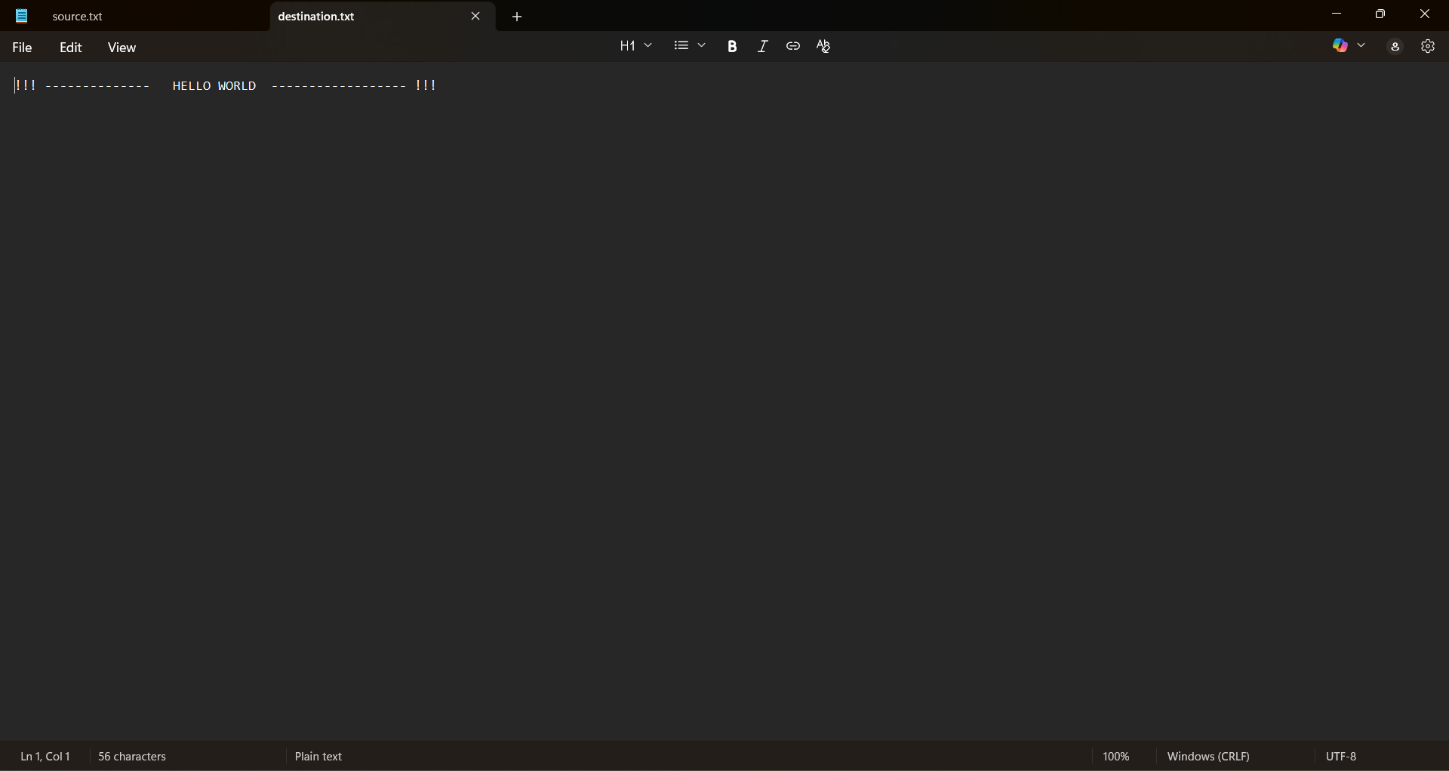

printf("File copied successfully");
fclose(fs);
fclose(ft);
getch();
}

OUTPUT

Create a file “prgm47.txt” and enter contents in it.

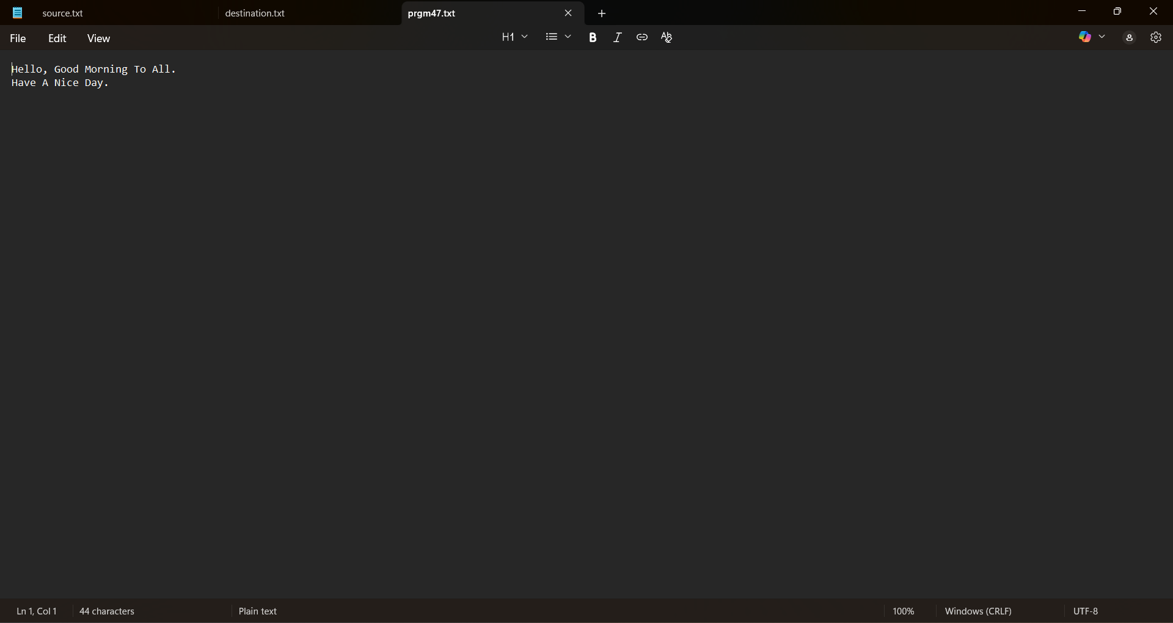

Open terminal from where the program is stored, type “gcc progrm47.c -o count” in terminal.
Then, type “count prgm47.txt”.

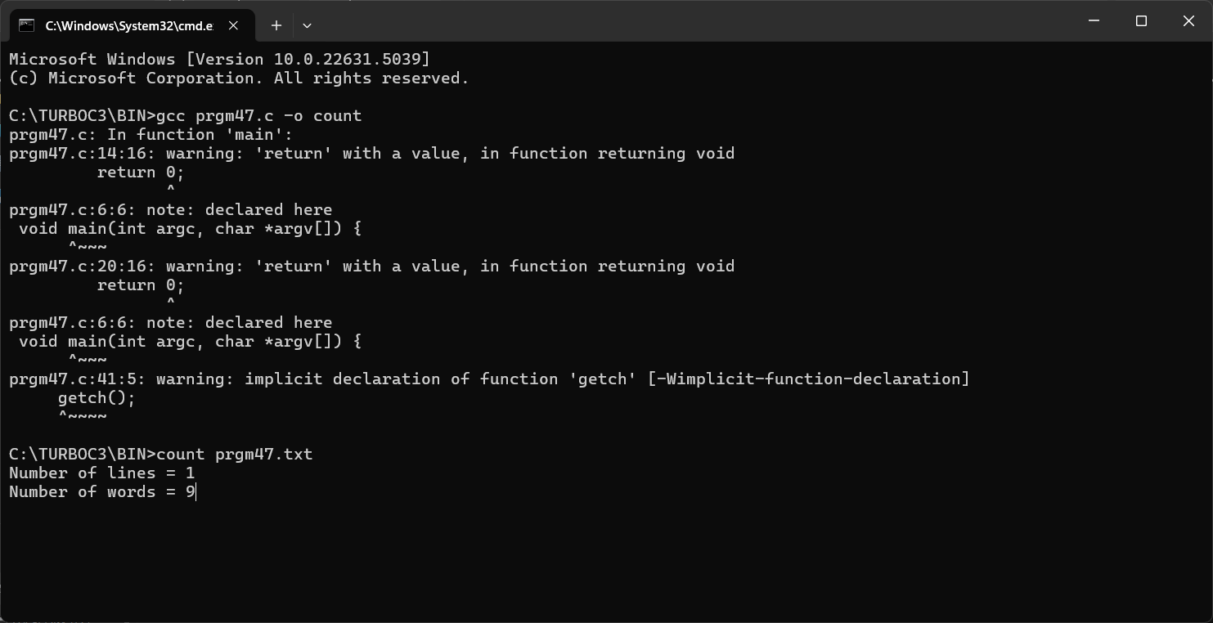

PROGRAM – 47

AIM: Program to count the number of words and number of lines in a file using command line argument.

SOURCE CODE:

#include <stdio.h>
#include <stdlib.h>
void main(int argc, char *argv[]) {
FILE *fp;
char ch;
int words = 0, lines = 0;
int inWord = 0;
if (argc != 2) {
printf("Invalid arguments");
return 0;
}
fp = fopen(argv[1], "r");
if (fp == NULL) {
printf("File cannot be opened");
return 0;
}

while ((ch = fgetc(fp)) != EOF) {
if (ch == '\n')
lines++;
if (ch == ' ' || ch == '\n' || ch == '\t')
inWord = 0;
else if (inWord == 0) {
inWord = 1;
words++;
}
}

fclose(fp);
printf("Number of lines = %d\n", lines);
printf("Number of words = %d", words);
getch();
}

OUTPUT

Create a file “prgm48.txt” and enter contents in it.
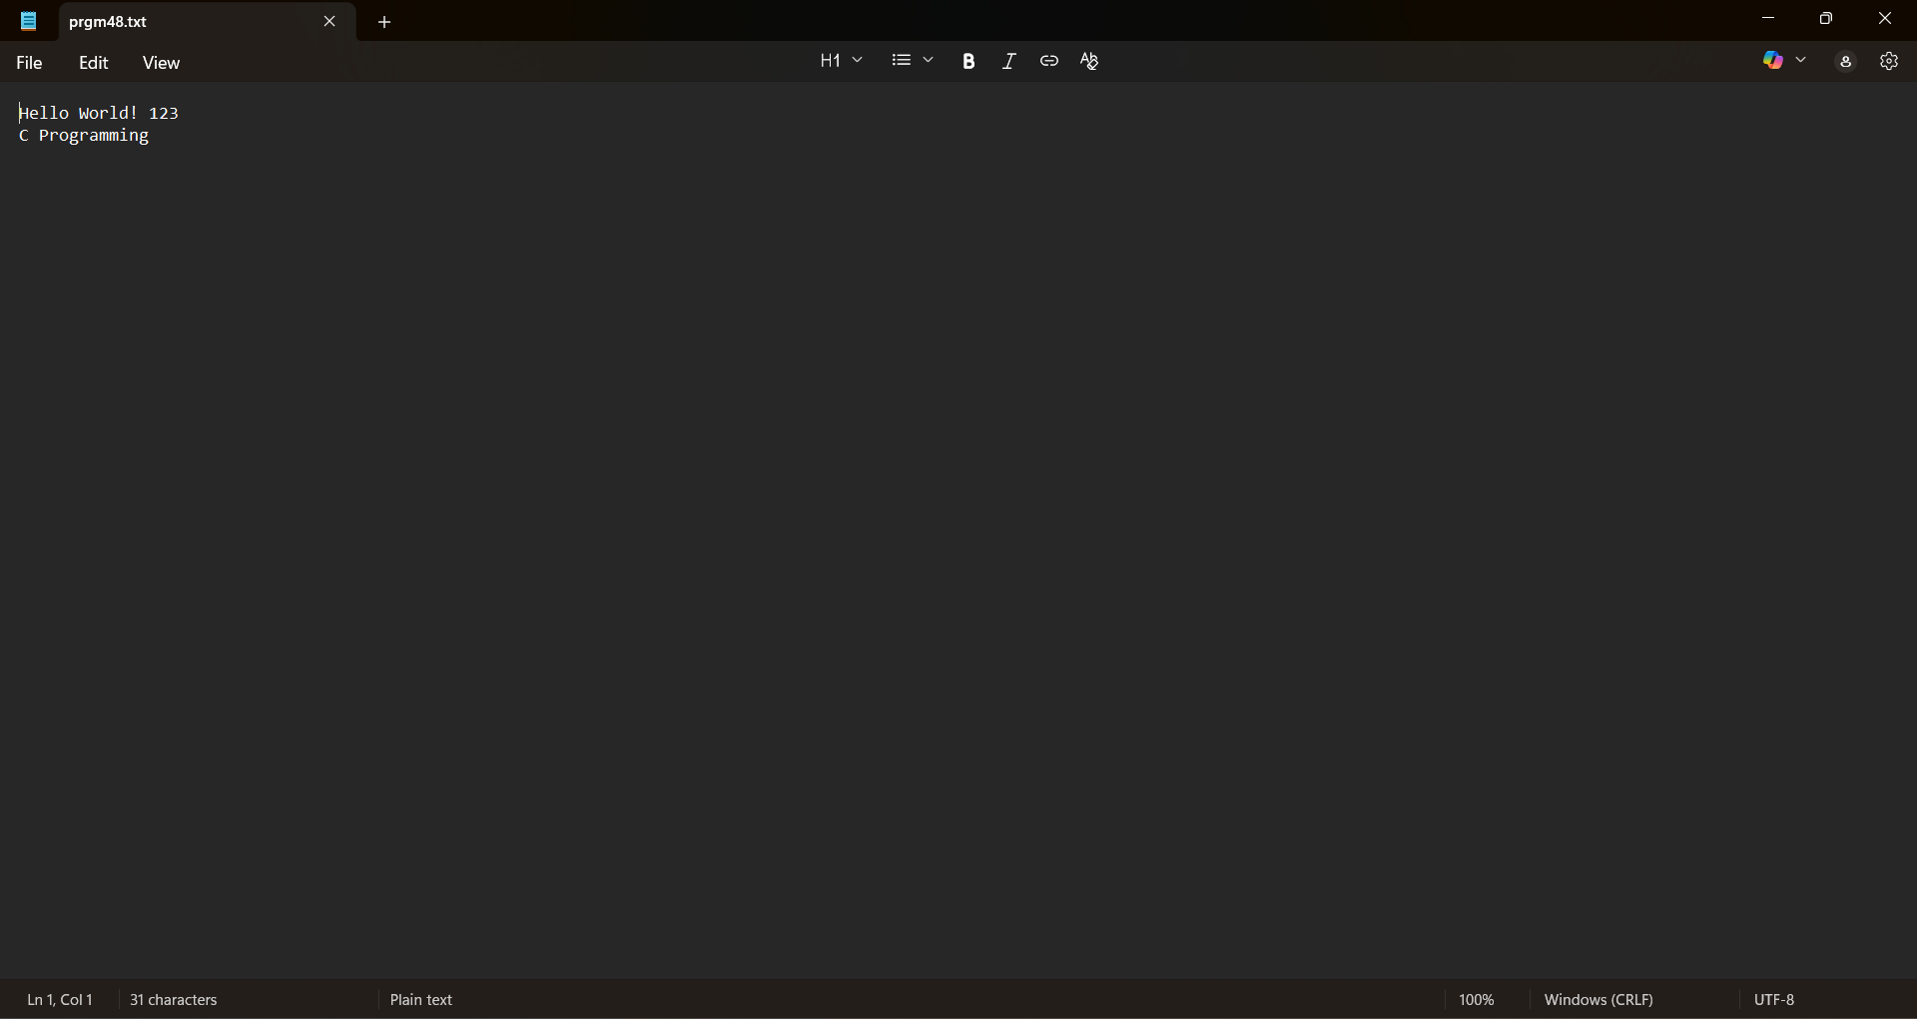

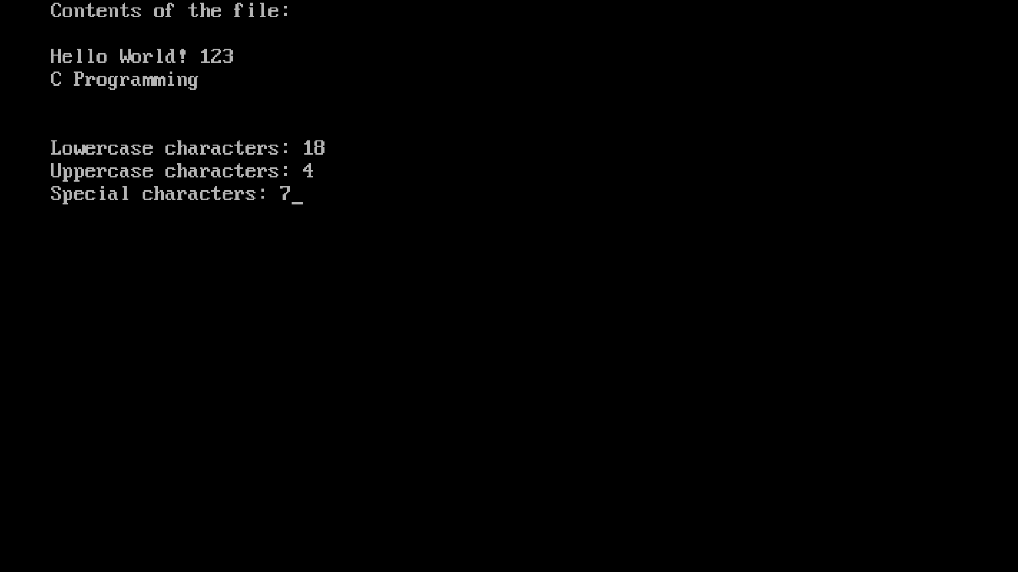

PROGRAM – 48

AIM : Program to count the number of lower case, upper case and special characters in a file

SOURCE CODE:

#include <stdio.h>
#include <conio.h>

void main() {
FILE *fp;
char ch;
int lower = 0, upper = 0, special = 0;
clrscr();
fp = fopen("prgm48.txt", "r");
if(fp == NULL) {
printf("File cannot be opened");
getch();
}
printf("Contents of the file:\n\n");
while((ch = fgetc(fp)) != EOF) {
printf("%c", ch);
if(ch >= 'a' && ch <= 'z')
lower++;
else if(ch >= 'A' && ch <= 'Z')
upper++;
else if(ch != '\n' && ch != '\r') // Ignore newline
special++;
}
fclose(fp);
printf("\n\nLowercase characters: %d\n", lower);
printf("Uppercase characters: %d\n", upper);
printf("Special characters: %d", special);
getch();
}
OUTPUT

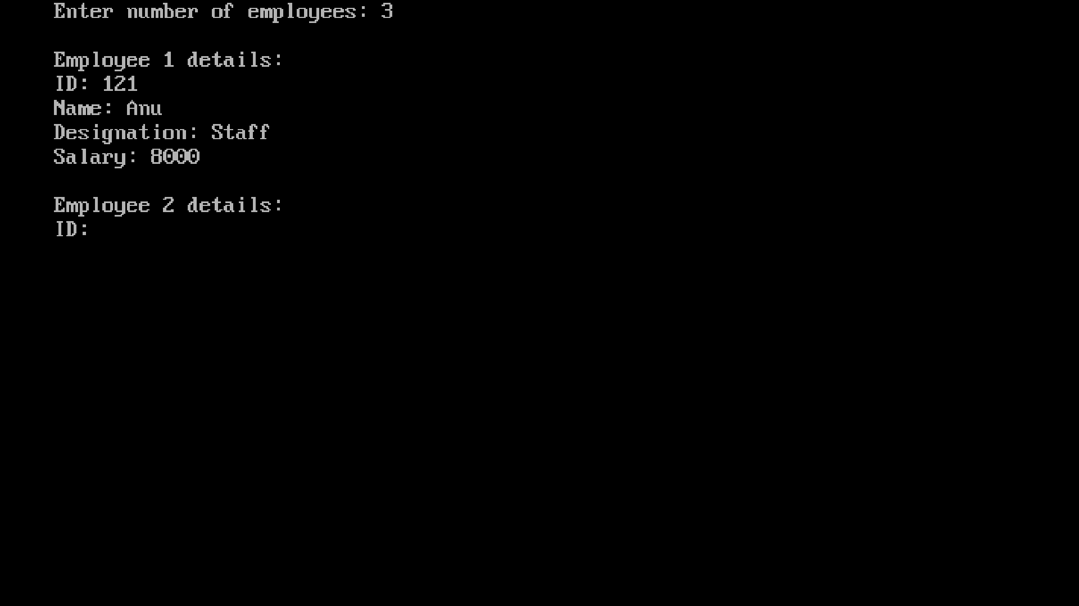

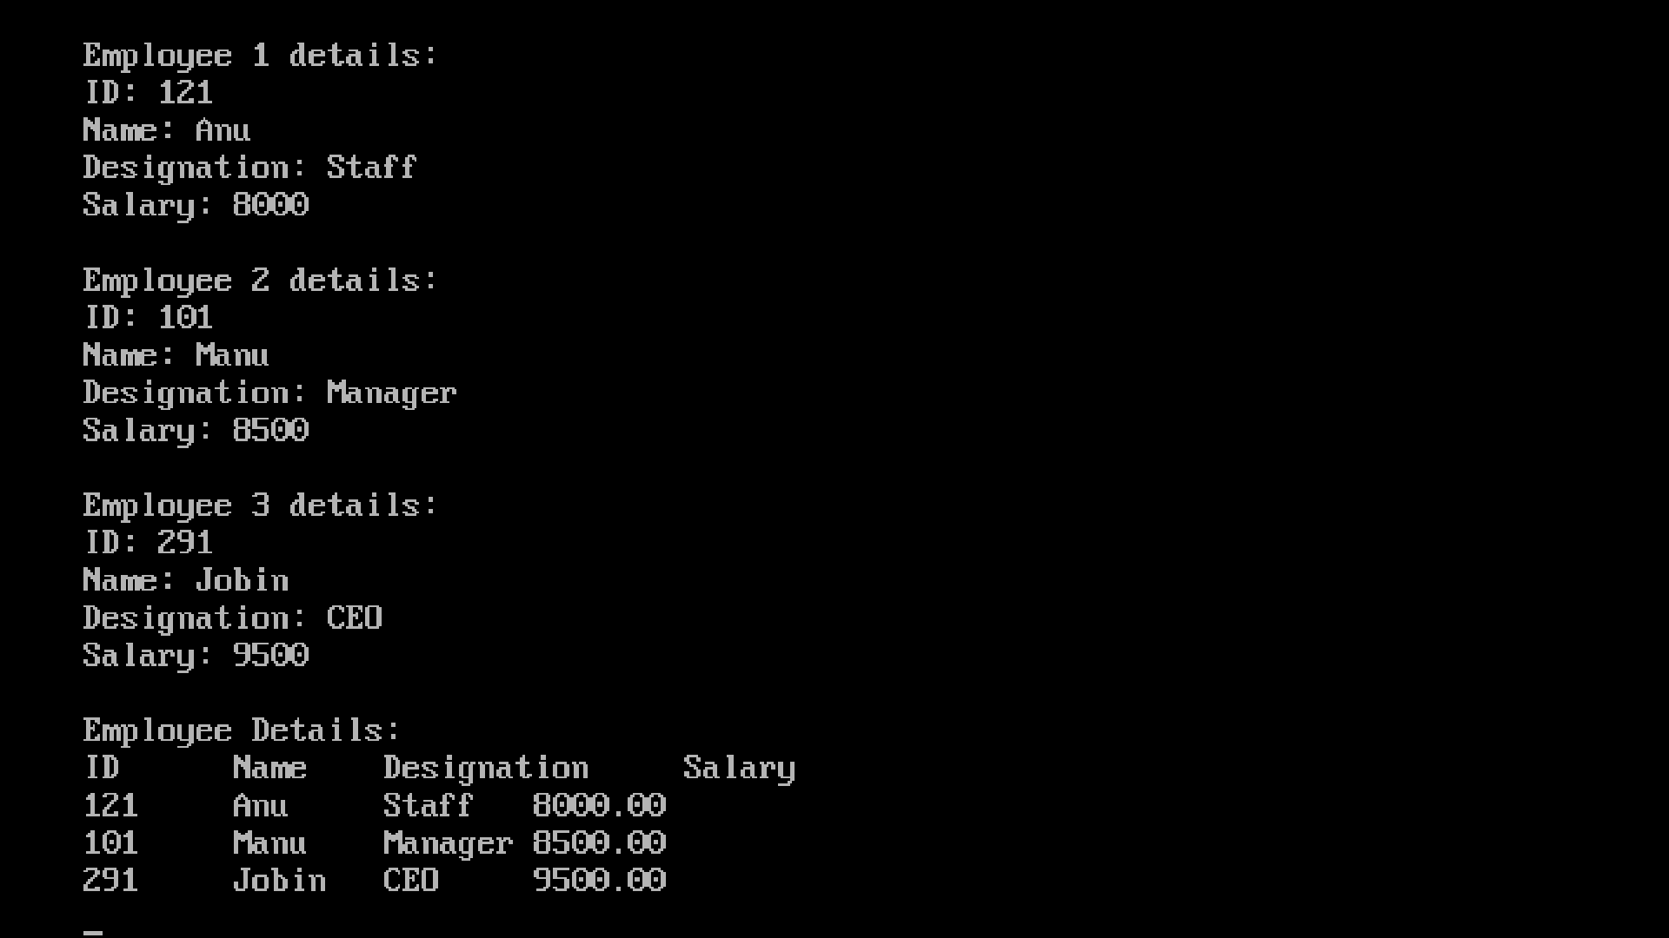

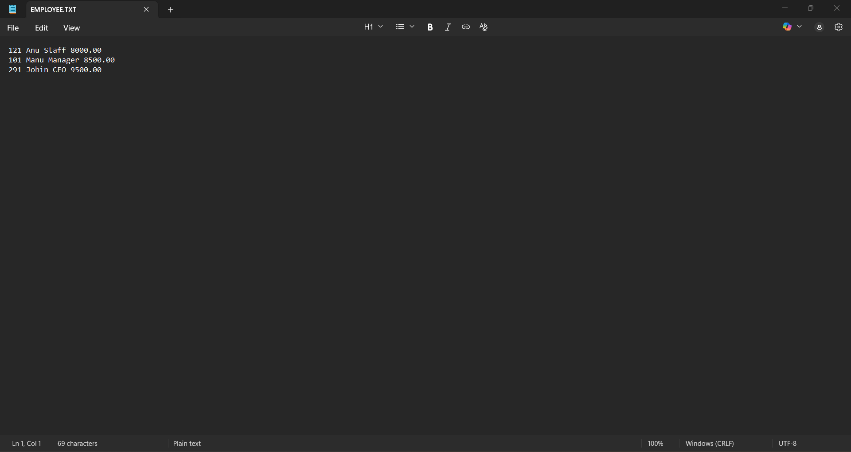

PROGRAM – 49

AIM : Create an employee file, read and display the details on console.

SOURCE CODE:

#include <stdio.h>
#include <conio.h>
#include <string.h>
struct employee {
int id;
char name[50];
char designation[50];
float salary;
};
void main() {
FILE *fp;
struct employee emp;
int n, i;
clrscr();
printf("Enter number of employees: ");
scanf("%d", &n);
getchar();
fp = fopen("employee.txt", "w");
if(fp == NULL) {
printf("Cannot create file");
getch();
return 0;
}

// Input employee details and write to file
for(i = 0; i < n; i++) {
printf("\nEmployee %d details:\n", i + 1);
printf("ID: ");
scanf("%d", &emp.id);
getchar(); // clear buffer

printf("Name: ");
gets(emp.name);

printf("Designation: ");
gets(emp.designation);

printf("Salary: ");
scanf("%f", &emp.salary);
getchar();
fprintf(fp, "%d %s %s %.2f\n", emp.id, emp.name, emp.designation, emp.salary);
}
fclose(fp);
fp = fopen("employee.txt", "r");
if(fp == NULL) {
printf("Cannot open file");
getch();
}
printf("\nEmployee Details:\n");
printf("ID\tName\tDesignation\tSalary\n");

while(fscanf(fp, "%d %s %s %f", &emp.id, emp.name, emp.designation, &emp.salary) != EOF) {
printf("%d\t%s\t%s\t%.2f\n", emp.id, emp.name, emp.designation, emp.salary);
}
fclose(fp);
getch();
}

OUTPUT

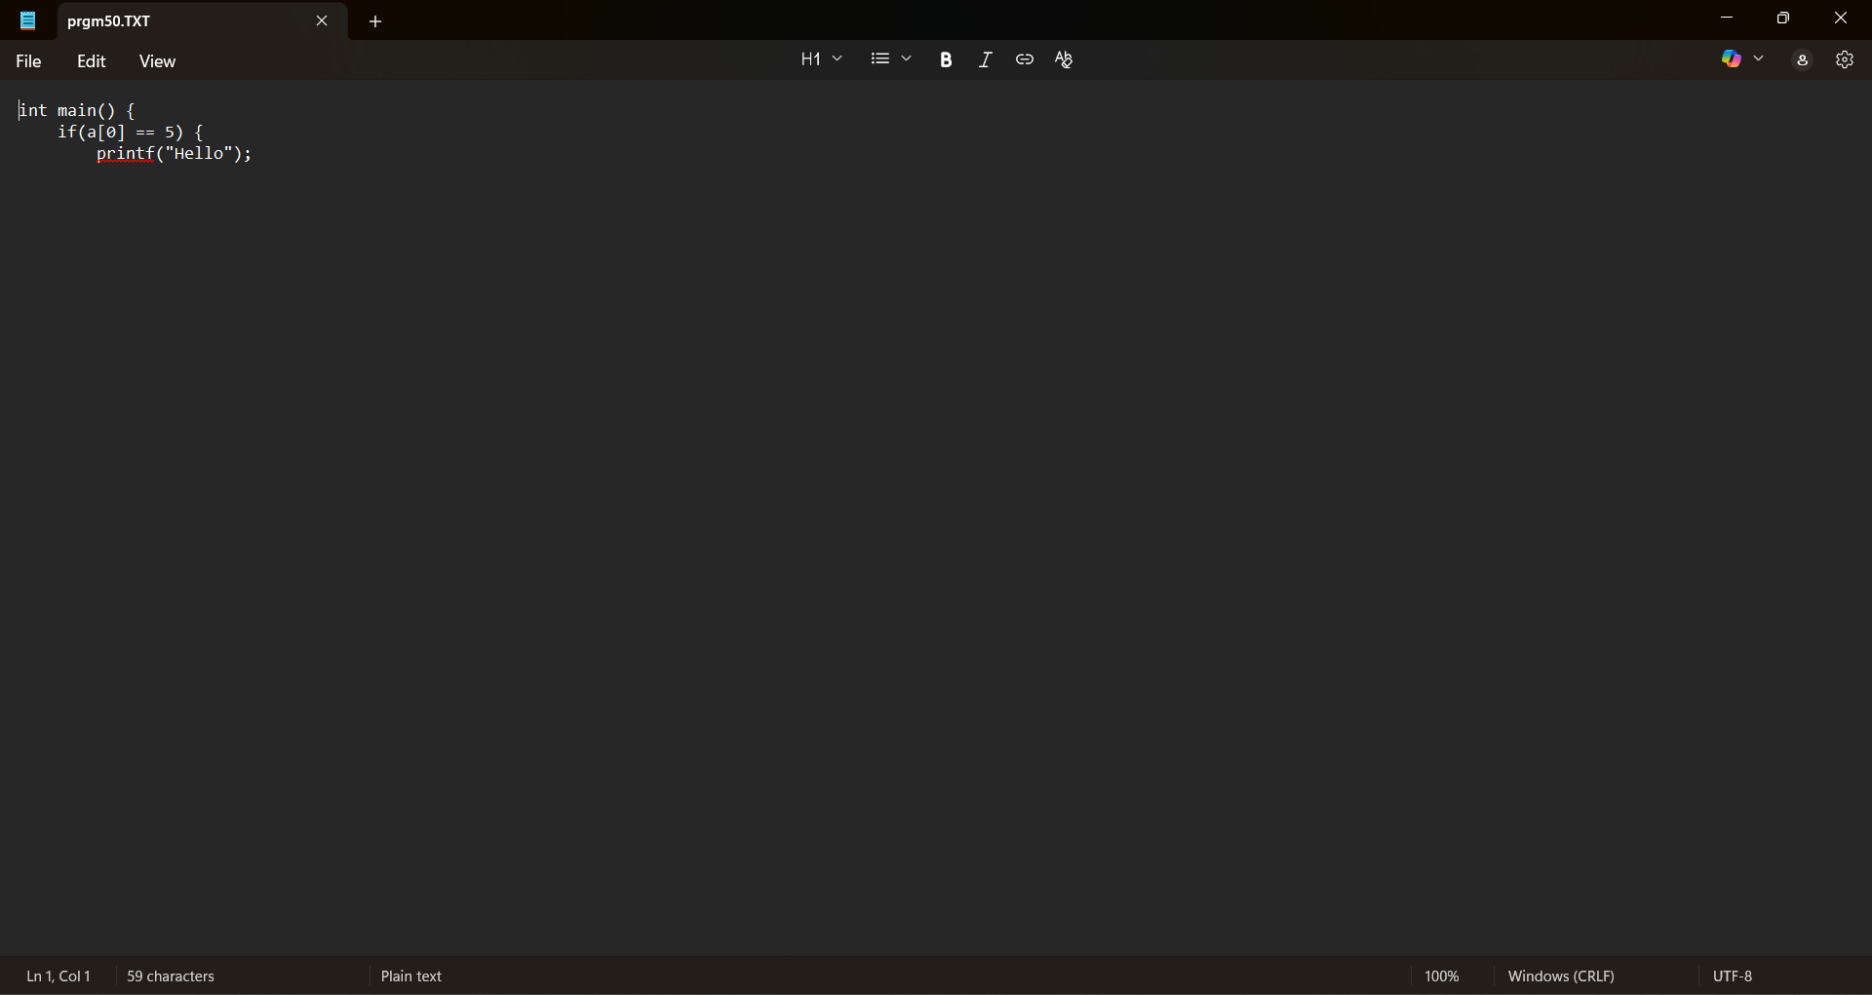

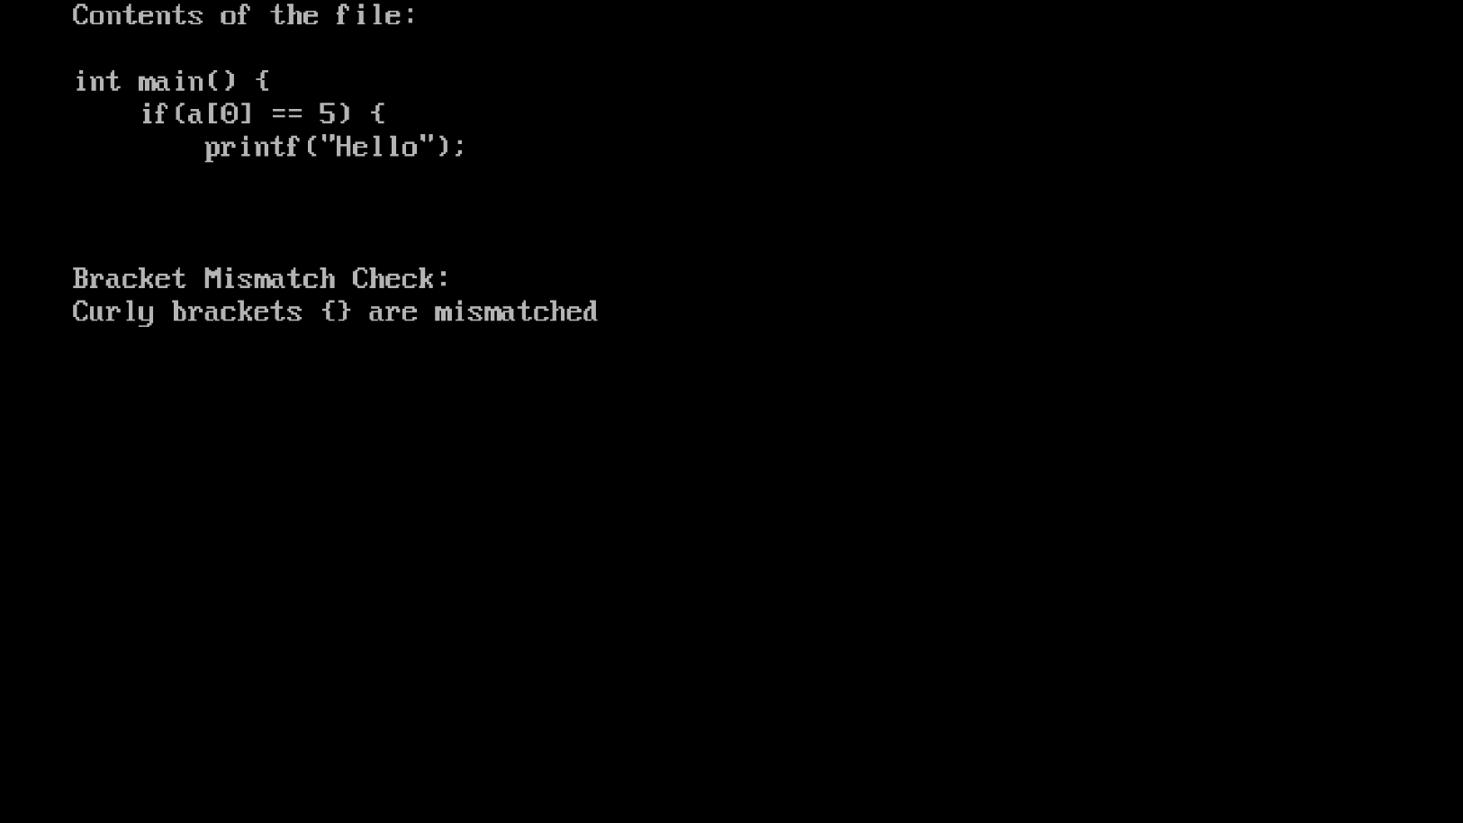

PROGRAM – 50

AIM : Program to find the mismatch of opening and closing brackets in a file.

SOURCE CODE:

#include <stdio.h>
#include <conio.h>
void main() {
FILE *fp;
char ch;
int round = 0, curly = 0, square = 0;
clrscr();
fp = fopen("prgm50.txt", "r");
if(fp == NULL) {
printf("Cannot open file");
getch();
return;
}
printf("Contents of the file:\n\n");
// Read file and display content
while((ch = fgetc(fp)) != EOF) {
printf("%c", ch);
// Count brackets
if(ch == '(') round++;
else if(ch == ')') round--;
else if(ch == '{') curly++;
else if(ch == '}') curly--;
else if(ch == '[') square++;
else if(ch == ']') square--;
}
fclose(fp);

printf("\n\nBracket Mismatch Check:\n");
if(round == 0 && curly == 0 && square == 0)
printf("All brackets are matched\n");
else {
if(round != 0) printf("Round brackets () are mismatched\n");
if(curly != 0) printf("Curly brackets {} are mismatched\n");
if(square != 0) printf("Square brackets [] are mismatched\n");
}
getch();
}

C PROJECT

BANKING MANAGEMENT SYSTEM

OUTPUT

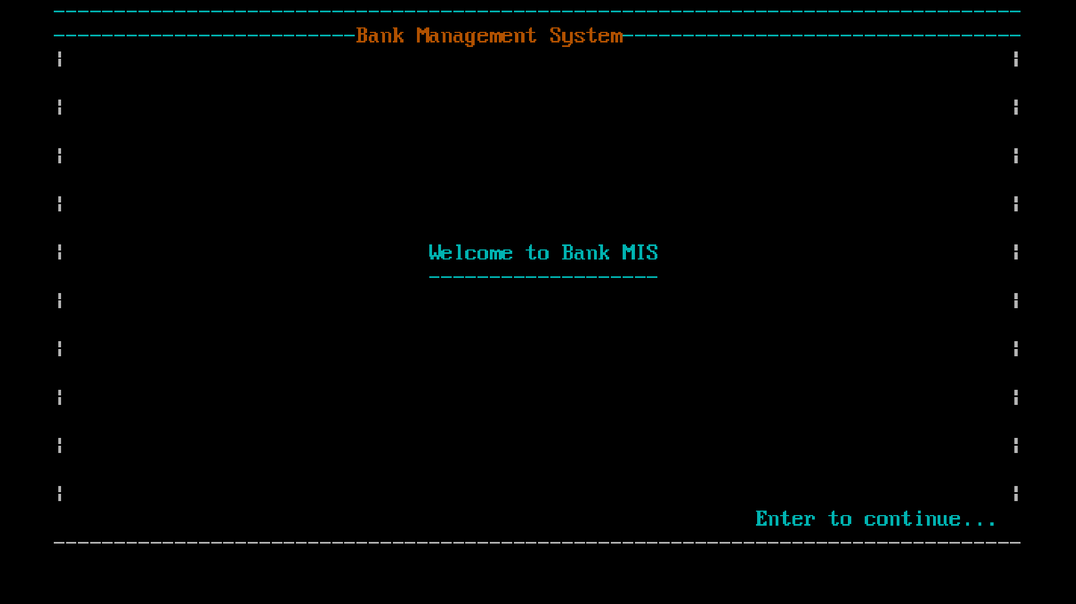

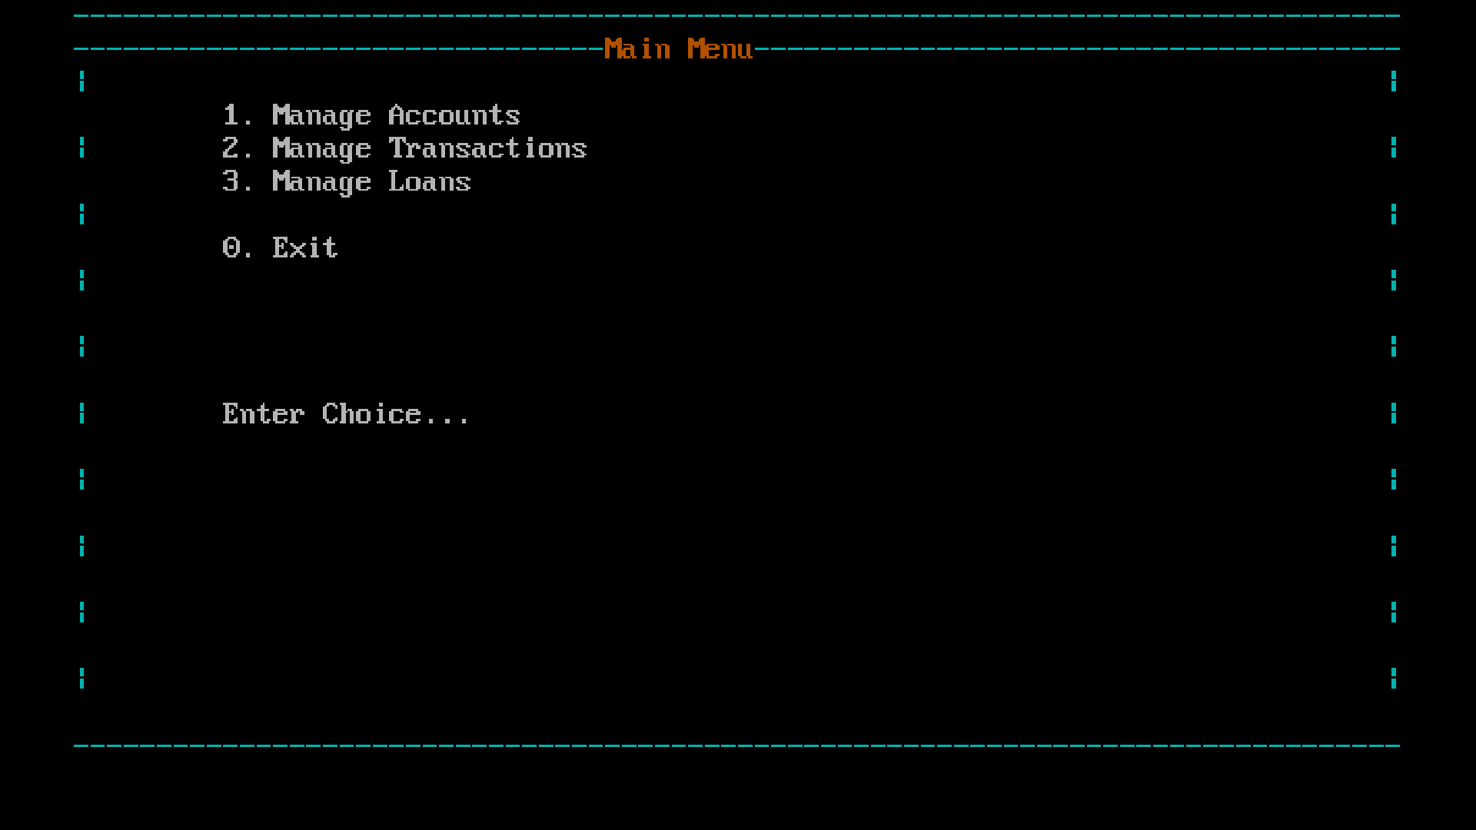

SOURCE CODE:

// Declaring header
#include<stdio.h>
#include<stdlib.h>
#include<string.h>
#include<conio.h>

#define yellow "\033[33m"
#define cyan "\033[36m"
#define red "\033[31m"
#define white "\033[37m"

#define width 80
#define height 22

int op, choice, nav, count, y, page;
// Declaring struct
// Account Structure
struct account{
int a_id;
char a_name[20];
char a_addr[40];
int a_bal;
}a1;
// Transaction Structure
struct transaction{
int t_id;
char a_no[20];
char t_date[12];
int t_type;
int t_amt;
}t1;
OUTPUT

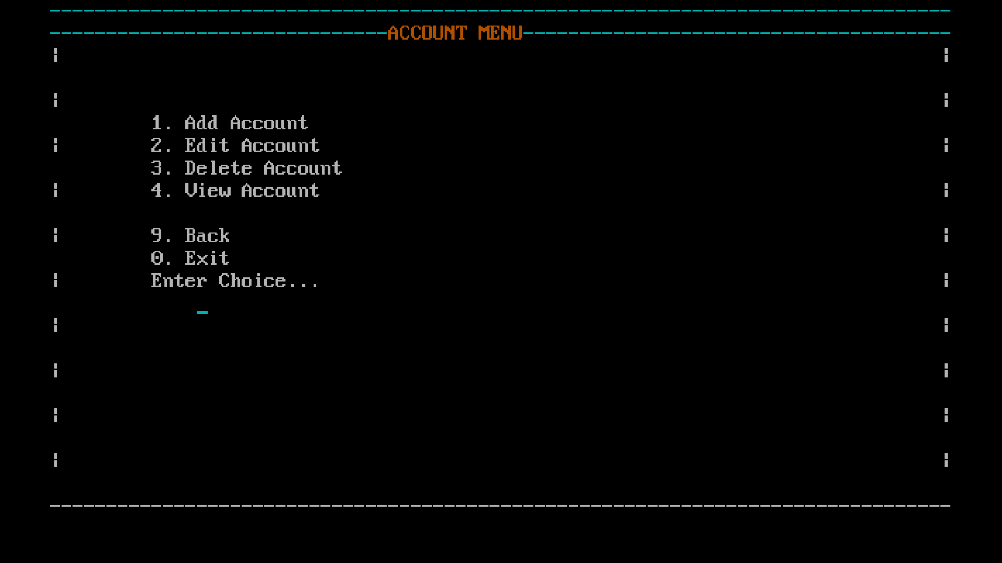

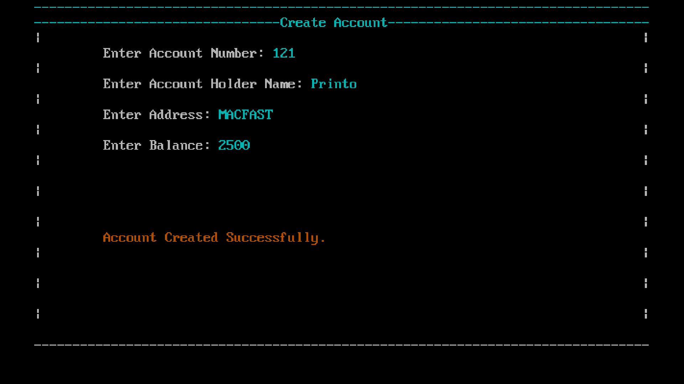
// Loan Structure
struct loan{
int l_id;
int a_no;
char l_date[12];
char l_type[20];
int l_amt;
int l_dur;
}l1;
// Declaration
// Menu
int operationMenu();
int manageAccount();
int manageTransaction();
int manageLoan();
// Creations
int createAccount();
int createTransaction();
int createLoan();
// Edit
int editAccount();
int editTransaction();
int editLoan();
// Delete
int deleteAccount();
int deleteTransaction();
int deleteLoan();

// View
int viewAccount();
int viewTransaction();
int viewLoan();
//utlitize
void gotoxy( int, int);
OUTPUT

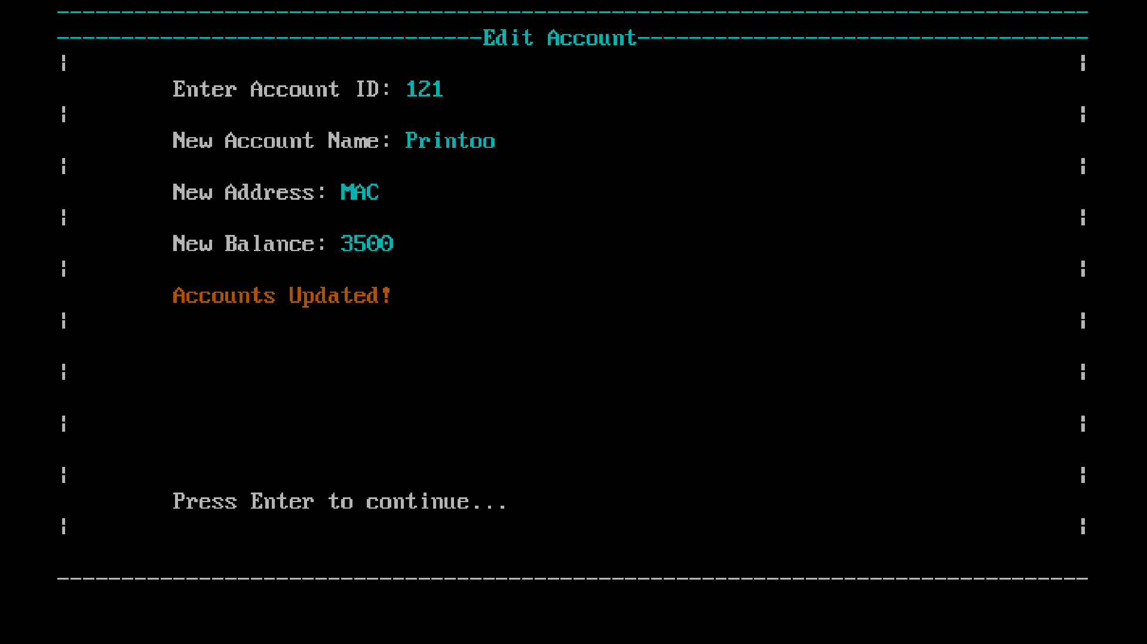

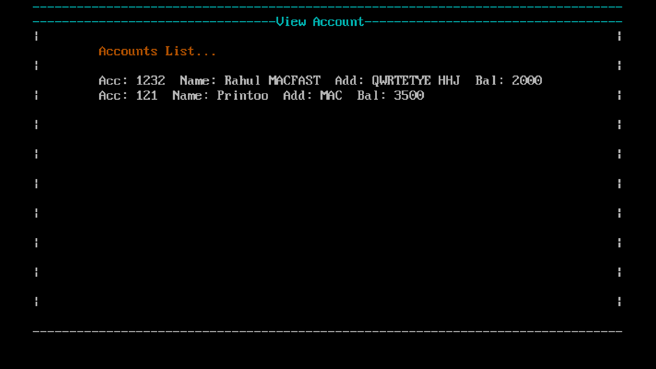

void delay();
void tuiFrame();
void drawLine(char, int);
void clearInside();
void clearScreen();
void renderScreen(const char *title);
void screenMainMenu();
int nextButton();
int exiting();
int bottomBar();
void screenAccounts();
void screenTransaction();
void screenLoan();
//move cursor
void gotoXY(int x, int y) {
printf("\033[%d;%dH", y, x); // \033 ansi value of escape, H move cursor.
}
//delayer
void delay(){
gotoXY(52, height);
printf(cyan"Press any key to continue...");
gotoXY(79, height);
getch();
return;
}
// Styling
void tuiFrame() {
int i,j;
// TOP BORDER
for(i = 0; i < width; i++) printf(cyan"-");
printf("\n");
// SIDES
for(i = 0; i < height - 2; i++) {
printf(cyan"|");
OUTPUT

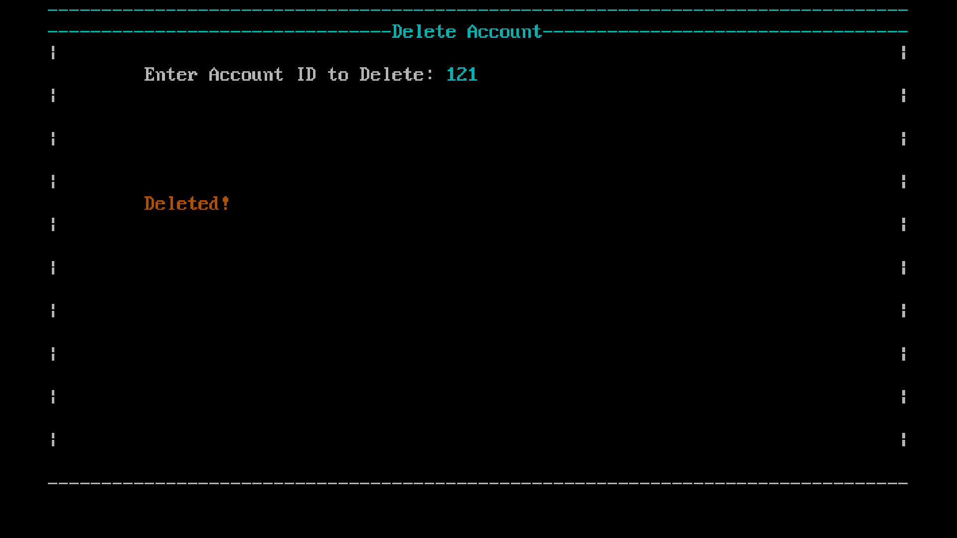

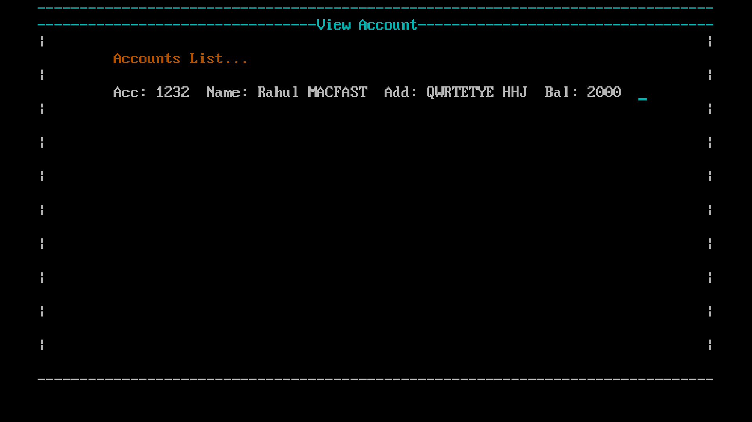

for(j = 0; j < width - 2; j++) {
printf(" ");
}
printf(cyan"|\n");
}
// BOTTOM BORDER
for(i = 0; i < width; i++) printf("-");
printf("\n");
}
void drawLine(char ch, int limit){
int i;
for(i = 0; i < limit; i++){
printf(cyan"%c", ch);
}
}
// Clear Inside
void clearInside() {
int x,y;
for (y = 3; y <= 22; y++) { // Leave title line intact
gotoXY(2, y);
for (x = 0; x < 76; x++)
printf(" ");
}
}
void clearScreen() {
printf("\033[2J\033[1;1H");
}
void renderScreen(const char *title){
int len = strlen(title);
int y = 0;
y = (80 - len)/2;
tuiFrame();
gotoXY(1,1);
drawLine('-', 80); // Draw the fixed 80x22 frame
OUTPUT

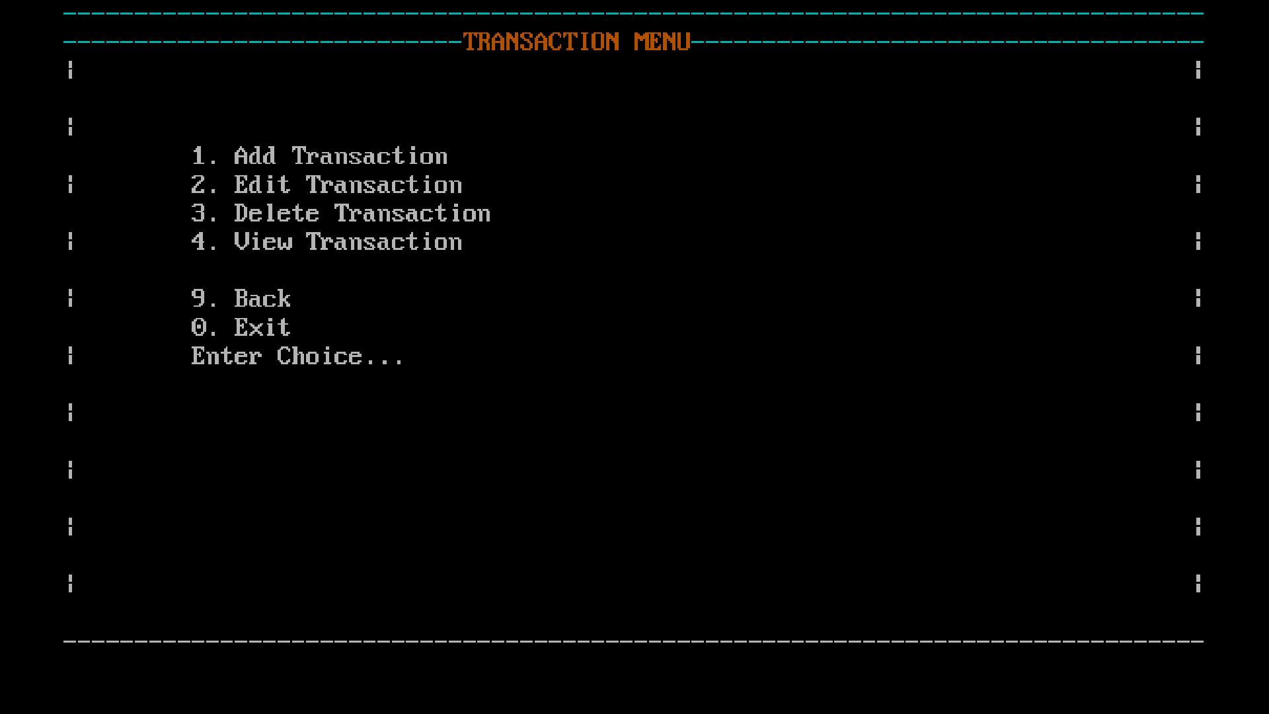

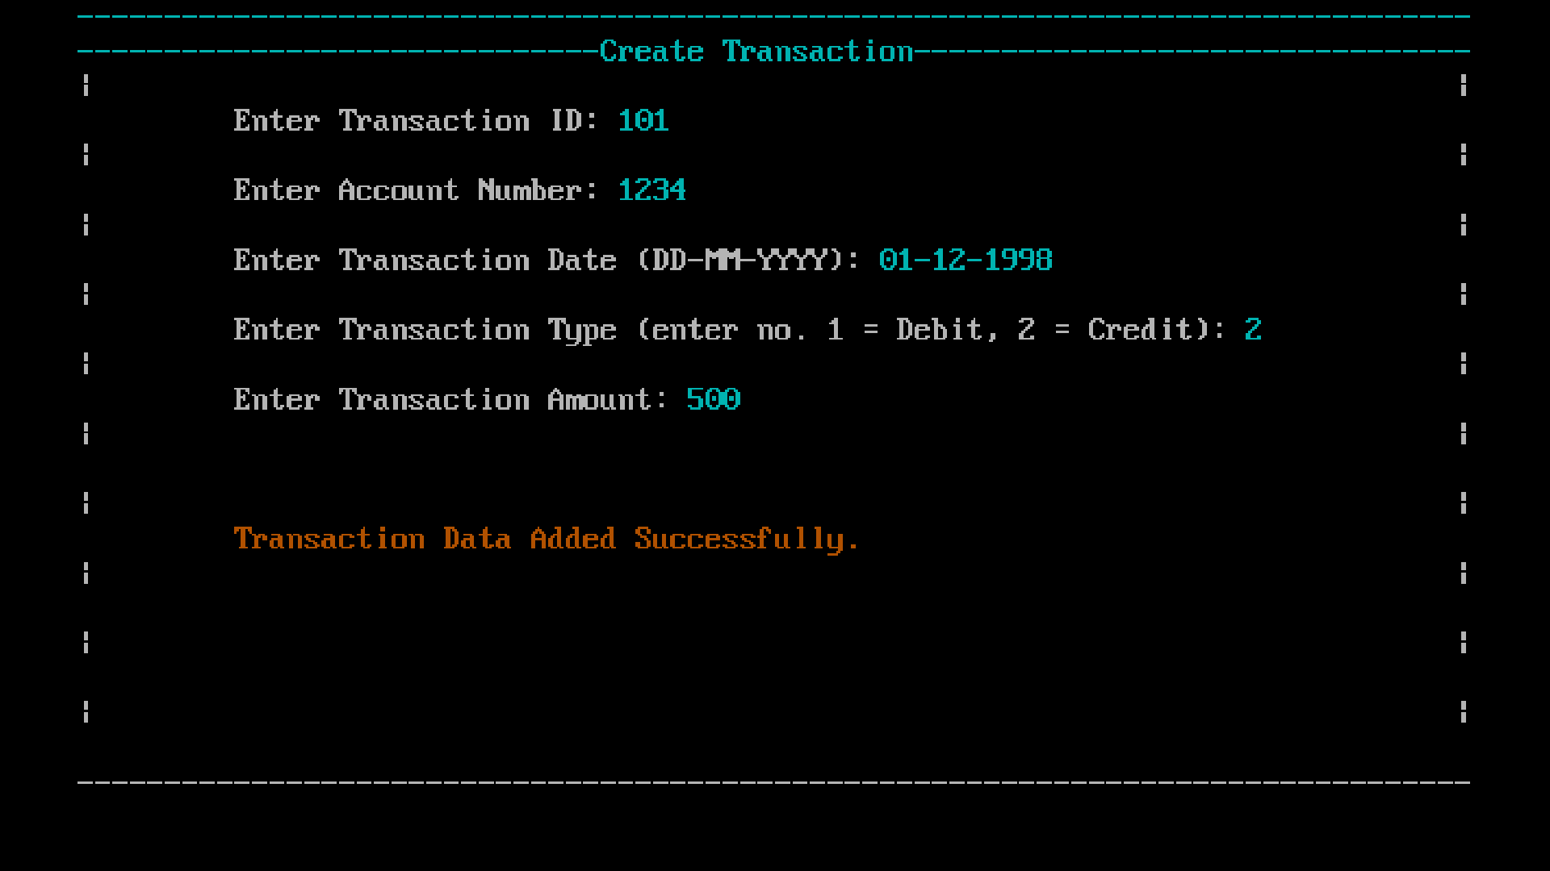

gotoXY(1,2);
drawLine('-', 80);
gotoXY(y,2); // Put title inside the box
printf("%s", title );
printf(cyan);
clearInside(); // Clear the content area for next screen
}
void screenMainMenu() {
renderScreen(yellow"Main Menu"); // clears and draws frame
gotoXY(10, 4); printf(white"1. Manage Accounts");
gotoXY(10, 5); printf("2. Manage Transactions");
gotoXY(10, 6); printf("3. Manage Loans");
gotoXY(10, 8); printf("0. Exit");
}
int nextButton(){
return 0;
}
int exiting(){
gotoXY(39,20);
printf(red"Exiting....");
exit(0);
return 0;
}
int bottomBar() {
int op;
gotoXY(10,20);
printf("9. Exit");
gotoXY(71,20);
printf("0. Next");
gotoXY(39,20);
scanf("%d", &op);
switch (op) {
case 0: return 0; // next page
case 9: return 9; // exit
OUTPUT

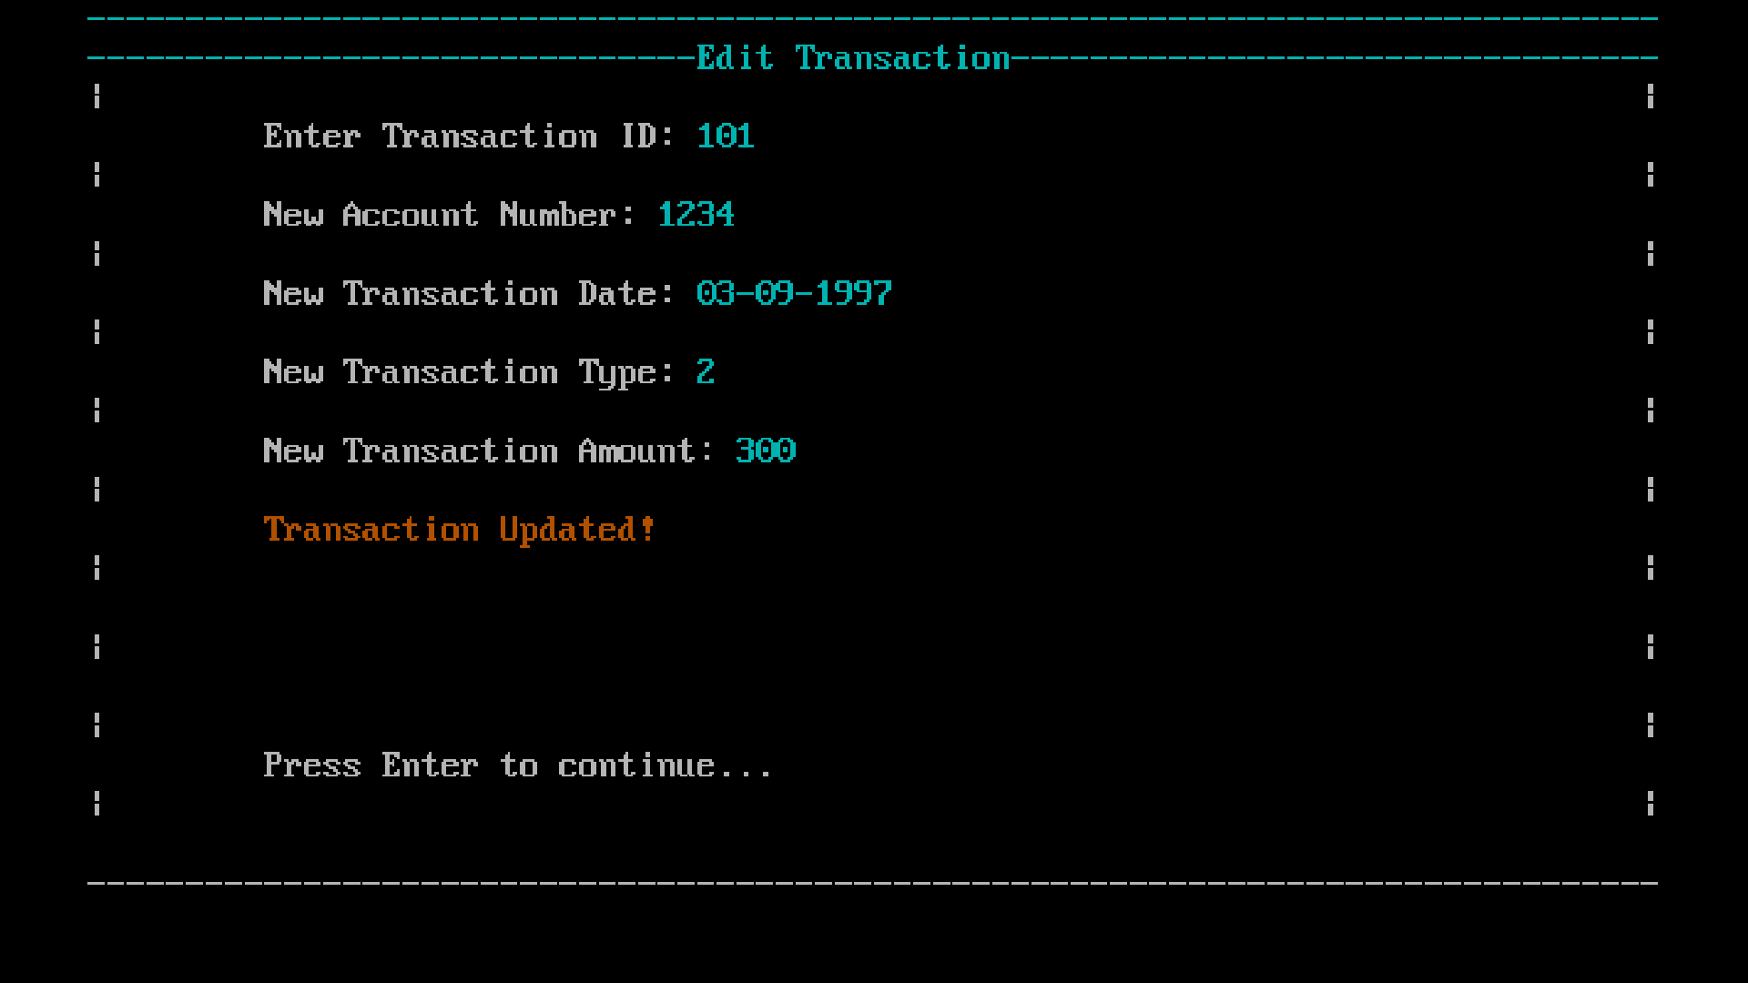

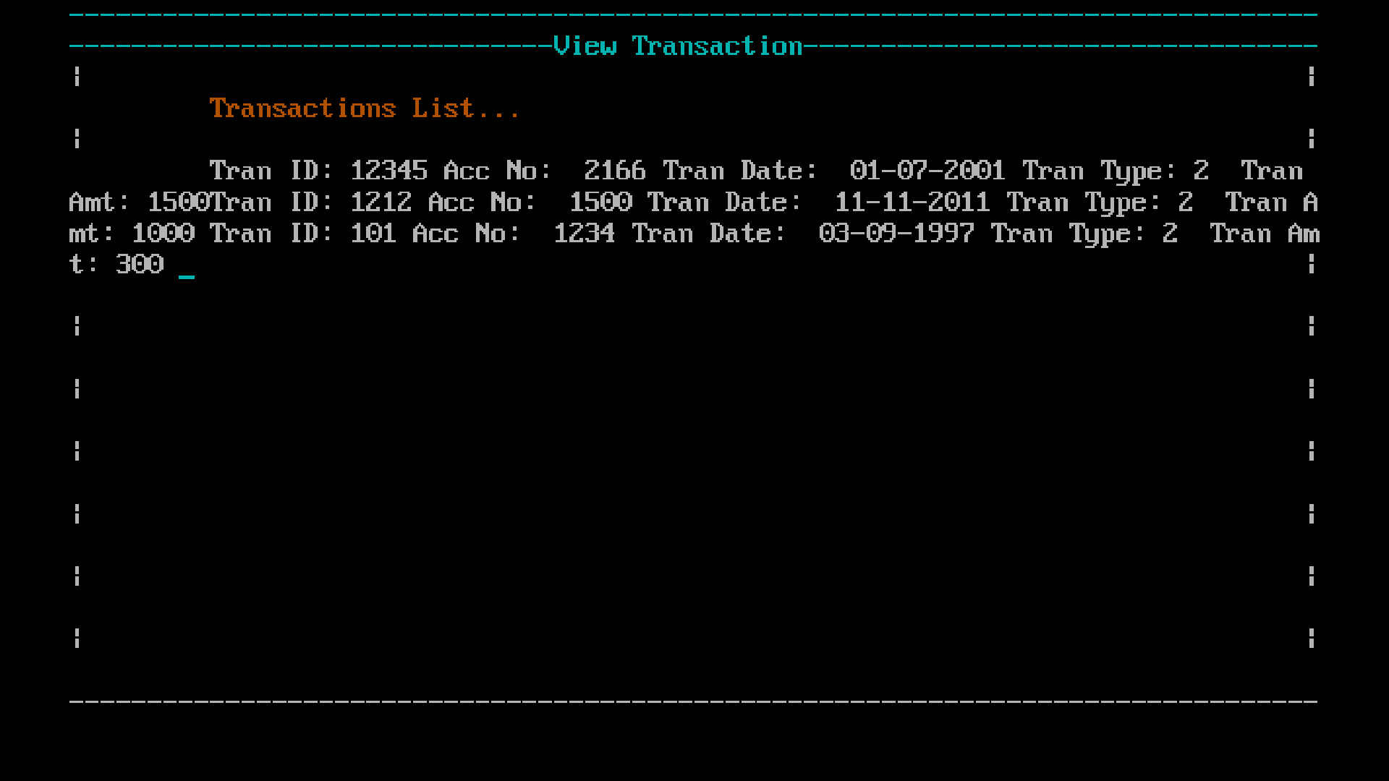

default:
gotoXY(30,20);
printf("Enter valid choice...");
getch();
return bottomBar();
}
}
void screenAccounts() {
clearInside();
gotoXY(30, 4); renderScreen(yellow"ACCOUNT MENU");
gotoXY(10, 6); printf(white"1. Add Account");
gotoXY(10, 7); printf("2. Edit Account");
gotoXY(10, 8); printf("3. Delete Account");
gotoXY(10, 9); printf("4. View Account");
gotoXY(10, 11); printf("9. Back");
gotoXY(10, 12); printf("0. Exit");
}
void screenTransaction() {
clearInside();
gotoXY(30, 4); renderScreen(yellow"TRANSACTION MENU");
gotoXY(10, 6); printf(white"1. Add Transaction");
gotoXY(10, 7); printf("2. Edit Transaction");
gotoXY(10, 8); printf("3. Delete Transaction");
gotoXY(10, 9); printf("4. View Transaction");
gotoXY(10, 11); printf("9. Back");
gotoXY(10, 12); printf("0. Exit");
}
void screenLoan() {
clearInside();
gotoXY(30, 4); renderScreen(yellow"LOAN MENU");
gotoXY(10, 6); printf(white"1. Add Loan");
gotoXY(10, 7); printf("2. Edit Loan");
gotoXY(10, 8); printf("3. Delete Loan");
gotoXY(10, 9); printf("4. View Loan");
OUTPUT

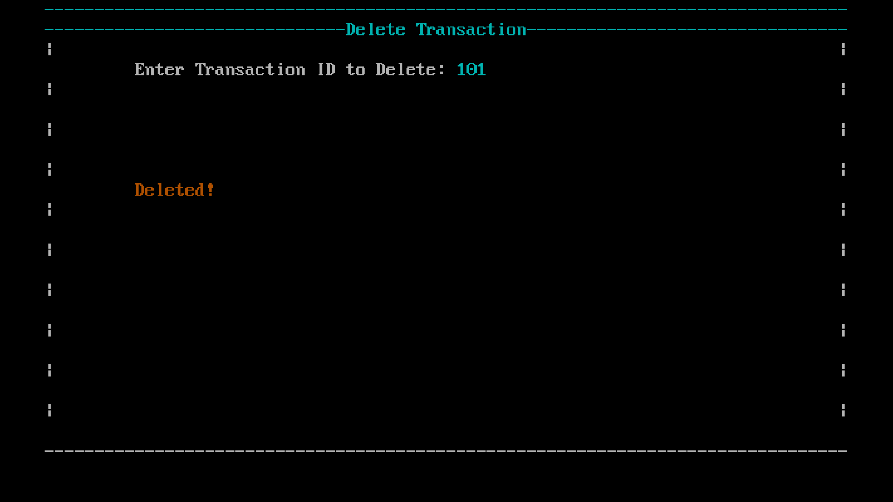

gotoXY(10, 11); printf("9. Back");
gotoXY(10, 12); printf("0. Exit");
}
// Main function
int main(){
// Declaring Menu Option
// This Will be the one function triggered
// All the actions are followed
renderScreen(yellow"Bank Management System");
gotoXY(32, 11);
printf("Welcome to Bank MIS");
gotoXY(32, 12);
printf("-------------------");
gotoXY(59, 22);
printf("Enter to continue...");
getch();
operationMenu();
return 0;
}
// All Banking Operations
int operationMenu(){
while(1){
// A pause which hlp with a gap
screenMainMenu();
gotoXY(10,13);
printf("Enter Choice...\n");
gotoXY(14,14);
scanf("%d", &choice);
switch (choice){
case 1:
manageAccount();
break;
case 2:
manageTransaction();
OUTPUT

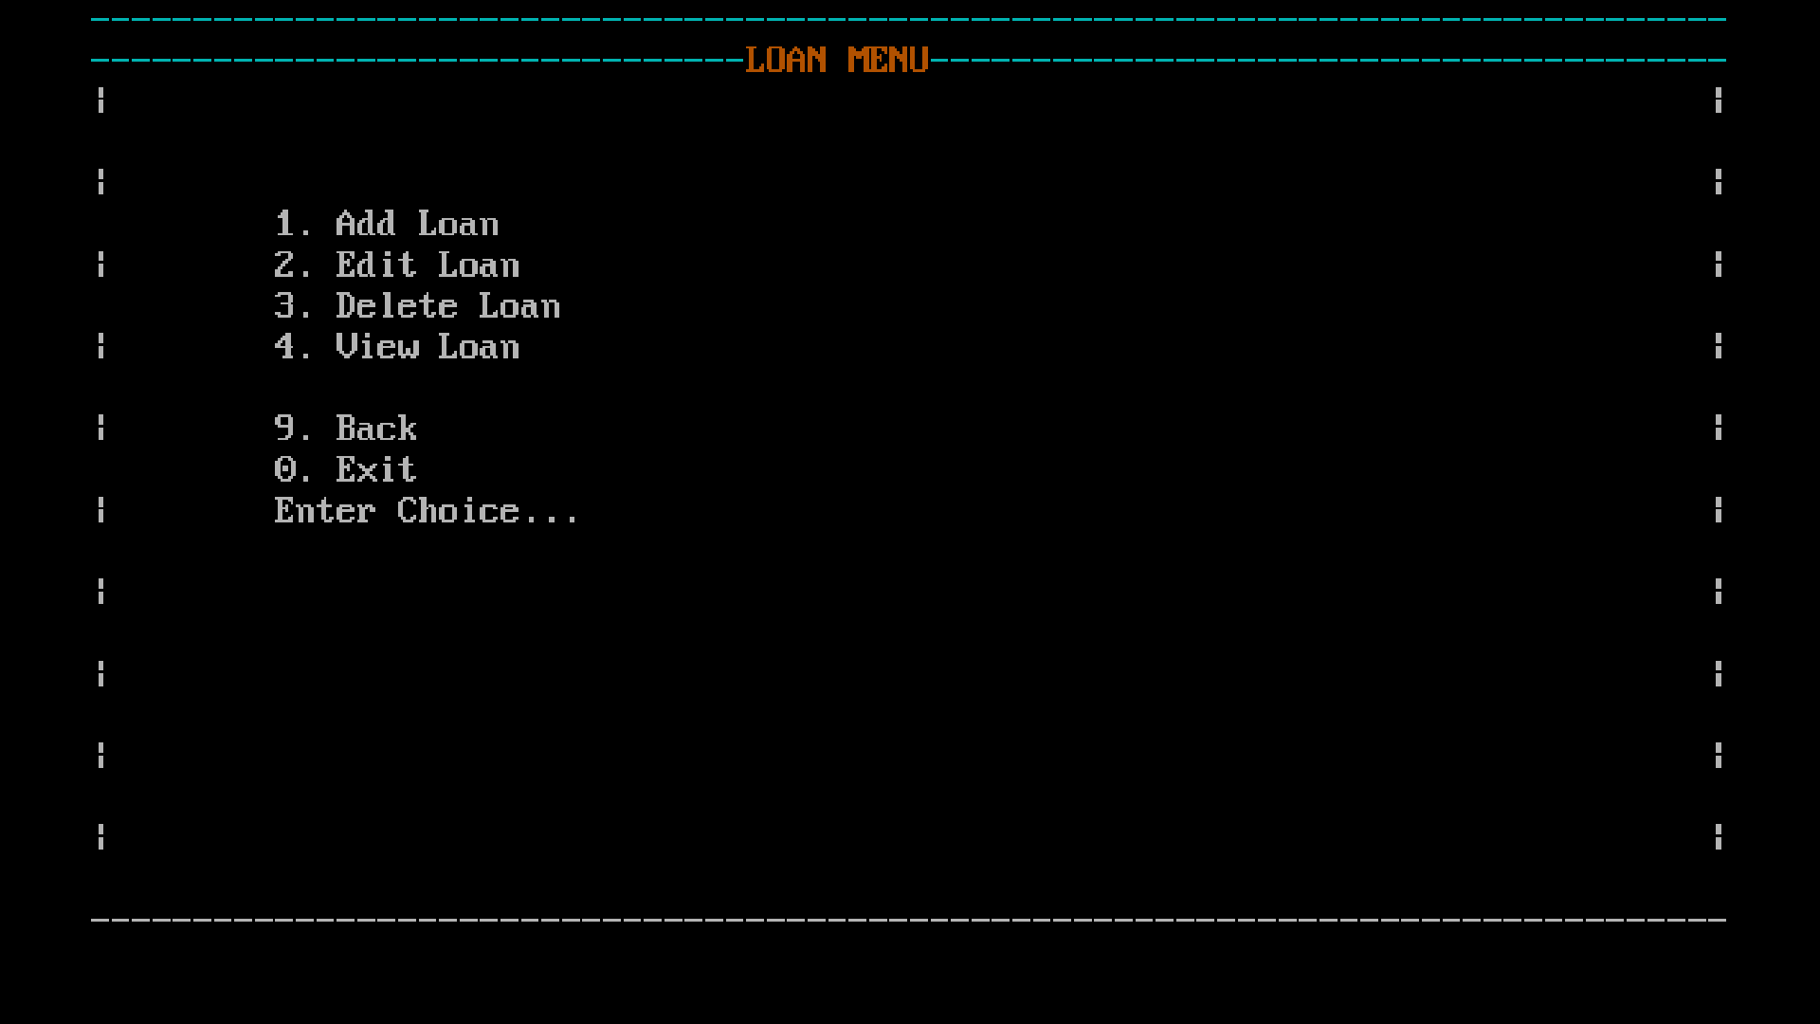

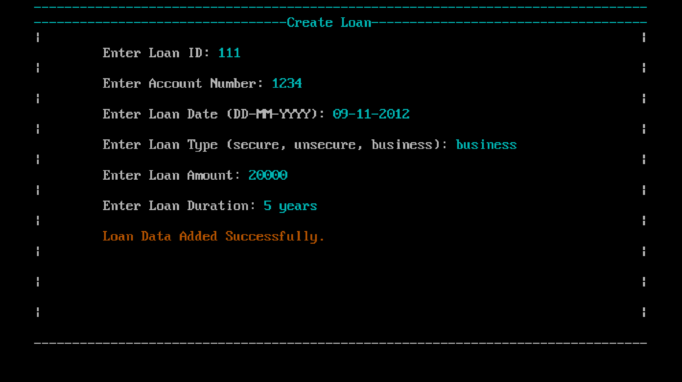

break;
case 3:
manageLoan();
break;
case 0:
exiting();
break;
default:
printf("Invalid Choice.\n");
}
}
}
// Insert Operation
int manageAccount()
{
screenAccounts();
gotoXY(10,13);
printf("Enter Choice...\n");
gotoXY(14,14);
scanf("%d", &op);
switch (op){
case 1:
createAccount();
break;
case 2:
editAccount();
break;
case 3:
deleteAccount();
break;
case 4:
viewAccount();
break;
case 9:
OUTPUT

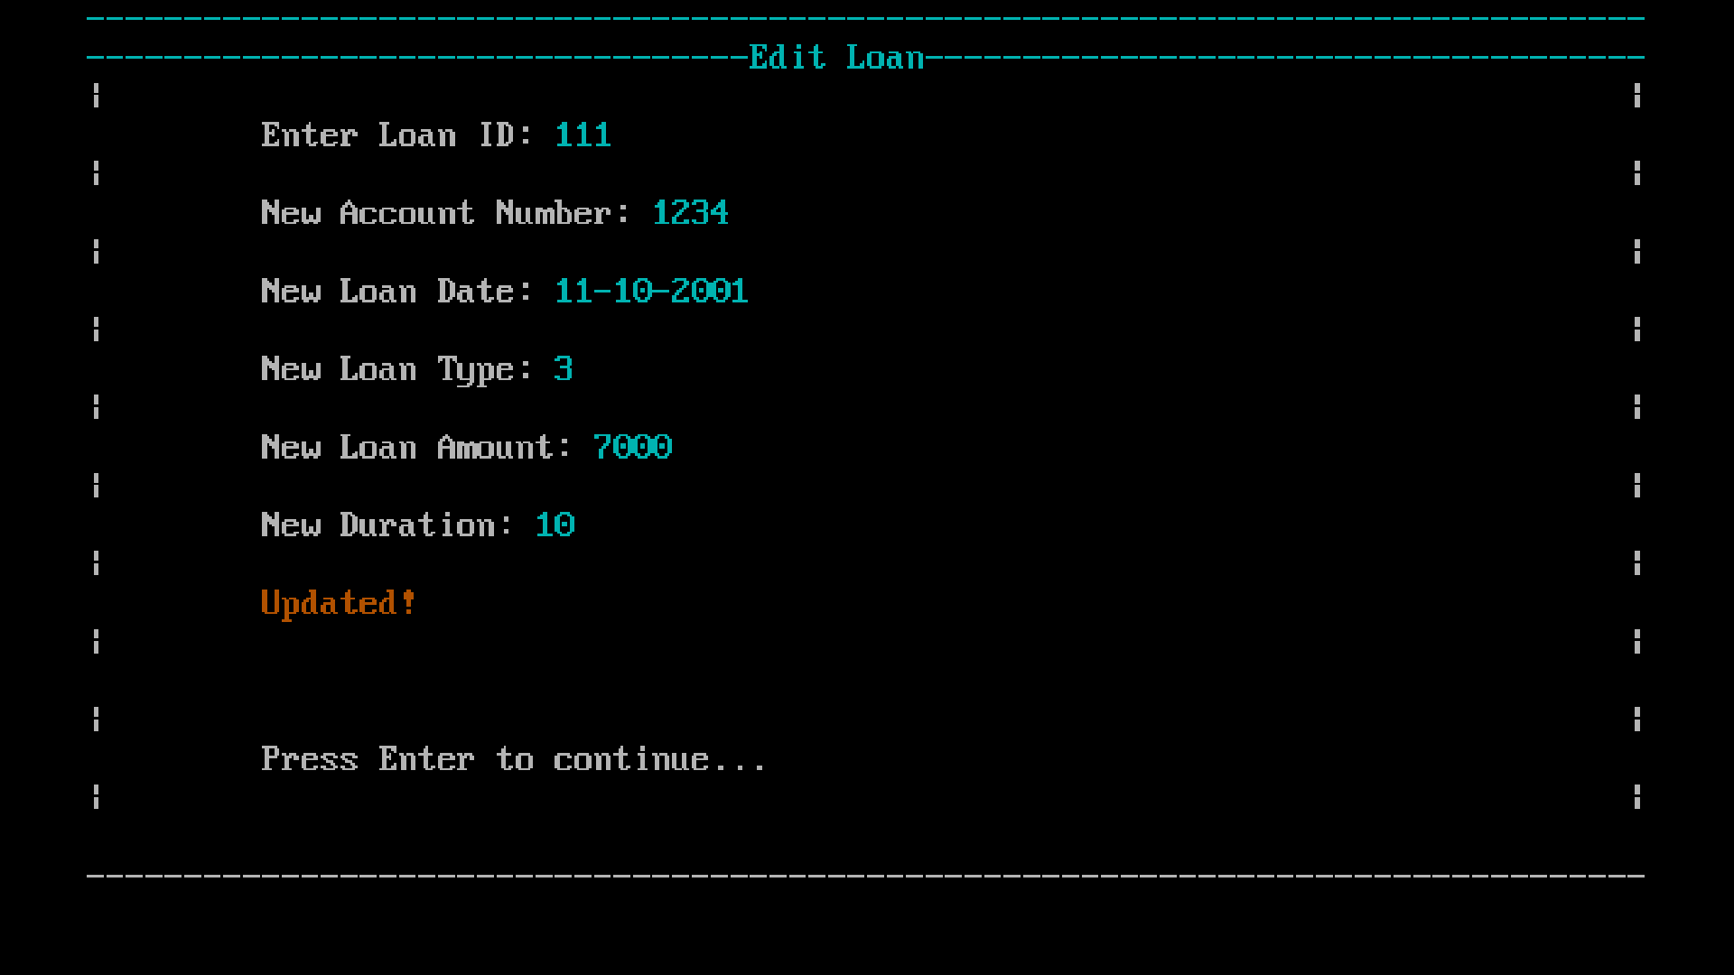

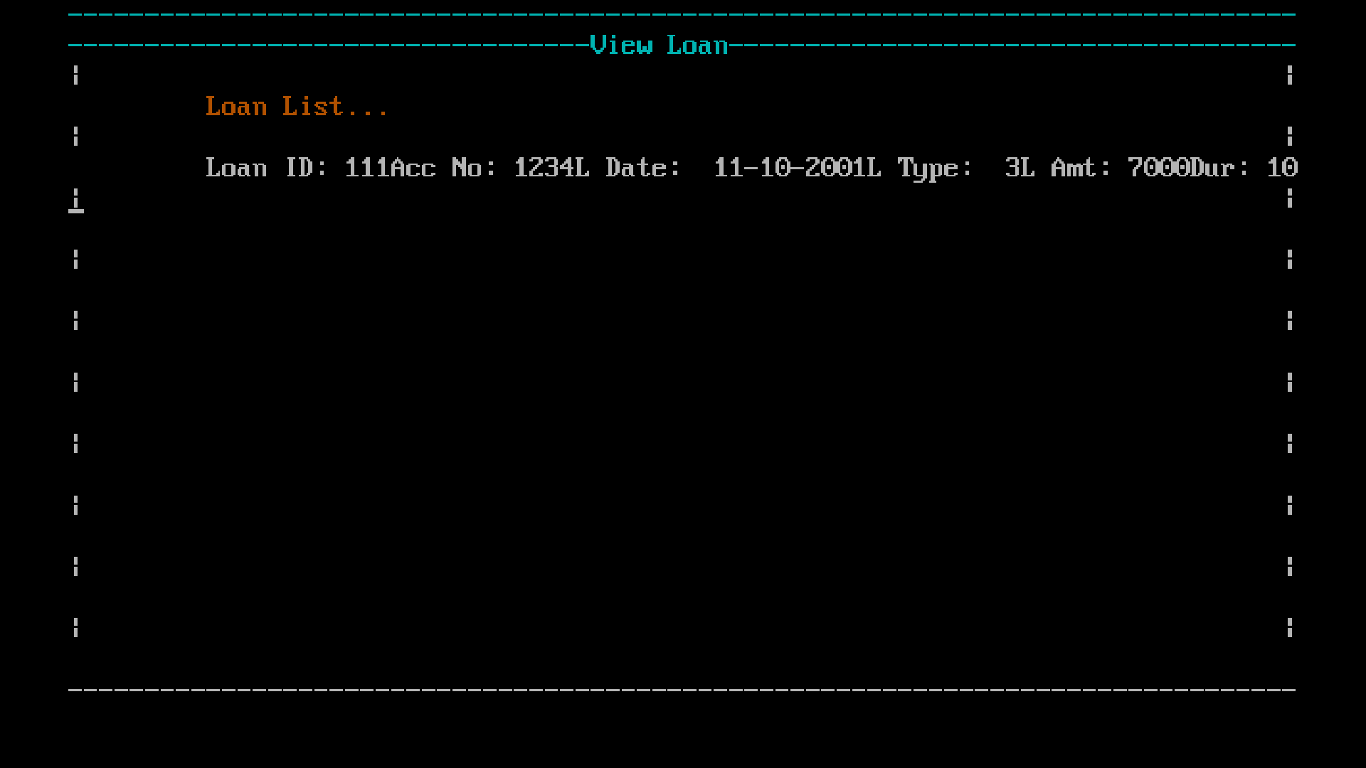
operationMenu();
break;
case 0:
exiting();
break;
default:
printf("Invalid Operation.");
}
return 0;
}
// Edit Opeeration
int manageTransaction(){
screenTransaction();
gotoXY(10,13);
printf("Enter Choice...\n");
gotoXY(14,14);
scanf("%d", &op);
switch (op){
case 1:
createTransaction();
break;
case 2:
editTransaction();
break;
case 3:
deleteTransaction();
break;
case 4:
viewTransaction();
break;
case 9:
operationMenu();
break;
case 0:
OUTPUT

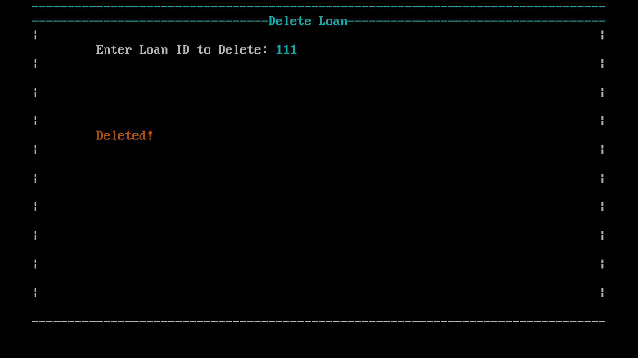

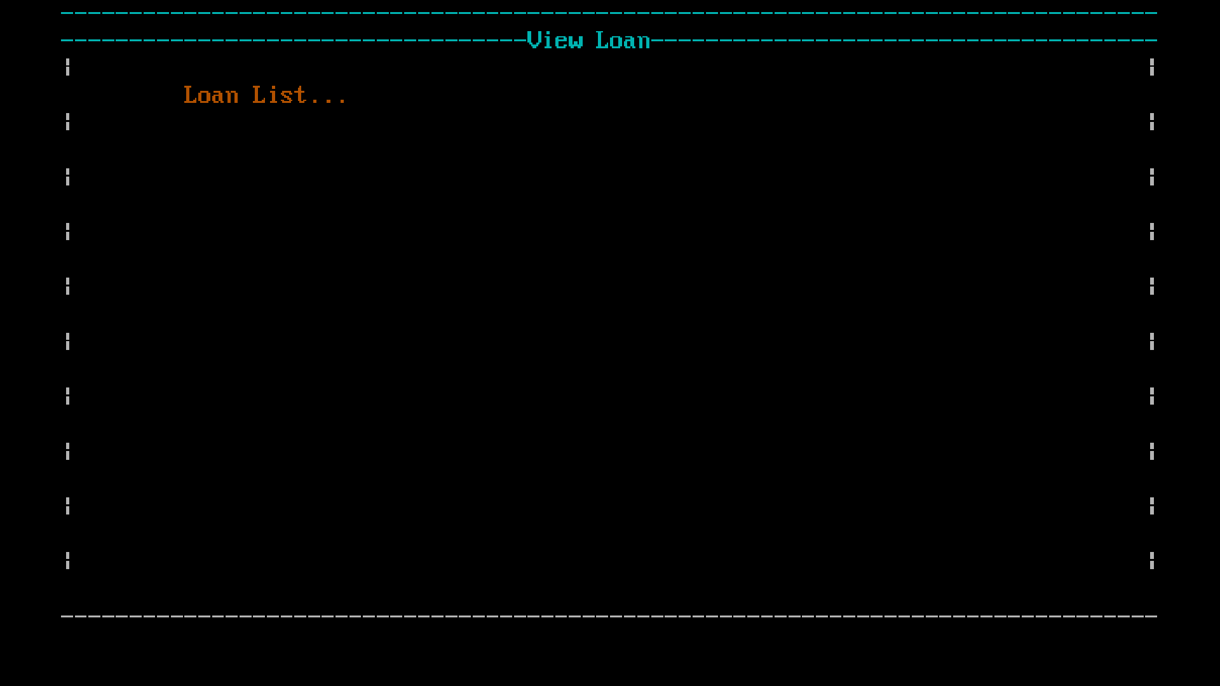
exiting();
break;
default:
printf("Invalid Operation.");
}
return 0;
}
// Delete Operation
int manageLoan(){
screenLoan();
gotoXY(10,13);
printf("Enter Choice...\n");
gotoXY(14,14);
scanf("%d", &op);
switch (op){
case 1:
createLoan();
break;
case 2:
editLoan();
break;
case 3:
deleteLoan();
break;
case 4:
viewLoan();
break;
case 9:
operationMenu();
break;
case 0:
exiting();
break;

default:
printf("Invalid Operation.");
}
return 0;
}
// Validations for Unique ID
int validAcc(int id){
FILE *fAcc = fopen("accounts.txt", "r");
while (fscanf(fAcc, "%d|%[^|]|%[^|]|%d\n",
&a1.a_id, a1.a_name, a1.a_addr, &a1.a_bal) != EOF) {
if(a1.a_id == id){
fclose(fAcc);
return 0;
}
}
fclose(fAcc);
return 1;
}
int validTran(int id){
FILE *fTran = fopen("transaction.txt", "r");
while (fscanf(fTran, "%d|%[^|]|%[^|]|%d|%d\n",
&t1.t_id, t1.a_no, t1.t_date,&t1.t_type, &t1.t_amt) != EOF) {
if(t1.t_id == id){
fclose(fTran);
return 0;
}
}
fclose(fTran);
return 1;
}
int validLoan(int id){
FILE *fLoan = fopen("loan.txt", "r");
while (fscanf(fLoan, "%d|%d|%[^|]|%[^|]|%d|%d\n", &l1.l_id, &l1.a_no, l1.l_date,l1.l_type, &l1.l_amt,

&l1.l_dur) != EOF) {
if (l1.l_id == id){
fclose(fLoan);
return 0;
}
}
fclose(fLoan);
return 1;
}
// FILE INSERTION OPERATIONS
// Inserting data into Accounts file
int createAccount() {
int id;
FILE *fAcc = fopen("accounts.txt", "a");
if (fAcc == NULL) {
gotoXY(10,4);
printf(red"Error opening Accounts file.\n");
return 1;
}
do{
renderScreen("Create Account");
gotoXY(10,4);
printf(white"Enter Account Number: ");
scanf("%d", &id);
if(!validAcc(id)){
gotoXY(10,6);
printf(yellow"Account No. already exists! Enter another.");
printf(white);
delay();
}
}while (!validAcc(id));
a1.a_id = id;
gotoXY(10,6);
printf("Enter Account Holder Name: ");

scanf(" %[^\n]", a1.a_name);
gotoXY(10,8);
printf("Enter Address: ");
scanf(" %[^\n]", a1.a_addr);
gotoXY(10,10);
printf("Enter Balance: ");
scanf("%d", &a1.a_bal);
fprintf(fAcc, "%d|%s|%s|%d\n", a1.a_id, a1.a_name, a1.a_addr, a1.a_bal);
fclose(fAcc);
gotoXY(10,16);
printf(yellow"Account Created Successfully.\n\n");
delay();
return 0;
}
// Inserting data into Transactions file
int createTransaction() {
int id;
FILE *fTran = fopen("transaction.txt", "a");
if (fTran == NULL) {
gotoXY(10,4);
printf(red"Error opening Transactions file.\n");
return 1;
}
do{
renderScreen("Create Transaction");
gotoXY(10,4);
printf(white"Enter Transaction ID: ");
scanf("%d", &id);
if(!validTran(id)){
gotoXY(10,6);
printf(yellow"Transaction ID already exists! Enter another.");
printf(white);
delay();
}

}while (!validTran(id));
t1.t_id = id;
gotoXY(10,6);
printf("Enter Account Number: ");
scanf(" %[^\n]", t1.a_no);
gotoXY(10,8);
printf("Enter Transaction Date (DD-MM-YYYY): ");
scanf(" %[^\n]", t1.t_date);
gotoXY(10,10);
printf("Enter Transaction Type (enter no. 1 = Debit, 2 = Credit): ");
scanf("%d", &t1.t_type);
gotoXY(10,12);
printf("Enter Transaction Amount: ");
scanf("%d", &t1.t_amt);
fprintf(fTran, "%d|%s|%s|%d|%d\n",t1.t_id, t1.a_no, t1.t_date, t1.t_type, t1.t_amt);
fclose(fTran);
gotoXY(10,16);
printf(yellow"Transaction Data Added Successfully.\n\n");
delay();
return 0;
}
// Inserting data into Loan file
int createLoan() {
int id;
FILE *fLoan = fopen("loan.txt", "a");
if (fLoan == NULL) {
gotoXY(10,4);
printf(red"Error opening Loans file.\n");
return 1;
}
do{
renderScreen("Create Loan");
gotoXY(10,4);
printf(white"Enter Loan ID: ");

scanf("%d", &id);
if(!validLoan(id)){
gotoXY(10,6);
printf(yellow"ID already exists! Enter another.");
printf(white);
}
}while (!validLoan(id));
l1.l_id = id;
gotoXY(10,6);
printf("Enter Account Number: ");
scanf("%d", &l1.a_no);
gotoXY(10,8);
printf("Enter Loan Date (DD-MM-YYYY): ");
scanf(" %[^\n]", l1.l_date);
gotoXY(10,10);
printf("Enter Loan Type (secure, unsecure, business): ");
scanf(" %[^\n]", l1.l_type);
gotoXY(10,12);
printf("Enter Loan Amount: ");
scanf("%d", &l1.l_amt);
gotoXY(10,14);
printf("Enter Loan Duration: ");
scanf("%d", &l1.l_dur);
fprintf(fLoan, "%d|%d|%s|%s|%d|%d\n",l1.l_id, l1.a_no, l1.l_date, l1.l_type, l1.l_amt, l1.l_dur);
fclose(fLoan);
gotoXY(10,16);
printf(yellow"Loan Data Added Successfully.\n\n");
getch();
return 0;
}
// FILE EDIT OPERATIONS
// Edit data in Account file
int editAccount() {
FILE *fAcc = fopen("accounts.txt", "r");

FILE *temp = fopen("temp_acc.txt", "w");
int id, found = 0;
renderScreen("Edit Account");
gotoXY(10,4);
printf(white"Enter Account ID: ");
scanf("%d", &id);
while (fscanf(fAcc, "%d|%[^|]|%[^|]|%d\n",&a1.a_id, a1.a_name, a1.a_addr, &a1.a_bal) != EOF) {
if (a1.a_id == id) {
found = 1;
gotoXY(10,6);
printf("New Account Name: ");
scanf(" %[^\n]",a1.a_name);
gotoXY(10,8);
printf("New Address: ");
scanf(" %[^\n]",a1.a_addr);
gotoXY(10,10);
printf("New Balance: ");
scanf("%d", &a1.a_bal);
}
fprintf(temp, "%d|%s|%s|%d\n",a1.a_id, a1.a_name, a1.a_addr, a1.a_bal);
}
fclose(fAcc);
fclose(temp);
remove("accounts.txt");
rename("temp_acc.txt", "accounts.txt");
if (found){
gotoXY(10,12);
printf(yellow"Accounts Updated!\n");
}
else{
gotoXY(10,12);
printf(red"Id Not Found!\n");
}
getch();

return 0;
}
// Edit data in Transaction file
int editTransaction() {
FILE *fTran = fopen("transaction.txt", "r");
FILE *temp = fopen("temp_tran.txt", "w");
int id, found = 0;
renderScreen("Edit Transaction");
gotoXY(10,4);
printf(white"Enter Transaction ID: ");
scanf("%d", &id);
while (fscanf(fTran, "%d|%[^|]|%[^|]|%d|%d\n",&t1.t_id, t1.a_no, t1.t_date,&t1.t_type, &t1.t_amt) != EOF) {
if (t1.t_id == id) {
found = 1;
gotoXY(10,6);
printf("New Account Number: ");
scanf(" %[^\n]", t1.a_no);
gotoXY(10,8);
printf("New Transaction Date: ");
scanf(" %[^\n]", t1.t_date);
gotoXY(10,10);
printf("New Transaction Type: ");
scanf("%d", &t1.t_type);
gotoXY(10,12);
printf("New Transaction Amount: ");
scanf("%d", &t1.t_amt);
}
fprintf(temp, "%d|%s|%s|%d|%d\n",t1.t_id, t1.a_no, t1.t_date,t1.t_type, t1.t_amt);
}
fclose(fTran);
fclose(temp);
remove("transaction.txt");
rename("temp_tran.txt", "transaction.txt");

if (found){
gotoXY(10,14);
printf(yellow"Transaction Updated!");
}
else{
gotoXY(10,14);
printf(red"Not Found!");
}
delay();
return 0;
}
// Edit data in Loan file
int editLoan() {
FILE *fLoan = fopen("loan.txt", "r");
FILE *temp = fopen("temp_loan.txt", "w");
int id, found = 0;
renderScreen("Edit Loan");
gotoXY(10,4);
printf(white"Enter Loan ID: ");
scanf("%d", &id);
while (fscanf(fLoan, "%d|%d|%[^|]|%[^|]|%d|%d\n",&l1.l_id, &l1.a_no, l1.l_date,l1.l_type, &l1.l_amt, &l1.l_dur) != EOF) {
if (l1.l_id == id) {
found = 1;
gotoXY(10,6);
printf("New Account Number: ");
scanf("%d", &l1.a_no);
gotoXY(10,8);
printf("New Loan Date: ");
scanf(" %[^\n]",l1.l_date);
gotoXY(10,10);
printf("New Loan Type: ");
scanf(" %[^\n]",l1.l_type);

gotoXY(10,12);
printf("New Loan Amount: ");
scanf("%d", &l1.l_amt);
gotoXY(10,14);
printf("New Duration: ");
scanf("%d", &l1.l_dur);
}
fprintf(temp, "%d|%d|%s|%s|%d|%d\n",l1.l_id, l1.a_no, l1.l_date,l1.l_type, l1.l_amt, l1.l_dur);
}
fclose(fLoan);
fclose(temp);
remove("loan.txt");
rename("temp_loan.txt", "loan.txt");
if (found){
gotoXY(10,16);
printf(yellow"Updated!");
}
else{
gotoXY(10,16);
printf(red"Not Found!");
}
delay();
return 0;
}
// FILE DELETE OPERATIONS
// Delete data in Account file
int deleteAccount() {
int found = 0;
FILE *fAcc = fopen("accounts.txt", "r");
FILE *temp = fopen("temp_acc.txt", "w");
int id;
renderScreen("Delete Account");
gotoXY(10,4);
printf(white"Enter Account ID to Delete: ");

scanf("%d", &id);
while (fscanf(fAcc, "%d|%[^|]|%[^|]|%d\n", &a1.a_id, a1.a_name, a1.a_addr, &a1.a_bal) != EOF) {
if (a1.a_id == id){
found = 1;
}
if (a1.a_id != id) {
fprintf(temp, "%d|%s|%s|%d\n",a1.a_id, a1.a_name, a1.a_addr, a1.a_bal);
}
}
if (found == 0){
printf(red"Cann't find ID...");
printf(white);
}
fclose(fAcc);
fclose(temp);
remove("accounts.txt");
rename("temp_acc.txt", "accounts.txt");
gotoXY(10,10);
if(found == 1){
printf(yellow"Deleted!\n");
printf(white);
}
delay();
return 0;
}
// Delete data in Transaction file
int deleteTransaction() {
int found = 0;
FILE *fTran = fopen("transaction.txt", "r");
FILE *temp = fopen("temp_tran.txt", "w");
int id;
renderScreen("Delete Transaction");
gotoXY(10,4);
printf(white"Enter Transaction ID to Delete: ");

scanf("%d", &id);
while (fscanf(fTran, "%d|%[^|]|%[^|]|%d|%d\n",&t1.t_id, t1.a_no, t1.t_date, &t1.t_type, &t1.t_amt) != EOF) {
if (t1.t_id == id){
found = 1;
}
if (t1.t_id != id) {
fprintf(temp, "%d|%s|%s|%d|%d\n",
t1.t_id, t1.a_no, t1.t_date, t1.t_type, t1.t_amt);
}
}
if (found == 0){
printf(red"Cann't find ID...");
printf(white);
}
fclose(fTran);
fclose(temp);
remove("transaction.txt");
rename("temp_tran.txt", "transaction.txt");
gotoXY(10,10);
if(found == 1){
printf(yellow"Deleted!\n");
printf(white);
}
delay();
return 0;
}
// Delete data in Loan file
int deleteLoan() {
int found = 0;
FILE *fLoan = fopen("loan.txt", "r");
FILE *temp = fopen("temp_loan.txt", "w");
int id;
renderScreen("Delete Loan");

gotoXY(10,4);
printf(white"Enter Loan ID to Delete: ");
scanf("%d", &id);
while (fscanf(fLoan, "%d|%d|%[^|]|%[^|]|%d|%d\n",&l1.l_id, &l1.a_no, l1.l_date, l1.l_type, &l1.l_amt, &l1.l_dur) != EOF) {
if (l1.l_id == id){
found = 1;
}
if (l1.l_id != id) {
fprintf(temp, "%d|%d|%s|%s|%d|%d\n",
l1.l_id, l1.a_no, l1.l_date, l1.l_type, l1.l_amt, l1.l_dur);
}
}
if (found == 0){
printf(red"Cann't find ID...");
printf(white);
}
fclose(fLoan);
fclose(temp);
remove("loan.txt");
rename("temp_loan.txt", "loan.txt");
gotoXY(10,10);
if(found == 1){
printf(yellow"Deleted!\n");
printf(white);
}
delay();
return 0;
}
// FILE VIEW OPERATIONS
// View data in Account file
int viewAccount() {
FILE *fAcc = fopen("accounts.txt", "r");
if (!fAcc) {

renderScreen("View Account");
gotoXY(10,4); printf("No accounts found.");
getch();
return 1;
}
page = 1;
while (1) {
renderScreen("View Account");
count = 0;
y = 6;
gotoXY(10,4);
printf("Accounts - Page %d", page);
while (count < 2 && fscanf(fAcc, "%d|%[^|]|%[^|]|%d\n", &a1.a_id, a1.a_name, a1.a_addr, &a1.a_bal) != EOF) {
gotoXY(10, y++); printf("Account ID : %d", a1.a_id);
gotoXY(10, y++); printf("Name : %s", a1.a_name);
gotoXY(10, y++); printf("Address : %s", a1.a_addr);
gotoXY(10, y++); printf("Balance : %d", a1.a_bal);
gotoXY(10, y++); drawLine('-', 60);
count++;
if (y >= 18) break;
}
if (count == 0) break;
nav = bottomBar();
if (nav == 9) break;
page++;
}
fclose(fAcc);
return 0;
}
// View data in Transaction file
int viewTransaction() {
FILE *fTran = fopen("transaction.txt", "r");
if (!fTran) {

renderScreen("View Transaction");
gotoXY(10,4); printf("No transactions found.");
getch();
return 1;
}
page = 1;
while (1) {
renderScreen("View Transaction");
count = 0;
y = 6;
gotoXY(10,4);
printf("Transactions - Page %d", page);
while (count < 2 && fscanf(fTran, "%d|%[^|]|%[^|]|%d|%d\n",&t1.t_id, t1.a_no, t1.t_date, &t1.t_type, &t1.t_amt) != EOF) {
gotoXY(10, y++); printf("Transaction ID : %d", t1.t_id);
gotoXY(10, y++); printf("Account No : %s", t1.a_no);
gotoXY(10, y++); printf("Date : %s", t1.t_date);
gotoXY(10, y++); printf("Type : %d", t1.t_type);
gotoXY(10, y++); printf("Amount : %d", t1.t_amt);
gotoXY(10, y++); drawLine('-', 60);
count++;
if (y >= 18) break;
}
if (count == 0) break;
nav = bottomBar();
if (nav == 9) break;

page++;
}
fclose(fTran);
return 0;
}
// View data in Loan file
int viewLoan() {

FILE *fLoan = fopen("loan.txt", "r");
if (!fLoan) {
renderScreen("View Loan");
gotoXY(10,4); printf("No loans found.");
getch();
return 1;
}
page = 1;
while (1) {
renderScreen("View Loan");
count = 0;
y = 6;
gotoXY(10,4);
printf("Loan Records - Page %d", page);
while (count < 2 && fscanf(fLoan, "%d|%d|%[^|]|%[^|]|%d|%d\n", &l1.l_id, &l1.a_no, l1.l_date, l1.l_type,&l1.l_amt, &l1.l_dur) != EOF) {
gotoXY(10, y++); printf("Loan ID : %d", l1.l_id);
gotoXY(10, y++); printf("Account No : %d", l1.a_no);
gotoXY(10, y++); printf("Date : %s", l1.l_date);
gotoXY(10, y++); printf("Type : %s", l1.l_type);
gotoXY(10, y++); printf("Amount : %d", l1.l_amt);
gotoXY(10, y++); printf("Duration : %d months", l1.l_dur);
gotoXY(10, y++); drawLine('-', 60);
count++;
if (y >= 18) break;
}
if (count == 0) break;
nav = bottomBar();
if (nav == 9) break;
page++;
}
fclose(fLoan);
return 0;
}

