Multiprint
A universal Repair Board
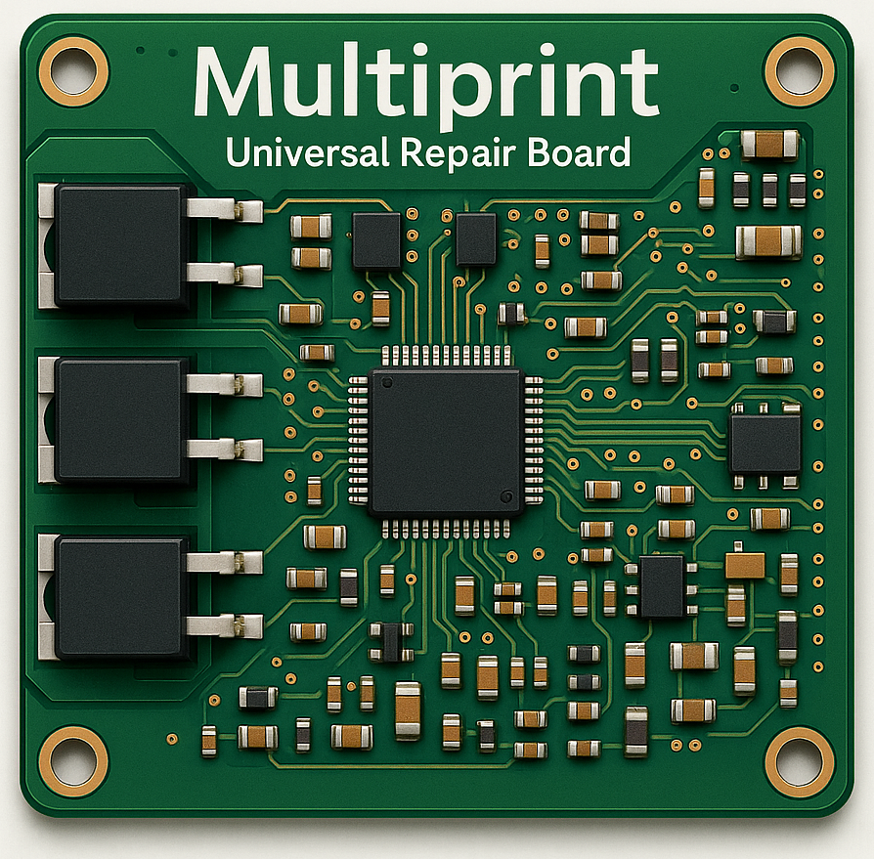

A product of:

Created by:
Marius van Engelenhoven
Table of Contents
Overview 3
Key Specifications 4
Absolute Maximum Ratings 4
Recommended Operating Conditions 4
Electrical Characteristics 5
Functional Description 5
I/O Overview 5
Power Architecture 6
Debug and Diagnostics 6
Communication 7
USB-C Interface 7
System Robustness 7
Design Philosophy 7
Component Selection Rationale 7
Design Challenges & Solutions 7
Testing & Validation 7
Installation & Usage Guidelines 7
Fuse Selection Guidelines (Output Side) 7
Repairer’s Notes 8
Mechanical Drawings & Pinout 8
License & Open Hardware Notice 8
Changelog & Version History 8

Overview
The Multiprint is a robust and highly flexible universal repair board designed for professional use in electronics diagnostics and restoration. It was developed specifically for scenarios where original controller or I/O circuits are damaged, unavailable, or economically unviable to replace. Whether in industrial systems, automotive applications, or consumer electronics, the Multiprint serves as a drop-in or bolt-on replacement to restore critical functionality. At the same time, thanks to its general-purpose input/output design, it can also be used as a compact standalone controller in simpler systems—no original circuit required.
At its core, the Multiprint combines two configurable inputs (analog or digital) with two powerful push/pull outputs, which can also operate together as an H-bridge. This compact yet flexible setup enables countless use cases, such as motor control, automation tasks, load monitoring, signal interfacing, switching logic, and more. Whether driving relays, monitoring sensors, controlling valves, or acting as an interface between systems, the board is designed to be quickly adaptable to the task at hand.
Electrical compatibility is a key strength: both the logic and output sections can operate from 9V to 60V, with inputs protected up to 60V and equipped with software-selectable pull-up and pull-down resistors. Outputs are capable of switching up to 100A, and current is measured with 10 mA resolution. Through software, current limits can be defined for safe and precise control.
For applications requiring communication, the built-in CAN bus interface allows seamless integration into industrial or automotive systems.
To aid diagnostics and development, the board includes a compact debug panel with status LEDs for all internal power rails and an error LED that can display fault codes. To conserve power, these indicators are activated only when a physical debug button is pressed.
The Multiprint is powered by the RP2040 microcontroller, which offers fast performance, ample I/O, and ease of programming via USB-C. While current versions use USB-C for programming only, future revisions are planned to support USB-C power input as well (within a safe current limit). For high-power applications, the output stage can be powered separately from the logic section.
Reliability and safety are embedded in the design. The control logic is protected by a dedicated fuse and remains operational even if the power side experiences a fault or overload. This separation allows the board to continue monitoring and reporting problems—an essential feature for both repair diagnostics and safe shutdown behavior.
Designed in alignment with the Right to Repair philosophy, the Multiprint is fully documented, adaptable, and intended to empower repair professionals and system designers alike.

Key Specifications

Absolute Maximum Ratings
Category | Parameter | Max Rating
Power Supply | Input Voltage (logic & output domains) | 0 V…60 V
 | Reverse Polarity Protection | 0V ...–60 V *
 | Logic Fuse | 2A Self Resettable
 | Output Fuse | User-defined **
Switching Outputs | Output Voltage | 0 V…60 V
 | Continuous Output Current | 60 A
 | Peak Output Current (short duration) | 100 A
Inputs (×2) | Input Voltage (analog/digital) | –0.3 V…60 V
CAN Bus | Common-Mode Voltage | –2 V…14 V
 | Differential Signal Range (CAN_H/CAN_L) | ±5 V
USB-C Port | VBUS Voltage (standard) | 0 V…5 V
 | VBUS Voltage (USB Power Delivery) | 0 V…9 V
 | Max Current via VBUS | Up to 5 A
 | CC/VCONN Pins | –0.5 V…5.5 V
*When power is applied in reverse (up to –60 V), the Multiprint will not operate, but it will remain undamaged.
**The output fuse is not included on the Multiprint board and must be selected by the user. This allows full flexibility depending on the connected load and required protection level. See: Fuse Selection Guidelines (Output Side)

Recommended Operating Conditions
Parameter | Symbol | Min | Typ | Max | Unit | Notes
Supply Voltage | Vsupply | 9 | 24 | 60 | V | Fused by user-installed automotive blade fuse
Input Voltage (Digital Mode) | Vin,dig | 0 | — | 60 | V | with 1 kΩ pull-up/down option
Input Voltage (Analog Mode) | Vin,ana | 0 | — | 60 | V | Input impedance defined in next table
USB-C Supply Voltage | Vusb | 4.75 | 5.0 | 9 | V
Ambient Operating Temperature | Tamb | –20 | 25 | 60 | °C | Board should be thermally managed >30 A

Electrical Characteristics
Parameter | Symbol | Min | Typ | Max | Unit | Notes
Input Pull-Up Resistance (Digital Mode) | RPU | 0.9 k | — | 1.12 k | Ω | Optional per input, software-configurable
Input Pull-Down Resistance (Digital Mode) | RPD | 0.9 k | — | 1.12k | Ω | Optional per input, software-configurable
Input Leakage Current (Analog Mode) | Ileak | — | <1 | 10 | µA | With pull-up/down disabled
Analog Input Resolution | — | — | 12 | — | bits | Determined by RP2040 ADC
Current Measurement Resolution | — | — | 10 | — | mA | Software current limiting enabled
H-Bridge Output Voltage Drop | Vdrop | — | 0.2 | 0.4 | V | At 10 A load, one leg of output
CAN Bus Common-Mode Voltage | Vcm | –2.0 | 2.5 | 7.0 | V | ISO 11898 compliant
CAN Differential Voltage | Vdiff | 1.5 | 2.0 | 3.0 | V | Between CAN_H and CAN_L

Functional Description
The Multiprint board is a compact yet powerful universal control and monitoring platform designed primarily for repair, prototyping, and low-volume production purposes. It combines high-power switching capabilities, precise current sensing, flexible input handling, and robust communication in a single, tightly integrated PCB.

I/O Overview
The board features:
- 2 configurable inputs, usable as analog or digital.
  - Connected to the RP2040 microcontroller.
  - Protected up to 60 V, readable between 0 and 3.3 V. Voltages between 3.3 V and 60 V will register as 3.3 V.
  - Optional internal pull-up or pull-down resistors of 1 kΩ can be enabled in digital mode.
- 2 push/pull outputs, each capable of sourcing/sinking up to 60 A @ 60 V.
  - Outputs are driven by NCE6050KA MOSFETs.
  - Can operate independently or be paired to form an H-bridge configuration.
  - Support PWM up to 20 kHz.
  - Output current is measured bidirectionally using shunt resistors and op-amps.
  - Current measurements are accurate to ~10 mA, and a software-defined current limit can be enforced.

Power Architecture
The board operates from a single external power input of 9–60 V DC, which feeds both the logic and switching domains. While the board is not galvanically isolated, the power domains are independently fused and functionally decoupled.
Input Path:
- Reverse Polarity Protection: Achieved with n N-channel MOSFET to prevent damage from incorrect wiring.
- Switching Domain: Input power is routed through an automotive blade fuse to directly power the MOSFET drivers and outputs.
- Logic Domain: The same input voltage is also routed through four resettable PTC fuses (0.5 A each, in parallel) to a TPS5430 buck converter, which regulates the voltage to 7 V.
Voltage Rails:
- 7 V rail:
  - Feeds an LM317 regulator to generate a clean 3.3 V for the RP2040 and its Flash memory.
  - Supplies the PCA82C250T CAN transceiver.
  - Powers a voltage doubler, generating ~10–14 V.
- 10 V rail:
  - Powers the low-side MOSFET drivers, ensuring strong gate drive voltage.
  - Used to generate VoutX+10 V, by stacking the 10V on top of each output rail (Vout1 and Vout2) to drive the high-side N-channel MOSFETs properly.
  - Also used to derive VoutX–10 V via another doubler stage.
- Op-amp rails:
  - Each output channel has its own isolated op-amp supply:
    - VoutX+10 V (stabilized by an LM317) as op-amp V+
    - VoutX–10 V (also stabilized by an LM317) as op-amp V−
  - This allows precise bidirectional current sensing across the output shunts.
- Output scaling:
  - The op-amp outputs are connected to MOSFET-based level shifters that convert the analog measurement signals from the floating ±10 V domains down to the microcontroller-readable 0–3.3 V range.

Debug and Diagnostics
A dedicated debug panel provides visual feedback:
- Status LEDs for all key voltage rails.
- A configurable error LED capable of signaling error codes.
- The entire debug section is user-activated via a physical button to save power during normal operation.

Communication
The board features a CAN bus interface using the PCA82C250T transceiver, enabling robust communication in automotive and industrial environments.

USB-C Interface
- Programming: USB-C provides easy firmware uploading using UF2 or SWD.
- Power: USB-C will also support logic power input and even switching power up to 20V 5A

System Robustness
- The logic and switching domains are fused independently to ensure partial functionality under fault conditions.
- In the event of an output short that blows the blade fuse, the microcontroller and diagnostics remain powered, allowing error detection and reporting.
- All external connections (inputs, outputs, and power) are heavily protected against overvoltage and the power is protected against polarity mistakes, ensuring high reliability in repair environments.

Design Philosophy

Component Selection Rationale

Design Challenges & Solutions

Testing & Validation

Installation & Usage Guidelines

Fuse Selection Guidelines (Output Side)
The Multiprint includes an automotive-style fuse holder on the switching power rail. However, no fuse is pre-installed: users are expected to select and insert an appropriate fuse based on their specific application. This design choice ensures the board remains flexible and suitable for a wide range of loads.
Fuse Holder Details:
- Type: Standard automotive blade fuse (ATO/ATC size).
- Location: Onboard, inline with the output power supply domain.
- Access: Easily replaceable without soldering.
Selection Guidelines:
- Current Rating: The Multiprint supports continuous switching up to 60 A. Select a fuse rated slightly above your expected continuous load.
- Voltage Rating: Use a fuse rated for 60 V DC or more.
- Response Type:
  - Use a slow-blow fuse for inductive loads (e.g. motors).
  - Use a fast-blow fuse for resistive loads or sensitive electronics.
- Testing: Always verify fuse performance in actual conditions. Monitor for nuisance tripping or insufficient protection.
Important Note:
The fuse protects the switching power rail only. The logic/control circuitry is protected by a separate fuse and remains operational even if the output fuse is blown

Repairer’s Notes

Mechanical Drawings & Pinout

License & Open Hardware Notice

Changelog & Version History

