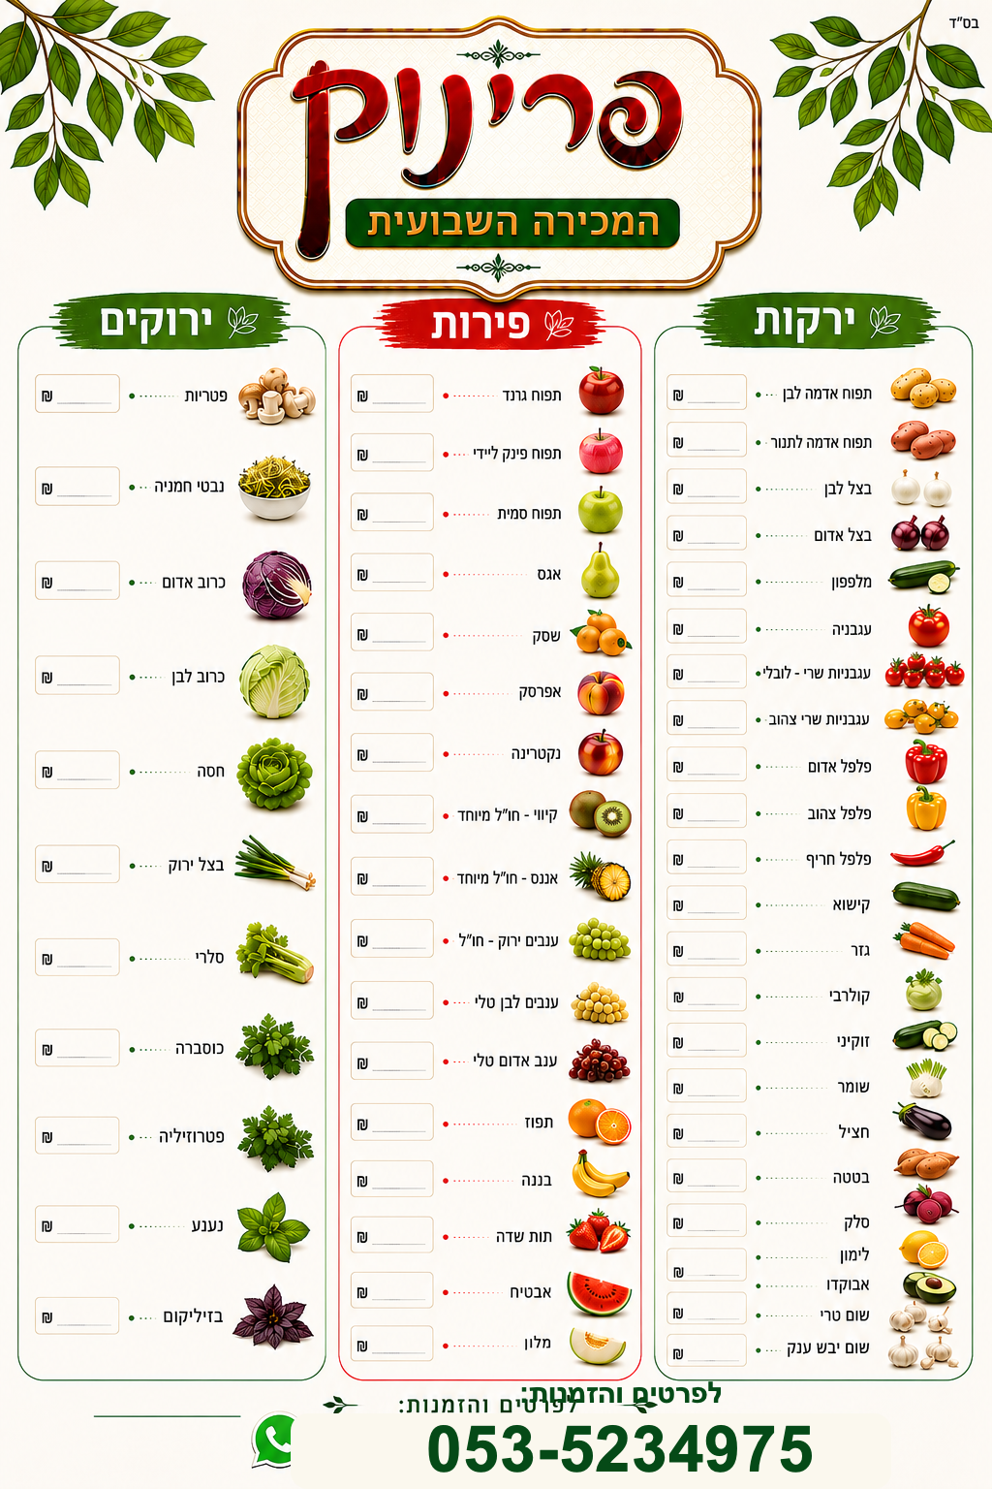
48 יחי׳
8.9

11.9
11.9
9.9 יחי׳
44
7.9
44
44.9
19.9
17.9
7.9
9.9
4.9
4.9
4.9
7.9
8.9
13.9
12.9
18.9
18.9
9.9
8.9
6.9
4.9
9.9
4.9
8.9
9.9
4.9
4.9
4.9
5.9
5.9
7.9
21.9
21.9
19.9
4.9
5.9
13.9
13.9
4.9
12.9
12
18.9
12.9
10.9
5.9

