Problem 1: Simulate a Differential Amplifier

LTSpice Circuit:

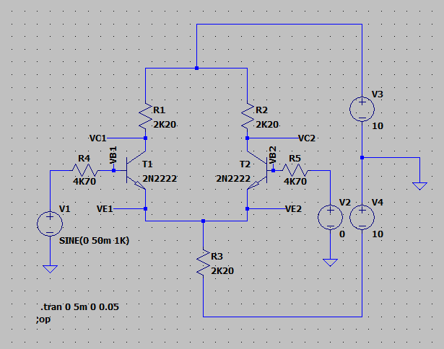

Task 1

Perform a dc operation point analysis for the above circuit. Determine the values for VBE(T1, T2), VC(T1, T2) , IC(T1, T2), IE(T1, T2), and IRE. What would happen with the values in the two branches if the transistors are not absolute identical.

|  |  |  |
| --- | --- | --- |
|  | T1 | T2 |
| $$V_{BE}$$ | 0.67362V | 0.67362V |
| $$V_{C}$$ | 5.38824V | 5.3824V |
| $$I_{C}$$ | 0.002099A | 0.002099A |
| $$I_{E}$$ | -0.002109A | -0.002109A |
| $$I_{RE}$$ | 0.004218A | |

Task 2

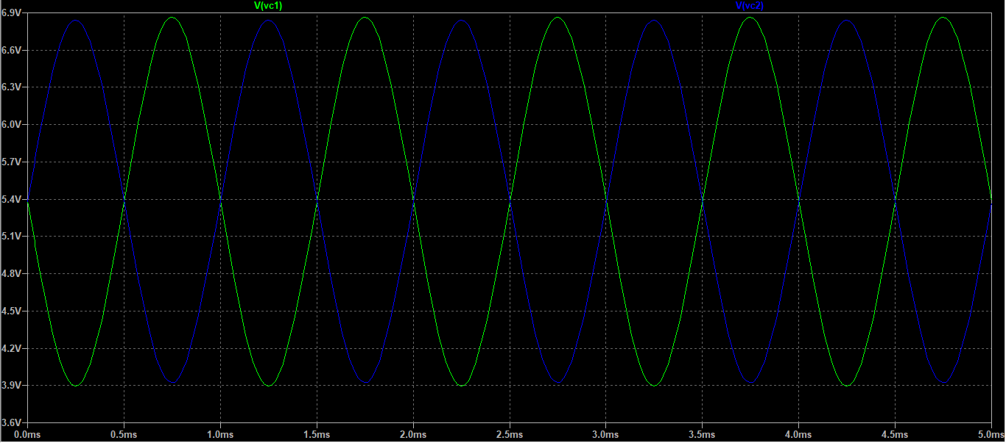

Figure: Collector voltages at output

Using the cursors, we obtain the peak-to-peak difference in Vout. Using this value, we can obtain the gain as follows:

$${dBA}_{V,diff}=20\log\left(\frac{2.9371795V}{2×50×{10}^{-3}V}\right)=29.358 dB$$

Task 3

After making the required changes, we obtain the following results:

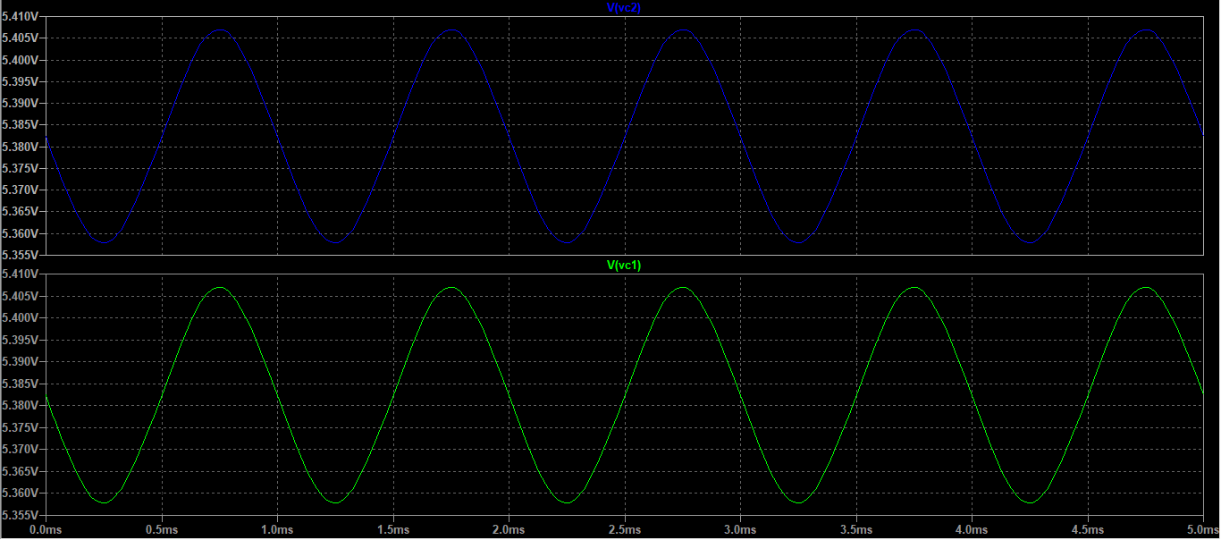

Figure: Output collector voltages

Using the cursors, we find that the difference between the peaks at a point in time. We obtain the following results:

$${dBA}_{V, cm}=20\log\left(\frac{V_{out}}{V_{in}}\right)=20\log\left(\frac{45.682203µV}{2×50mV}\right)=-6.805 dB$$

Task 4

$$CMRR=20\log\left(\frac{A_{V,diff}}{A_{V, cm}}\right)=20\log\left(A_{V,diff}\right)-20\log\left(A_{V,cm}\right)=29.358+6.805=36.163 dB$$

Task 5

On replacing R3 with a constant current source, we have the following final set-up:

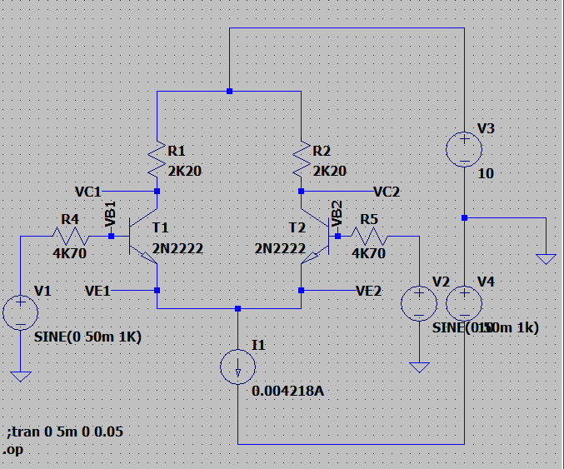

Figure: Differential Amplifier with current source

Sub-task 1

On completing the operation point analysis, we obtain the following values:

|  |  |  |
| --- | --- | --- |
|  | T1 | T2 |
| $$V_{C}$$ | **5.38225V** | **5.38225V** |
| $$V_{BE}$$ | 0.6736225V | 0.6736225V |
| $$I_{C}$$ | **0.00209898A** | **0.00209898A** |
| $$I_{E}$$ | **-0.002109A** | **-0.002109A** |
| $$I1$$ | **0.004218A** | |

Sub-task 2

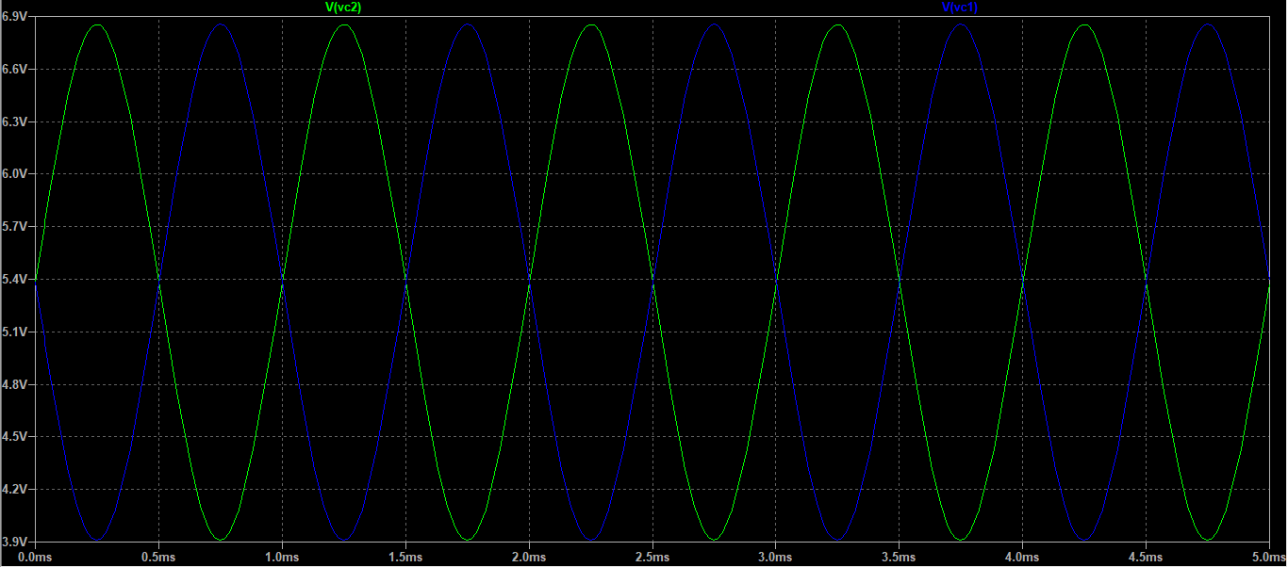

Figure: Collector voltage outputs

Using cursors, we find the difference between the peaks of the output voltage. Using the value, we can make the following calculations:

$$dBA_{V,diff}=20\log\left(\frac{V_{out}}{V_{in}}\right)=20\log\left(\frac{2.9424655V}{2×50mV}\right)=29.425dB$$

Sub-task 3

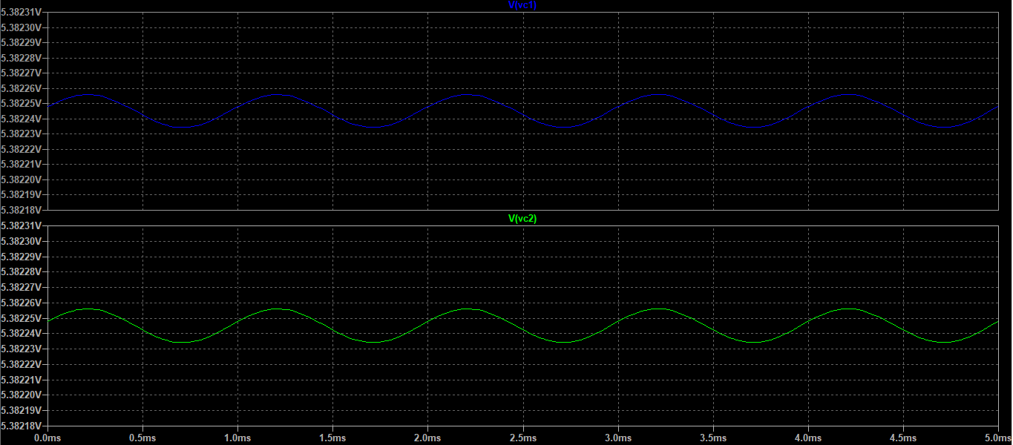

Figure: Common mode simulation results

$$dBA_{V,cm}=20\log\left(\frac{V_{out}}{V_{in}}\right)=20\log\left(\frac{64.035565nV}{2×50mV}\right)=-123.872 dB$$

Sub-task 4

$$CMRR=20\log\left(\frac{A_{V,diff}}{A_{V, cm}}\right)=20\log\left(A_{V,diff}\right)-20\log\left(A_{V,cm}\right)$$

$$CMRR=29.425dB+123.872 dB=153.297 dB$$

**Problem 2: Construct an OP-Amp**

For this task, we are required to construct the following circuit:

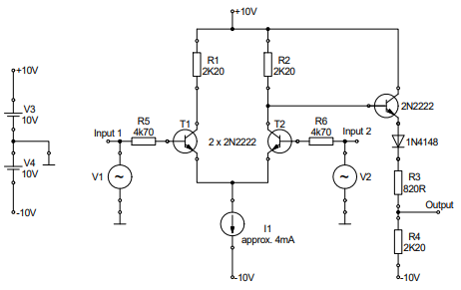

Figure: OP-Amp Circuit

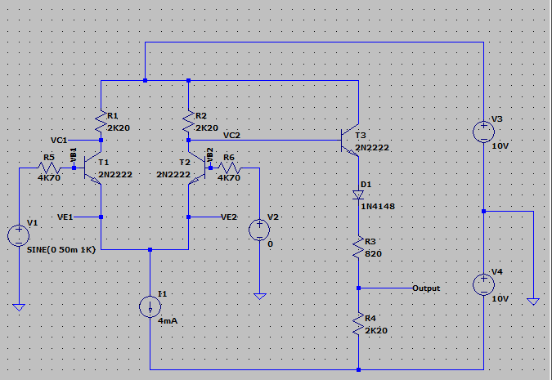

Figure: Op-Amp circuit Implementation

Task 1(!!!!!!!!!!!!!!!PROBLEM!!!!!!!!!!!!!!!!!------both calculated and simulated results different from Uwe but match each other)

Calculate the voltage at the output of the emitter follower when both inputs are connected to ground. Assume β = 200 and UBE = 0.7V . The forward voltage drop of the diode is 0.7V.

$$I_{E2}=I_{C2}=\frac{I_{1}}{2}=2mA=2×{10}^{-3}A$$

$$V_{R2}=I_{C2}R_{2}= 4.4V$$

Using KVL:

$$V_{CB}=V_{R2}=4.4V$$

$$V_{CE}=V_{CB}+V_{BE}=5.1V$$

$$-10-10+5.1+0.7+I_{E3}R_{3}+I_{E3}R_{4}=0$$

$$I_{E3}=4.702×{10}^{-3}A$$

Using KVL about output:

$$V_{out}-(-10V)=10.344V$$

$$V_{out}= 0.344V$$

Task 2

Using the DC Operating Point analysis, we found the following results:

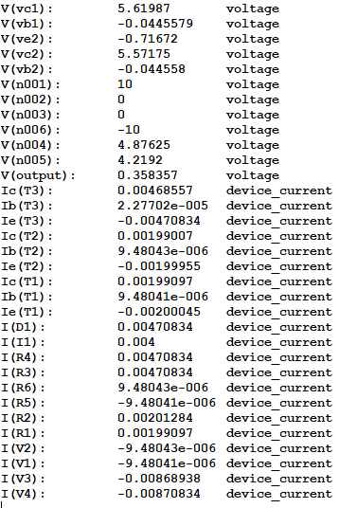

As we can see, according to the simulation,

$$V_{out}=0.358V$$

This value is very close to our calculated value, so the DC Operation Analysis meets our expectations.

Task 3 (PROBLEM!!!!!!----Not sure if results are okay)

As in the first problem, we find AV,diff by setting V1 at input 1 to sine, with f = 1KHz and u = 50 mV. Furthermore, V2 is set to GND.

We find the following results:

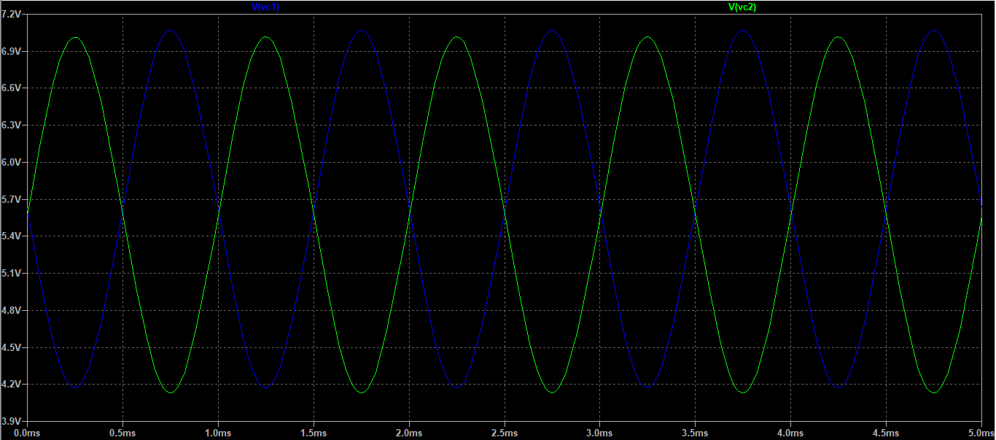

Figure: Collector Output Voltages in Differential Input Mode

$${dBA}_{V, diff}=20\log\left(\frac{2.8376463V}{50mV×2}\right)=29.0592 dB$$

Setting V2 to be the same as V1 and repeating the simulation, we obtain the following output:

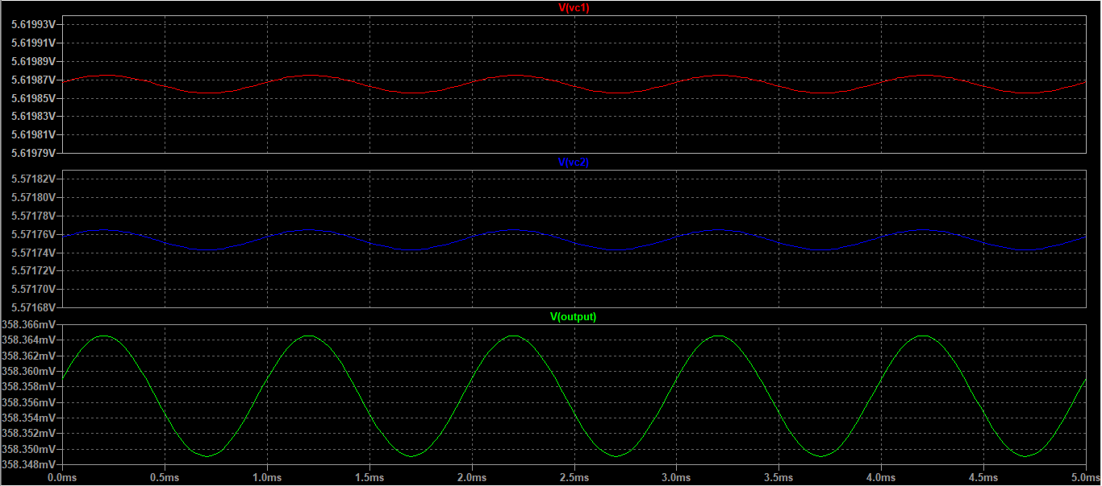

Figure: Collector Output Voltages in Common Input Mode

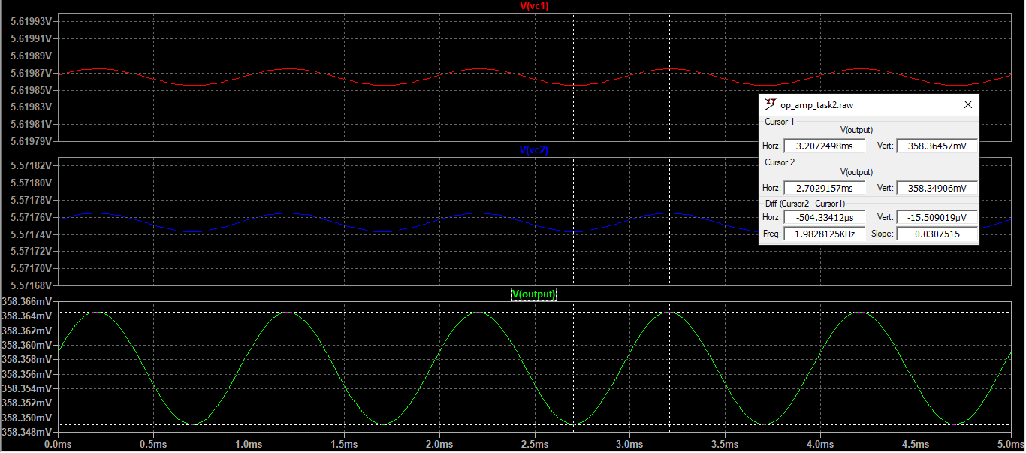

$$dBA_{v, cm}=20\log\left((15.509019µV)/(50mV×2)\right)=-76.1883 dB$$

$$CMRR=dBA_{V,diff}-dBA_{V,cm}=105.2475 dB$$

Task 4

To determine the inverting and non-inverting inputs, we first supply a sinusoidal input at V1, set V2 to GND, and observe the output:

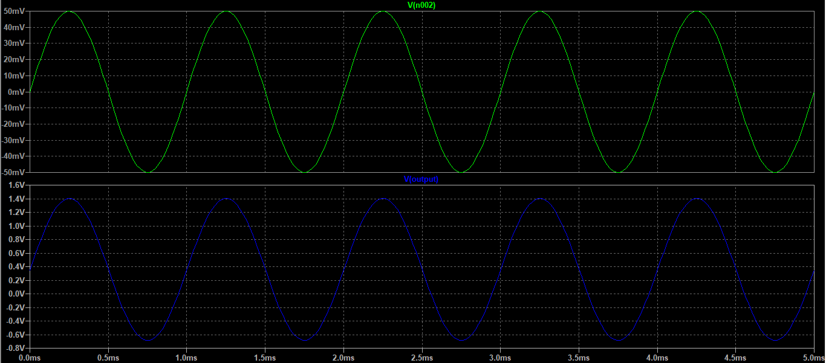

Figure: Output with Sinusoidal Input at V1, V2 set to GND

We see that the output is in phase with the input. Therefore, this is the non-inverting input.

Now, we supply V2 with a sinusoidal input, set V1 to 0 and observe the output:

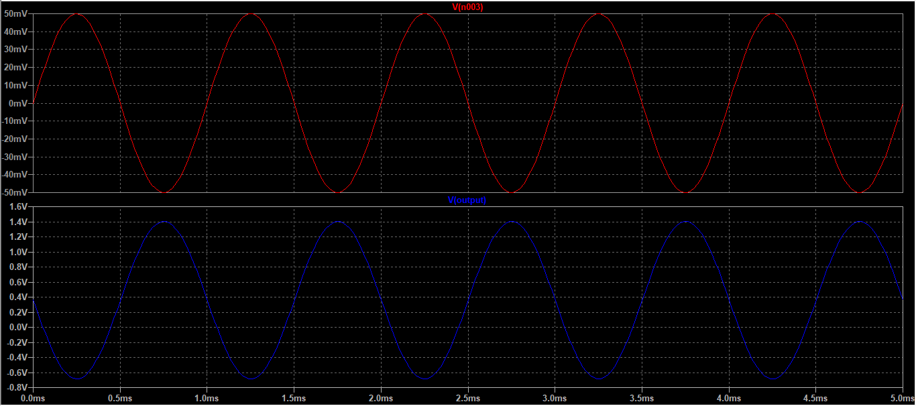

Figure: Output with Sinusoidal Input at V2, V1 set to GND

From the simulation results, we see that the output is inverted for an input at V2.

Therefore, V2 is the inverting input.

**Problem 3: Designing a non-inverting amplifier**

Task 1

We use the following diagram to make our calculations:

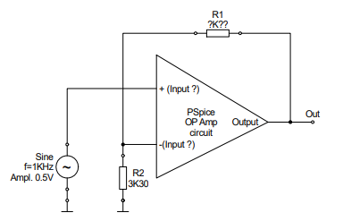

Figure: Op-Amp Circuit

$$\frac{0-V_{S}}{3300}=\frac{V_{S}-V_{out}}{R1}$$

$$-\frac{1}{3300}=\frac{1}{R1}-\frac{1}{R1}⋅\frac{V_{out}}{V_{S}}$$

$$-\frac{1}{3300}=\frac{1}{R1}-\frac{3}{R1}$$

$$-\frac{1}{3300}=-\frac{2}{R1}$$

$$R1=6600Ω$$

Task 2

A simulation of the input and output voltages is provided below:

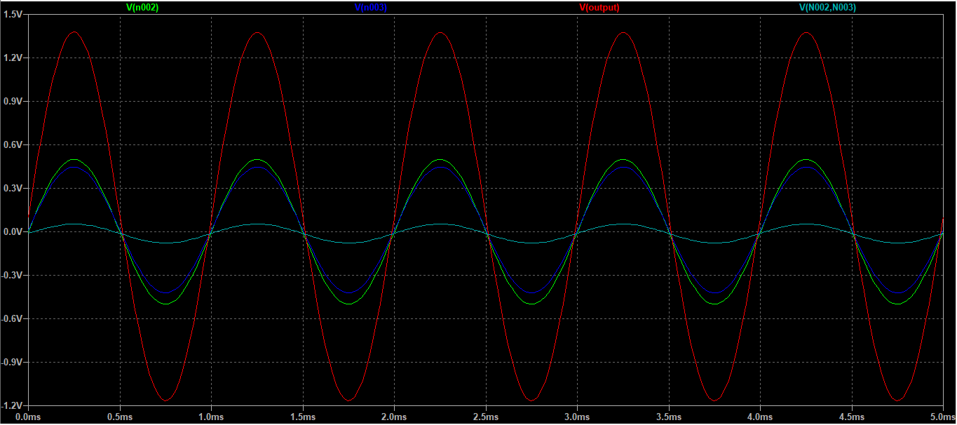

Figure: Input and Output Signals for the Feedback based Op-Amp

Separate plots for input and output signals:

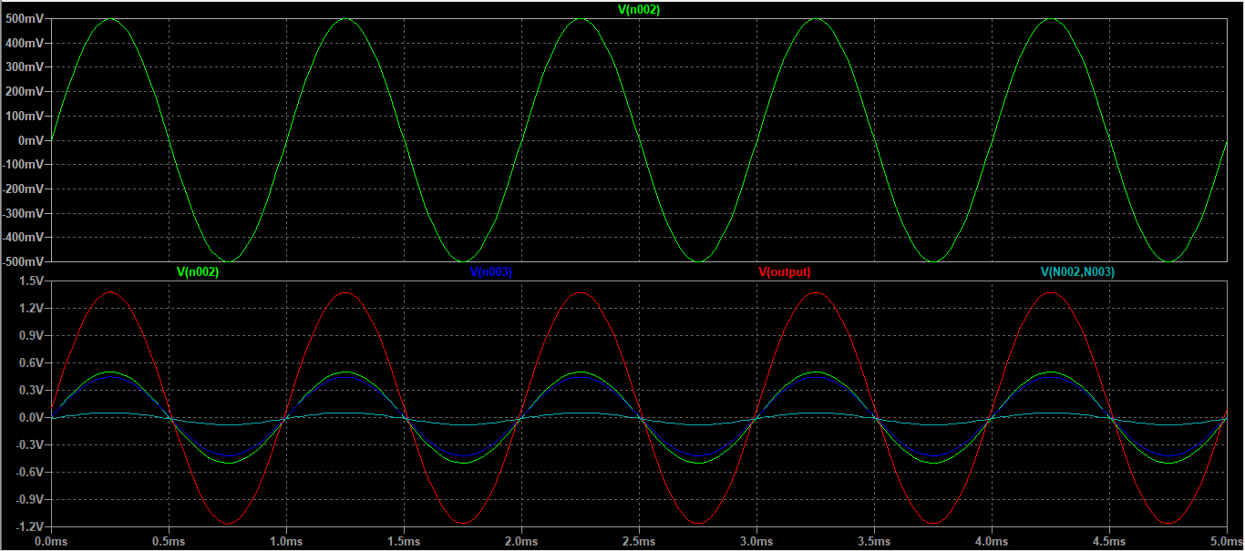

Figure: Input and Output Signals for the Feedback based Op-Amp

Gain calculation:

$$Gain=\frac{V_{out, Vpp}}{V_{in, VPP}}=\frac{2.5407413V}{995.64758mV}=2.552$$

Task 3

We use the following block diagram to explain the difference between the measured gain and the theoretical gain:

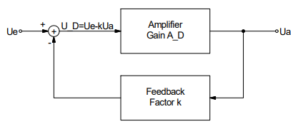

Figure: Block Diagram for a feedback system

$$U_{e}=V_{in}, U_{a}=V_{out}, A_{D}=A_{v}, K=Feedback Factor$$

$$\left(V_{in}-K⋅V_{out}\right)A_{V}=V_{out}$$

$$A_{V}V_{in}-A_{V}KV_{out}=V_{out}$$

$$A_{V}V_{in}=\left(1+A_{V}K\right)V_{out}$$

$$\frac{V_{out}}{V_{in}}=\frac{A_{V}}{1+A_{V}K}$$

As we can see, because of the feedback loop, a weighted version of the output is subtracted from the input during every cycle, which provides us with a new gain, or the closed loop gain, which is lower than the open loop gain.

Using the derivation, we find that the feedback factor in this case is K = 0.0588

Task 4