**Jacobs University Bremen**

**CO-526-B: Electronics Lab**

**Fall 2021**

**Lab Experiment 5: Metal Oxide Field Effect Transistor**

**Priontu Chowdhury**

**Introduction**

In this lab, we familiarize ourselves with the characteristics and application of MOSFETs, which are one of the most common transistors used in industry today. The experiments include the investigation of I-V characteristics and implementation of MOSFETs as amplifiers and switches.

**Theory**

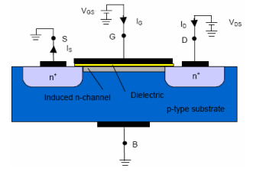

Figure: Schematic cross section of an enhancement-type NMOS transistor

The MOSFET has three regions of operation:

1. Cut-off Region

This region occurs when gate-to-source voltage is less than the threshold voltage ($V_{GS}<V_{th}$). In this region, there is no current flow between the source and drain terminals.

1. Linear (Triode) Region

This occurs when $V_{GS}>V_{TH}$ but $V_{DS}<V_{GS}-V_{TH}$. For this region, the current flow is a function of both gate-to-source voltage and the drain-to-source voltage. The relation is described below:



1. Saturation Region

This occurs when $V_{GS}>V_{TH}$ but $V_{DS}>V_{GS}-V_{TH}$. If $V_{DS}$ is sufficiently small, we can describe the I/V relation as follows:



For a $V_{DS}$ that is sufficiently larger than $V_{GS}-V_{TH}$, the channel is pinched off, which leads to the following I/V relation:



**Prelab: Field Effect Transistor**

**Problem 1: Metal Oxide Semiconductor Field Effect Transistors (MOSFET)**

Question 1

An enhanced MOSFET does not initially contain a conduction channel. The channel is generated by applying a voltage across the gate-source terminals that is larger than the threshold voltage. Therefore, in this case the channel is an induced channel.

For a depletion MOSFET, the channel is permanently fabricated during the construction of the MOSFET using doping methods.

Question 2

In PMOS, the source and the drain are made of P-type semiconductor, and in NMOS, the source and the drain terminals are made of N-type semiconductors. Consequently, the current flowing through the PMOS channel is hole current (holes are the majority carriers), while the current flowing through the NMOS channel is electron current (electrons are the majority carriers).

**Problem 2: MOSFET as Amplifier**

Question 1

For this task, we use the following circuit:

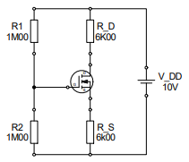

Figure: MOSFET circuit

First, we apply voltage division across the outer circuit:

$$V_{R2}=\frac{R2}{R1+R2}V_{DD}=5V$$

Now, we apply KVL across the $V_{GS}$ region:

$$-V_{R2}+V_{GS}+V_{RS}=0$$

$$V_{RS}=V_{R2}-V_{GS}$$

We know:



Where k = 0.5 mA/V2, and VTH = 1V.

$$I_{DS}=0.5{\left(V_{GS}-1\right)}^{2}$$

All the current in the drain passed into the source.

$$I_{DS}=\frac{V_{RS}}{RS}=\frac{V_{R2}-V_{GS}}{RS}=\frac{5-V_{GS}}{6000}$$

Therefore, we can use these equations to obtain the following:

$$\frac{5-V_{GS}}{6000}=0.5{\left(V_{GS}-1\right)}^{2}$$

$$5-V_{GS}=3{\left(V_{GS}-1\right)}^{2}$$

$$3V_{GS}^{2}-5V_{GS}-2=0$$

$$V_{GS}=2V or V_{GS}=-\frac{1}{3}(<V_{TH}, so rejected)$$

$$∴V_{GS}=2V$$

$$I_{D}= \frac{5-V_{GS}}{6000}=5×{10}^{-4}A=0.5mA$$

Using KVL to the left of the transistor:

$$-V_{DD}+V_{RD}+V_{DS}+V_{RS}=0$$

$$V_{DS}=V_{DD}-I_{DS}R_{D}-I_{DS}R_{S}=10-3-3=4V$$

$$V_{DS}=4V$$

Question 2

Firstly, we notice that the following holds true:

$$V_{GS}>V_{TH}$$

Now, we verify the following:

$$V_{GS}-V_{TH}=2-1=1$$

$$V_{DS}=4$$

$$∴V_{DS}>V_{GS}-V_{TH}$$

Hence, the MOSFET operates in saturation region.

**Problem 3: MOSFET as Switch**

We are required to find the operating point of the following circuit:

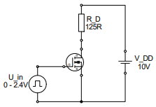

Figure: MOSFET circuit

We are using the following information to obtain our data:

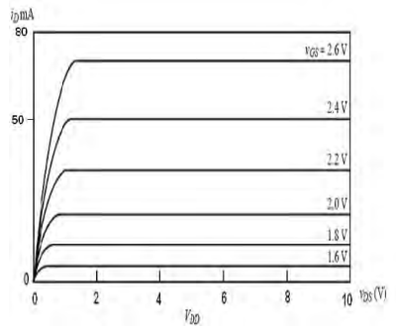

Figure: Characteristic ID/VDS curve

Using KVL across the transistor, we obtain the following relation:

$$V_{DS}=V_{DD}-V_{RD}=V_{DD}-I_{D}R_{D}$$

$$I_{D}=\frac{V_{DD}}{R_{D}}-\frac{V_{DS}}{R_{D}}=-0.008V_{DS}+ 0.08$$

$$I_{D}=-0.008V_{DS}+ 0.08$$

Drawing this linear relation on the curve, we see that the relation holds true. At $V_{DS}=0V, I_{D}=80mA$ and at $V_{DS}=10V, I_{D}=0mA$.

Using the intersection points, we see that at $V_{GS}=2.4V, I_{D}=50mA$, which means $V_{DS}=3.75V$

Therefore, for $V_{GS}=2.4V: I_{D}=50mA, V_{DS}=3.75V$, and the MOSFET operates in saturation mode.

Again, for $V_{GS}=0V:I_{D}=0mA, V_{DS}=0V$, where the MOSFET operates in cut-off region.

**Experimental Set-up and Results**

**Problem 1: I/V Characteristics of a MOSFET**

In this section, we explore the current/voltage characteristics of an NMOS Field Effect Transistor.

Task 1

For this task, we were required to use the following circuit to determine $U_{th}$:

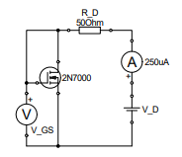

Figure: NMOS circuit

We set up the circuit as provided in lab, and we appropriated circuit conditions so as to set $I_{D}≈250μA$. Then, we recorded $U_{th}$ and $I_{D}$ as follows:

$$I_{D}=249.18 μA$$

$$U_{th}=2.049 V$$

Task 2

Then, we used the following circuit to obtain the transfer characteristic of the MOSFET:

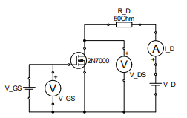

Figure: Determining transfer characteristics

To accomplish this, we keep $V_{DS}$ at 5V and vary the gate-source voltage from 0V to 3V.

We obtain the following results:

|  |  |  |  |
| --- | --- | --- | --- |
| $$I_{D} /mA$$ | $$V_{D}/ V$$ | $$V_{GS}/V$$ | $$V_{DS}/V$$ |
| 0 | 5 | 0 | 5.088 |
| 0 | 5 | 1.0634 | 5.088 |
| 0.287 | 5 | 2.0534 | 5.072 |
| 0.981 | 5 | 2.1678 | 5.033 |
| 2.53 | 5.1 | 2.2701 | 5.037 |
| 40.55 | 7.4 | 2.3523 | 5.016 |
| 44.23 | 7.6 | 2.4499 | 5.033 |
| 47.28 | 7.8 | 2.5401 | 5.022 |
| 51.2 | 8 | 2.6555 | 5.019 |
| 54.94 | 8.1 | 2.7632 | 5.013 |
| 58.53 | 8.3 | 2.8627 | 5.019 |
| 63.16 | 8.5 | 2.9624 | 5.023 |

Task 3

For this task, we use the same circuit to measure the output characteristic for the gate source voltages of 2.2V, 2.4V and 2.6V. The drain-source voltages are scanned from 0V to 4V. For our case, $V_{th}=2.049V$, which is greater than 2V. Therefore, using $V_{GS}=2V$ is not useful in our case, as the transistor will be in cut-off region.

For the next step, we use $V_{GS}=2.201V(V_{GS}-V_{TH}=0.152V)$, which means the transistor is active. For this $V_{GS}$, we obtain the following results:

|  |  |  |
| --- | --- | --- |
| $$V_{D}/V$$ | $$V_{DS}/V$$ | $$I_{D}/mA$$ |
| 0.1 | 0.127 | 0.923 |
| 0.2 | 0.235 | 1.036 |
| 0.3 | 0.32 | 1.055 |
| 0.5 | 0.469 | 1.112 |
| 1 | 1.037 | 1.16 |
| 2 | 2.025 | 1.208 |
| 3 | 2.954 | 1.242 |
| 4 | 4.042 | 1.282 |

Next, we use $V_{GS}=2.4V(V_{GS}-V_{TH}=0.351V)$, which means the transistor is active. For this $V_{GS}$, we obtain the following results:

|  |  |  |
| --- | --- | --- |
| $$V_{D}/V$$ | $$V_{DS}/V$$ | $$I_{D}/mA$$ |
| 0.1 | 0.032 | 1.172 |
| 0.2 | 0.084 | 3.46 |
| 0.3 | 0.134 | 4.368 |
| 0.4 | 0.189 | 4.945 |
| 0.5 | 0.29 | 5.451 |
| 1 | 0.679 | 6.621 |
| 2 | 1.412 | 10.983 |
| 3 | 2.096 | 16.237 |
| 4 | 2.813 | 22.226 |

Next, we use $V_{GS}=2.6V(V_{GS}-V_{TH}=0.551V)$, which means the transistor is active. For this $V_{GS}$, we obtain the following results:

|  |  |  |
| --- | --- | --- |
| $$V_{D}/V$$ | $$V_{DS}/V$$ | $$I_{D}/mA$$ |
| 0.1 | 0.016 | 2.3 |
| 0.2 | 0.032 | 4.318 |
| 0.3 | 0.047 | 5.549 |
| 0.4 | 0.055 | 6.973 |
| 0.5 | 0.072 | 8.611 |
| 0.6 | 0.087 | 9.964 |
| 0.7 | 0.103 | 11.336 |
| 1 | 0.171 | 15.601 |
| 2 | 1.184 | 16.555 |
| 3 | 1.84 | 21.126 |
| 4 | 2.509 | 26.656 |

**Problem 2: MOSFET as an Amplifier**

In this section, we design and realize an amplifier circuit using a MOSFET.

For the following tasks, we use the following circuit:

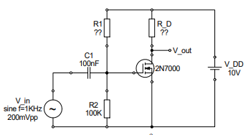

Figure: Amplifier circuit

$$V_{GS}=2.7V, V_{DS}=5V, k=72.2mA/V^{2} ,V_{th}=2.049V$$

Task 1

Firstly, we are required to find R1 and RD.

Next, running a KVL around RD, we find:

$$-V_{DD}+V_{RD}+V_{DS}=0$$

$$V_{RD}=V_{DD}-V_{DS}=5V$$

$$I_{D}=k{\left(V_{GS}-V_{TH}\right)}^{2}= 0.0306A$$

$$R_{D}=\frac{V_{RD}}{I_{D}}=163.407Ω$$

We can find R1 by using voltage division on the outer loop:

$$V_{R2}=V_{GS}=2.7V$$

$$V_{R2}=\frac{R2}{R1+R2}V_{DD}$$

$$R1+R2=\frac{R2}{V_{R2}}V_{DD}$$

$$R1=\frac{R2}{V_{R2}}V_{DD}-R1=270.37KΩ$$

Task 2

After obtaining the resistor values, we assembled the above circuit on the breadboard. We used a $150Ω$ resistor for $R_{D}$, because that was the closest resistor we could find to the required value.

Task 3

We applied a sinusoidal input signal with an amplitude of 100mV and frequency of 1KHz to the input of the circuit.

Task 4

The input and output signals were displayed on the oscilloscope, and the phase relation between them is measured, as shown below:

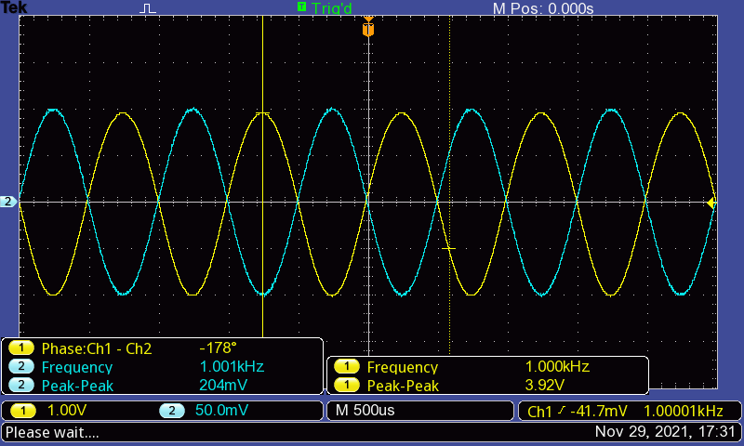  
Figure: Oscilloscope display of input, output and measurements

**Evaluation**

**Problem 1: I/V Characteristic of a MOSFET**

Question 1

Question 2

Question 3

**Problem 2: MOSFET as Amplifier**

Question 1

In saturation mode, $I_{D}$ only depends on $V_{GS}$, and we can see that the output of the circuit ($V_{out}$) is only dependent on the current flowing through $R_{D}$. Therefore, it can be concluded that the MOSFET is in saturation mode.

Question 2

$$A_{V}=\frac{3.92V}{204mV}=19.216$$

$$V_{out(max)}=5+0.5\left(3.92\right)=6.96V$$

$$V_{in(max)}=\frac{6.96V}{19.216}=0.362V$$

This is the maximum input voltage for which clipping doesn’t occur.

Question 3

$$V_{out}=V_{DS}=V_{DD}-I_{D}R_{D}$$

$$I_{D}=K.{\left(V_{GS}-V_{TH}\right)}^{2}$$

$$V_{out}=V_{DD}-K{\left(V_{GS}-V_{TH}\right)}^{2}.R_{D}$$

$$A_{V}=\frac{V_{out}}{V_{in}}=\frac{V_{DD}-K{\left(V_{GS}-V_{TH}\right)}^{2}.R_{D}}{V_{in}}$$

Theoretical value:

$$A_{V}=\frac{10-0.0722{\left(2.7-2.049\right)}^{2}×163.407}{0.2}=25$$

Question 4

Theoretical value:

$$A_{V}=\frac{10-0.0722{\left(2.7-2.049\right)}^{2}×163.407}{0.2}=25$$

Experimental value:

$$A_{V}=\frac{3.92V}{204mV}=19.216$$

As we can see, the gain obtained through experimental findings is smaller, and has a significant difference from the theoretical value. It’s possible that this is due to the usage of a $150Ω$ resistor rather than a $163Ω$ one for $R_{D}$. This was the only resistor we could find with the closest value to our calculated value in component box. Moreover, the transistor might have a different value from “k” than that we used in our calculations. The measure function of the oscilloscope has an error of about 5%, which might also play a role. All of this error also propagated to provide us a final output value that is lower.

Question 5

According to our findings, the input and output have a phase difference of $178°≈180°.$ This occurs because, when the amplitude of the input signal increases in the positive direction, the drain current also increases positively, which results in a increase in the voltage across $R_{D}$, and as $V_{out}=V_{DS}=V_{DD}-I_{D}R_{D}$, this results in a decrease in output voltage. Therefore, $V_{out}$ and $V_{in}$ always propagate in opposite directions, which gives then a $180°$ phase difference.

**Conclusion**

In this lab, we studied the characteristics and application of MOSFETs. In the lab, we used a circuit structure using a MOSFET to determine the threshold voltage of the MOSFET. Then, we used the same MOSFET in a different circuit to determine the transfer characteristics of the MOSFET. When we evaluated the data obtained, we saw that it was a bit irregular, which could be the result of self-heating of the transistor. However, overall, the data correlated with our understanding of theoretical constructs. We were able to obtain an understanding of the relation of the drain current with the gate-source voltage. We also observed how drain current varies with drain-source voltage for different gate-source voltages that are greater than the threshold voltages. From the curves we developed based on our data, we were able to distinguish the saturation mode of operation from the triode mode of operation.

For the next experiment, we used a MOSFET as an amplifier. We determined the appropriate resistors required, and built an amplifier circuit using the MOSFET. Then, we supplied an input signal to the circuit, and observed the output. On the oscilloscope, we saw that the output is an amplified version of the input with a phase difference of $180°$. When evaluating the data, we noticed that our experimental gain was smaller than the theoretical gain, which we were able to attribute to the $R_{D}$ resistor we used for our experimentation, which was different from the calculated value by about 13 units.

Furthermore, the resolution of the oscilloscope also contributes to the error in experimental values. Measurements taken using the measure function have about 5% error, while those taken using cursors have about 10% error. Moreover, we do not account for the tolerances of the circuit components in our calculations. The resistors we use have about 1-2% tolerance, and the same goes for signal generator. Therefore, these errors propagate to provide us measured values that deviate largely from the simulated and theoretical values, which we consider as values obtained under ideal conditions.

**References**

* Electronics Lab Manual (Uwe Pagel)
* http://www.faculty.jacobs-university.de/upagel/