HashDash User Manual
Version 2.0

Introduction
HashDash is a forensic tool designed to verify the integrity of digital evidence during transfer. It calculates cryptographic hashes (MD5 and SHA-256) of files and verifies that copies match the originals exactly.

What HashDash Does
✓ Verifies file integrity
✓ Copies and verifies evidence
✓ Automates processing
✓ Generates court-ready reports
✓ Maintains chain of custody logs

Understanding the Interface
Here is the main HashDash window:

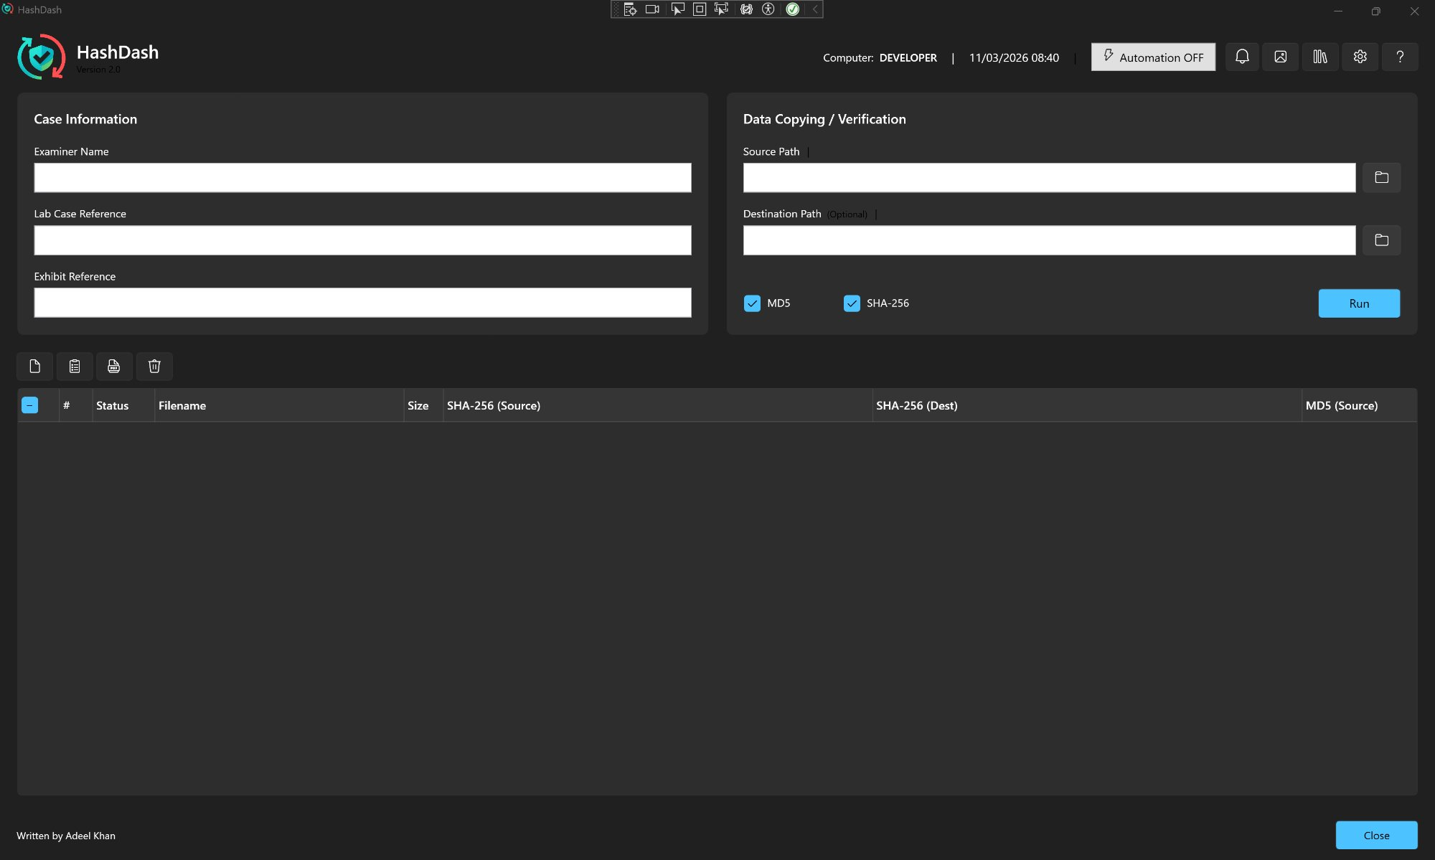

Interface Overview

Top Bar (Header)
• Computer Name & Date/Time: Shows current computer and timestamp
• Automation Button: Toggle automation ON/OFF
• Bell Icon (🔔): View notifications (shows red badge when new notifications arrive)
• Screenshot Icon (📷): Capture current screen
• Duplicates Icon: Find duplicate files
• Settings Icon (⚙): Configure HashDash settings
• Help Icon (?): Access help menu, manual, and change log

Left Panel: Case Information
This panel contains three required fields:
1. Examiner Name: Your name (the person conducting the examination)
2. Lab Case Reference: Your lab's case number or reference
3. Exhibit Reference: The exhibit number or identifier for this evidence
Note: All three fields are required for automation mode.

Right Panel: Data Copying / Verification
Source Path: Click the folder icon to select the original evidence folder
Destination Path (Optional): Click the folder icon to select where to copy files
• Leave empty for hash-only mode (no copying)
• Required for automation mode
Hash Algorithms: Check MD5 and/or SHA-256 (SHA-256 recommended)
Run Button: Click to start processing (blue button, bottom right)

Table Toolbar
Icons above the results table:
📋 Export Detailed Log: Save technical log file
📊 Export CSV: Export results to spreadsheet
📄 Export PDF: Generate PDF report
🗑️ Clear: Clear all files from table

Results Table
After running verification, results appear in columns:
• # - File number
• Status - Verification status (Verified, Failed, etc.)
• Filename - Name of the file
• Size - File size
• SHA-256 (Source) - Hash from original file
• SHA-256 (Dest) - Hash from copied file
• MD5 (Source) - MD5 hash from original (if enabled)

Task 1: Verify Files Without Copying
Use this when you only need to calculate hashes without copying files.

Step-by-Step Instructions:
Step 1: Fill in Case Information
• Click in the "Examiner Name" field (left panel)
• Type your name
• Click in "Lab Case Reference" and type the case number
• Click in "Exhibit Reference" and type the exhibit ID
Step 2: Select Source Files
• Look at the right panel labeled "Data Copying / Verification"
• Click the folder icon (📁) next to "Source Path"
• Browse to your evidence folder
• Click inside the folder, then click "Open" or "Select Folder"
Step 3: Choose Hash Algorithm
• Check the boxes for MD5 and/or SHA-256
• Recommended: Use SHA-256 for forensic work
Step 4: Leave Destination Empty
• Do NOT select a destination path
• This tells HashDash to hash only (no copying)
Step 5: Click Run
• Click the blue "Run" button in the bottom right
• Watch progress in the table below

What You'll See:
• File list appears in the table
• Status shows "Hashing..." then "Hash Complete"
• Hash values appear in the SHA-256/MD5 columns
• When done, all files show "Hash Complete" in green

Task 2: Copy Files and Verify Integrity
Use this to copy evidence to a new location and verify the copies are identical to the originals.

Step-by-Step Instructions:
Step 1: Fill in Case Information
(Same as Task 1 - see previous page)
Step 2: Select Source Folder
• Click the folder icon next to "Source Path"
• Browse to your ORIGINAL evidence folder
• Select the folder and click "Open"
Step 3: Select Destination Folder
• Click the folder icon next to "Destination Path"
• Browse to where you want to COPY the files
• Make sure you have enough disk space
• Select the folder and click "Open"
Step 4: Choose Hash Algorithms
• Check MD5 and/or SHA-256
• Recommended: Check both for maximum verification
Step 5: Click Run
• Click the blue "Run" button
• Do NOT close the window or interrupt the process

What Happens:
HashDash will:
1. Calculate hashes of all source files
2. Copy each file to the destination
3. Calculate hashes of the copied files
4. Compare the hashes
5. Mark each file as "Verified" (green) or "Hash Mismatch" (red)
6. Automatically generate a PDF report
The PDF report is saved to:
[Your Destination Folder]\Data Transfer Logs\

Understanding Results:
✓ Green "Verified" = Files match perfectly. Success!
✗ Red "Hash Mismatch" = Files DON'T match. Investigate immediately!
If you see "Hash Mismatch":
• Check the source media for corruption
• Verify the destination drive is working
• Try copying to a different location
• Document the mismatch in your case notes

Task 3: Set Up Automatic Processing
Automation mode allows HashDash to automatically process files when they arrive. For example, when you connect a USB drive containing evidence.

Step-by-Step Instructions:
Step 1: Fill in ALL Case Information
• Automation requires all three fields:
- Examiner Name
- Lab Case Reference
- Exhibit Reference
Step 2: Select Source Folder
• This is the folder HashDash will monitor
• Example: The root of a USB drive or network folder
Step 3: Select Destination Folder
• REQUIRED for automation
• This is where files will be copied
Step 4: Enable Automation
• Look at the top right corner
• Click the "Automation OFF" button
Step 5: Configure Trigger File (First Time Only)
• A settings window will appear
• Enter the "trigger filename" (e.g., "report.xml")
• This is the file that signals "start processing"
• Click "Save"
Step 6: Automation is Now Active
• Button changes to "Automation ON" (blue)
• Yellow banner appears: "AUTOMATION ACTIVE - Monitoring..."
• All fields are now locked (you can't edit them)

How Automation Works:
Once automation is enabled:
1. HashDash watches the source folder
2. When it detects the trigger file (e.g., "report.xml"), it automatically:
• Loads all files in the folder
• Copies and verifies everything
• Generates a PDF report
• Shows a completion notification
• Disables automation (ready for next case)
Example:
You set the trigger to "report.xml". When you connect a USB drive that contains a file called "report.xml", HashDash immediately starts processing all files on that drive.

Turning Off Automation:
Click the "Automation ON" button again to turn it off. This will unlock all fields and stop monitoring.

Task 4: Export Results
After processing, you can export results in different formats.

Export as PDF (Recommended)
1. Click the PDF icon (📄) in the table toolbar
2. Choose where to save the file
3. Click "Save"
The PDF report includes:
• Case information (examiner, case ref, exhibit ref)
• Computer name and timestamps
• Source and destination paths
• File-by-file verification results
• Hash values (SHA-256, MD5)
• File dates and sizes
Note: When using Copy & Verify mode, a PDF is automatically saved to:
[Destination Folder]\Data Transfer Logs\

Export as CSV
1. Click the CSV icon (📊) in the table toolbar
2. Choose where to save the file
3. Click "Save"
CSV files can be opened in Excel or any spreadsheet program for further analysis.

Export Detailed Log
1. Click the log icon (📋) in the table toolbar
2. Choose where to save the file
3. Click "Save"
The detailed log contains:
• Timestamps for every operation
• Duration of each file process
• Technical details
• Error messages (if any)

Understanding the Results Table

Status Column
The Status column shows what happened to each file:
✓ "Verified" (Green)
File was copied and verified successfully. Hashes match.
✓ "Hash Complete" (Green)
Hash calculated successfully (hash-only mode).
✗ "Hash Mismatch" (Red)
CRITICAL: Copied file doesn't match the original!
Action required: Investigate immediately.
✗ "Failed" (Red)
An error occurred. Check the error details.
⚠ "Cancelled" (Orange)
Process was stopped by user.

Hash Columns
SHA-256 (Source): The hash calculated from the original file
SHA-256 (Dest): The hash calculated from the copied file
MD5 (Source): The MD5 hash from the original file (if enabled)
These should match exactly if the copy is identical to the original.

Additional Features

Notifications (Bell Icon)
The bell icon in the top right shows notifications.
• Red badge = You have unread notifications
• Click the bell to view notification history
• Shows automation completion, warnings, and system messages

Screenshot Capture
The camera icon (📷) captures the current screen.
Use this to:
• Document verification results
• Capture evidence of successful processing
• Save a visual record for case files
Click the icon, choose where to save, and the screenshot is saved as a PNG image.

Duplicate Detection
Click the duplicates icon to find files with identical hashes.
Useful for:
• Identifying redundant files
• Finding duplicate evidence
• Reducing storage needs

Settings
Click the settings icon (⚙) to configure:
Database Tab:
• Set database location for process logs
Automation Tab:
• Set trigger file pattern
• Choose whether to include subdirectories

Help Menu
Click the help icon (?) to access:
• About - Version information
• User Manual - This document
• Change Log - What's new in this version
• View Process Logs - Database of past processing sessions

Best Practices for Forensic Work

Always:
✓ Use SHA-256 (more secure than MD5 alone)
✓ Fill in all case information completely
✓ Save PDF reports with your evidence
✓ Never interrupt the verification process
✓ Document any hash mismatches immediately
✓ Verify write access before starting large transfers
✓ Check disk space before copying

Network Drives:
• Ensure stable network connection
• Test write access before starting
• Allow extra time for network transfers
• Monitor for connection interruptions

Large Datasets:
• Check available disk space first
• Use automation for overnight processing
• Export CSV for easier review of many files
• Consider processing in smaller batches if needed

Troubleshooting Common Issues

Problem: Cannot select source folder
Possible solutions:
• Check you have read permissions for the folder
• For network drives, verify you're connected
• Try running HashDash as Administrator
• Make sure the folder path is valid

Problem: "Access Denied" error
Possible solutions:
• Check folder permissions
• Close any programs that might have files open
• For network paths, verify your credentials
• Run HashDash as Administrator

Problem: Automation not starting
Checklist:
• Are all case information fields filled in?
• Is a destination folder selected?
• Is the trigger file name correct?
• Does the button show "Automation ON"?
• Is the yellow monitoring banner visible?

Problem: Hash mismatch errors
Steps to take:
1. Check source media for corruption (run disk check)
2. Verify destination drive is healthy
3. Try copying to a different location
4. Verify network connection is stable (if using network drives)
5. Document the mismatch in your case notes
6. Consider using different media

Problem: Process is very slow
This is normal for:
• Large files (several GB each)
• Many files (thousands)
• Network transfers (slower than local)
Tips:
• Do not interrupt - let it complete
• For very large datasets, use automation overnight
• Local drives are faster than network drives

Quick Reference Card

Top Bar Icons (Left to Right):
Automation Button - Toggle automation ON/OFF
🔔 Bell - View notifications
📷 Camera - Capture screenshot
🔍 Duplicates - Find duplicate files
⚙ Settings - Configure HashDash
? Help - Help menu

Table Toolbar Icons:
📋 Log - Export detailed technical log
📊 CSV - Export to spreadsheet
📄 PDF - Generate PDF report
🗑️ Clear - Clear file list

Common File Locations:
Database:
C:\Users\[YourName]\AppData\Local\HashDash\ProcessLog.db
Detailed Logs:
[HashDash Installation Folder]\Logs\
PDF Reports (Automatic):
[Your Destination Folder]\Data Transfer Logs\

For additional help, click the Help icon (?) in HashDash and select "About" for version information.

Written by Adeel Khan
HashDash v2.0 - User Manual

