**ASSIGNMENT**

**Question:**

Given the data file https://docs.google.com/spreadsheets/d/17oglaqSxYPbkYLYHLOVd21GYhLmwno2R_1V0s6Nm9P4/edit#gid=1211902635,

Write SQL query for the following.

1. Number of Orders, Total Order Amount, Average Order Value by SKU.

2. Assuming south, north and central regions of India, the top 3 categories that are sold in each regions by the total order value.

3. Number of Orders and Total Order Amount by date, day of week and month.

State the description of the insight and inference from the output along with the SQL query for it.

**Answer:**

I have created a table named AmazonSaleData and fetched a given excel data in Mysql workbench. I have renamed some column names to access data easily.

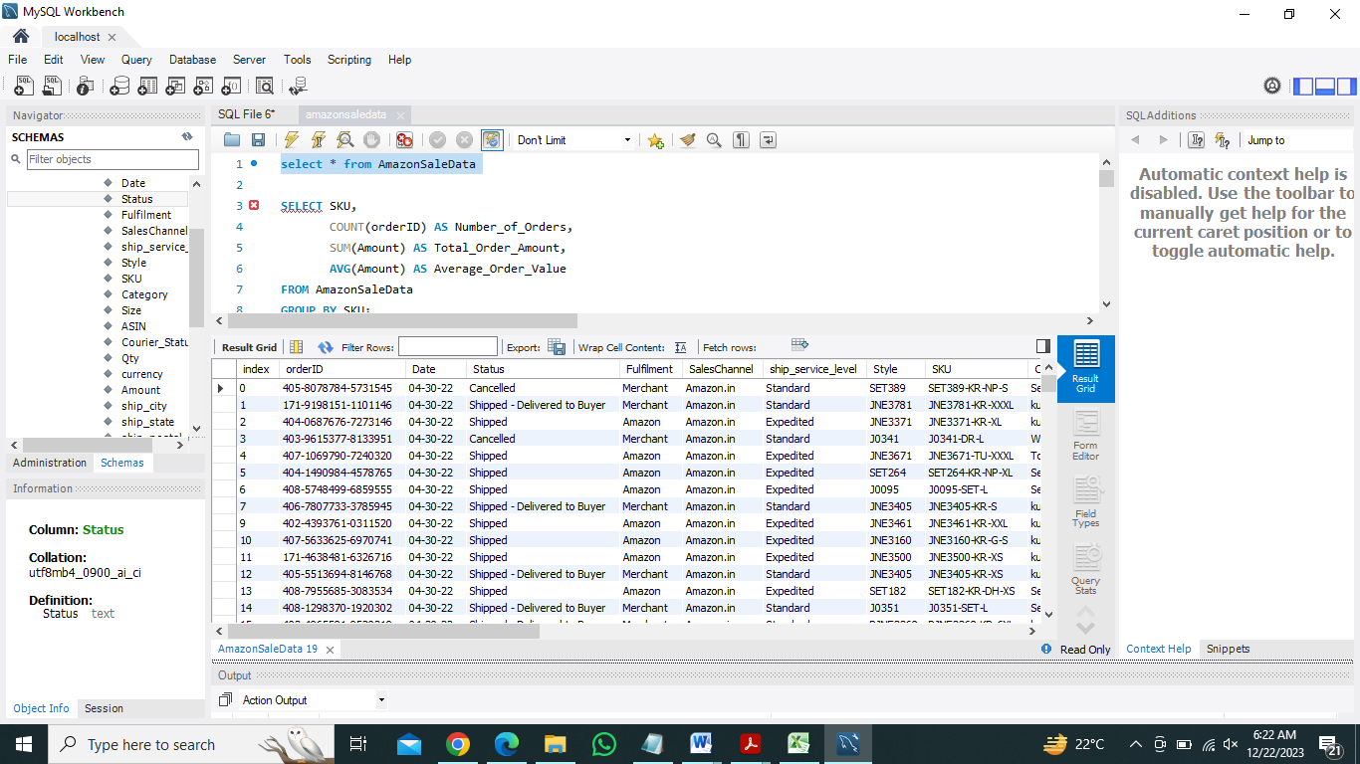

1. **Number of Orders, Total Order Amount, Average Order Value by SKU.**

**Query:**

SELECT SKU,

COUNT(orderID) AS Number_of_Orders,

SUM(Amount) AS Total_Order_Amount,

AVG(Amount) AS Average_Order_Value

FROM AmazonSaleData

GROUP BY SKU;

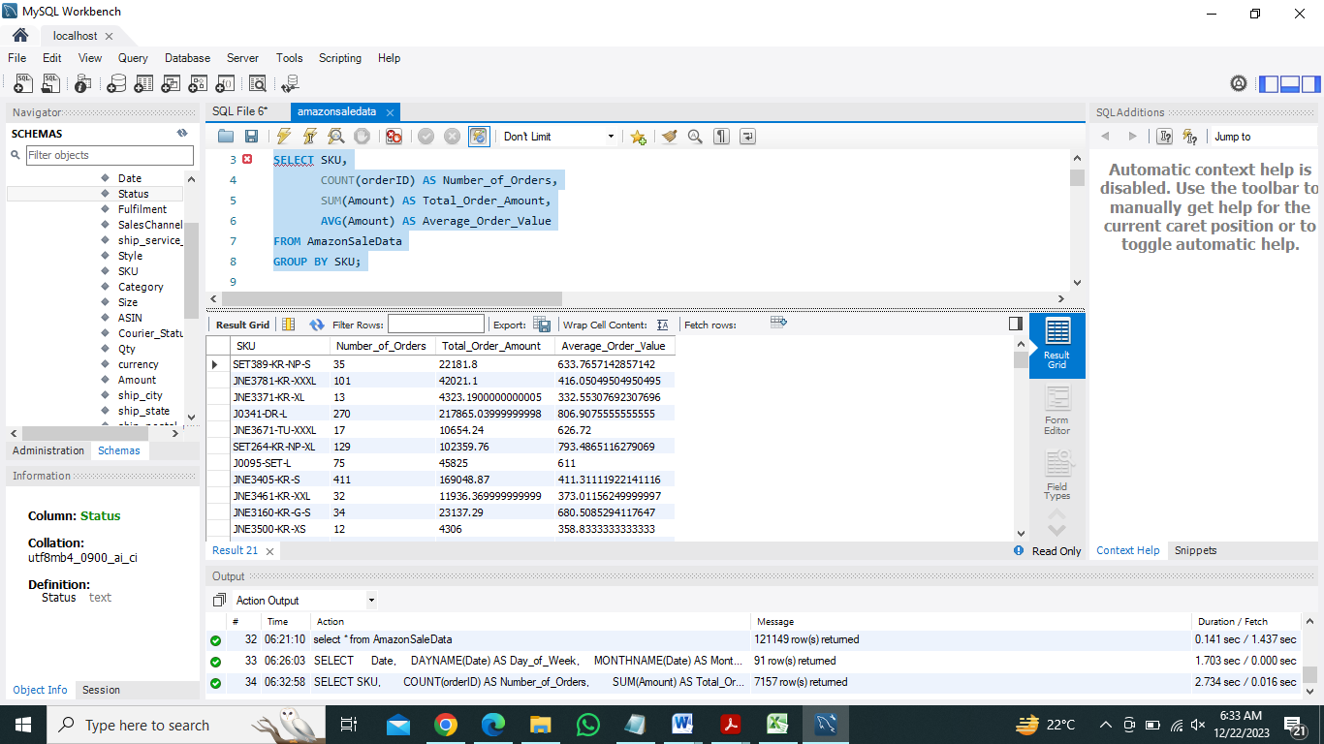

**Insight:**

* JNE3797-KR-L has the highest number of orders 722 compared to others listed.
* SKU JNE3797-KR-XS stands out with a notably high total order amount INR 303616.69999999995 among the listed SKUs.

**Sales Trends and Preferences:**

* SKU JNE3797-KR-XS with a high total order amount might represent a product that's in high demand or has a higher price point, contributing significantly to the overall revenue.
* SKUs with lower average order values might represent items that are either more frequently purchased but at lower prices or items that are less popular among buyers.

**Marketing or Stocking Strategy:** The JNE3797-KR-L has a high number of orders, indicating it might be a popular product among customers. This could be used as a reference for future marketing or stocking strategies to capitalize on its popularity.

**Inference:** SKU JNE3797-KR-XS appears to be a high-value item, contributing significantly to the total order amount despite having fewer orders. This could be a premium product or a higher-priced item that might require further analysis to understand its performance and its impact on overall revenue.

1. **Assuming south, north and central regions of india, the top 3 categories that are sold in each regions by the total order value.**

**Query:**

WITH StateRegionMapping AS (

SELECT

CASE

-- South Region

WHEN ship_state IN ('ANDAMAN & NICOBAR', 'ANDHRA PRADESH', 'ARUNACHAL PRADESH', 'ASSAM', 'Goa', 'KERALA', 'LAKSHADWEEP', 'MIZORAM', 'PUDUCHERRY', 'TELANGANA', 'TRIPURA') THEN 'South'

-- North Region

WHEN ship_state IN ('CHANDIGARH', 'DELHI', 'HARYANA', 'HIMACHAL PRADESH', 'JAMMU & KASHMIR', 'PUNJAB', 'UTTAR PRADESH', 'UTTARAKHAND') THEN 'North'

-- Central Region

WHEN ship_state IN ('CHHATTISGARH', 'DADRA AND NAGAR', 'GUJARAT', 'MAHARASHTRA', 'MADHYA PRADESH', 'RAJASTHAN') THEN 'Central'

-- Assign 'Other' region to the remaining states

ELSE 'Other'

END AS Region,

Category,

Amount

FROM AmazonSaleData

WHERE ship_country = 'In' -- Consider only Indian states

)

, RegionCategorySales AS (

SELECT

Region,

Category,

SUM(Amount) AS Total_Order_Value,

RANK() OVER (PARTITION BY Region ORDER BY SUM(Amount) DESC) AS Category_Rank

FROM StateRegionMapping

GROUP BY Region, Category

)

SELECT

Region,

Category,

Total_Order_Value

FROM RegionCategorySales

WHERE Region IN ('South', 'North', 'Central') AND Category_Rank <= 3;

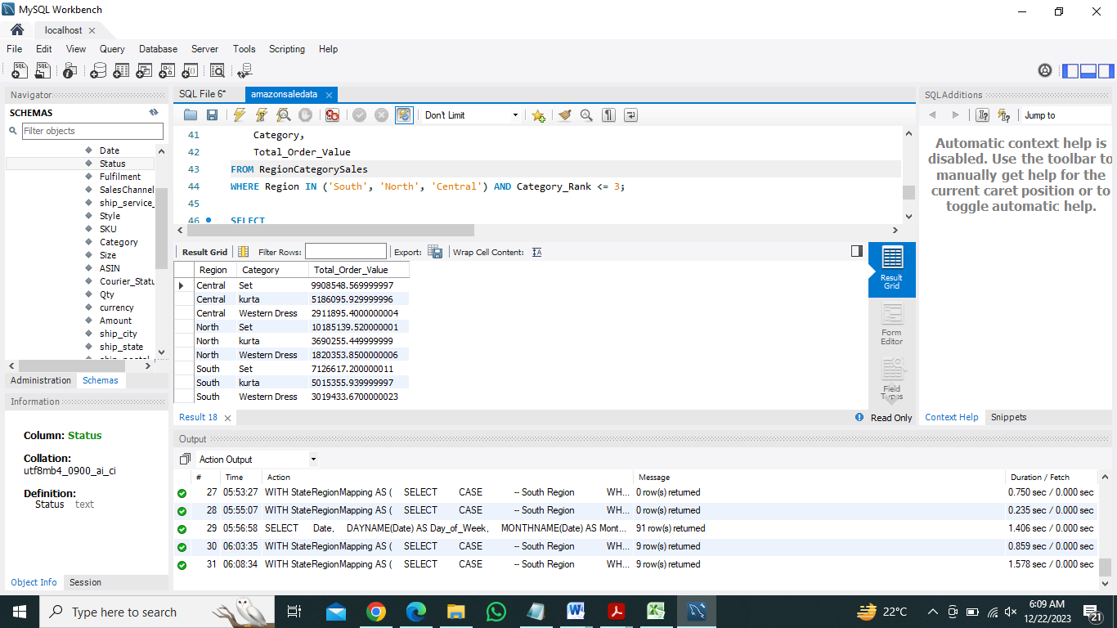

**Insight:**

**Central Region**: The highest total order value comes from the category 'Set' with a value of approximately INR 9,908,548. 'Kurta' and 'Western Dress' follow, with order values of around INR 5,186,096 and INR 2,911,895 respectively.

**North Region**: 'Set' category has the highest total order value of approximately INR 10,185,140. 'Kurta' and 'Western Dress' have order values of about INR 3,690,255 and INR 1,820,354 respectively, following the 'Set' category.

**South Region**: 'Set' category holds the highest total order value at around INR 7,126,617. Following 'Set,' 'Kurta' and 'Western Dress' have total order values of approximately INR 5,015,356 and INR 3,019,434 respectively.

**Inference:**

* Across all three regions, the 'Set' category appears to be a top-selling category in terms of total order value.
* The 'Kurta' category consistently secures the second-highest order value in each region, showing its popularity among customers across the North, South, and Central regions.
* 'Western Dress' follows as the third-highest selling category in each region, although with a considerable gap compared to 'Set' and 'Kurta.'

**Business Insight:**

* The 'Set' category appears to be a highly demanded product across all regions and might indicate a popular trend or seasonal item that attracts a larger customer base.
* Understanding the popularity of 'Kurta' and 'Western Dress' across regions could help in targeted marketing strategies or inventory management to meet demand effectively.

1. **Number of Orders and Total Order Amount by date, day of week and month.**

SELECT

Date,

DAYNAME(Date) AS Day_of_Week,

MONTHNAME(Date) AS Month,

COUNT(orderID) AS Number_of_Orders,

SUM(Amount) AS Total_Order_Amount

FROM AmazonSaleData

GROUP BY Date, Day_of_Week, Month;

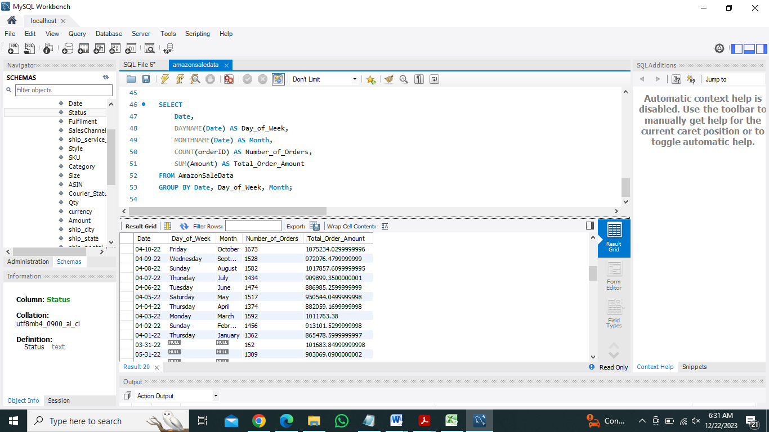

**Insight:**

April: There's a consistent trend of high order volume and total order amount across the month, peaking around the middle of the month, particularly between 20th to 24th of April. The number of orders and total order amounts gradually increase from the beginning of the month towards the middle, showing a substantial spike in sales during this period.

May: The sales trend in May starts strong but experiences fluctuations and gradual decrease toward the end of the month. There is a dip in the number of orders and total order amounts as the month progresses.

June: Similar to May, June also starts with a good number of orders and total order amounts. However, there's a visible decline in both parameters as the month progresses, showing a consistent decrease toward the end of June.

**Inference:**

April Peak: The mid to late April period experiences the highest sales in terms of both order volume and total order amounts, indicating potential promotional activities, seasonal trends, or product launches contributing to increased customer activity during this time.

May and June Trends: While May starts with a strong sales trend, it encounters fluctuations and a gradual decline throughout the month. June follows a similar trend, starting strong but gradually decreasing as the month progresses.

Potential Factors: Promotions, seasonality, marketing campaigns, or product launches could be driving the surge in April's sales. Conversely, the declining trend in May and June might signal the end of promotions or seasonal shifts affecting customer behavior.