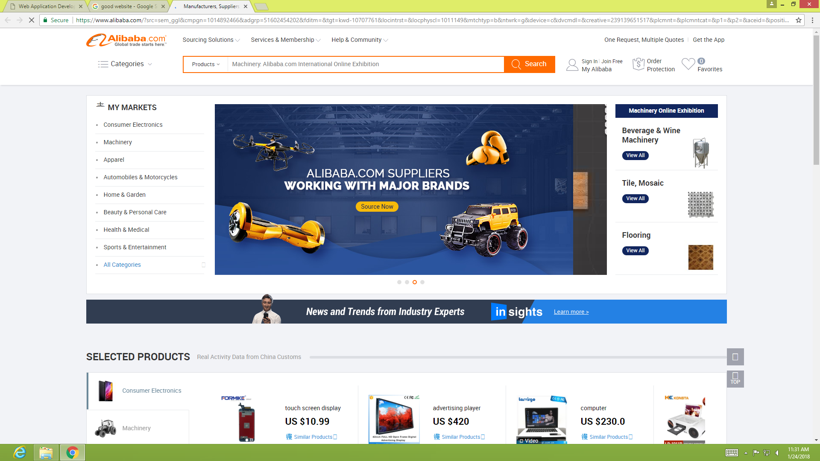
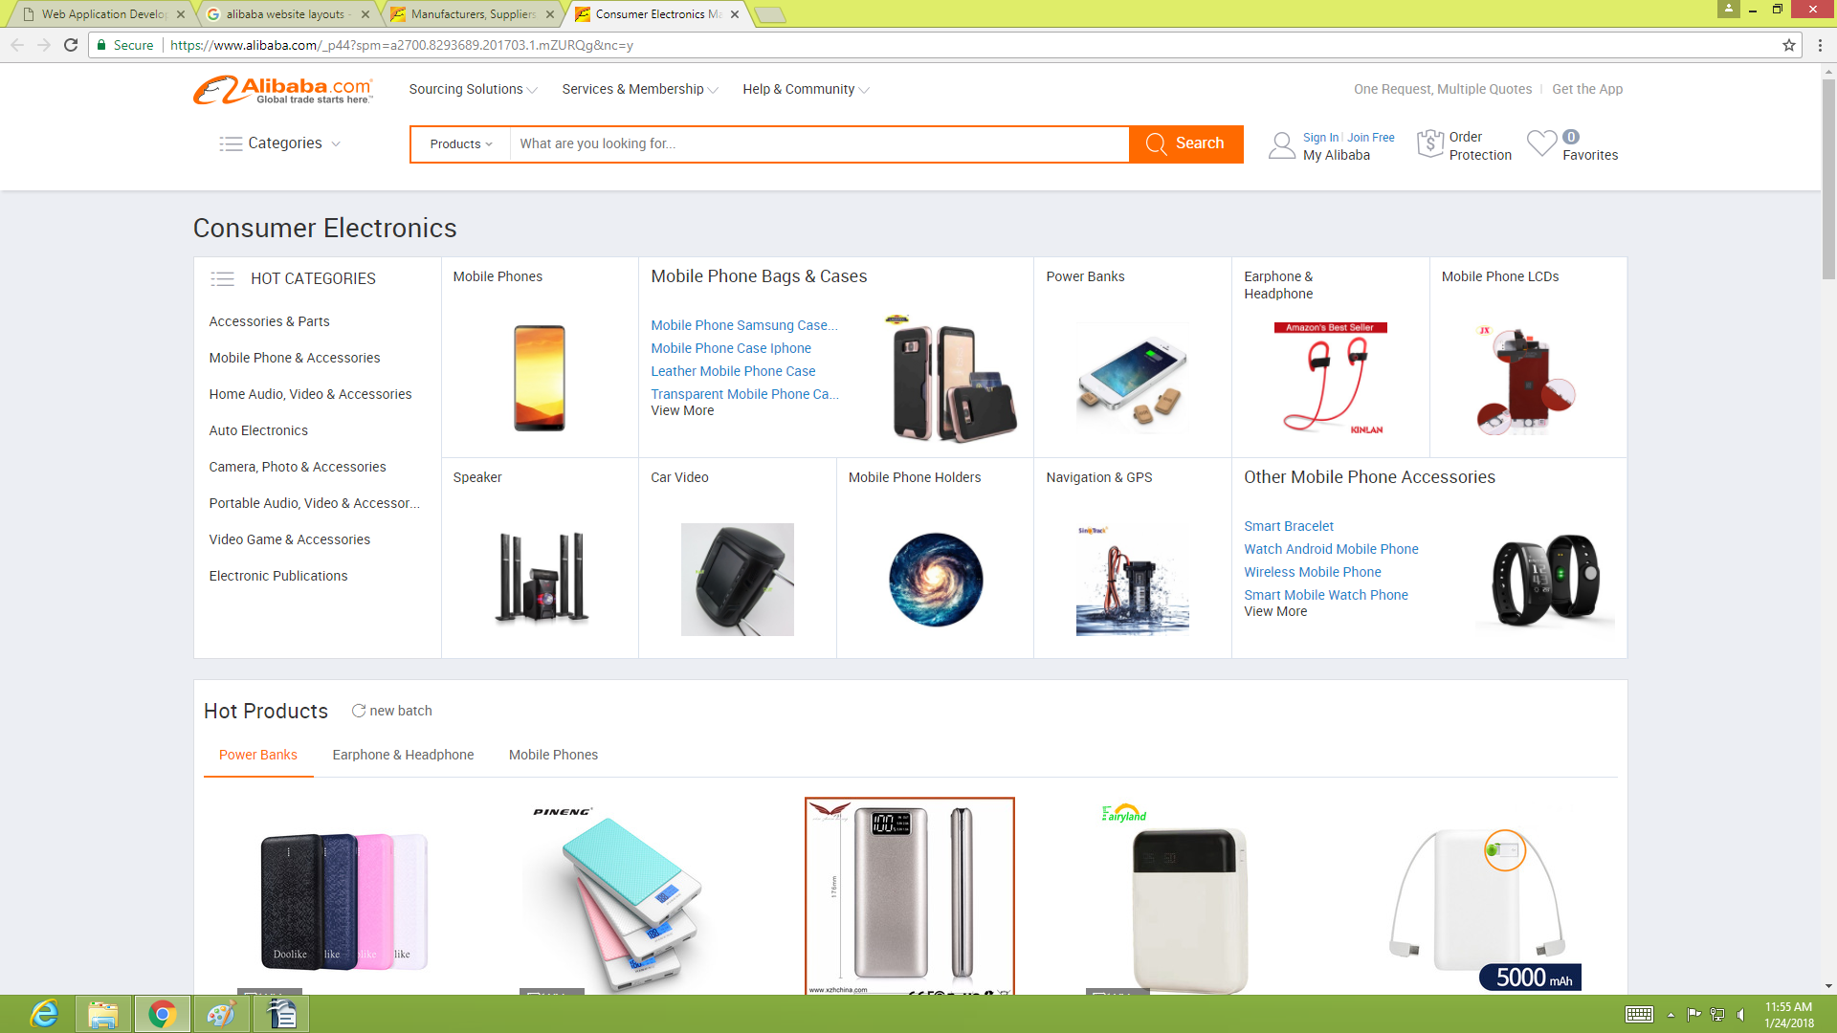
Fixed colums
Logo
Content of fixed into one display are
Inactive space
Search tool
Organized,hierarchical navigation links
1.The Alibaba websit Application A Recommended Products section can be added to your Homepage Product List Page, Product Details Page or a Customized Page design.it has a 15 sections of Recommended Products in each page with customized section titles and flexible products layouts selection.

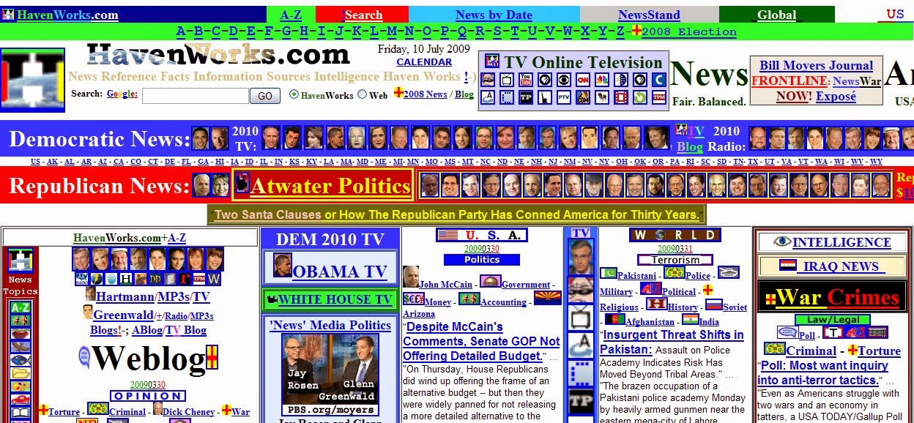
2.Browse the Web for examples of poor Web design on mainstream Web sites.

ans:
my head still aches from it.Too many colors! I would say, the worst looking design website I have ever seen. I think it's a portal site for political news wires but because of the overload of nonsense on it I just can't tell for sure. It is however broken up into categories, and if you can hang in there you can figure it out eventually.

3.Write a short essay critiquing a Web siteâ€™s design. Describe the structural layout of the site and determine whether information is presented clearly and is easily accessible.

Ways to Improve a website we should preface this list with a note that these are simply recommendations base on your experience across thousands of websites. Results are going to vary from site to site. The best thing you can do is test each change, track the result and then make a decision if it should be a permanent one or not.

Switch to wordPress
Replace flash with jQuery
Clean up your code
Upgrade your hosting
Customize your title tags
optimize youe existing content
Consolidate your navigation
Showcase one main call to action
provide your contact information

4.Browse the Web for sites that use unique navigation methods. Write a short essay describing why the method is or is not successful, or prepare a short slide presentation that you can present to your class.
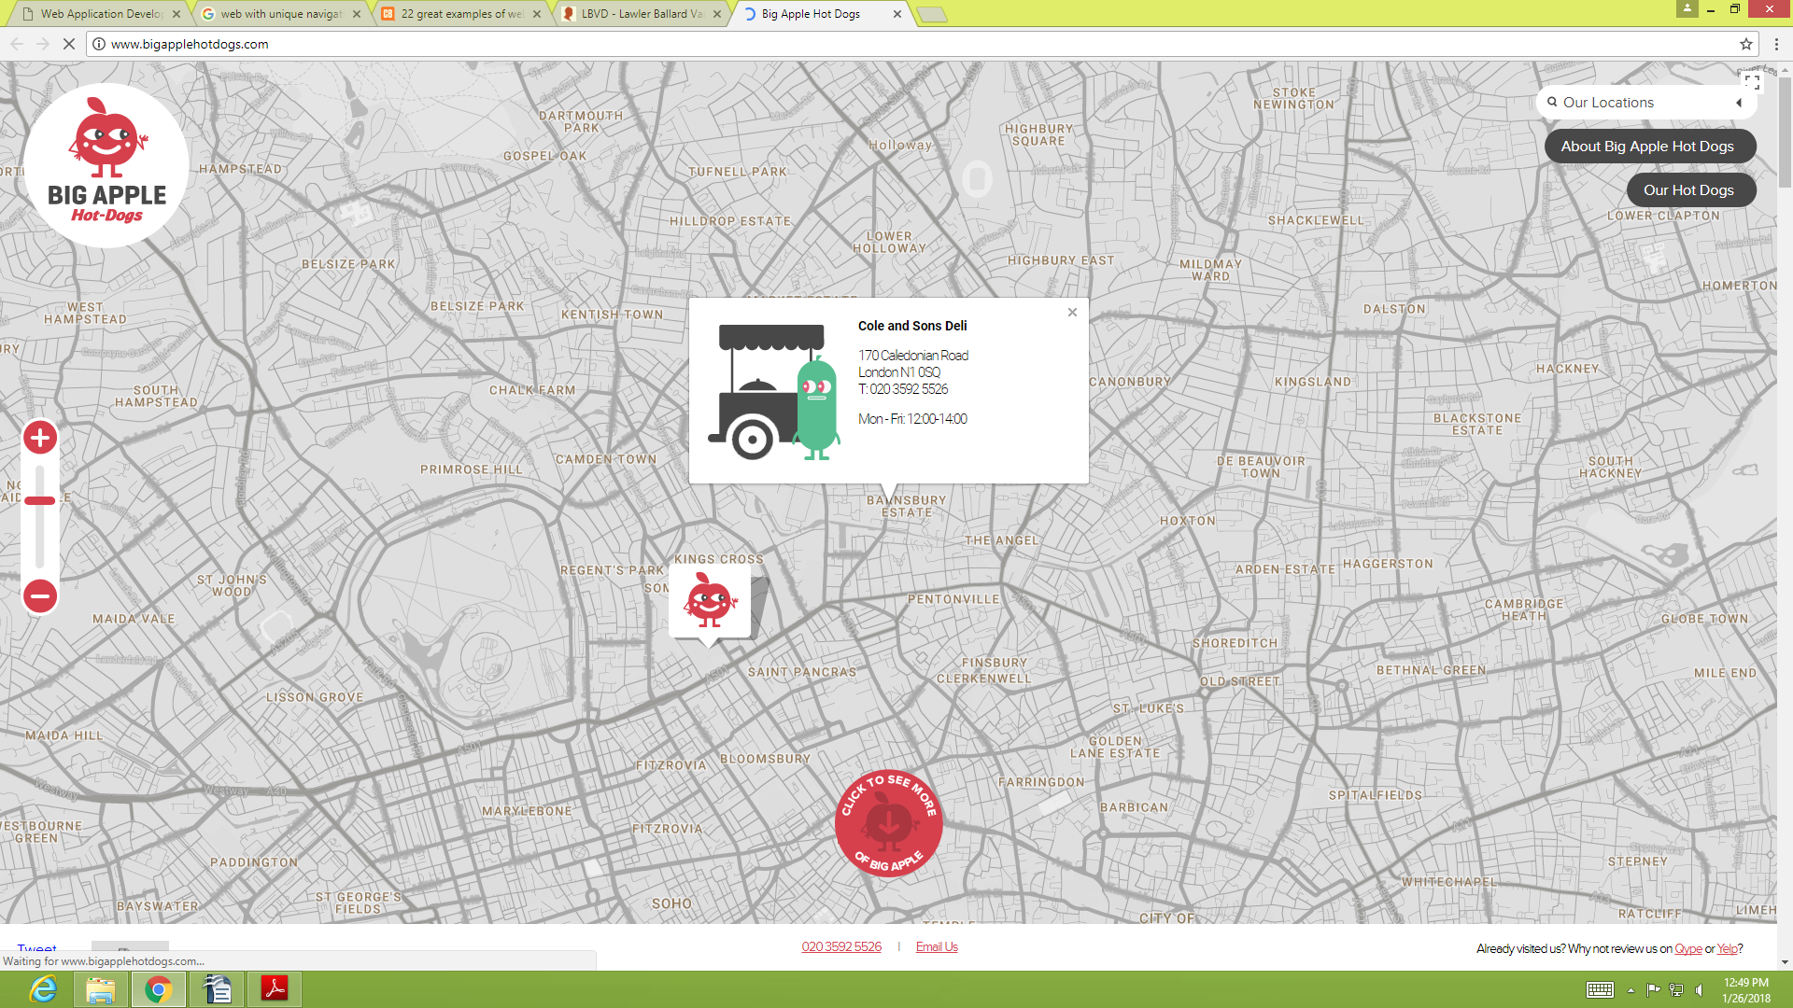
Ans:
This quirky site for a hot dog business in London uses minimal navigation to create a clean, simple interface that showcases the content and product.

5.Find a Web site that you think needs improvements in itsÂ design.
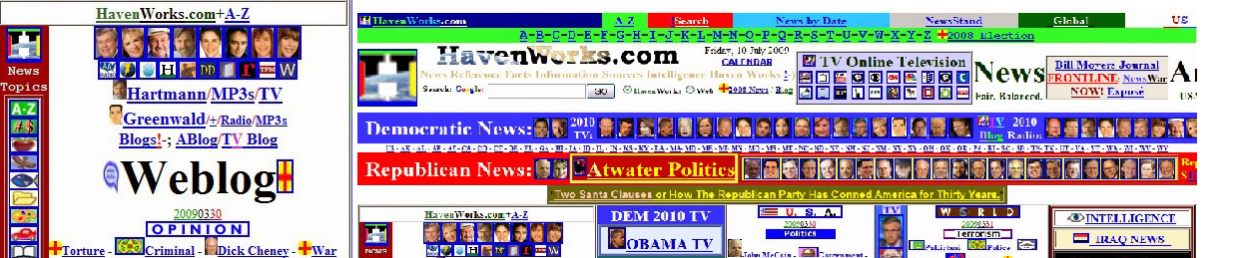

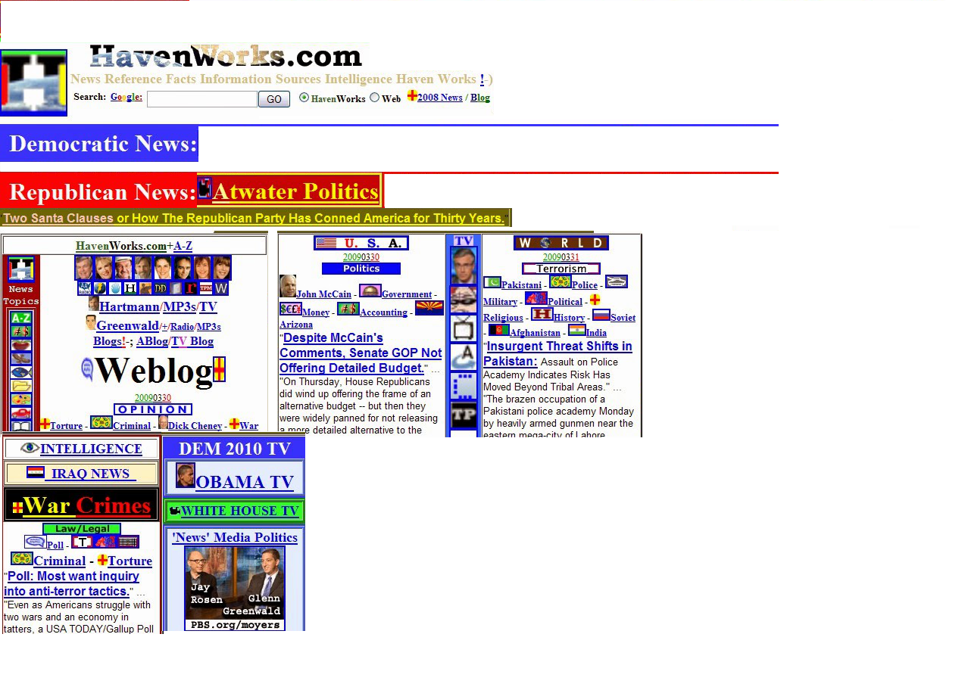
No more worst looking design, and ads

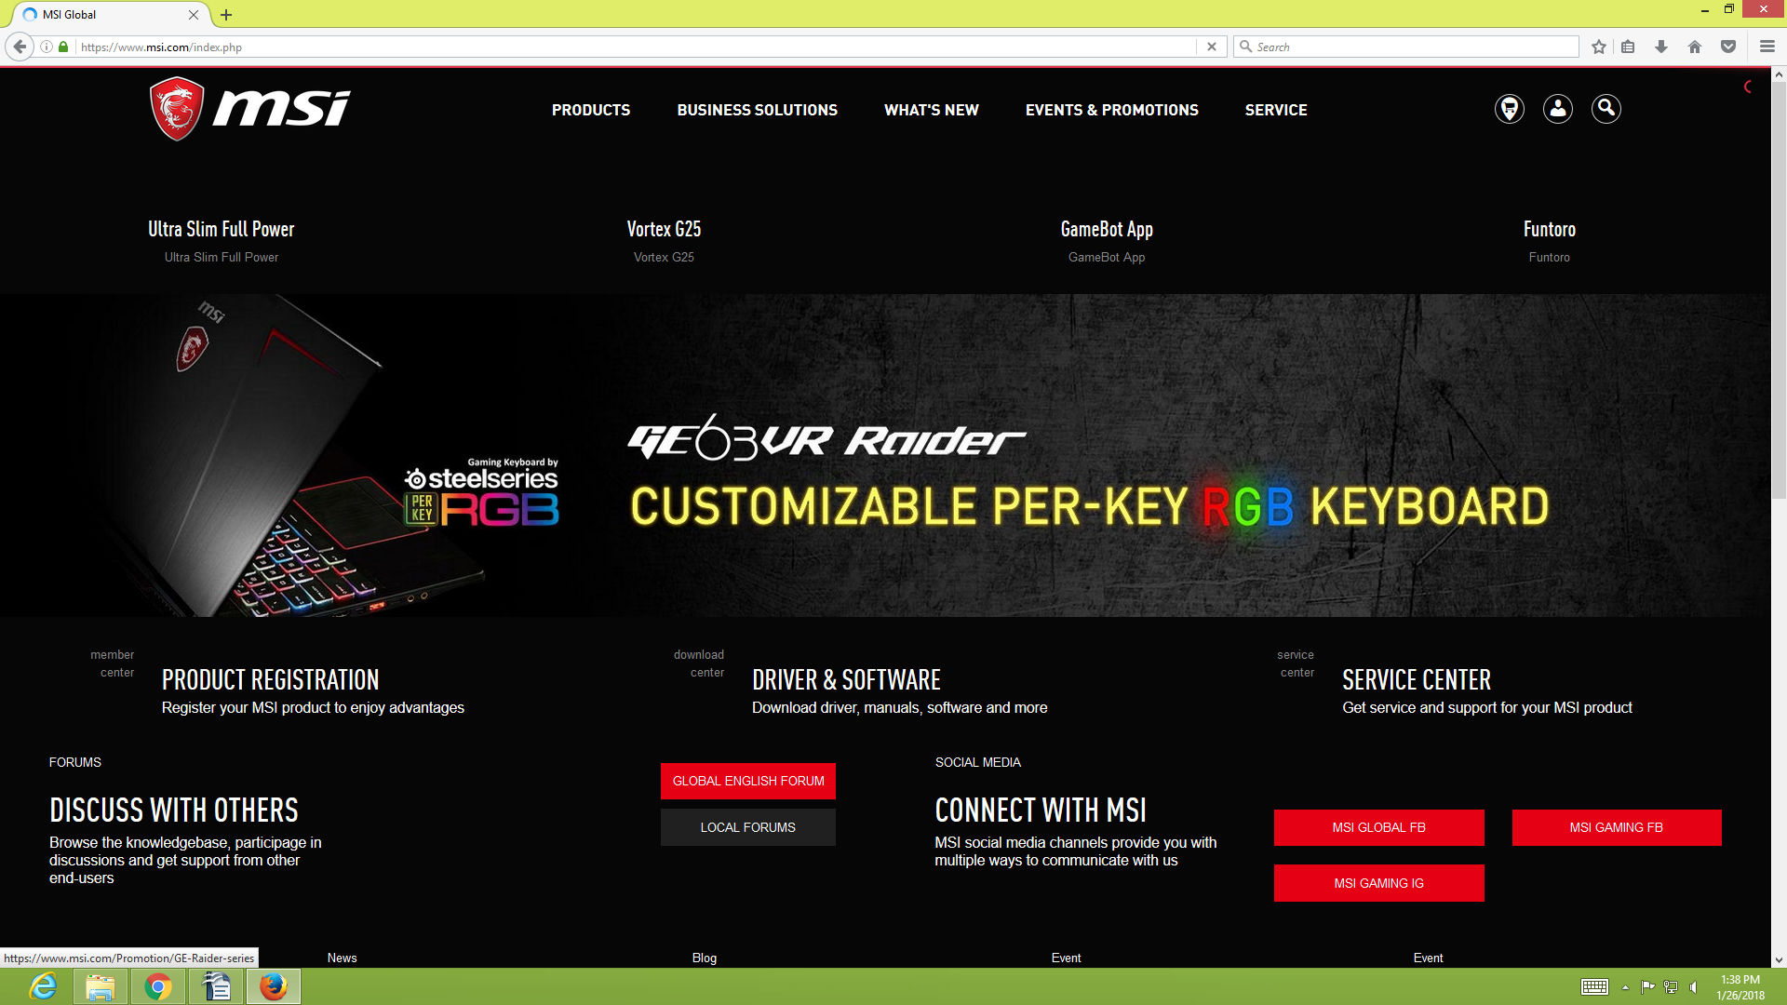
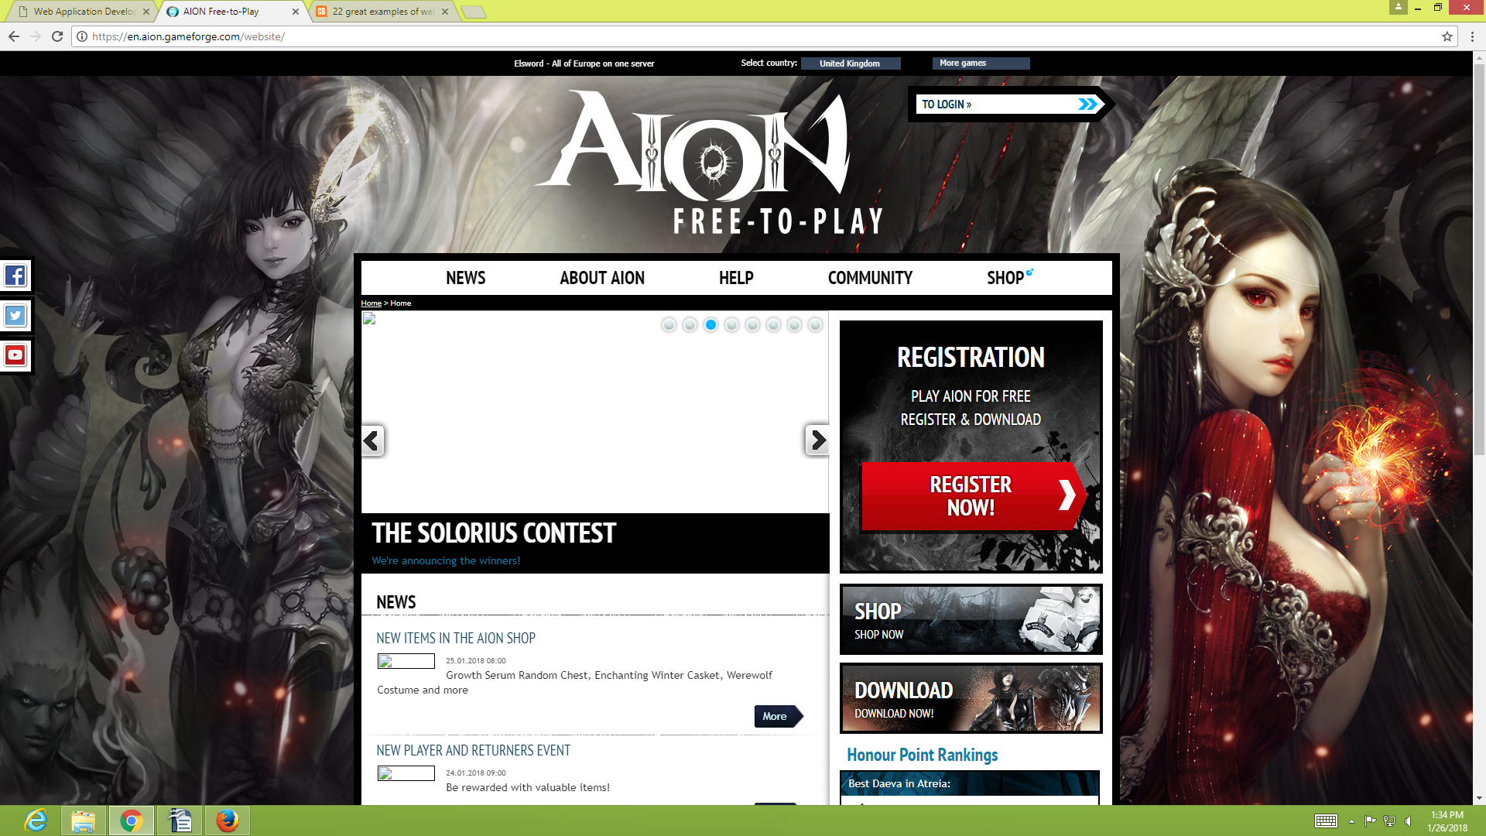
6.Test cross-browser compatibility.

