Name: Barvadiya Prisa G.
Roll No: 2
Enrollment No: 250802007
Division: Ds1-E2
Program: B.Sc. It
Course: Data-science-I

*EXERCISE-5*
Question--1
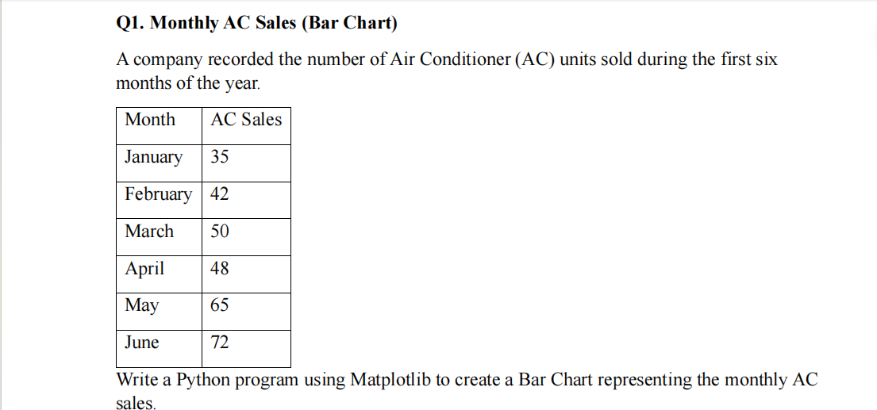
Code:
import pandas as pd
import matplotlib. pyplot as plt
df = pd. read_csv("Ac_sale.csv")

plt.bar(df["Month"], df["Ac_sales"], color="lightpink")
plt.title("Monthly ac Sales")
plt.xlabel("Month")
plt.ylabel("Sales")
plt. show()
output:
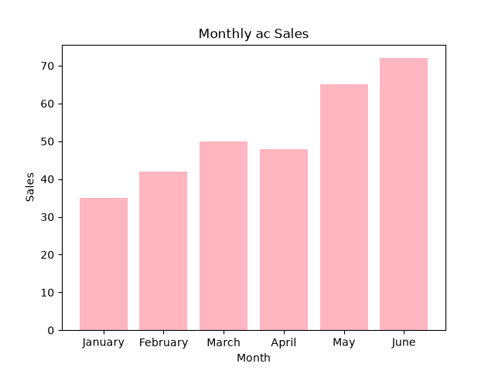
Question—2

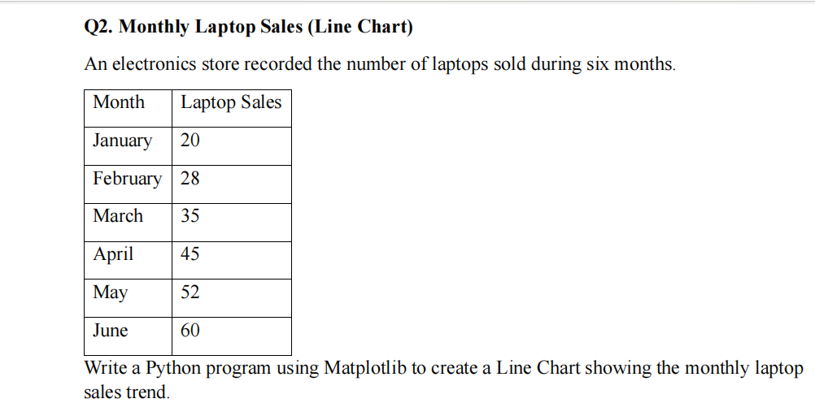
Code:

import pandas as pd
import matplotlib.pyplot as plt

df = pd.read_csv("laptop_sales.csv")
plt.plot(df["Month"], df["laptop_sales"], marker='o')

plt.title("Monthly laptop_sales")
plt.xlabel("Month")
plt.ylabel("laptop_sales")
plt.show()

output:
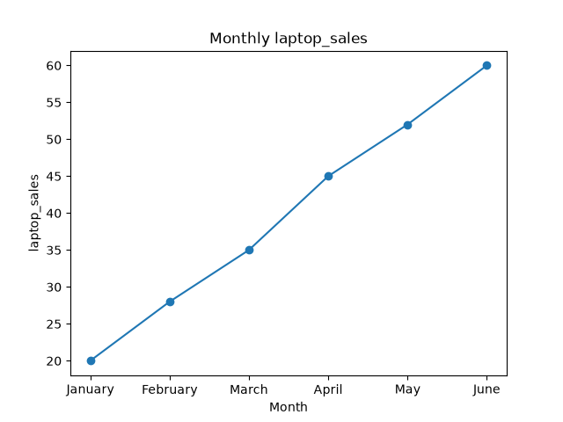
Question—3
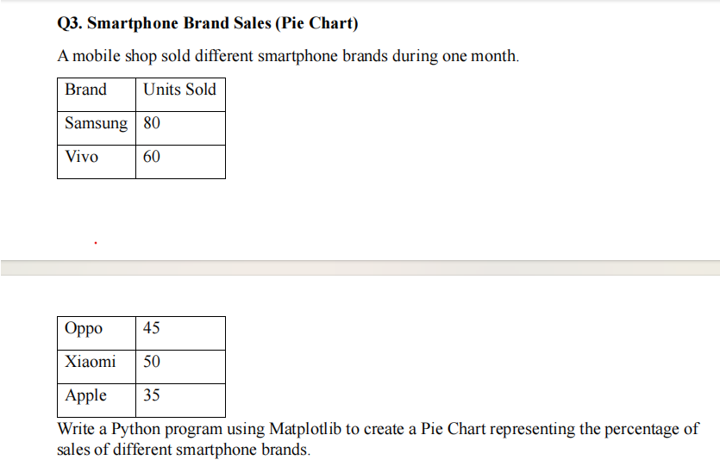
Code:

import pandas as pd
import matplotlib.pyplot as plt
df = pd.read_csv("brand_sales.csv")
plt.pie(df["Units sold"],
labels=df["Brand"],
autopct='%1.1f%%',
colors=['#058360','#85BC02','#456AF0','#ABCBCA',
'#234BAA'])
plt.title("Smartphone Brand Sales")
plt.show()

Output:

Question—4
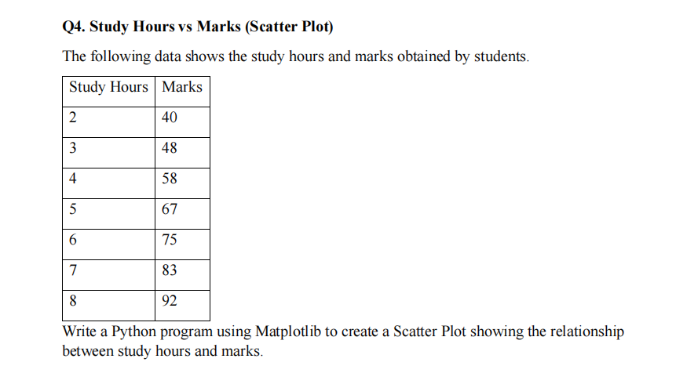

Code:
import pandas as pd
import matplotlib.pyplot as plt
df = pd.read_csv("study_hours.csv")
plt.scatter(df["Study Hours"],
df["Marks"],color="#023BDF")
plt.title("Study_hours vs Marks")
plt.xlabel("Study Hours")
plt.ylabel("Marks")
plt.show()

Output:
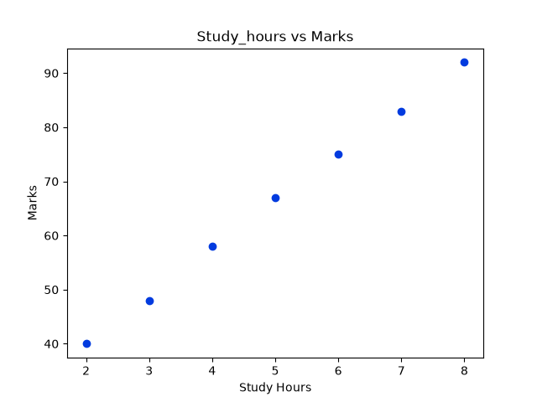
Question—5

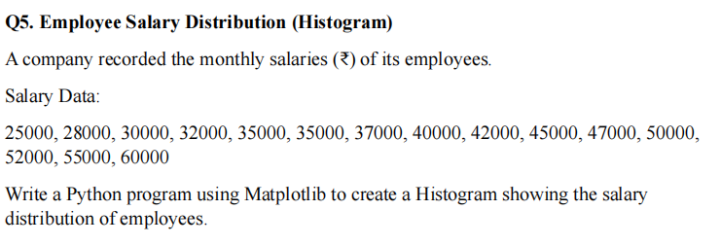

Code:

import pandas as pd
import matplotlib.pyplot as plt
df = pd.read_csv("employee_salary_distribution.csv")
plt.hist(df["salary"],color="#0125CD")
plt.title("salary distribution")
plt.xlabel("monthly salary")
plt.ylabel("number of employees")
plt.show()

Output:
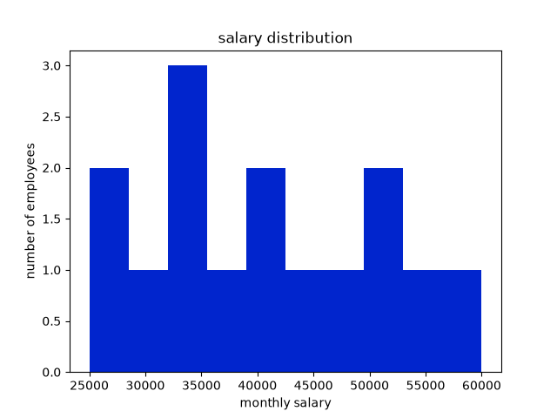
Question—6
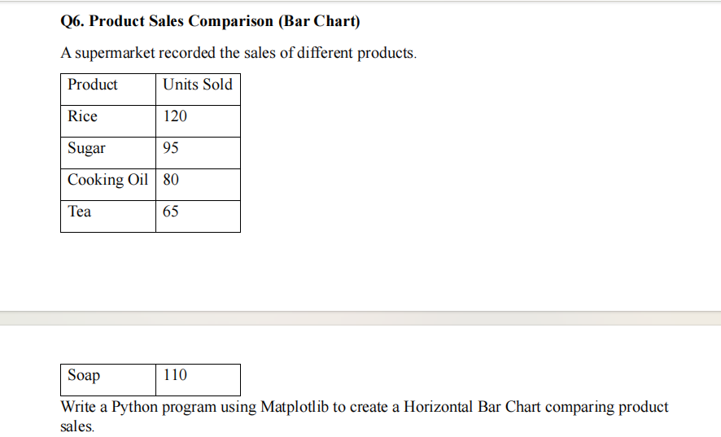
Code:
import pandas as pd
import matplotlib.pyplot as plt
product=["Rice","Sugar","Cooking oil","Tea","Soap"]
Units_Sold=[120,95,80,65,110]
plt.bar(product,Units_Sold,color="#12ABCD")
plt.title("Product sales comparison")
plt.xlabel("Product")
plt.ylabel("Units Sold")
plt.show()

Output:
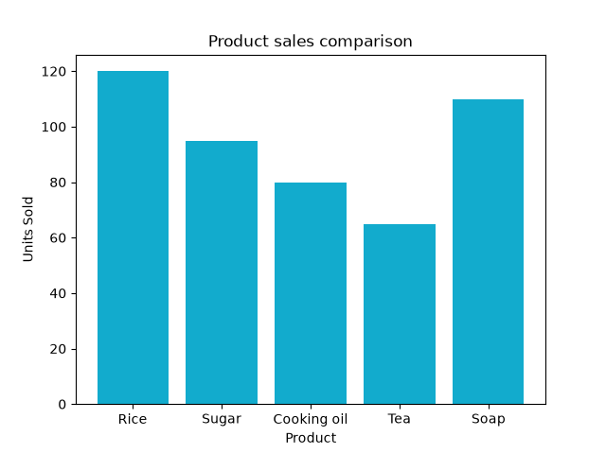
Question—7
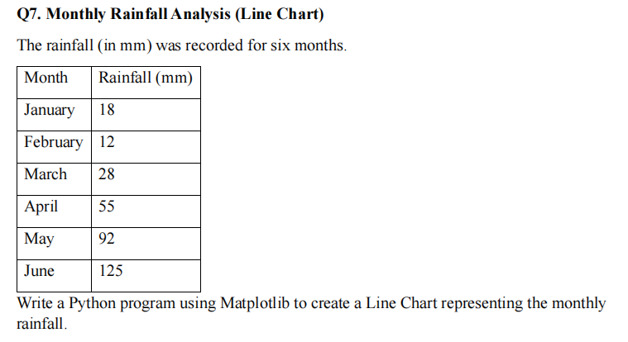

Code:

import pandas as pd
import matplotlib.pyplot as plt
month=["January","February","March","April","May",
"June"]
rainfall=[50,40,60,120,200,150]
plt.plot(month,rainfall,marker='o')
plt.title("Monthly Rainfall Analysis")
plt.xlabel("Month")
plt.ylabel("Rainfall (mm)")
plt.show()

Output:

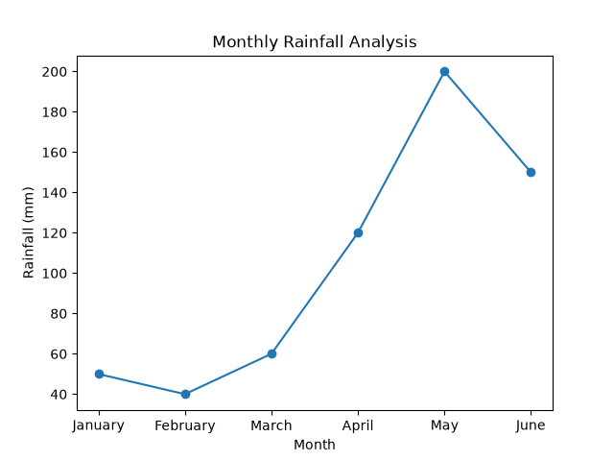
Question—8
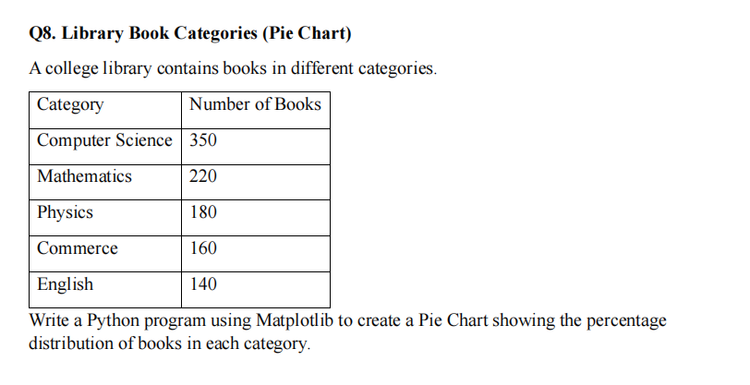

Output:
import pandas as pd
import matplotlib.pyplot as plt
category=["Computer Science","Mathematics","Physics","Commerce","English"]
number_of_books=[350,220,180,160,140]
plt.pie(number_of_books,labels=category,autopct="%1.3f%%")
plt.title("Library Book Categories")
plt.show()

Output:
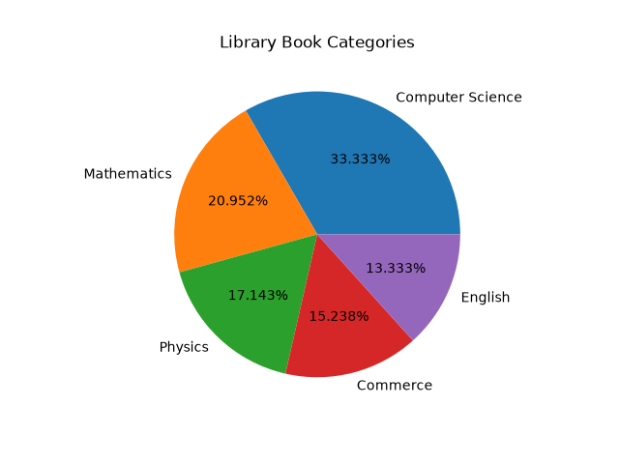
Question—9
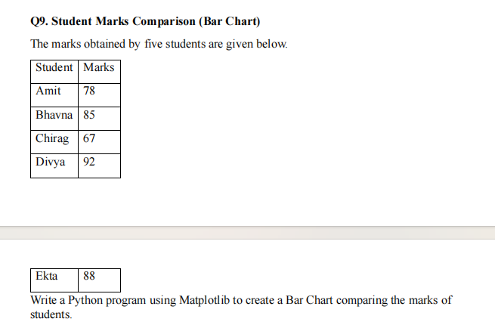
Output:
import pandas as pd
import matplotlib.pyplot as plt
student = ["Amit", "Bhavna", "Chirag", "Divya", "Ekta"]
marks = [78, 85, 67, 92, 88]
plt.bar(student, marks, color="#345ABA")
plt.title("Student Marks Comparison")
plt.xlabel("Student")
plt.ylabel("Marks")
plt.show()

Output:
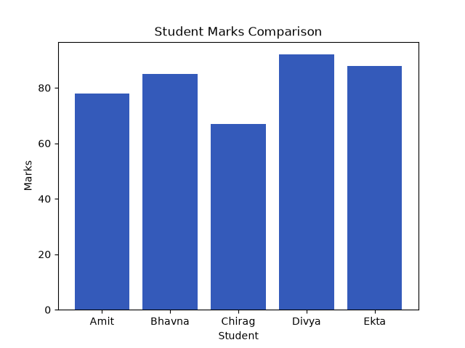
Question—10
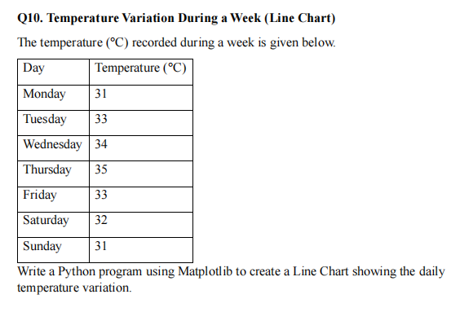
Code:
import pandas as pd
import matplotlib.pyplot as plt
days = ["Monday","Tuesday","Wednesday","Thursday",
"Friday","Saturday","Sunday",]
temperature = [31, 33, 34, 35, 33, 32, 31]
plt.plot(days, temperature, marker="o")
plt.title("Temperature Variation During a Week")
plt.xlabel("Day")
plt.ylabel("Temperature (°C)")
plt.show()

Output:
