**Index**

1. **Specification**
   1. **Revision of the specifications (if needed)( Description of any extra hypothesis on the project specifications)**
2. **Conceptual (ER) and logical data models**
   1. **Explanation of the ER diagram (if needed)**
   2. **Explanation of the logical model (if needed)**
   3. **Relation model of the database in sql or graphical format**
3. **Description of the views, materialized view tables and code of the materialization triggers**
4. **ORM relationship design with explanations**
5. **Entities code**
6. **Interface diagrams or functional analysis of the specifications**
7. **List of components**
   1. **Motivations of the components design (if needed)**
8. **UML sequence diagrams (optional, only for salient events)**

**Report**

1. **Specification(da fare)**
   1. **Revision of the specifications (if needed)( Description of any extra hypothesis on the project specifications) (da fare)**
2. **Conceptual (ER) and logical data models(da fare)**

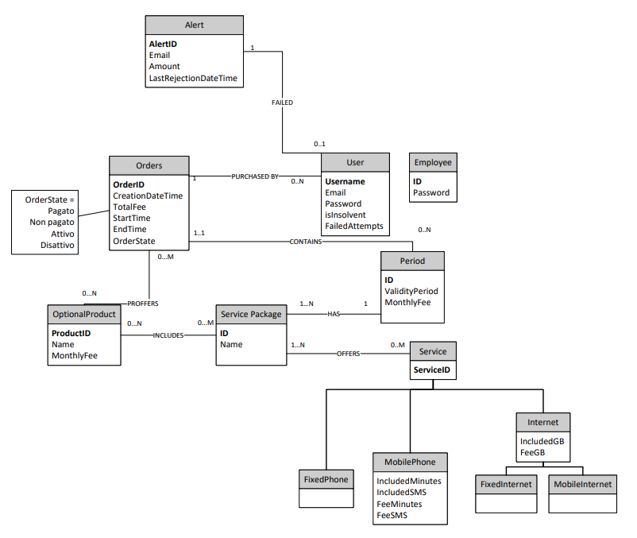

* 1. **Explanation of the ER diagram (if needed) (da fare)**
  2. **Explanation of the logical model (if needed) (da fare)**
  3. **Relation model of the database in sql or graphical format(da fare)**

1. **Description of the views, materialized view tables and code of the materialization triggers(da fare)**
2. **ORM relationship design with explanations(da fare)**
3. **Entities code(da fare)**
4. **Interface diagrams or functional analysis of the specifications(da fare)**
5. **List of components(da fare)**
   1. **Motivations of the components design (if needed) (da fare)**
6. **UML sequence diagrams (optional, only for salient events) (da fare)**