For an educational website on farm animals, you can turn raw NCBI genome files into intuitive, visually engaging concepts. Because non-specialists often assume more chromosomes equal a larger genome, livestock genomics is full of counterintuitive facts that make great interactive features.
Here are four high-impact plot ideas designed for web learning, complete with the biological story behind each.

1. The "Karyotype Paradox" (Genome Size vs. Chromosome Count)
- The Concept: Compare total genome size (in Gigabases, Gb) alongside the diploid chromosome count ($2n$).
- The Educational Hook: Show students that fewer chromosomes do not mean less DNA. Total mammalian genome sizes are nearly identical (~2.5–2.9 Gb), but chromosome numbers vary dramatically—from $2n=38$ in pigs to $2n=60$ in goats and cattle.
- Special Highlight (Goat vs. Sheep): Goats ($2n=60$) and sheep ($2n=54$) are closely related, but sheep have 3 fewer pairs of chromosomes. This is a classic example of Robertsonian translocation—sheep Chromosomes 1, 2, and 3 were formed by two ancestral goat-like chromosomes fusing together!
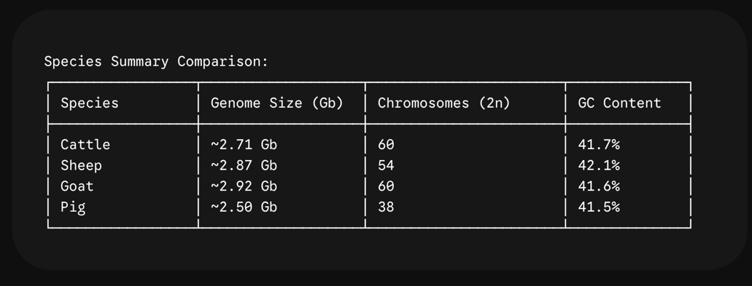

2. Interactive Chromosome Length "Idiogram" Bar Chart
- The Concept: A bar plot showing individual chromosome lengths (in Megabases, Mb) ordered from Chromosome 1 down to sex chromosomes (X and Y).
- The Educational Hook: In pigs ($2n=38$), individual chromosomes are much larger on average because the ~2.5 Gb genome is packed into fewer pieces. Hovering over a chromosome in an interactive plot can reveal its size and key known gene hubs (e.g., coat color genes, growth markers).

3. "What's Inside DNA?" (Genome Composition Pie / Stacked Bar)
- The Concept: Break down the genome into functional regions:
  - Exons / Protein-Coding Regions: ~1.5%
  - Introns: ~30–35%
  - Transposons & Repetitive DNA: ~45–50% (LINEs, SINEs, LTRs)
  - Intergenic Regions: ~15–20%
- The Educational Hook: Users are usually shocked to learn that less than 2% of an animal's DNA directly codes for proteins, while nearly half consists of repetitive "jumping genes" (transposons).

