Priscilla Philby Oommen (Reg No 2648541)

FULL STACK DEVELOPMENT (MAI412-2)
CIA 1 / MIDTRIMESTER EXAM

PART - I:
i) Benchmark analysis
OpenStreetMap (OSM) uses a traditional, data-rich map style rather than a minimalist design. It relies on third-party apps for its user experience, offers detailed local information such as hiking trails and cycling paths, and allows users to directly edit and contribute map data through crowdsourcing. Data is licensed under the Open Database License (ODbL), allowing free use, modification, and commercial application with proper attribution. Built by millions of registered users and contributors who map roads, buildings, trails, and shops. The main OpenStreetMap website provides mapping and editing tools, while many navigation functions are provided by third-party apps that use OSM data. This distinction is important for a fair benchmark.

Target users:
Everyday users, travellers, Volunteer map contributors, Developers and GIS professionals, Field workers and local organizations

Workflow:
- Finding a place
Open OpenStreetMap -> Enter a place or address in search bar -> View the location on the map -> Inspect the area and use an appropriate navigation tool
Discovering nearby places and moving from map viewing to turn-by-turn navigation may require additional steps or another app.

- Adding a missing place
Sign in or create an account -> Open the map editor and find the location -> Add the feature and enter its details -> Review and save the changes
New contributors may struggle with map-editing concepts, choosing the correct feature category, and understanding data tags.

Existing features:
- Allows people to view, create, edit, and share geographic information.
- Interactive map - Zoom, pan, and explore geographic areas. Easy visual exploration
- Location search - Search for places and addresses. Helps users locate destinations
- Map layers - Switch between map styles, including cycling and transport layers. Supports different needs
- Map editing - Add or modify roads, buildings, and places. Encourages community participation
- Map Notes - Report missing or incorrect information. Enables community feedback
- Feature inspection - Click the map to inspect nearby geographic features. Helps users understand map data
- Open geographic data - Access reusable mapping data. Supports developers and GIS analysis
- Community support - Use documentation, forums, and mapping guidance. Helps users learn and resolve issues

Screenshot of 2 observations
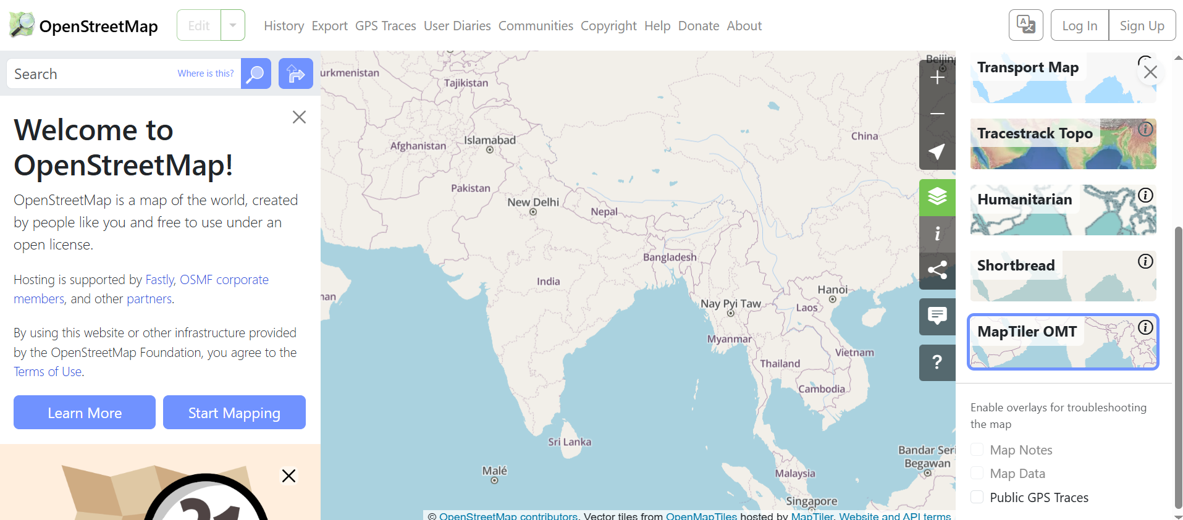
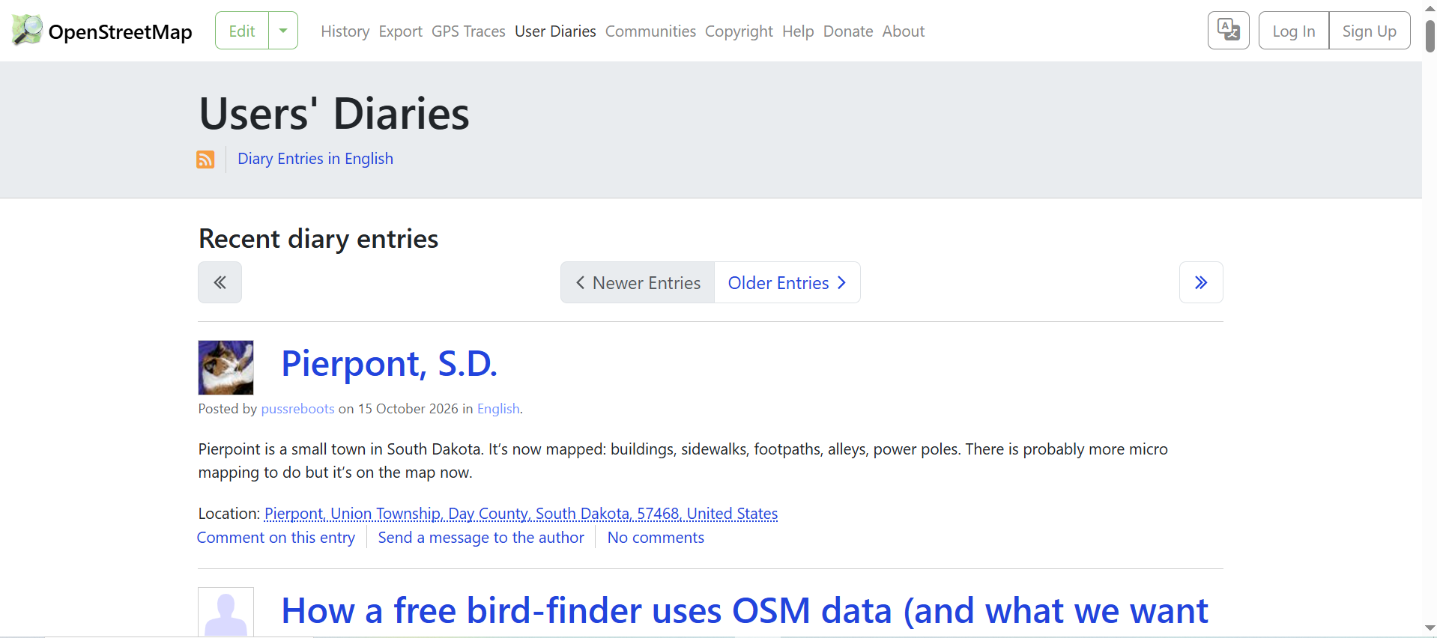

ii) Problem definition
OpenStreetMap allows users to explore geographic locations, but users who want to quickly find nearby places such as pharmacies, restaurants, cafes, and supermarkets may need a more straightforward discovery experience.
Users may find it difficult to discover nearby cafes, restaurants, supermarkets, or other places by category directly on the main website. Search by category, distance, and user preferences.
UX opportunity: Add a “Nearby places” feature with category icons, filters, and a list of results sorted by distance.

Impact of the Problem
- Increased time and effort: Users may spend more time searching and navigating the map to locate relevant places.
- Reduced user-friendliness: First-time users may find the interface difficult to understand or navigate.
- Limited interactivity: Users may benefit from more responsive search, filtering, and place-selection features.
- Difficulty discovering relevant places: Finding and comparing nearby pharmacies, restaurants, supermarkets, and other services may require additional effort.
- Reduced user satisfaction: A less intuitive experience may discourage users from exploring the map or using its features.

Problem Statement: Improving Interactivity and Nearby Place Discovery in OpenStreetMap
OpenStreetMap allows users to explore geographic locations. But, users may find it difficult to quickly discover nearby places based on categories such as food, healthcare, shopping, distance, and user preferences. Additionally, improving the website's interactivity and user-friendliness can make navigation and place discovery easier, particularly for first-time users. The existing map-based experience may require users to perform multiple searches or navigate the map repeatedly to find relevant locations and view their details.
Therefore, there is a need to develop a simple, interactive, and user-friendly web interface that enables users to search for nearby places, filter results by category, view place information, and interact with map elements efficiently.

Innovative solution:
The proposed solution will use HTML, CSS, and JavaScript to improve usability, simplify navigation, and provide a more engaging place-discovery experience.
Develop an interactive and user-friendly Nearby Places Finder using:
- HTML: Structure the search bar, category filters, place cards, and navigation elements.
- CSS: Create an attractive, responsive layout with clear visual hierarchy and interactive hover effects.
- JavaScript: Implement live search, category filtering, clickable place cards, and dynamic feedback messages.
- OpenStreetMap integration: Provide links that allow users to view selected locations on the OpenStreetMap website.

Proposed interface features
Smart search: Users enter a place name or keyword, and JavaScript filters the displayed results without reloading the page.
Interactive category filters: Users select Food, Healthcare, Shopping, or All to narrow down the results.
Place information cards: Each card displays a place name, category, address, and optional distance using sample data.
Responsive layout: Tailwind CSS utilities such as grid-cols-1, sm:grid-cols-2, and lg:grid-cols-3 adapt the layout to different screen sizes.
View on OpenStreetMap: A button or link opens the corresponding location in OpenStreetMap.

Technologies and their roles
HTML5 - Semantic structure, forms, buttons, and content
Tailwind CSS - Responsive styling, spacing, colors, grids, and hover effects
JavaScript - Search, filtering, card interactions, and dynamic messages
OpenStreetMap links - Connect users to geographic locations

Expected Outcome:
The proposed interface does not replace OpenStreetMap. It will make nearby place discovery faster, simplify navigation, improve interactivity, and provide a more user-friendly experience for people exploring locations through OpenStreetMap. It provides a simpler, task-focused way to discover places and can link users to the original map for geographic context.

PART II -
JavaScript Events:
Submit: Validates the form and applies the search, User searches for “pharmacy”
Input: Clears old validation feedback while typing. User corrects an invalid search
Click: Changes the active category and filters cards. User clicks “Healthcare”

How Fetch API and JSON work
The implementation follows this workflow:
- User opens the webpage
- JavaScript sends a fetch() request to Overpass API
- API returns JSON containing OpenStreetMap features
- JavaScript processes and filters the JSON data
- Display matching place cards or an empty/error message
For example, await response.json() converts the API response into a JavaScript object. The code then uses .filter() and .map() to select named places and prepare them for display.

5. Error handling and feedback
- Invalid input: Requests at least two characters.
- Loading state: Displays a loading message during the API request.
- No results: Shows an empty-state message when no cards match.
- API or network failure: Displays an error and allows the user to try again by reloading the page.
- Unexpected response: Checks that the API returned an elements array before processing it.
- Overlapping requests: Uses a request counter to avoid rendering outdated responses.

Screenshots of output:
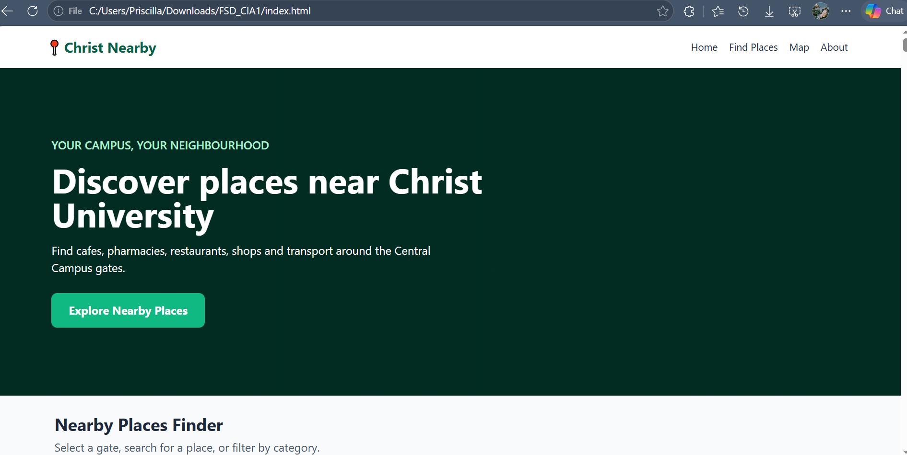
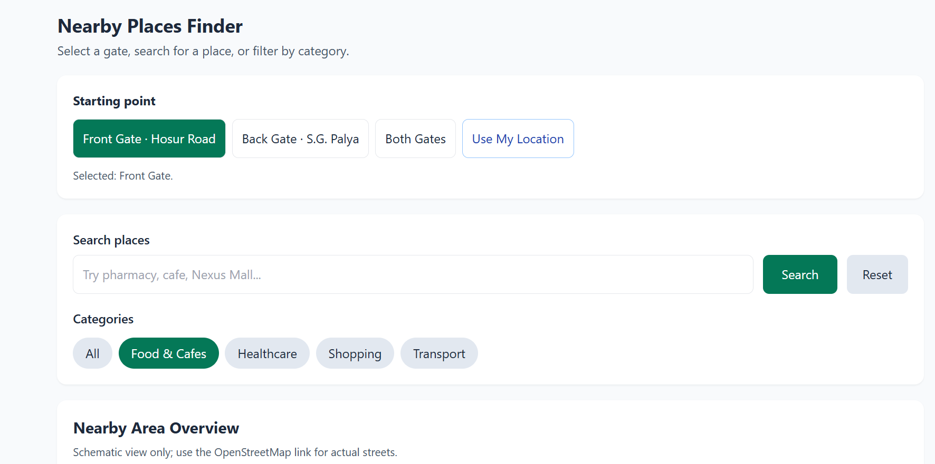
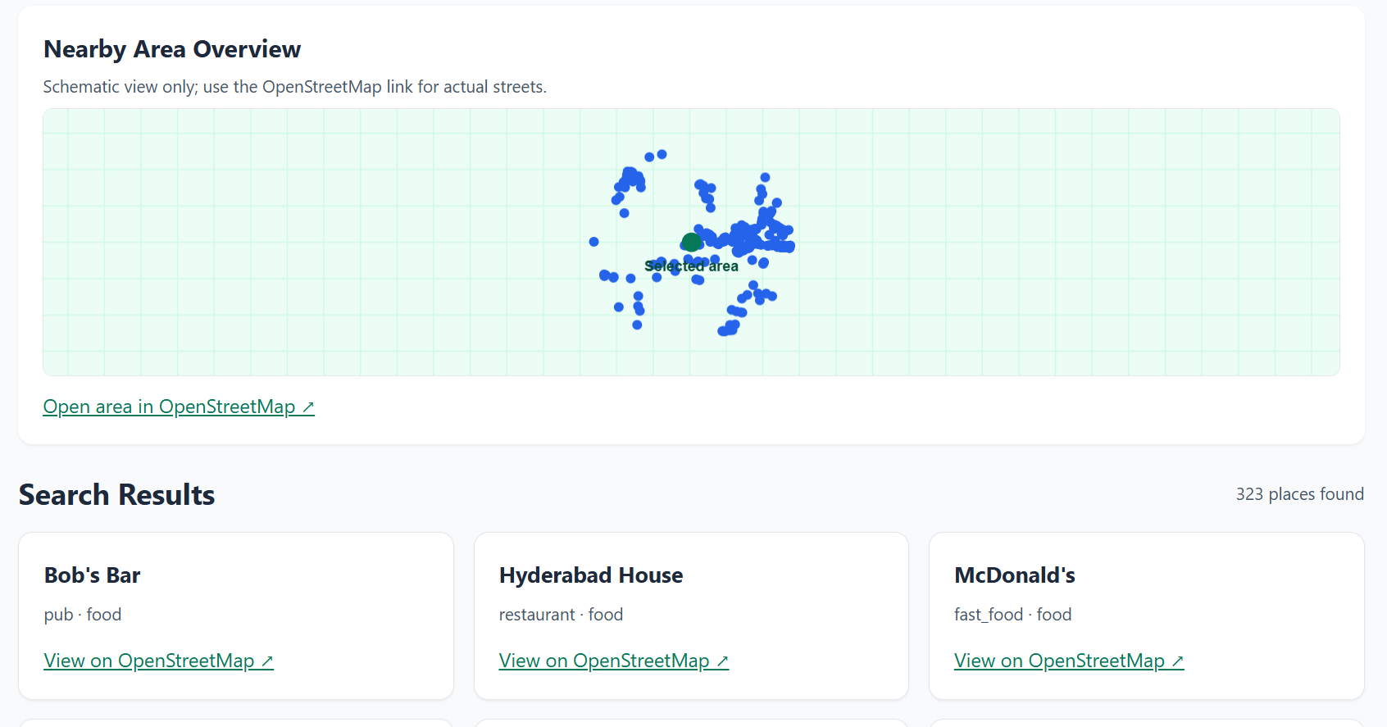
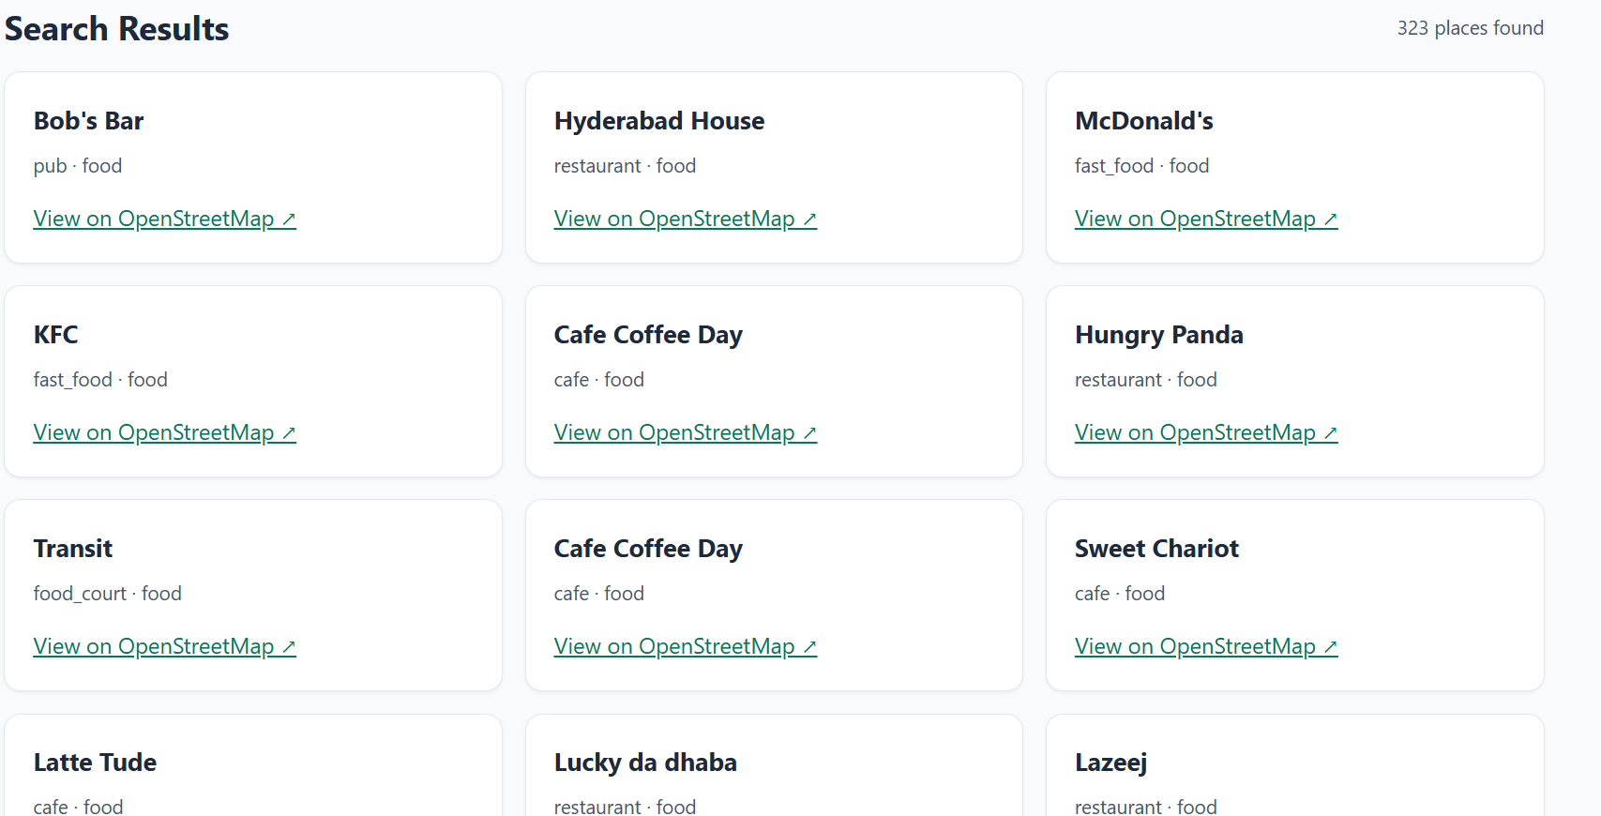

Implementation Explanation
The project is a Nearby Places Finder for Christ University Central Campus. It improves the OpenStreetMap (OSM) user experience by helping students find nearby places such as cafés, shops, pharmacies, bus stops, and other facilities.
1. HTML5 — Structure of the webpage
HTML5 creates the basic layout of the website using semantic tags:
- <header> – Contains the website title and navigation bar.
- <nav> – Provides navigation links.
- <main> – Holds the main content.
- <section> – Separates the hero area, search tools, and nearby places.
- <article> – Displays each nearby place as a card.
- <footer> – Displays footer information.
2. Tailwind CSS — Styling and responsiveness
Tailwind CSS is used to make the website attractive and responsive.
- Creates a flexible navigation bar using Flexbox.
- Adds colours, spacing, buttons, and card layouts.
- Makes the webpage work on mobile phones, tablets, and computers.
- Displays the Christ University entrance image in the hero section.
3. JavaScript — Interactive features
JavaScript makes the website interactive.
- Search: Filters places by name.
- Category filter: Displays selected types of places, such as cafés or shops.
- Gate selection: Lets users choose the front gate or back gate as their starting point.
- Retry button: Allows users to try loading places again if an error occurs.
4. OpenStreetMap and Fetch API
The website uses the Overpass API, which retrieves nearby place information from OpenStreetMap.
- The user selects a campus gate.
- JavaScript sends a request to the Overpass API using fetch().
- The API returns place information in JSON format.
- JavaScript processes the JSON data.
- The places are displayed as cards on the webpage.
The page also displays loading, error, and empty-result messages when necessary.
5. Geolocation API
The Geolocation API can access the user's current location after permission is granted. This allows the user to search for nearby places based on their current position instead of the campus gate.
6. Canvas API
The Canvas API draws a simple schematic illustration with dots representing places. It demonstrates the use of HTML Canvas, but it is not a real interactive map.
7. Input validation and error handling
The website checks the search input and handles situations such as:
- Empty search results.
- Internet or API connection failures.
- Invalid or unavailable location data.
- Loading delays.
If the API fails, the code can display clearly labelled sample places as fallback data.
Implementation workflow
- User opens the website
- Selects a campus gate or current location
- Fetch API requests nearby places from OpenStreetMap
- JavaScript processes the JSON response
- Displays nearby places and lets users search and filter

I developed a responsive nearby-places website for Christ University using HTML5, Tailwind CSS, and JavaScript. HTML5 provides the semantic structure, and Tailwind CSS handles styling and responsive design. JavaScript adds search, category filtering, gate selection, and error handling. The Fetch API retrieves nearby places from OpenStreetMap through the Overpass API, and the JSON response is processed and displayed as cards. I also implemented the Geolocation API to access the user's location and the Canvas API to draw a simple schematic. Finally, I added loading messages, empty states, and fallback sample data to improve the user experience.

