**Name: S. Priscilla Grace Rose Sugumar**

**STATISTICAL ANALYSIS PROJECT - SAS**



Null Hypothesis: The weights change after Liquid diet.

Alternate Hypothesis : The weights do not change after Liquid diet.

**Output:**

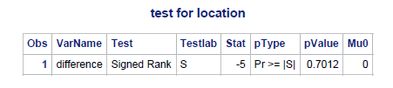

We performed Wilcoxon Signed Rank Test and we got the P value as 0.7012

Since the P value Is greater than 0.05 the Null Hypothesis is accepted.



Solution:

The test performed here is Wilcoxon Rank Sum Method

The Null Hypothesis: The yields of the varieties C and Dare the same.

The Alternate Hypothesis: The yields of the varieties C and D are different.

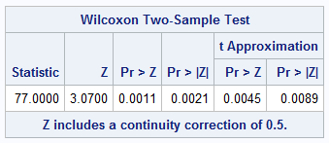

The p value is 0.0021

**Sol:**

The p value observed is 0.0021 which is less than the level of significance α (0.05). The Alternate Hypothesis (H1) is accepted. So, the yields are different between varieties C and D.





a.

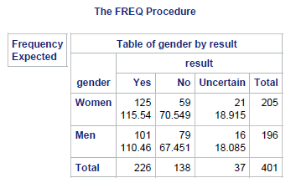

b.

Null Hypothesis (H0): The gender of students and response of the survey are not associated.

Alternative Hypothesis (H1) : The gender of students and response of the survey are associated.

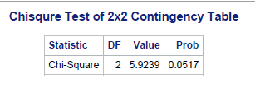

The P-Value is **0.0517**

Since the p-value 0.0517 is greater than α level 0.05, Null hypothesis (H0) is accepted**.**



Null Hypothesis (H0) : The probabilities of developing infection is not different.

Alternative Hypothesis (H1) : The probabilities of developing infection is different.

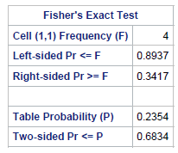

The P-value is 0.6834

Since the p-value 0.6834 is greater than α level 0.05, Null hypothesis (H0) is accepted. 

1. 

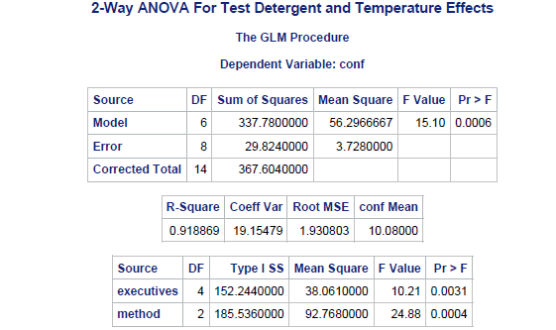

|  |  |  |  |  |  |
| --- | --- | --- | --- | --- | --- |
| Source | DF | Sum of Squares | Mean Squares | FValue | Pr>F |
| Executive | 4 | 152.244 | 38.06 | 10.21 | 0.0031 |
| Method | 2 | 185.536 | 92.568 | 24.88 | 0.004 |
| Error | 8 | 29.824 | 3.72 |  |  |
| Corrected Total | 14 | 367.604 |  |  |  |

**b.)**Null Hypothesis(H0) : Confidence ratings of three methods is equal

Alternate Hypothesis(H1) : Confidence ratings of three methods is not equal



Since p-value 0.0004 is lesser than α level 0.05, Alternate hypothesis (H1) is accepted.

**c.)**

Null Hypothesis (H0) : Confidence ratings of five executives is equal.

Alternative Hypothesis (H1) : Confidence ratings of five executives is not equal.



Since p-value 0.0031 is lesser than α level 0.05, Alternate hypothesis (H1) is accepted.

**d.)**

1. Confidence rating between 1st and 3rd method is different because

p-value 0.0030 which is lesser than alpha value, **rejects H0**.

1. Confidence rating between 1st and 2nd method is different because

p-value 0.0001 which is less than alpha value, **rejects H0**.

1. Confidence rating between 2nd and 3rd method is different because

p-value 0.0226 which is less than alpha value, **rejects H0**.

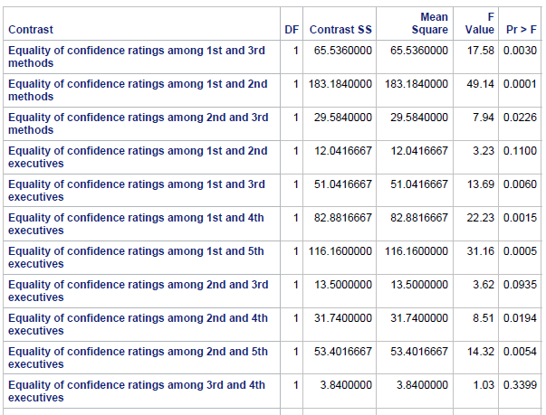

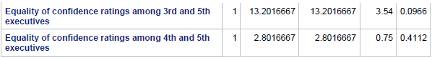

**e.) The equality of confidence rating for a pair of executives**

1. Confidence rating between 1st and 2nd executive is same because

p-value 0.110 which is greater than alpha value, **accepts H0**.

1. Confidence rating between 1st and 3rd executive is not same because

p-value 0.006 which is less than alpha value, **rejects H0**.

1. Confidence rating between 1st and 4th executive is not same because

p-value 0.0015 which is less than alpha value, **rejects H0**.

1. Confidence rating between 1st and 5th executive is not same because

p-value 0.0005 which is less than alpha value, **rejects H0**.

1. Confidence rating between 2nd and 3rd executive is same because

p-value 0.0935 which is greater than alpha value, **accepts H0**.

1. Confidence rating between 2nd and 4th executive is not same because

p-value 0.0194 which is less than alpha value, **rejects H0**.

1. Confidence rating between 2nd and 5th executive is same not because

p-value 0.0054 which is less than alpha value, **rejects H0**.

1. Confidence rating between 3rd and 4th executive is same because

p-value 0.3399 which is greater than alpha value, **accepts H0**.

1. Confidence rating between 3rd and 5th executive is same because

p-value 0.0966 which is greater than alpha value, **accepts H0**.

1. Confidence rating between 4th and 5th executive is same because

p-value 0.4112 which is greater than alpha value, **accepts H0**.



