**WEEK-4**

**SPRING REST USING SPRING BOOT 3**

**Spring rest hands-on**

**1.Exercise:Create a Spring Web Project using Maven**

**Code:**

**SpringLearnApplication.java**

package com.cognizant.spring_learn;

import org.slf4j.Logger;

import org.slf4j.LoggerFactory;

import org.springframework.boot.SpringApplication;

import org.springframework.boot.autoconfigure.SpringBootApplication;

@SpringBootApplication

public class SpringLearnApplication {

private static final Logger LOGGER = LoggerFactory.getLogger(SpringLearnApplication.class);

public static void main(String[] args) {

SpringApplication.run(SpringLearnApplication.class, args);

LOGGER.info("STARTING MAIN");

}

}

**Output:**

**After building the project**

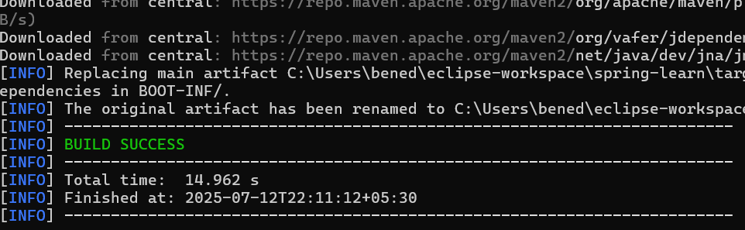

**Eclipse output**

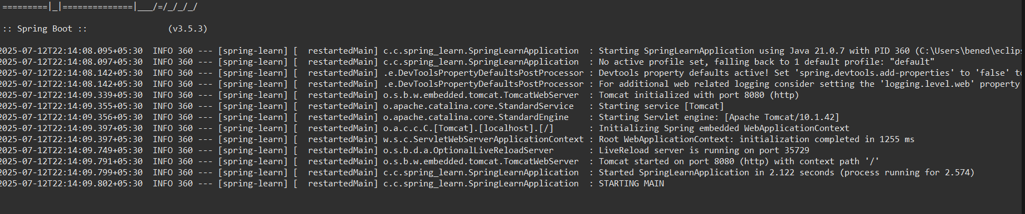

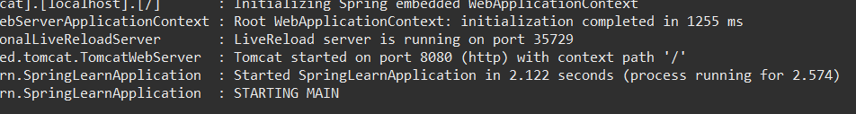

**2.Exercise:Spring Core – Load Country from Spring Configuration XML**

**Code:**

**country.xml:**

<?xml version="1.0" encoding="UTF-8"?>

<beans xmlns="http://www.springframework.org/schema/beans"

xmlns:xsi="http://www.w3.org/2001/XMLSchema-instance"

xsi:schemaLocation="

http://www.springframework.org/schema/beans

http://www.springframework.org/schema/beans/spring-beans.xsd">

<bean id="country" class="com.cognizant.spring_learn.Country">

<property name="code" value="IN" />

<property name="name" value="India" />

</bean>

</beans>

**Country.java:**

package com.cognizant.spring_learn;

import org.slf4j.Logger;

import org.slf4j.LoggerFactory;

public class Country {

private static final Logger LOGGER = LoggerFactory.getLogger(Country.class);

private String code;

private String name;

public Country() {

LOGGER.debug("Inside Country Constructor.");

}

public String getCode() {

LOGGER.debug("Inside getCode()");

return code;

}

public void setCode(String code) {

LOGGER.debug("Inside setCode()");

this.code = code;

}

public String getName() {

LOGGER.debug("Inside getName()");

return name;

}

public void setName(String name) {

LOGGER.debug("Inside setName()");

this.name = name;

}

@Override

public String toString() {

return "Country [code=" + code + ", name=" + name + "]";

}

}

**SpringLearnApplication.java:**

package com.cognizant.spring_learn;

import org.slf4j.Logger;

import org.slf4j.LoggerFactory;

import org.springframework.context.ApplicationContext;

import org.springframework.context.support.ClassPathXmlApplicationContext;

public class SpringLearnApplication {

private static final Logger LOGGER = LoggerFactory.getLogger(SpringLearnApplication.class);

public static void main(String[] args) {

LOGGER.debug("START");

displayCountry();

LOGGER.debug("END");

}

public static void displayCountry() {

ApplicationContext context = new ClassPathXmlApplicationContext("country.xml");

Country country = context.getBean("country", Country.class);

LOGGER.debug("Country : {}", country.toString());

}

}

**logback.xml:**

<?xml version="1.0" encoding="UTF-8"?>

<configuration>

<appender name="STDOUT" class="ch.qos.logback.core.ConsoleAppender">

<encoder>

<pattern>%d{HH:mm:ss.SSS} [%thread] %-5level %logger{36} - %msg%n</pattern>

</encoder>

</appender>

<root level="debug">

<appender-ref ref="STDOUT" />

</root>

</configuration>

**Output:**

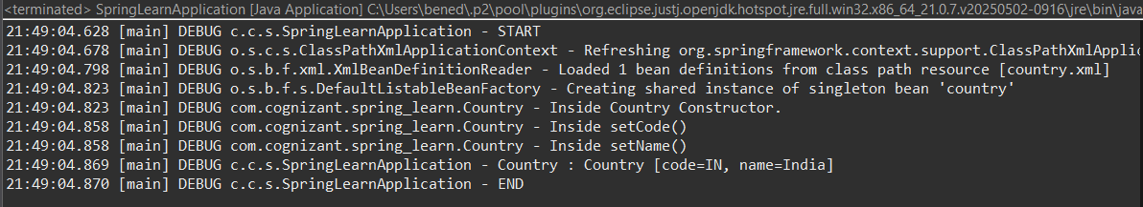

**3.Exercise:Hello World RESTful Web Service**

**Code:**

**HelloController.java**

package com.cognizant.spring_learn.controller;

import org.slf4j.Logger;

import org.slf4j.LoggerFactory;

import org.springframework.web.bind.annotation.GetMapping;

import org.springframework.web.bind.annotation.RestController;

@RestController

public class HelloController {

private static final Logger LOGGER = LoggerFactory.getLogger(HelloController.class);

@GetMapping("/hello")

public String sayHello() {

LOGGER.info("START - sayHello()");

String response = "Hello World!!";

LOGGER.info("END - sayHello()");

return response;

}}

**application.properties:**

spring.application.name=spring-learn

server.port=8083

**Outputs:**

**Chrome output**

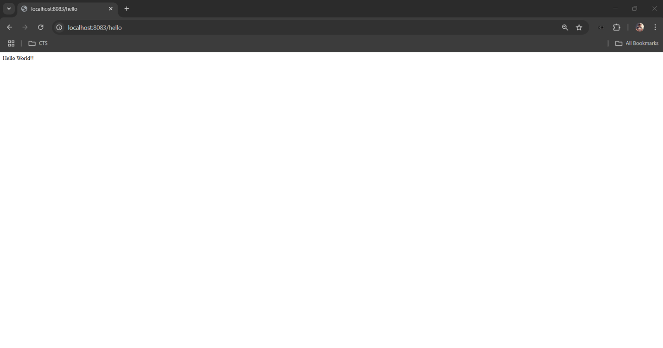

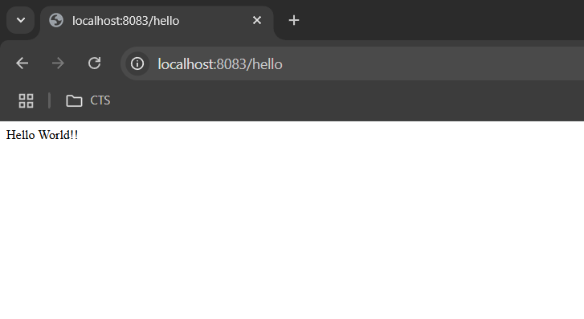

**Postman output**

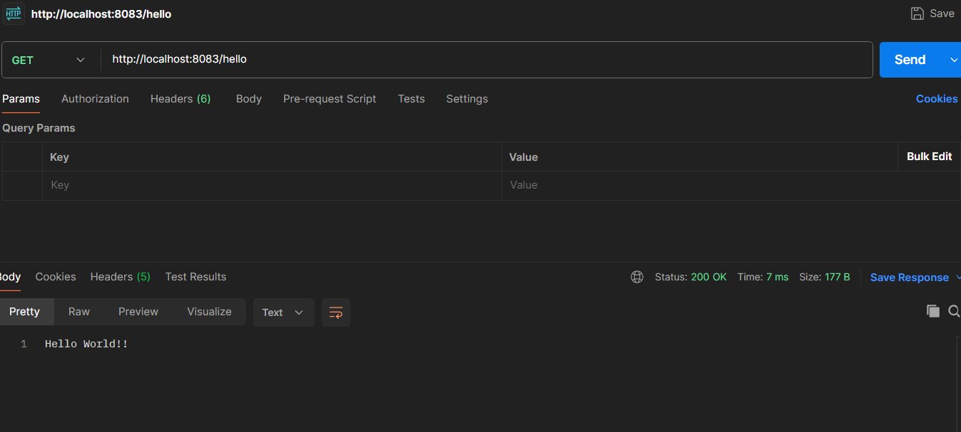

**Eclipse output**

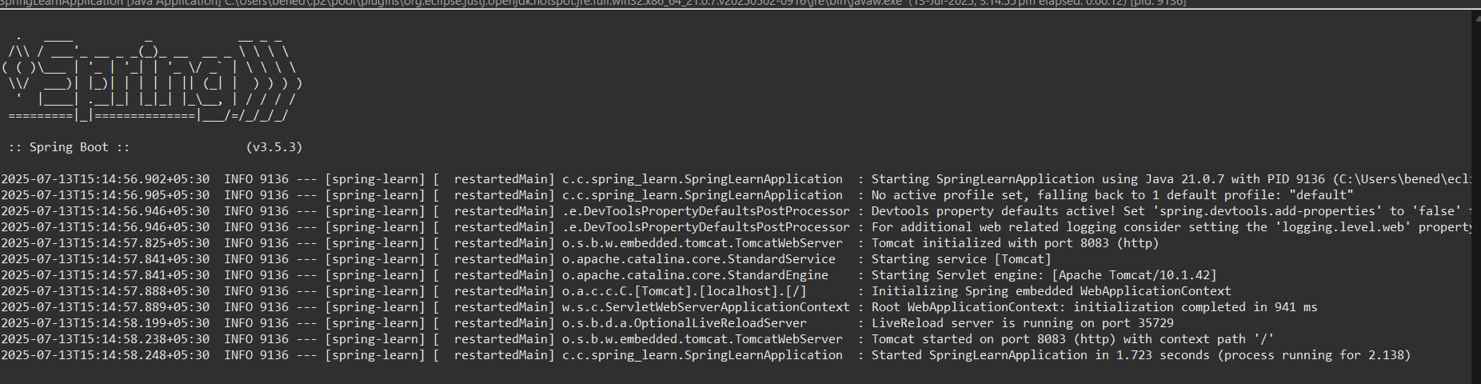

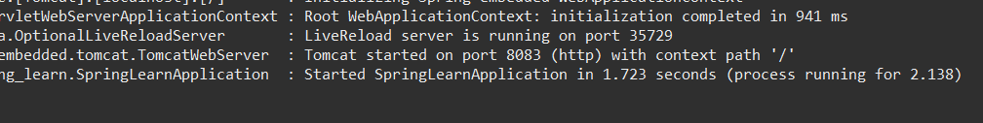

**4.Exercise:REST - Country Web Service**

**Code:**

**Country.java**

package com.cognizant.spring_learn.model;

public class Country {

private String code;

private String name;

public Country() {

}

public Country(String code, String name) {

this.code = code;

this.name = name;

}

public String getCode() {

return code;

}

public void setCode(String code) {

this.code = code;

}

public String getName() {

return name;

}

public void setName(String name) {

this.name = name;

}

}

**CountryController.java**

package com.cognizant.spring_learn.controller;

import com.cognizant.spring_learn.model.Country;

import org.springframework.context.ApplicationContext;

import org.springframework.context.support.ClassPathXmlApplicationContext;

import org.springframework.web.bind.annotation.RequestMapping;

import org.springframework.web.bind.annotation.RestController;

@RestController

public class CountryController {

@RequestMapping("/country")

public Country getCountryIndia() {

ApplicationContext context = new ClassPathXmlApplicationContext("country.xml");

Country country = (Country) context.getBean("country");

return country;

}

}

**country.xml**

<?xml version="1.0" encoding="UTF-8"?>

<beans xmlns="http://www.springframework.org/schema/beans"

xmlns:xsi="http://www.w3.org/2001/XMLSchema-instance"

xsi:schemaLocation="http://www.springframework.org/schema/beans

https://www.springframework.org/schema/beans/spring-beans.xsd">

<bean id="country" class="com.cognizant.spring_learn.model.Country">

<property name="code" value="JP" />

<property name="name" value="JAPAN" />

</bean>

</beans>

**Output:**

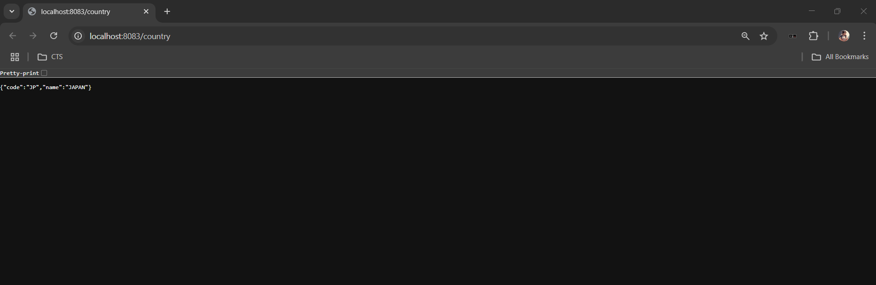

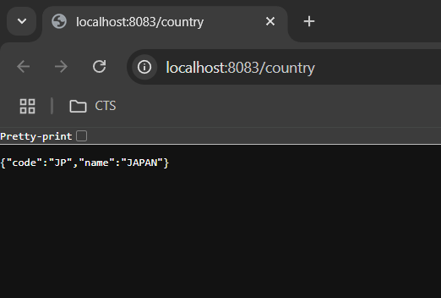

**5.Exercise:REST - Get country based on country code**

**Code:**

**Country.java**

package com.cognizant.spring_learn.model;

public class Country {

private String code;

private String name;

public Country() {

}

public Country(String code, String name) {

this.code = code;

this.name = name;

}

public String getCode() {

return code;

}

public void setCode(String code) {

this.code = code;

}

public String getName() {

return name;

}

public void setName(String name) {

this.name = name;

}

}

**CountryController.java**

package com.cognizant.spring_learn.controller;

import com.cognizant.spring_learn.model.Country;

import com.cognizant.spring_learn.service.CountryService;

import org.springframework.beans.factory.annotation.Autowired;

import org.springframework.web.bind.annotation.*;

@RestController

public class CountryController {

@Autowired

private CountryService countryService;

@GetMapping("/countries/{code}")

public Country getCountry(@PathVariable String code) {

return countryService.getCountry(code);

}

}

**country.xml**

<?xml version="1.0" encoding="UTF-8"?>

<beans xmlns="http://www.springframework.org/schema/beans"

xmlns:xsi="http://www.w3.org/2001/XMLSchema-instance"

xsi:schemaLocation="http://www.springframework.org/schema/beans

https://www.springframework.org/schema/beans/spring-beans.xsd">

<bean id="countryList" class="java.util.ArrayList">

<constructor-arg>

<list>

<bean class="com.cognizant.spring_learn.model.Country">

<property name="code" value="IN" />

<property name="name" value="India" />

</bean>

<bean class="com.cognizant.spring_learn.model.Country">

<property name="code" value="US" />

<property name="name" value="United States" />

</bean>

<bean class="com.cognizant.spring_learn.model.Country">

<property name="code" value="GE" />

<property name="name" value="Germany" />

</bean>

<bean class="com.cognizant.spring_learn.model.Country">

<property name="code" value="JP" />

<property name="name" value="Japan" />

</bean>

</list>

</constructor-arg>

</bean>

</beans>

**CountryService.java**

package com.cognizant.spring_learn.service;

import com.cognizant.spring_learn.model.Country;

import org.springframework.context.ApplicationContext;

import org.springframework.context.support.ClassPathXmlApplicationContext;

import org.springframework.stereotype.Service;

import java.util.List;

@Service

public class CountryService {

public Country getCountry(String code) {

try (ClassPathXmlApplicationContext context = new ClassPathXmlApplicationContext("country.xml")) {

List<Country> countryList = (List<Country>) context.getBean("countryList");

return countryList.stream()

.filter(c -> c.getCode().equalsIgnoreCase(code))

.findFirst()

.orElse(null);

} }}

**Output:**

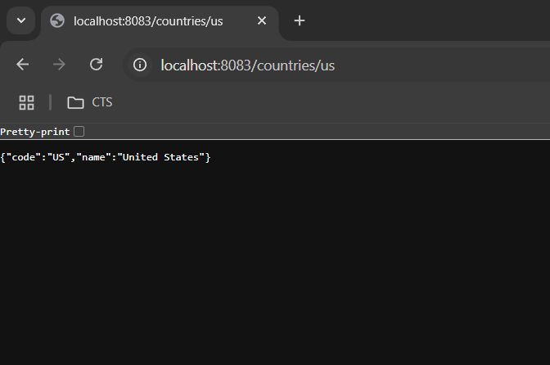

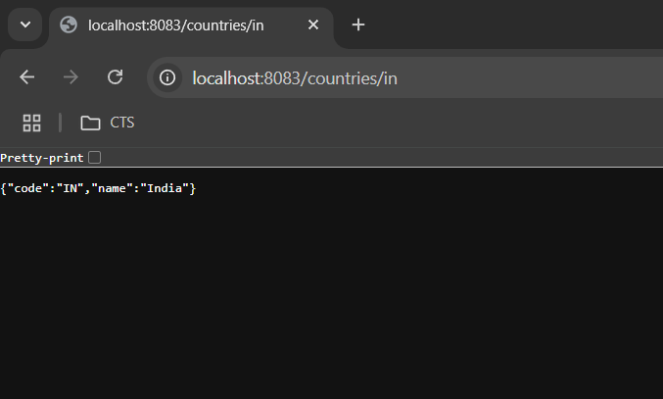

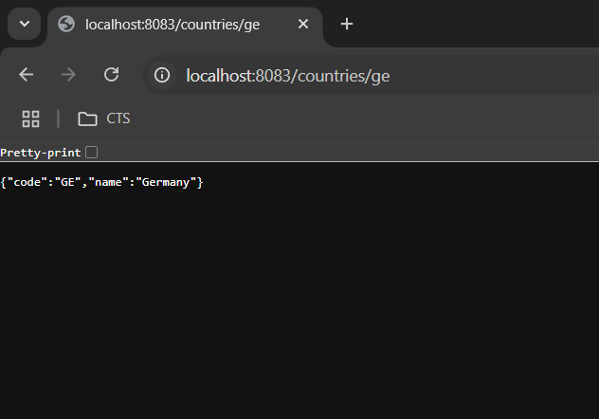

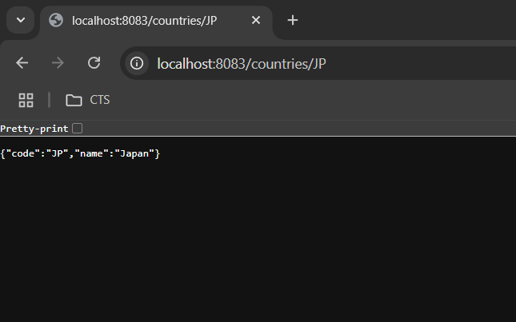

**JWT hands-on**

**6.Exercise:Create authentication service that returns JWT**

**Code:**

**AuthenticationController.java:**

package com.cognizant.spring_learn.controller;

import org.slf4j.Logger;

import org.slf4j.LoggerFactory;

import org.springframework.web.bind.annotation.*;

import io.jsonwebtoken.JwtBuilder;

import io.jsonwebtoken.Jwts;

import io.jsonwebtoken.SignatureAlgorithm;

import java.util.Base64;

import java.util.Date;

import java.util.HashMap;

import java.util.Map;

@RestController

public class AuthenticationController {

private static final Logger LOGGER = LoggerFactory.getLogger(AuthenticationController.class);

@GetMapping("/authenticate")

public Map<String, String> authenticate(@RequestHeader("Authorization") String authHeader) {

LOGGER.info("START - /authenticate");

LOGGER.debug("Authorization Header: {}", authHeader);

String user = getUser(authHeader);

LOGGER.debug("User extracted: {}", user);

String token = generateJwt(user);

Map<String, String> map = new HashMap<>();

map.put("token", token);

LOGGER.info("END - /authenticate");

return map;

}

private String getUser(String authHeader) {

LOGGER.debug("Decoding Authorization Header");

String encodedCredentials = authHeader.substring("Basic ".length());

byte[] decodedBytes = Base64.getDecoder().decode(encodedCredentials);

String decodedCredentials = new String(decodedBytes);

LOGGER.debug("Decoded Credentials: {}", decodedCredentials);

return decodedCredentials.split(":")[0]; // extract username

}

private String generateJwt(String user) {

JwtBuilder builder = Jwts.builder();

builder.setSubject(user);

builder.setIssuedAt(new Date());

builder.setExpiration(new Date(System.currentTimeMillis() + 1200000)); // 20 min

builder.signWith(SignatureAlgorithm.HS256, "secretkey");

return builder.compact();

}

}

**SecurityConfig.java:**

package com.cognizant.spring_learn.config;

import org.springframework.context.annotation.Configuration;

import org.springframework.security.config.annotation.authentication.builders.AuthenticationManagerBuilder;

import org.springframework.security.config.annotation.web.configuration.*;

import org.springframework.security.config.annotation.web.builders.HttpSecurity;

@Configuration

@EnableWebSecurity

public class SecurityConfig extends WebSecurityConfigurerAdapter {

@Override

protected void configure(HttpSecurity http) throws Exception {

http

.csrf().disable()

.authorizeRequests()

.antMatchers("/countries").hasRole("USER")

.antMatchers("/authenticate").hasAnyRole("USER", "ADMIN")

.anyRequest().authenticated()

.and()

.httpBasic();

}

@Override

protected void configure(AuthenticationManagerBuilder auth) throws Exception {

auth.inMemoryAuthentication()

.withUser("user").password("{noop}pwd").roles("USER")

.and()

.withUser("admin").password("{noop}adminpwd").roles("ADMIN");

}

}

**application.properties:**

spring.application.name=spring-learn

server.port=8090

**pom.xml(JWT library)**

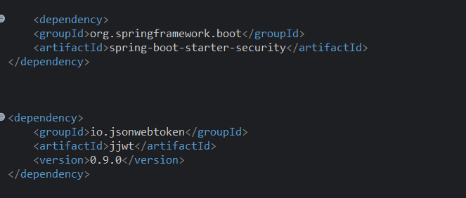

**Output:**

