**WEEK-6**

**Exercise-1**

**Code:**

**[App.js](http://app.js)**

import logo from './logo.svg';

import './App.css';

function App() {

return (

<h1>Welcome the first session of React</h1>

);

}

export default App;

**Output:**

**Chrome output**

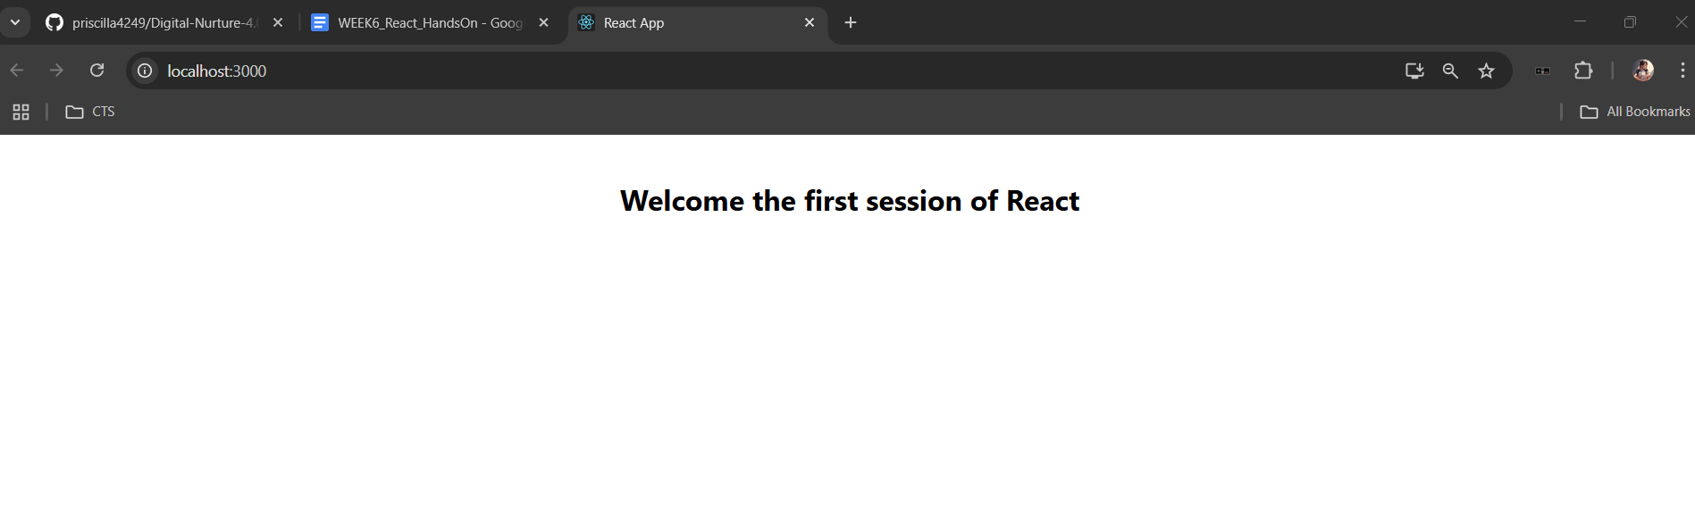

**Command prompt output**

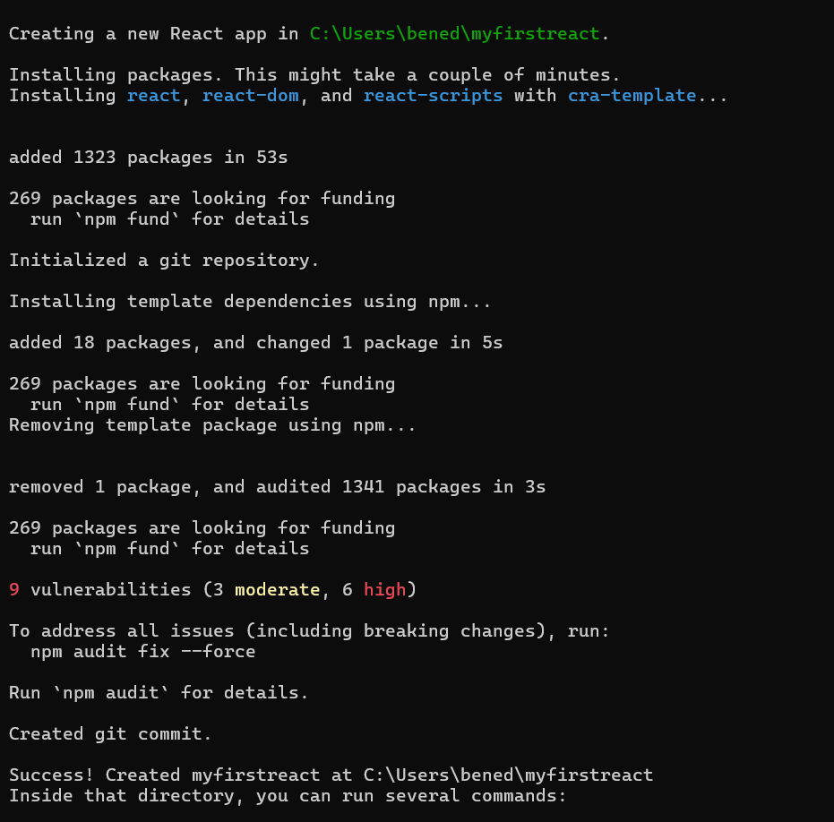

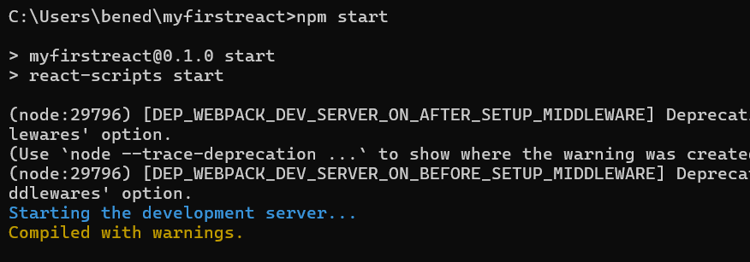

**Exercise-2**

**Code:**

**Home.js**

import React, { Component } from 'react';

class Home extends Component {

render() {

return (

<div>

<h3>Welcome to the Home page of the Student Management Portal</h3>

</div>

);

}

}

export default Home;

**About.js**

import React, { Component } from 'react';

class About extends Component {

render() {

return (

<div>

<h3>Welcome to the About page of the Student Management Portal</h3>

</div>

);

}

}

export default About;

**[Contact.js](http://contact.js)**

import React, { Component } from 'react';

class Contact extends Component {

render() {

return (

<div>

<h3>Welcome to the Contact page of the Student Management Portal</h3>

</div>

);

}

}

export default Contact;

**[App.js](http://app.js)**

import logo from './logo.svg';

import './App.css';

import React from 'react';

import Home from './Components/Home';

import About from './Components/About';

import Contact from './Components/Contact';

function App() {

return (

<div className="container">

<Home />

<About />

<Contact />

</div>

);

}

export default App;

**Output:**

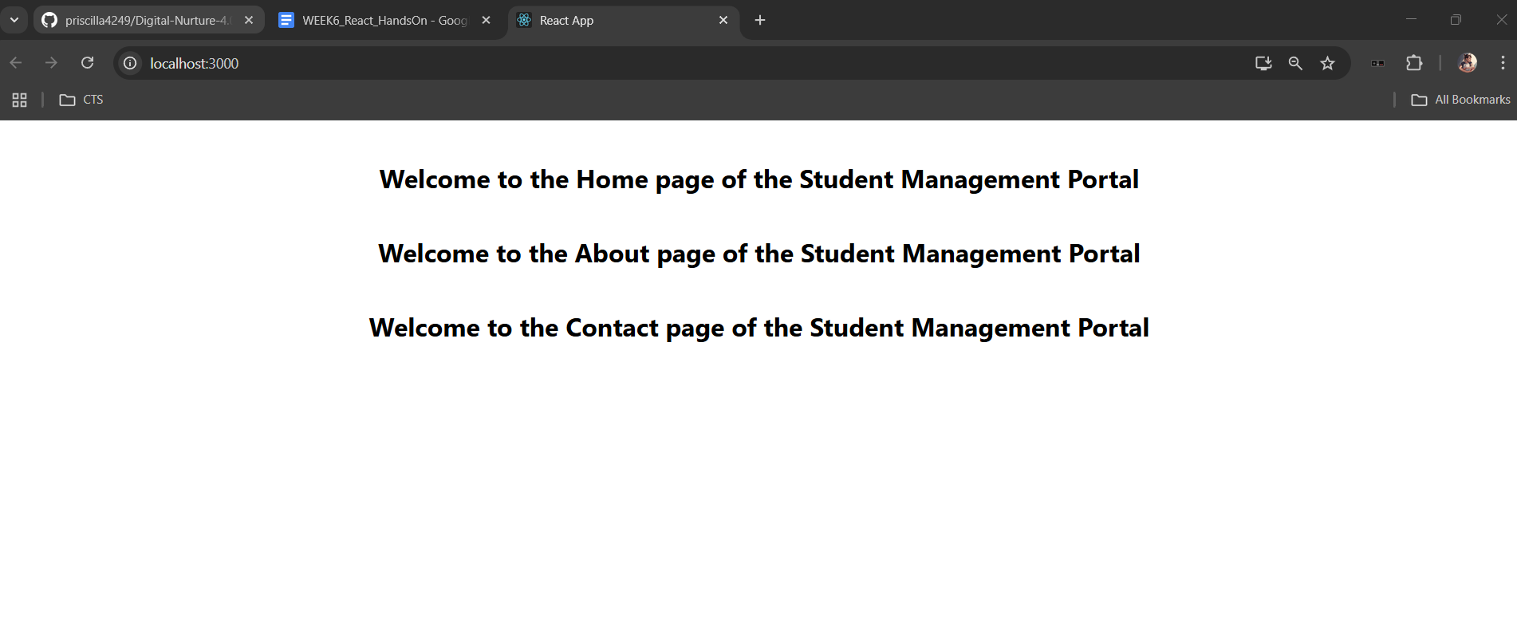

**Exercise-3**

**Code:**

**CalculateScore.js**

import React from 'react';

import '../Stylesheets/mystyle.css';

const percentToDecimal = (decimal) => {

return (decimal.toFixed(2) + '%');

};

const calcScore = (total, goal) => {

return percentToDecimal(total / goal);

};

export const CalculateScore = ({ Name, School, total, goal }) => (

<div className="formatstyle">

<h1><font color="Brown">Student Details:</font></h1>

<div className="Name">

<b><span>Name: </span></b>

<span>{Name}</span>

</div>

<div className="School">

<b><span>School: </span></b>

<span>{School}</span>

</div>

<div className="Total">

<b><span>Total:</span></b>

<span>{total}</span>

<span> Marks</span>

</div>

<div className="Score">

<b>Score:</b>

<span>{calcScore(total, goal)}</span>

</div>

</div>

);

**mystyle.css**

.Name{

font-weight: 300;

color:blue;

}

.School{

color:crimson;

}

.Total{

color:darkmagenta;

}

.formatstyle{

text-align: center;

font-size: large;

}

.Score{

color:forestgreen;}

**App.js**

import logo from './logo.svg';

import './App.css';

import {CalculateScore} from '../src/Components/CalculateScore'

function App() {

return (

<div>

<CalculateScore Name={"Steeve"}

School={"DNV Public School"}

total={284}

goal={3}

/>

</div>

);

}

export default App;

**Output:**

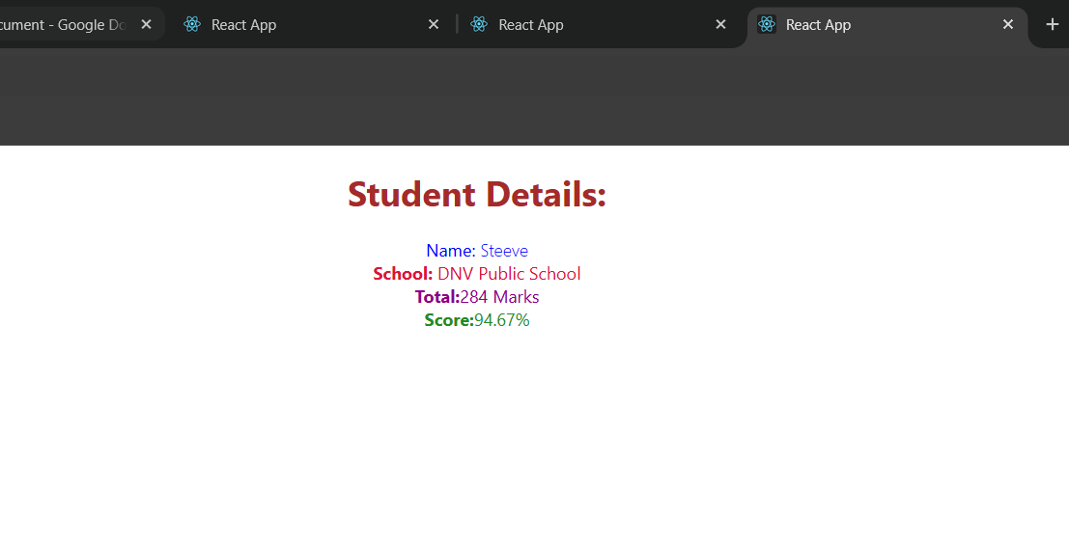

**Exercise-4**

**Code:**

**[Post.js](http://posts.js)**

import React from 'react';

class Post {

constructor(id, title, body) {

this.id = id;

this.title = title;

this.body = body;

}

}

class Posts extends React.Component {

constructor(props) {

super(props);

this.state = {

posts: []

};

}

loadPosts() {

fetch('https://jsonplaceholder.typicode.com/posts')

.then(response => response.json())

.then(data => {

const postObjects = data.map(p => new Post(p.id, p.title, p.body));

this.setState({ posts: postObjects });

})

.catch(error => console.error("Error fetching posts:", error));

}

componentDidMount() {

this.loadPosts();

}

render() {

return (

<div>

<h1>Posts</h1>

{this.state.posts.map(post => (

<div key={post.id}>

<h3>{post.title}</h3>

<p>{post.body}</p>

</div>

))}

</div>

);

}

componentDidCatch(error, info) {

alert('An error occurred: ' + error.toString());

console.error("There was an error in the component:", error, info);

}

}

export default Posts;

**[App.js](http://app.js)**

import React from 'react';

import Posts from './Posts';

function App() {

return (

<div className="App">

<Posts />

</div>

);

}

export default App;

**Output:**

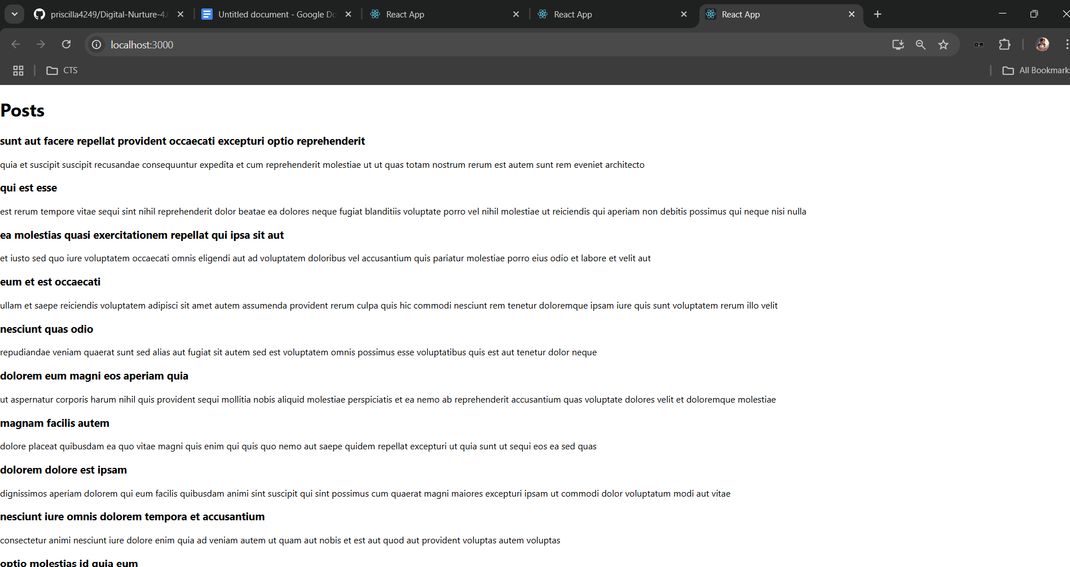

**Exercise-5**

**Code:**

**CohortDetails.module.css**

.box {

width: 300px;

display: inline-block;

margin: 10px;

padding: 10px 20px;

border: 1px solid black;

border-radius: 10px;

}

dt {

font-weight: 500;

}

**CohortDetails.js**

import styles from './CohortDetails.module.css';

function CohortDetails(props) {

const { cohortCode, technology, startDate, currentStatus, coachName, trainerName } = props.cohort;

const headingStyle = {

color: currentStatus.toLowerCase() === 'ongoing' ? 'green' : 'blue'

};

return (

<div className={styles.box}>

<h3 style={headingStyle}>

{cohortCode} - <span>{technology}</span>

</h3>

<dl>

<dt>Started On</dt>

<dd>{startDate}</dd>

<dt>Current Status</dt>

<dd>{currentStatus}</dd>

<dt>Coach</dt>

<dd>{coachName}</dd>

<dt>Trainer</dt>

<dd>{trainerName}</dd>

</dl>

</div>

);

}

export default CohortDetails;

**Output:**

