**WEEK-7**

**Exercise-9:**

**Code:**

**ListofPlayers.js**

import React from "react";

export default function ListofPlayers({ players }) {

let players70 = [];

players.map((item) => {

if (item.score <= 70) {

players70.push(item);

}

});

return (

<div style={{ marginLeft: "20px" }}>

<h1>List of Players</h1>

{players.map((item) => {

return (

<div>

<li>Mr. {item.name} <span> {item.score} </span></li>

</div>

);

})}

<hr />

<h1>List of Players having Scores Less than 70</h1>

{players70.map((item) => {

return (

<div>

<li>Mr. {item.name} <span> {item.score} </span></li>

</div>

);

})}

</div>

);

}

**[IndianPlayers.js](http://listofplayers.js)**

import React from "react";

export function OddPlayers([first, , third, , fifth]) {

return (

<div style={{ marginLeft: "20px" }}>

<li> First : {first} </li>

<li> Third : {third} </li>

<li> Fifth : {fifth} </li>

</div>

);

}

export function EvenPlayers([, second, , fourth, , sixth]) {

return (

<div style={{ marginLeft: "20px" }}>

<li> Second : {second} </li>

<li> Fourth : {fourth} </li>

<li> Sixth : {sixth} </li>

</div>

);

}

const T20Players = ['First Player', 'Second Player', 'Third Player'];

const RanjiTrophyPlayers = ['Fourth Player', 'Fifth Player', 'Sixth Player'];

export const IndianPlayers = [...T20Players, ...RanjiTrophyPlayers];

**[App.js](http://app.js)**

import React from "react";

import ListofPlayers from "./ListofPlayers";

import { OddPlayers, EvenPlayers, IndianPlayers } from "./IndianPlayers";

import "./App.css";

export default function App() {

var flag = false;

const players = [

{ name: "Jack", score: 50 },

{ name: "Michael", score: 70 },

{ name: "John", score: 40 },

{ name: "Ann", score: 61 },

{ name: "Elisabeth", score: 61 },

{ name: "Sachin", score: 95 },

{ name: "Dhoni", score: 100 },

{ name: "Virat", score: 84 },

{ name: "Jadeja", score: 64 },

{ name: "Raina", score: 75 },

{ name: "Rohit", score: 80 },

];

const IndianTeam = ["Sachin1", "Dhoni2", "Virat3", "Rohit4", "Yuvraj5", "Raina6"];

if (flag === true) {

return <ListofPlayers players={players} />;

} else {

return (

<div>

<h1 style={{ marginLeft: "20px" }}>Odd Players</h1>

{OddPlayers(IndianTeam)}

<hr style={{ marginLeft: "20px", width: "95%" }} />

<h1 style={{ marginLeft: "20px" }}>Even Players</h1>

{EvenPlayers(IndianTeam)}

<hr style={{ marginLeft: "20px", width: "95%" }} />

<h1 style={{ marginLeft: "20px" }}>List of Indian Players Merged:</h1>

<div style={{ marginLeft: "20px" }}>

{IndianPlayers.map((item, index) => (

<div key={index}>

<li>Mr. {item}</li>

</div>

))}

</div>

</div>

);

}

}

**Output:**

**When Flag=false**

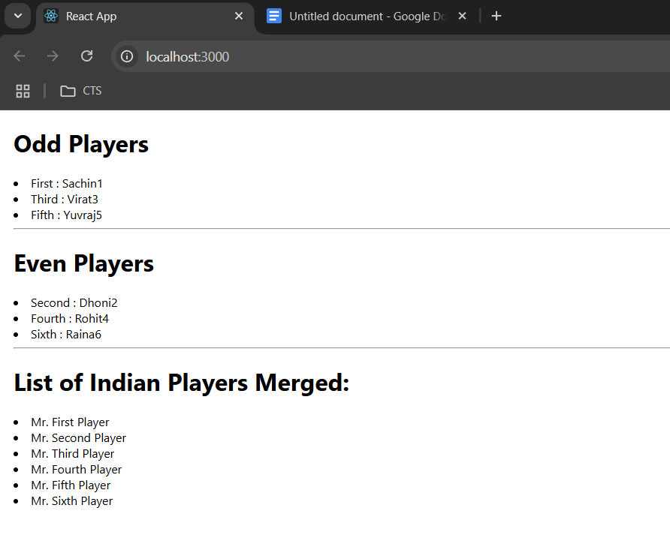

**When Flag=true**

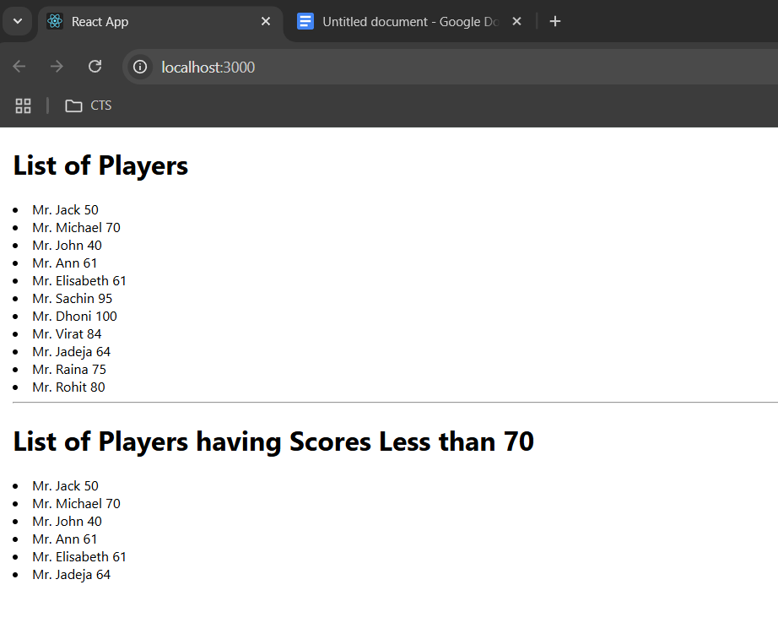

**Exercise-10:**

**Code:**

**App.js**

import React from 'react';

import sr from './office.jpg';

import './App.css';

function App() {

const ItemName = { Name: "DBS", Rent: 50000, Address: 'Chennai' };

let colors = [];

if (ItemName.Rent <= 60000) {

colors.push('textRed');

} else {

colors.push('textGreen');

}

const element = "Office Space";

const jsxatt = <img src={sr} width="25%" height="25%" alt="Office Space" />;

return (

<div>

<h1>{element} , at Affordable Range</h1>

{jsxatt}

<h1>Name: {ItemName.Name}</h1>

<h3 className={colors.join(' ')}>Rent: Rs. {ItemName.Rent}</h3>

<h3>Address: {ItemName.Address}</h3>

</div>

);

}

export default App;

**App.css**

.textRed {

color: red;

}

.textGreen {

color: green;

}

body {

margin-left: 330px;

margin-top: 50px;

}

**Output:**

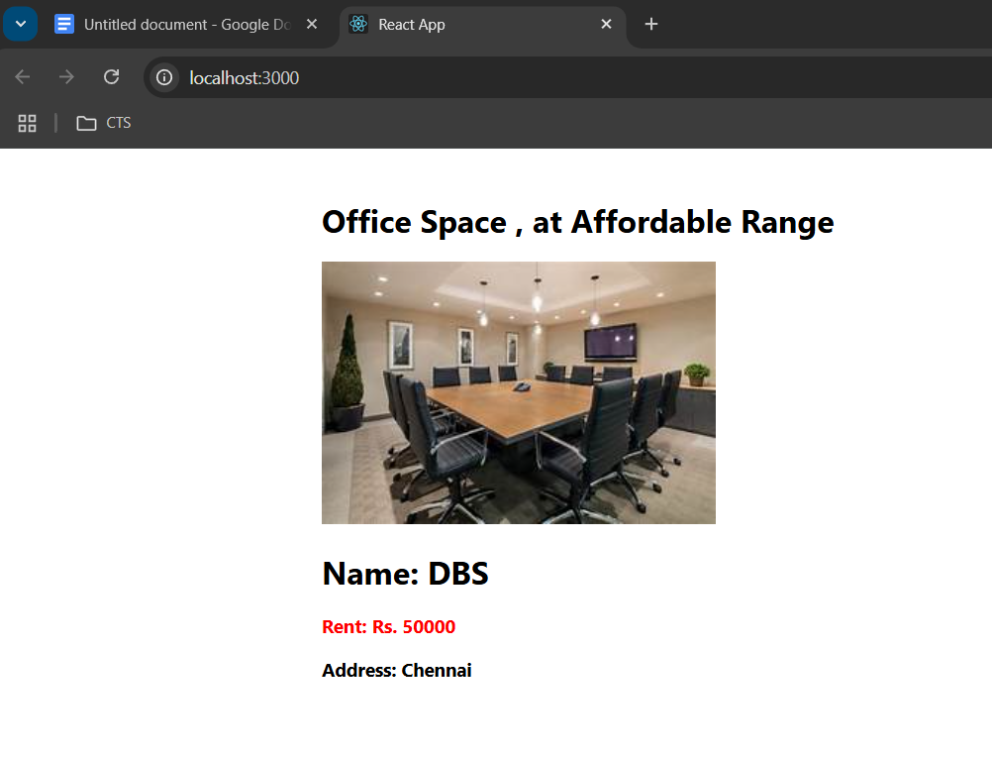

**Exercise-11:**

**Code:**

[App.js](http://app.js)  
  
import React, { useState } from "react";

import "./App.css";

function App() {

const [count, setCount] = useState(5);

const [amount, setAmount] = useState("");

const [currency, setCurrency] = useState("");

const incrementCounter = () => {

setCount(count + 1);

};

const sayHello = () => {

alert("Hello! Member1");

};

const handleIncrementClick = () => {

incrementCounter();

sayHello();

};

const decrementCounter = () => {

setCount(count - 1);

};

const sayWelcome = (msg) => {

alert(msg);

};

const clickMessage = (e) => {

e.preventDefault();

alert("I was clicked");

};

const handleSubmit = (e) => {

e.preventDefault();

if (currency.toLowerCase() === "euro") {

const euroRate = 80;

const converted = amount * euroRate;

alert(`Converting to ${currency} Amount is ${converted}`);

} else {

alert("Please enter Euro as currency");

}

};

return (

<div style={{ padding: "20px" }}>

<h2>{count}</h2>

<div className="button-group">

<button onClick={handleIncrementClick}>Increment</button>

<button onClick={decrementCounter}>Decrement</button>

<button onClick={() => sayWelcome("welcome")}>Say welcome</button>

<button onClick={clickMessage}>Click on me</button>

</div>

<h1 style={{ color: "green" }}>Currency Convertor!!!</h1>

<form className="form-container" onSubmit={handleSubmit}>

<div className="form-group">

<label>Amount:</label>

<input

type="number"

value={amount}

onChange={(e) => setAmount(e.target.value)}

/>

</div>

<div className="form-group">

<label>Currency:</label>

<textarea

rows="3"

value={currency}

onChange={(e) => setCurrency(e.target.value)}

></textarea>

</div>

<div className="submit-container">

<button type="submit">Submit</button>

</div>

</form>

</div>

);

}

export default App;

**App.css**

h1 {

font-family: Arial, sans-serif;

font-weight: bold;

}

button {

padding: 5px 10px;

}

.button-group {

display: flex;

flex-direction: column;

align-items: flex-start;

gap: 5px;

margin-bottom: 15px;

}

.form-container {

display: flex;

flex-direction: column;

align-items: flex-start;

}

.form-group {

display: flex;

align-items: center;

margin-bottom: 10px;

}

.form-group label {

width: 80px;

}

.form-group input,

.form-group textarea {

padding: 4px;

width: 200px;

}

.form-group textarea {

resize: none;

}

.submit-container {

display: flex;

justify-content: center;

width: calc(80px + 200px);

}

**Output**

**When “increment” button is clicked:**

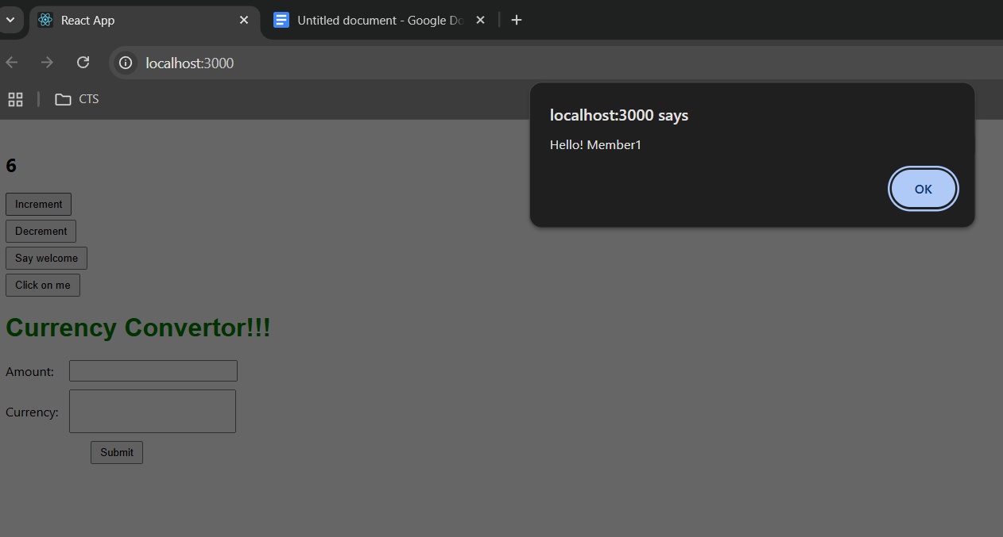

**When “Say welcome” button is clicked:**

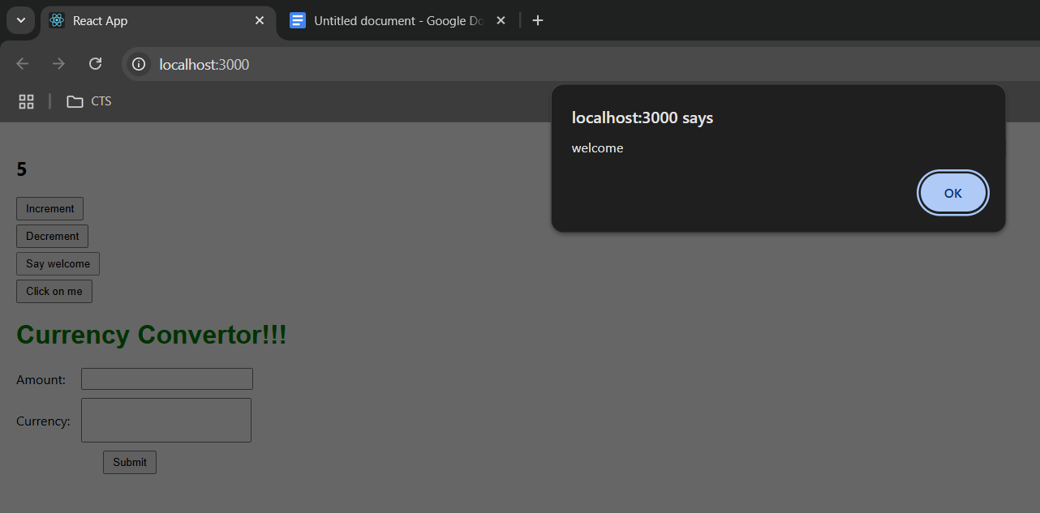

**When “Click on me” button is clicked:**

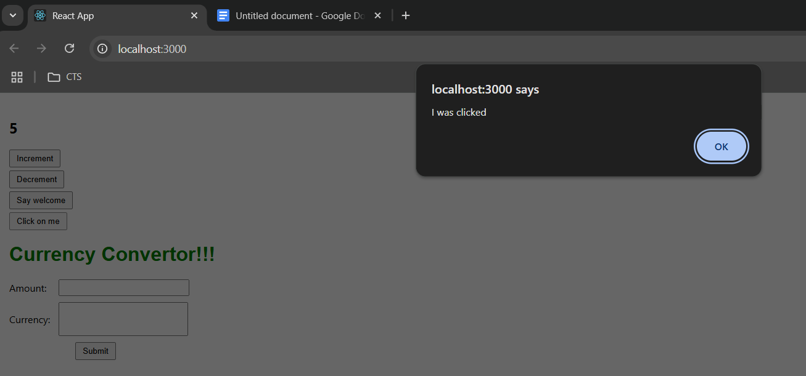

**Currency convertor result:**

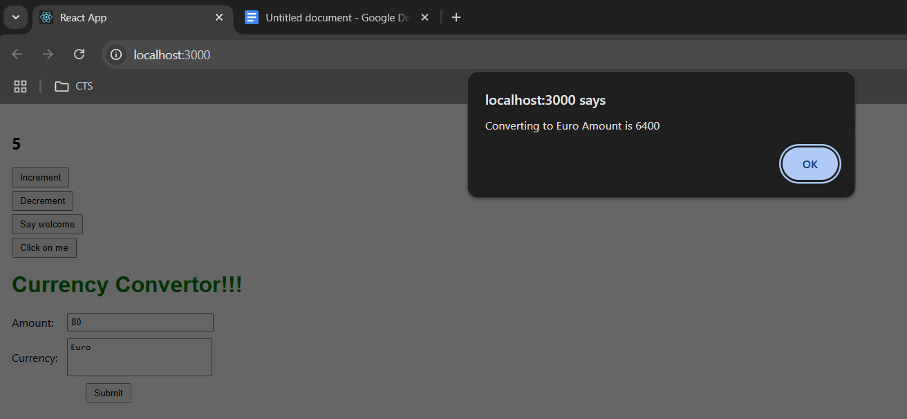

**Exercise-12:**

**Code:**

[App.js](http://app.js)

import React, { useState } from 'react';

import './App.css';

function LoginButton(props) {

return (

<button onClick={props.onClick}>

Login

</button>

);

}

function LogoutButton(props) {

return (

<button onClick={props.onClick}>

Logout

</button>

);

}

function UserGreeting() {

return <h1>Welcome back</h1>;

}

function GuestGreeting() {

return <h1>Please sign up.</h1>;

}

function Greeting(props) {

const isLoggedIn = props.isLoggedIn;

if (isLoggedIn) {

return <UserGreeting />;

}

return <GuestGreeting />;

}

function App() {

const [isLoggedIn, setIsLoggedIn] = useState(false);

const handleLoginClick = () => {

setIsLoggedIn(true);

};

const handleLogoutClick = () => {

setIsLoggedIn(false);

};

let button;

if (isLoggedIn) {

button = <LogoutButton onClick={handleLogoutClick} />;

} else {

button = <LoginButton onClick={handleLoginClick} />;

}

return (

<div className="App">

<Greeting isLoggedIn={isLoggedIn} />

{button}

</div>

);

}

export default App;

**App.css**

.App {

text-align: left;

margin-top: 100px;

margin-left: 200px;

}

button {

margin-top: 10px;

padding: 5px 10px;

cursor: pointer;

}

**Output**

**User Page**

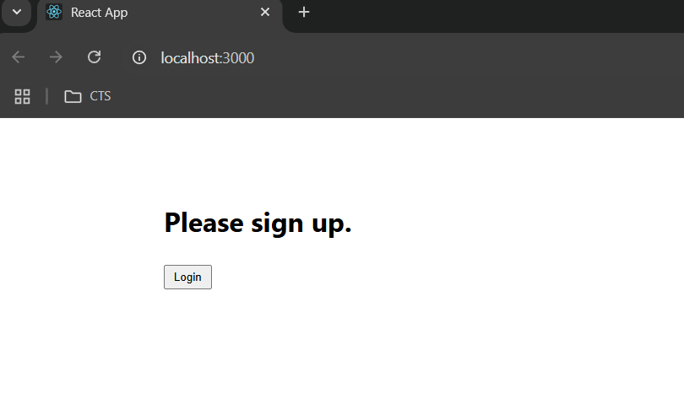

**Guest Page**

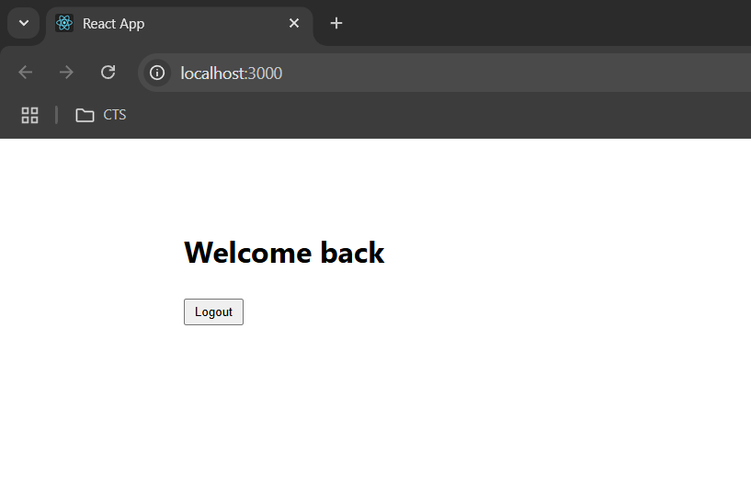

**Exercise-13:**

**Code:**

**blogs.js**

export const blogs = [

{ title: "React Learning", author: "Stephen Biz", content: "Welcome to learning React!" },

{ title: "Installation", author: "Schwezdenier", content: "You can install React from npm." }

];

**books.js**

export const books = [

{ id: 101, bname: "Master React", price: 670 },

{ id: 102, bname: "Deep Dive into Angular 11", price: 800 },

{ id: 103, bname: "Mongo Essentials", price: 450 }

];

**courses.js**

export const courses = [

{ cname: "Angular", date: "4/5/2021" },

{ cname: "React", date: "6/3/2020" }

];

**[App.js](http://app.js)**

import React from 'react';

import './App.css';

import { books } from './data/books';

import { blogs } from './data/blogs';

import { courses } from './data/courses';

function App() {

const showBooks = true;

const showBlogs = true;

const showCourses = true;

const bookdet = (

<ul>

{showBooks && books.map((book) => (

<div key={book.id}>

<h3>{book.bname}</h3>

<h4>{book.price}</h4>

</div>

))}

</ul>

);

let content;

if (showBlogs) {

content = blogs.map((blog, index) => (

<div key={index}>

<h2>{blog.title}</h2>

<h4>{blog.author}</h4>

<p>{blog.content}</p>

</div>

));

} else {

content = <p>No Blogs Available</p>;

}

const coursedet = showCourses ? (

courses.map((course, index) => (

<div key={index}>

<h2>{course.cname}</h2>

<p1>{course.date}</p1>

</div>

))

) : (

<p>No Courses Available</p>

);

return (

<div className="container">

<div className="mystyle1">

<h1>Course Details</h1>

{coursedet}

</div>

<div className="st2">

<h1>Book Details</h1>

{bookdet}

</div>

<div className="v1">

<h1>Blog Details</h1>

{content}

</div>

</div>

);

}

export default App;

**App.css**

.container {

display: flex;

margin-left: 70px;

gap: 30px;

margin-top: 70px;

}

.st2, .mystyle1 {

border-right: 4px solid green;

padding-right: 20px;

min-width: 250px;

}

.v1 {

padding-right: 20px;

min-width: 250px;

}

h1 {

font-weight: bold;

}

h2, h3, h4, p1{

font-weight: bold;

}

p {

margin: 0;

}

ul {

list-style-type: none;

padding: 0;

margin-left: 50px;

}

**Output**

