**WEEK-8**

**GIT**

**Exercise:1**

**Set up my machine with Git Configuration and integrated notepad++.exe to Git and made it a default editor.**

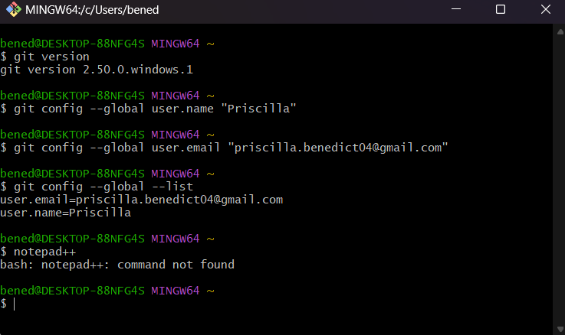

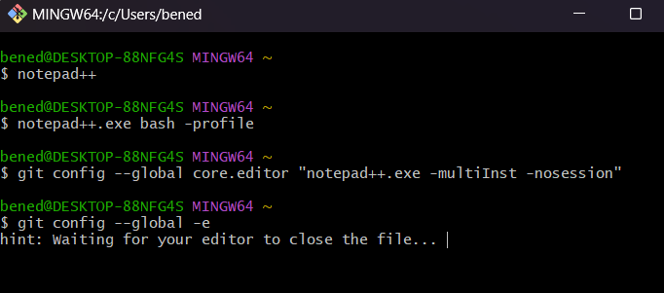

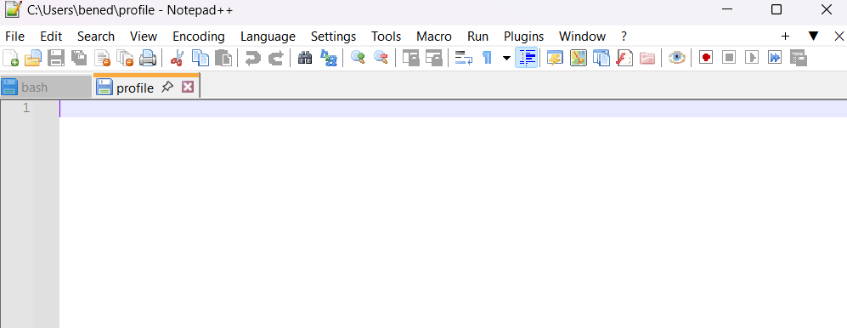

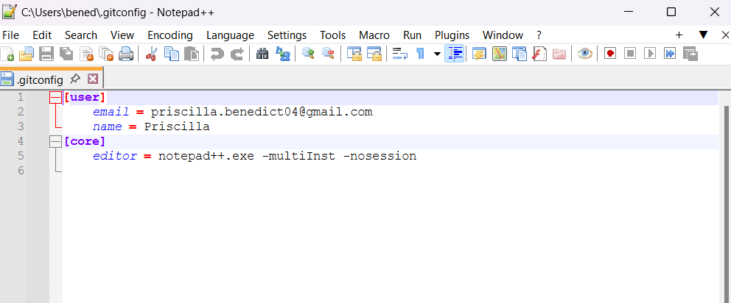

**Added a file to source code repository**

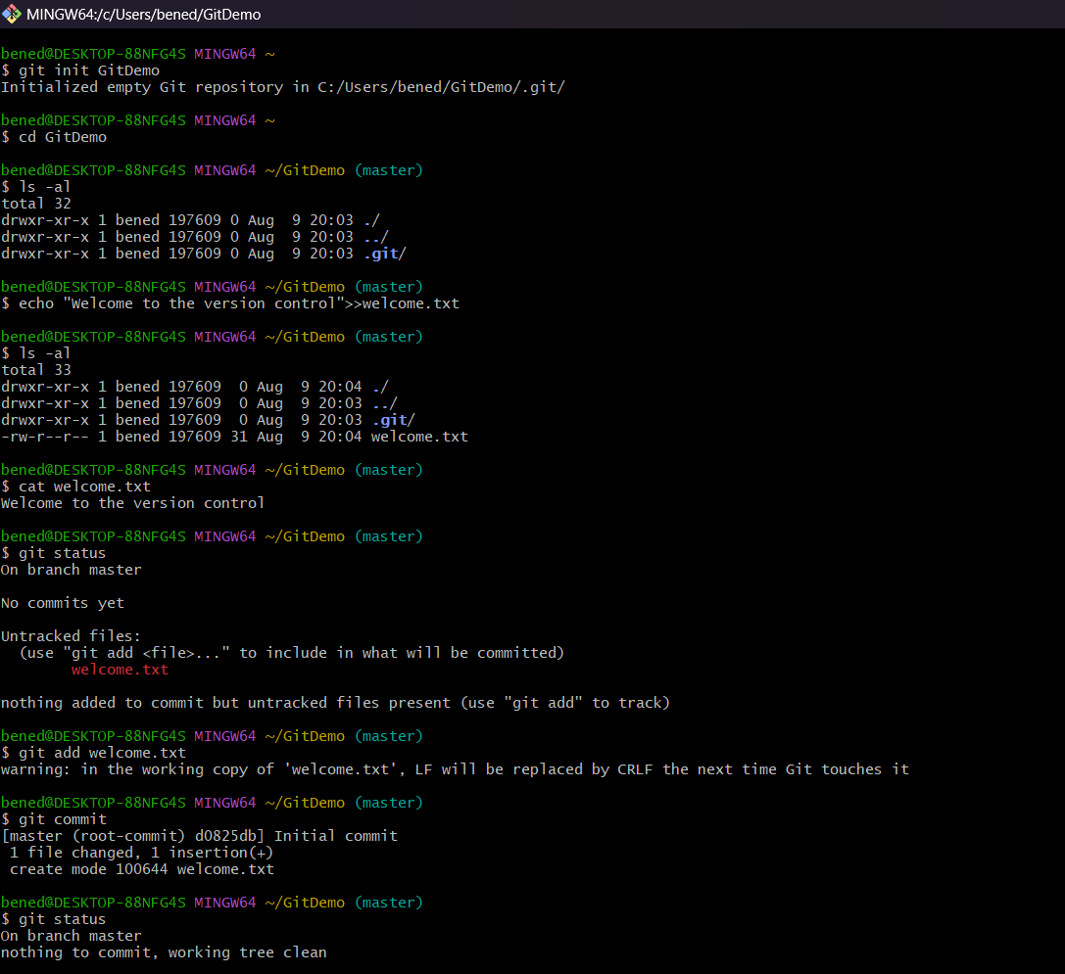

**Signed Up with GitLab and created a remote repository “GitDemo”**

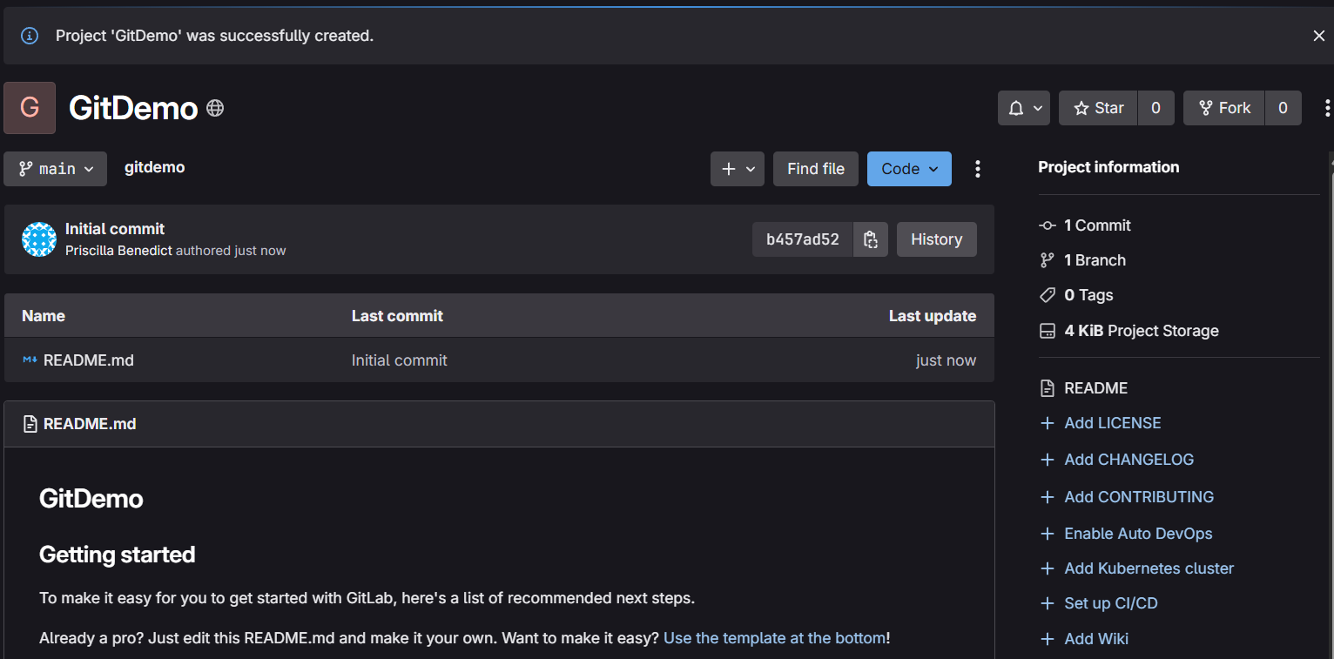

**Pushed the local to remote repository**

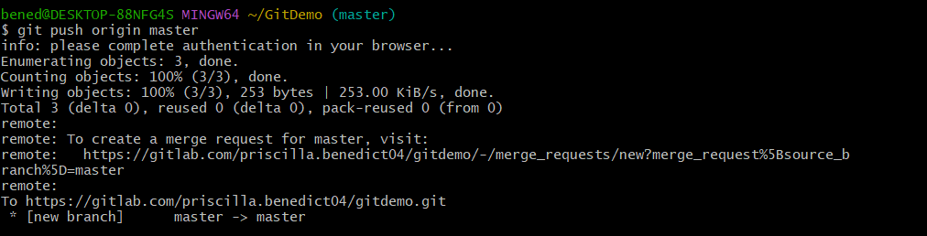

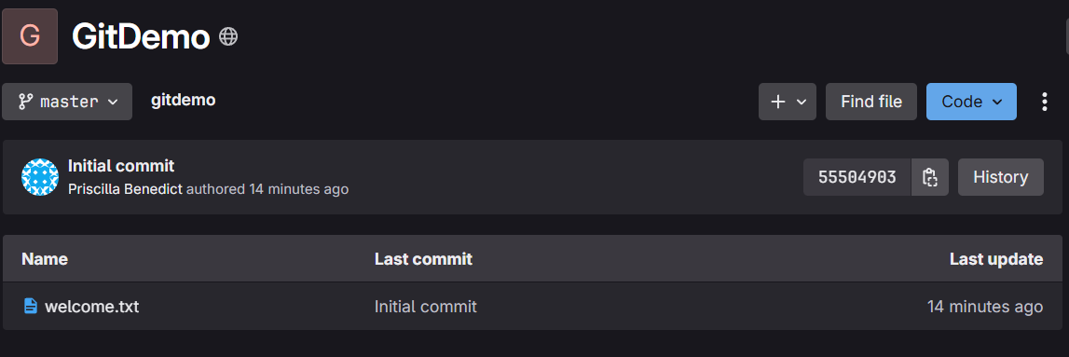

**Pulled the remote repository**

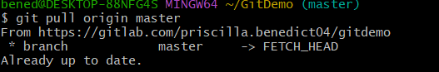

**Exercise:2**

**Created .log file and log folder in the working directory of Git and updated .gitignore file**

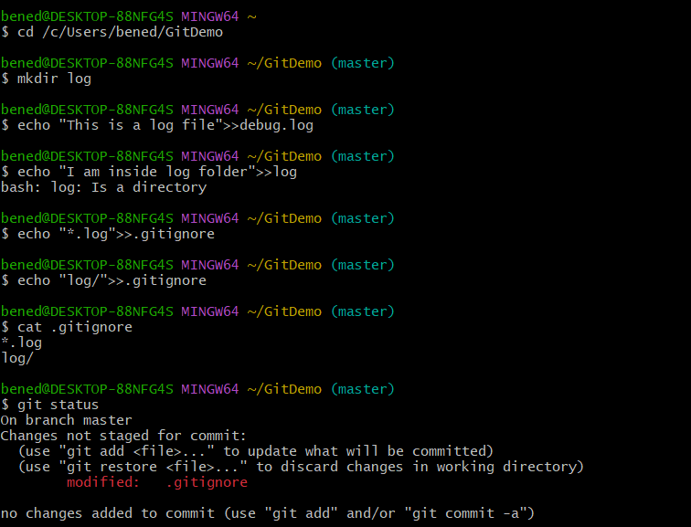

**.log extensions and log folder were ignored**

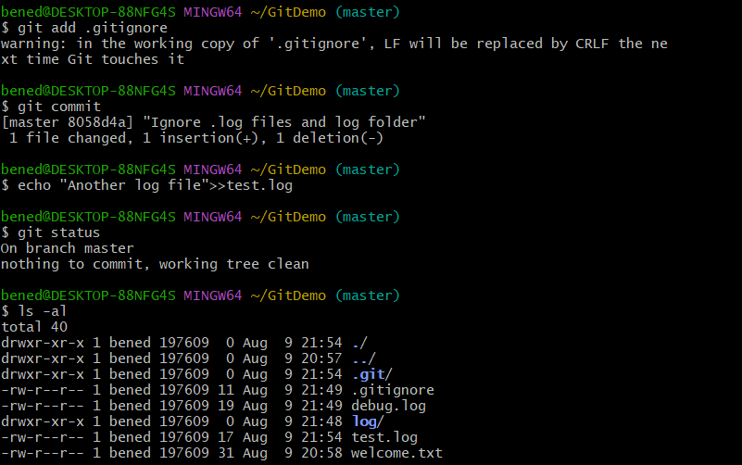

**Git status reflects the same about working directory, local repository and git repository.**

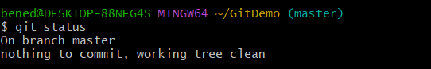

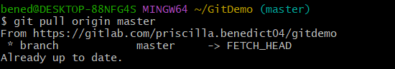

**Exercise:3**

**Branching:**

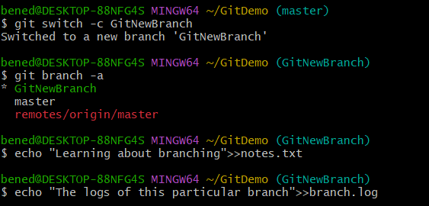

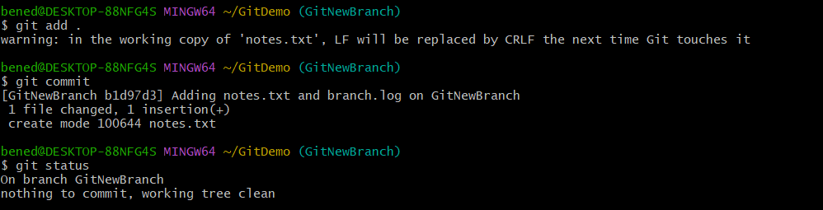

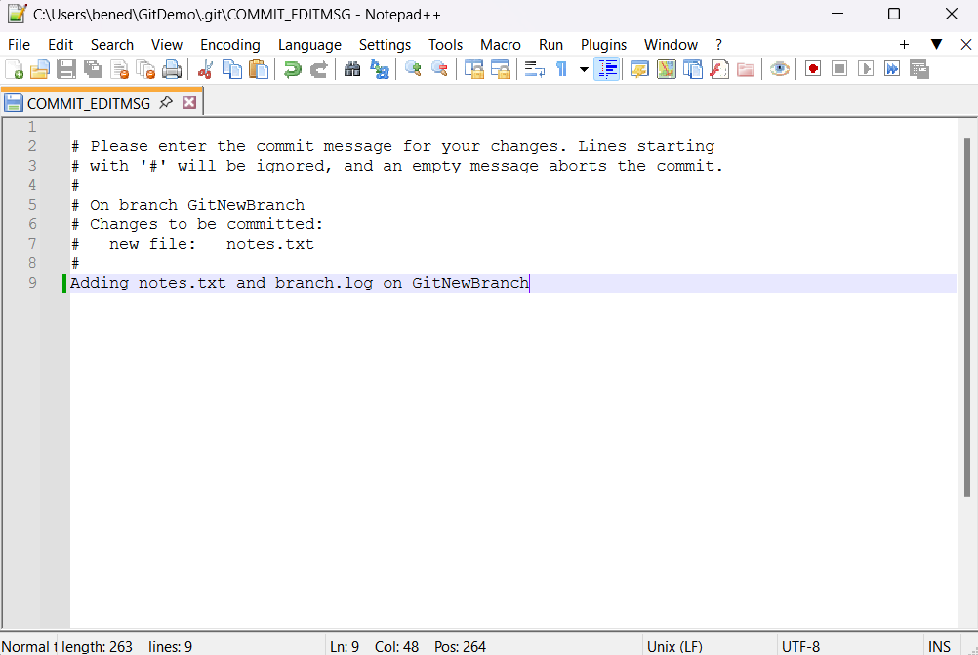

**Merging:**

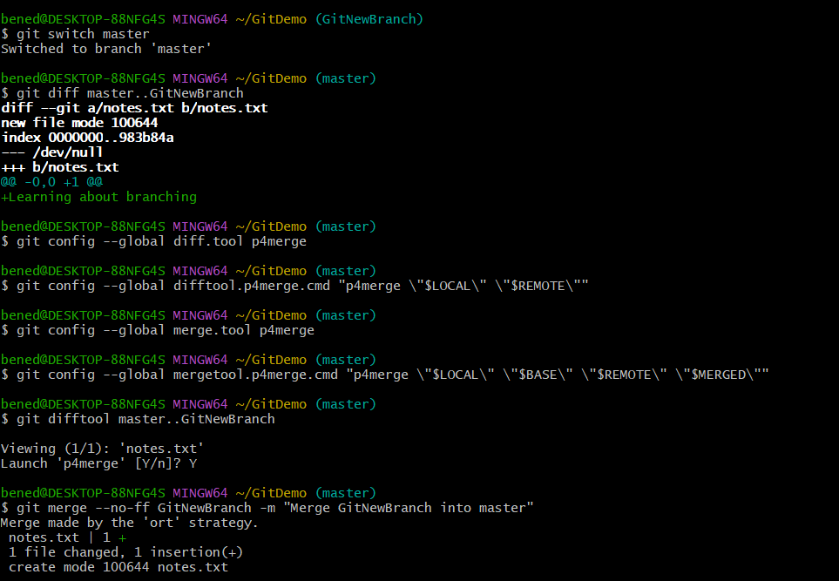

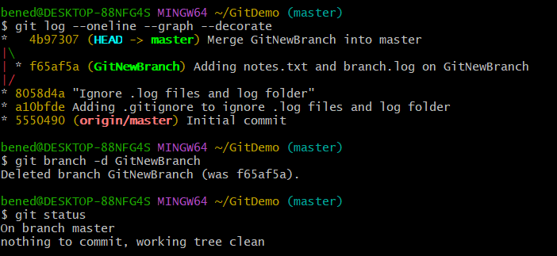

**Exercise:4**

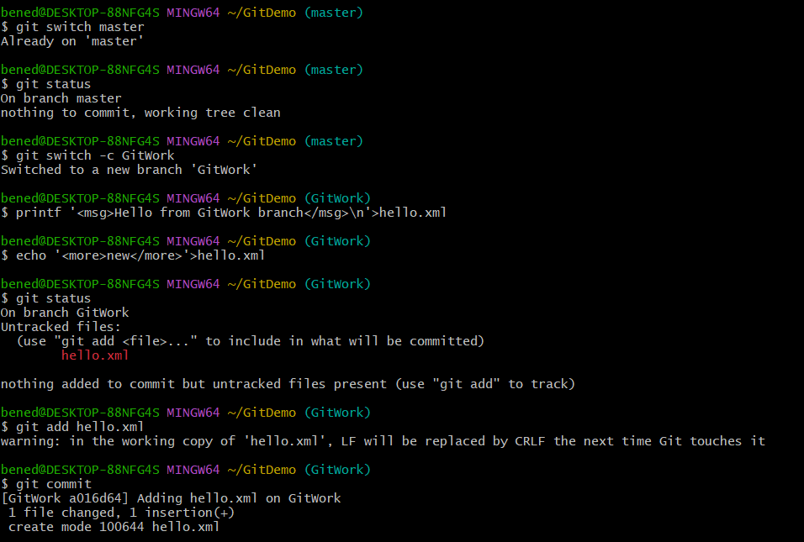

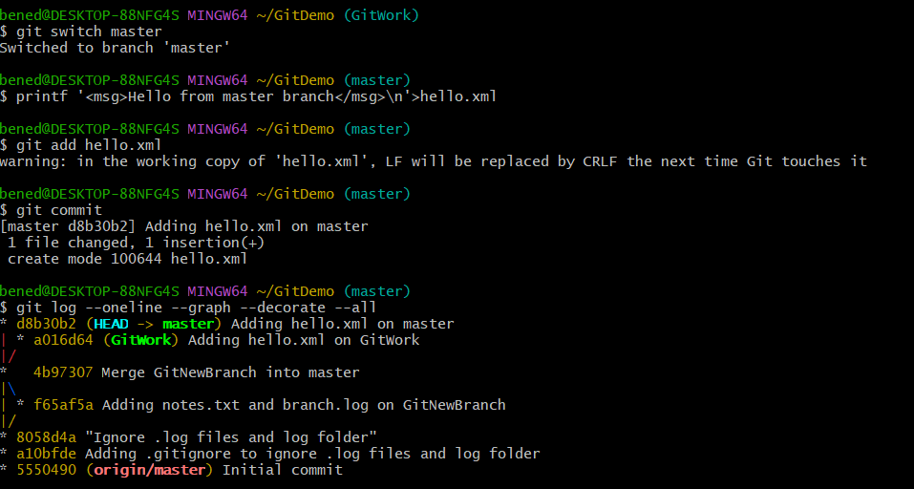

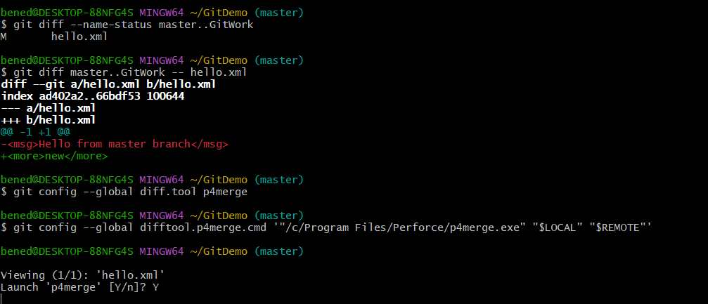

**Visualisation using P4Merge tool**

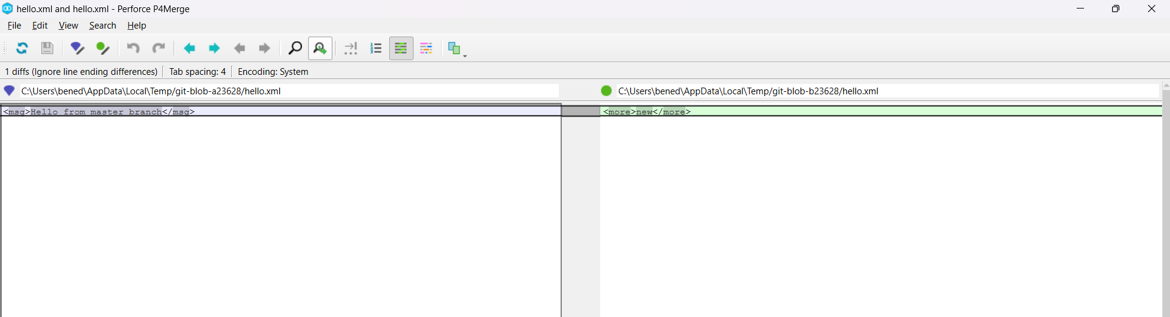

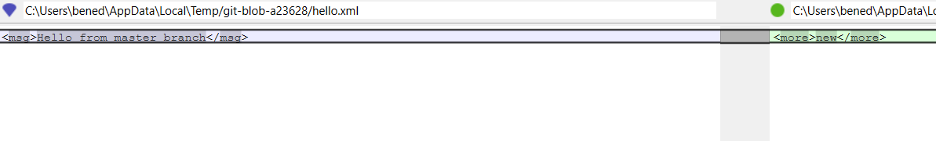

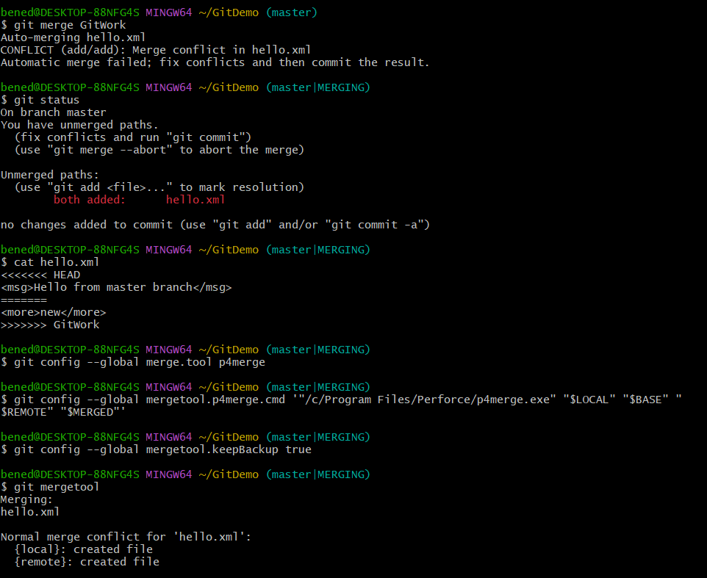

**Used 3-way merge tool to resolve the conflict**

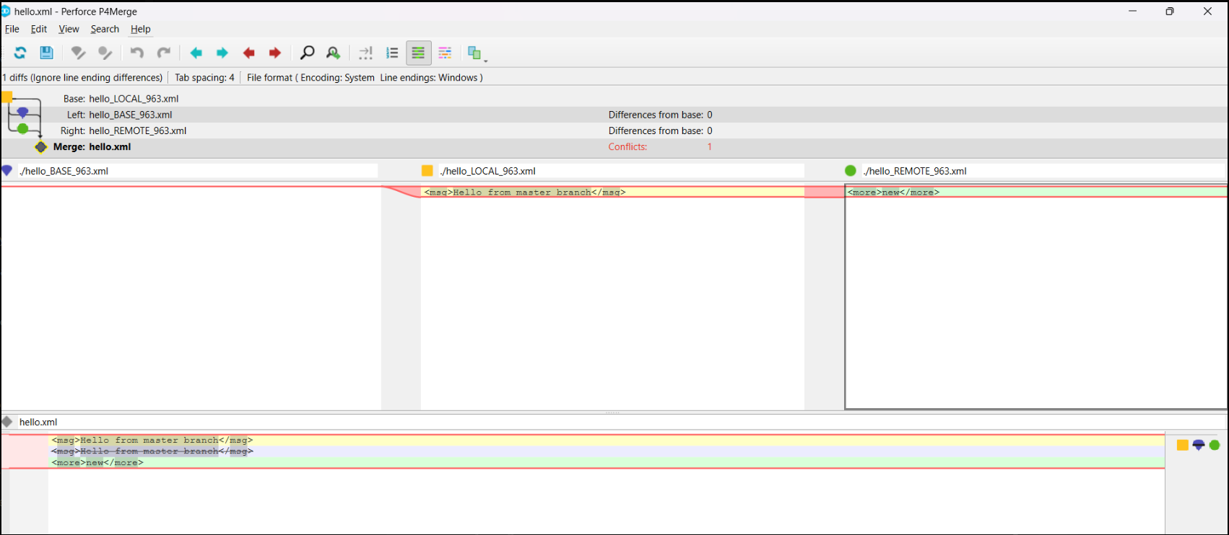

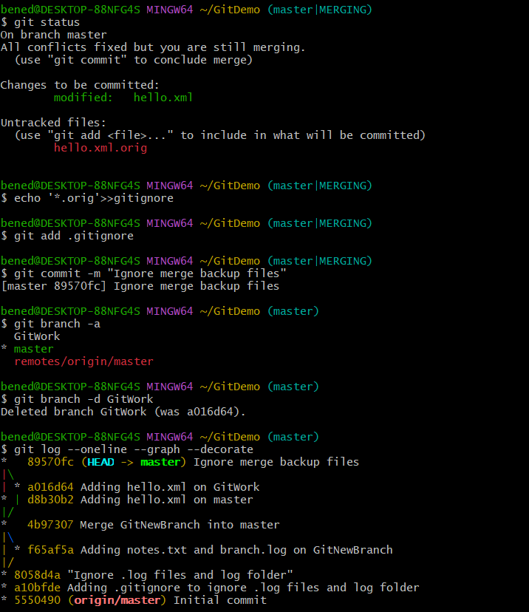

**Exercise:5**

**Verified if master is in clean state**

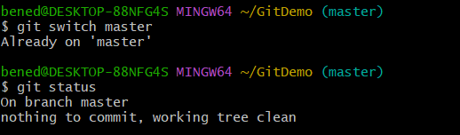

**Listed out all the available branches and pulled the remote git repository to the master**

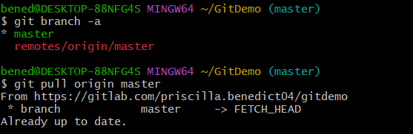

**Pushed the changes, which are pending from “Git-T03-HOL_002” to the remote repository**

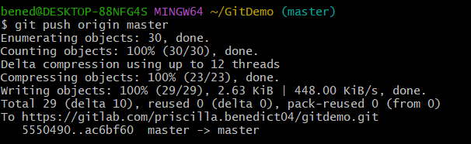

**Observed that the changes are reflected in the remote repository.**

