WDD330: Final Web Application Proposal

StrideMap
Overview
StrideMap is a web application designed to help runners track their running activity, explore new running routes and also improve their performance through guided videos.
The problem I am trying to solve is the lack of a simple all-in-one app that combines run tracking, route visualization, and training videos in one place. As a beginner runner, I use multiple apps for maps and workouts which I find to be inconvenient and disorganized.
In other words, this project is a simple all in one app for those who are interested in running.
Target Audience
- Beginners
- Advanced runners
- Anyone who wants a simple app to track runs and find new routes (I find it quite fun to use different routes every time I go for a run, you never get bored)
Major functions
- Log runs: so, users can save their runs ( the distance, time, date, how they feel, among others)
- View their run history: they will be able to see a list of their previous runs ( I am also considering adding a “progress bar” or a graphic so they can visualize their progress, I am also considering adding “streaks”)
- Generate routes: usars would be able to create or view running routes on the app. They can ask for a new one
- if they do not like the one created, they will be able to choose how much they can or want to run
- Map display: the app will show routes using a map.
- Watch running videos: they will be able to watch videos about running techniques, experiences, inspiration, empowering, or even call to action videos for those who are losing motivation, among many others
- Warm up and stretching videos
- Basic stats: I will also add the total runs and distance so they can visualize their progress
- Responsive design: I want this app to work on both desktop and mobile so they can always check the app
- Genre Friendly: I would love to make it useful and likeable to both genres, feminine and masculine, Ill make sure to use colors that can be use by both.
Wireframe
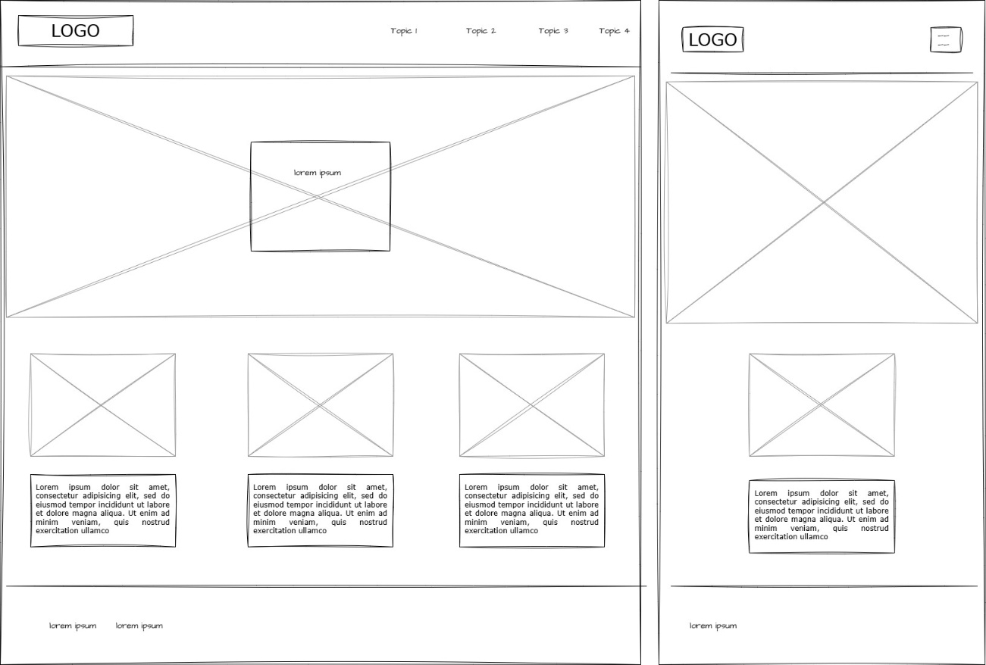
External data
- Mapbox API (for maps nd routes)
- Youtube Data API (for the videos)
Data storage
Local Storage: is used to store logged runs, users preferences, recently view routes or videos, among others.
Modules
- UI module: handles layout, pages and visual components.
- Map module: Integrates the mapbox and manages route rendering.
- API module: fetches videos data from YouTube api.
- Run management module: handles adding, editing, and displaying runs.
- Data storage module: in simple words, it saves the data.
- Event handling module handles the user interactions like clicks, map, buttons, forms, among others.
Design
- Colors: (I haven’t decided the palette yet, but it might be one of these one’s)
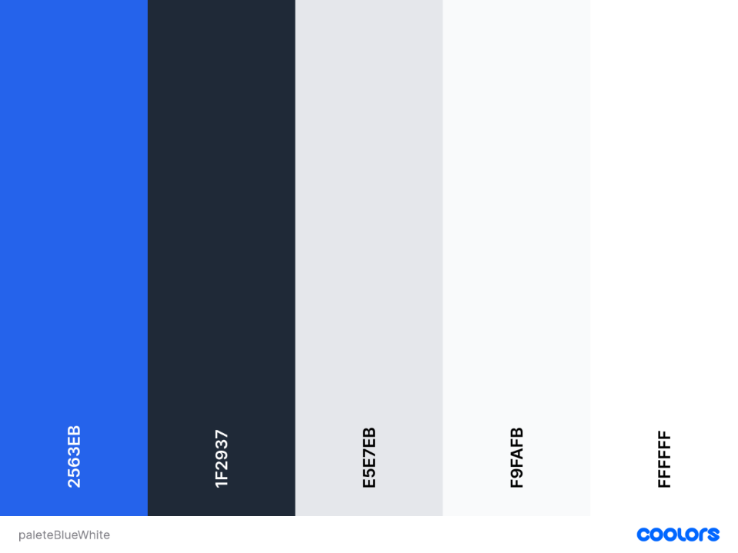
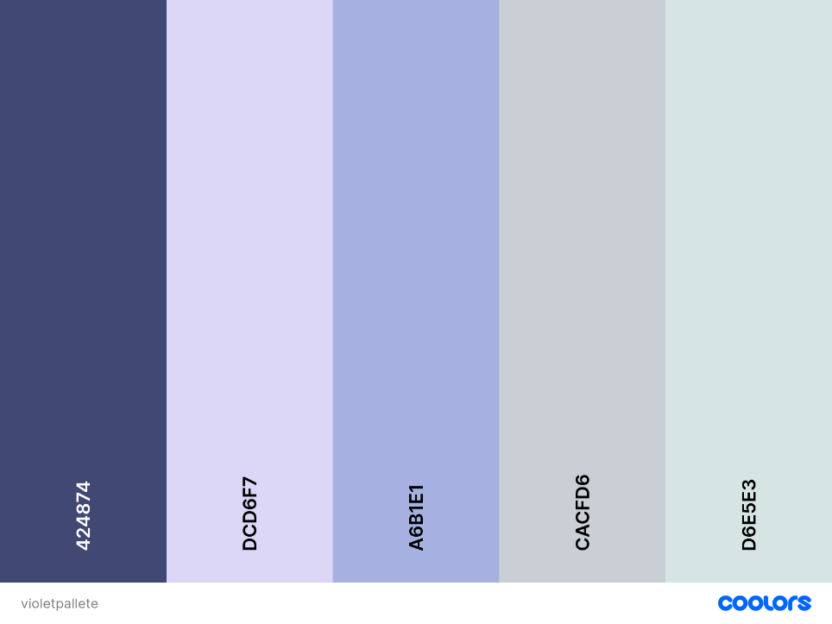
- Fonts:
- Titles: poppins or Passion One
- Text: Open sains
- Icon: I was thinking about something simple like a running shoe or a map pin with a path
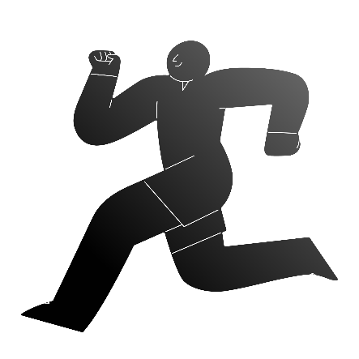
Timeline
- WEEK 5
- Create HTML pages
- Add basic CSS
- Add Mapbox and display basic map
- WEEK 6
- Add run tracking
- Store and display the run data (local storage)
- Add Youtube API and display videos
- WEEK 7
- Add route generation feature
- Improve design
- Testing and bug fixes
- If I have time, add the streaks or something else
- Submit project
Project planning (Trello link): https://trello.com/invite/b/69a71faf1651a20de1a029c0/ATTI10e4d406610e8f5e8117a07f7f2c5cd2E7767E52/wdd330-stridemap

