Priscilla Wong - Lab 8
PART 1:
- Create a table named courses. It should contain
crn (int 11, primary key)
prefix (varchar 4, not null)
number (smallint 4, not null)
title (varchar 255, not null)
collate should be utf8_unicode_ci
SQL Command:
CREATE TABLE courses (
crn INT(11) PRIMARY KEY,
prefix VARCHAR(4) NOT NULL,
number SMALLINT(4) NOT NULL,
title VARCHAR(255) NOT NULL
)
COLLATE = utf8_unicode_ci;
Output:
MySQL returned an empty result set (i.e. zero rows). (Query took 0.0059 seconds.)
- Create a table named students. It should contain
rin (int 9, primary key)
rcsID (char 7)
first name (varchar 100, not null)
last name (varchar 100, not null)
alias (varchar 100, not null)
phone (int 10)
collate should be utf8_unicode_ci
SQL Command:
CREATE TABLE students (
rin INT(9) PRIMARY KEY,
rcsID CHAR(7) NOT NULL,
first_name VARCHAR(100) NOT NULL,
last_name VARCHAR(100) NOT NULL,
alias VARCHAR(100) NOT NULL,
phone INT (10)
)
COLLATE = utf8_unicode_ci;
Output:
MySQL returned an empty result set (i.e. zero rows). (Query took 0.0095 seconds.)

PART 2:
- Add address fields (street, city, state, zip) to the students table
SQL Command:
ALTER TABLE students
ADD COLUMN street VARCHAR(255),
ADD COLUMN city VARCHAR(100),
ADD COLUMN state CHAR(2),
ADD COLUMN zip CHAR(10);
Output:
MySQL returned an empty result set (i.e. zero rows). (Query took 0.0077 seconds.)
- Add section and year fields to the courses table
SQL Command:
ALTER TABLE courses
ADD COLUMN section VARCHAR(10),
ADD COLUMN year YEAR;
Output:
MySQL returned an empty result set (i.e. zero rows). (Query took 0.0082 seconds.)
- CREATE a grades table containing
id (int primary key, auto increment)
crn (foreign key)
rin (foreign key)
grade (int 3 not null)
SQL Command:
CREATE TABLE grades (
id INT PRIMARY KEY AUTO_INCREMENT,
crn INT,
rin INT,
grade INT(3) NOT NULL,
FOREIGN KEY (crn) REFERENCES courses(crn),
FOREIGN KEY (rin) REFERENCES students(rin)
)
CHARACTER SET utf8
COLLATE utf8_unicode_ci;
Output:
MySQL returned an empty result set (i.e. zero rows). (Query took 0.0386 seconds.)
- INSERT at least 4 courses into the courses table
SQL Command:
INSERT INTO courses (crn, prefix, number, title, section, year) VALUES
(37514, 'CSCI', 1100, 'Introduction to Computer Science', 1, '2025'),
(37730, 'MATH', 2010, 'Multivar Calculus & Matrix Algebra', 2, '2025'),
(73048, 'ITWS', 2110, 'Web Systems Development', 1, '2025'),
(35797, 'PHYS', 1100, 'Physics I', 2, '2025');
Output:
4 rows inserted. (Query took 0.0016 seconds.)
- INSERT at least 4 students into the students table
SQL Command:
INSERT INTO students (RIN, RCSID, first_name, last_name, alias, phone, street, city, state, zip)
VALUES
(662057099, 'wongp4', 'Priscilla', 'Wong', 'priscilla', 1231231231, '1 College Ave', 'Troy', 'NY', '12180'),
(662057098, 'sitc', 'Courteney', 'Sit', 'courteney', 1231231232, '2 College Ave', 'Troy', 'NY', '12180'),
(662057097, 'spauln', 'Nicole', 'Spaulding', 'nicole', 1231231233, '3 College Ave', 'Troy', 'NY', '12180'),
(662057096, 'siongd', 'Dana', 'Siong Sin', 'dana', 1231231234, '4 College Ave', 'Troy', 'NY', '12180');
Output:
4 rows inserted. (Query took 0.0029 seconds.)
- ADD 10 grades into the grades table
SQL Command:
INSERT INTO grades (crn, RIN, grade)
VALUES
(37514, 662057099, 94),
(37730, 662057098, 88),
(73048, 662057097, 91),
(35797, 662057096, 85),
(37730, 662057099, 82),
(35797, 662057098, 79),
(35797, 662057097, 89),
(37514, 662057096, 94),
(73048, 662057099, 87),
(73048, 662057098, 92);
Output:
10 rows inserted.
Inserted row id: 10 (Query took 0.0057 seconds.)
- list all students in the following sequences; in alphabetical order by rin, last name, RCSid, and firstname
SQL Command:
SELECT * FROM students ORDER BY rin ASC, last_name ASC, rcsID ASC, first_name ASC;
Output:
Showing rows 0 - 3 (4 total, Query took 0.0006 seconds.) [rin: 662057096... - 662057099...] [last_name: SIONG SIN... - WONG...] [rcsID: SIONGD... - WONGP4...] [first_name: DANA... - PRISCILLA...]
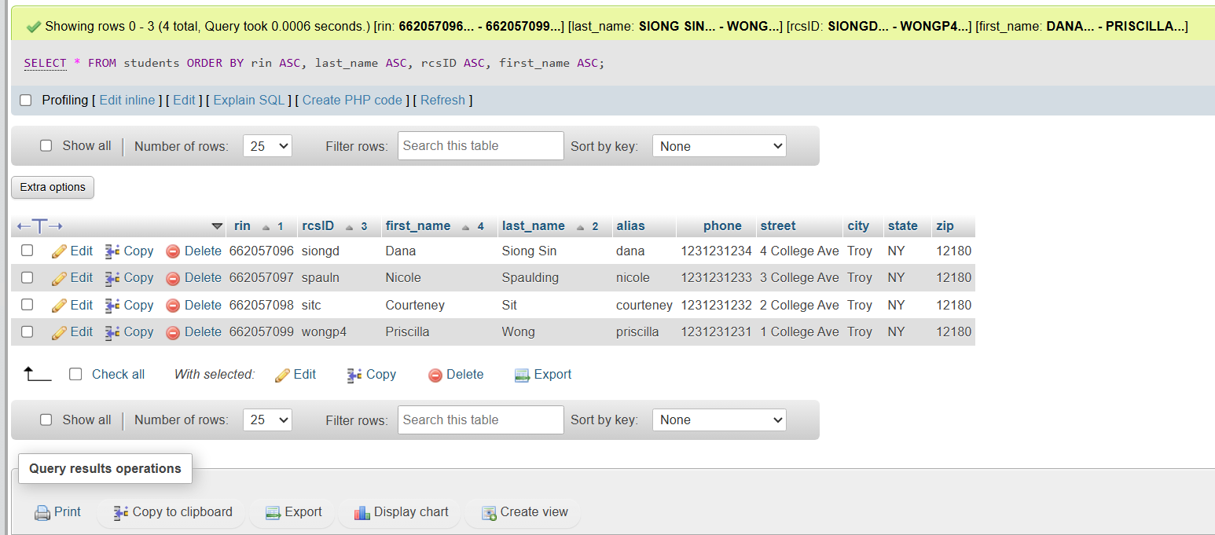
- list all students rin, name and address if their grade in any course was higher than a 90
SQL Command:
SELECT DISTINCT s.rin, s.first_name, s.last_name, s.street, s.city, s.state, s.zip
FROM students s
JOIN grades g ON s.RIN = g.RIN
WHERE g.grade > 90;
Output:
Showing rows 0 - 3 (4 total, Query took 0.0008 seconds.)
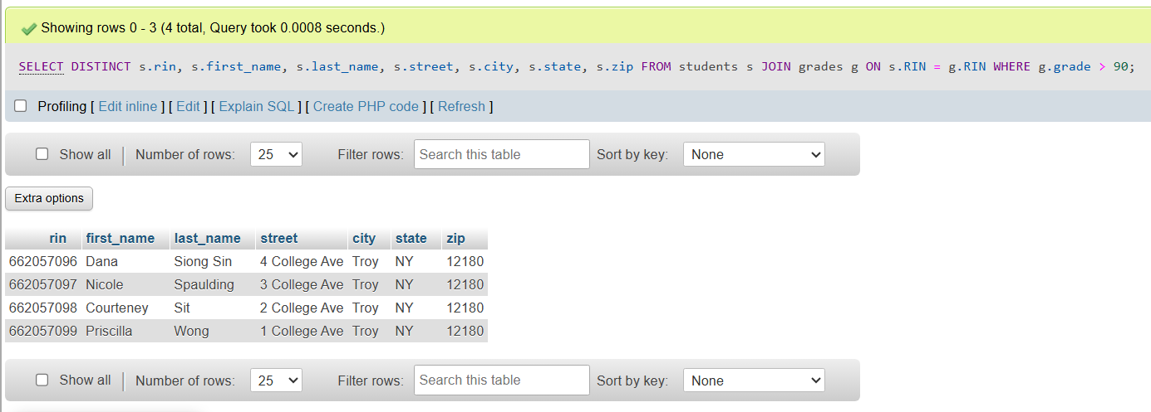
- list out the average grade in each course
SQL Command:
SELECT c.title, AVG(g.grade) AS average_grade
FROM grades g
JOIN courses c ON g.crn = c.crn
GROUP BY c.crn;
Output:
Showing rows 0 - 3 (4 total, Query took 0.0006 seconds.)
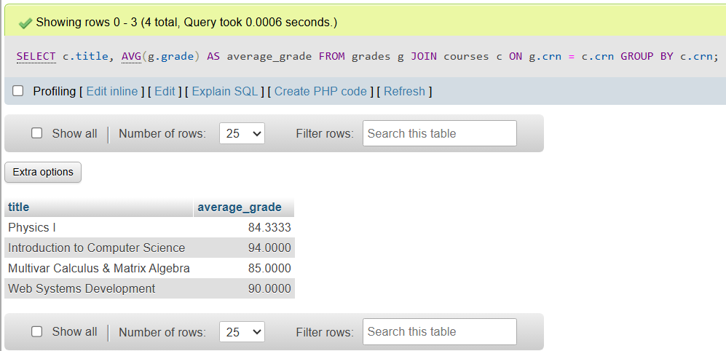
- list out the number of students in each course
SQL Command:
SELECT c.title, COUNT(DISTINCT g.rin) AS num_students
FROM grades g
JOIN courses c ON g.crn = c.crn
GROUP BY c.crn;
Output:
Showing rows 0 - 3 (4 total, Query took 0.0007 seconds.)
