Cross-sell intelligence
LOB penetration, whitespace identification & market basket analysis

Working document for global Sales Operations
Data source: PAS Gold Layer (Fabric)
Status: Directional — built for speed, refined over time
Last updated: April 2026

Strategic context
This analysis is built from PAS data transformed into a dedicated Gold Layer in Microsoft Fabric. The intent is speed and direction — not perfection. If the numbers are even directionally correct, the opportunity is too large to ignore.

The core thesis: the majority of our clients are significantly under-penetrated. Growth does not require finding new clients — it requires doing more with the clients who already trust us.

This document covers three layers of analysis, each building on the last:
- Headline metrics — the numbers that get attention in a room
- Dashboard design — how to visualise penetration, risk, and whitespace
- Market basket analysis — product bundles and gap identification at scale, powered by PySpark

Headline metrics
The following metrics are designed to land with senior stakeholders. Each one reframes the cross-sell conversation from aspiration to evidence.

LOB penetration distribution
The single most powerful number: what percentage of clients have 2 or fewer lines of business? If the answer is 80%, the room should be uncomfortable. This is not a data point — it is a strategic indictment of under-penetration.

Revenue step-function by LOB count
Average revenue per client, segmented by number of LOBs held. If clients with 3+ LOBs generate 3–4x the revenue of single-LOB clients, that is not a cross-sell argument — it is an economic model. Every additional LOB added to an existing client is worth $X on average.

Metric | What it tells you | Why it lands
LOB penetration distribution | % of clients at 1, 2, 3, 4, 5, 6+ LOBs | Makes under-penetration visceral
Avg revenue by LOB count | Revenue step-function as LOBs increase | Turns cross-sell into an economic model
Revenue concentration risk | % of total brokerage from single-LOB clients | Reframes as retention risk
LOB penetration by tier | Avg LOBs for top 50 / top 100 clients | Sharpest whitespace if largest clients are under-penetrated
Marginal revenue per LOB | Revenue delta from 1→2 vs 2→3 vs 3→4 | Shapes where to focus effort
Lonely LOB distribution | Which products most often appear as only LOB | Tells practice groups where retention exposure lives
Product pair frequency | Which LOB combinations co-occur most often | Reveals natural bundles

Dashboard design
The dashboard tells a story in layers: headline shock, structural diagnosis, then actionable whitespace. Below is the target layout with illustrative data.

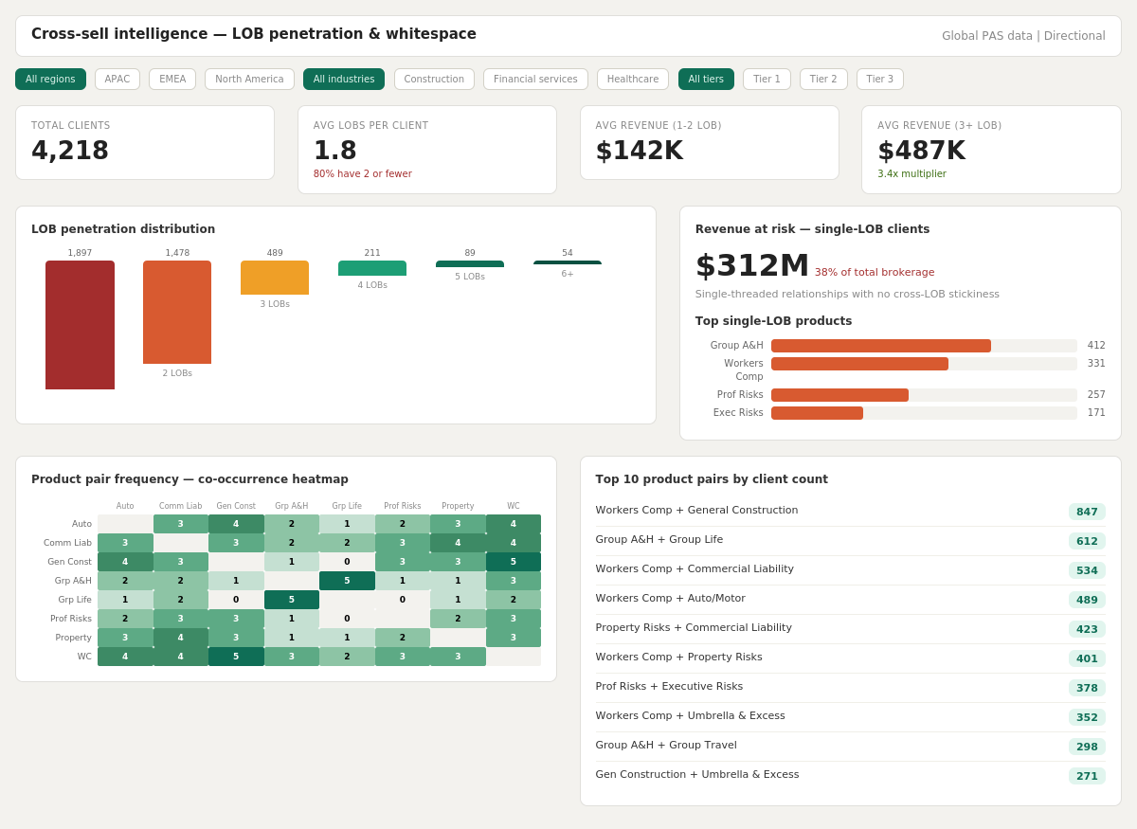

Figure 1: Dashboard mockup — Cross-sell intelligence (illustrative data)

Layout breakdown
Section | Position | Content | Purpose
Metric cards | Top row | Total clients, Avg LOBs, Avg revenue by bucket | Headline numbers that frame the problem
LOB distribution | Mid-left | Bar chart by LOB bucket | Visual proof of under-penetration skew
Revenue at risk | Mid-right | Single-LOB revenue + lonely LOB bars | Retention risk framing
Heatmap | Bottom-left | Product co-occurrence matrix | Natural bundles + sparse whitespace zones
Top pairs list | Bottom-right | Ranked product pairs by client count | Quick-read for non-analytical audiences

Slicer interactions
The power is in the slicers. Toggle to Construction and the entire dashboard reshapes — different product bundles, different risk profile, different whitespace. Toggle to Tier 1 and you are looking at your biggest clients’ gaps. Each view is a different conversation a broker can have next week.

DAX formulas & implementation
All formulas assume a Gold Layer table (PAS_Gold) with: Company, Product, NetBrokerage, NetPremium. Additional columns (Industry, Region, Tier, Broker) enhance segmentation.

Count of products per client
LOB Count =
CALCULATE(
DISTINCTCOUNT( PAS_Gold[Product] ),
ALLEXCEPT( PAS_Gold, PAS_Gold[Company] )
)

Average revenue per client
Avg Revenue Per Client =
AVERAGEX(
VALUES( PAS_Gold[Company] ),
CALCULATE( SUM( PAS_Gold[NetBrokerage] ) )
)

Client LOB count (calculated column)
Client LOB Count =
VAR _Count =
CALCULATE(
DISTINCTCOUNT( PAS_Gold[Product] ),
ALLEXCEPT( PAS_Gold, PAS_Gold[Company] )
)
RETURN _Count

Revenue concentration — single-LOB clients
Single LOB Revenue % =
DIVIDE(
CALCULATE(
SUM( PAS_Gold[NetBrokerage] ),
FILTER(
VALUES( PAS_Gold[Company] ),
CALCULATE( DISTINCTCOUNT( PAS_Gold[Product] ) ) = 1
)
),
SUM( PAS_Gold[NetBrokerage] )
)

Product pair frequency (DAX)
Note: DAX handles pairs but struggles with triplets/quads at scale. For bundle sizes 3+, use PySpark (next section).
ProductPairs =
VAR _Pairs =
GENERATE(
SUMMARIZE( PAS_Gold, PAS_Gold[Company],
PAS_Gold[Product] ),
VAR _CurrentCompany = PAS_Gold[Company]
VAR _CurrentProduct = PAS_Gold[Product]
RETURN
CALCULATETABLE(
DISTINCT( PAS_Gold[Product] ),
PAS_Gold[Company] = _CurrentCompany,
PAS_Gold[Product] > _CurrentProduct
)
)
RETURN _Pairs

Market basket analysis — PySpark
For triplet and quad bundles, computation belongs in the Fabric Gold Layer — a PySpark notebook that pre-computes bundles and writes to gold tables. DAX then reads and presents.

Why PySpark, not DAX
- 20 LOBs = 190 pairs, 1,140 triplets, 4,845 quads
- DAX iterates row-by-row; PySpark distributes across Spark cluster
- Pre-computed gold tables make Power BI fast and simple
- Clean separation: Fabric does combinatorics, Power BI does presentation

Bundle computation
from pyspark.sql import SparkSession
from pyspark.sql.functions import (
collect_set, size, col, explode, lit,
array_sort, concat_ws, count, avg, row_number
)
from pyspark.sql.window import Window
from itertools import combinations

spark = SparkSession.builder.getOrCreate()

# 1. Load Gold Layer PAS data
df = spark.read.format('delta').load(
'abfss://<workspace>@onelake.dfs.fabric.microsoft.com/
<lakehouse>.Lakehouse/Tables/pas_gold'
)

# 2. Build client product sets
client_products = (
df.groupBy('Company')
.agg(
collect_set('Product').alias('products'),
size(collect_set('Product')).alias('lob_count'),
)
)

# 3. UDF for combinations
from pyspark.sql.types import ArrayType, StringType
from pyspark.sql.functions import udf

def generate_combos(products, bundle_size):
if not products or len(products) < bundle_size:
return []
return ['|'.join(c)
for c in combinations(sorted(products),
bundle_size)]

combo_udf = udf(
lambda prods, n: generate_combos(prods, n),
ArrayType(StringType())
)

# 4. Top bundles at each depth
TOP_N = 10
results = []

for bundle_size in [2, 3, 4]:
bundles = (
client_products
.filter(col('lob_count') >= bundle_size)
.withColumn('bundle',
explode(combo_udf(
col('products'), lit(bundle_size))))
.groupBy('bundle')
.agg(count('*').alias('client_count'))
.withColumn('rank', row_number().over(
Window.orderBy(
col('client_count').desc())))
.filter(col('rank') <= TOP_N)
.withColumn('bundle_size',
lit(bundle_size))
)
results.append(bundles)

all_bundles = results[0]
for r in results[1:]:
all_bundles = all_bundles.unionByName(
r, allowMissingColumns=True)

# 5. Write to Gold table
all_bundles.write.format('delta')
.mode('overwrite').save(
'...Tables/gold_product_bundles')

Gap analysis — missing bundle components
Flags clients who partially match a high-frequency bundle but are missing one or more components. This is the actionable cross-sell output.

from pyspark.sql.functions import (
array_except, split
)

top_bundles = (
spark.read.format('delta')
.load('...Tables/gold_product_bundles')
.filter(col('client_count') >= 50)
.select('bundle','bundle_size',
'client_count')
)

gaps = (
client_products
.crossJoin(top_bundles)
.withColumn('bundle_products',
split(col('bundle'), '\\|'))
.withColumn('missing',
array_except(
col('bundle_products'),
col('products')))
.withColumn('missing_count',
size(col('missing')))
.filter(
(col('missing_count') >= 1) &
(col('missing_count') <= 2))
.select('Company', 'bundle',
'bundle_size', 'client_count',
'missing', 'missing_count')
)

gaps.write.format('delta')
.mode('overwrite').save(
'...Tables/gold_crosssell_gaps')

Output tables
Table | Key columns | Use
gold_product_bundles | bundle, bundle_size, client_count, rank | Top 10 bundles at each depth
gold_crosssell_gaps | Company, bundle, missing, missing_count | Clients partially matching a top bundle with specific products missing

Power BI consumes both tables. The bundles table powers ranked lists. The gaps table powers client-level drillthrough: select a client, see which bundles they almost match, and exactly what products are missing.

Execution sequencing

Phase | Deliverable | Audience | Outcome
1 — Headline | Gold layer + penetration metrics + dashboard | Global Sales Ops leadership | Gets attention: under-penetration stat + revenue multiplier
2 — Segmentation | Basket analysis by industry, tier, region | Regional / practice leads | Actionable whitespace by segment
3 — Bundle engine | PySpark bundles + gap analysis tables | Sales Ops + execution teams | Named client recommendations with statistical backing
4 — Execution | Local cross-sell strategy deployment | Brokers / client managers | Specific conversations: Client X should have Product Y

Data quality position
This is PAS data. It is directional. The framing for any stakeholder conversation: “If we are even half right, we are leaving significant revenue on the table.” This disarms the data quality objection before it lands.

Architecture note
This entire analysis is a product of one curated Gold Layer in Microsoft Fabric. No new tools were purchased. No AI was required for the first punch. Deliberate data architecture exposed what was always sitting in the data.

The APAC Loom blueprint — proven in APAC — is the template being applied here. The cross-sell dashboard is the first visible proof that architecture produces business outcomes at global scale.

Future phases (graph-based relationship analysis, agentic cross-sell recommendations) depend on getting this Gold Layer foundation right first. The architecture enables what comes next.

