**DBS PROJECT REPORT**

**PERSONAL HEALTH RECORD**

**(PHR) SYSTEM:**

**GROUP 11**

**CS F212**

**BITS PILANI**

17-04-2024

**Problem Description:**

In today's fast-paced world, individuals often find it challenging to keep track of their health information. This includes doctor visits, medications, lab results, vaccinations, and even personal health trends like menstruation cycles. Having a centralized, user-controlled platform for storing health records can greatly alleviate this issue. It provides users with a convenient way to manage and access their health data whenever needed. Privacy and security are paramount when dealing with sensitive health information. The system must implement robust security measures to safeguard users' data from unauthorized access or breaches. User control is also essential. Users should have complete control over who can access their health records and how they are shared with healthcare providers or family members. Implementing features such as data access controls can enhance the security and privacy of the platform. It should prioritize user experience, with an intuitive interface and easy navigation to facilitate effortless data input and retrieval. Accessibility features should be incorporated to ensure that all individuals can use the app effectively and easily. Customizable preferences and personalized health insights can enhance user engagement and encourage regular use of the platform. Compliance ensures that user data is handled ethically and legally, fostering trust and confidence among users.

By addressing these key aspects, this record system can serve as a valuable tool for individuals to manage their health records effectively, promote proactive healthcare management, and facilitate better communication with healthcare providers.

We have tried to create a personal health record system, a secure, user-controlled platform where individuals can store their health records, including doctor visits, lab results, medications, and vaccinations. The database would facilitate health data management, making it easier for users to track their health history and share information with healthcare providers when necessary.

**Moving Onto the Specifications and Features:**

The project will begin with a login page which will lead to different pages for users and the admin.

The users are only allowed to add their details and medical reports to the database. Apart from feeding medical information into the portal, users will be able to access the following features:

1. **Tracking Lab Reports And Family History** :-

**Keeps log of the user's medical history, and family history of diseases, including conditions like diabetes and asthma, for future check-ups. Also tracks all post-appointment reports, ensuring a comprehensive overview of the user's medical journey.**

* Lab reports play a crucial role in healthcare as they provide objective data about a person's health status. These reports can include blood tests, urine tests, imaging studies (like X-rays or MRIs), and other diagnostic tests.
* The personal health record system allows users to input their lab reports within the app. This feature ensures that all pertinent health information is centralized and easily accessible to the user.
* Users can manually enter relevant information from paper reports into the system. The system may also support automatic retrieval of lab reports from the system, upon request of the user.
* Each lab report entry typically includes details such as the type of test conducted, the date of the test, specific test results (e.g., cholesterol levels, blood glucose levels), and the status of the report.
* By keeping track of lab reports over time, users can monitor changes in their health metrics, track the effectiveness of treatments or interventions, and provide comprehensive information to healthcare providers during follow-up appointments.
* Family history refers to the record of health conditions and diseases that run in a person's family. It provides valuable insights into potential genetic predispositions and risk factors for certain medical conditions.
* The personal health record system allows users to document and track their family's medical history within the app. This typically includes information about immediate family members (e.g., parents, siblings, children) as well as extended family members (e.g., grandparents, aunts, uncles).
* Users can input details about specific health conditions or diseases that are present in their family tree, such as diabetes, asthma, heart disease, cancer, and other hereditary conditions.
* Tracking family history helps users and their healthcare providers assess potential genetic risks and make informed decisions about preventive measures, screening tests, and lifestyle modifications.
* Integrating family history data with other health records in the app provides a comprehensive overview of the user's medical journey and helps healthcare providers tailor personalized care plans based on individual risk factors and genetic predispositions.
* By incorporating these features into the personal health record system, users can maintain a detailed and up-to-date record of their medical history, including lab reports and family health information. This comprehensive overview facilitates proactive health management, improves communication with healthcare providers, and enhances the quality of care received during check-ups and follow-up appointments.

1. **Tracking Appointments :-**

**This component will keep track of all appointments and will help you plan your further appointments accordingly. Scheduling appointments for regular checks are important to keep your health intact.**

* The tracking appointments feature serves the crucial purpose of helping users manage their healthcare schedules efficiently. In today's fast-paced life, it's easy to overlook or forget upcoming medical appointments, which can have adverse effects on one's health.
* Regular check-ups and follow-up appointments are essential for preventive healthcare, early detection of health issues, and effective management of chronic conditions. By staying organized and keeping track of appointments, users can prioritize their health and ensure timely medical care. Regular check-ups and follow-up appointments enable healthcare providers to monitor the user's health status, address any emerging issues promptly, and adjust treatment plans as needed.
* The personal health record system allows users to input and store details of all their medical appointments within the system. This includes appointments with doctors, specialists, dentists, therapists, and other healthcare providers.
* Users can record various information related to each appointment, such as the date and time of the appointment, the healthcare provider's name and specialty, and the  diagnosis from the visit (e.g., specific health concern). Users can easily access their appointment history within this record system, providing a convenient overview of their healthcare timeline.
* The feature encourages proactive health management and empowers users to take control of their healthcare journey. It promotes a preventive approach to healthcare, helping users maintain optimal health and well-being. Additionally, by documenting appointment history within the personal health record system, users can track their healthcare utilization over time, identify patterns or trends in their healthcare needs, and make informed decisions about future appointments and healthcare priorities.
* In summary, the tracking appointments feature plays a vital role in helping users stay organized, prioritize their health, and ensure timely access to medical care. By providing a centralized platform for managing healthcare schedules, the personal health record system promotes proactive health management and enhances the overall quality of care received by users.

1. **Prescription Records and Reminders for Medicine Intake:-**

**Keeps track of all medicines that have been prescribed to the patient currently. Also keeps track of all past prescriptions. Once the details of the current intake of medicines by the user is entered along with the prescription details, the user can receive notifications for timely medicine intake throughout the day.**

* Prescription records serve as a vital component of a comprehensive personal health record system. They help users keep track of medications prescribed to them by healthcare providers, both current and past, reducing the risk of medication errors or missed doses and helps in providing accurate information to healthcare providers during consultations and emergencies.
* The personal health record system allows users to maintain a detailed record of all medications prescribed to them. This includes both current medications being taken and past prescriptions.
* Users can input various details related to each prescription, such as the name of the medication, dosage strength, date when dosage starts, dosage ending date and the time at which the medicine has to be taken.
* Prescription records are organized in a user-friendly interface, allowing users to easily access and review their medication history. The system may provide filtering or search functionalities to quickly locate specific medications or prescription details.
* Access to past prescription records enables users and healthcare providers to review medication history, identify patterns or trends in medication use, and make informed decisions about current and future treatment options.
* Prescription records facilitate communication between users and healthcare providers, enabling discussions about medication efficacy, side effects, and potential adjustments to treatment plans.
* The feature also enhances medication safety by providing users with a comprehensive overview of their medication history, including details of past prescriptions that may be relevant for assessing drug interactions or contraindications.
* In summary, the prescription records feature plays a crucial role in helping users manage their medication regimens, track their medication history, and communicate effectively with healthcare providers. By providing a centralized platform for documenting prescription information, the personal health record system promotes medication safety, adherence, and continuity of care, ultimately contributing to improved health outcomes for users.

1. **Vaccination Records :-**

**Provides a detailed account of the vaccines the user has been given since birth and the vaccinations due if any.**

* Vaccination records are crucial for monitoring an individual's immunization status and ensuring they receive recommended vaccines to prevent infectious diseases. They support informed decision-making about vaccination recommendations, allowing users to discuss their immunization needs with healthcare providers and make choices that align with their healthcare preferences and priorities.
* This feature helps users keep track of their vaccination history, including vaccines received from childhood through adulthood, and provides guidance on vaccinations that may be due based on current recommendations.
* The personal health record system allows users to maintain a comprehensive record of all vaccinations they have received since birth or since they started using the app, providing users with a clear overview of their immunization history.
* Users can input details of each vaccination, including the name of vaccine administered, the date it’s supposed to be taken, and if the user has taken that specific vaccination or not.
* The system may highlight vaccines that are currently up-to-date and flag those that are due for booster doses or follow-up vaccinations.
* By maintaining vaccination records, users can ensure they are up-to-date with their immunizations and receive timely doses of recommended vaccines. This helps protect against vaccine-preventable diseases and contributes to public health efforts to control infectious outbreaks.
* In summary, the Vaccination Records feature plays a vital role in helping users manage their immunization history, stay up-to-date with recommended vaccines, and contribute to efforts to prevent infectious diseases. By providing a centralized platform for documenting vaccination information, the personal health record system promotes public health goals, supports informed decision-making, and enhances continuity of care for users.

1. **Menstruation Cycle Record :-**

**Keeps history of the user’s menstrual cycles  and predicts menstruation periods and notifies the user of the beginning of the next menstrual period.**

* This feature allows users to track their menstrual cycles within the personal health record system.
* Users can input details of each menstrual cycle, including the start date and duration of menstruation, as well as how long their period usually lasts.
* The system may also include features for predicting future menstruation periods based on past cycle data, helping users anticipate and prepare for their menstrual cycles, allowing them to plan ahead and manage their activities accordingly.
* By maintaining a history of menstrual cycles, users can track patterns and trends in their menstrual health, identify any abnormalities or changes, and share relevant information with healthcare providers during consultations or check-ups.
* The Menstruation Cycle Record feature helps users monitor and understand their menstrual health, empowering them to make informed decisions about their reproductive well-being.
* In summary, the Menstruation Cycle Record feature offers valuable tools for users to manage their menstrual health effectively. By integrating these features into the personal health record system, users can conveniently track both their menstrual health and medication regimens in one centralized platform, promoting holistic health management and wellness. By providing personalized notifications and reminders, the personal health record system supports users in maintaining their overall health and well-being.

LAB_PROJECT

* lr_id
* lr_name
* lr_status
* test_date
* test_result

MEDICINE

* med_id
* med_name
* strength
* starting_date
* end_date
* mtime

U_DISEASE

U_LAB_REPORTS

VACCINATION

MEDICATION

HAS

M_CYCLE

MAKES

APPOINTMENTS

* app_no
* diagnosis
* adate
* atime
* doctor

VACCINE

* v_id
* v_name
* due_date
* taken

USER

* id
* f_name
* l_name
* dob
* sex

CYCLE REMINDER

* c_id
* starting_date
* cycle_length
* cycle_gap

DISEASE

* d_id
* d_name

FAMILY HISTORY

* sno
* disease
* relation

# **Converting the ER model to a relational schema**

Step 1:

All entities and relations were converted to tables.

1. USERS

|  |  |  |  |  |  |  |  |  |  |
| --- | --- | --- | --- | --- | --- | --- | --- | --- | --- |
| id | u_name | pass | f_name | l_name | weight | height | dob | sex | phone |

1. FAMILY_HISTORY

|  |  |  |
| --- | --- | --- |
| s_no | disease | relation |

1. HAS

|  |  |
| --- | --- |
| s_no | id |

1. VACCINE

|  |  |  |  |
| --- | --- | --- | --- |
| v_id | v_name | due_date | taken |

1. VACCINATION

|  |  |
| --- | --- |
| v_id | id |

1. MEDICINE

|  |  |  |  |  |  |
| --- | --- | --- | --- | --- | --- |
| med_id | med_name | strength | starting_data | end_date | mtime |

1. MEDICATION

|  |  |
| --- | --- |
| med_id | id |

1. DISEASE

|  |  |
| --- | --- |
| d_id | d_name |

1. U_DISEASE

|  |  |
| --- | --- |
| d_id | id |

1. LAB_REPORT

|  |  |  |  |  |
| --- | --- | --- | --- | --- |
| lr_id | lr_name | lr_status | test_date | test_result |

1. U_LAB_REPORT

|  |  |
| --- | --- |
| ­lr_id | id |

1. APPOINTMENTS

|  |  |  |  |  |
| --- | --- | --- | --- | --- |
| app_no | diagnosis | adate | atime | doctor |

1. MAKES

|  |  |
| --- | --- |
| app_no | id |

1. CYCLE_REMINDER

|  |  |  |  |
| --- | --- | --- | --- |
| c_id | starting_date | cycle_length | cycle_gap |

1. M_CYCLE

|  |  |
| --- | --- |
| c_id | id |

Step 2:

These tables were checked for redundancies and unnecessary tables were removed.

For example, the table for relation vaccination was removed and id was introduced as a foreign key into the vaccine table.

1. USERS

|  |  |  |  |  |  |  |  |  |  |
| --- | --- | --- | --- | --- | --- | --- | --- | --- | --- |
| id | u_name | pass | f_name | l_name | weight | height | dob | sex | phone |

1. FAMILY_HISTORY

|  |  |  |  |
| --- | --- | --- | --- |
| s_no | disease | relation | id(F.K.) |

1. VACCINE

|  |  |  |  |  |
| --- | --- | --- | --- | --- |
| v_id | v_name | due_date | taken | id(F.K.) |

1. MEDICINE

|  |  |  |  |  |  |  |
| --- | --- | --- | --- | --- | --- | --- |
| med_id | med_name | strength | starting_date | end_date | mtime | id(F.K.) |

1. DISEASE

|  |  |  |
| --- | --- | --- |
| d_id | d_name | id(F.K.) |

1. LAB_REPORT

|  |  |  |  |  |  |
| --- | --- | --- | --- | --- | --- |
| lr_id | lr_name | lr_status | test_date | test_result | id(F.K.) |

1. APPOINTMENTS

|  |  |  |  |  |
| --- | --- | --- | --- | --- |
| app_no | diagnosis | adate | atime | doctor |

1. MAKES

|  |  |
| --- | --- |
| app_no | id |

1. CYCLE_REMINDER

|  |  |  |  |  |
| --- | --- | --- | --- | --- |
| c_id | starting_date | cycle_length | cycle_gap | id(F.K.) |

Step 3: Normalizing relations and entities

1. USERS

|  |  |  |  |  |  |  |  |  |  |
| --- | --- | --- | --- | --- | --- | --- | --- | --- | --- |
| id | u_name | pass | f_name | l_name | weight | height | dob | sex | phone_no |

**1 NF:** Here, ‘phone_no’ is a multivalued attribute. Therefore, we add another attribute, ‘phone_id’ which works as a serial no to identify each phone number of the user. After this step, ‘id’ and ‘phone_id’ together make up the new primary key of the USER entity.

1. USERS

|  |  |  |  |  |  |  |  |  |  |  |
| --- | --- | --- | --- | --- | --- | --- | --- | --- | --- | --- |
| id | u_name | pass | f_name | l_name | weight | height | dob | sex | phone_id | phone_no |

**2NF:** A relation/entity must have no partial dependencies in order to be in 2nd normal form.

The functional dependencies in this entity are:

Id -> u_name, pass, f_name, l_name, weight, height, dob, sex

phone_id -> phone_no

As can be inferred from above, partial dependencies exist in this entity and therefore the entity needs to be decomposed. Taking this entity as R, it can be decomposed into R1 and R2 as follows:

R1(ID, u_name, pass, f_name, l_name, weight, height, dob, sex) and

R2(ID, phone_id, phone_no)

The functional dependencies that exist now are

R1: ID -> u_name, pass, f_name, l_name, weight, height, dob, sex and

R2: ID, phone_id -> phone_no

The common attribute in R1 and R2 is id and it is the candidate key of R1, therefore ensuring lossless decomposition.

1. USERS

|  |  |  |  |  |  |  |  |  |
| --- | --- | --- | --- | --- | --- | --- | --- | --- |
| id | u_name | pass | f_name | l_name | weight | height | dob | sex |

1. USERS_PH

|  |  |  |
| --- | --- | --- |
| id | phone_id | phone_no |

**3NF:** For a relation/entity to be in 3NF it must not have any transitive dependencies.

USER and USER_PH do not have any transitive dependencies and are therefore in 3NF.

**BCNF:** For a relation/entity to be in BCNF, the LHS of all functional dependencies in the relation/entity must be either candidate or super keys. This property is satisfied in both USER and USER_PH.

1. FAMILY_HISTORY

|  |  |  |  |
| --- | --- | --- | --- |
| s_no | disease | relation | id(F.K) |

**1NF**: There are no multivalued or composite attributes in this relation. Therefore, it is in 1NF.

**2NF:** The functional dependencies in this relation are:

s_no -> disease, relation, id

There are no partial dependencies in this relation and therefore it is in 2NF.

**3NF:** In this relation, there are no transitive dependencies. It is, therefore, already in 3NF.

**BCNF**: The LHS of all the functional dependencies in this relation are candidate keys and hence, this relation is in BCNF.

1. VACCINE

|  |  |  |  |  |
| --- | --- | --- | --- | --- |
| v_id | v_name | due_date | taken | id(F.K.) |

**1NF**: There are no multivalued or composite attributes in this relation. Therefore, it is in 1NF.

**2NF:** The functional dependencies in this relation are:

v_id -> v_name, due_date, taken, id

There are no partial dependencies in this relation and therefore it is in 2NF.

**3NF:** In this relation, there are no transitive dependencies. It is therefore, already in 3NF.

**BCNF:** The LHS of all the functional dependencies in this relation are candidate keys and hence, this relation is in BCNF.

1. MEDICINE

|  |  |  |  |  |  |  |
| --- | --- | --- | --- | --- | --- | --- |
| med_id | med_name | strength | starting_date | end_date | mtime | id(F.K.) |

**1NF**: There are no multivalued or composite attributes in this relation. Therefore, it is in 1NF.

**2NF:** The functional dependencies in this relation are:

med_id -> med_name, strength, starting_date, end_date, mtime, id

There are no partial dependencies in this relation and therefore it is in 2NF.

**3NF:** In this relation, there are no transitive dependencies. It is therefore, already in 3NF.

**BCNF:** The LHS of all the functional dependencies in this relation are candidate keys and hence, this relation is in BCNF.

1. DISEASE

|  |  |  |
| --- | --- | --- |
| d_id | d_name | id(F.K.) |

**1NF**: There are no multivalued or composite attributes in this relation. Therefore, it is in 1NF.

**2NF:** The functional dependencies in this relation are:

d_id -> d_name, id

There are no partial dependencies in this relation and therefore it is in 2NF.

**3NF:** In this relation, there are no transitive dependencies. It is therefore, already in 3NF.

**BCNF:** The LHS of all the functional dependencies in this relation are candidate keys and hence, this relation is in BCNF.

1. LAB_REPORT

|  |  |  |  |  |  |
| --- | --- | --- | --- | --- | --- |
| lr_id | lr_name | lr_status | test_date | test_result | id(F.K.) |

**1NF**: There are no multivalued or composite attributes in this relation. Therefore, it is in 1NF.

**2NF:** The functional dependencies in this relation are:

lr_id -> lr_name, test_date, test_result, id

There are no partial dependencies in this relation and therefore it is in 2NF.

**3NF:** In this relation, there are no transitive dependencies. It is, therefore, already in 3NF.

**BCNF:** The LHS of all the functional dependencies in this relation are candidate keys and hence, this relation is in BCNF.

1. APPOINTMENTS

|  |  |  |  |  |  |  |
| --- | --- | --- | --- | --- | --- | --- |
| app_no | adate | atime | doctor | diagnosis1 | diagnosis2 | diagnosis3 |

**1 NF:** Here, ‘diagnosis’ is a multivalued attribute. Hence, we break it into 3 attributes:

‘Diagnosis1’, ‘Diagnosis2’, ‘Diagnosis3’, thereby ensuring that this entity is in the 1st normal form

**2NF:** The functional dependencies in this relation are:

app_no -> adate, atime, doctor, diagnosis1, diagnosis2, diagnosis3

There are no partial dependencies in this relation and therefore it is in 2NF.

**3NF:** In this relation, there are no transitive dependencies. It is therefore, already in 3NF.

**BCNF:** The LHS of all the functional dependencies in this relation are candidate keys and hence, this relation is in BCNF.

1. MAKES

|  |  |
| --- | --- |
| app_no(F.K.) | id(F.K.) |

**1NF**: There are no multivalued or composite attributes in this relation. Therefore, it is in 1NF.

**2NF:** The functional dependencies in this relation are:

app_no-> id

There are no partial dependencies in this relation and therefore it is in 2NF.

**3NF:** In this relation, there are no transitive dependencies. It is therefore, already in 3NF.

**BCNF:** The LHS of all the functional dependencies in this relation are candidate keys and hence, this relation is in BCNF.

1. CYCLE_REMINDER

|  |  |  |  |  |
| --- | --- | --- | --- | --- |
| c_id | starting_date | cycle_length | cycle_gap | id(F.K.) |

**1NF**: There are no multivalued or composite attributes in this relation. Therefore, it is in 1NF.

**2NF:** The functional dependencies in this relation are:

c_id -> starting_date, cycle_length, cycle_gap, id

There are no partial dependencies in this relation and therefore it is in 2NF.

**3NF:** In this relation, there are no transitive dependencies. It is therefore, already in 3NF.

**BCNF:** The LHS of all the functional dependencies in this relation are candidate keys and hence, this relation is in BCNF.

**TECHNICAL DETAILS:**

**TABLES:**

**Users table:**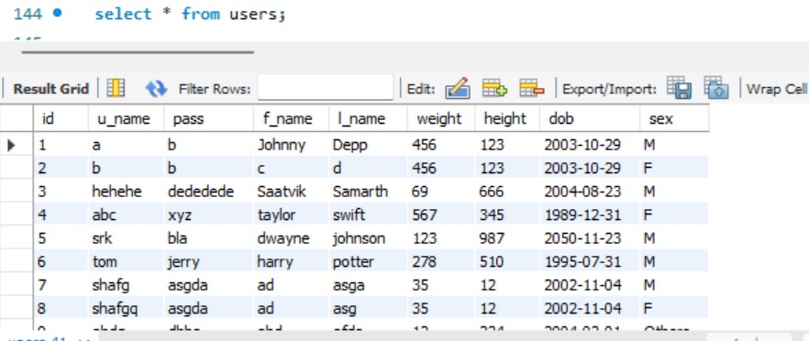

**Medicine table:**

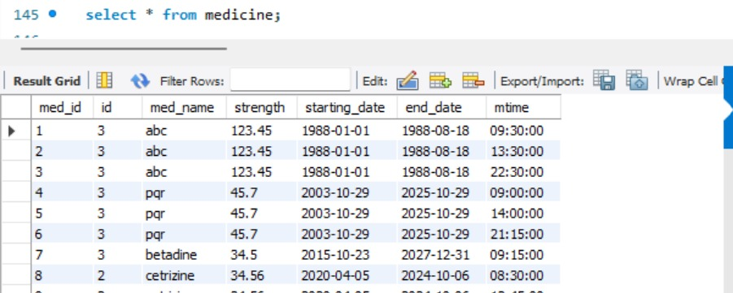

**Family History table:**

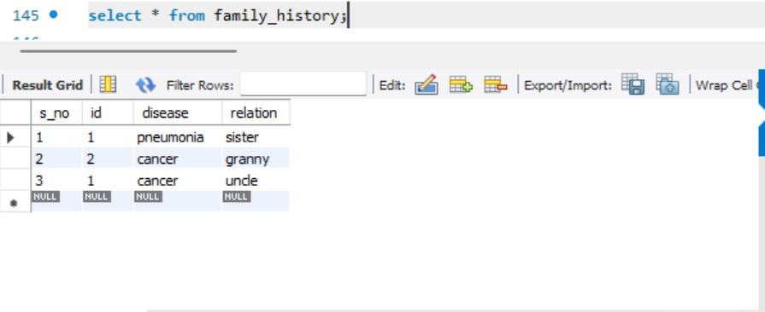

**Cycle Reminder table:**

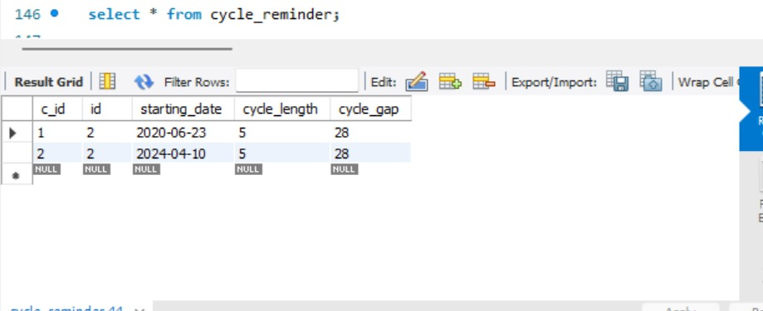

**Vaccine table:**

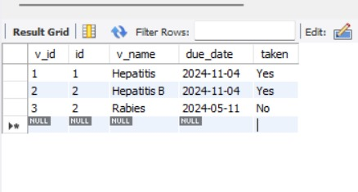

**Lab Report table:**

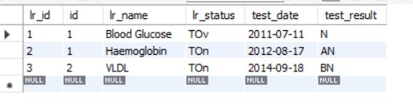

**Appointments table:**

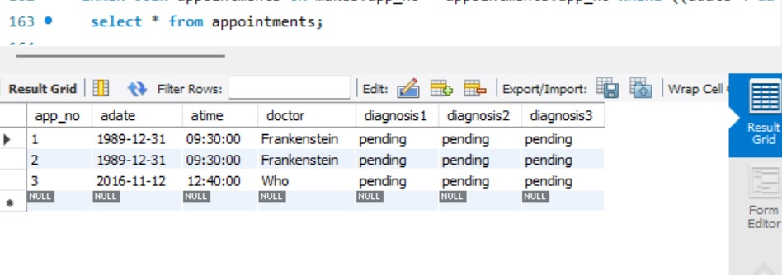

**Makes table:**

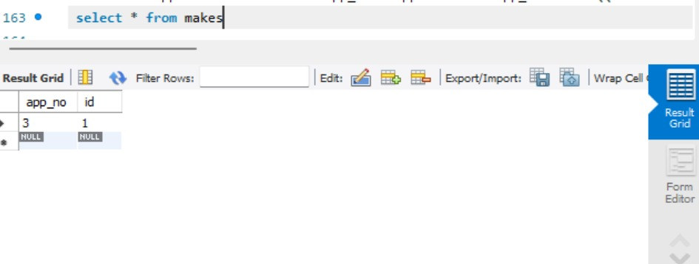

**Users_ph table:**

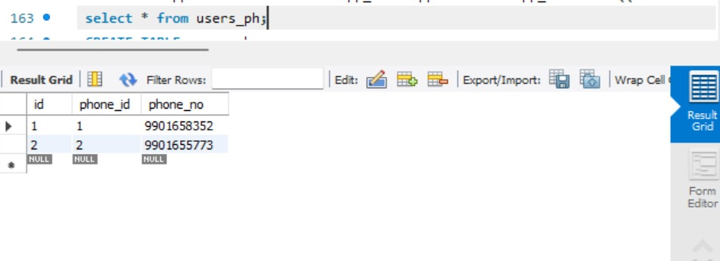

**Disease table:**

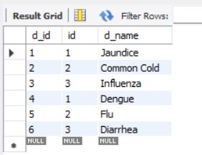

**CREATE, INSERT, UPDATE, DELETE:**

**Create:**

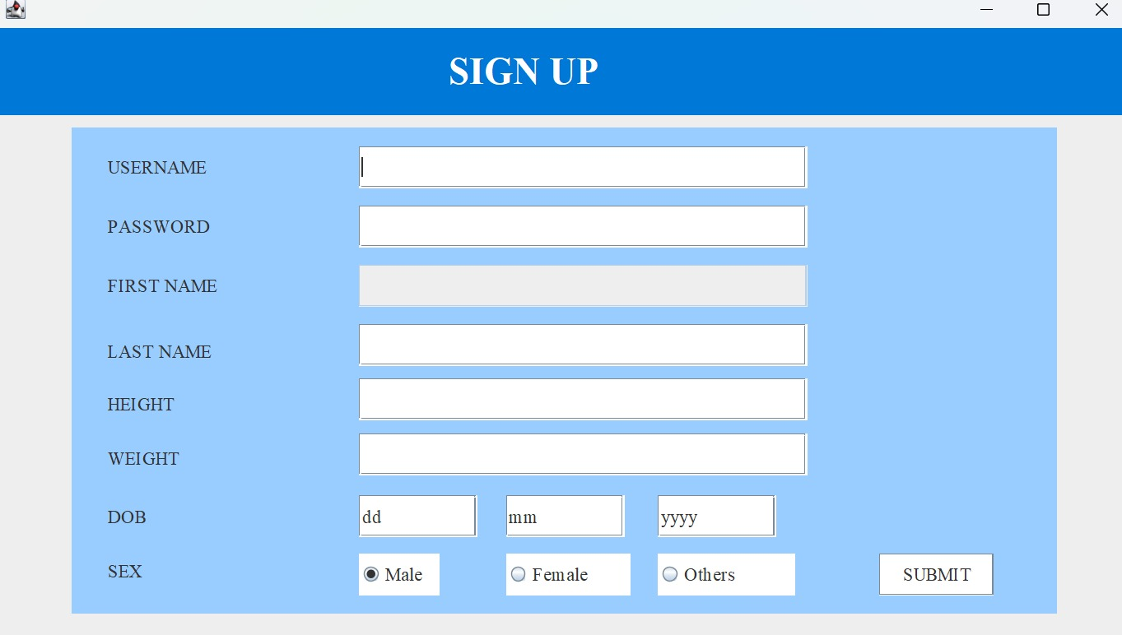

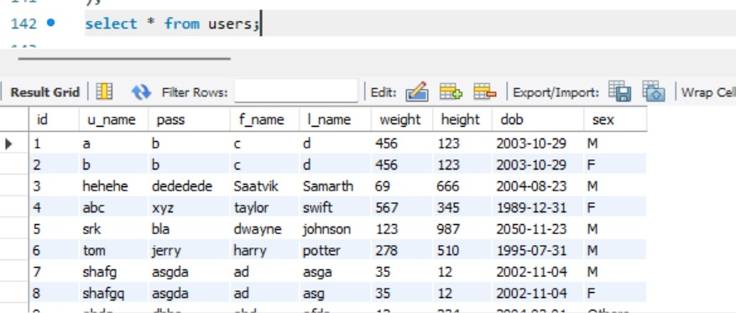

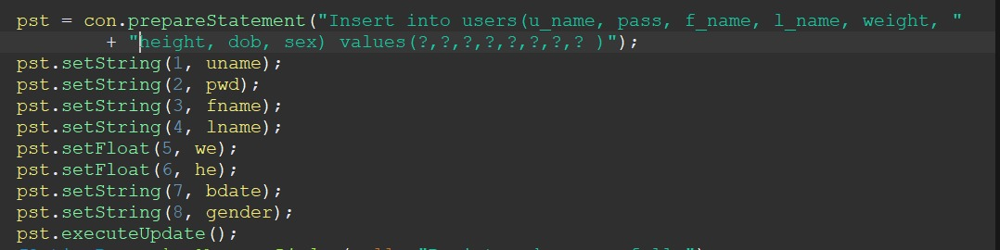

**Insert:**

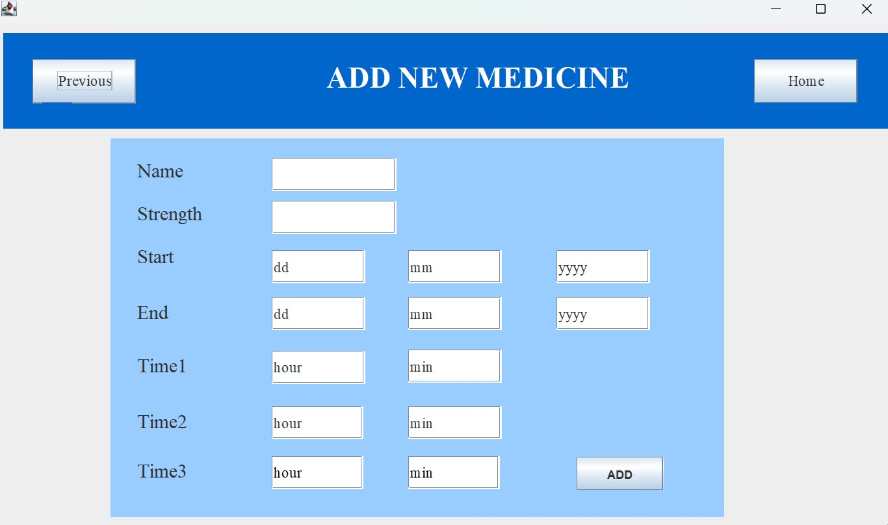

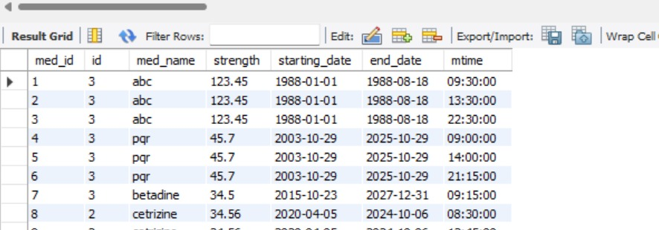

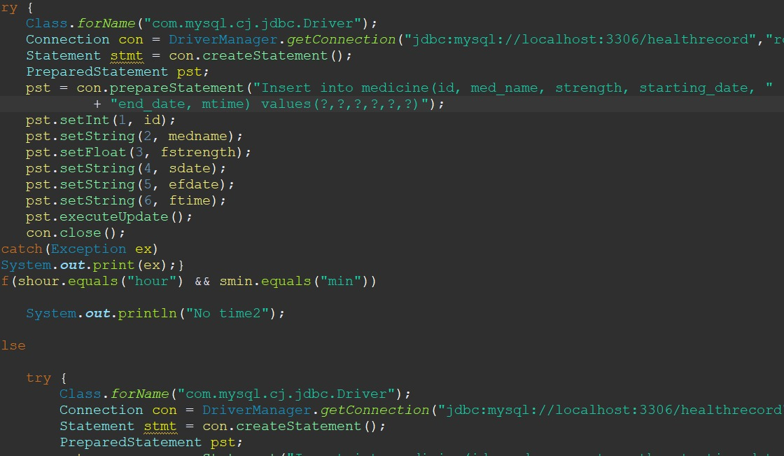

**Update:**

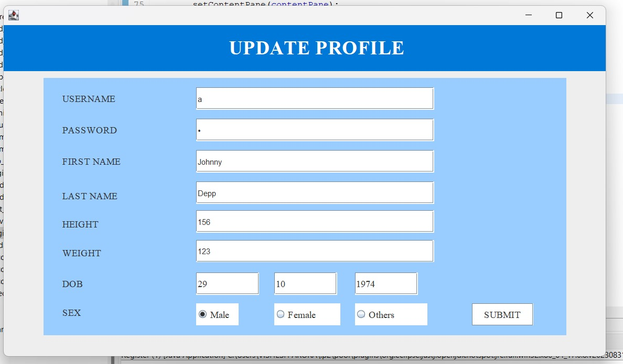

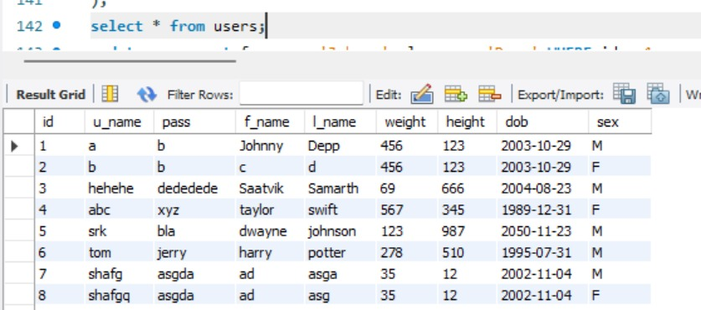



**COMPLEX QUERIES:**

1.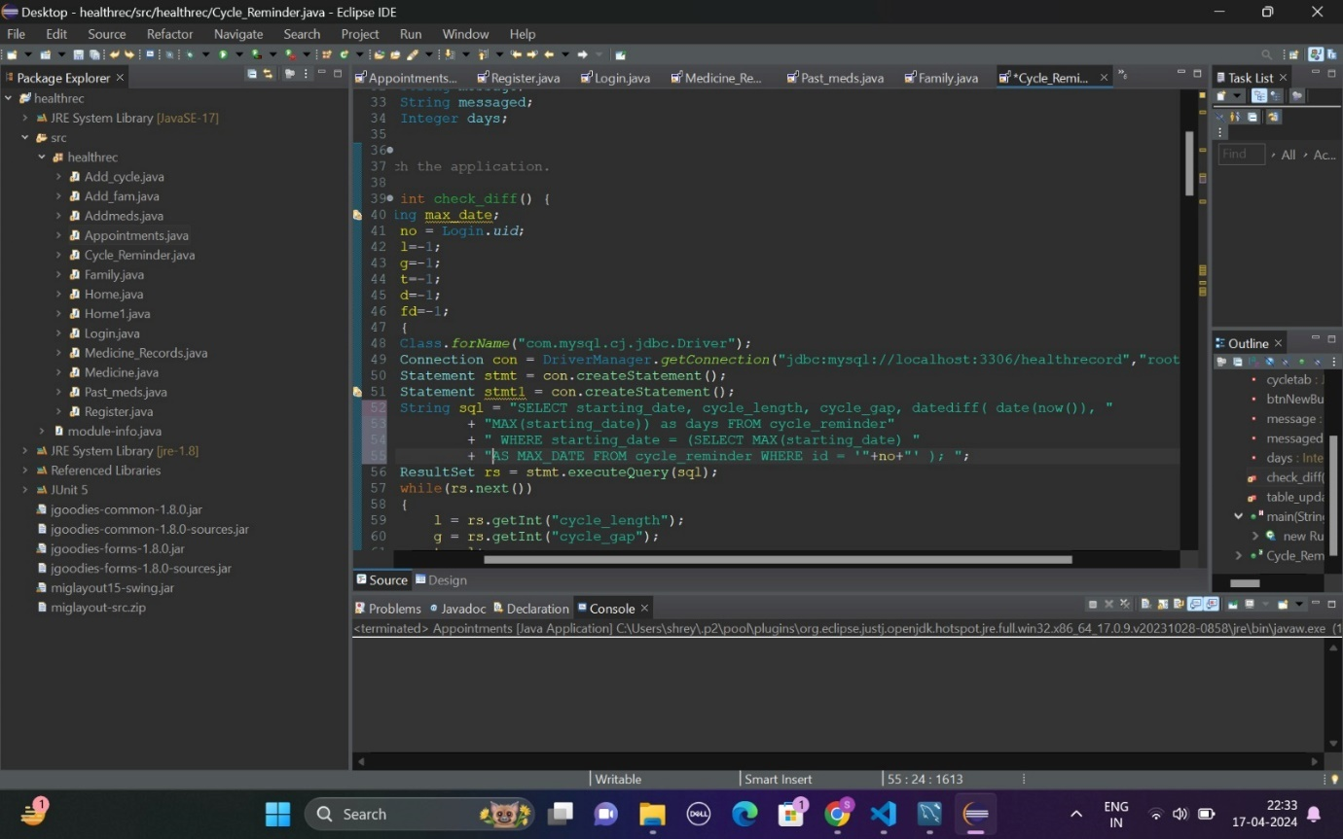

**Output:**

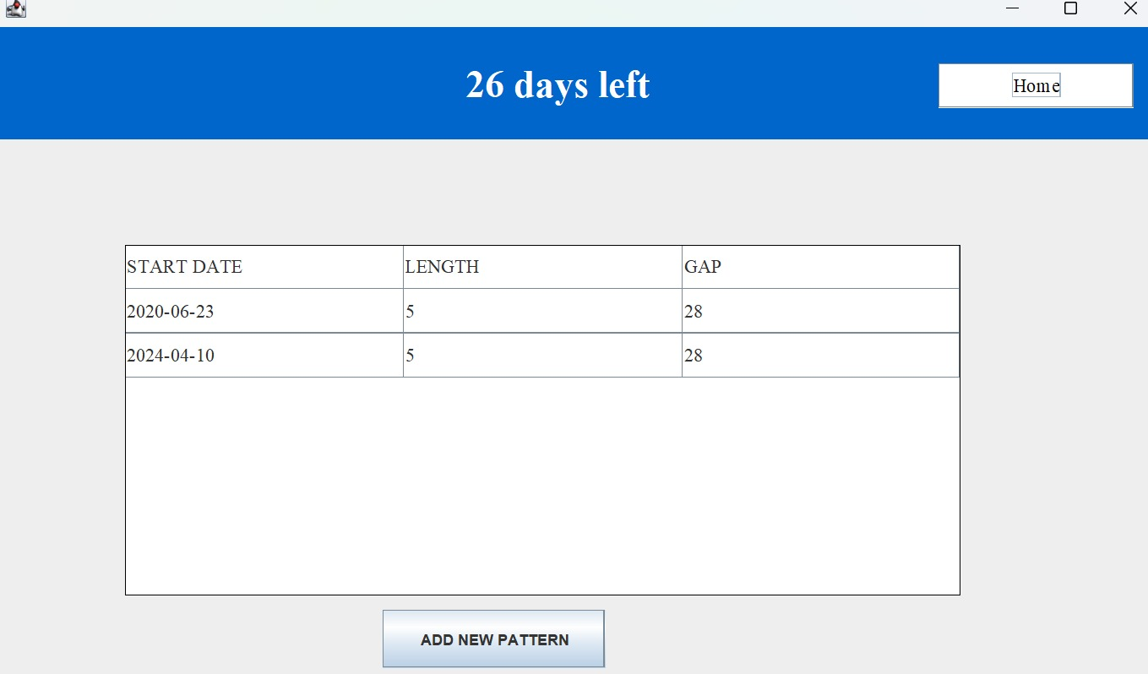

2.

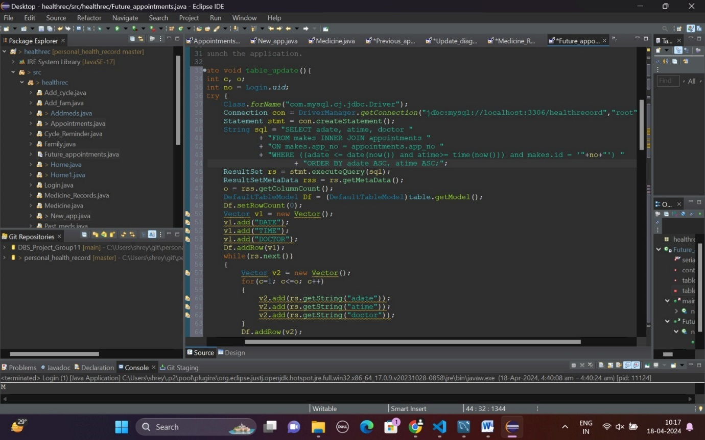

**Output:**

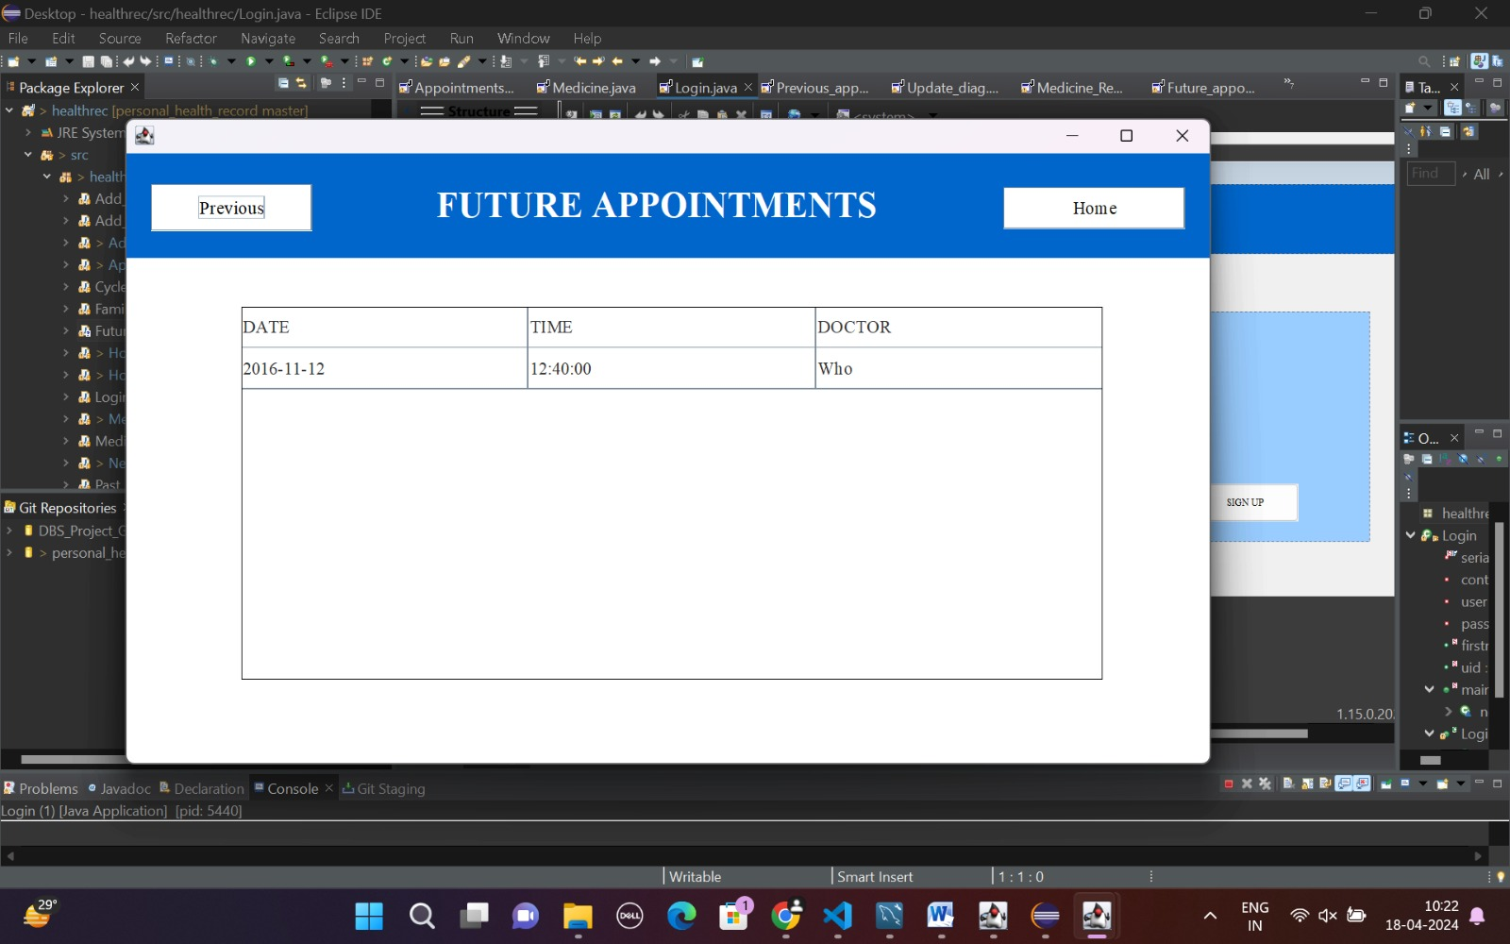

3.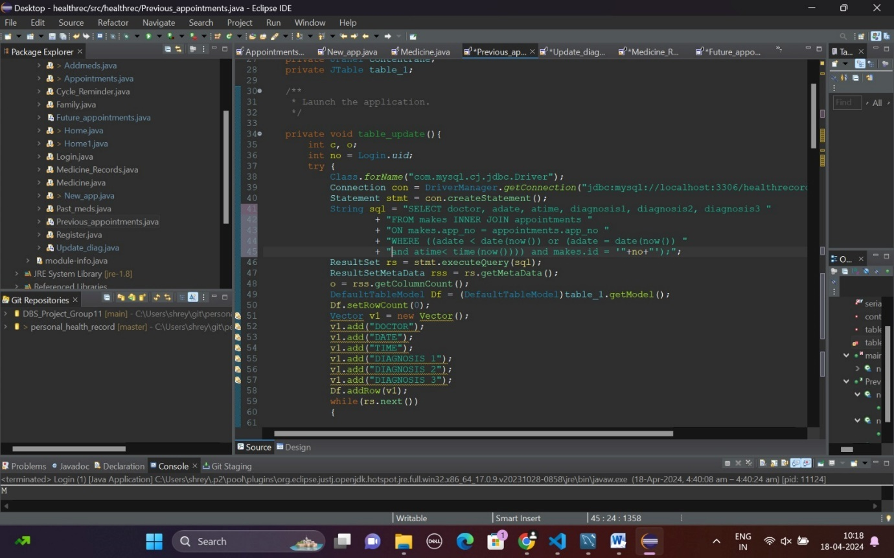

**Output:**

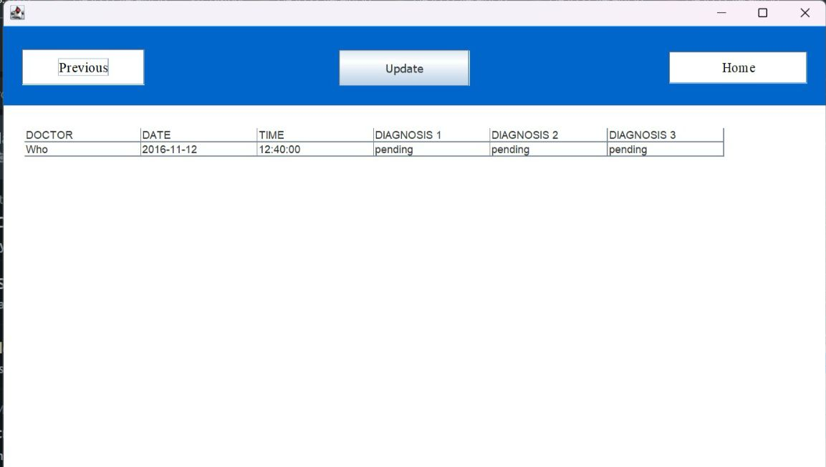

**REPORT SAMPLES:**

**Keeping track of medicines:**

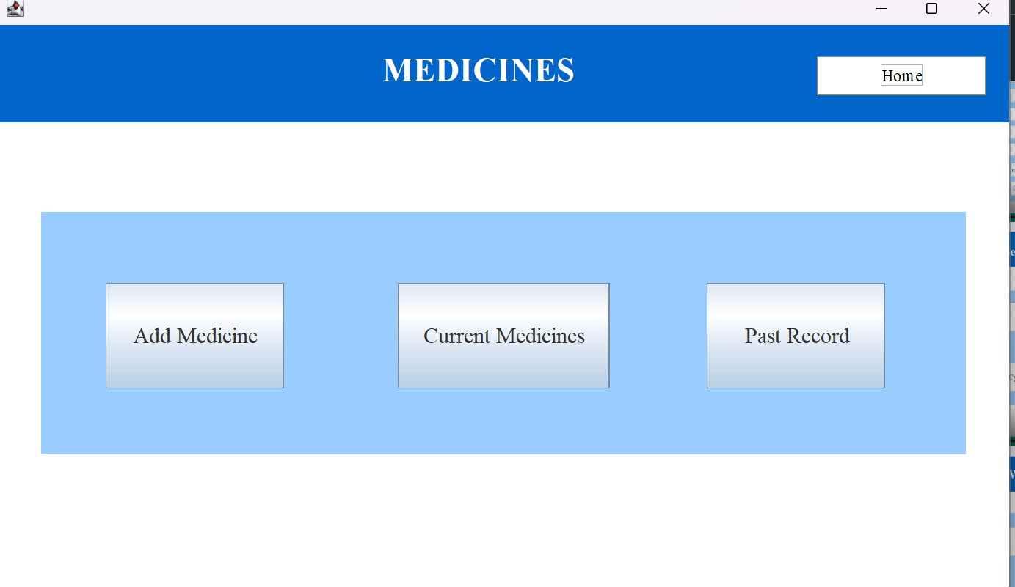

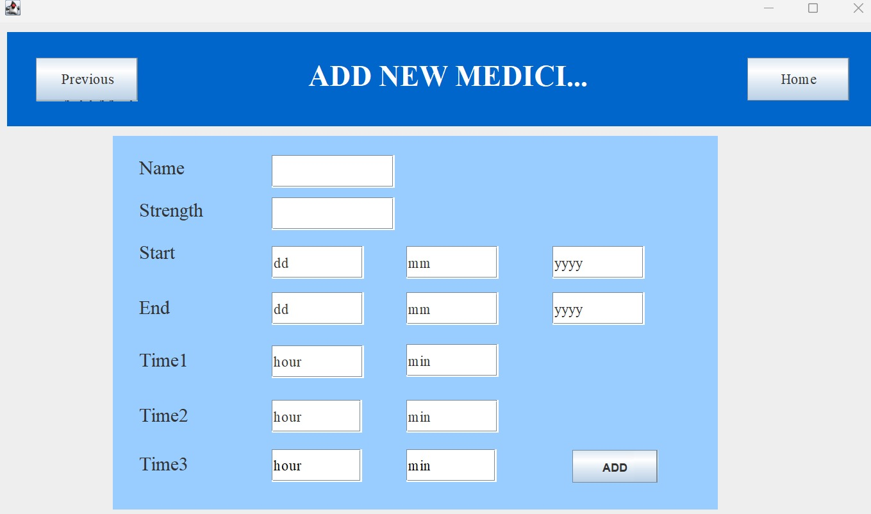

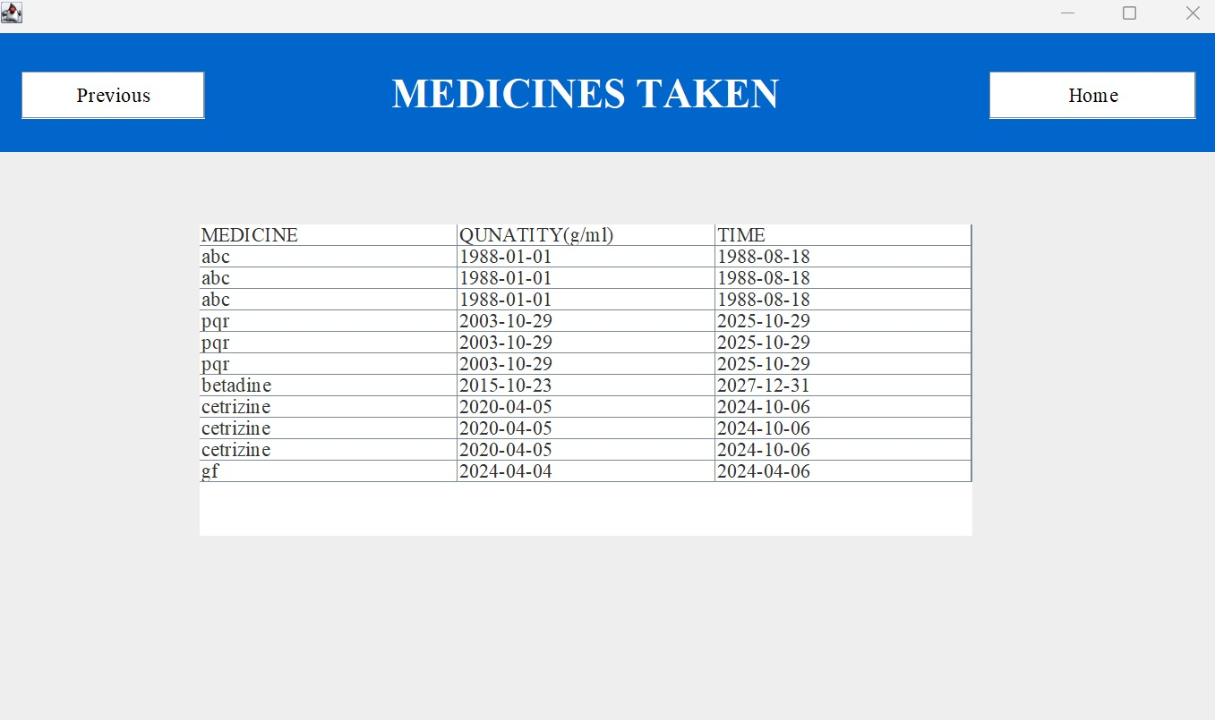

**Keeping track of family history:**

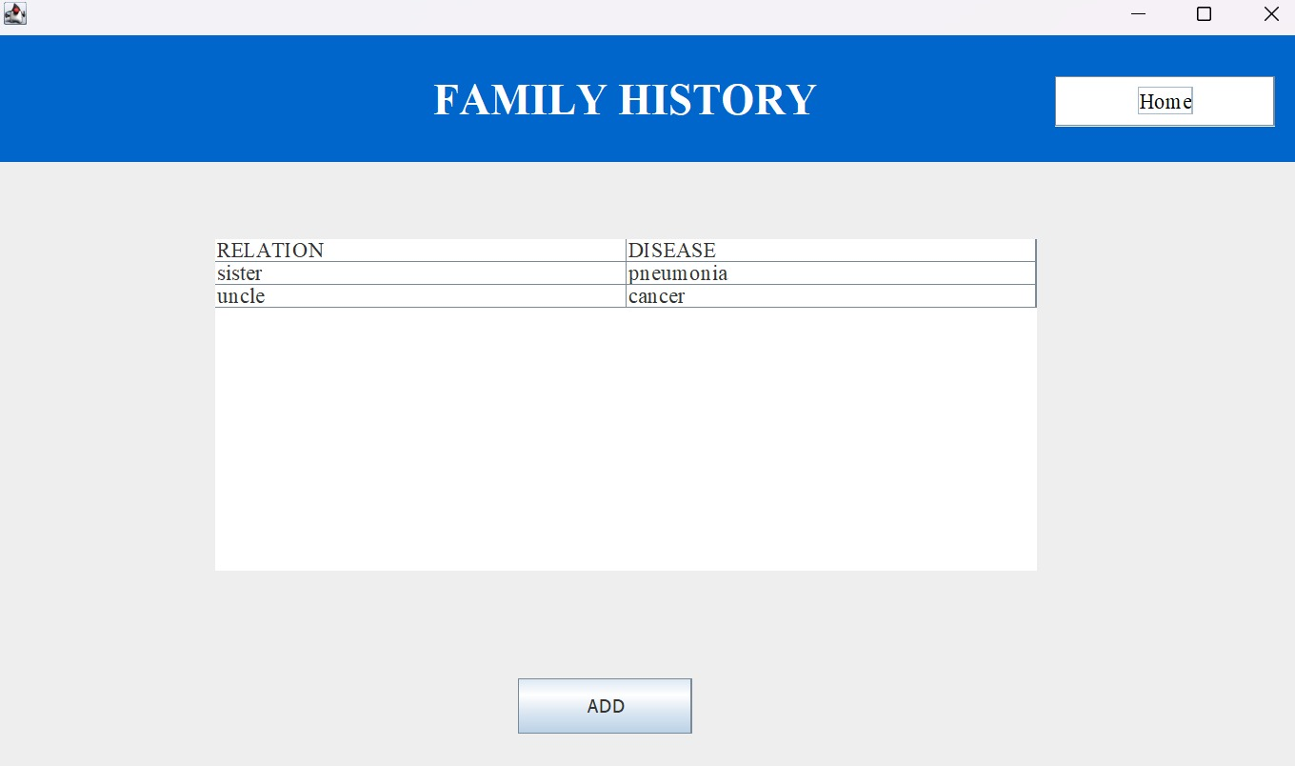

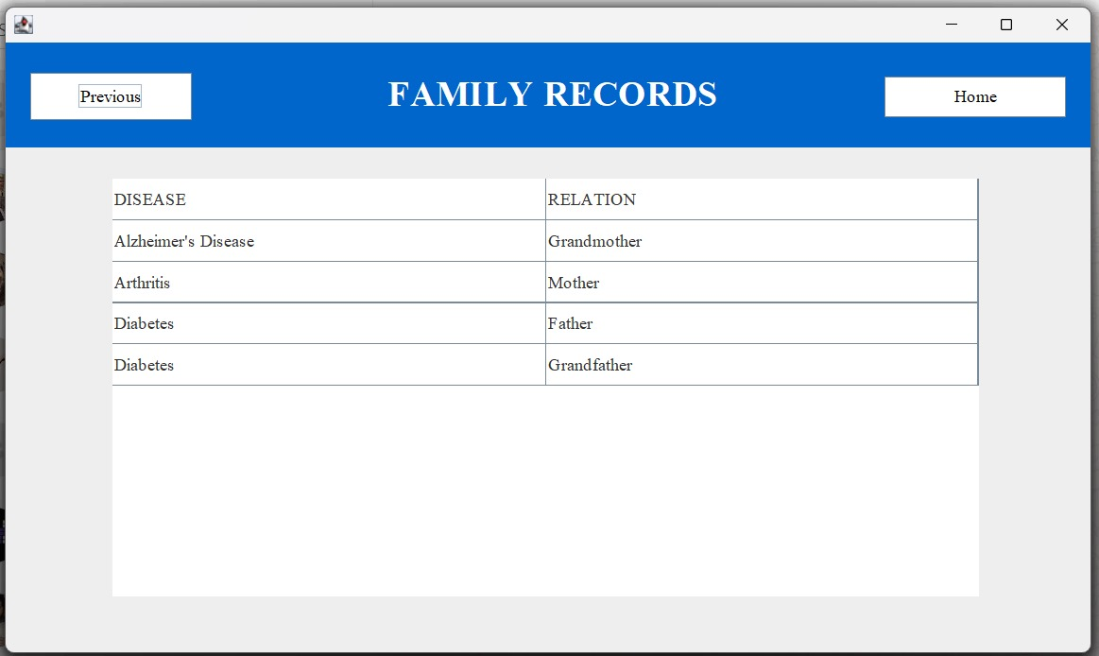

**Keeping track of vaccines:**

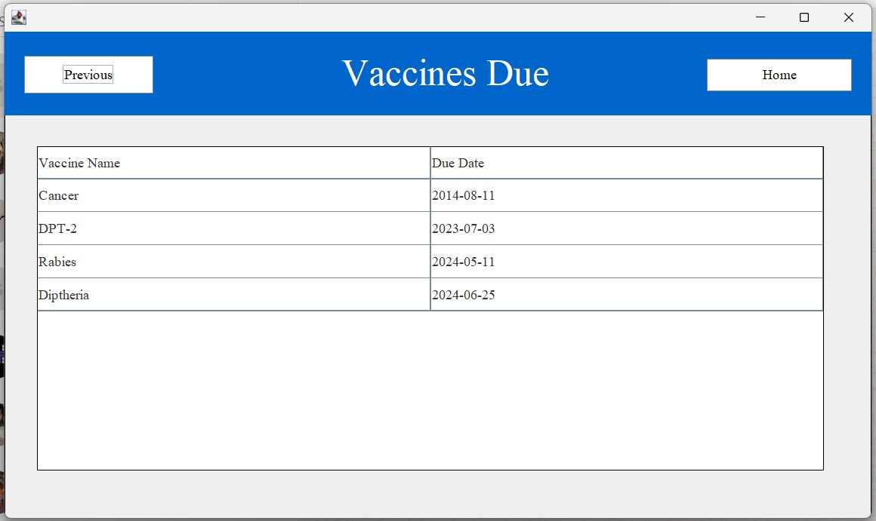

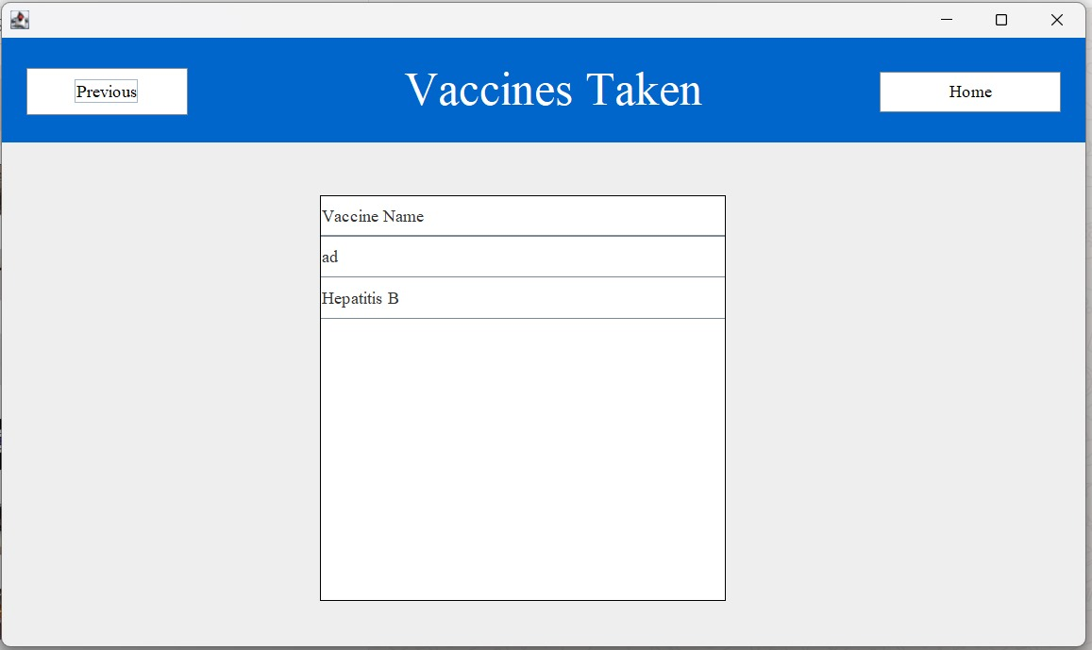

**Keeping track of lab reports:**

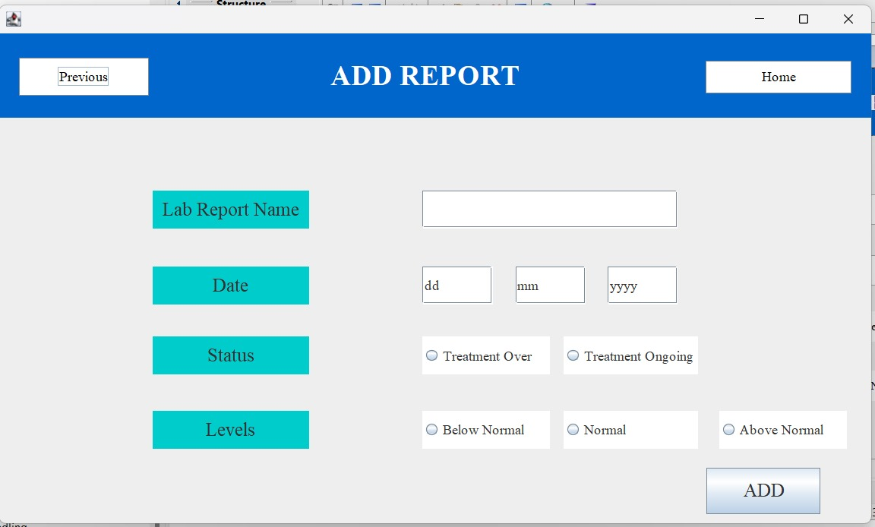

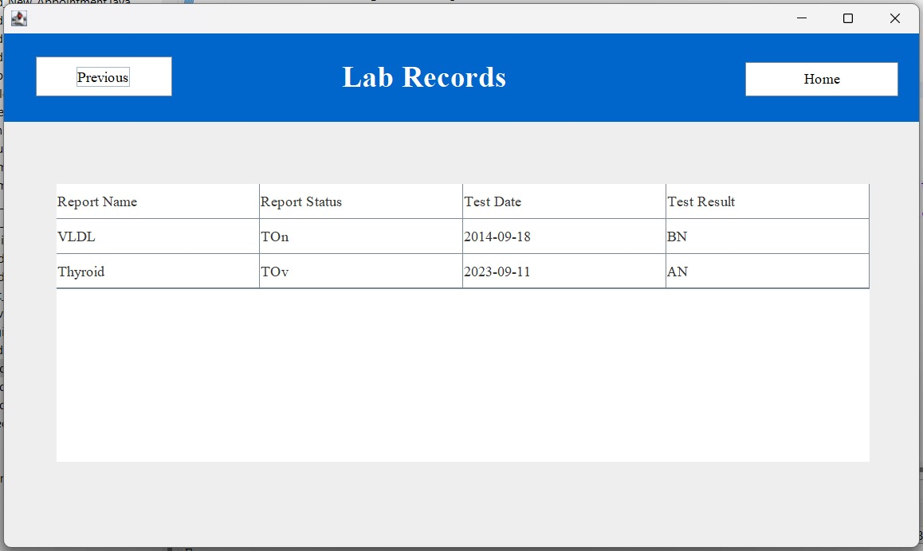

**Keeping track of menstruation cycles:**



**Keeping track of appointments:**

