**Project Details**

This project is for AultCare to demonstrate a working movie application.

This application allows you to:

* Enter movies from your home library and store them. The movie stores the title, genre, actor, actress and a rating from 1-5.
* Search from the list using a combination of genre/title/actor/actresses.
* Search from the list with a single search criterion
* Sort the search results.
* Add a movie to our favorite list and view it under “My favorites” tab.
* Delete a movie

**Technology Used:**

* PostgreSQL
* Angular JS
* HTML
* CSS
* Node JS
* Express JS

**Code**

Complete code is at: <https://github.com/prishah1194/movie_app>

**How to run**

* Install PostgreSQL (create database named movies, create movies table following data definition from seed.sql)
* Install node.js
* Clone the repository to your machine from git
* npm install
* npm start

**Screenshot Walkthrough**

* **Submitting a movie**

Home page

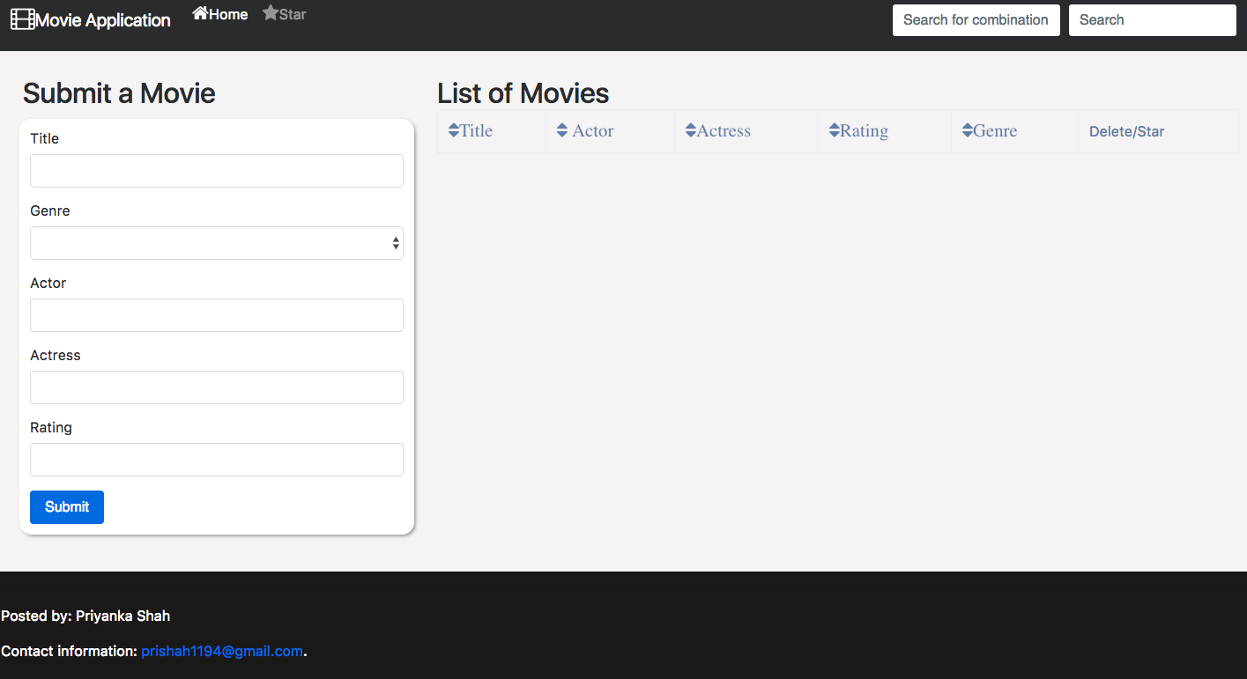

Movie Information Entered in the fields

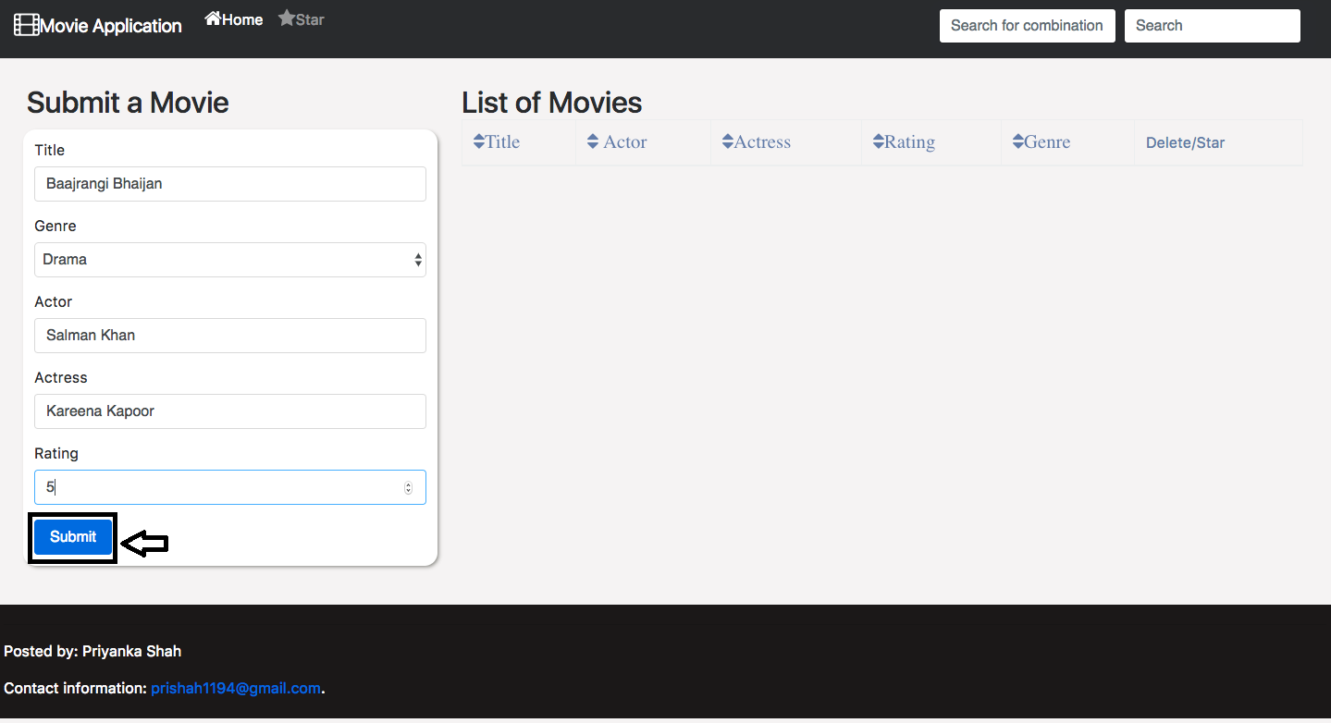

After pressing the submit button, the movie shows up on the list of movies.

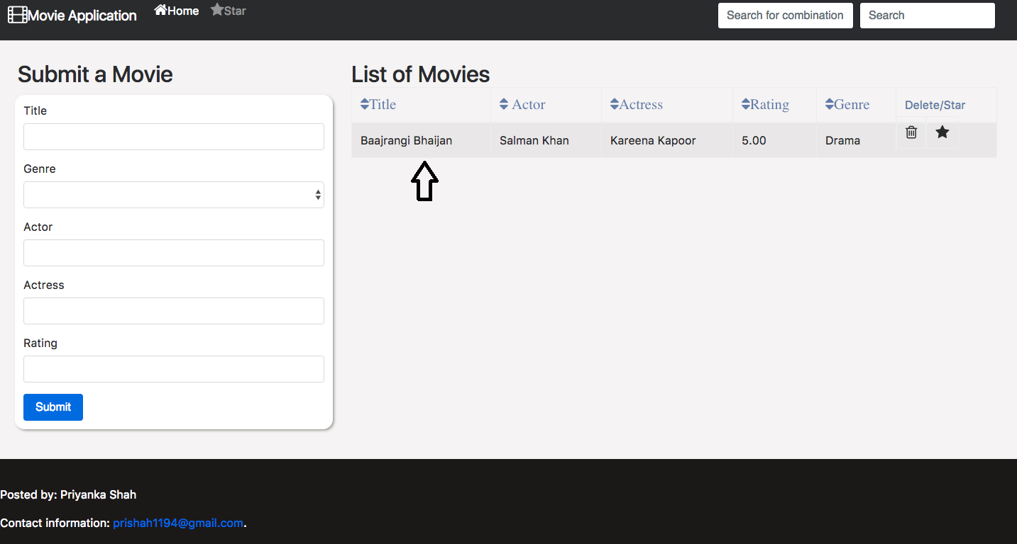

* **Viewing the movie list**

Entire list of movies would be shown as

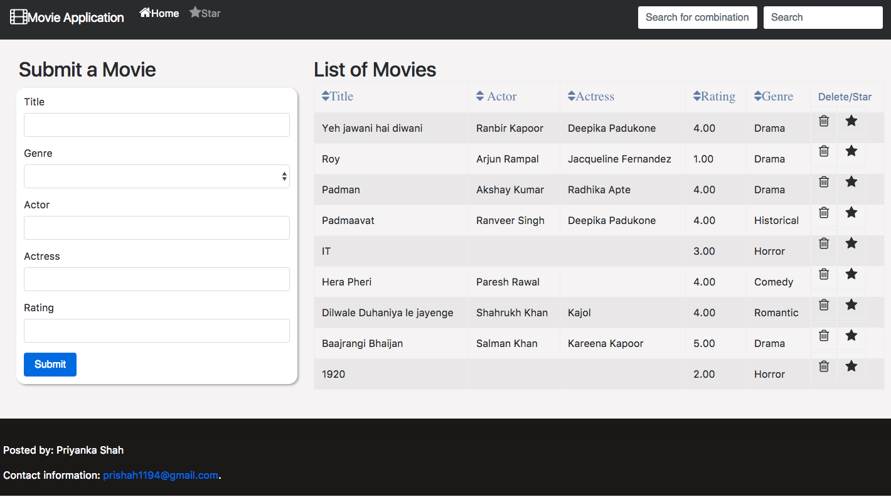

* **Single search criteria**

Single search can be performed by genre, title, actor/actress.

Search by Genre (this can be used to find the list of actor/actress within a genre irrespective of the movie they worked in)

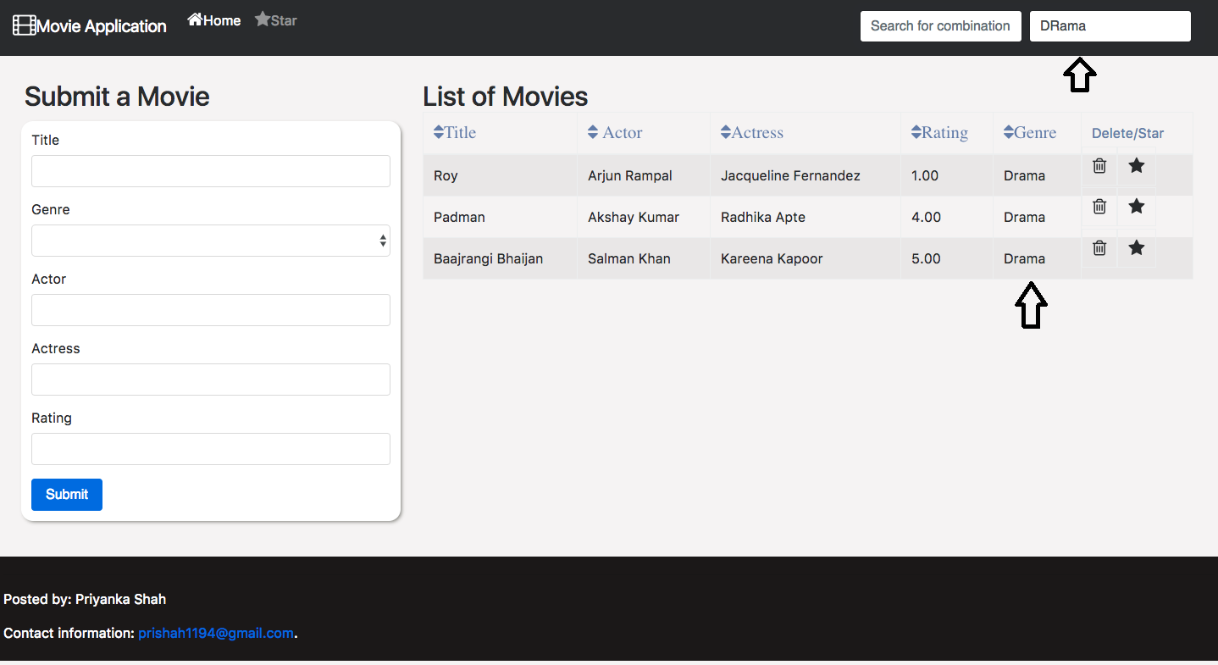

Search by Title

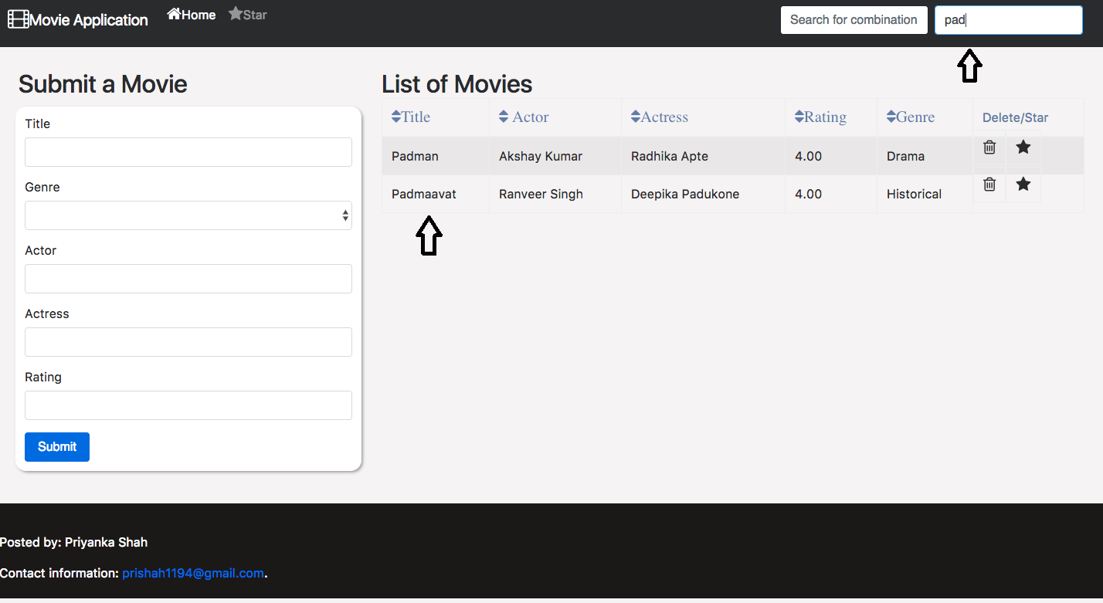

Search by Actor

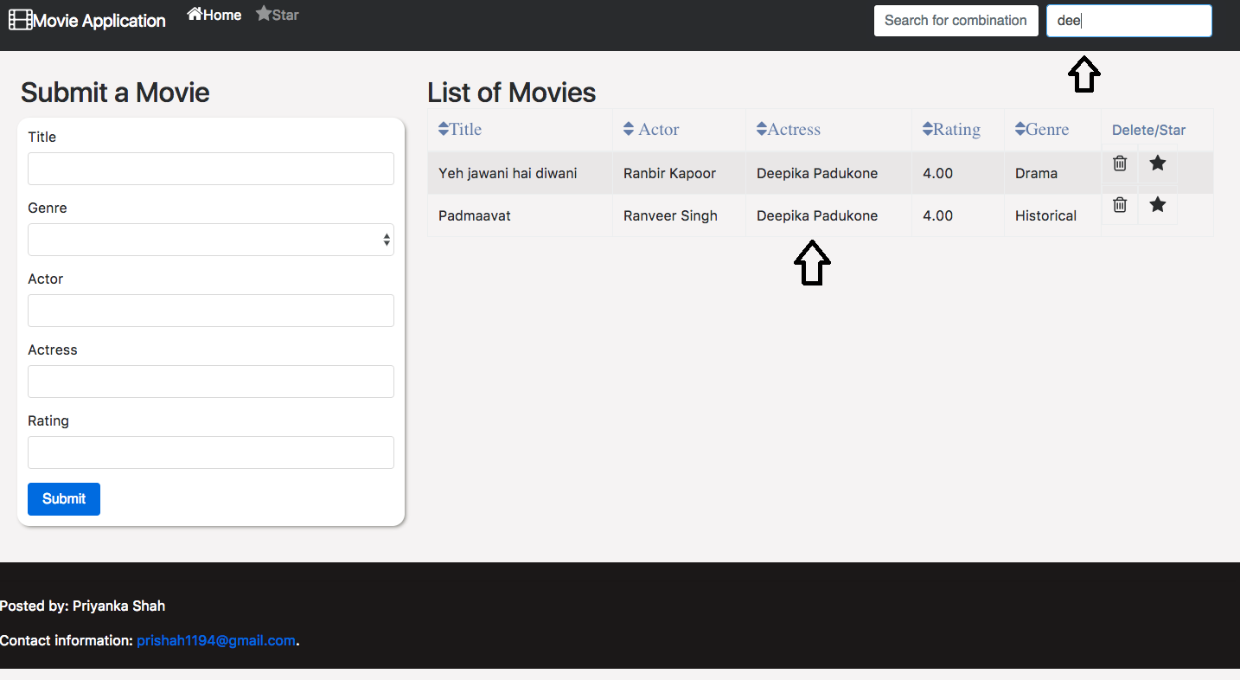

* **Searching by combination**

Searches can be performed on a combination of title/genre/actor/actresses. This can be used to find a particular movie within a genre for an actor/actress(other use cases can be applied too)

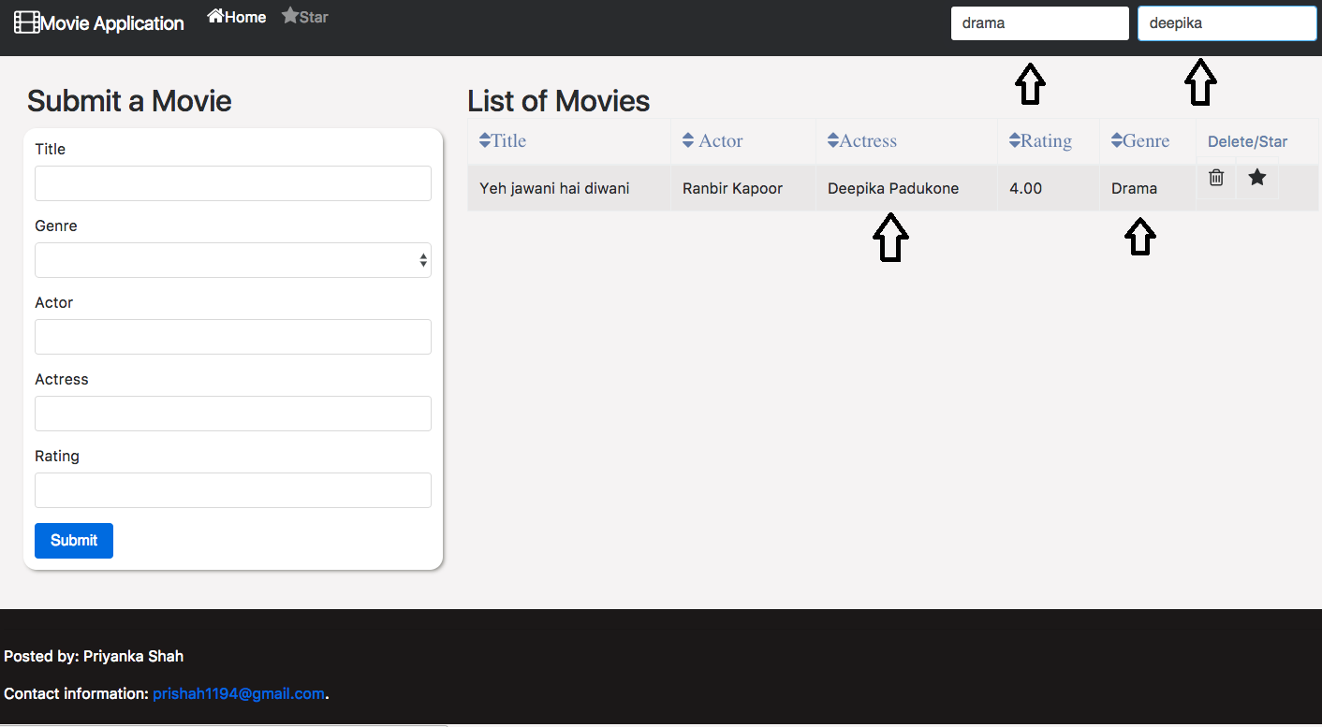

* **Sorting search results**

Sort by Title (Can be done ascending/descending)

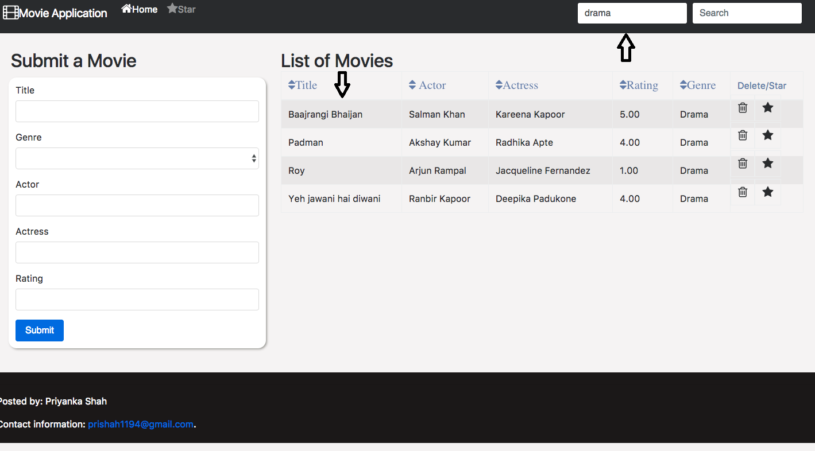

Sort by Actor (Can be done ascending/descending)

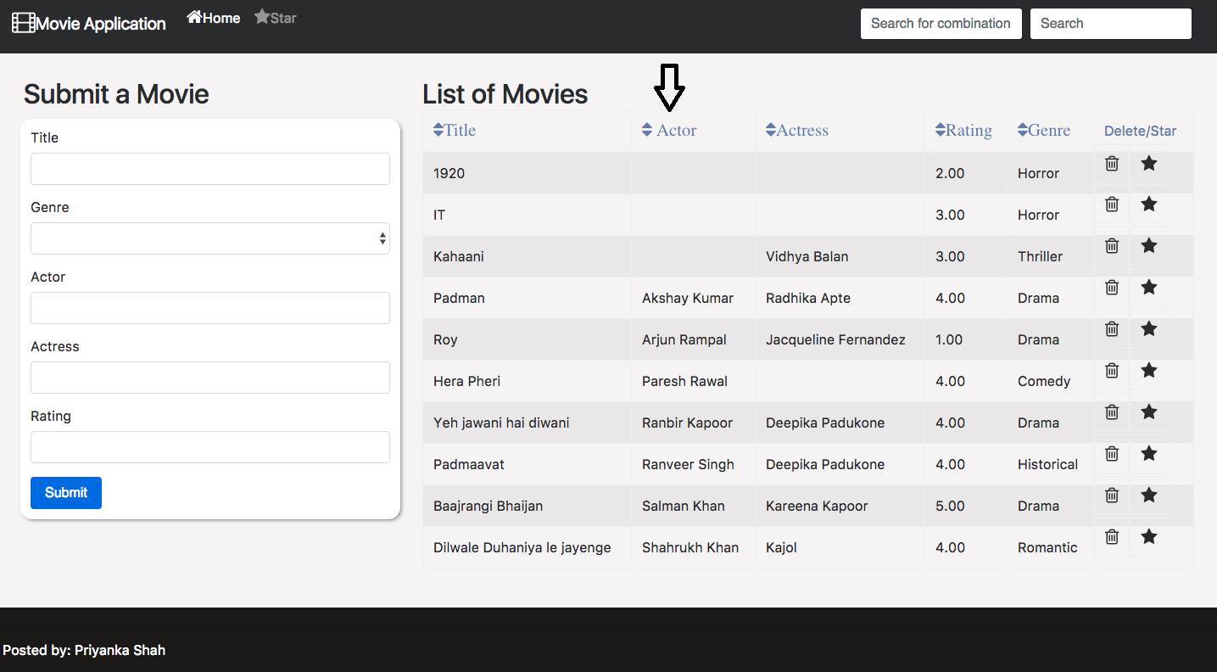

Sort by Rating(Ascending)

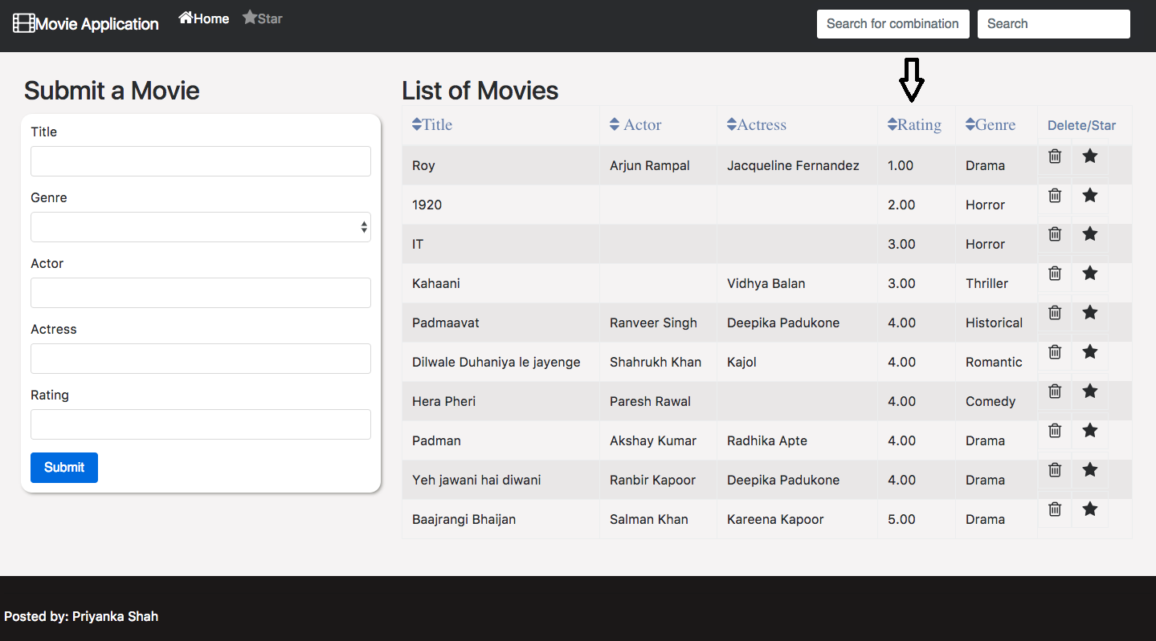

Sort by Rating(Descending)

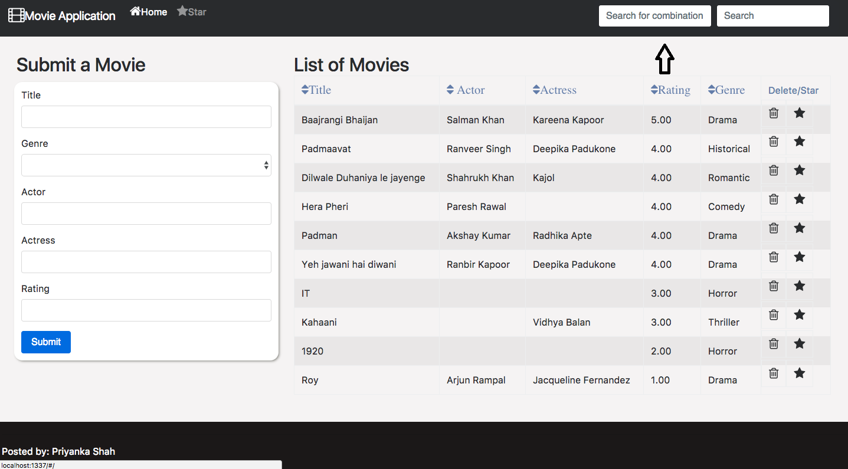

* Deleting a movie

Initial Page before deleting

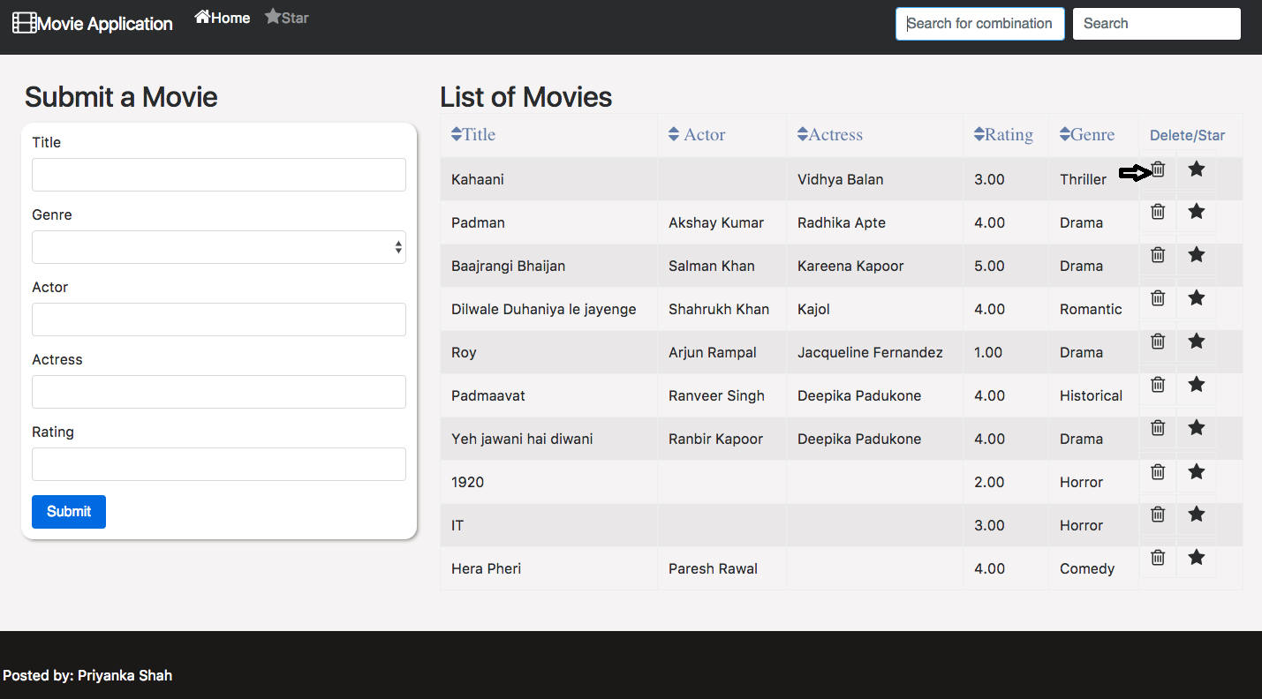

Movie Page after deletion



* **Adding a movie to favorites**

Favorites page initially

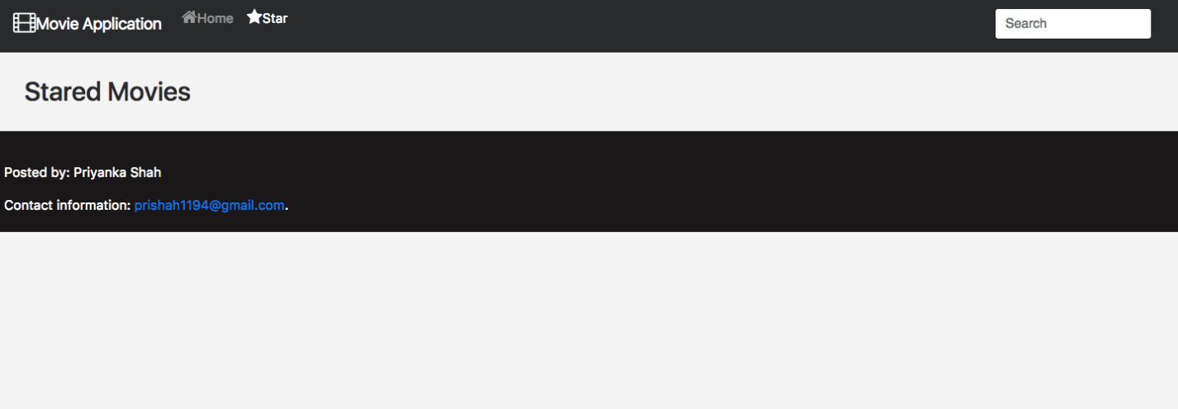

Starring a movie

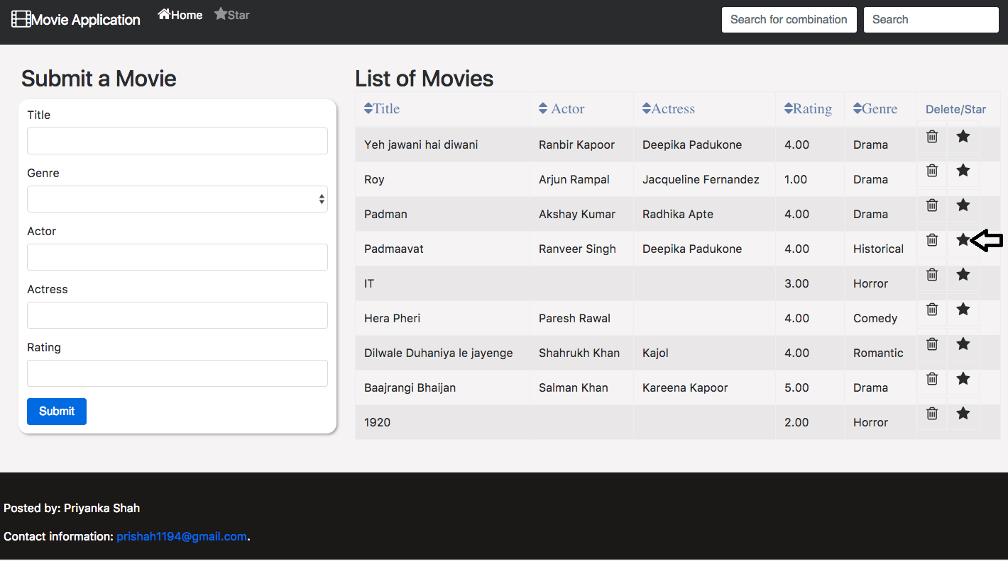

Viewing favorites

