Installed software:

* JDK 7 (/user/local/jdk1.7.0_04)
* Maven 2
* Tortoise HG (context menu options integrated in Nautilus file explorer)
* Apache Tomcat 7 (/usr/local/tomcat7)
* MySQL 5.1 server + GUI (via Applications -> Programming -> MySQL Administrator)
* PGAdmissions web-app sources (/home/pgadmin/src/pgadmissions)

User details:

|  |  |  |
| --- | --- | --- |
| **Description** | **User** | **Password** |
| OS user | pgadmin | pgadmin |
| MySQL root | root | pgadmin |
| MySQL web-app user | pgadmissions | pgadmission |
| Mercurial user  (in /home/pgadmin/.hgrc) | [a.knowles@ucl.ac.uk](mailto:a.knowles@ucl.ac.uk) | pg@m1ss1ion |
| Tomcat admin  (in /usr/local/tomcat7/conf/tomcat-users.xml) | admin | admin |

General:

* If there are network connection issues check the proxy settings  
  for system wide network access: System -> Preferences -> Network Proxy  
  for TortoiseHG: /home/pgadmin/.hgrc
* MySQL database and Tomcat server are starting automatically
* For external access to the web server: use the assigned IP in a terminal shell with   
  “ifconfig -a”:  
  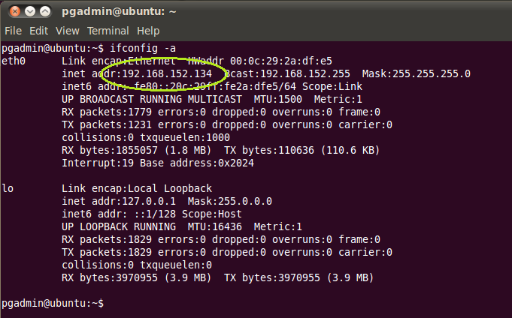
* To access the Mercurial repository right-click on /home/pgadmin/src/pgadmissions then TortoiseHG -> Repository Explorer
* To update and deploy a new version:
  1. Pull changes from Mercurial repository (via Repository Explorer)
  2. Open a terminal shell, change to /home/pgadmin/src/pgadmissions
  3. Run “mvn clean package”
  4. If there aren’t any build errors copy the webapp file from target to the webserver with:  
     “cp target/pgadmissions.war /usr/local/tomcat7/webapps/”  
     This restarts the web-application and the new version is available after a couple of seconds.