Foot Step Power Generation

Under the guidance of- **Dr. Brajesh Kumar**

**Sumant Kumar Arya, Suraj Kalindi, Sweety Shaw, Vaishali Singh**

Final Year, UG student, Dept. of Electronics and communication Engineering,

REC, Ramgarh(2018-22)

----------------------------------------------------------***----------------------------------------------------------------------

**ABSTRACT-** Man has been using energy resources at a very high pace. Due to this a lot of energy resources have been exhausted and wasted. Proposal for the utilization of waste energy of foot power with human locomotion is quite relevant and important for highly populated countries like India. If this energy made possible for utilization then it will be a great invention. In this project we are converting non- conventional energy from footstep into an Electrical Energy using Piezo-electric sensor. We will be discussing about it in depth in further extension. Non conventional energy system is very essential at this point to our nation. Non conventional energy using foot step needs no fuel input. The power generation is much worthy but it has little initial cost effective factors.

1. **INTRODUCTION**

As the availability of conventional energy declines, there is need to find alternate energy sources. The Power produced by most of the states electricity are insufficient to meet even domestic utilities, in such situation it is very difficult to divert the energy for other public needs. So an alternative source must be discovered, many proposed Solar Energy but it would be a costliest affair and also unavailability of solar energy in winter and rainy season makes it in dependable. Hence an alternative cheapest method must me choosen. So this project has been taken up, which aimed to generate electricity with Footstep Mechanism. Here the concept used is to convert Mechanical Energy to Electrical energy using Piezo sensors and ESP2886. Out of various energy resources, the technology described in this project is safe and pollution free. Thus it will be an extremely viable alternative in coming days.

1. **NEED OF THE SYSTEM**

The utilization of waste energy of foot power with human motion is very important for highly populated countries. India and China where the roads, railway stations, temples, etc. are all over crowded and millions of people move around the clock. It is the alternative source of energy.

1. **BLOCK DIAGRAM**

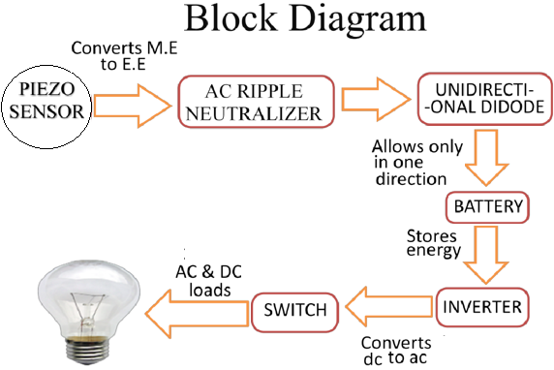

1. **COMPONENTS**

**IV.1** **Piezo sensor**-Piezoelectric force sensors are low impedance voltage force sensors designed for generating analog voltage signals when a force is applied on the piezoelectric crystal and are widely used in machines for measuring force. A piezoelectric pressure sensor is also known as a piezoelectric sensor pressure. Piezoelectric transducers operate based on the piezoelectric effect. This effect happens when a polarized crystalline material undergoes stress or deformation. The stress then causes a shift in the orientation of the internal dipoles of the material.

**IV.II** **TP Battery Module-** The TP4056 chip is a lithium Ion battery charger for a single cell battery, protecting the cell from over and under charging. It has two status outputs indicating charging in progress, and charging complete.

**IV.III** **ESP 8266-** The ESP8266 Serial WIFI Wireless Transceiver Module is a self-contained SOC with integrated TCP/IP protocol stack that can give any microcontroller access to your Wi-Fi network. The ESP8266 is capable of either hosting an application or offloading all Wi-Fi networking functions from another application processor.

**IV.V** **ThinkSpeak-** ThingSpeak is an IoT analytics platform service that allows you to aggregate, visualize, and analyze live data streams in the cloud. You can send data to ThingSpeak from your devices, create instant visualization of live data, and send alerts. ThingSpeak provides instant visualizations of data posted by your devices to ThingSpeak. With the ability to execute .ThingSpeak you can perform on line analysis and processing of the data as it comes in.

1. **WORKING**

Whenever force is applied on piezo electric crystals that force is converted to Electrical energy. And that minute voltage which is stored in the Lithium ion battery. This battery is connected to TP module and LED. By using ESP module we will see the battery status updated by TP4056 module on the server ThingSpeak. So that anyone can see the status of the battery percentage from any place. We are using conventional battery charging unit also for giving supply to the circuitry. The basic working principle of our project is based on the piezoelectric effect. Non-conventional energy using foot step is converting mechanical energy into the electrical energy. Foot step board consists of 7 piezoelectric sensors which are connected in parallel. When the pressure is applied on the sensors, these sensors will convert mechanical energy into electrical energy. This electrical energy will be stored in the12V rechargeable battery connected. We are using conventional battery charging unit also for giving supply to the circuitry. An inverter is used to convert the 12 Volt D.C to the 230 Volt A.C. This 230 Volt A.C voltage is used to activate the loads. By using this AC voltage we can operate AC loads. In this we use the Battery Monitoring System, we will use Wemos D1 Mini with ESP8266 Chip to send the battery status data to Thing to Speak cloud. The Thing to speak will display the battery voltage along with battery percentage in both the charging and discharging cases.

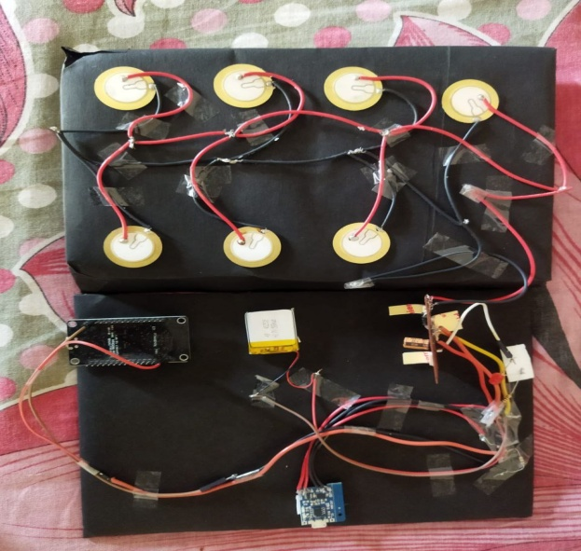 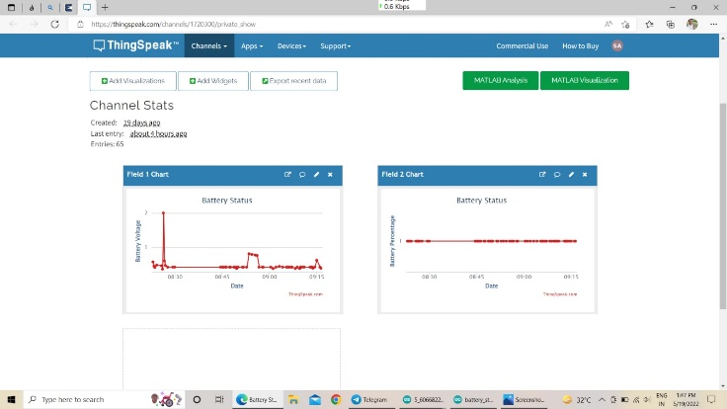

Fig:V.1 Hardware Setup Fig: V.II Output(ThinkSpeak)

|  |  |  |  |  |
| --- | --- | --- | --- | --- |
| **Day** |  | **Analog value** |  | **Battery status** |
| 01 |  | 10 |  | 0.42 V, 4% charge |
| 02 |  | 64 |  | 0.77V, 10% charge |
| 03 |  | 70 |  | 0.81V, 20% charge |

Fig: V.III Observation Table

1. **CONCLUSION**

In concluding the words of our project, since the power generation using foot step get its energy requirments from the Non-renewable source of energy. There is no need of power from the mains and there is less pollution in this source of energy. It is able to extend this project by using same arrangements and construct in the footsteps/speed breaker so that increase the power production rate by fixing school and college, highways etc. Thus in all we conclude that this technology can be prove to be an efficacious system of power generation using human locomotion.

1. **FUTURE SCOPE**

In future aspects we can use this principle in the speed breakers at highways where are rushes of the vehicles too much thus it would increase input torque and ultimately output. This technique would be really very effective in populated places . So in coming year we can see its widely uses in school, cinema theaters, shopping complex ,etc.

1. **REFERENCES**

[1] https://how2electronics.com

[2] aip.scitation.org

[3] Sarat Kumar Shaoo/ foot step power generation/ IAEME/ vol. 07/ 2016

[4] Farahiyah Mustafa/ study of foot step power generation using piezo electric tile/ ISSN: 2502-40752, DOI :10.1159/ igeecs.v15.i2/ 593-599/ vol. 15/ 2019