Ceremonial Entheogen Use in Puerto Rico: A Descriptive Survey of Participants and a Small Facilitator Subsample
Yamil O. Ortiz Ortiz$​^{1}$
Jean C. Vélez Rodríguez$​^{2}$
Julián M. Hernández Torres$​^{2,3}$
Juliana Millán-Torres$​^{4}$
Paulina Rullán Farinacci$​^{5}$
Carolina Riollano$​^{6}$
Angélica N. Grajales Roldán$​^{1}$
Adriana I. Rodríguez Massa$​^{1}$
$​^{1}$Centro de Investigaciones Sociales, Facultad de Ciencias Sociales, University of Puerto Rico, Río Piedras Campus, San Juan, Puerto Rico
$​^{2}$Puerto Rico Institute for Psychedelic Science, Medicine & Awareness, San Juan, Puerto Rico
$​^{3}$Behavioral Sciences Research Institute, University of Puerto Rico, Medical Sciences Campus, San Juan, Puerto Rico
$​^{4}$Colectivo Psicodélico de Puerto Rico, Colectivo Psicodélico Inc., and Within Psychological Services, San Juan, Puerto Rico
$​^{5}$Department of Psychiatry, School of Medicine, University of Puerto Rico, Medical Sciences Campus, San Juan, Puerto Rico
$​^{6}$Colectivo Psicodélico de Puerto Rico, San Juan, Puerto Rico
Corresponding author: Jean C. Vélez Rodríguez, jean.velez5@upr.edu
Abstract
Ceremonial entheogen use occurs in Puerto Rico outside clinical and regulatory structures, and the practices surrounding it have not been described. We conducted an anonymous, bilingual, cross-sectional online survey of adults aged 21 and over reporting involvement in entheogen-assisted ceremonies in Puerto Rico, recruited by convenience and chain referral, February–June 2026. Of 100 submissions, 73 identified a role: 72 as participants and 8 as facilitators, 7 of whom were both. Respondents were middle-aged (mean 42.4 years), mostly university-educated, and almost all resident in Puerto Rico. Most recent ceremonies were typically single, multi-hour events in natural settings involving psilocybin mushrooms or ayahuasca, and satisfaction was strongly ceiling-weighted (median 6 of 6). Preparation was near-universal among those answering while pre-ceremony screening was not, and the small facilitator subsample described training and emergency planning as informal rather than credentialed. Five of 67 participants answering reported ever experiencing non-consensual physical contact during a ceremony, and 2 of 65 at their most recent one. A comparison of any preparation against none, specified in the analysis plan before testing, was positive in direction but rests on five unprepared respondents and is exploratory. These findings describe this sample only and support no prevalence or causal claim.
Keywords: entheogens; psychedelics; ceremonial use; Puerto Rico; harm reduction; survey research

Introduction
Ceremonial use of entheogens—psilocybin-containing mushrooms, ayahuasca, and related preparations taken in structured group or guided settings—has become substantially more visible across the Americas over the past two decades, largely outside the clinical-trial infrastructure that generates most of the contemporary research literature (Golden et al. 2022; Carvalho et al. 2025). The resulting evidence base is asymmetric. Randomized clinical research characterizes carefully screened participants receiving standardized doses under monitored conditions, and its samples remain narrow (Hughes and Garcia-Romeu 2024; Marcus and Rush 2026), while community ceremonial practice is documented mainly through ethnographic and qualitative work, with comparatively few survey-level descriptions of who takes part and under what conditions (Carvalho et al. 2025; Teixeira et al. 2026).
Puerto Rico occupies an unusual position: a Spanish-speaking Caribbean jurisdiction where psilocybin, DMT, and related compounds remain Schedule I under the federal Controlled Substances Act (United States Congress 1970) and the territory’s aligned statute (Legislative Assembly of Puerto Rico 1971), outside the decriminalization and regulated-access reforms reshaping parts of the United States (Siegel et al. 2023). It is also a setting with a long-documented tradition of spiritually framed healing practice—espiritismo and related practices—described in the clinical and public health literature for more than four decades (Koss 1980; Comas-Díaz 1981; Bird and Canino 1981; Zerrate et al. 2022).
Local survey evidence on entheogen use is nonetheless minimal. One published Puerto Rico–specific survey exists, conducted by members of the present research team, but it is narrower in scope: it characterizes psilocybin use patterns, motivations, and personality correlates rather than ceremonial practice, and addresses neither facilitation nor safety (Vélez Rodríguez et al. 2026). An unpublished thesis has examined university-community perceptions of psilocybin mushrooms (Doelter Morales and Martínez Miranda 2020). Neither describes how ceremonies are conducted. Basic descriptive questions—who takes part, which substances are used, where and for how long ceremonies occur, whether participants are prepared or screened beforehand, and what adverse experiences are reported—therefore have no published local answer.
A descriptive characterization contributes in three ways: it establishes whether practices reported here resemble the harm-reduction structures clinical and retreat-based frameworks assume—preparation, screening, and a plan for difficult experiences (Gorman et al. 2021; Pilecki et al. 2021; Dutton et al. 2025); it identifies which safety outcomes, including boundary violations measurable in naturalistic samples (Kruger et al. 2025; Peluso et al. 2020), occur at frequencies justifying measurement in a larger study; and it produces the instrument-level evidence a confirmatory study would need. None of this depends on a test reaching significance: the description and its measurement lessons are the result.
Our objectives were to describe the sample and the ceremonial context, and to examine bivariate associations between preparation and reported ceremony outcomes and between participant-observable facilitator practices and perceived safety. A safety and adverse-event domain, absent from the original protocol, was added during analysis. Every objective is descriptive. The design supports no statement about how common these practices are in Puerto Rico, and no statement about what any practice produces.

Methods

Design, ethics, and consent
This was a single-timepoint, cross-sectional, self-administered, non-probability online survey of adults reporting involvement in entheogen-assisted spiritual ceremonies in Puerto Rico; the analysis is unweighted. The study was approved by the Institutional Review Board of the University of Puerto Rico, Medical Sciences Campus (protocol 2509472552, approved 4 November 2025) and was fielded on KoboToolbox between 24 February and 9 June 2026. Participation was fully anonymous: no names, dates of birth, or other personal identifiers were collected. The information sheet (purpose, procedures, risks, voluntariness, data retention) was presented within the questionnaire itself; respondents who read it and proceeded thereby gave informed consent, a procedure described in the protocol and approved as submitted, so no signed consent document was collected or required. Every item offered “prefer not to answer”, withdrawal was permitted at any point, no compensation was offered, and mental-health resources were listed. Reporting follows STROBE (checklist supplied as Supplementary Material).

Recruitment and sample construction
Recruitment used convenience sampling with chain referral, promoted through Facebook, Instagram, Twitter/X, and WhatsApp and by bulletin-board announcements at the University of Puerto Rico Río Piedras and Medical Sciences campuses. Inclusion criteria were age 21 or older, ability to read and write in Spanish, access to an internet-connected device, and prior participation in an entheogen-assisted spiritual ceremony in Puerto Rico. These criteria were self-assessed and advisory rather than enforced by instrument logic: only age gated the questionnaire, the form was fielded bilingually, respondents reporting no ceremony involvement reached the role fork regardless, and residence in Puerto Rico was never required. The recruitment target of 100 responses was met.
Sample construction is shown in Figure 1: of 100 submissions, 13 were abandoned and 14 of the remaining 87 screened out (16%), leaving the analytic sample of $N=73$. Roles are not a partition: 7 of the 8 facilitators also identify as participants, so the facilitator branch is largely a subset of the participant branch rather than a separate group of people. The branches are nonetheless unlinked at the ceremony level—no ceremony or facilitator identifier exists, and a dual-role respondent’s ceremonies led differ from those attended—so facilitator- and participant-reported measures cannot be crossed. A continuation-prompt gate further routes only 69 of the 72 self-identified participants to participant items; the other 3, all dual-role, appear as structural skips throughout.

Instrument
No validated Puerto Rico–specific instrument exists, so the questionnaire was developed by the research team, reviewed iteratively, professionally translated, and given a final cross-language consistency review. It was deployed as one bilingual XLSForm, Spanish default with English available via the platform’s language switcher, so open-text responses were mixed-language.
The primary outcome, satisfaction with the most recent ceremony, was a 0 (very unpleasant)–6 (very pleasant) ordinal item. The primary exposure captured self-directed preparation for these ceremonies, aside from facilitator instructions (yes/sometimes/no). The two differ in referent—the outcome asks about one event, the exposure about a general practice—so the primary analysis relates a single-ceremony outcome to a habitual exposure. Secondary participant-side measures (comfort and safety, trust in the facilitator, prior knowledge of the facilitator’s background, screening questions asked, and prior disclosure to a health professional) all refer to the most recent ceremony. The non-consensual contact item asked whether the respondent had ever experienced unexpected or unclearly consented physical touch during a ceremony, explicitly including moments of uncertainty or absent recall—broader than a narrower assault framing, and the resulting figure should be read accordingly. A parallel most-recent-ceremony item is also reported; the lifetime item does not match the facilitator-practice measures crossed against it in §3.4, a mismatch restated there. Facilitator-branch items covered training, screening approach, distress-response protocol, emergency planning, and crisis signs witnessed. Three substance variables were kept distinct and never merged: facilitator-led, participant (all ceremonies attended), and most-recent-ceremony. Attention checks were branch-specific. Verbatim wording and anchors appear in Supplementary Table S1.

Missing data, structural skips, and disclosure
Denominators shift across items for two distinct reasons, kept separate throughout: structural skips arise from branch logic and are reported as their own row in Tables 2 and 3, while item nonresponse is the residual. Every figure carries its own base. “Prefer not to answer” and “I’m not sure” were retained as substantive categories in all frequency tables, excluded from ordinal numeric tests because they carry no rank position, and treated as item-missing rather than scored as zero in composite indices.
Counts are reported exactly throughout, including cells below five. The disclosure protection this study relies on is its design rather than cell masking: no direct identifiers were collected, all reporting is aggregate, and no free-text response is quoted anywhere. Masking would in any case have been cosmetic, since every table’s stated base lets a masked count be recovered by simple arithmetic.
Because the platform recorded no duplicate-detection metadata, IP, or device information, duplicate submissions were screened manually on nickname and password; no analytic row required exclusion, and the two respondents failing an attention check were flagged rather than dropped, per protocol (Supplementary Material §S7).

Statistical approach
The outcome distribution was strongly ceiling-weighted and several exposures had thin or unbalanced categories, so all tests were nonparametric: Mann–Whitney $U$, Kruskal–Wallis $H$, permutation $χ^{2}$ with 10,000 label permutations (seed 20260715) for thin contingency tables, and Fisher’s exact test at very small $n$. Effect sizes were rank-biserial $r_{rb}$ with the common-language effect size, epsilon-squared $ε^{2}$, and Cramér’s $V$ respectively, with Wilson 95% confidence intervals for prevalences.
The preparation-to-satisfaction comparison was designated in the analysis plan as the primary comparison before any test was run, and is reported uncorrected, with a tie-aware permutation test as a robustness check because the outcome is heavily tied. The study was not preregistered, and the analysis plan was written after data collection. All other bivariate tests were assigned to four prespecified, thematically organized families—bivariate, substance-stratified, safety-domain, and legal-knowledge—each corrected jointly by the Benjamini–Hochberg procedure (Supplementary Tables S4–S7). Two variables, non-consensual contact and screening received, recur as predictor or outcome across three of the four families, so family-wise correction does not bound the error rate for conclusions about either variable across every test in which it appears; no q-value in any family is below 0.05, so this does not change any result. One exploratory proportional-odds model was fitted (Supplementary Table S8). Analyses were conducted in Python; the full pipeline is available (see Data availability).

Protocol deviations
Three deviations are reported transparently. The protocol’s four-arm preparation $×$ integration design is not estimable: the instrument has no clean participant integration-received item, and the preparation split is badly unbalanced, so preparation was examined against the outcome directly and no integration measure is reconstructed anywhere. The protocol also specified crossing facilitator training and protocol items against participant-perceived safety, and a harm-reduction score mixing both branches; since facilitator self-report cannot be linked to the ceremony any participant attended, both would have paired unrelated events. Two participant-answerable proxies substitute for the first—prior knowledge of the facilitator’s background and whether screening questions were asked—facilitator self-report is presented separately and descriptively, and two branch-specific composites replace the mixed one. Two skip-logic errors in the instrument were also identified (Supplementary Material §S6).

Results

Respondents
The analytic sample of 73 adults skewed middle-aged and highly educated (Table 1): mean age 42.4 years, 49% women, 78% holding a bachelor’s degree or above, and 61% describing their economic situation as comfortable. Sixty-eight (94% of the 72 answering) reported residing in Puerto Rico; residency was a descriptive covariate rather than an inclusion filter, and the presence of respondents living elsewhere tempers any reading of the sample as describing Puerto Rico specifically. Free-text engagement was substantial relative to sample size: 37 open-text fields yielded 285 non-empty answers, roughly three-quarters in Spanish. A coding scaffold for the research team’s thematic analysis accompanies these data (Supplementary Material §S8); the corpus is not interpreted here.

The ceremonial context
Participants reported extensive but not recent ceremonial histories. Among the 67 answering, the median number of lifetime ceremonies attended was 6 (IQR 3–12, range 1–250) against a median of 1 in the past 12 months (IQR 0–2), and 45% reported their last ceremony more than 12 months earlier (Table 2).
Across all ceremonies attended, participants most often reported magic mushrooms, ayahuasca, tobacco, and cacao, followed by an “other” category that only 3 of the 18 selecting it specified via free text, leaving it uninterpretable, and then DMT, LSD, MDMA, and ketamine, in descending order (Figure 2, base $n=67$). For the most recent ceremony, the individually reportable groups were magic mushrooms ($n=31$) and ayahuasca ($n=23$), every remaining substance being pooled into a combined group ($n=11$) under a prespecified rule.
The most recent ceremony was typically a discrete, multi-hour, outdoor event: a single ceremony rather than a retreat for 74%, a natural setting for 55%, and most often either 4–6 hours or an overnight event of roughly 12 hours or more (Table 2).

Preparation, screening, and prior knowledge
Preparation was near-universal among those answering: 82% prepared and 9% sometimes did, against 9% reporting none (Table 3). This imbalance is why the four-arm design was abandoned and it constrains every preparation analysis below. Participant-observable facilitator practices were common but not uniform: 81% knew about the facilitator’s background beforehand, but only 59% reported being asked screening questions, against 23% who were not and 11% who were unsure. Disclosure outside the ceremonial context was uncommon: 12% had spoken to a health professional about their participation beforehand.
A participant-side index counting these three practices (range 0–3) was constructed for the 54 with complete data on all three (Table 3); no respondent reported zero practices. Internal consistency was low ($α=0.14$, 95% CI $-0.36$–0.47), consistent both with the items capturing distinct protective practices rather than one latent construct and with their differing referents, since preparation is asked as a general practice while the other two ask about the most recent ceremony. The score is read as a count of practices present rather than as a validated scale.

Experience and perceived safety
Reported satisfaction was overwhelmingly positive and strongly ceiling-weighted: 63 of the 72 participants gave a numeric score, with a median of 6 and the mode at the scale maximum (Figure 3’s caption decomposes the remainder into structural skips, item nonresponse, and a “prefer not to answer”). Perceived in-ceremony comfort and safety was similarly high and undifferentiated, returning a median of 3 in both facilitator-background subgroups large enough to characterize ($n=54$, $n=8$; the third, $n=2$, is not) and differing neither by that background knowledge nor by whether screening questions were asked. Trust in the facilitator was the one participant-side comparison differing at the uncorrected level—median 4 (IQR 3–4) among the 54 who knew the facilitator’s background beforehand against 3 among both smaller groups ($H=8.15$, $p=0.017$, tie-aware permutation $p=0.010$, $ε^{2}=0.10$; thinnest group $n=3$)—and did not survive correction ($q=0.102$). Satisfaction did not differ significantly by most-recent-ceremony substance ($H=4.98$, $p=0.083$, $q=0.166$). Full test tables are in Supplementary Tables S4–S7.
The safety domain produced the sample’s most consequential descriptive finding. Of the 67 participants answering the lifetime non-consensual contact item, 61 (91%) reported no such contact, 5 (7%) reported that it occurred, and 1 was unsure; the within-sample proportion was 7.5% (Wilson 95% CI 3.2–16.3). The parallel most-recent-ceremony item, answered by 65, returned 2 affirmative and 62 negative, with 1 declining: of the 5 reporting the experience ever, 2 placed it at the most recent ceremony and 3 did not. That bears directly on what follows, because the facilitator-practice measures crossed against the lifetime item all describe the most recent ceremony, so for those 3 respondents exposure and outcome refer to different events. Non-consensual contact was associated with prior knowledge of the facilitator’s background at the uncorrected level (permutation $χ^{2}=18.90$, $p=0.047$, $V=0.38$, $n=67$) but not with screening (permutation $χ^{2}=13.64$, $p=0.094$, $V=0.32$, $n=66$); neither survived correction (both $q=0.236$), nor did the comparison by substance ($p=0.486$) or by the harm-reduction index ($p=0.641$). These cross-tabulations are published rather than withheld: withholding would remove the only evidence this study can offer on whether such reports cluster with any measured practice, and no respondent is identifiable in an anonymous survey with no identifiers collected. Every result here is hypothesis-generating, rests on the referent mismatch just described, and is powered neither to confirm nor to rule out an association. A related measurement observation: a perceived-life-impact item had zero variance, all 67 respondents choosing the same option.

Facilitator practice
Eight respondents identified as facilitators, 7 of whom also identified as participants; every facilitator answering a substantive item is one of those 7, so this section and the participant results above describe overlapping, not independent, samples, and no comparison at this base is meaningful. Of the 7 answering, most cited personal experience and self-study as their preparation for the role and none reported formal certification or academic coursework; emergency planning was uniformly informal or conditional, with none selecting a formal written plan. All 7 reported witnessing crisis signs, most commonly disorientation, feeling overwhelmed, fainting, difficulty breathing, or panic attacks (each $n=3$), and less often signs of self-harm or suicidal thoughts ($n=2$). Full distributions, including screening and distress-response practices, and the undefined odds ratios this branch returns, are in Supplementary Tables S2–S3.

Preparation and reported satisfaction
Among the 63 participants giving a numeric satisfaction score, 58 reported some preparation (median 6, IQR 5–6) and 5 reported none (median 4, IQR 3–5; Figure 4); a sixth respondent reporting no preparation did not answer the outcome, which is why this base is 5 rather than the 6 in Table 3. The Mann–Whitney comparison specified in the analysis plan returned $U=218.0$, $p=0.041$, $r_{rb}=0.50$, and a common-language effect size of 0.75; a tie-aware permutation test gave $p=0.024$. The structural weakness of this comparison precedes its result: the no-preparation group contains five respondents. The prespecified three-level sensitivity analysis was non-significant ($H=4.24$, $p=0.120$, $q=0.359$), the practice index was unassociated with satisfaction ($H=2.09$, $p=0.352$, $q=0.422$), and an exploratory proportional-odds model adjusting for age and facilitator trust placed preparation short of conventional significance (OR 5.21, 95% CI 0.84–32.41, $p=0.077$) while trust reached it (OR 2.20, 95% CI 1.06–4.53, $p=0.033$), at roughly 12 cases per estimated parameter (Supplementary Table S8). No test in any corrected family was significant at $q<0.05$.

Discussion

A structurally informal practice landscape
The most stable picture this sample supports is a practice organized around informal, relationally transmitted expertise rather than credentialed or documented protocol. Among the facilitators who self-reported, training came from personal experience, self-study, mentorship, and family tradition; none reported formal certification or academic coursework, and emergency planning was uniformly informal or conditional. This sits at some distance from the structured preparation, screening, and difficult-experience protocols that harm-reduction frameworks for psychedelic settings assume (Gorman et al. 2021; Pilecki et al. 2021; Dutton et al. 2025), is consistent with survey evidence that people who use psychedelics support clearer practice standards (Kruger et al. 2023), and is a reminder that in community settings the containing structure is the setting itself rather than a protocol (Hartogsohn 2017).
On the participant side the informality reads differently. Preparation was near-universal among those answering, but roughly a quarter reported that no screening questions were asked and a further group was uncertain. The asymmetry is worth separating: preparation is something participants largely do, whether self-directed or instructed, whereas screening must be done to them, and was substantially less consistent here. If that asymmetry holds in a larger sample it would locate the intervention target on the facilitator side—but this sample cannot establish whether it holds, and eight facilitators cannot characterize screening practice.
The demographic profile—middle-aged, university-educated, economically comfortable—resembles ceremony-attender cohorts described elsewhere, though older and more educated. Its mean age of 42.4 years and 78% holding a bachelor’s degree or above compare with 37.6 years and 49% degree-holding among United States neo-shamanic ayahuasca ceremony attenders (Pagni et al. 2025), 37.0 years among ceremonial ayahuasca retreat attenders in the Peruvian Amazon (Ruffell et al. 2021), and 40 years with 59% degree-holding in a large international naturalistic psilocybin cohort (Nayak et al. 2023); the 49% here identifying as women falls inside the 44–61% those three report, as it does for international psychedelic-survey samples (Kopra et al. 2023; Robinson et al. 2026) and this team’s psilocybin-specific Puerto Rico survey (Vélez Rodríguez et al. 2026). That convergence is best read as evidence about who responds to online psychedelic surveys, not about who attends ceremonies (Bethlehem 2010).

A ceiling that limits what satisfaction can reveal
Reported satisfaction clustered at the top of its scale, and a perceived-life-impact item had no variance at all—a substantive finding, consistent with naturalistic cohorts reporting predominantly positive appraisals (Nayak et al. 2023; Ruffell et al. 2021), but one that also constrains the analysis severely. An outcome with almost no variance in the lower range cannot discriminate between groups, and the null results across the corrected families are consistent with that constraint rather than with the absence of any association. Ceiling behavior is a known property of self-report scales for hallucinogen experience rather than a peculiarity of this instrument (Bouso et al. 2016). Satisfaction, measured this way, is close to exhausted as an outcome here; future work needs measures with headroom in both directions before group comparisons on experience quality can be informative.

Safety signals the design can identify but not quantify
Five of 67 participants answering reported non-consensual physical contact at some point, two of them at their most recent ceremony, and facilitators reported having witnessed crisis signs at a base of seven at which no rate is estimable. These come from different reporters—none of the five reporting non-consensual contact is a facilitator—and cannot be combined. That such reports appear at all is consistent with survey-based evidence on boundary violations in naturalistic psychedelic settings (Kruger et al. 2025; McNamee et al. 2023) and with the community harm-reduction literature that developed in response (Peluso et al. 2020), and the crisis signs described are of a kind documented at non-trivial rates in large naturalistic samples (Carbonaro et al. 2016; Bouso et al. 2022). The item used here was deliberately broad, covering unexpected touch and uncertain or unremembered consent, so the figure should not be read against a narrower legal or clinical standard.
The study establishes that these events occur among respondents and that an instrument of this kind can capture them; it cannot establish how often they occur, in whom, or under what conditions. The cross-tabulations against participant-side proxies pair a lifetime outcome with single-ceremony exposures, are powered neither to confirm nor to rule out an association, and did not survive correction, so treating any of them as an actionable signal would overstate them considerably. The safety domain justified its inclusion by identifying a measurement priority, not by producing an estimate.

The preparation finding as a design lesson
The preparation-to-satisfaction comparison is this study’s pre-specified comparison and its most fragile result, and those two facts should be held together rather than traded off. The direction was positive and the effect sizes were not small, but the no-preparation group contained five respondents answering the outcome, the three-level sensitivity analysis was non-significant, and the adjusted model placed preparation short of significance with a confidence interval spanning nearly two orders of magnitude. Nothing here establishes the finding.
The durable contribution is diagnostic: the preparation split was unbalanced enough to dissolve the original four-arm design and remains the binding constraint on the primary analysis, so any successor study will need either a sampling strategy that reaches unprepared participants in usable numbers or a question that does not depend on that contrast. Reporting the deviation rather than absorbing it quietly is what makes the constraint visible to the next design.

Limitations
The sample was non-probability, unweighted, and self-selected; the concentration in higher education and favorable economic self-ratings describe who responded, not who participates, and nothing here supports a statement about how common ceremonial entheogen use is in Puerto Rico. Roughly 6% of those answering the residency item lived outside Puerto Rico, further tempering a Puerto Rico–specific reading, and eligibility criteria were self-assessed rather than enforced.
Role subsamples were small and unevenly sized, and the facilitator branch of eight supports no rate and no association test. Because 7 of those 8 also answered as participants, the facilitator-side and participant-side statistics are not independent samples and should not be read as two separate groups. The reports are nonetheless unlinked at the ceremony level, which is not a minor inconvenience: it eliminated the protocol’s integration-proxy comparison, its perceived-safety-by-training analysis, and its mixed harm-reduction composite, and no statement in this paper connects what facilitators reported doing to what participants reported experiencing.
Two referent mismatches limit the associations reported here: the safety cross-tabulations pair a lifetime outcome with most-recent-ceremony exposures, and the primary comparison pairs a most-recent-ceremony outcome with a general-practice exposure. All measures were single-timepoint self-report, and for most respondents the most recent ceremony was distant—45% reported more than 12 months ago—so recall error is plausible and unmeasurable. The instrument contains no integration measure, is unvalidated, and produced mixed first reliability evidence (Supplementary Table S9) alongside two documented skip-logic errors (Supplementary Material §S6).

Conclusion
Within this self-selected sample of 73 adults, ceremonial entheogen use in Puerto Rico is described by a middle-aged, university-educated, overwhelmingly Puerto Rico–resident group whose most recent ceremonies were typically single, multi-hour, outdoor events described in strongly positive terms. Preparation was near-universal while screening was not, and the small facilitator subsample described training and emergency planning as informal. Five of 67 reported non-consensual physical contact, and facilitators reported crisis events at a base too small to rate. These findings describe this sample alone, support no prevalence estimate and no inference about what any practice produces, and take their principal value from identifying what a properly powered successor study would need to measure, sample, and correct.

Author contributions
YOOO conceived the study, led protocol development and ethics submission, and supervised the project. YOOO, JCVR, JMHT, JMT, PRF, CR, ANGR, and AIRM contributed to instrument development and review. JCVR led data curation, formal analysis, and manuscript drafting. JMHT contributed to methodology and analysis review. JMT, PRF, and CR contributed to interpretation and clinical/community context. ANGR and AIRM contributed to recruitment and data collection. All authors reviewed and approved the final manuscript.

Funding
This research received no specific grant from any funding agency in the public, commercial, or not-for-profit sectors.

Competing interests
Several authors are affiliated with organizations that conduct, advocate for, or provide services related to psychedelic and entheogen research and practice, including the Puerto Rico Institute for Psychedelic Science, Medicine & Awareness and the Colectivo Psicodélico de Puerto Rico. These affiliations are disclosed as potential non-financial competing interests. No author received financial support from, or holds a financial interest in, any commercial entity with an interest in the subject matter of this article.

Data availability
The anonymous survey data and the complete analysis code that generates every result reported here will be deposited in a public repository on publication, and the digital object identifier will be recorded here. The data contain no direct identifiers by design. Until deposit, both are available from the corresponding author.

Generative AI use declaration
Large language model tooling (Anthropic Claude) was used to assist with statistical analysis code development and with drafting and editing of this manuscript. All analyses were specified by the authors, all outputs were verified against the source data by the authors, and the authors take full responsibility for the content of this article.

References
Bethlehem, Jelke. 2010. “Selection Bias in Web Surveys.” International Statistical Review 78 (2): 161–88. https://doi.org/10.1111/j.1751-5823.2010.00112.x.
Bird, Hector R., and Ian Canino. 1981. “The Sociopsychiatry of Espiritismo: Findings of a Study in Psychiatric Populations of Puerto Rican and Other Hispanic Children.” Journal of the American Academy of Child Psychiatry 20 (4): 725–40. https://doi.org/10.1097/00004583-198102000-00005.
Bouso, José Carlos, Óscar Andión, Jerome J. Sarris, et al. 2022. “Adverse Effects of Ayahuasca: Results from the Global Ayahuasca Survey.” PLOS Global Public Health 2 (11): e0000438. https://doi.org/10.1371/journal.pgph.0000438.
Bouso, José Carlos, Eduardo J. Pedrero-Pérez, Sam Gandy, and Miguel Á. Alcázar-Córcoles. 2016. “Measuring the Subjective: Revisiting the Psychometric Properties of Three Rating Scales That Assess the Acute Effects of Hallucinogens.” Human Psychopharmacology: Clinical and Experimental 31 (5): 356–72. https://doi.org/10.1002/hup.2545.
Carbonaro, Theresa M., Matthew P. Bradstreet, Frederick S. Barrett, et al. 2016. “Survey Study of Challenging Experiences After Ingesting Psilocybin Mushrooms: Acute and Enduring Positive and Negative Consequences.” Journal of Psychopharmacology 30 (12): 1268–78. https://doi.org/10.1177/0269881116662634.
Carvalho, Laura C., Jorge Encantado, Hannes Kettner, Christopher Timmermann, Diogo Veiga, and Pedro J. Teixeira. 2025. “A Scoping Review of Research in Naturalistic Studies with Psychedelics.” Journal of Psychoactive Drugs, 1–14. https://doi.org/10.1080/02791072.2025.2520221.
Comas-Díaz, Lillian. 1981. “Puerto Rican Espiritismo and Psychotherapy.” American Journal of Orthopsychiatry 51 (4): 636–45. https://doi.org/10.1111/j.1939-0025.1981.tb01410.x.
Doelter Morales, Fransheska M., and Jonathan E. Martínez Miranda. 2020. “Hongos mágicos...más Allá de Las Alucinaciones: Análisis Político-Social y Estudio Exploratorio Del Conocimiento y Las Percepciones Que Tiene La Comunidad de La Universidad de Puerto Rico, Recinto de Río Piedras Sobre El Uso de Los Hongos Psicodélicos a Diciembre de 2020.” M.A. thesis, University of Puerto Rico, Río Piedras Campus.
Dutton, Carissa, Emma North, Ylona Chun Tie, Jessica Oliva, and Petra Skeffington. 2025. “Harm Reduction Practises for Users of Psychedelic Drugs: A Scoping Review.” Harm Reduction Journal 22 (1): 158. https://doi.org/10.1186/s12954-025-01264-2.
Golden, Tasha L., Susan Magsamen, Clara C. Sandu, et al. 2022. “Effects of Setting on Psychedelic Experiences, Therapies, and Outcomes: A Rapid Scoping Review of the Literature.” In Disruptive Psychopharmacology, vol. 56. Current Topics in Behavioral Neurosciences. Springer. https://doi.org/10.1007/7854_2021_298.
Gorman, Ingmar, Elizabeth M. Nielson, Aja Molinar, Ksenia Cassidy, and Jonathan Sabbagh. 2021. “Psychedelic Harm Reduction and Integration: A Transtheoretical Model for Clinical Practice.” Frontiers in Psychology 12: 645246. https://doi.org/10.3389/fpsyg.2021.645246.
Hartogsohn, Ido. 2017. “Constructing Drug Effects: A History of Set and Setting.” Drug Science, Policy and Law 3: 2050324516683325. https://doi.org/10.1177/2050324516683325.
Hughes, Marcus E., and Albert Garcia-Romeu. 2024. “Ethnoracial Inclusion in Clinical Trials of Psychedelics: A Systematic Review.” eClinicalMedicine 74: 102711. https://doi.org/10.1016/j.eclinm.2024.102711.
Kopra, Emma I., Jason A. Ferris, Adam R. Winstock, Kim P. C. Kuypers, Allan H. Young, and James J. Rucker. 2023. “Investigation of Self-Treatment with Lysergic Acid Diethylamide and Psilocybin Mushrooms: Findings from the Global Drug Survey 2020.” Journal of Psychopharmacology 37 (7): 733–48. https://doi.org/10.1177/02698811231158245.
Koss, Joan D. 1980. “The Therapist-Spiritist Training Project in Puerto Rico: An Experiment to Relate the Traditional Healing System to the Public Health System.” Social Science & Medicine. Part B: Medical Anthropology 14 (4): 255–66. https://doi.org/10.1016/0160-7987(80)90051-4.
Kruger, Daniel J., Jacob S. Aday, Christopher W. Fields, et al. 2025. “Psychedelic Therapist Sexual Misconduct and Other Adverse Experiences Among a Sample of Naturalistic Psychedelic Users.” Psychedelic Medicine 3 (1): 41–47. https://doi.org/10.1089/psymed.2024.0011.
Kruger, Daniel J., Julie Barron, Moss Herberholz, and Kevin F. Boehnke. 2023. “Preferences and Support for Psychedelic Policies and Practices Among Those Using Psychedelics.” Journal of Psychoactive Drugs 55 (5): 650–59. https://doi.org/10.1080/02791072.2023.2228784.
Legislative Assembly of Puerto Rico. 1971. Ley de Sustancias Controladas de Puerto Rico.
Marcus, Olivia, and Brian Rush. 2026. “Psychedelics for the Treatment of Substance Use Disorders: A Narrative Review of the Literature.” Substance Use & Addiction Journal 47 (1): 279–96. https://doi.org/10.1177/29767342251351123.
McNamee, Sarah, Neşe Devenot, and Meaghan Buisson. 2023. “Studying Harms Is Key to Improving Psychedelic-Assisted Therapy—Participants Call for Changes to Research Landscape.” JAMA Psychiatry 80 (5): 411–12. https://doi.org/10.1001/jamapsychiatry.2023.0099.
Nayak, Sandeep M., Hillary Jackson, Nathan D. Sepeda, et al. 2023. “Naturalistic Psilocybin Use Is Associated with Persisting Improvements in Mental Health and Wellbeing: Results from a Prospective, Longitudinal Survey.” Frontiers in Psychiatry 14: 1199642. https://doi.org/10.3389/fpsyt.2023.1199642.
Pagni, Broc A., Andrea Halman, Jerome Sarris, Richard Chenhall, Michael P. Bogenschutz, and Daniel Perkins. 2025. “Long-Term Mental Health and Wellbeing Outcomes Associated with Naturalistic Ayahuasca Consumption.” Journal of Psychoactive Drugs, 1–11. https://doi.org/10.1080/02791072.2025.2465800.
Peluso, Daniela, Emily Sinclair, Beatriz Labate, and Clancy Cavnar. 2020. “Reflections on Crafting an Ayahuasca Community Guide for the Awareness of Sexual Abuse.” Journal of Psychedelic Studies 4 (1): 24–33. https://doi.org/10.1556/2054.2020.00124.
Pilecki, Brian, Jason B. Luoma, Geoff J. Bathje, Joseph Rhea, and Vilmarie Fraguada Narloch. 2021. “Ethical and Legal Issues in Psychedelic Harm Reduction and Integration Therapy.” Harm Reduction Journal 18 (1): 40. https://doi.org/10.1186/s12954-021-00489-1.
Robinson, Jill, Noah Wallace, Esenia Cassidy, Stephanie Lake, and Philippe Lucas. 2026. “Field Notes from Inner Space: Global Psychedelic Survey Participants Report Health Benefits, Personal Growth, and Life Transformations.” Contemporary Drug Problems, ahead of print. https://doi.org/10.1177/00914509261444382.
Ruffell, Simon G. D., Nige Netzband, WaiFung Tsang, et al. 2021. “Ceremonial Ayahuasca in Amazonian Retreats—Mental Health and Epigenetic Outcomes from a Six-Month Naturalistic Study.” Frontiers in Psychiatry 12: 687615. https://doi.org/10.3389/fpsyt.2021.687615.
Siegel, Joshua S., James E. Daily, Demetrius A. Perry, and Ginger E. Nicol. 2023. “Psychedelic Drug Legislative Reform and Legalization in the US.” JAMA Psychiatry 80 (1): 77–83. https://doi.org/10.1001/jamapsychiatry.2022.4101.
Teixeira, Pedro J., Jorge Encantado, Helena D. Amaro, et al. 2026. “Ayahuasca and Public Health III: Health Status of a Sample of Ayahuasca Ceremony Attenders in Portugal.” Journal of Psychoactive Drugs, 1–11. https://doi.org/10.1080/02791072.2026.2631378.
United States Congress. 1970. Controlled Substances Act.
Vélez Rodríguez, Jean C., Yanice Duquesne-Maldonado, Julián M. Hernández Torres, Istoni Da’Luz Sant’Ana, and Cruz M. Nazario. 2026. “Psilocybin Use in Puerto Rico: Patterns, Motivations, and Personality Correlates from an Online Survey.” Journal of Psychedelic Studies, ahead of print. https://doi.org/10.1556/2054.2026.00519.
Zerrate, M. Carolina, Sara B. VanBronkhorst, Jaimie Klotz, et al. 2022. “Espiritismo and Santeria: A Gateway to Child Mental Health Services Among Puerto Rican Families?” Child and Adolescent Psychiatry and Mental Health 16 (1): 3. https://doi.org/10.1186/s13034-022-00439-0.

Tables and Figures
Table 1. Sociodemographic characteristics of the analytic sample ($N=73$). Bases differ by item and are stated with each; counts are exact and percentages are of respondents answering.
Characteristic | Category | $n$​ | % answering
Age, years ($n=72$) | Mean 42.4 (SD 11.9); median 41 (IQR 34–50); range 21–71
Gender ($n=71$) | Woman | 35 | 49
 | Man | 30 | 42
 | Non-binary | 4 | 6
 | Prefer not to answer | 2 | 3
Education ($n=72$) | Bachelor’s degree | 34 | 47
 | Master’s degree | 19 | 26
 | Associate’s degree | 7 | 10
 | High school diploma / GED | 6 | 8
 | Doctorate | 3 | 4
 | Prefer not to answer | 3 | 4
Economic situation ($n=72$) | Comfortable | 44 | 61
 | Tight | 20 | 28
 | Difficult | 6 | 8
 | Prefer not to answer | 2 | 3
Country of residence ($n=72$) | Puerto Rico | 68 | 94
 | United States | 3 | 4
 | Spain | 1 | 1

Table 2. Most-recent-ceremony context, participant-reported. Participant branch only: 72 respondents identified as participants, of whom 3 were not routed to these items by the continuation gate described in Methods and appear as structural skips. Item nonresponse is the residual between the per-item base and 69. Counts are exact; percentages are of respondents answering the item.
Item | Category | $n$​ | % answering
Time since last ceremony | More than 12 months ago | 30 | 45
($n=66$ answering) | 2 to 6 months ago | 20 | 30
 | 7 to 12 months ago | 11 | 17
 | During the past month | 4 | 6
 | Prefer not to answer | 1 | 2
 | Structural skip (not routed) | 3 | —
 | Item nonresponse | 3 | —
Place ($n=67$ answering) | Natural setting (forest, beach, mountain) | 37 | 55
 | Private home | 15 | 22
 | Retreat center or wellness facility | 9 | 13
 | Other | 3 | 4
 | Urban or residential space used informally | 2 | 3
 | Prefer not to answer | 1 | 1
 | Structural skip (not routed) | 3 | —
 | Item nonresponse | 2 | —
Format ($n=65$ answering) | Single ceremony | 48 | 74
 | Retreat or series of ceremonies | 13 | 20
 | Prefer not to answer | 3 | 5
 | Not sure | 1 | 2
 | Structural skip (not routed) | 3 | —
 | Item nonresponse | 4 | —
Duration ($n=65$ answering) | 4 to 6 hours | 19 | 29
 | Overnight ($∼$12+ hours) | 19 | 29
 | 7 to 12 hours | 14 | 22
 | 1 to 3 hours | 7 | 11
 | 2 to 3 days | 4 | 6
 | 4 to 6 days | 1 | 2
 | Less than 1 hour | 1 | 2
 | Structural skip (not routed) | 3 | —
 | Item nonresponse | 4 | —

Table 3. Participant-reported protective practices and safety outcomes. Bases are per item and differ because each is asked under its own skip condition; the 3 structural skips are the dual-role respondents not routed to the participant section. Counts are exact throughout. The two non-consensual contact items differ in referent: the first asks about any ceremony ever, the second about the most recent ceremony only.
Item | Category | $n$​ | % answering
Item | Category | $n$​ | % answering
Self-directed preparation ($n=67$) | Yes | 55 | 82
 | Sometimes | 6 | 9
 | No | 6 | 9
 | Structural skip / item nonresponse | 3 / 2 | —
Knew facilitator’s background ($n=67$) | Yes | 54 | 81
 | A little | 8 | 12
 | No | 4 | 6
 | Prefer not to answer | 1 | 1
 | Structural skip / item nonresponse | 3 / 2 | —
Facilitator asked screening questions ($n=66$) | Yes | 39 | 59
 | No | 15 | 23
 | Not sure | 7 | 11
 | Prefer not to answer | 5 | 8
 | Structural skip / item nonresponse | 3 / 3 | —
Spoke to a health professional beforehand ($n=65$) | No | 54 | 83
 | Yes | 8 | 12
 | Prefer not to answer | 2 | 3
 | Not sure | 1 | 2
 | Structural skip / item nonresponse | 3 / 4 | —
Non-consensual physical contact, ever ($n=67$) | No | 61 | 91
 | Yes | 5 | 7
 | Not sure | 1 | 1
 | Structural skip / item nonresponse | 3 / 2 | —
Non-consensual physical contact, most recent ceremony ($n=65$) | No | 62 | 95
 | Yes | 2 | 3
 | Prefer not to answer | 1 | 2
 | Structural skip / item nonresponse | 3 / 4 | —
Harm-reduction practice index ($n=54$ complete cases) | All three practices | 35 | 65
 | Two practices | 16 | 30
 | One practice | 3 | 6
 | No practices | 0 | 0
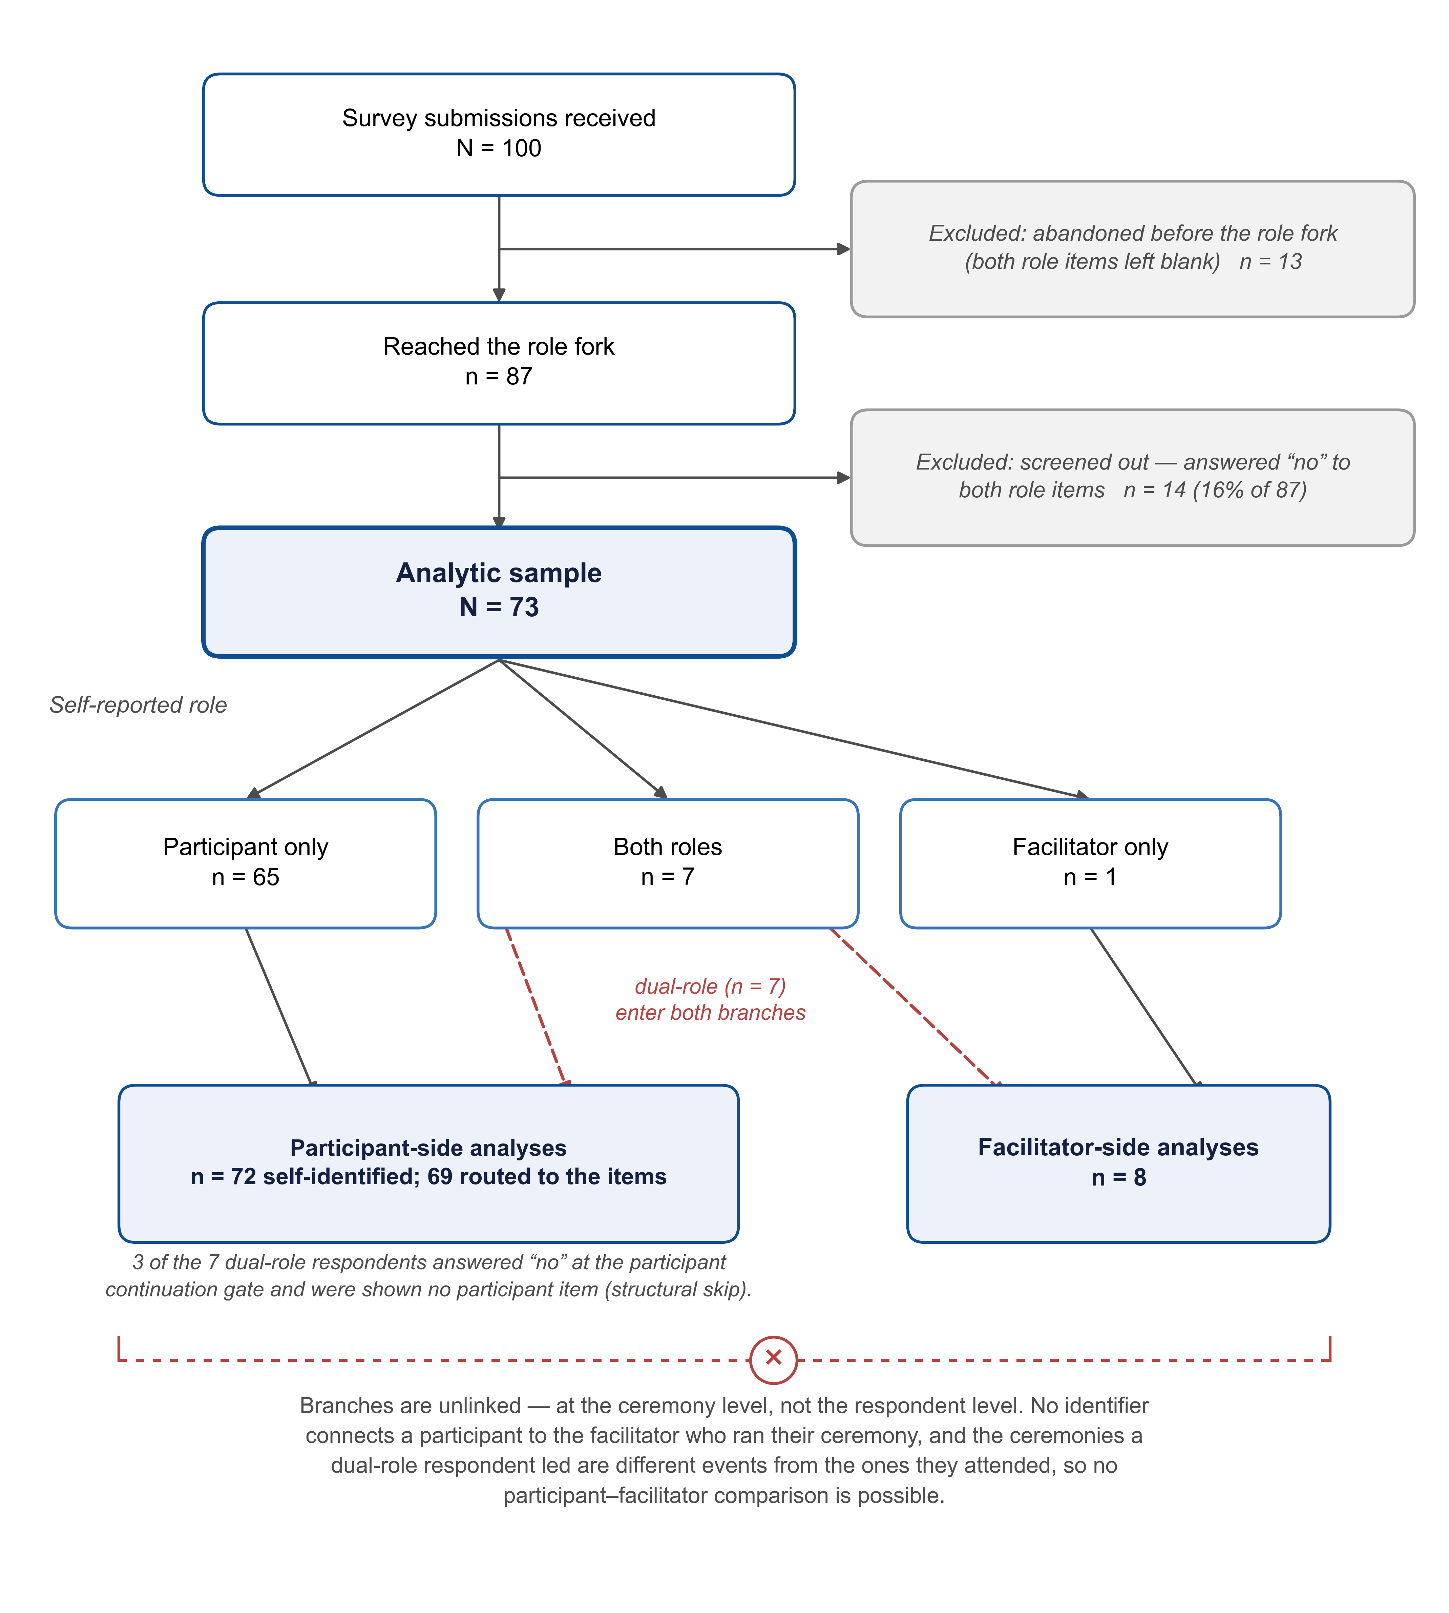
Figure 1. Sample construction and role structure. Of 100 submissions, 13 were abandoned before the role fork and 14 of the remaining 87 screened out by answering “no” to both role items, leaving an analytic sample of $N=73$. Roles are not mutually exclusive: the 7 dual-role respondents enter both branches, giving 72 participant-side and 8 facilitator-side reports, and 3 of those 7 were stopped by the participant continuation gate, so 69 respondents were actually routed to the participant items. The branches are unlinked at the ceremony level — no identifier connects a participant to the facilitator who ran their ceremony, and the ceremonies a dual-role respondent led are different events from those they attended — so no participant–facilitator comparison is possible.
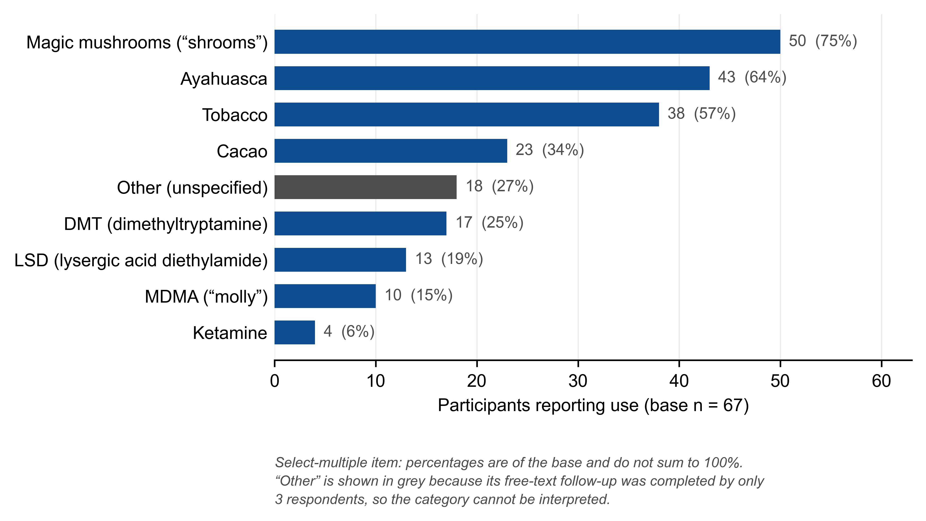
Figure 2. Substances used across all ceremonies attended, participant-reported (select-multiple; base $n=67$ participants answering). Bars are labeled with the count and the percentage of that base; because respondents could select more than one substance, percentages need not sum to 100%. The “other” bar is drawn in grey because its free-text follow-up was completed by only 3 respondents, leaving the category uninterpretable. Distinct from the facilitator-led substance variable and from the most-recent-ceremony substance variable.
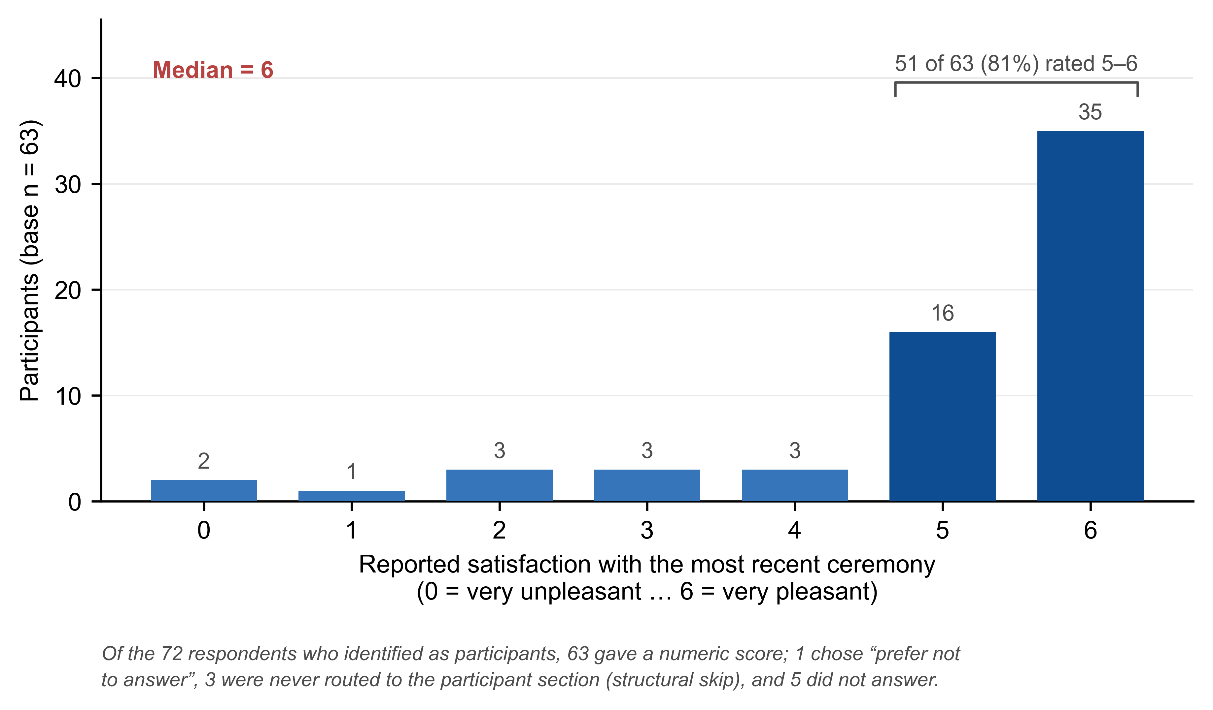
Figure 3. Distribution of reported satisfaction with the most recent ceremony (0 = very unpleasant to 6 = very pleasant). Of the 72 respondents identifying as participants, 63 gave a numeric score and form the base; the remaining 9 comprise 1 “prefer not to answer”, 3 structural skips at the continuation gate, and 5 item nonresponses. Median 6, with 51 of 63 (81%) answering 5 or 6 — the ceiling that limits how much variance any predictor can explain.
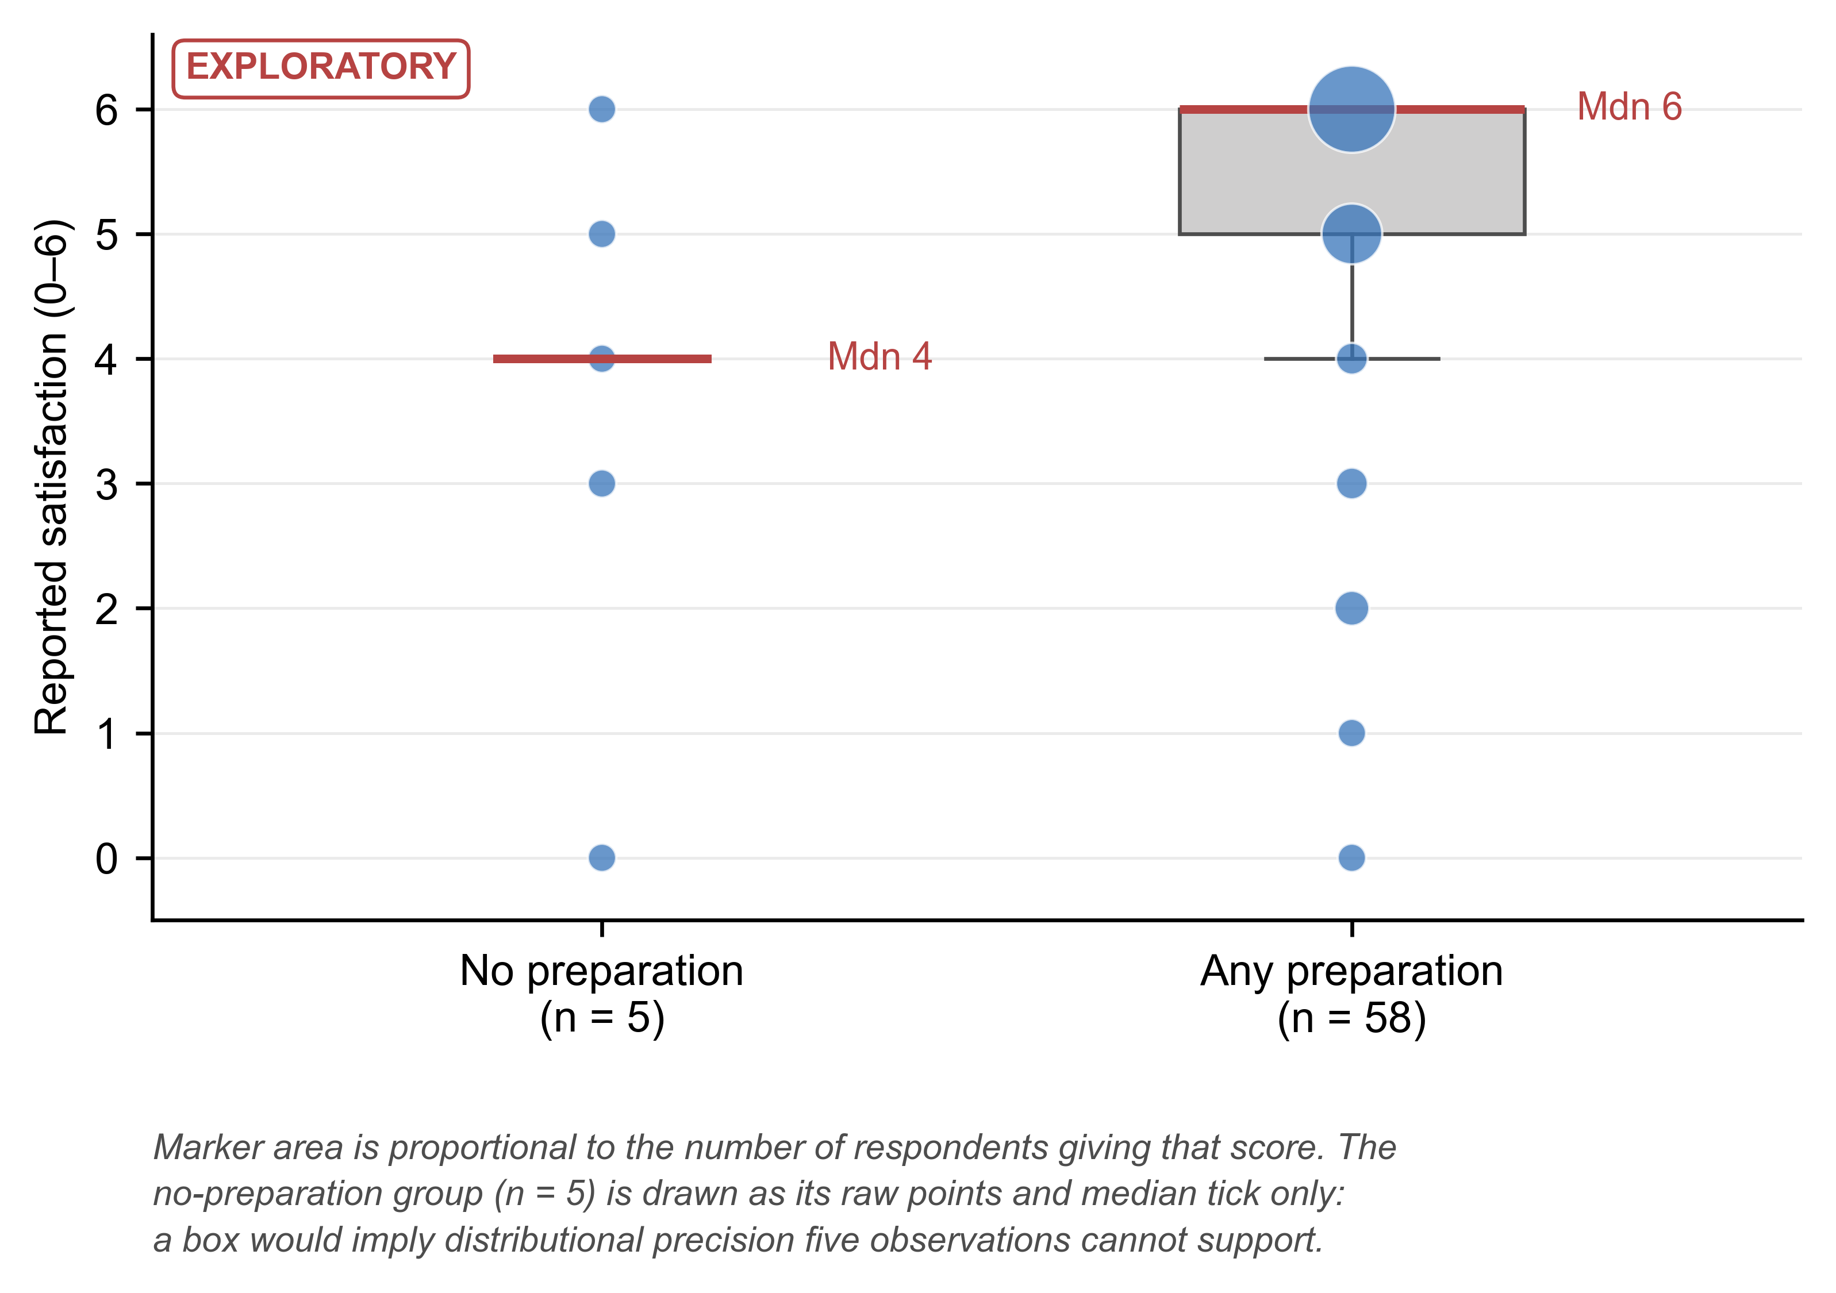
Figure 4. Reported satisfaction by self-directed preparation status. Any preparation, $n=58$ answering the outcome (median 6, IQR 5–6); no preparation, $n=5$ (median 4, IQR 3–5). Marker area is proportional to the number of respondents giving each score, since scores tie heavily at the ceiling. The no-preparation group is drawn as its five raw points and a median tick rather than a box, which at that $n$ would imply distributional precision the data cannot support. Exploratory: this comparison is suggestive, not confirmatory.

