Ceremonial Entheogen Use in Puerto Rico: A Descriptive Survey of Participants and a Small Facilitator Subsample
Jean C. Vélez Rodríguez¹
Julián M. Hernández Torres^{1,2}
Angélica N. Grajales Roldán⁶
Juliana Millán-Torres³
Paulina Rullán Farinacci^{4,5}
Adriana I. Rodríguez Massa⁶
Carolina Riollano³
Yamil O. Ortiz Ortiz^{6,7}
¹Puerto Rico Institute for Psychedelic Science, Medicine & Awareness, San Juan, Puerto Rico
²Behavioral Sciences Research Institute, University of Puerto Rico, Medical Sciences Campus, San Juan, Puerto Rico
³Colectivo Psicodélico de Puerto Rico, Colectivo Psicodélico Inc., and Within Psychological Services, San Juan, Puerto Rico
⁴Department of Psychiatry, School of Medicine, University of Puerto Rico, Medical Sciences Campus, San Juan, Puerto Rico
⁵Pravan Foundation
⁶Department of Psychology, University of Puerto Rico, Río Piedras Campus, San Juan, Puerto Rico
⁷Centro de Investigaciones Sociales, Facultad de Ciencias Sociales, University of Puerto Rico, Río Piedras Campus, San Juan, Puerto Rico
Corresponding author: Jean C. Vélez Rodríguez, jean.velez5@upr.edu
Abstract
Ceremonial entheogen use occurs in Puerto Rico outside clinical and regulatory structures, and the practices surrounding it have not been described. We conducted an anonymous, bilingual, cross-sectional online survey of adults aged 21 and over reporting involvement in entheogen-assisted ceremonies in Puerto Rico, recruited by convenience and chain referral, February–June 2026. Of 100 submissions, 73 identified a role: 72 as participants and 8 as facilitators, 7 of whom were both. Respondents were middle-aged (mean 42.4 years), mostly university-educated, and almost all resident in Puerto Rico. Most recent ceremonies were typically single, multi-hour events in natural settings involving psilocybin mushrooms or ayahuasca, and satisfaction was strongly ceiling-weighted (median 6 of 6). Preparation was near-universal among those answering while pre-ceremony screening was not, and the small facilitator subsample described training and emergency planning as informal rather than credentialed. Five of 67 participants answering reported ever experiencing non-consensual physical contact during a ceremony, and 2 of 65 at their most recent one. A comparison of any preparation against none, specified in the analysis plan before testing, was positive in direction but rests on five unprepared respondents and is exploratory. These findings describe this sample only and support no prevalence or causal claim.
Keywords: entheogens; psychedelics; ceremonial use; Puerto Rico; harm reduction; survey research

1 Introduction
Ceremonial use of entheogens, psilocybin-containing mushrooms, ayahuasca, and related preparations taken in structured group or guided settings, has become substantially more visible across the Americas over the past two decades, largely outside the clinical-trial infrastructure that generates most of the contemporary research literature (Carvalho et al., 2025). The resulting evidence base is asymmetric. Randomized clinical trials characterize carefully screened participants receiving standardized doses under monitored conditions, and its samples remain ethnoracially narrow (Hughes and Garcia-Romeu, 2024; Marcus and Rush, 2026). On the other hand, community ceremonial practice is documented mainly through ethnographic and qualitative work, with comparatively few survey-level descriptions of who takes part and under what conditions (Carvalho et al., 2025; Teixeira et al., 2026).
Puerto Rico occupies an unusual position as a Spanish-speaking Caribbean jurisdiction where psilocybin, DMT, and related compounds remain Schedule I under the federal Controlled Substances Act (United States Congress, 1970) and the territory’s aligned statute (Legislative Assembly of Puerto Rico, 1971), outside the decriminalization and regulated-access reforms reshaping parts of the United States (Siegel et al., 2023). It is also a setting with a long-documented tradition of spiritually framed healing practice (i.e. espiritismo and related practices) described in the clinical and public health literature for more than four decades (Koss, 1980; Comas-Díaz, 1981; Bird and Canino, 1981; Zerrate et al., 2022).
Local survey evidence on entheogen use is nonetheless minimal. To the author’s knowledge, only one published Puerto Rico–specific survey exists (Vélez Rodríguez et al., 2026). This survey characterized psilocybin use patterns, motivations, and personality correlates. Another survey, as part of an unpublished thesis, examined perceptions of psilocybin mushrooms in a non-random sample of university students (Doelter Morales and Martínez Miranda, 2020). However, neither study collected data on ceremonial entheogen use patterns, outcomes, practices, and safety. In addition, both studies focused mainly on psilocybin use without expanding on other substance use patterns, and neither describes how ceremonies are conducted. No descriptive characterization of ceremonial use of entheogens in Puerto Rico currently exists.
A descriptive characterization can contribute to an evidence base on ceremonial entheogen use in Puerto Rico in three ways. First, it establishes whether practices reported here resemble a harm-reduction approach. Harm-reduction considerations include but are not limited to: preparation, screening, environment, ethical and legal issues, managing emergencies or difficult experiences, and integration of the experience (Gorman et al., 2021; Pilecki et al., 2021; Dutton et al., 2025). Second, it provides initial data on safety outcomes and adverse experiences, such as inappropriate sexual contact and sexual abuse, within these communities in Puerto Rico (Kruger et al., 2025; Peluso et al., 2020). Third, it produces instrument-level evidence that provides insights into future research directions and the necessity of higher-powered studies.
This study aims to describe a sample of participants and facilitators of ceremonial entheogen use in Puerto Rico, and to examine bivariate associations between preparation and reported ceremony outcomes and between participant-reported facilitator practices and perceived safety.

2 Methods

2.1 Design, ethics, and consent
This study employed a cross-sectional, self-administered, non-probability online survey design. We collected data on a sample of adults 21 and older reporting prior involvement in entheogen-assisted spiritual ceremonies in Puerto Rico using a self-administered questionnaire fielded on KoboToolbox (KoboToolbox, 2026) between 24 February and 9 June 2026. Participation was fully anonymous: no names, dates of birth, or other personal identifiers were collected. The information sheet (purpose, procedures, risks, voluntariness, data retention) was presented within the questionnaire itself. Respondents who read it and proceeded thereby gave informed consent. No signed consent document was collected or required. Every item offered a “prefer not to answer” option and withdrawal was permitted at any point. No compensation was offered, and mental-health resources were listed for the participants’ benefit. Reporting follows STROBE. The study was approved by the Institutional Review Board of the University of Puerto Rico, Medical Sciences Campus (OPPHIE 2509472552).

2.2 Recruitment and sample construction
Recruitment used convenience sampling with chain referral, promoted through Facebook, Instagram, Twitter/X, and WhatsApp and by bulletin-board announcements at the University of Puerto Rico Río Piedras and Medical Sciences campuses. Inclusion criteria were age 21 or older, ability to read and write in Spanish, access to an internet-connected device, and prior participation in an entheogen-assisted spiritual ceremony in Puerto Rico.
Sample construction is shown in Figure 1. Out of 100 submissions, 13 were abandoned and 14 of the remaining 87 screened out (16%), leaving the analytic sample of N = 73. Seven of the 8 facilitators also identified as participants.

2.3 Instrument
To the author’s knowledge, no validated Spanish-language instrument for characterizing ceremonial entheogen use exists for Puerto Rico, so the questionnaire was purpose-built by the research team, whose members had direct experience with ceremonial psychedelic/entheogen practice in Puerto Rico and used that experience to inform item content. Development proceeded in stages: an initial list of target constructs was drawn from the study’s research questions and hypotheses; a pool of candidate items was drafted from that list; items were then reviewed iteratively by the full team to correct errors, consolidate and adjust response categories, and revise wording for clarity and relevance; and items judged out of scope, irrelevant, or too sensitive for the study’s objectives were removed. The retained item set was translated from Spanish to English by a professional translator using a direct-translation technique, after which the team performed a final bilingual pass to check grammatical accuracy and equivalence between language versions.
No formal pretesting (cognitive interviewing, expert content-validity review, or a pilot administration) preceded fielding, and no back-translation was performed. The present analysis therefore constitutes the first reliability evidence for the instrument rather than a validation of an existing one. The questionnaire was administered as an anonymous, self-administered online survey (KoboToolbox XLSForm), with branching skip logic gating sociodemographic and role-specific items behind an eligibility/consent screen and a subsequent role self-identification item. Nearly every item offered a “prefer not to answer” option. Seven attention-check items were included, administered separately by branch (three for facilitators, four for participants) rather than uniformly across the full sample. Completion was estimated at 20–25 minutes. Verbatim English wording and response anchors for the items carrying the principal results appear in Table 1. Because both language versions live in one form rather than in two parallel questionnaires, every respondent saw the same item set regardless of the language they answered in.

2.4 Measurement
The primary outcome, satisfaction with the most recent ceremony, was a 0 (very unpleasant)–6 (very pleasant) ordinal item. The primary exposure captured self-directed preparation for these ceremonies, aside from facilitator instructions (yes/sometimes/no). The two differ in referent: the outcome asks about one event, the exposure about a general practice. Secondary participant-side measures (comfort and safety, trust in the facilitator, prior knowledge of the facilitator’s background, screening questions asked, and prior disclosure to a health professional) all refer to the most recent ceremony. The non-consensual contact item asked whether the respondent had ever experienced unexpected or unclearly consented physical touch during a ceremony, explicitly including moments of uncertainty or absent recall. A parallel most-recent-ceremony item is also reported. Facilitator-branch items covered training, screening approach, distress-response protocol, emergency planning, and crisis signs witnessed. Three substance variables were kept distinct and never merged: facilitator-led, participant (all ceremonies attended), and most-recent-ceremony. Attention checks were branch-specific.

2.5 Missing data and data quality
Missingness was decomposed per item into four mutually exclusive states: answered substantively, answered “prefer not to answer” or “not sure”, left blank while routed, and never shown by the skip logic (Table 2). Almost all apparent missingness on the participant items is structural: 5 of the 72 participant-side respondents were never routed to the participant section, and among the 67 who were, genuine item nonresponse never exceeded 3 respondents (4.5%) on any item, the maximum falling on the satisfaction outcome. Retained non-response categories were more common than blanks and concentrated on a single item, whether the facilitator asked screening questions (12 of the 67 answering “not sure” or “prefer not to answer”). On the facilitator side each item was left blank by 1 of the 8 routed respondents. No imputation was performed, and no item approached a level of nonresponse at which it would be warranted.
Attention checks were branch-specific rather than uniform so each respondent was judged only on their own branch. Facilitators answered 21 of 21 attention items correctly; participants answered 241, of which 3 were incorrect, concentrated in 2 respondents. Per protocol both were flagged and retained, not dropped. Because the platform never populated its duplicate-detection field and recorded no IP or device information, duplicate submissions were screened manually on the respondent-chosen nickname and password. Exactly one exact nickname-and-password match exists across the 100 submissions, and its earlier member is a blank abandoned submission already excluded before analysis; nickname-only and password-only repeats were common Spanish words that respondents in this thematic context would plausibly choose independently. No analytic row required exclusion on duplicate grounds.

2.6 Statistical approach
The outcome distribution was strongly ceiling-weighted and several exposures had thin or unbalanced categories, so all tests were nonparametric: Mann–Whitney U, Kruskal–Wallis H, permutation χ² with 10,000 label permutations (seed 20260715) for thin contingency tables, and Fisher’s exact test at very small n. Effect sizes were rank-biserial r_{rb} with the common-language effect size, epsilon-squared ε², and Cramér’s V respectively, with Wilson 95% confidence intervals for prevalences.
The preparation-to-satisfaction comparison was designated in the analysis plan as the primary comparison before any test was run, and is reported uncorrected, with a tie-aware permutation test as a robustness check because the outcome is heavily tied. All other bivariate tests were assigned to four prespecified, thematically organized families, such as bivariate, substance-stratified, safety-domain, and legal-knowledge,each corrected jointly by the Benjamini–Hochberg procedure. Analyses were conducted in Python; the full pipeline is available (see Data availability).

2.7 Protocol deviations
Three deviations are reported transparently. The protocol’s preparation × integration design is not estimable: the instrument has no clean participant integration-received item, and the preparation split is badly unbalanced, so preparation was examined against the outcome directly and no integration measure is reconstructed anywhere. The protocol also specified crossing facilitator training and protocol items against participant-perceived safety; since facilitator self-report cannot be linked to the ceremony any participant attended, these would have paired unrelated events. Two participant-answerable proxies substitute for the first (prior knowledge of the facilitator’s background and whether screening questions were asked) facilitator self-report is presented separately and descriptively, and a facilitator-side readiness composite replaces the mixed one. Two skip-logic errors in the instrument were also identified and are described in the Limitations.

3 Results

3.1 Respondents
The analytic sample of 73 adults skewed middle-aged and highly educated (Table 3) with mean age 42.4 years, 49% women, 78% holding a bachelor’s degree or above, and 61% describing their economic situation as comfortable. Sixty-eight (94% of the 72 answering) reported residing in Puerto Rico. Free-text engagement was substantial relative to sample size: 37 open-text fields yielded 285 non-empty answers, roughly three-quarters in Spanish.

3.2 The ceremonial context
Participants reported extensive but not recent ceremonial histories. Among the 67 answering, the median number of lifetime ceremonies attended was 6 (IQR 3–12, range 1–250) against a median of 1 in the past 12 months (IQR 0–2), and 45% reported their last ceremony more than 12 months earlier (Table 4).
Across all ceremonies attended, participants most often reported magic mushrooms, ayahuasca, tobacco, and cacao, followed by an “other” category that only 3 of the 18 selecting it specified via free text, and then DMT, LSD, MDMA, and ketamine, in descending order (Figure 2, base n = 67). For the most recent ceremony, the individually reportable groups were magic mushrooms (n = 31) and ayahuasca (n = 23), every remaining substance being pooled into a combined group (n = 11) under a prespecified rule.
The most recent ceremony was typically a discrete, multi-hour, outdoor event: a single ceremony rather than a retreat for 74%, a natural setting for 55%, and most often either 4–6 hours or an overnight event of roughly 12 hours or more (Table 4).

3.3 Preparation, screening, and prior knowledge
Preparation was near-universal among those answering: 82% prepared and 9% sometimes did, against 9% reporting none (Table 5). Participant-observable facilitator practices were common but not uniform as 81% knew about the facilitator’s background beforehand, but only 59% reported being asked screening questions, against 23% who were not and 11% who were unsure. Disclosure outside the ceremonial context was uncommon: 12% had spoken to a health professional about their participation beforehand. Among the 54 respondents who answered all three of preparation, prior knowledge of the facilitator’s background, and screening, every one reported at least one of them.

3.4 Experience and perceived safety
Reported satisfaction was overwhelmingly positive and strongly ceiling-weighted: 63 of the 72 participants gave a numeric score, with a median of 6 and the mode at the scale maximum (Figure 3’s caption decomposes the remainder into structural skips, item nonresponse, and a “prefer not to answer”). Perceived in-ceremony comfort and safety was similarly high and undifferentiated, returning a median of 3 in both facilitator-background subgroups large enough to characterize (n = 54, n = 8; the third, n = 2, is not) and differing neither by that background knowledge nor by whether screening questions were asked. Trust in the facilitator was the one participant-side comparison differing at the uncorrected level: median 4 (IQR 3–4) among the 54 who knew the facilitator’s background beforehand against 3 among both smaller groups (H = 8.15, p = 0.017, tie-aware permutation p = 0.010, ε² = 0.10; thinnest group n = 3), and did not survive correction (q = 0.085). Satisfaction did not differ significantly by most-recent-ceremony substance (H = 4.98, p = 0.083, q = 0.166).
Of the 67 participants answering the lifetime non-consensual contact item, 61 (91%) reported no such contact, 5 (7%) reported that it occurred, and 1 was unsure; the within-sample proportion was 7.5% (Wilson 95% CI 3.2–16.3). The parallel most-recent-ceremony item, answered by 65, returned 2 affirmative and 62 negative, with 1 declining: of the 5 reporting the experience ever, 2 placed it at the most recent ceremony and 3 did not. Non-consensual contact was associated with prior knowledge of the facilitator’s background at the uncorrected level (permutation χ² = 18.90, p = 0.047, V = 0.38, n = 67) but not with screening (permutation χ² = 13.64, p = 0.094, V = 0.32, n = 66); neither survived correction (both q = 0.188), nor did the comparison by substance (p = 0.486).

3.5 Facilitator practice
Eight respondents identified as facilitators, 7 of whom also identified as participants; the eighth, the sole facilitator-only respondent, answered no facilitator item, so every proportion below is of the 7 who answered. Preparation for the role came from personal experience and self-study (6 of 7), mentorship or apprenticeship (4), and family or ancestral tradition (3); none reported formal certification or academic coursework. Screening was conversational rather than structured: 6 began with an interview or conversation, 4 asked about medical history and 4 about current medication, 3 asked about mental-health challenges, and 2 said they welcome anyone who feels called to take part. Responses to a difficult experience were likewise non-clinical — singing, music, or sound (5), grounding exercises (4), calming words (3), consented physical touch (2), with one reporting use of a “trip killer” medication and one never having faced the situation. Six gave preparation instructions beforehand and six worked outdoors or near nature. Dosing was mostly devolved to participants (3 of 7). Emergency planning was informal or unwritten (4) or dependent on the situation (3), and none selected a formal written plan.
All 7 reported witnessing crisis signs, most commonly disorientation, feeling overwhelmed, fainting, difficulty breathing, or panic attacks (each n = 3), and less often signs of self-harm or suicidal thoughts (n = 2). These counts are not rates: three respondents reported several signs each, two reported a single sign, one answered only “I’m not sure” and one only “other”, so the distribution concentrates in three people. Association tests within this branch returned undefined odds ratios, Fisher’s exact p = 0.143 against the distress-response protocol and p = 0.429 against the emergency plan, with two further tests unrunnable for want of non-degenerate data; every 2×2 table here has at least one margin of two or fewer. They establish an analytic approach for a larger facilitator sample rather than evidence for or against any association.

3.6 Preparation and reported satisfaction
Among the 63 participants, 58 reported some preparation (median 6, IQR 5–6) and 5 reported none (median 4, IQR 3–5; Figure 4); a sixth respondent reporting no preparation did not answer the outcome, which is why this base is 5 rather than the 6 in Table 5. A Mann–Whitney comparison returned U = 218.0, p = 0.041, r_{rb} = 0.50, and a common-language effect size of 0.75; a tie-aware permutation test gave p = 0.024.

4 Discussion

4.1 A structurally informal practice landscape
The most stable picture this sample supports is a practice organized around informal, relationally transmitted expertise rather than credentialed or documented protocol. Among the facilitators who self-reported, training came from personal experience, self-study, mentorship, and family tradition; none reported formal certification or academic coursework, and emergency planning was uniformly informal or conditional. This sits at some distance from the structured preparation, screening, and difficult-experience protocols that harm-reduction frameworks for psychedelic settings assume (Dutton et al., 2025), is consistent with survey evidence that people who use psychedelics support clearer practice standards (Kruger et al., 2023), and is a reminder that in community settings the containing structure is the setting itself rather than a protocol (Hartogsohn, 2017).
On the participant side the informality reads differently. Preparation was near-universal among those answering, but roughly a quarter reported that no screening questions were asked and a further group was uncertain. The asymmetry is worth separating: preparation is something participants largely do, whether self-directed or instructed, whereas screening must be done to them, and was substantially less consistent here. If that asymmetry holds in a larger sample it would locate the intervention target on the facilitator side, which this sample cannot establish.
The demographic profile, middle-aged, university-educated, economically comfortable, resembles ceremony-attender cohorts described elsewhere, though older and more educated. Its mean age of 42.4 years and 78% holding a bachelor’s degree or above compare with 37.6 years and 49% degree-holding among North America neo-shamanic ayahuasca ceremony attenders (Pagni et al., 2025), 37.0 years among ceremonial ayahuasca retreat attenders in the Peruvian Amazon (Ruffell et al., 2021), and 40 years with 59% degree-holding in a large international naturalistic psilocybin cohort (Nayak et al., 2023); the 49% here identifying as women falls inside the 44–61% those three report, as it does for international psychedelic-survey samples (Kopra et al., 2023; Robinson et al., 2026) and the psilocybin-specific Puerto Rico survey (Vélez Rodríguez et al., 2026). That convergence is best read as evidence about who responds to online psychedelic surveys, not about who attends ceremonies (Bethlehem, 2010).

4.2 A ceiling that limits what satisfaction can reveal
Reported satisfaction clustered at the top of its scale, and a perceived-life-impact item had no variance at all, a substantive finding, consistent with naturalistic cohorts reporting predominantly positive appraisals (Nayak et al., 2023; Ruffell et al., 2021), but one that also constrains the analysis severely. An outcome with almost no variance in the lower range cannot discriminate between groups, and the null results across the corrected families are consistent with that constraint rather than with the absence of any association. Ceiling behavior is a known property of self-report scales for hallucinogen experience rather than a peculiarity of this instrument (Bouso et al., 2016). Satisfaction, measured this way, is close to exhausted as an outcome here; future work needs measures with headroom in both directions before group comparisons on experience quality can be informative.

4.3 Safety signals the design can identify but not quantify
Five of 67 participants answering reported non-consensual physical contact at some point, two of them at their most recent ceremony, and facilitators reported having witnessed crisis signs at a base of seven at which no rate is estimable. These come from different reporters and cannot be combined. That such reports appear at all is consistent with survey-based evidence on boundary violations in naturalistic psychedelic settings (Kruger et al., 2025; McNamee et al., 2023) and with the community harm-reduction literature that developed in response (Peluso et al., 2020), and the crisis signs described are of a kind documented at non-trivial rates in large naturalistic samples (Carbonaro et al., 2016; Bouso et al., 2022). The item used here was deliberately broad, covering unexpected touch and uncertain or unremembered consent, so the figure should not be read against a narrower legal or clinical standard.
The study establishes that these events occur among respondents and that an instrument of this kind can capture them; it cannot establish how often they occur, in whom, or under what conditions. The cross-tabulations against participant-side proxies are powered neither to confirm nor to rule out an association and did not survive correction, so treating any of them as an actionable signal would overstate them considerably. The safety domain justified its inclusion by identifying a measurement priority, not by producing an estimate.

4.4 Limitations
The sample was non-probability, unweighted, and self-selected; the concentration in higher education and favorable economic self-ratings describe who responded, not who participates, and nothing here supports a statement about how common ceremonial entheogen use is in Puerto Rico. Roughly 6% of those answering the residency item lived outside Puerto Rico, further tempering a Puerto Rico–specific reading, and eligibility criteria were self-assessed rather than enforced.
Role subsamples were small and unevenly sized, and the facilitator branch of eight supports no rate and no association test. Because 7 of those 8 also answered as participants, the facilitator-side and participant-side statistics are not independent samples and should not be read as two separate groups. The reports are nonetheless unlinked at the ceremony level, which eliminated the protocol’s integration-proxy comparison, its perceived-safety-by-training analysis, and its mixed harm-reduction composite.
The preparation-to-satisfaction comparison is this study’s most fragile result. The direction was positive and the effect sizes were not small, but the no-preparation group contained five respondents answering the outcome. Nothing here establishes the finding. The preparation split remains the binding constraint on the primary analysis, so any successor study will need either a sampling strategy that reaches unprepared participants in usable numbers or a question that does not depend on that contrast.
Two referent mismatches limit the associations reported here. The safety cross-tabulations pair a lifetime outcome with most-recent-ceremony exposures, so for the 3 respondents who reported non-consensual contact at some ceremony other than their most recent one, exposure and outcome describe different events. The primary comparison pairs a most-recent-ceremony outcome with a general-practice exposure.
All measures were single-timepoint self-report, and for most respondents the most recent ceremony was distant (45% reported more than 12 months ago) so recall error is plausible and unmeasurable. The instrument contains no integration measure, is unvalidated, and produced only preliminary two-item reliability evidence (α = 0.58 for trust and in-ceremony comfort; α = 0.86 for the two legal-knowledge items). Two skip-logic errors were identified in the fielded form and are reported so a future deployment can correct them. A follow-up item asking why a respondent felt uncomfortable or unsafe required the comfort-and-safety variable to equal two different values at once, making it structurally unreachable rather than merely unpopular: no respondent could have answered it. A general legal-worry item was gated on the general legal-knowledge item equalling “prefer not to answer”, the opposite of what a parallel item would require, so only six respondents reached it while its most-recent-ceremony counterpart was asked broadly (n = 57); the two are neither comparable nor parallel, and the general item is excluded from all analyses. Two response categories are uninterpretable as collected: the substance “other” option, specified in free text by only 3 of the 18 who selected it, and the 12 of 67 respondents answering “not sure” or “prefer not to answer” on whether they were screened—the item on which retained non-response concentrated.

4.5 Conclusion
Within this self-selected sample of 73 adults, ceremonial entheogen use in Puerto Rico is described by a middle-aged, university-educated, overwhelmingly Puerto Rico–resident group whose most recent ceremonies were typically single, multi-hour, outdoor events described in strongly positive terms. Preparation was near-universal while screening was not, and the small facilitator subsample described training and emergency planning as informal. Five of 67 reported non-consensual physical contact, and facilitators reported crisis events at a base too small to rate. These findings describe this sample alone, support no prevalence estimate and no inference about what any practice produces, and take their principal value from identifying what a properly powered successor study would need to measure, sample, and correct.

Author contributions
JCVR, JMHT, JMT, PRF and CR conceived the study. JCVR and JMHT led protocol development and ethics submission, and YOOO supervised the project. JMHT led instrument development, and JCVR, JMT, PRF, CR, ANGR, and AIRM contributed to instrument development and review. JCVR led data curation, formal analysis, and manuscript drafting. JMHT contributed to methodology and analysis review. JMT, PRF, and CR contributed to interpretation and clinical/community context. ANGR and AIRM contributed to recruitment and data collection. All authors reviewed and approved the final manuscript.

Funding
This research received no specific grant from any funding agency in the public, commercial, or not-for-profit sectors.

Competing interests
Several authors are affiliated with organizations that conduct, advocate for, or provide services related to psychedelic and entheogen research and practice, including the Puerto Rico Institute for Psychedelic Science, Medicine & Awareness and the Colectivo Psicodélico de Puerto Rico. These affiliations are disclosed as potential non-financial competing interests. No author received financial support from, or holds a financial interest in, any commercial entity with an interest in the subject matter of this article.

Data availability
The anonymous survey data and the complete analysis code that generates every result reported here will be deposited in a public repository on publication, and the digital object identifier will be recorded here. The data contain no direct identifiers by design. Until deposit, both are available from the corresponding author. Every number reported here is generated by an executable Python pipeline that reads the raw survey export and the XLSForm directly, so all response decodes derive from the form rather than from hand-entered value maps; the pipeline regenerates the full analysis in one command.

Generative AI use declaration
Large language model tooling was used to assist with statistical analysis code development and with drafting and editing of this manuscript. All analyses were specified by the authors, all outputs were verified against the source data by the authors, and the authors take full responsibility for the content of this article.

References
Bethlehem, J. (2010). Selection bias in web surveys. International Statistical Review 78(2), 161–188.
Bird, H. R. and I. Canino (1981). The sociopsychiatry of espiritismo: Findings of a study in psychiatric populations of Puerto Rican and other Hispanic children. Journal of the American Academy of Child Psychiatry 20(4), 725–740.
Bouso, J. C., Ó. Andión, J. J. Sarris, M. Scheidegger, L. F. Tófoli, E. S. Opaleye, V. Schubert, and D. Perkins (2022). Adverse effects of ayahuasca: Results from the Global Ayahuasca Survey. PLOS Global Public Health 2(11), e0000438.
Bouso, J. C., E. J. Pedrero-Pérez, S. Gandy, and M. Á. Alcázar-Córcoles (2016). Measuring the subjective: Revisiting the psychometric properties of three rating scales that assess the acute effects of hallucinogens. Human Psychopharmacology: Clinical and Experimental 31(5), 356–372.
Carbonaro, T. M., M. P. Bradstreet, F. S. Barrett, K. A. MacLean, R. Jesse, M. W. Johnson, and R. R. Griffiths (2016). Survey study of challenging experiences after ingesting psilocybin mushrooms: Acute and enduring positive and negative consequences. Journal of Psychopharmacology 30(12), 1268–1278.
Carvalho, L. C., J. Encantado, H. Kettner, C. Timmermann, D. Veiga, and P. J. Teixeira (2025). A scoping review of research in naturalistic studies with psychedelics. Journal of Psychoactive Drugs, 1–14. Online First; volume/issue not yet assigned as of 2026-08-13.
Comas-Díaz, L. (1981). Puerto Rican espiritismo and psychotherapy. American Journal of Orthopsychiatry 51(4), 636–645.
Doelter Morales, F. M. and J. E. Martínez Miranda (2020). Hongos mágicos…más allá de las alucinaciones: Análisis político-social y estudio exploratorio del conocimiento y las percepciones que tiene la comunidad de la Universidad de Puerto Rico, Recinto de Río Piedras sobre el uso de los hongos psicodélicos a diciembre de 2020. M.a. thesis, University of Puerto Rico, Río Piedras Campus. Unpublished; repository record https://repositorio.upr.edu/handle/11721/2540. No DOI assigned.
Dutton, C., E. North, Y. Chun Tie, J. Oliva, and P. Skeffington (2025). Harm reduction practises for users of psychedelic drugs: A scoping review. Harm Reduction Journal 22(1), 158.
Gorman, I., E. M. Nielson, A. Molinar, K. Cassidy, and J. Sabbagh (2021). Psychedelic harm reduction and integration: A transtheoretical model for clinical practice. Frontiers in Psychology 12, 645246.
Hartogsohn, I. (2017). Constructing drug effects: A history of set and setting. Drug Science, Policy and Law 3, 2050324516683325. Article number in place of page range, per the journal’s continuous-numbering convention.
Hughes, M. E. and A. Garcia-Romeu (2024). Ethnoracial inclusion in clinical trials of psychedelics: A systematic review. eClinicalMedicine 74, 102711.
KoboToolbox (2026). KoboToolbox. Computer software. Hosted survey platform used to build and field the XLSForm instrument; data collected 24 February – 9 June 2026.
Kopra, E. I., J. A. Ferris, A. R. Winstock, K. P. C. Kuypers, A. H. Young, and J. J. Rucker (2023). Investigation of self-treatment with lysergic acid diethylamide and psilocybin mushrooms: Findings from the Global Drug Survey 2020. Journal of Psychopharmacology 37(7), 733–748.
Koss, J. D. (1980). The therapist-spiritist training project in Puerto Rico: An experiment to relate the traditional healing system to the public health system. Social Science & Medicine. Part B: Medical Anthropology 14(4), 255–266.
Kruger, D. J., J. S. Aday, C. W. Fields, N. Kolbman, N. Glynos, J. Barron, M. Herberholz, and K. F. Boehnke (2025). Psychedelic therapist sexual misconduct and other adverse experiences among a sample of naturalistic psychedelic users. Psychedelic Medicine 3(1), 41–47.
Kruger, D. J., J. Barron, M. Herberholz, and K. F. Boehnke (2023). Preferences and support for psychedelic policies and practices among those using psychedelics. Journal of Psychoactive Drugs 55(5), 650–659.
Legislative Assembly of Puerto Rico (1971). Ley de Sustancias Controladas de Puerto Rico. Ley Núm. 4 de 23 de junio de 1971, según enmendada; codified at 24 L.P.R.A. § 2101 et seq. Puerto Rico’s territorial controlled-substances statute, aligned with the federal Controlled Substances Act.
Marcus, O. and B. Rush (2026). Psychedelics for the treatment of substance use disorders: A narrative review of the literature. Substance Use & Addiction Journal 47(1), 279–296. Published online first 2025-07-27; cited here to the 2026 print issue, 47(1):279–296.
McNamee, S., N. Devenot, and M. Buisson (2023). Studying harms is key to improving psychedelic-assisted therapy—participants call for changes to research landscape. JAMA Psychiatry 80(5), 411–412. CrossRef records the first page only (411).
Nayak, S. M., H. Jackson, N. D. Sepeda, D. S. Mathai, S. So, A. Yaffe, H. Zaki, T. J. Brasher, M. X. Lowe, D. R. P. Jolly, F. S. Barrett, R. R. Griffiths, J. C. Strickland, M. W. Johnson, H. Jackson, and A. Garcia-Romeu (2023). Naturalistic psilocybin use is associated with persisting improvements in mental health and wellbeing: Results from a prospective, longitudinal survey. Frontiers in Psychiatry 14, 1199642.
Pagni, B. A., A. Halman, J. Sarris, R. Chenhall, M. P. Bogenschutz, and D. Perkins (2025). Long-term mental health and wellbeing outcomes associated with naturalistic ayahuasca consumption. Journal of Psychoactive Drugs, 1–11. Online First; volume/issue not yet assigned as of 2026-08-13.
Peluso, D., E. Sinclair, B. Labate, and C. Cavnar (2020). Reflections on crafting an ayahuasca community guide for the awareness of sexual abuse. Journal of Psychedelic Studies 4(1), 24–33.
Pilecki, B., J. B. Luoma, G. J. Bathje, J. Rhea, and V. F. Narloch (2021). Ethical and legal issues in psychedelic harm reduction and integration therapy. Harm Reduction Journal 18(1), 40.
Robinson, J., N. Wallace, E. Cassidy, S. Lake, and P. Lucas (2026). Field notes from inner space: Global psychedelic survey participants report health benefits, personal growth, and life transformations. Contemporary Drug Problems. Online First; volume/issue/pages not yet assigned as of 2026-08-13.
Ruffell, S. G. D., N. Netzband, W. Tsang, M. Davies, A. Inserra, M. Butler, J. J. H. Rucker, L. F. Tófoli, E. L. Dempster, A. H. Young, and C. J. A. Morgan (2021). Ceremonial ayahuasca in amazonian retreats—mental health and epigenetic outcomes from a six-month naturalistic study. Frontiers in Psychiatry 12, 687615.
Siegel, J. S., J. E. Daily, D. A. Perry, and G. E. Nicol (2023). Psychedelic drug legislative reform and legalization in the US. JAMA Psychiatry 80(1), 77–83.
Teixeira, P. J., J. Encantado, H. D. Amaro, D. Veiga, L. C. Carvalho, M. Á. Alcázar-Córcoles, J. Hallak, R. G. Dos Santos, J. C. Bouso, and M. Kohek (2026). Ayahuasca and public health III: Health status of a sample of ayahuasca ceremony attenders in Portugal. Journal of Psychoactive Drugs, 1–11. Online First, published 2026-03-19; volume/issue not yet assigned as of 2026-08-13. Cross-sectional online survey, n=203 ayahuasca ceremony attenders; closely analogous design published in the target journal.
United States Congress (1970). Controlled substances act. 21 U.S.C. § 812, Pub. L. No. 91-513, 84 Stat. 1242. Codifies the federal Schedule I classification of psilocybin, DMT, and other classic psychedelics that applies uniformly across U.S. states and territories, including Puerto Rico.
Vélez Rodríguez, J. C., Y. Duquesne-Maldonado, J. M. Hernández Torres, I. Da’Luz Sant’Ana, and C. M. Nazario (2026). Psilocybin use in Puerto Rico: Patterns, motivations, and personality correlates from an online survey. Journal of Psychedelic Studies. Online First, published 2026-04-15; volume/issue/pages not yet assigned as of 2026-08-13. Companion output from the same research team as the present study; distinct in scope (single-substance psilocybin use-pattern and personality survey vs. this study’s multi-substance ceremonial-practice and safety focus).
Zerrate, M. C., S. B. VanBronkhorst, J. Klotz, A. A. Caraballo, G. Canino, H. R. Bird, and C. S. Duarte (2022). Espiritismo and santeria: A gateway to child mental health services among Puerto Rican families? Child and Adolescent Psychiatry and Mental Health 16(1), 3.

Tables and Figures
Table 1: Verbatim English wording and response anchors for the items carrying the principal results. The questionnaire was a single bilingual XLSForm with Spanish as the default language and English selectable through the platform’s language switcher: every item carries both labels in the same form, so this is a native bilingual instrument rather than a post-hoc translation of a Spanish original. Note that the raw comfort-and-safety option list is stored best-first; the analysis re-orders it so that a higher code always means a more positive response, consistent with every other ordinal scale here.
Item (construct) | Wording | Response options
Satisfaction (primary outcome) | “From 0 to 6, how pleasant was the ceremony?” | 0 Very unpleasant; 1 Unpleasant; 2 Somewhat unpleasant; 3 Neither pleasant nor unpleasant; 4 Somewhat pleasant; 5 Pleasant; 6 Very pleasant; Prefer not to answer
Self-directed preparation (primary exposure) | “Aside from the facilitator’s instructions or recommendations, do you personally engage in preparation for these ceremonies?” | Yes; Sometimes; No; Prefer not to answer
In-ceremony comfort and safety | “During the ceremony, how would you describe your overall sense of comfort and safety?” | 0 I felt very uncomfortable or unsafe; 1 At times I felt somewhat uncomfortable or unsafe; 2 I felt mostly comfortable and safe; 3 I felt completely comfortable and safe; Prefer not to answer
Trust in facilitator | “How much did you trust the person who facilitated the ceremony?” | 0 Not at all; 1 A little; 2 Moderately; 3 A lot; 4 Completely; Prefer not to answer
Non-consensual physical contact (lifetime) | “Have you ever experienced physical touch during a ceremony that felt unexpected or that you did not clearly agree to beforehand? This could include moments where you were unsure, uncomfortable, or did not remember giving permission.” | Yes; No; I’m not sure; Prefer not to answer
Non-consensual physical contact (most recent ceremony) | “During your most recent ceremony, did you experience any physical touch that felt unexpected or that you didn’t clearly agree to beforehand?” | Yes; No; I’m not sure; Prefer not to answer

Table 2: Missing-data decomposition by item, analytic sample (N = 73). The four states are mutually exclusive and sum to 73 on every row. Substantive = a real response category; PNA/not sure = a retained non-response category, kept as its own category throughout and never dropped; Blank = routed to the item and left empty, the only genuine item nonresponse; Not routed = the skip logic never showed the item. Routing conditions are transcribed from the XLSForm relevant expressions, not inferred from empty cells.
Item | Substantive | PNA/not sure | Blank | Not routed
Sociodemographic branch — routed n = 73 of 73
Age | 72 | 0 | 1 | 0
Gender | 71 | 0 | 2 | 0
Education | 72 | 0 | 1 | 0
Economic situation | 70 | 2 | 1 | 0
Country of residence | 72 | 0 | 1 | 0
Participant branch — routed n = 67 of 73
Substances, all ceremonies attended | 67 | 0 | 0 | 6
Substance, most recent ceremony | 65 | 1 | 1 | 6
Time since last ceremony | 65 | 1 | 1 | 6
Place, most recent ceremony | 66 | 1 | 0 | 6
Format, most recent ceremony | 62 | 3 | 2 | 6
Duration, most recent ceremony | 65 | 0 | 2 | 6
Self-directed preparation | 67 | 0 | 0 | 6
Knew facilitator’s background | 66 | 1 | 0 | 6
Facilitator asked screening questions | 54 | 12 | 1 | 6
Spoke to a health professional beforehand | 62 | 3 | 2 | 6
Satisfaction, most recent ceremony | 63 | 1 | 3 | 6
Trust in facilitator | 65 | 2 | 0 | 6
In-ceremony comfort and safety | 65 | 1 | 1 | 6
Non-consensual contact, ever | 66 | 1 | 0 | 6
Non-consensual contact, most recent | 64 | 1 | 2 | 6
Facilitator branch — routed n = 8 of 73
Facilitator training background | 7 | 0 | 1 | 65
Emergency plan | 7 | 0 | 1 | 65
Crisis signs witnessed | 6 | 1 | 1 | 65

Table 3: Sociodemographic characteristics of the analytic sample (N = 73). Bases differ by item and are stated with each; counts are exact and percentages are of respondents answering.
Characteristic | Category | n | % answering
Age, years (n = 72) | Mean 42.4 (SD 11.9); median 41.0 (IQR 34.0–50.0); range 21–71
Gender (n = 71) | Woman | 35 | 49.3
 | Man | 30 | 42.3
 | Non-binary | 4 | 5.6
 | Prefer not to answer | 2 | 2.8
Education (n = 72) | Bachelor’s degree | 34 | 47.2
 | Master’s degree | 19 | 26.4
 | Associate’s degree | 7 | 9.7
 | High school diploma / GED | 6 | 8.3
 | Doctorate | 3 | 4.2
 | Prefer not to answer | 3 | 4.2
Economic situation (n = 72) | Comfortable | 44 | 61.1
 | Tight | 20 | 27.8
 | Difficult | 6 | 8.3
 | Prefer not to answer | 2 | 2.8
Country of residence (n = 72) | Puerto Rico | 68 | 94.4
 | United States | 3 | 4.2
 | Spain | 1 | 1.4

Table 4: Most-recent-ceremony context, participant-reported. Participant branch only: 72 respondents identified as participants, of whom 5 were not routed to these items and appear as structural skips: 3 dual-role respondents stopped by the continuation gate described in Methods, and 2 who answered “prefer not to answer” to the facilitator role item and so satisfied neither arm of the section’s relevance condition. Item nonresponse is the residual between the per-item base and 67. Counts are exact; percentages are of respondents answering the item.
Item | Category | n | % answering
Time since last ceremony | More than 12 months ago | 30 | 45.5
(n = 66 answering) | 2 to 6 months ago | 20 | 30.3
 | 7 to 12 months ago | 11 | 16.7
 | During the past month | 4 | 6.1
 | Prefer not to answer | 1 | 1.5
 | Structural skip (not routed) | 5 | —
 | Item nonresponse | 1 | —
Place (n = 67 answering) | Natural setting (forest, beach, mountain) | 37 | 55.2
 | Private home | 15 | 22.4
 | Retreat center or wellness facility | 9 | 13.4
 | Other | 3 | 4.5
 | Urban or residential space used informally | 2 | 3.0
 | Prefer not to answer | 1 | 1.5
 | Structural skip (not routed) | 5 | —
 | Item nonresponse | 0 | —
Format (n = 65 answering) | Single ceremony | 48 | 73.8
 | Retreat or series of ceremonies | 13 | 20.0
 | Prefer not to answer | 3 | 4.6
 | Not sure | 1 | 1.5
 | Structural skip (not routed) | 5 | —
 | Item nonresponse | 2 | —
Duration (n = 65 answering) | 4 to 6 hours | 19 | 29.2
 | Overnight (∼12+ hours) | 19 | 29.2
 | 7 to 12 hours | 14 | 21.5
 | 1 to 3 hours | 7 | 10.8
 | 2 to 3 days | 4 | 6.2
 | 4 to 6 days | 1 | 1.5
 | Less than 1 hour | 1 | 1.5
 | Structural skip (not routed) | 5 | —
 | Item nonresponse | 2 | —

Table 5: Participant-reported protective practices and safety outcomes. Bases are per item and differ because each is asked under its own skip condition; the 5 structural skips are the 3 dual-role respondents stopped by the continuation gate plus 2 who answered “prefer not to answer” to the facilitator role item and so were never routed to the participant section. Counts are exact throughout. The two non-consensual contact items differ in referent: the first asks about any ceremony ever, the second about the most recent ceremony only.
Item | Category | n | % answering
Self-directed preparation (n = 67) | Yes | 55 | 82.1
 | Sometimes | 6 | 9.0
 | No | 6 | 9.0
 | Structural skip / item nonresponse | 5 / 0 | —
Knew facilitator’s background (n = 67) | Yes | 54 | 80.6
 | A little | 8 | 11.9
 | No | 4 | 6.0
 | Prefer not to answer | 1 | 1.5
 | Structural skip / item nonresponse | 5 / 0 | —
Facilitator asked screening questions (n = 66) | Yes | 39 | 59.1
 | No | 15 | 22.7
 | Not sure | 7 | 10.6
 | Prefer not to answer | 5 | 7.6
 | Structural skip / item nonresponse | 5 / 1 | —
Spoke to a health professional beforehand (n = 65) | No | 54 | 83.1
 | Yes | 8 | 12.3
 | Prefer not to answer | 2 | 3.1
 | Not sure | 1 | 1.5
 | Structural skip / item nonresponse | 5 / 2 | —
Non-consensual physical contact, ever (n = 67) | No | 61 | 91.0
 | Yes | 5 | 7.5
 | Not sure | 1 | 1.5
 | Structural skip / item nonresponse | 5 / 0 | —
Non-consensual physical contact, most recent ceremony (n = 65) | No | 62 | 95.4
 | Yes | 2 | 3.1
 | Prefer not to answer | 1 | 1.5
 | Structural skip / item nonresponse | 5 / 2 | —

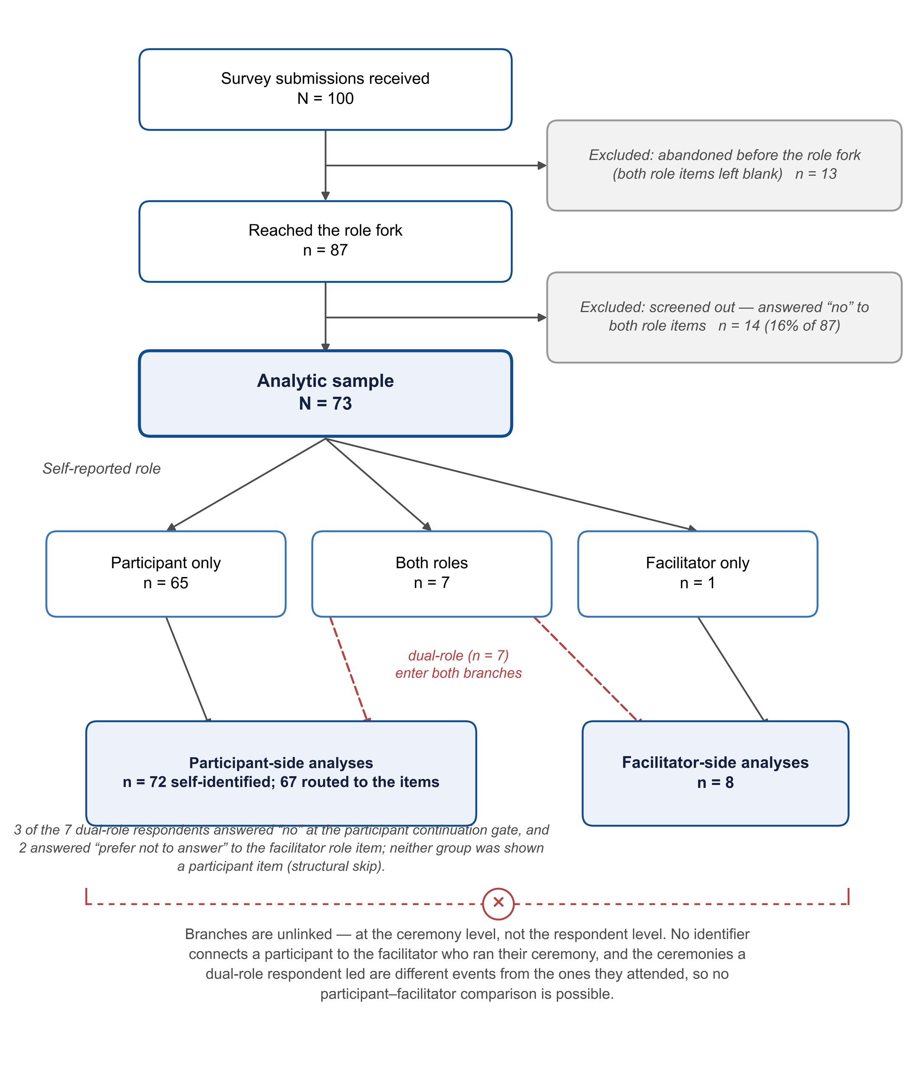
Figure 1: Sample construction and role structure. Of 100 submissions, 13 were abandoned before the role fork and 14 of the remaining 87 screened out by answering “no” to both role items, leaving an analytic sample of N = 73. Roles are not mutually exclusive: the 7 dual-role respondents enter both branches, giving 72 participant-side and 8 facilitator-side reports, and 3 of those 7 were stopped by the participant continuation gate and 2 further participants answered “prefer not to answer” to the facilitator role item, satisfying neither arm of the participant section’s relevance condition, so 67 respondents were actually routed to the participant items. The branches are unlinked at the ceremony level — no identifier connects a participant to the facilitator who ran their ceremony, and the ceremonies a dual-role respondent led are different events from those they attended — so no participant–facilitator comparison is possible.

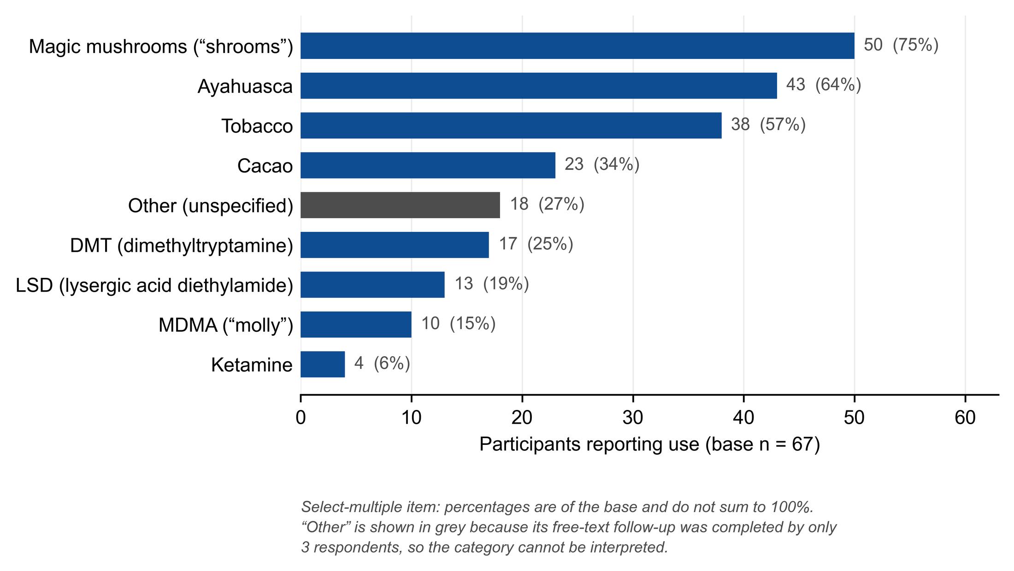
Figure 2: Substances used across all ceremonies attended, participant-reported (select-multiple; base n = 67 participants answering). Bars are labeled with the count and the percentage of that base; because respondents could select more than one substance, percentages need not sum to 100%. The “other” bar is drawn in grey because its free-text follow-up was completed by only 3 respondents. Distinct from the facilitator-led substance variable and from the most-recent-ceremony substance variable.

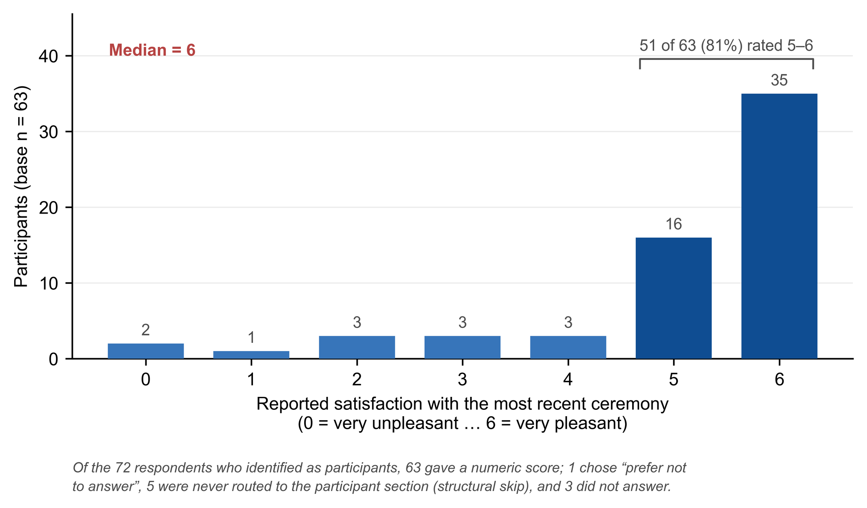
Figure 3: Distribution of reported satisfaction with the most recent ceremony (0 = very unpleasant to 6 = very pleasant). Of the 72 respondents identifying as participants, 63 gave a numeric score and form the base; the remaining 9 comprise 1 “prefer not to answer”, 5 structural skips, and 3 item nonresponses. Median 6, with 51 of 63 (81%) answering 5 or 6 — the ceiling that limits how much variance any predictor can explain.

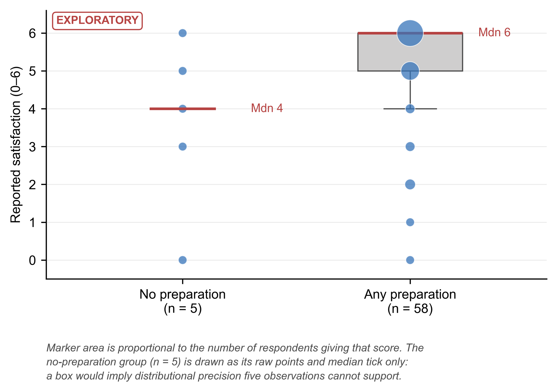
Figure 4: Reported satisfaction by self-directed preparation status. Any preparation, n = 58 answering the outcome (median 6, IQR 5–6); no preparation, n = 5 (median 4, IQR 3–5). Marker area is proportional to the number of respondents giving each score, since scores tie heavily at the ceiling. The no-preparation group is drawn as its five raw points and a median tick rather than a box, which at that n would imply distributional precision the data cannot support. Exploratory: this comparison is suggestive, not confirmatory.

