## **General Download Instructions**

You need to download following software to start the preprocessing steps– (i) **mtex-5.1.1.zip** (ii) **DREAM3D-6.4.197-Win64.zip** and (iii) **ParaView-5.5.0-RC4-Qt5-Windows-64bit.zip.**

# **DREAM3D**

1. Browse to the folder **DREAM3D-6.4.197-Win64** and double-click on **DREAM3D** executable. Browse to the directory **PRISMS_workshop_final -> Input -> HCP**, and load the pipeline **PRISMS_pipeline_HCP.json**.
2. Click on the **StatsGenerator** filter in the pipeline window. Click on the **ODF** button and click on the radiobox under **ODF parameters** displaying **Bulk Load From File**. Click on the **Select** button and choose the file containing the EBSD data. Choose the angle representation as **Euler** and the delimiter as **Space**, as in Fig. 1. Then click on the button displaying **Load Data** to generate the pole figures.

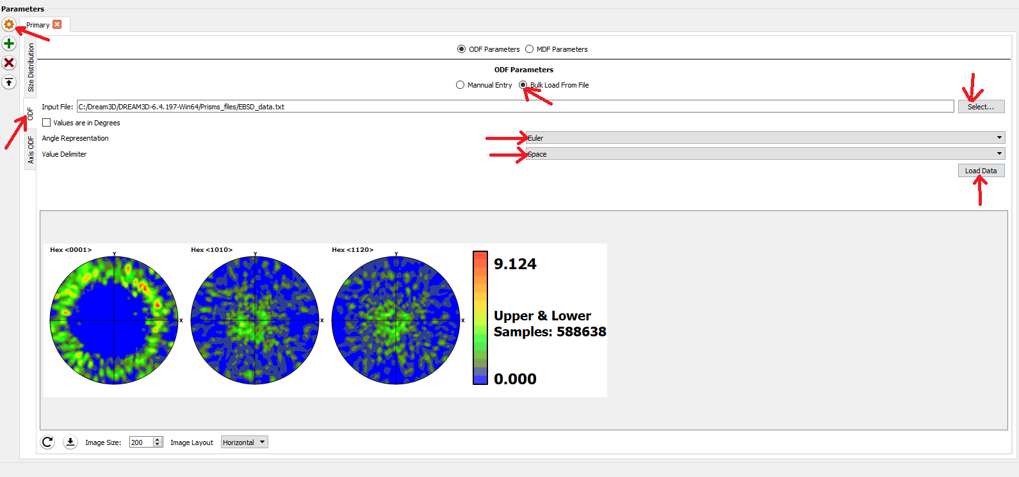

Fig. 1

1. Click on the **Size Distribution** tab and then on **Create Data** as in Fig. 2. This completes the process of generating the size, shape and orientation distributions.

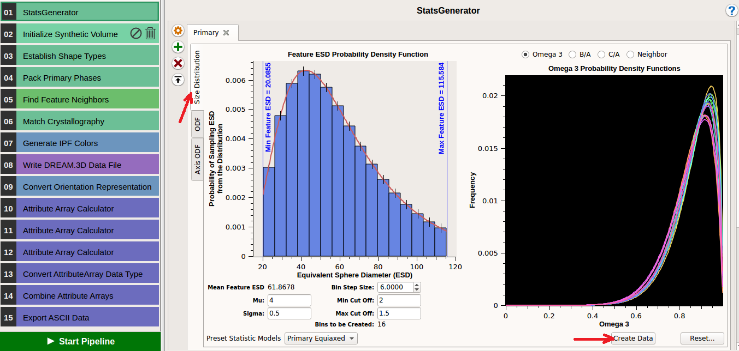

Fig. 2

1. Click on the **Initialize Synthetic Volume** filter in the pipeline window. Here the box dimensions can be specified. Choose dimensions of 32 voxels along x, y and z respectively(Fig. 3). Choose the resolution as 11 along each direction. Check the box next to **Estimate Number of Features** to get the approximate number of grains.

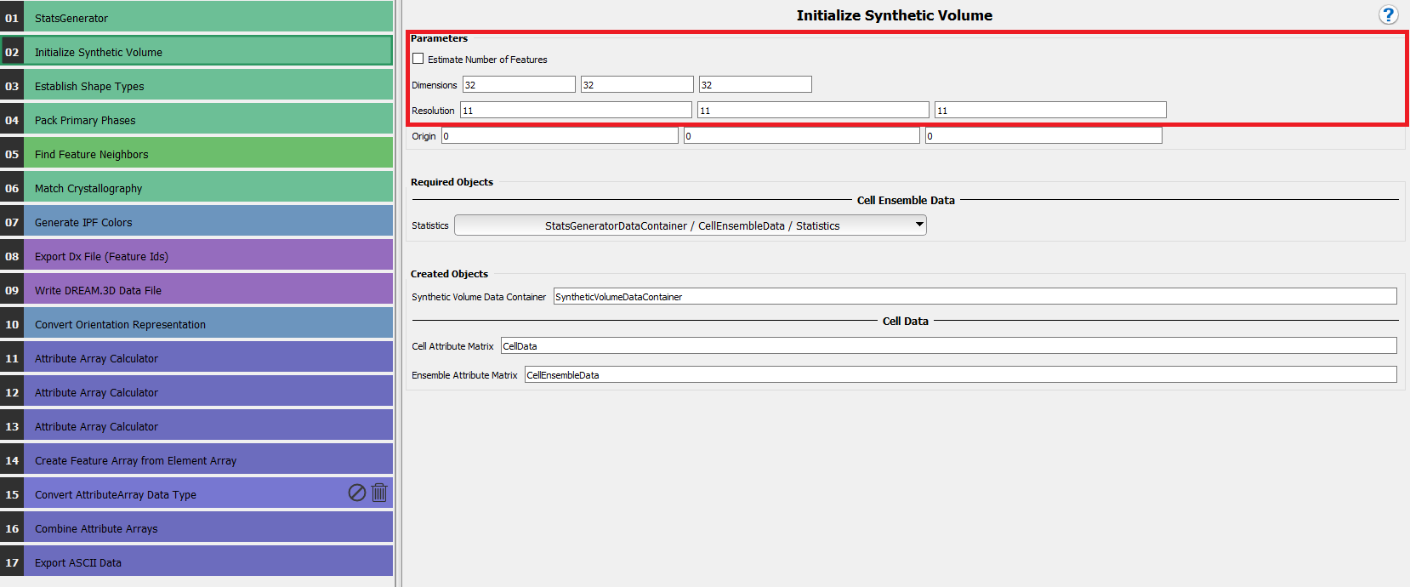

Fig. 3

1. Click on the **Export Dx File (Feature Ids)** filter in the pipeline window. This filter will generate an output file containing the grain-ids for all the voxels in the format required as input in PRISMS-CPFE. In the present case, specify the output file address (you have to specify a path) and file name as **grainID.txt**(Fig. 4).

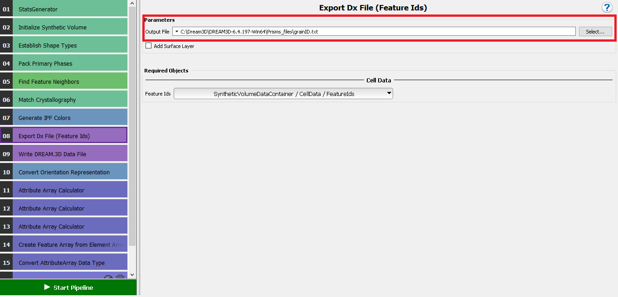

Fig. 4

1. Click on the **Write DREAM3D Data File** filter in the pipeline window(Fig. 5). This is performed so that the microstructure can be visualized in a visualization software like Paraview. Name the file **Magnesium.dream3d** depending on the material. Check the box next to **Write Xdmf File**.

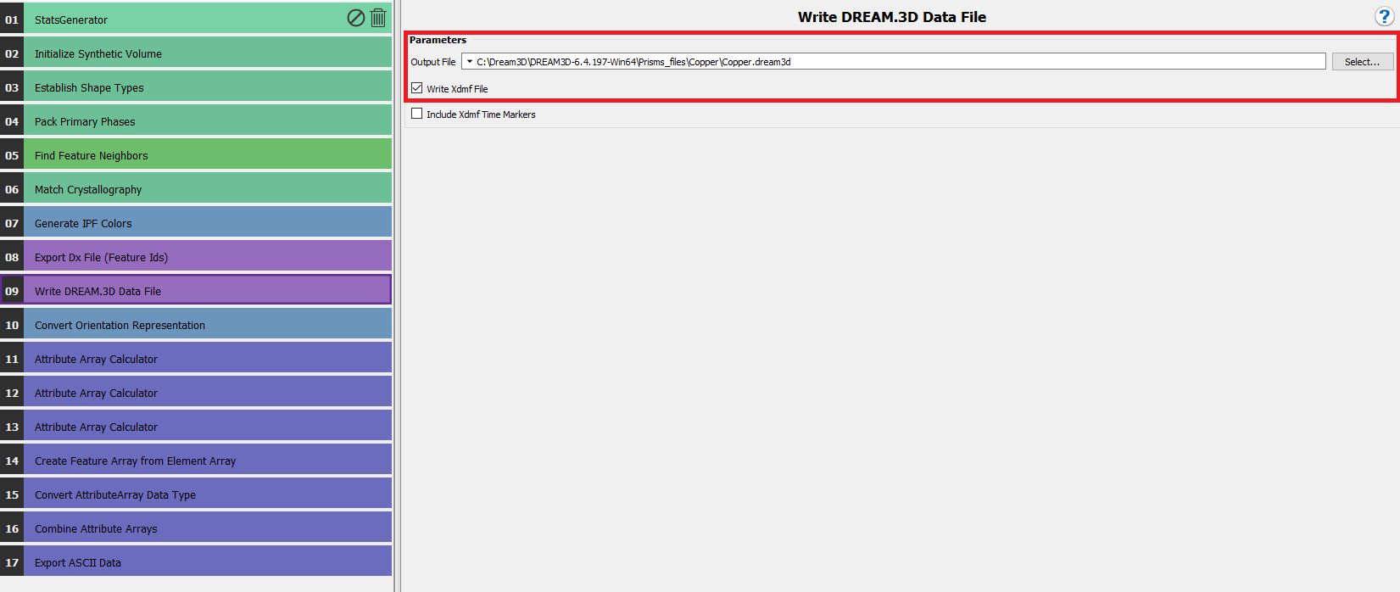

Fig. 5

1. Click on the **Export ASCII Data** filter in the pipeline window. Specify the output path as required, file extension as **.txt**, **maximum tuples per line** as **1** and **(space)** as the delimiter. For **Attribute Arrays to Export** choose **SyntheticVolumeDataContainer / CellData**, and then double-click on the data container **orientations**( Fig. 6). This will eventually generate the file **orientations.txt**.

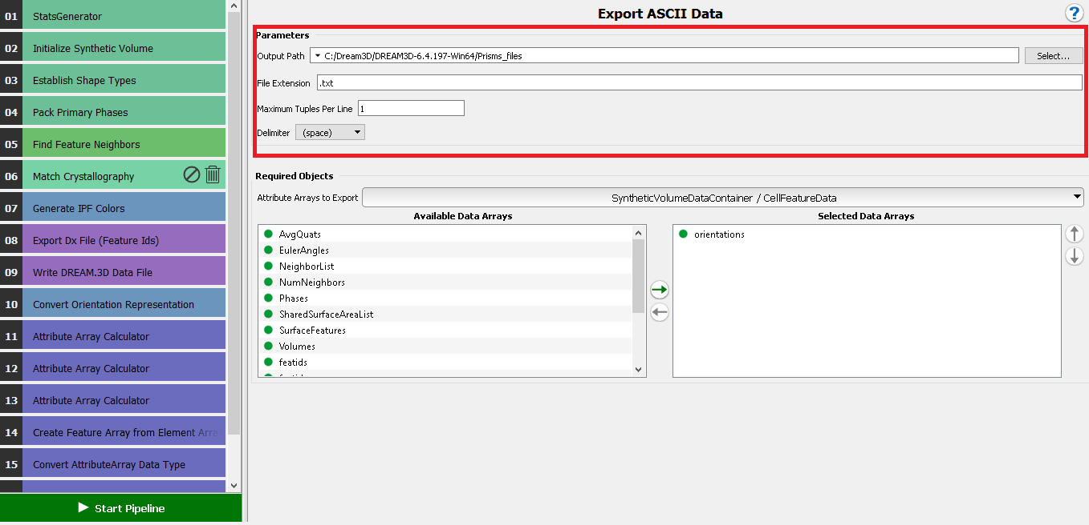

Fig. 6

1. Click on **Start pipeline** (Fig. 6).

## **Viusalization of microstructure in Paraview**

To visualize the outputs from CPFE we can go through the following steps.

1. Browse to **ParaView-5.5.0-RC4-Qt5-Windows-64bit** -> **ParaView-5.5.0-RC4-Qt5-Windows-64bit** -> **bin** in the main directorycontaining the paraview installation, and double-click on the **Paraview icon** .
2. Then click on **File-> Open,** and choose the file with **.xdmf** extension that you wish to visualize. A window will pop up asking for a reader to open it with. Choose **Xdmf Reader** and the file will get loaded in Paraview.
3. The filename is visible in a small section to the left hand side of the window. Next, click on **apply** on properties. Additionally, it has next to it the symbol of a closed eye, which means that it is visible or not. If it is not, click on the closed eye icon to open it. Fig. 7 depicts the window before and after opening the file.

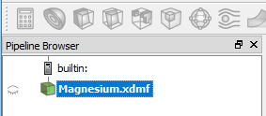 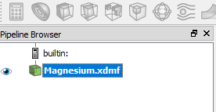

Fig. 7

1. In the toolbar, there is a drop down menu that reads **Solid Color**. Click on that menu and choose **Feature Ids**. Adjacent to it is another drop down men that reads **Outline**. Click on it and choose **Surface**. The microstructure is now visible with a colorbar for reference, which denotes the grain IDs (Fig. 8).

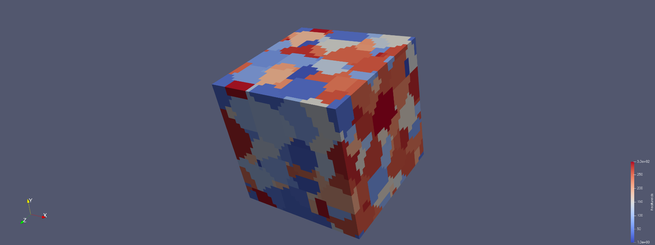

Fig. 8

# **MATLAB and Set Path**

1. In Google Chrome you should already have a tab that reads **CAEN Software**. Else open a new tab and in the address bar type [**https://appsanywhere.engin.umich.edu/**](https://appsanywhere.engin.umich.edu/)**.** This should load the webpage.
2. In the top right corner, a search bar is present that by default reads **Search Apps**. Click there and type MATLAB. A list of software packages will appear in the space below. Look for the application **MATLAB 64-bit R2017a** and click on the button **Launch.**
3. The taskbar at the bottom of the screen appears, as in the following image. Click on the blue icon denoted by the arrow.



1. A prompt should appear as in the following image. Click on the green icon that shows **Launch.** This should start MATLAB on your PC, which would take a couple of moments to initialize.

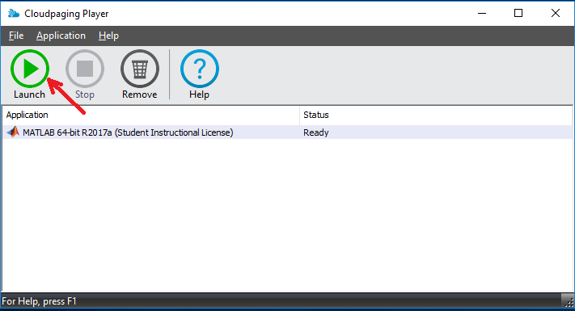

1. Once initialized we need to add the MTEX directory to the MATLAB path. Click on the **HOME** tab on the top left corner of the MATLAB window, and on the icon **Set Path** as depicted in the figure below.

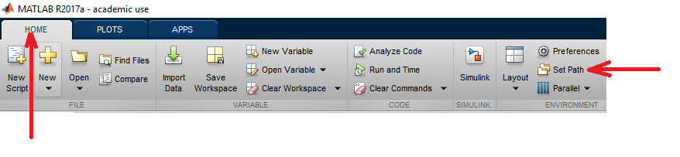

1. A window will then appear to modify MATLAB’s search path. Click on the button **Add with Subfolders…** and then choose the folder to be added. In this case, the folder to be added is **path-to-mtex/mtex-5.1.1.** Choosing that folder will add it and all its subfolders to the MATLAB search path. Then click on **Save** to retain those settings permanently. This is depicted in the figure below.

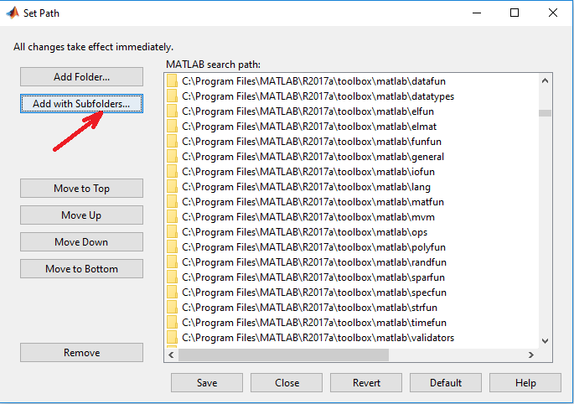

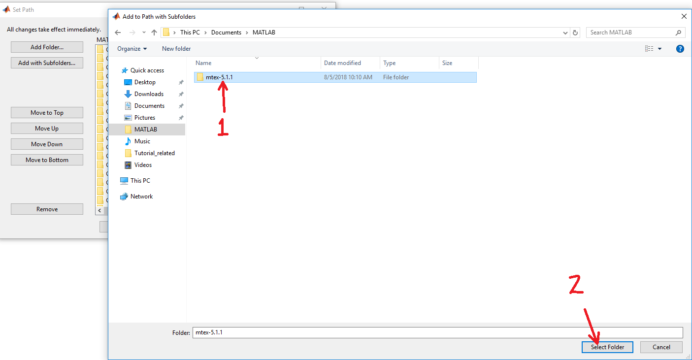

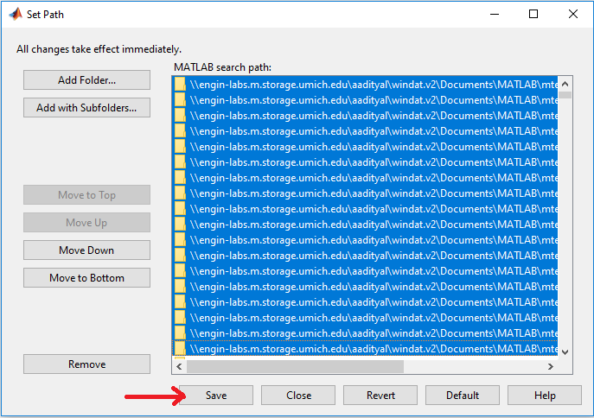

1. Then in the MATLAB command window type startup_mtex, to initialize MTEX. The command prompt will look as follows.

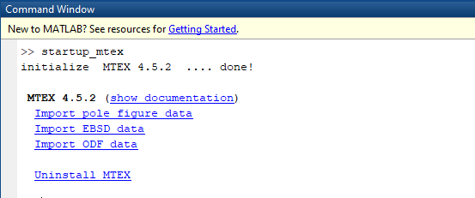

This completes the process of opening MATLAB and adding the MTEX directory so that we can readily access it’s functions.

# **Pole Figures with MTEX – Experimental data for Magnesium**

Here we generate the pole figures for the microstructure generated by DREAM3D.

1. Copy the **plot_polefromori_Mg.m** script from **PRISMS_workshop_final\PRISMS_workshop_final\Input\HCP**. Ensure that the files **mgdata.txt** and **plot_polefromori_Mg.m** are in the same folder.
2. Click on the **EDITOR** tab and run the script by clicking on the green button denoting **Run** on the toolstrip**,** as shown in the following image.

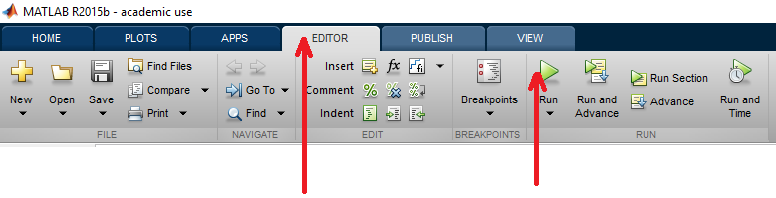

That should generate the pole figures from the available orientation data from experiments.

# **Pole Figures with MTEX – DREAM3D RVE for Magnesium**

Here we generate the pole figures for the microstructure generated by DREAM3D.

1. Copy the **polefigure_initial_Mg.m** script from **PRISMS_workshop_final\PRISMS_workshop_final\Input\HCP**. Ensure that the files **grainID.txt**, **orientations.txt** and **polefigure_initial_Mg.m** are in the same folder.
2. Open the script **polefigure_initial_Mg.m** in MATLAB. In lines 5, 6 and 7 ensure that the number of voxels in the x, y and z directions matches with those specified in the line 1 of **grainID.txt**.

% Number of voxels in x,y and z directions

xnum = 32 ;

ynum = 32 ;

znum = 32 ;

1. Ensure the crystal symmetry and sample symmetry appear as follows

%% Specify crystal symmetry. In this case it is Magnesium

cs = crystalSymmetry('6/mmm', [3.21 3.21 5.213], 'X||a*', 'Y||b', 'Z||c*');

%% Specify sample symmetry

ss = specimenSymmetry('triclinic');

1. The <0 0 0 1>, <-1 0 1 0> and <-2 1 1 0> are computed here and appear as the following lines in the script

%% Calculate pole figure

pf1 = calcPoleFigure(odf,Miller({0,0,0,1},ori.CS),'resolution',2*degree,'complete') ;

pf2 = calcPoleFigure(odf,Miller({-1,0,1,0},ori.CS),'resolution',2*degree,'complete') ;

pf3 = calcPoleFigure(odf,Miller({-2,1,1,0},ori.CS),'resolution',2*degree,'complete') ;

The result of the run is the <0 0 0 1>, <-1 0 1 0> and <-2 1 1 0> pole figures for the initial microstructure. The miller indices can be changed to anything else by just changing one line of code. For example, if we need the <1 -3 2 1> pole figure, the command for pole figure calculation would look as follows

pf = calcPoleFigure(odf,Miller({1,-3,2,1},ori.CS),'resolution',2*degree,'complete') ;

# **Pole Figures with MTEX – Experimental data for Copper**

Here we generate the pole figures for the microstructure generated by DREAM3D.

1. Copy the **plot_polefromori_Cu.m** script from **PRISMS_workshop_final\PRISMS_workshop_final\Input\FCC**. Ensure that the files **copperdata.txt** and **plot_polefromori_Cu.m** are in the same folder.
2. Click on the **EDITOR** tab and run the script by clicking on the green button denoting **Run** on the toolstrip**,** as shown in the following image.



That should generate the pole figures from the available orientation data from experiments.

# **Pole Figures with MTEX – DREAM3D RVE for Copper**

Here we generate the pole figures for the microstructure generated by DREAM3D.

1. Copy the **polefigure_initial_Cu.m** script from **PRISMS_workshop_final\PRISMS_workshop_final\Input\FCC**. Ensure that the files **grainID.txt**, **orientations.txt** and **polefigure_initial_Cu.m** are in the same folder.
2. Open the script **polefigure_initial_Cu.m** in MATLAB. In lines 5, 6 and 7 ensure that the number of voxels in the x, y and z directions matches with those specified in the line 1 of **grainID.txt**.

% Number of voxels in x,y and z directions

xnum = 32 ;

ynum = 32 ;

znum = 32 ;

1. Ensure the crystal symmetry and sample symmetry appear as follows

%% Specify crystal symmetry. In this case it is Magnesium

cs = crystalSymmetry('cubic');

%% Specify sample symmetry

ss = specimenSymmetry('triclinic');

1. The <0 0 1>, <0 1 1> and <1 1 1> are computed here and appear as the following lines in the script

%% Calculate pole figure

pf1 = calcPoleFigure(odf,Miller({0,0,1},ori.CS),'resolution',2*degree,'complete') ;

pf2 = calcPoleFigure(odf,Miller({0,1,1},ori.CS),'resolution',2*degree,'complete') ;

pf3 = calcPoleFigure(odf,Miller({1,1,1},ori.CS),'resolution',2*degree,'complete') ;

The result of the run is the <0 0 1>, <0 1 1> and <1 1 1> pole figures for the initial microstructure. The miller indices can be changed to anything else by just changing one line of code. For example, if we need the <1 2 1> pole figure, the command for pole figure calculation would look as follows

pf = calcPoleFigure(odf,Miller({1,2,1},ori.CS),'resolution',2*degree,'complete') ;