## **Visualization of output fields in Paraview**

To visualize the outputs from CPFE we can go through the following steps.

1. Browse to **ParaView-5.5.0-RC4-Qt5-Windows-64bit** -> **ParaView-5.5.0-RC4-Qt5-Windows-64bit** -> **bin** in the main directorycontaining the Paraview installation, and double-click on the Paraview icon .
2. Then click on **File-> Open,** and choose the file with **.vtu** extension that you wish to visualize. This will load the file into Paraview.
3. The filename is visible in a small section to the left hand side of the window. Click on Apply in the properties and make sure that the file is visible. Click on the closed eye icon to open it. The image below depicts the window before and after opening the file.

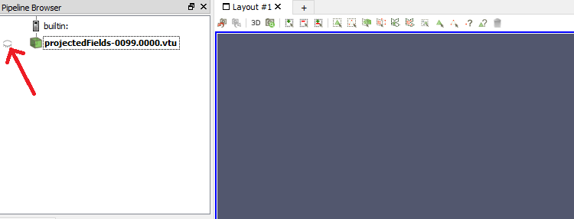

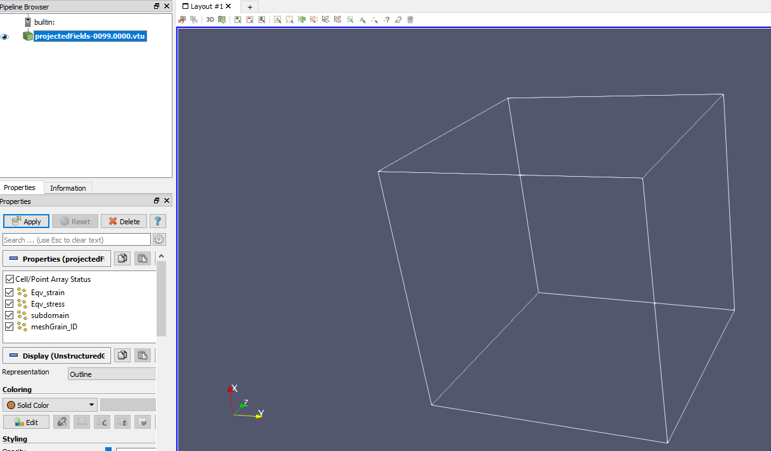

1. In the toolbar, there is a drop down menu that reads **Solid Color**. Click on that menu to choose a particular variable of choice. Adjacent to it is another drop down men that reads **Outline**. Click on it and choose **Surface With Edges**. The variation of that variable in space is now visualized with a colorbar for reference. The viewer should look something like below.

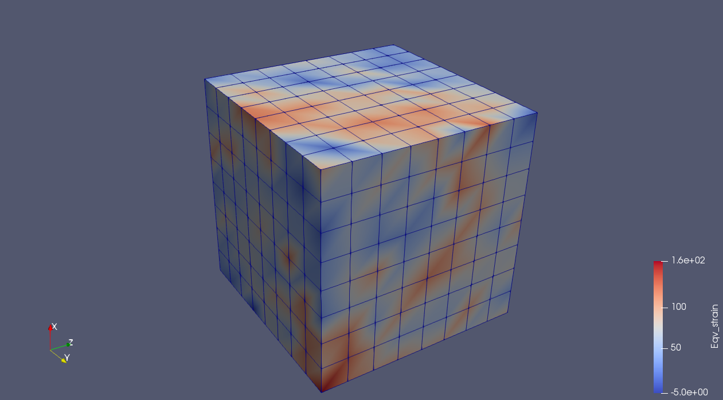

The same can be repeated for other variables as well.

## **Visualizing a deforming mesh**

The deformed mesh can be visualized using the solution files and the **Warp By Vector** filter in Paraview by following the steps below.

1. Load Paraview and load a **solution** file with **.pvtu** extension, and then click on apply to open it.
2. Choose the field variable as **u(**for displacement**),** the Zcomponent and **Surface.**
3. Then click on the **Filters** dropdown in the menu bar, click on **Alphabetical** andclick on the **Warp By Vector** filter, as seen below.

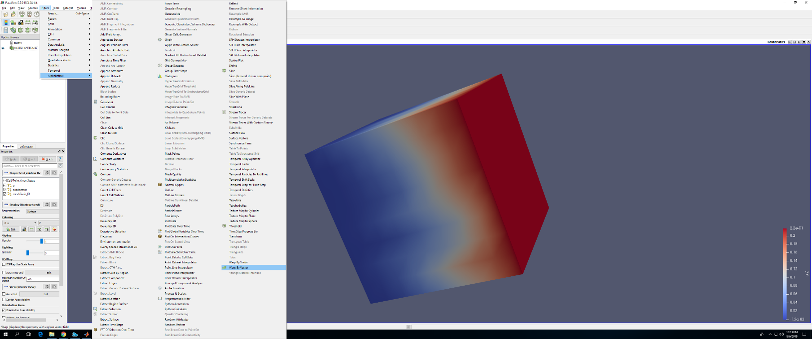

1. This appears as a filter in the pipeline below the solution file. Then click on apply, and the deformed mesh will be visible in the viewer. It looks like the following.

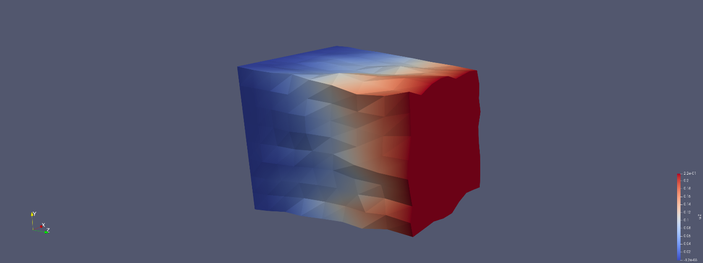

# **Stress-strain curve**

To plot the stress-strain curve using MS-Excel we go through the following steps

1. Open MS Excel
2. Click on **File ->** **Open**, and then choose the file **stressstrain.txt**.
3. Click on the **Insert** tab, choose the **Scatter** option and **Scatter with Straight Lines** suboption. It should look as below.

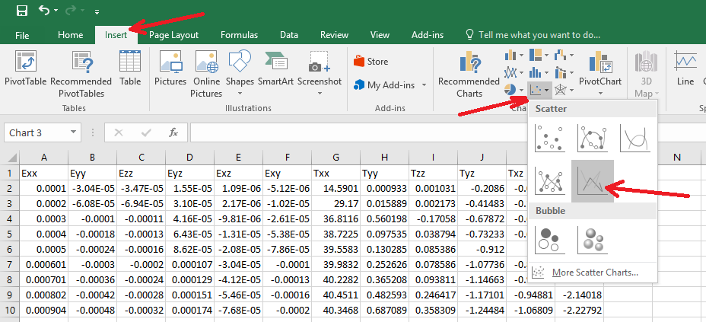

1. The focus then shifts to the **Design** tab. Here, click on **Select Data** and a window pops up. Click on the **Add** button to select the relevant data for plotting. This appears as below.

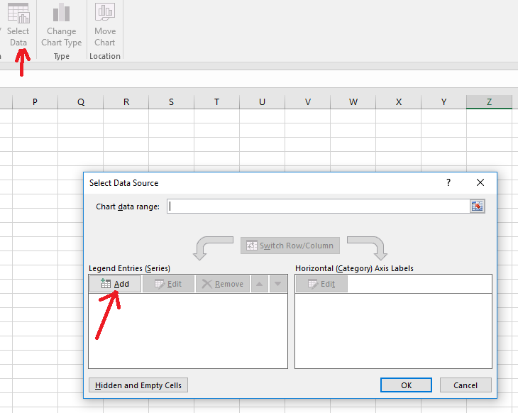

1. A window appears asking for three inputs – **Series name**, **Series x values**, **Series y values**. For the **Series name** type **Stress-strain curve.** For **Series x values** choose the column containing the strain data that you wish to plot, starting from the first numerical value. Similarly, for **Series y values** choose the column containing the stress data that you wish to plot, starting from the first numerical value. It should look something similar to below. Then, click on **OK**.

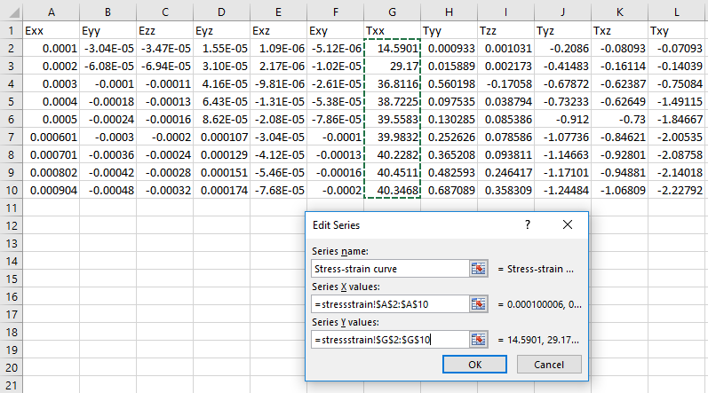

1. Click **OK** again and the stress-strain curve will be generated.

## **Pole Figures with MTEX – Output microstructure**

The orientations output from PRISMS-CPFE is written to a file named **orientationsOutput.** To visualize this output do the following.

1. In a directory copy the **orientationsOutput** file and the MATLAB script, **oriplot_big.m.**
2. Launch MATLAB and browse to the directory in which these files are present.
3. Open **oriplot_big.m.** Ensure that the crystal and sample symmetry are set accordingly.
4. Run the script and it should generate the required pole figures.

Lines 45-47 show how Miller indices can be specified whose pole figures are needed.