CryptoCreatures Brady Marks

Cryptocreatures is a decentralized application on the Ethereum blockchain that facilitates the ownership exchange of digital artifacts between buyers and sellers using Ether as a currency. It takes the concept behind many digital collectibles a step further by also facilitating the trading of a CryptoCreature’s mutable traits in order to manipulate their value and sell to make a profit.

Originally inspired by Cryptopunks, when someone buys a CryptoCreature, they not only own the code on the blockchain that represents that image, they also own that image. For practicality reasons, to maintain processing speed, each CryptoCreature is a 32 x 32 pixelated image. All 1000 CryptoCreatures would be released at the same time and available to be claimed. There value, like other digital collectibles — specifically Cryptopunks — lies in the scarcity of all their attributes compared to the group. Each CryptoCreature, when claimed comes with eight traits, half of which are tradeable. The immutable traits consist of their name, body/body color, eyes, and hair. The other four traits that are originally randomly distributed to each CryptoCreature: background color, hair/head accessory, clothing, and shoes.

Owners of a CryptoCreature can choose to treat it as a Cryptopunk and monitor its market value until they deem it profitable to sell for Ether. However the four mutable traits can only be traded for other traits. Additionally one can only trade a single mutable trait, ie. red shoes, for the same single mutable trait of the same category, ie. green shoes. This ensures that no one person with lots of Ether can either buy out all the traits to create an impossible-to-compete-with combination. Also it prevents people from trading a hat for shoes, so then no CryptoCreature has two hats or two sets of shoes.

The backgrounds may more obviously distinguish value than the other traits. To explain further, solid backgrounds are the most common, followed by striped/polka dot, rainbow, and then the rarest would be those backgrounds with a sidekick next to the CryptoCreature (see visuals below). The incentive for, say, a green CryptoCreature with a rare background to trade that background, would be if other green CryptoCreatures with similar traits, also had the same background. Trading the background that the other green CryptoCreatures have would then potentially allow said CryptoCreature to have a more valuable combination of traits. Different from Cryptopunks, the potential for values to always be changing keeps users engaged more consistently for longer. If owners want to keep the value of their creature up, they must be monitoring the trading that goes on, and continually compare the attributes and value of other Cryptocreatures with their own.

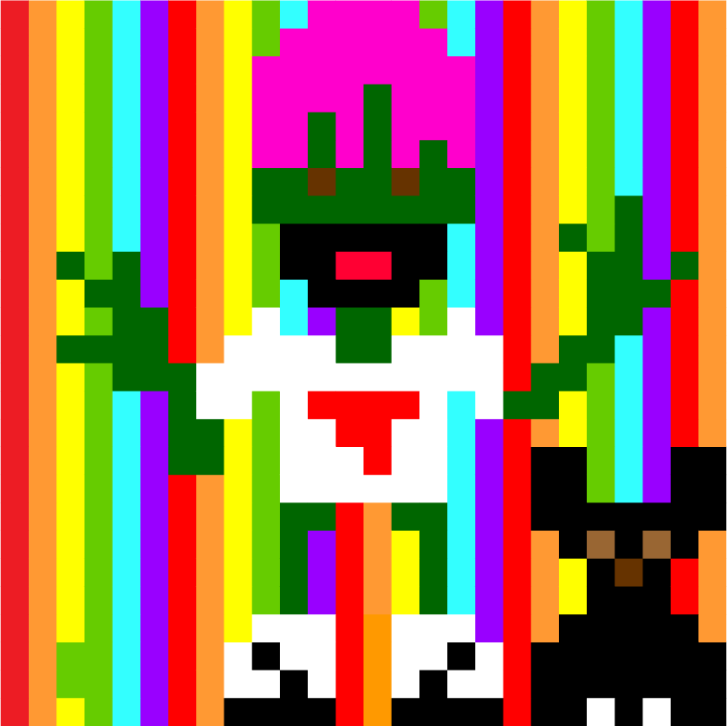

Name: Booger Brain

Immutable Traits:

-Green Body

-Pink Hair

-Brown Eyes

Exchangeable Traits:

-Rainbow Background + Sidekick

-Black Beard

-White Graphic Tee

-White Sneakers

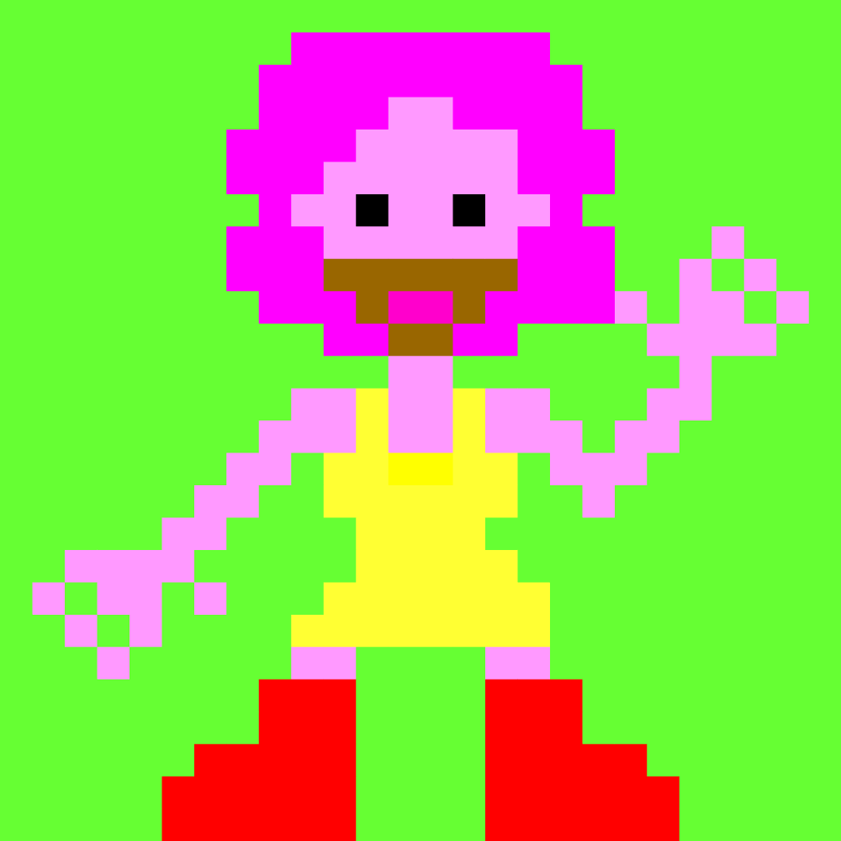

Name: P.J.

Immutable Traits:

-Pink Body

-Pink Hair

-Black Eyes

Exchangeable Traits:

-Green Background

-Brown Beard

-Yellow Dress

-Red Boots

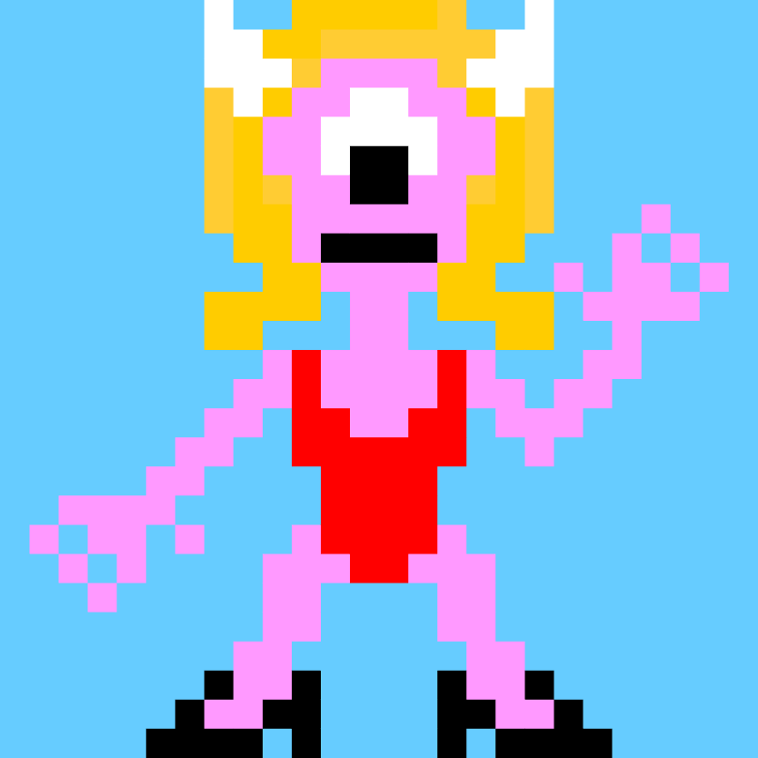

Name: Jerry

Immutable Traits:

-Pink Body

-Yellow Hair

-One Eye

Exchangeable Traits:

-Blue Background

-Horns

-Red Bathing Suit

-Black Heels