**Introduction**

According to Wikipedia, as of June 2019, Singapore's population stood at 5.70 million. A large percentage of its population are not permanent residents; of its total population of 5.70 million in 2019, 4.03 million were residents (citizens & permanent residents), and 1.68 million were non-residents. It is the second-densest sovereign state in the world, after the microstate Monaco. Not only is that Singapore is one of the top financial hubs in the world, it also aims to become region’s tech and innovation hub to attract more foreign talent in such a tiny island. With high influx of foreign workers and land scarcity in Singapore, all these have helped to boost rental volume in the including rental housing - in very prime locations, like the city center. Singapore is divided into districts as shown below:

**Singapore District Map: CCR, RCR and OCR**

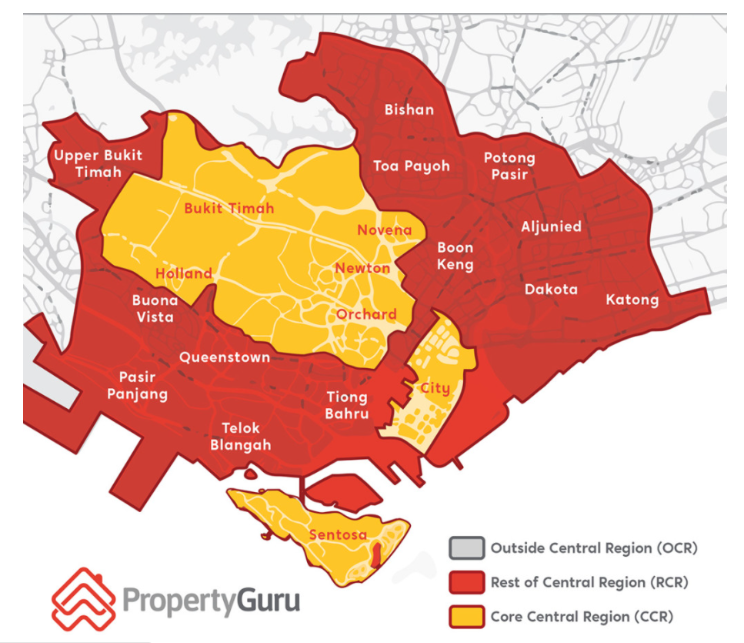

1. Core Central Region (CCR): City, Downtown Core and Sentosa - The Core Central Region, also known as the CCR, includes the traditional prime areas of Singapore, the Downtown Core (including parts of Bugis south of Ophir Road), as well as Sentosa. **Postal Districts: 9, 10, 11, 1(part), 2(part), 4(part), 6(part), 7(part)**

2. Rest of Central Region (RCR) is regarded as the intermediate, or mid-tier, region in terms of pricing, between the mass market condos in the OCR region and the high-value properties in the CCR. **Postal Districts: 1(part), 2(part), 3, 4(part), 5(part), 6(part), 7(part), 8, 12(part), 13(part), 14(part), 15(part), 20(part).**

3. Outside Central Region (OCR) is about three-quarters the size of Singapore, and basically refers to areas where mass-market condos at the lower range of price points are located. **Postal Districts: 5(part), 14(part), 15(part), 16, 17, 18, 19, 20(part), 22, 23, 25, 26, 27, 28.**

**Problem and Target Audience**

Hence, I would like to take this opportunity to explore and analyze the rental markets across Singapore in terms of locations, amenities nearby and etc. This would be best suit for foreigners who are seeking for rental housing in Singapore or investors who are interested in the rental business.