TRINETRA
AI-Powered Email Threat Detection, GeoLocation & Forensic Intelligence Platform
Smart India Hackathon 2026
Problem Statement: SIH26106
Team: TrinetraAI

1. Executive Summary
TRINETRA is a prototype email-security and forensic-intelligence platform designed around SIH26106. It combines email artifact parsing, authentication/header analysis, behavioral NLP, URL and domain analysis, IP/network intelligence, geolocation, graph correlation, risk fusion, case history and structured forensic reporting. The prototype demonstrates artifact-based analysis; true pre-delivery blocking requires integration at a mail gateway, SMTP/IMAP/API or equivalent institutional control point.

2. SIH26106 Problem Context
The problem statement calls for detection of fraudulent email together with technical origin tracing and forensic intelligence. Its requirements include NLP/ML detection, header/protocol analysis, SPF/DKIM/DMARC, relay reconstruction, IP/geolocation analysis, anonymizer indicators, domain intelligence, threat-intelligence correlation, graph analysis, alerts, forensic reports, case management, and privacy/evidence safeguards.

3. Research Basis and Gap
A 2023 systematic literature review examined 38 BEC-phishing studies from 950 initially identified papers and notes the difficulty of detecting many BEC messages with conventional approaches. It also reports frequent use of body and header features. Research on malicious-site geolocation describes IP-based passive geolocation as a rapid, database-driven approach whose reliability varies by database. TRINETRA combines technical email evidence, content/behavioral signals, infrastructure context, historical correlation and graph intelligence in one investigation workflow.

4. Proposed Solution
Raw Email → Preserve & Seal → Parse → Analyze → Enrich → Fuse Evidence → Correlate → Investigate → Report. Primary users include SOC analysts, incident responders, institutional security teams, cybercrime/fraud investigation workflows and enterprise/government security administrators.

5. End-to-End Architecture
The architecture contains ingestion/evidence preservation, RFC 5322/MIME processing, header/authentication analysis, content/behavioral analysis, URL/domain intelligence, GeoIP/ASN context, multi-layer risk fusion, graph intelligence, attribution support and structured forensic reporting.

6. Privacy, Evidence Integrity and Chain of Custody
The original artifact is preserved before downstream analysis. SHA-256 sealing and later verification provide integrity checks; sensitive information can be masked for display and processing. Public repositories must not contain private emails, credentials, API keys or unnecessary personal data.

7. Prototype Interface
The prototype demonstrates an active investigation workspace, three-layer evidence package, NLP behavioral analysis, header authentication, approximate-origin intelligence, graph intelligence, URL/attachment findings, searchable case history and a structured forensic PDF.

8. Demonstrated Scenarios
Scenario 1: Executive BEC Fraud. Scenario 2: Banking/KYC phishing. Scenario 3: Clean Corporate Notice. These are controlled demonstration scenarios and are not evidence about real organizations or domains.

9. Testing and Verification
The repository documentation reports 11 backend tests passing, including RFC 5322 parsing, SPF/DKIM-related analysis, risk fusion and PDF export, plus a successful frontend production build. A production evaluation should additionally report precision, recall, F1, false-positive/negative rates, latency, throughput and geolocation error/confidence using a reproducible dataset.

10. Technical Stack
Frontend: React 19, Vite, Tailwind CSS, Leaflet. Backend: Python 3.11+, FastAPI. Security: RFC 5322/MIME, SPF/DKIM/DMARC, URL/domain analysis. Intelligence: MaxMind GeoLite2 City/ASN and optional external feeds. AI/NLP: Gemini where configured plus deterministic offline fallback. Data/Graph: SQLite, optional PostgreSQL/Neo4j. Reporting: structured forensic PDF generation.

11. Real-Time / Pre-Interaction Deployment
The SIH requirement calls for real/near-real-time alerting before user interaction. The current prototype demonstrates artifact ingestion and analysis. A production deployment would place TRINETRA at a mail gateway, SMTP/IMAP/provider API or equivalent control point, producing a decision such as deliver, quarantine or alert before normal user access.

12. Feasibility
Technical feasibility follows from established web, parsing, intelligence and database components. Operationally, the dashboard is designed for analyst workflows. Local GeoIP and deterministic analysis reduce dependence on remote services. The pipeline can be separated into workers/services for higher-volume deployment.

13. Key Engineering Advantages
Evidence-first processing; multi-layer evidence fusion; offline-capable local analysis; campaign-level graph correlation; and explainable investigation views.

14. Limitations
GeoIP is approximate; VPN/Tor/proxy/compromised accounts can obscure origin; header inference depends on available data; AI outputs are probabilistic; external feeds can be rate-limited; artifact ingestion is not the same as production interception; and a generated legal certificate does not itself guarantee court admissibility.

15. Future Scope
Mail-gateway integration, enterprise provider connectors, SIEM/SOC integration, richer DNS/WHOIS intelligence, additional threat feeds, calibrated ML models, campaign clustering, advanced attachment/media analysis, analyst feedback and scalable distributed processing.

16. Conclusion
TRINETRA integrates email evidence, behavioral signals, infrastructure context and relationship-level intelligence into one analyst workflow. The prototype demonstrates the journey from email artifact to risk assessment, approximate origin context, graph correlation, case history and structured reporting.

Architecture Reference
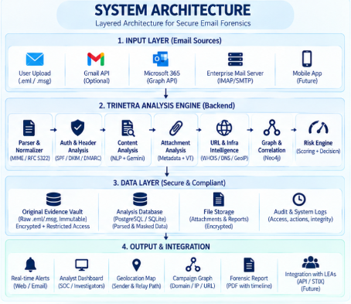

17. Prototype Visual Evidence
Active Investigation Workspace
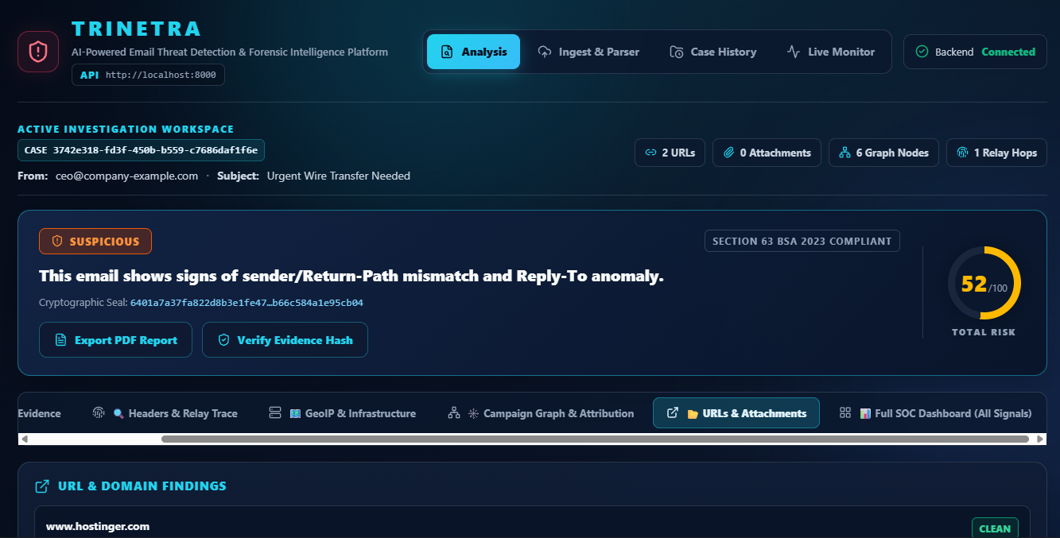
Prototype screenshot supplied for project documentation.
Three-Layer Evidence Fusion
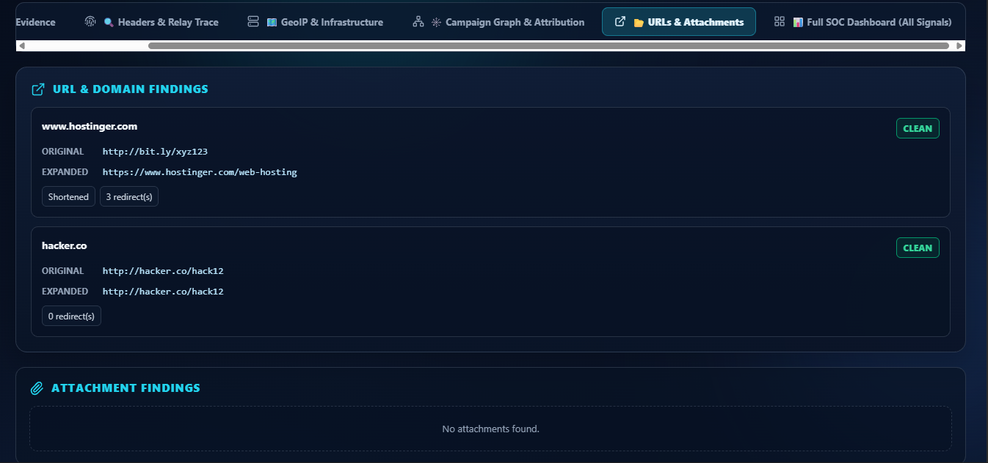
Prototype screenshot supplied for project documentation.
NLP Behavioral Analysis and Attribution
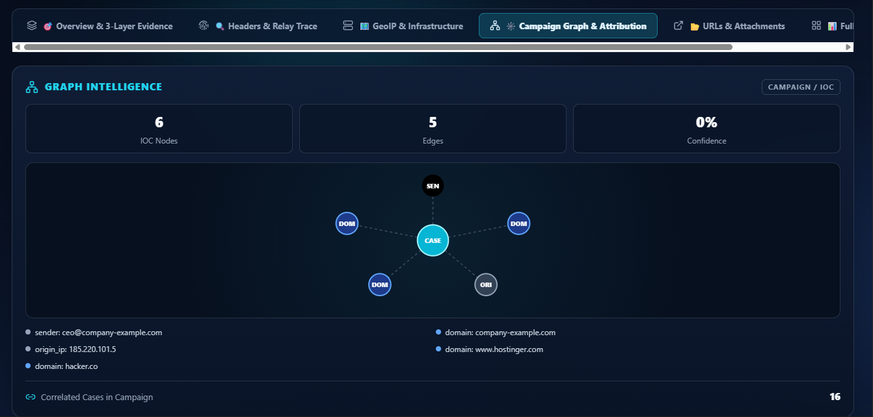
Prototype screenshot supplied for project documentation.
Graph Intelligence
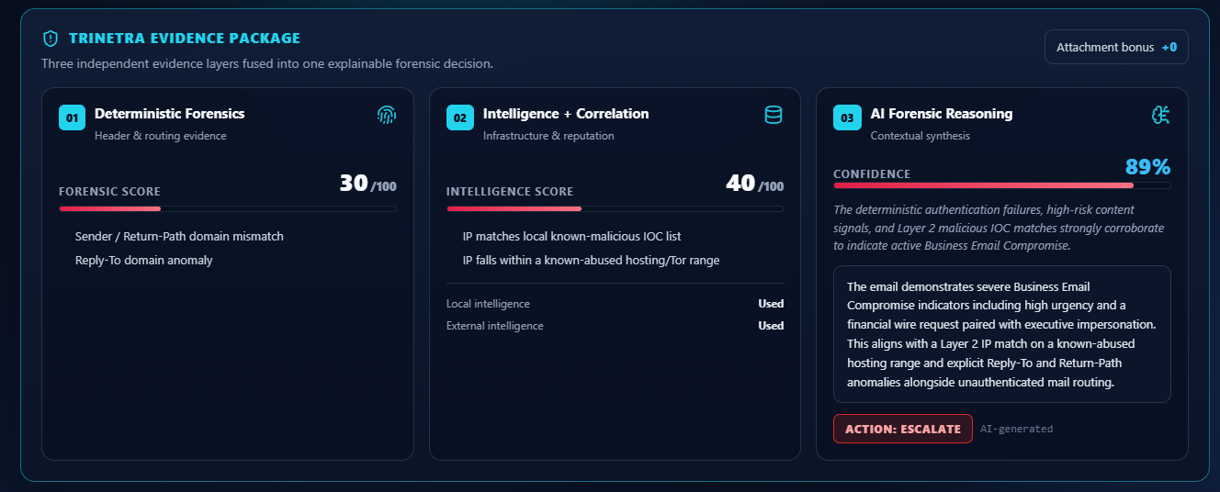
Prototype screenshot supplied for project documentation.
URL and Attachment Findings
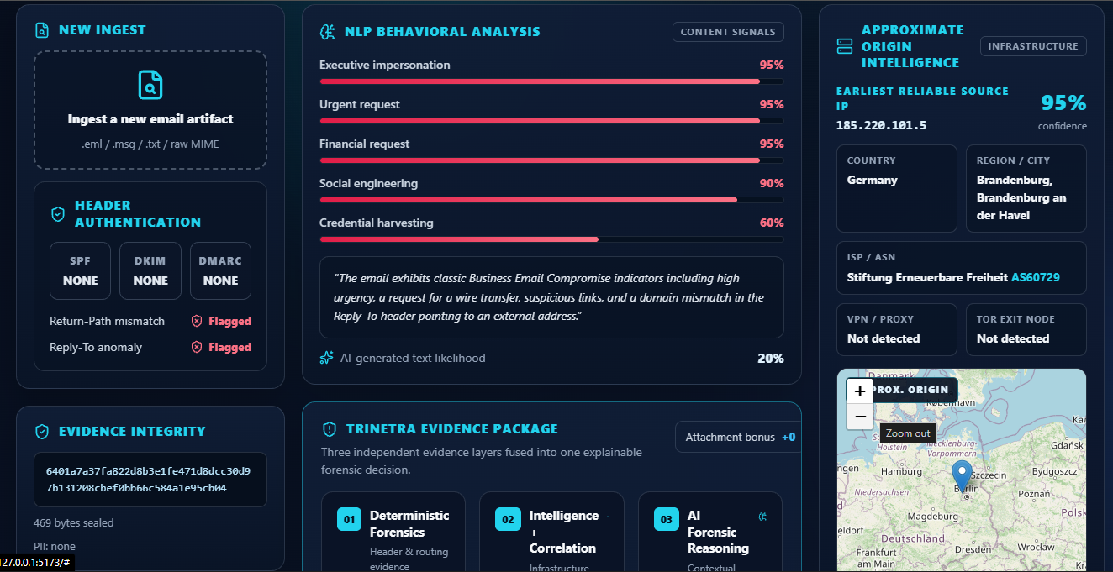
Prototype screenshot supplied for project documentation.
Forensic Case History
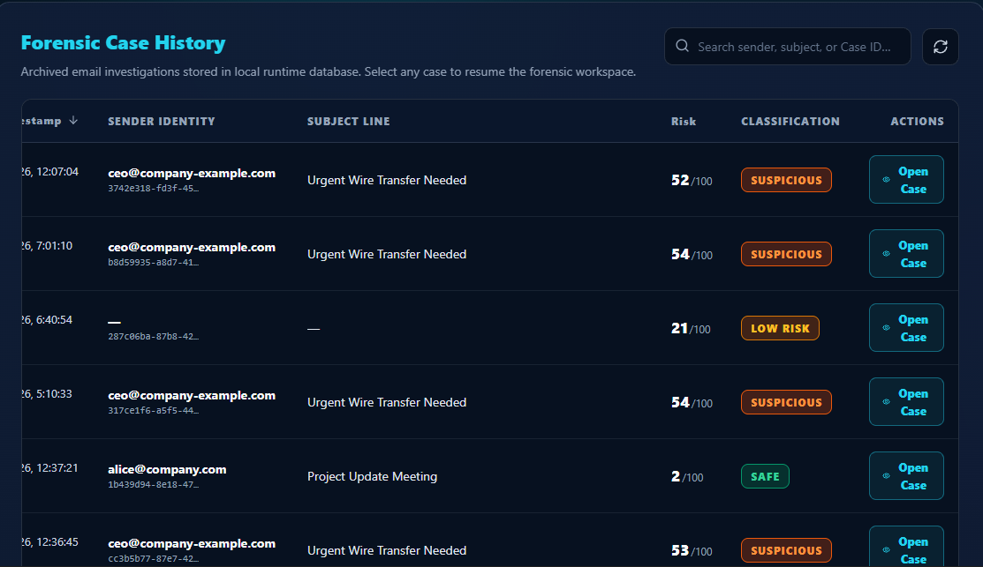
Prototype screenshot supplied for project documentation.
Forensic Technical Report
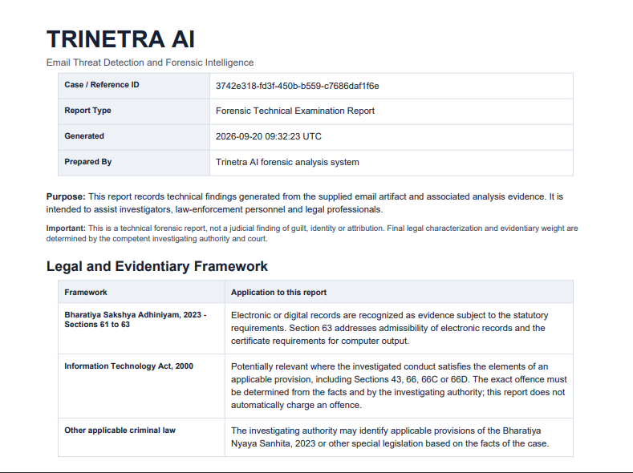
Prototype screenshot supplied for project documentation.
Live Monitor
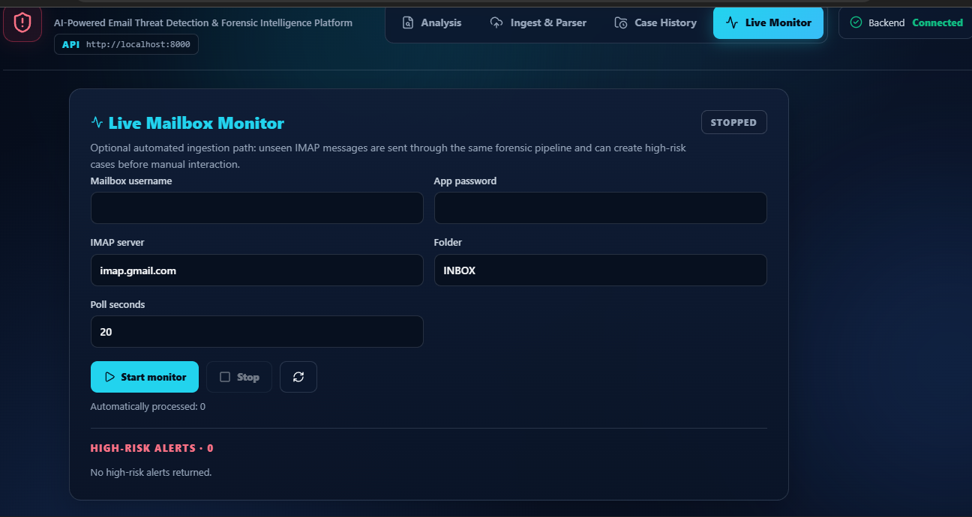

Prototype screenshot supplied for project documentation.
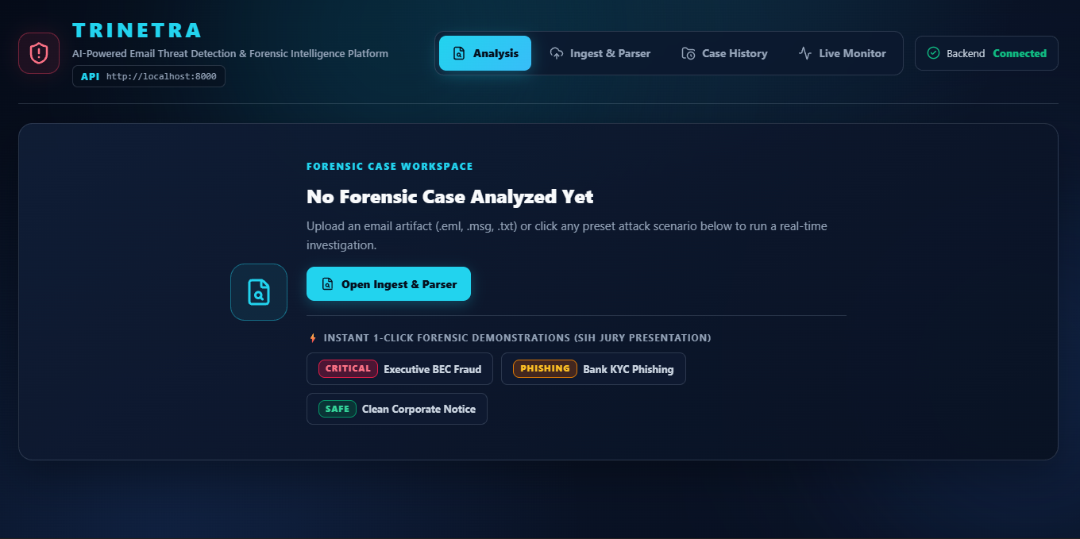

18. References
- Atlam, H. F., & Oluwatimilehin, O. (2023). Business Email Compromise Phishing Detection Based on Machine Learning: A Systematic Literature Review. Electronics, 12(1), 42. https://doi.org/10.3390/electronics12010042
- Mansoori, M., & Welch, I. (2020). How do they find us? A study of geolocation tracking techniques of malicious web sites. Computers & Security, 97, 101948. https://doi.org/10.1016/j.cose.2020.101948
- Geolocation Based E-Mail Forensics: A Timeline Analysis Approach. IEEE Xplore, document 11263637.
- Phishing in India – Analytical Study. ResearchGate.
- Government of India. The Bharatiya Sakshya Adhiniyam, 2023, Section 63.
- Smart India Hackathon 2026 — Problem Statement SIH26106.
Report note: This document distinguishes demonstrated prototype functionality from future production integration and does not treat automated analysis or generated reports as proof of human identity or guaranteed legal admissibility.

