A Project Report On

"GrocyGo: AI-Powered Smart Grocery S Meal Planning"

Prepared by

PRITKUMAR DINESHBHAI VEKARIYA

22SE02IE059

under the mentorship of

Mr Adarsh Kushwaha
Designation to Lecturer, School of Engineering



NOVEMBER 2025

P P SAVANI UNIVERSITY DEPARTMENT OF SCHOOL OF ENGINEERING (INFORMATION TECHNOLOGY & ENGINEERING)

P P SAVANI UNIVERSITY
NH NO.: 8, VILLAGE: DHAMDOD, TA. MANGROL, NEAR KOSAMBA, SURAT – 394 125. (GUJARAT).

ABSTRACT

CERTIFICATE

This is to certify that the Project Report submitted by PRITKUMAR DINESHBHAI VEKARIYA (22SE02IE059) to the P P SAVANI UNIVERSITY
for the partial fulfilment of the subject credit requirements is a bonafied work carried out by the student.

This is to further certify that I have been supervising the Major/Minor Project of PRITKUMAR DINESHBHAI VEKARIYA (22SE02IE059).

The contents of this report, in full or in parts, have not been submitted to any other Institute or University for award of any degree, diploma or titles.

Sign of Faculty Mentor :

Name of Faculty Mentor: Mr. Adarsh Kushwaha

Date:

ABSTRACT

ACKKNOWLEDGMENT

This report would not have been possible without my teachers who were always there when I needed them the most. I take this chance to acknowledge them and extend my sincere gratitude for helping me make this Report a possible.

I wish to thank my faculty mentor Mr. Adarsh Kushwaha, Designation to Lecturer, School of Engineering. It has been an honor to learn under their mentorship.

As my mentor, he has constantly motivated me to remain focused on achieving my goal. Their observations and guidance helped me to establish the overall direction of the report and to move forward with learning in depth. Their vital support at each juncture, which culminated in successful completion of my project work. I express my sincere gratitude to them for constant support during the project work.

I am also thankful to faculty members of the department for constant support and guidance.

I am thankful to Dean, School of Engineering for his initiative of imparting Project during tenure of your study making us learn new things and to help us in expanding our horizons.

Name of Student : PRITKUMAR DINESHBHAI VEKARIYA
Enrollment No : 22SE02IE059

ABSTRACT

ABSTRACT

This project presents the development of an GrocyGo: AI-Powered Smart Grocery S Meal Planning, designed to simulate human-like conversations and provide intelligent responses to user queries. The main objective of the project is to explore the integration of artificial intelligence with modern web technologies to create an interactive and user- friendly application. The frontend of the software is built using React and styled with CSS, offering a clean and responsive user interface. The backend is developed with Node.js and Express, while firebase is used for data storage, ensuring efficient performance and scalability. Figma was utilized for designing the user interface during the planning phase. This full-stack project demonstrates the practical use of AI in real- world web applications and emphasizes the importance of seamless API integration, data handling, and UI/UX design. The AI powered recipe generator can be extended for various domains, such as education, customer support, and virtual assistance.

 | ABSTRACT
Index  Section | Page
Acknowledgement | ii
Abstract | iii
List of figures… | vii
CHAPTER-1: INTRODUCTION  1.1 Overview | 1
1.1.1 Project Goals | 1
1.2 Objective | 2
1.3 Scope of work | 2
CHAPTER-2: PROJECT OVERVIEW  2.1 Existing System | 4
2.2 Proposed System - GrocyGo | 4
2.3 Feasibility Analysis | 5
CHAPTER-3: Software Requirements Specifications (SRS)  3.1 Introduction | 7
3.2 Purpose of the System | 7
3.3 Scope of the System | 7
3.4 Functional Requirements | 7
3.5 Non-Functional Requirements | 8
3.6 System Interfaces | 8
CHAPTER-4: System Architecture + UML Diagrams  4.1 System Architecture Overvie | 9
4.2 Use Case Diagram | 10
4.3 Data Flow Diagram | 11
4.3.1 Level 0 DFD | 11
4.3.2 Level 1 DFD | 12
4.3.3 Level 2 DFD | 12
4.4 ER Diagram | 17
4.5 Sequence Diagram (AI Recipe Suggestion) | 18
4.6 Class Diagram | 19
CHAPTER-5: PROJECT OVERVIEW  5.1 Designing | 20
5.2 Home Page | 20
5.3 Chat Page | 21
5.4 Login Page | 22
5.5 Help Page… | 23

ABSTRACT
5.6 Sign up Page 24
CHAPTER-6: TOOLS S TECHNOLOGIES
  - Languages 26
  - Framework and libraries 26
  - Development Environment 27
  - Testing and Debugging Tools 27
CHAPTER-7: PROJECT DETAILS
  - Front-end of Website 29
    - React Web Application 29
    - Flutter Mobile Application 30
  - Responsiveness behavior of website 30
  - Backend of Website 31
CHAPTER-8: LEARNING OUTCOMES
  - Skill Enhancement 31
  - Practical Experience 32
  - Project Exposure 33
  - Professional Growth 33
  - Solution Of Challenges 34
CHAPTER-9: CONCLUSION
  - Summary of Project 35
  - Future Directions 35
Final Reflection 36

ABSTRACT

List of figures
Flow Chart 10
Use Case Diagram 11
Level 0 DFD 11
Level 1 DFD 12
Level 2 DFD – Process 2 13
Level 2 DFD – Process 3 13
Level 2 DFD – Process 4 14
Level 2 DFD – Process 5 14
Level 2 DFD – Process 6 15
Level 2 DFD – Process 7 15
Level 2 DFD – Process 8 16
ER Diagram 17
Sequence Diagram (AI Recipes Suggestion) 18
Class Diagram (Simplified) 19
Inventory Page 21
Recipes Page 22
Meal Plan Page 23
Shopping List Page 24
Analyst Page 25

CHAPTER-1: INTRODUCTION

Overview
Effective grocery management has become a daily challenge for households and individuals who struggle to track their kitchen stock, plan meals, and avoid food wastage. With busy lifestyles, people often forget what groceries they already have, buy duplicates, or fail to use items before they expire. Additionally, deciding “What should I cook today?” becomes even harder without a clear understanding of available ingredients.
GrocyGo is a comprehensive, multi-platform solution designed to simplify and automate grocery-related decisions. It provides a web application (React), a mobile application (Flutter), and a Node.js backend that manages real-time inventory data, meal planning, AI-driven recipe suggestions, and automated shopping lists.
The system includes an AI recommendation engine, powered by a dataset of over 8,000 recipes, which intelligently suggests meals based on available groceries. It also generates smart shopping lists and sends alerts for low-stock or near-expiry items. This unified system blends user-friendly interfaces, robust backend logic, and modern AI capabilities to deliver a complete, real-world grocery management experience.

Project Goals

The primary goals of GrocyGo are:

To design a multi-platform grocery management system
Accessible via both web (React) and mobile (Flutter) applications.

To build an intelligent AI recommendation engine
Using a large dataset of 8000+ recipes for meal suggestions based on available ingredients.

To offer a seamless inventory management workflow
Add, update, track quantities, and monitor expiry dates easily across devices.

To automate meal planning and shopping list generation
Automatically populate lists when items run low or when a recipe requires additional ingredients.

To reduce food wastage
Suggest recipes for near-expiry items and alert users before groceries spoil.

To develop a scalable backend
Using Node.js, Express, and modular API endpoints.

To support cross-device syncing
Ensuring consistent data across web and mobile clients.

Objective
The main objectives of the GrocyGo system are:

- Develop a responsive web interface using React for desktop and browser-based usage.
- Build a mobile application using Flutter for on-the-go inventory updates and meal access.
- Implement Node.js backend APIs to manage inventory, recipes, notifications, users, and meal plans.

Create an AI module capable of filtering and ranking thousands of recipes based on:
  - ingredients available
  - dietary preference
  - missing ingredients
  - preparation time
- Generate intelligent shopping lists that update automatically during inventory or recipe selection.
- Provide expiry alerts and low-stock notifications to minimize wastage.
- Maintain structured models for inventory, recipes, meal plans, and notifications.
- Integrate both web and mobile clients with backend APIs ensuring real-time synchronization.
- Ensure scalability and code modularity for potential future upgrades.

Scope of Work
In-Scope (What This Project Includes):

Platform Development
- Web Application (React)
- Mobile Application (Flutter)
- Backend Server (Node.js + Express)

Key Functional Features
- Add, edit, delete grocery items
- Track quantities, categories, expiry dates
- AI-powered meal suggestion using 8000+ recipes
- Smart shopping list generation
- Meal planning and scheduling
- Notifications for:
  - Low stock
  - Expiry alerts
  - New suggestions
- Search + filter for recipes and inventory
- Dashboard for viewing inventory statistics

AI Functionalities
- Ingredient-based recipe filtering
- Suggest meals based on expiry-due items

- Detect missing ingredients and auto-add to list

Out of Scope (Not Covered in This Version) :
- Barcode scanning using external hardware
- Voice assistant integration (Alexa/Google Assistant)
- Multi-user home group syncing (future upgrade)
- Automated grocery order placement
- Nutrition database with calorie analysis
- Offline mode for mobile (advanced future work)

CHAPTER-2: SYSTEM ANALYSIS

Existing System
Most households today rely on manual or semi-digital methods to manage groceries, meals, and shopping lists. These methods include:

Manual Inventory Tracking
  - No record of existing items
  - Forgetting what is stored in fridge, freezer, pantry
  - Difficulty tracking expiry dates
  - High wastage due to spoiled items

Random Meal Planning
  - Everyday question: “What should I cook?”
  - Meals planned without checking ingredients
  - No link between meal plan and inventory

Traditional Shopping Lists
  - Written on paper or a simple notes app
  - No automatic syncing
  - Cannot detect low-stock items
  - No suggestions for missing ingredients

No Analytics or Usage Monitoring
  - No data on what items frequently expire
  - No visibility into monthly usage
  - No understanding of shopping frequency

Limitations of Existing System
  - Time-consuming
  - Error-prone
  - No intelligence
  - No cross-device sync
  - No smart notifications
  - Leads to over-buying, wastage, and stress

Proposed System – GrocyGo
The proposed GrocyGo system replaces manual work with a smart, automated, multi- platform solution.

Key Features of Proposed System

- Smart Inventory Management
  - Add items with quantity, location, expiry
  - Automatic expiry alerts
  - Low-stock notifications

AI-Powered Recipe Engine
  - Suggests meals based on available ingredients
  - Uses 8000+ recipe dataset
  - Shows missing vs available ingredients

Dynamic Meal Planning
  - Weekly planner
  - AI meal suggestions
  - Sync with recipes

Smart Shopping List
  - Auto-generated based on missing/low items
  - Link with recipes and meal planner
  - Mobile-friendly lists

Analytics Dashboard
  - Category distribution
  - Expiry analysis
  - Usage trends
  - Shopping frequency

Multi-platform Support
  - React web app
  - Flutter mobile app
  - Node.js backend
  - REST APIs

Advantages of Proposed System
- Reduces food wastage
- Simplifies meal decisions
- Saves time during shopping
- Enhances kitchen efficiency
- Smart notifications improve productivity
- Works across devices seamlessly

Feasibility Analysis

Technical Feasibility
    - React + Flutter + Node.js are stable and reliable
    - AI logic runs efficiently on large dataset
    - Suitable for scalable expansion

Operational Feasibility
    - Simple UI
    - Easy for families and individuals
    - Automated reminders reduce cognitive load

Economic Feasibility
    - Minimal cost for deployment
    - No expensive hardware required
    - Open-source tools reduce expense

CHAPTER-3: SOFTWAREREQUIREMENTSSPECIFICATION (SRS)

Introduction
This SRS defines the complete functional and non-functional requirements of the GrocyGo system.
It covers the system purpose, scope, user needs, module behavior, interfaces, and constraints.

Purpose of the System
    - Provide intelligent grocery management
    - Suggest meals using AI
    - Prevent food wastage
    - Enable cross-platform access
    - Help users plan meals and shopping efficiently

Scope of the System

Includes:
    - Provide intelligent grocery management
    - Suggest meals using AI
    - Prevent food wastage
    - Enable cross-platform access
    - Help users plan meals and shopping efficiently

Excludes:
    - Voice commands
    - Barcode hardware scanning
    - Direct grocery ordering

Functional Requirements

Inventory Module
- Add item with name, quantity, unit, location, expiry
- Edit or delete items
- Search inventory
- Show expiry alerts
- Categorize items

Recipe Module
- View recipe details
- Show available vs missing ingredients
- AI recipe generator
- Filter recipes (Course, Diet)
- Save recipes

Meal Planning Module
- Plan meals for breakfast/lunch/dinner
- Weekly calendar view

- AI meal suggestions
- Replace meals

Shopping List Module
- Add/remove items
- Auto-generate list from missing ingredients
- Show suggestions
- Mark completed items

Notification Module
- Low stock alerts
- Expiry alerts
- AI suggestions

Analytics Module
- View charts
- Track expiry trends
- View usage and shopping frequency

Non-Functional Requirements

Performance Requirements
    - API response < 1 sec
    - Load large recipes dataset efficiently

Security
    - Input validation
    - Protected API routes
    - Secure communication

Usability
    - Responsive UI
    - Easy navigation
    - Clear visual indicators

Reliability
    - Stable backend
    - Consistent data flow

Portability
    - Works on all browsers
    - Flutter app for Android/iOS

System Interfaces

User Interfaces
    - React dashboard with navigation
    - Flutter app with bottom navigation
    - Forms, dialogs, cards, charts

Backend Interfaces
    - REST APIs (JSON)
    - Routes for each module
    - AI suggestion endpoint

Dataset Interface
    - Recipe CSV file
    - Parsed and filtered by Node.js

Constraints
    - Internet connection required

    - AI accuracy depends on dataset
    - No multi-user cloud sync yet

CHAPTER-4: SYSTEMARCHITECTURE+UMLDIAGRAMS

System Architecture Overview
GrocyGo follows a three-tier architecture:

Presentation Layer
  - React Web App
  - Flutter Mobile App

Application Logic Layer
  - Node.js + Express backend
  - AI recipe engine
  - Business logic controllers

Data Layer
  - Inventory data
  - Recipe dataset (CSV)
  - Meal plans S Shopping list
  - Logs and analytics

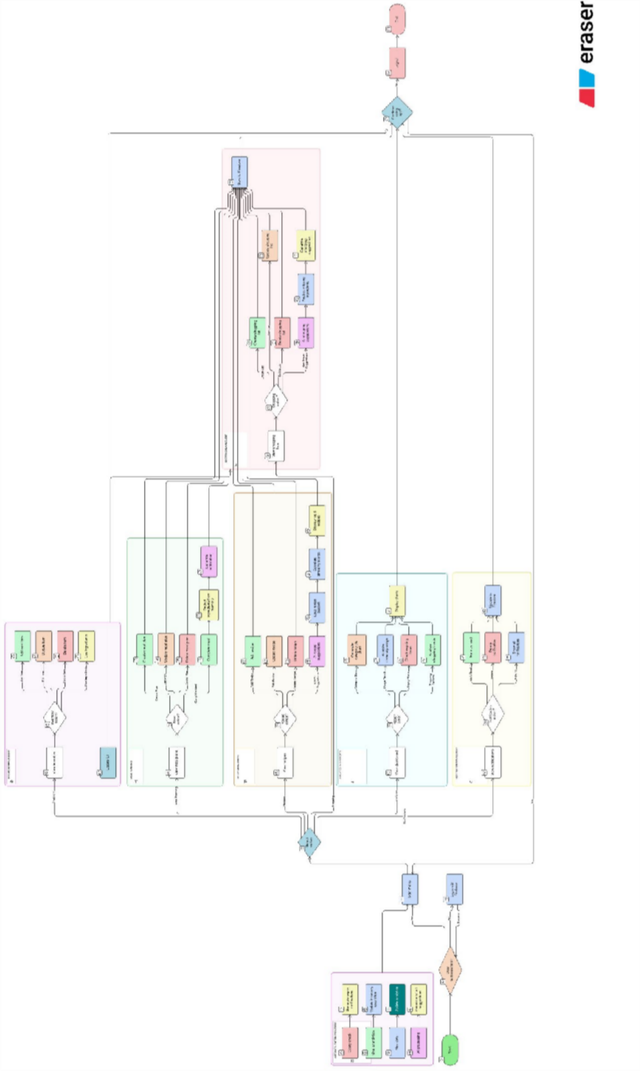

Use Case Diagram

Actors:
- User
- System (AI Engine)

Use Cases:
- Manage Inventory
- View/Add Recipes
- Generate AI Recipe Suggestions
- Create Meal Plan
- Manage Shopping List
- View Analytics
- Receive Notifications
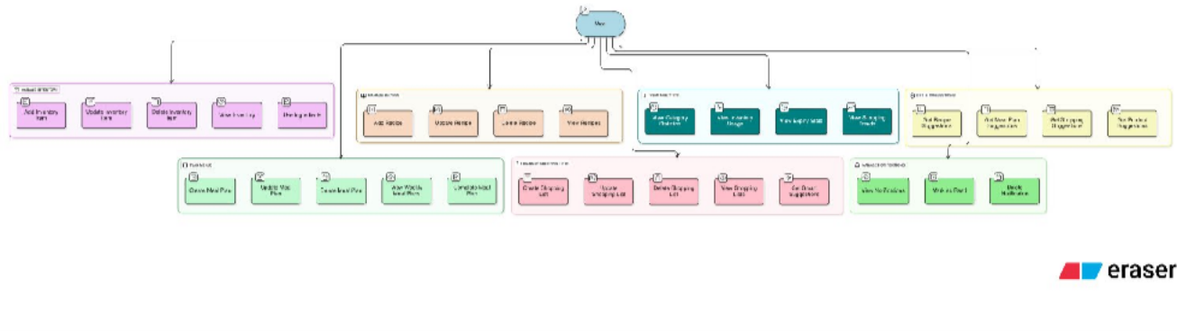

Data Flow Diagram
    - Level 0 DFD
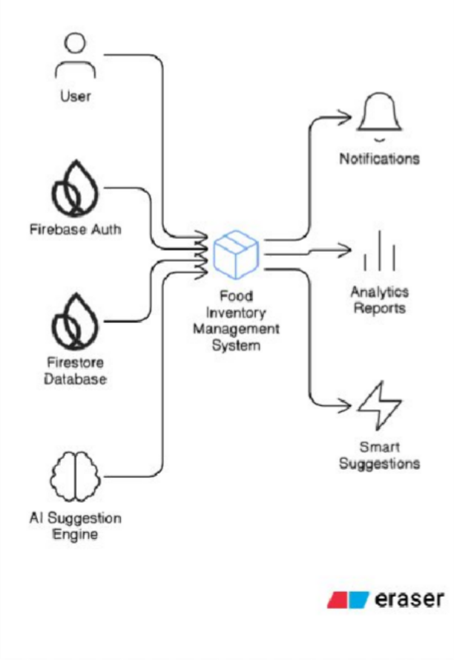

    - Level 1 DFD
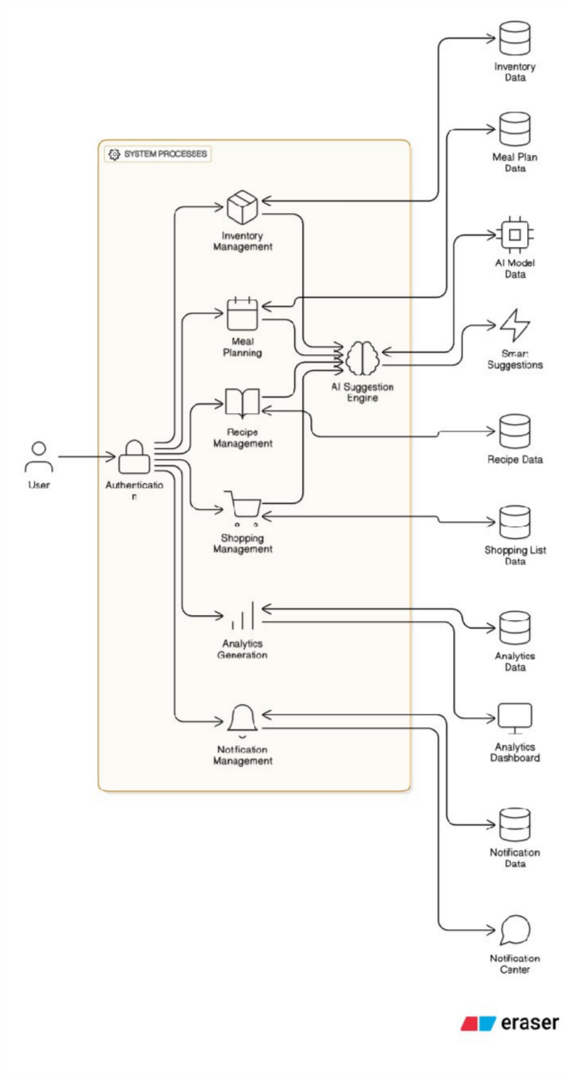

    - Level 2 DFD (Detailed Processes) Process 1: Authentication S Authorization
User Credentials → [1.1 Verify Token] → User Session → [1.2 User Data Access] → All Processes

Process 2: Inventory Management
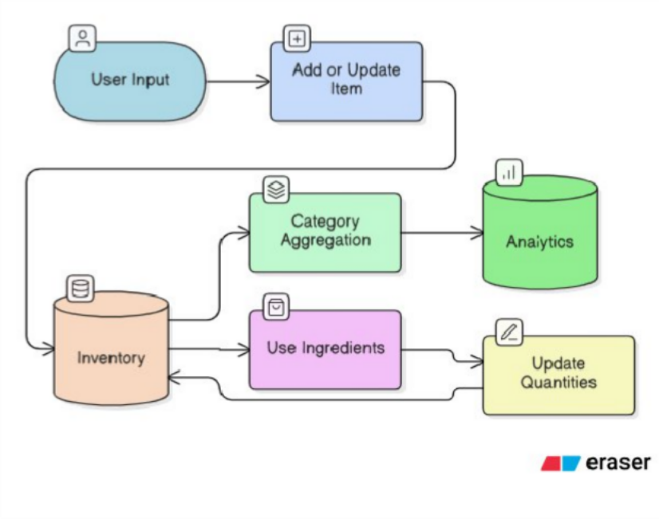
Process 3: Meal Planning
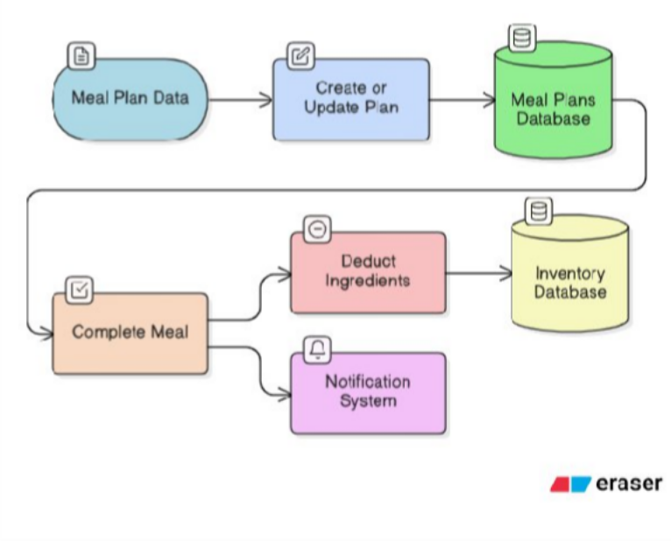

Process 4: Recipe Management
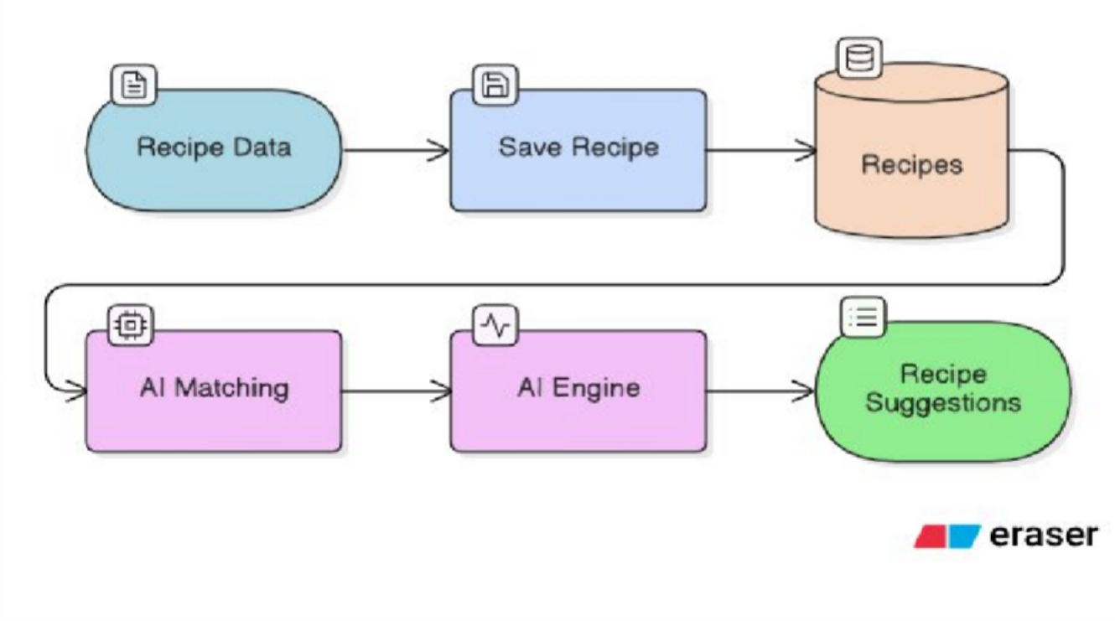
Process 5: Shopping Management
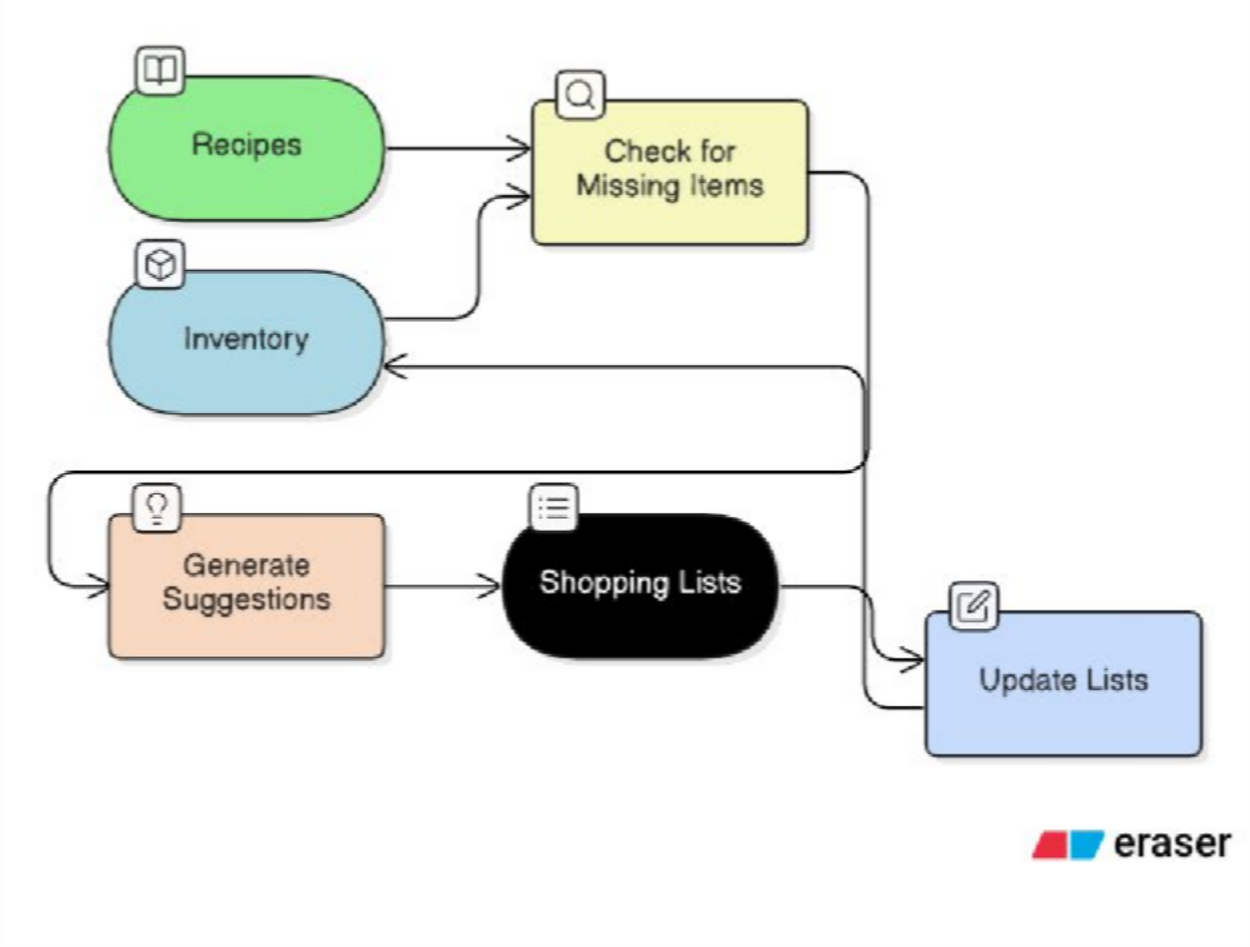

Process 6: Analytics Generation
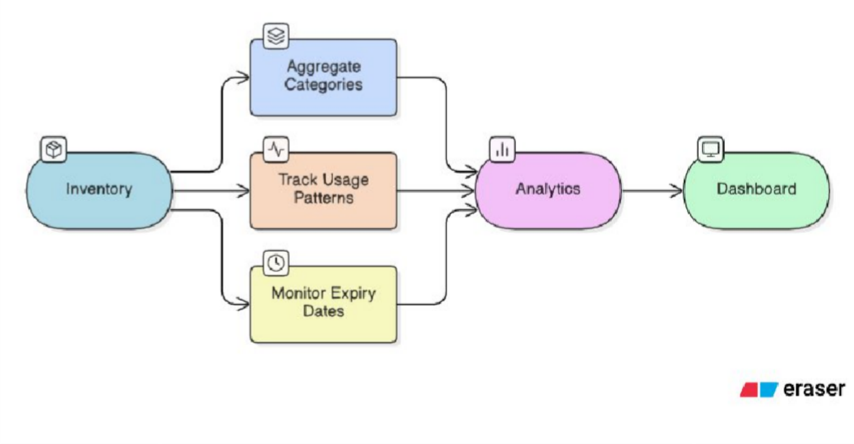
Process 7: Notification Management
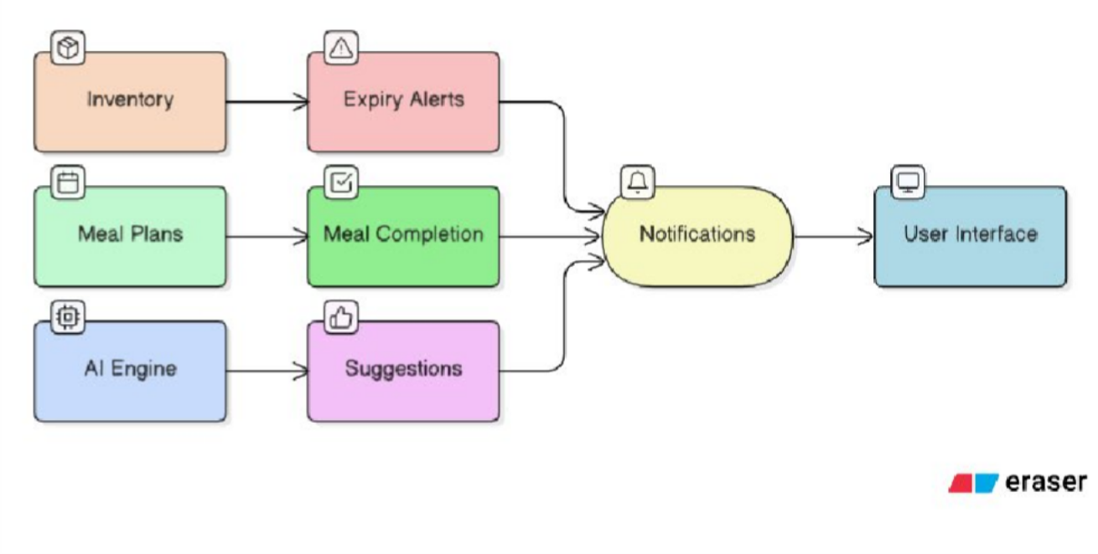

Process 8: AI Suggestion Engine
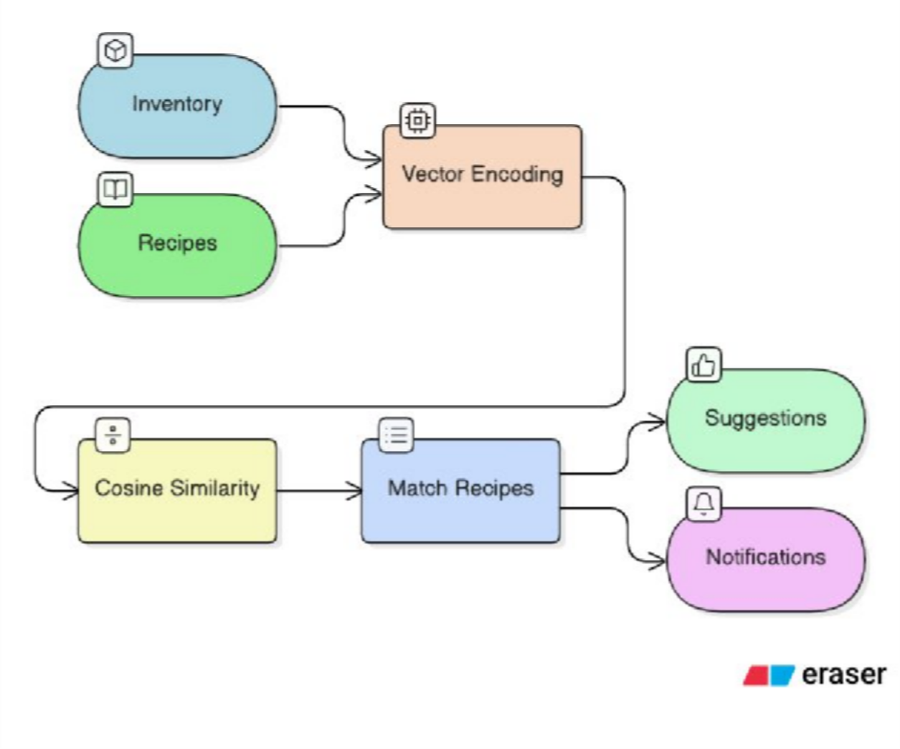

  - ER Diagram
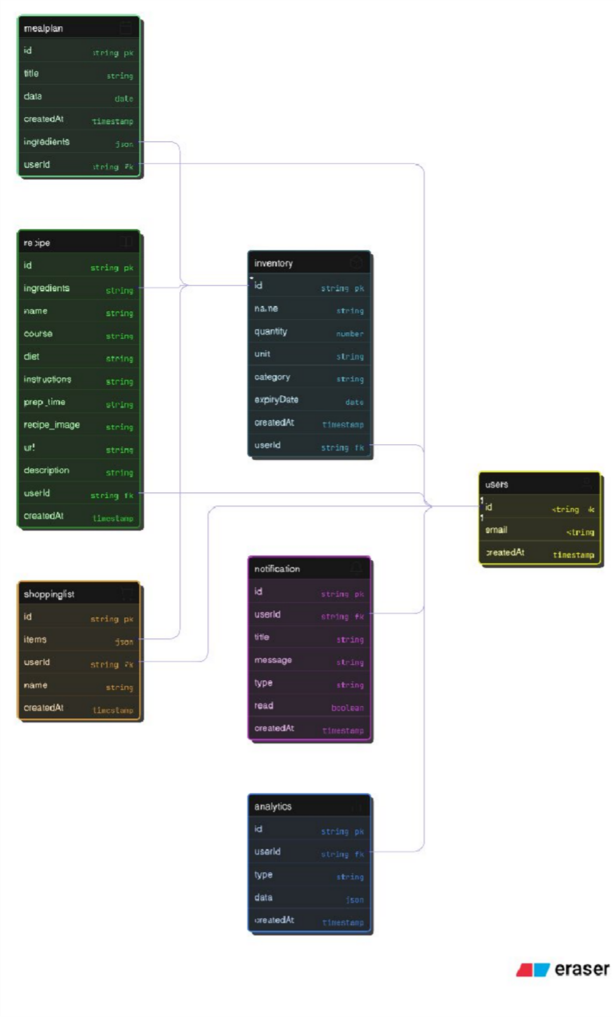

  - Sequence Diagram (AI Recipe Suggestion)
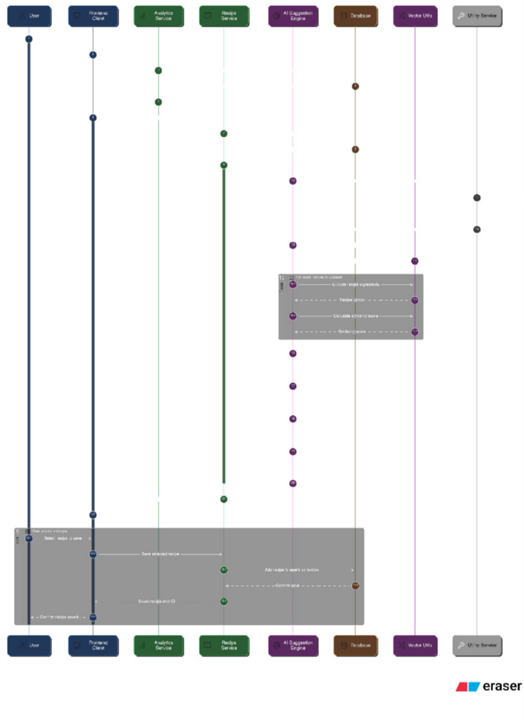

  - Class Diagram (Simplified)
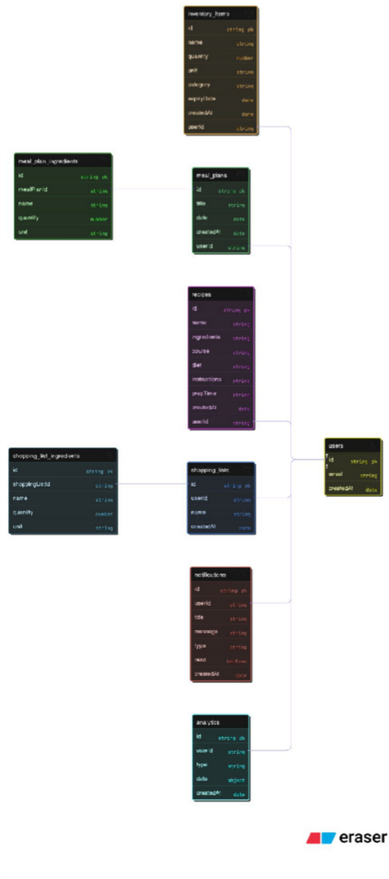

CHAPTER-5: PROJECT OVERVIEW

Designing
The design philosophy behind GrocyGo focuses on:

Simplicity and Usability
The UI uses clean layouts, large icons, soft colors, and intuitive navigation. Users can easily add items, view expiry reminders, and check recipes without confusion.

Multi-Platform Consistency
Both React (web) and Flutter (mobile) versions follow similar design patterns:
  - Search bars
  - Card-based lists
  - Tabs for different modules
  - Icons indicating location, expiry, or action
This ensures that users switching between devices have a unified experience.

Dashboard-Centric Workflow
Every page focuses on solving a specific problem:
  - Inventory → View what's available
  - Recipes → Suggest what to cook
  - Meal Plans → Structure weekly meals
  - Shopping List → Auto-generate what to buy
  - Analytics → Understand usage and waste

Visual Indicators and Color Coding
Visual cues make the system understandable instantly:
  - Green labels → Items safe for longer
  - Red labels → Expiring soon
  - Badges → Diet type, course type
  - Graphs → Inventory insights

Mobile-Friendly Design
Flutter mobile design includes:
  - Bottom navigation
  - Floating action buttons (FAB)
  - Scrollable lists
  - Touch-friendly controls

Inventory Page

PPSU

Purpose
To help users manage all kitchen items, track quantities, monitor expiry dates, and organize groceries by location.

Key Features (Web + Mobile)
- Add new items with name, quantity, unit, category, and storage location
- Expiry tracking with color-coded alerts
- Search functionality to quickly find items

- Delete or edit items via action icons
- Different locations: fridge, freezer, pantry, counter, etc.
- Real-time syncing with backend
- List view showing:
  - Name
  - Quantity S Unit
  - Location
  - Days to expiry

UI Characteristics from Screenshot
- Clean table view (web)
- Card-based item list (mobile)
- Expiring soon badge
- Simple intuitive filtering
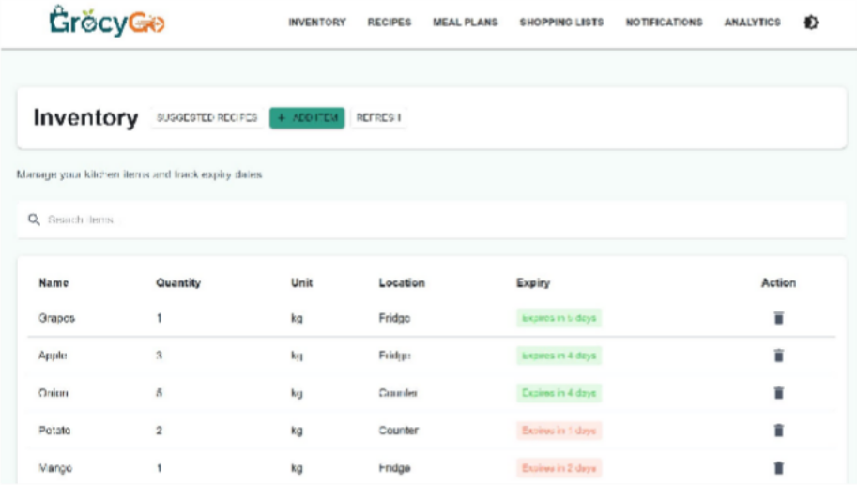
This makes the Inventory Page the core of the entire system

R
eci pe s Pa ge

PPSU

Purpose
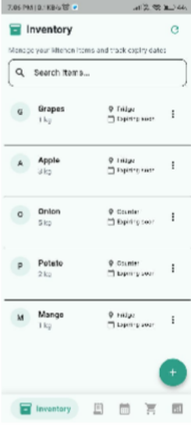
To help users discover, save, and prepare recipes using the ingredients they already have at home.

Key Features
    - Saved Recipes Section
    - View ingredients with “You have” vs “Need to buy” indicators
    - Recipe cards with:
      - Image
      - Course type
      - Diet type
      - Ingredient list

Add/Remove recipes
    - AI Recipe Generator using:
      - Ingredient availability
      - Course
      - Diet
      - 8000+ recipe dataset

AI Contribution
The AI engine checks:
    - Available ingredients
    - Missing ingredients
    - Closest match recipes

    - Percentage of compatibility

UI Characteristics
    - Attractive recipe cards with thumbnails
    - Color-coded ingredient badges (green = available, red = missing)
    - Dropdowns for filtering courses and diets
    - Mobile version scrolls horizontally for saved recipes
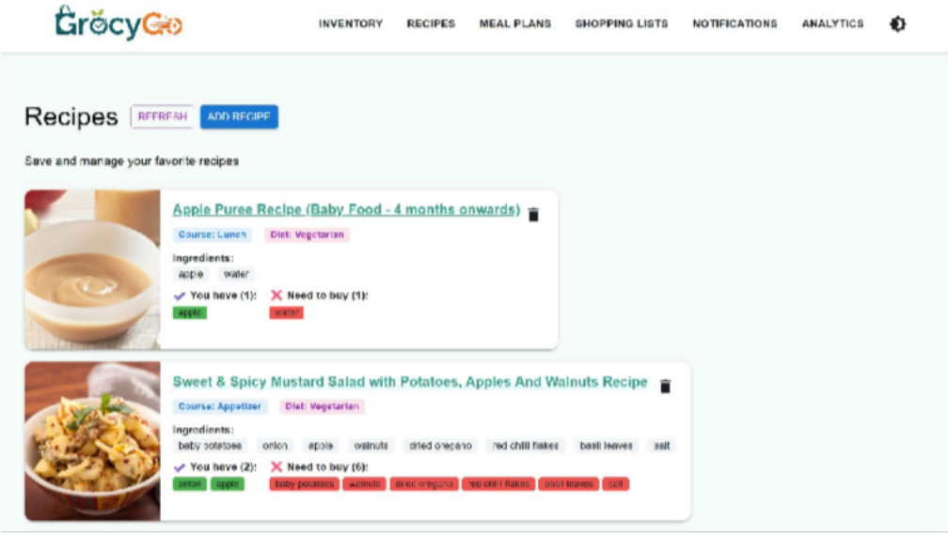
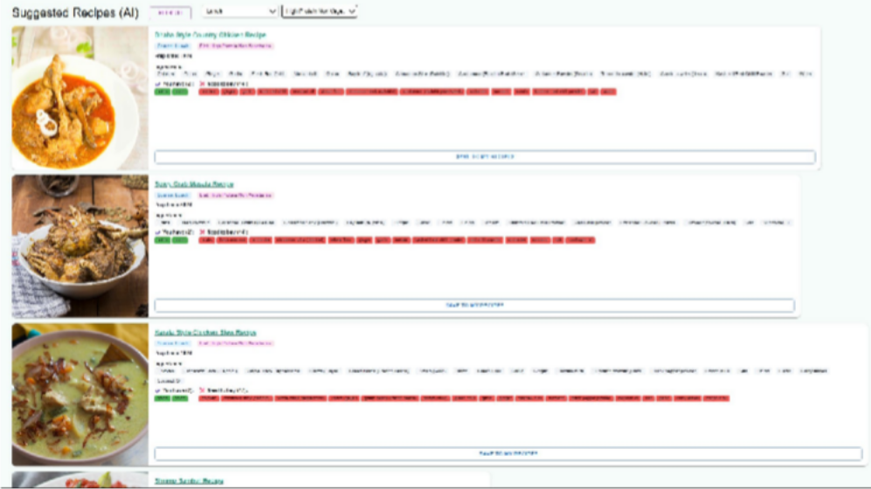
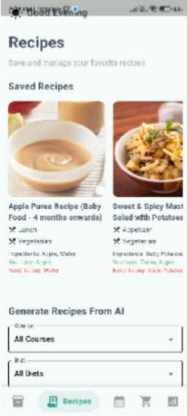
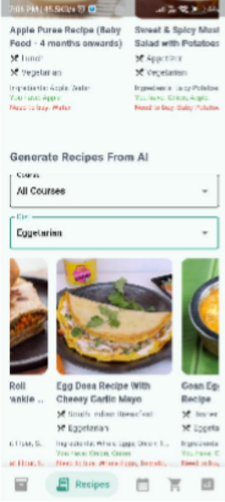

Meal Plans Page

PPSU

Purpose
To allow users to plan their meals for the week or day and get AI-suggested meal options.

Key Features
- Weekly meal calendar (Web)
- Daily meal selector (Mobile)
- Add:
  - Breakfast
  - Lunch
  - Dinner

    - Sync meal plans with recipes
    - Remove or replace meals easily
    - AI Meal Suggestions Panel with category filters (Vegan, High Protein, etc.)

AI Meal Suggestion Logic
Based on:
    - Selected diet
    - Recipe compatibility
    - Ingredient availability
    - Meal type

UI Characteristics
    - Calendar navigation arrows
    - Add meal placeholders (+ Add Breakfast, + Add Dinner)
    - Suggestion cards with ingredient availability indicators This page is highly practical for weekly household planning.
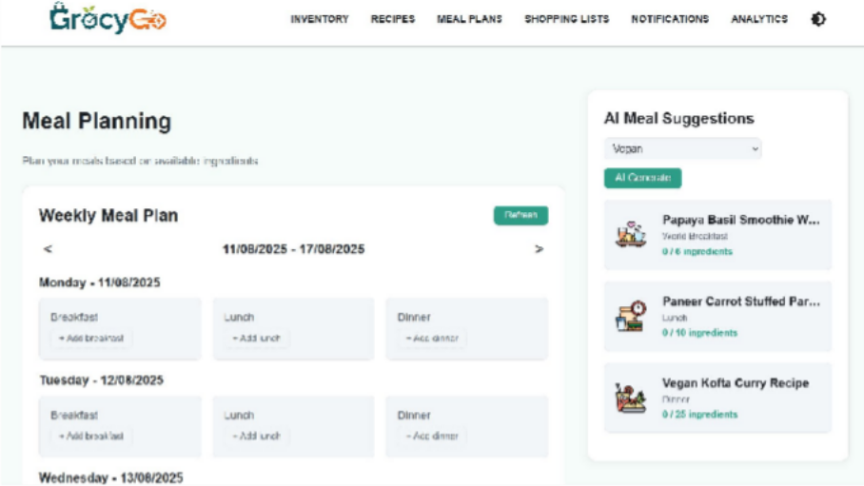
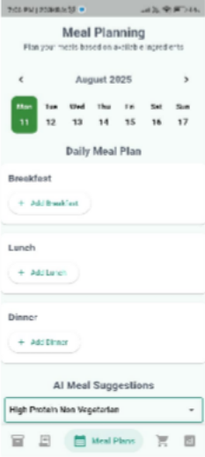

Shopping List Page

Purpose
Automatically generate a shopping list based on inventory shortages and recipe requirements.

Key Features
    - Manual and AI-generated shopping list
    - Smart Suggestions section with auto-generate option
    - Add items directly from missing recipe ingredients
    - Total estimated cost (if pricing attached)
    - Mark items as completed
    - Sync shopping list with mobile app

UI Characteristics
    - Left side → Shopping List
    - Right side → Smart AI Suggestions
    - Simple add box for manual item entry
    - Based on inventory and meal plan data
This makes grocery shopping efficient and reduces forgetfulness.

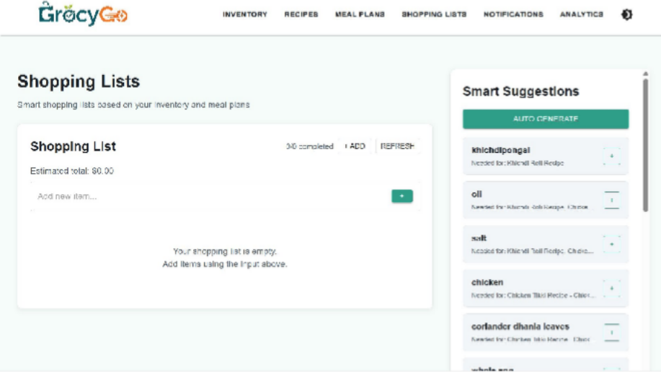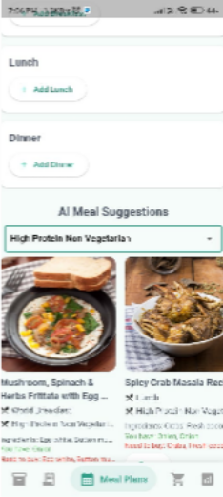

Analytics Page

Purpose
To give insights into user behavior, inventory patterns, wastage risks, and shopping frequency.

Key Insights (from screenshot)
- Groceries by Category (Pie Chart)
  - Vegetables
  - Fruits
  - Uncategorized items

Inventory Usage Over Time
  - Items added vs used
  - Helps track consumption patterns
- Expiring Items per Month (Bar Chart)
  - Helps reduce food waste

Shopping Frequency per Month
  - Shows how often users shop
  - Helps optimize recurring shopping cycles

Technology Used
- Chart rendering libraries (React charts)
- Backend aggregation of data
- Color-coded visual reports

UI Characteristics
- Dark theme dashboard
- Multiple cards
- Charts neatly arranged
- Icons and labels for clarity

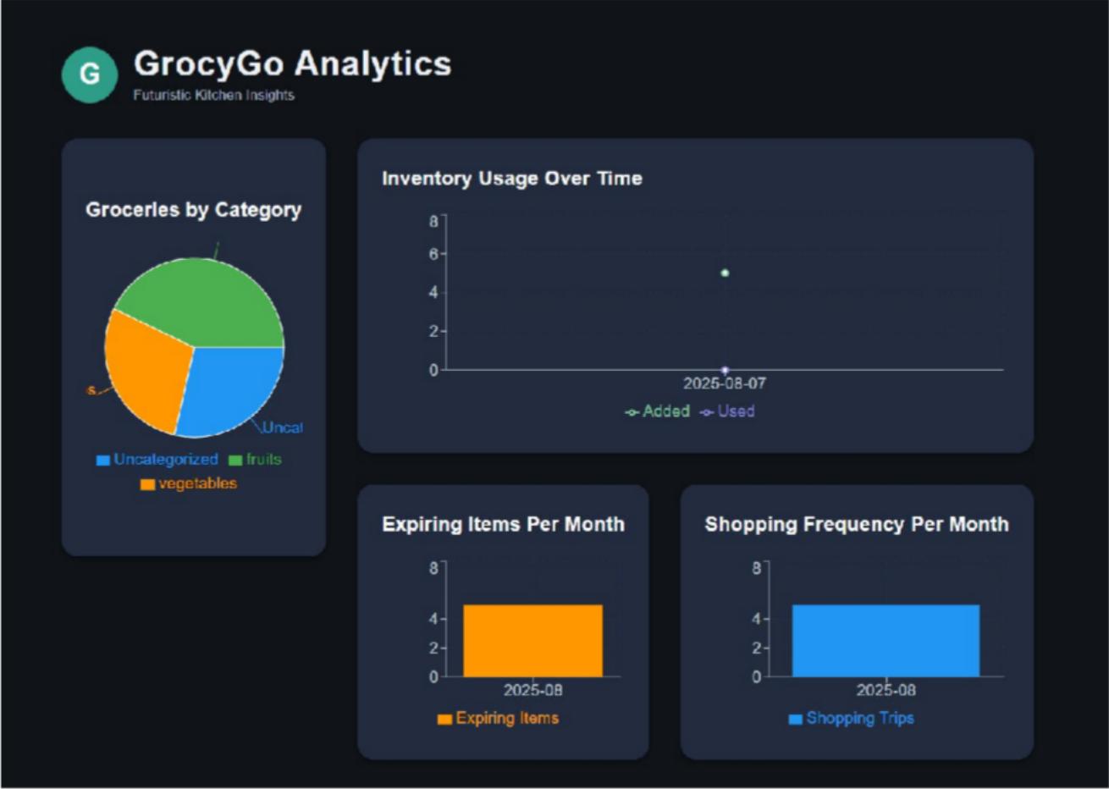

PPSU
25
P P Savani University Department of School Of Engineering

CHAPTER-6: TOOLS S TECHOLOGIES

Languages
GrocyGo uses a combination of modern programming languages suitable for full- stack development and AI integration.

JavaScript (ES6+)
Used for:
  - Backend development (Node.js, Express)
  - Web frontend (React.js)
  - AI logic and recipe filtering
  - Data processing scripts
JavaScript enables asynchronous operations, API handling, and modular development.

Dart
Used for:
  - Building the Flutter mobile application
  - Cross-platform UI rendering
  - Smooth animations and responsive layouts
Dart powers the mobile side of the project with excellent performance.

JSON / CSV
Used for:
  - Data exchange between frontend and backend
  - Storing recipe dataset (8000+ recipes in CSV format)
  - API response formatting

HTML S CSS
Used within React for:
  - Structuring web UI
  - Styling layout, components, and responsive elements

Frameworks and Libraries
GrocyGo uses popular frameworks to ensure fast development, modularity, and consistency across devices.

React.js (Web Application)
Used for:
  - Building the web dashboard
  - Rendering inventory, recipes, meal plans, shopping list, analytics
  - Component-based UI
  - State management through hooks and contexts

Flutter (Mobile Application)
Used for:
  - Building Android/iOS hybrid app
  - Bottom navigation
  - Dynamic lists, cards, and dialogs
  - Native-like performance

  - Easy integration with backend via REST APIs

Node.js + Express.js (Backend Server)
Used for:
  - Creating REST APIs
  - Handling CRUD operations for inventory, recipes, shopping lists
  - Implementing AI filtering logic
  - Managing routes, controllers, and middleware
  - Running scheduled tasks (expiry alerts, usage tracking)

AI Logic Libraries
  - Custom JavaScript filtering algorithms
  - Dataset parsing libraries
  - Fuzzy matching and ingredient scoring
  - Machine-learning style ranking (rule-based scoring)

Charting Libraries
Used on Analytics page:
  - React Chart Libraries (e.g., Chart.js / Recharts) For pie charts, bar graphs, and line charts.

Other Supporting Libraries
  - Axios / Fetch API → For API requests
  - Moment.js / Date libraries → Expiry calculations
  - Flutter packages (provider, http, intl) → For mobile UI S data handling

Development Environment
GrocyGo was developed using modern and developer-friendly tools suitable for multi- platform development.

Visual Studio Code
Used for:
  - Writing backend (Node.js)
  - Writing frontend (React.js)
  - Working with API requests
  - Code formatting and debugging

Android Studio
Used for:
  - Running Flutter mobile emulator
  - Debugging mobile UI
  - Testing device compatibility

Node Package Manager (NPM)
Used for managing backend and frontend dependencies:
  - Installing libraries
  - Running development servers
  - Building React app

Git S GitHub
Used for:
  - Version control
  - Tracking changes
  - Storing project repository
  - Collaborative development

Browser Developer Tools

Used for:
  - Inspecting UI elements
  - Debugging network responses
  - Testing responsiveness

Local Server Environment
  - Node.js server running on localhost (development mode)
  - Flutter app connected via emulator or real device
  - React app served via Vite/React development server

Testing and Debugging Tools
Testing tools ensure that GrocyGo functions correctly across multiple devices and platforms.

Postman / Thunder Client
Used for:
  - Testing API endpoints
  - Checking requests and responses
  - Debugging backend logic

Flutter Debug Console
Used for:
  - Resolving UI errors
  - Monitoring logs
  - Testing REST API integration in the mobile app

Browser DevTools (Chrome)
Used for:
  - Inspecting React components
  - Monitoring API calls
  - Fixing styling or layout issues
  - Tracking performance

Console Logging (Node.js S React)
Used for:
  - Debugging backend operations
  - Checking AI filtering logic
  - Monitoring real-time behavior

Emulator S Real Device Testing
Used for:
  - Testing Flutter app on different screen sizes
  - Ensuring mobile UI responsiveness
  - Verifying API sync with backend

CHAPTER-7: PROJECT DETAILS

Front-end of Project

The front-end layer of GrocyGo includes two separate clients:
- React Web Application (Desktop and Browser)
- Flutter Mobile Application (Android/iOS)

Both clients communicate with the Node.js backend via REST APIs.

    - React Web Application
The web application is designed to function as a full-featured dashboard for kitchen management. It provides users with a rich, clean UI to manage groceries, view recipes, plan meals, generate shopping lists, and analyze usage trends.

Key Characteristics
      - Component-based architecture for modularity
      - Reusable UI components (cards, tables, forms, charts)
      - Contexts S Hooks for state management
      - Clean navigation bar with sections:
        - Inventory
        - Recipes
        - Meal Plans
        - Shopping Lists
        - Notifications
        - Analytics

Major Web Modules
- Inventory Page
  - Add/Edit/Delete items
  - Expiry tracking
  - Search filter
  - Table layout for quick scanning

Recipes Page
  - Saved recipes
  - Ingredient comparison (“You have” vs “Need to buy”)
  - Add custom recipes
  - AI recipe generator

Meal Planning Page
  - Weekly planner
  - Day-wise breakfast, lunch, dinner
  - AI meal suggestions panel

Shopping List Page
  - Editable shopping list
  - Smart suggestions based on recipes
  - Auto-generate missing items

Analytics Page
  - Pie charts, bar graphs, and line charts
  - Usage trends over time
  - Expiry insights

  - Shopping frequency

All pages are optimized for fast loading and clean visual hierarchy.

    - Flutter Mobile Application
The mobile app is designed to provide a refined and simplified user experience on the go.

Key Characteristics
      - Cross-platform UI (Android/iOS)
      - Bottom navigation bar for quick switching between screens
      - Floating action buttons (FAB) for adding items
      - Responsive card-based interface
      - REST API integration with backend server

Mobile Modules
      - Inventory list with icons, quantities, expiry tags
      - Saved recipes with thumbnails
      - AI recipe generator with filters
      - Daily meal planner
      - Scrollable recipe cards
      - Quick-access shopping list
The mobile interface prioritizes convenience and quick actions, making daily inventory updates easier.

Responsiveness Behavior of Website
The GrocyGo website is fully responsive and adapts smoothly to multiple display sizes using modern CSS, flexbox, and grid layouts.

Responsive Features
- Dynamic Grid System
  - Inventory table adjusts column width
  - Recipe cards shift from row layout (desktop) to stacked layout (tablet/mobile)

Flexible Navigation Bar
  - Converts from horizontal menu (desktop) to compact hamburger or stacked items on smaller screens

Scalable Cards and Tables
  - Ingredient badges wrap properly
  - Meal planner sections stack vertically on smaller screens

Responsive Forms
  - Input boxes auto-resize
  - Buttons expand for tap-friendly experience

Charts Adaptation
  - Analytics graphs adjust height/width
  - Legends reposition based on space

Optimized for Mobile Browsers
  - Touch-friendly buttons
  - Scrollable sections
  - Reduced padding for small screens
The responsive behavior ensures that users can use GrocyGo from laptops, tablets,

and mobile browsers without functional loss.

Backend of Website
GrocyGo’s backend is built using Node.js + Express, structured in a clean modular architecture for maintainability and scalability.

Key Responsibilities of Backend
- A P I - M a n a g e m e n t Handles all CRUD operations for:
  - Inventory
  - Recipes
  - Meal Plans
  - Shopping Lists
  - Notifications
  - Analytics data

AI Recipe Engine
  - Parses and filters from 8000+ recipe dataset
  - Matches ingredients with user inventory
  - Ranks recipes based on:
    - Available ingredients
    - Missing ingredients
    - Diet/course filters
  - Returns recipe suggestions for both web S mobile

Data Storage S Processing
  - Models for items, recipes, usage logs, meal plans
  - Expiry date calculations
  - Low-stock analysis
  - Meal plan linking with inventory

Business Logic Layer
  - Auto-generate shopping list
  - Notification triggers
  - Meal compatibility checking
  - Usage tracking for analytics

Scheduled Tasks (Cron Jobs)
  - Generate expiry reminders
  - Refresh analytics data
  - Clean unused entries

Security S Validation
  - Input validation
  - API route protection
  - Sanitization of data

Backend Architecture
- Routes → Define API endpoints
- Controllers → Contain business logic
- Models → Data structures
- AI Engine → Recipe filtering and scoring
- Utils/Middleware → Logging, validation, helpers

The backend ensures stable communication among the React web app, Flutter mobile app, and database/datasets.

Chapter 8: Learning Outcomes

8.2 Skill Enhancement
The project significantly improved both technical and soft skills. The major enhancements include:

Full-Stack Development Skills
  - Working with React.js for modern, component-based web development
  - Building cross-platform UI using Flutter (Dart)
  - Designing scalable backend APIs using Node.js S Express.js

AI and Data Handling
  - Processing a dataset of 8000+ recipes
  - Implementing AI-based recipe suggestion logic
  - Understanding filtering, scoring, and recommendation strategies

UI/UX Design Skills
  - Designing clean and intuitive user interfaces
  - Creating responsive layouts for different screen sizes
  - Using icons, color coding, and cards for a better user experience

Cloud S API Interaction
  - Working with REST APIs
  - Structuring JSON responses
  - Handling request/response cycles in both web and mobile apps

Problem Solving
  - Breaking down a large system into manageable modules
  - Designing efficient logic for expiry tracking, analytics, and automation

Practical Experience
The project offered real-world technical exposure beyond theoretical learning.

End-to-End Application Development Hands-on experience in building:
  - Frontend (React, Flutter)
  - Backend (Node.js)
  - AI module
  - Analytics dashboard
  - Cross-device syncing

Working with Real Data
  - Cleaning, parsing, and filtering a large recipe dataset
  - Ensuring data accuracy in recommendations

Implementing User-Oriented Features
  - Inventory management
  - Meal planning
  - Auto-generated shopping list
  - AI suggestions

Debugging S Performance Optimization

  - Solving API issues
  - Fixing mobile layout responsiveness
  - Reducing unnecessary re-renders in React
  - Managing state effectively

Multi-Platform Deployment Understanding differences between:
  - Web UI behavior
  - Mobile UI behavior
  - Backend resource usage

Project Exposure
The project provided exposure to modern technologies, industry-standard tools, and real-world development workflows.

Exposure to Modern Tech Stack
  - React.js → Component-based SPA development
  - Flutter → Hybrid mobile development
  - Node.js → Scalable backend services
  - Charting libraries → Data visualization
  - AI dataset filtering → Smart decision systems

Working with Industry Practices
  - Version control using Git S GitHub
  - MVC structure in backend
  - Code modularity and reusability
  - API documentation and testing

Real User Workflow Understanding Exposure to actual user needs like:
  - Managing groceries
  - Preventing wastage
  - Meal planning
  - Shopping optimization
This created a practical understanding of consumer-facing applications.

Professional Growth
The project contributed to overall professional development in the following ways:

Improved Technical Confidence
Building a large multi-platform system boosted confidence in:
  - Full-stack development
  - AI integration
  - Cross-device syncing

Time S Task Management Managing:
  - Web development
  - Mobile development
  - Backend logic
  - Dataset integration

Helped develop strong organization and multitasking abilities.
- Communication S Documentation
Creating diagrams, writing structured code, and documenting API routes enhanced professional communication skills.

System Thinking
Learning how different modules interact:
  - Inventory → Recipes → Meal Plans → Shopping List → Analytics Developed a strong understanding of complex system workflows.

Industry Readiness
Experience in real-world technologies made the project a strong foundation for future professional roles in:
  - Full-stack development
  - Mobile development
  - AI-powered applications

Solution Of Challenges
During development several technical and conceptual challenges were faced and solved:

Handling Large Recipe Dataset
Challenge: Filtering and matching recipes from 8000+ entries. Solution:
  - Implemented optimized string matching
  - Scoring system for available vs missing ingredients
  - Cached dataset for faster response

Syncing Data Across Web and Mobile
Challenge: Keeping both platforms updated with same data. Solution:
  - Created consistent API design
  - Maintained centralized backend logic

Designing Responsive User Interfaces
Challenge: Same UI needed to work on various screen sizes. Solution:
  - Used flexbox, grid, and responsive CSS
  - In Flutter, used adaptive layouts and scrollable widgets
- Expiry Tracking S Notifications Challenge: Accurate reminder generation. Solution:
  - Implemented date-difference calculations
  - Cron-like scheduling for backend scripts

Avoiding UI Performance Issues
Challenge: Rendering large lists (inventory S recipes). Solution:
  - Used pagination and optimized rendering
  - Simplified and modularized components

Managing Multi-Layer Architecture
Challenge: Coordinating frontend, backend, AI, and data. Solution:
  - Followed clear MVC pattern
  - Documented API endpoints
  - Built modular controllers and utilities

CHAPTER-9: CONCLUSION

Summary of Project
The GrocyGo project successfully delivers a complete, intelligent, and user-friendly grocery management ecosystem designed for modern households. It integrates a React- based web dashboard, a Flutter-powered mobile application, and a Node.js backend to provide seamless multi-platform access. The system supports automated inventory management, AI-driven recipe recommendations, meal planning, and smart shopping list generation.

By leveraging an 8000+ recipe dataset, GrocyGo’s AI engine helps users decide “what to cook” based on available ingredients, dietary filters, and missing items. The system also tracks expiry dates, identifies low-stock items, and visualizes usage trends through an analytics dashboard.

Overall, the project demonstrates strong technical execution, covering the full spectrum of front-end design, backend logic, data processing, API integration, and AI functionality. It addresses real-world challenges such as food wastage, meal planning difficulty, and inefficient grocery shopping.

Future Directions
Although GrocyGo already delivers a robust set of features, several enhancements can further extend its functionality and user impact:

User Authentication and Multi-User Support
  - Enable login system
  - Allow multiple family members to sync shared inventory

Barcode and QR Scanning
  - Scan grocery items using mobile camera
  - Automatically fill item details

Real-Time Cloud Database
  - Replace CSV/data files with Firestore or MongoDB
  - Enable cross-device live syncing

Advanced AI Recommendation System
  - Personalized recipe suggestions
  - Nutritional analysis (calories, protein, vitamins)
  - AI-based meal planning for health goals

Voice Assistant Integration
  - Add support for Google Assistant or Alexa
  - “What can I cook today?” voice commands

Automated Grocery Ordering
  - Integrate with online grocery platforms
  - Auto-order missing items directly

Offline Mode for Mobile App
  - Allow inventory updates without internet
  - Sync when connection is restored

Weekly Usage Predictions
  - Predictable shopping patterns
  - AI-based forecasting for purchase reminders
These enhancements can elevate GrocyGo from a student project to a fully commercial smart-kitchen platform.

Final Reflection
Developing GrocyGo has been a meaningful journey of technical growth, creativity, and problem solving. The project pushed me to work across multiple technologies—React, Flutter, Node.js, AI algorithms, and large datasets—while thinking like a real product developer. I learned how to design user-first interfaces, write scalable backend logic, structure APIs, and integrate intelligent features that solve practical household challenges.
The experience strengthened my full-stack skills, deepened my understanding of AI- driven systems, and taught me how to convert an idea into a complete, functional, multi- platform application. Most importantly, GrocyGo showed how technology can genuinely simplify everyday life and reduce food waste, proving the value of thoughtful software design.

