PRITAM CHATTERJEE

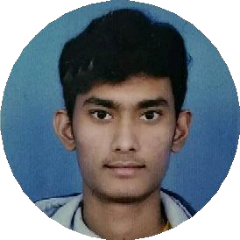

**PERSONAL DETAILS**

**DATE** [**OF BIRTH**- 16-06-2000](mailto:rivuchatterjee.500@gmail.com)

**FATHER'S NAME**- DEBAPRASAD CHATTERJEE

## Email- [rivuchatterjee.500@gmail.com](mailto:rivuchatterjee.500@gmail.com)

Phone- 8918834400

Address -

VILL + P.O.- HABRA PRAFULLANAGAR PIN- 743268

NORTH 24 PARGANAS WEST BENGAL

# OBJECTIVE

I’M SEEKING A POSITION IN THE WEB DESIGN FIELD WHERE MY INTERPERSONAL SKILLS AND WIDE ARRAY OF KNOWLEDGE WILL BE BEST UTILIZED.

# EDUCATION

2015 MADHYAMIK

WBBSE 76.26%

2017

2020

HIGHERSECONDARY WBCHSE

70.25%

DIPLOMA IN ELECTRICAL ENGINEERING WBSCTE

70%

2023 1 YEAR WEB DESIGN COURSE

**SKILLS**

## Adobe Photoshop HTML

CSS

JavaScript

JQuery

**PERSONAL STRENGTHS** GOOD COMMUNICATION FLEXIBILITY

CREATIVETHINKING TEAMWORK& LEADERSHIP

# HOBBY

TRAVELLING, EXPLORE INNOVATIVE DESIGN AND WEBSITES , LISTENING MUSIC

# INTERESTS

GRAPHICS DESIGN AND VISUAL ARTS CODING AND TECHNOLOGY

USER INTERFACE RESEARCH

# LANGUAGES KNOWN

BENGALI, ENGLISH, HINDI