Download and Install Node js from https://nodejs.org/en/download/

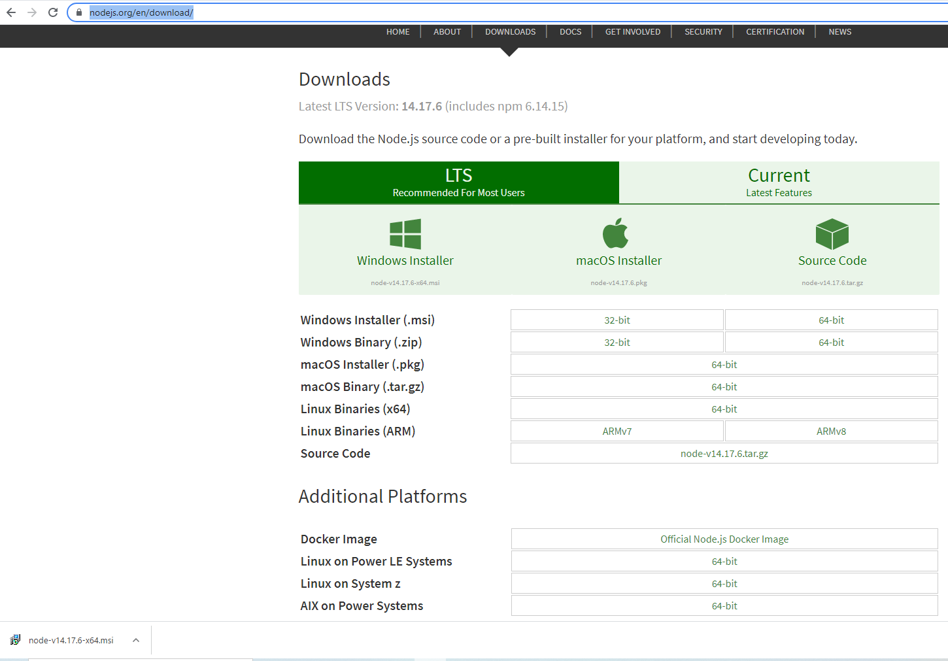
Create path variable for Node:

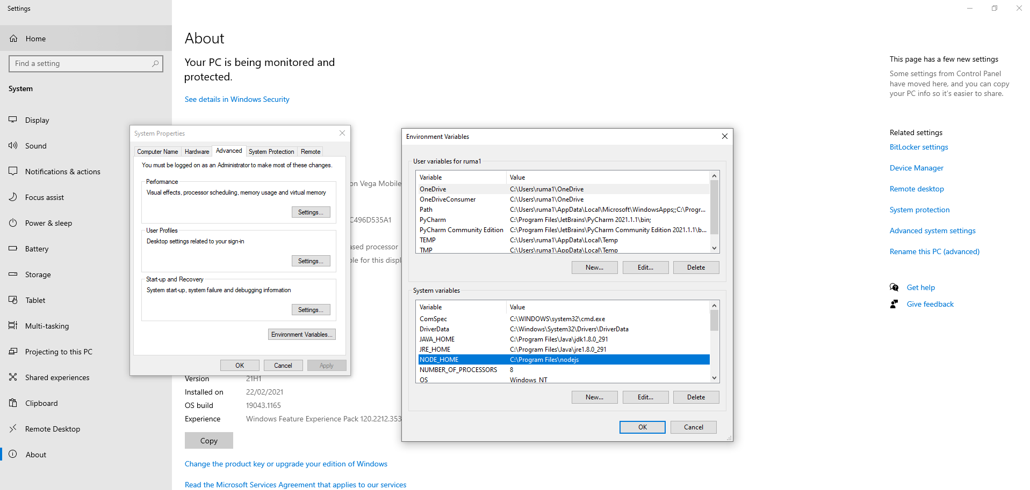
Create your project folder and Run npm init from that location:

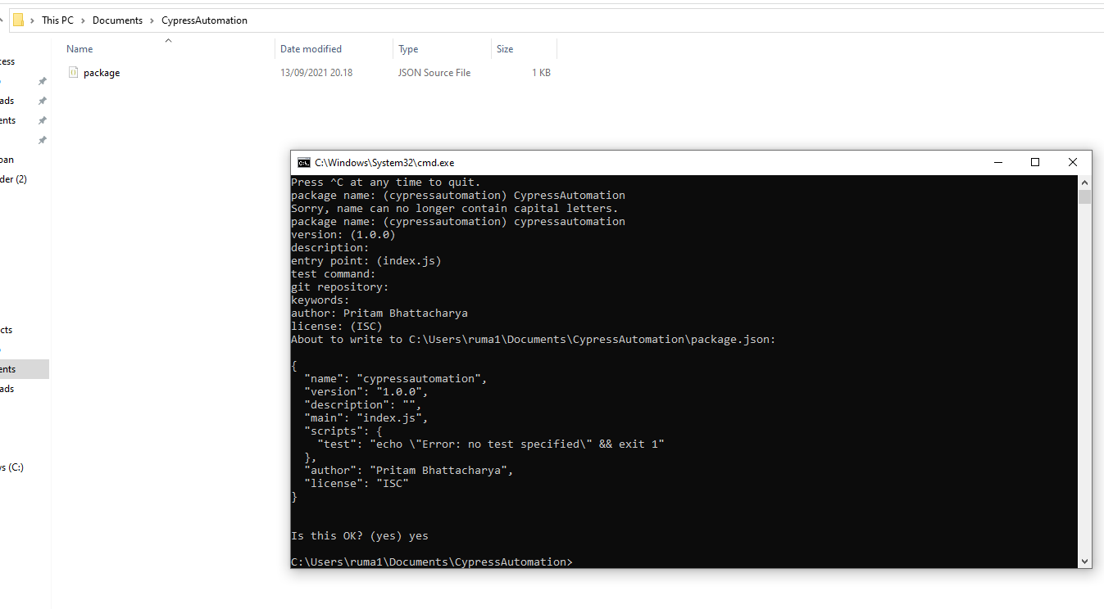
Install cypress:

Run command npm install cypress –save-dev

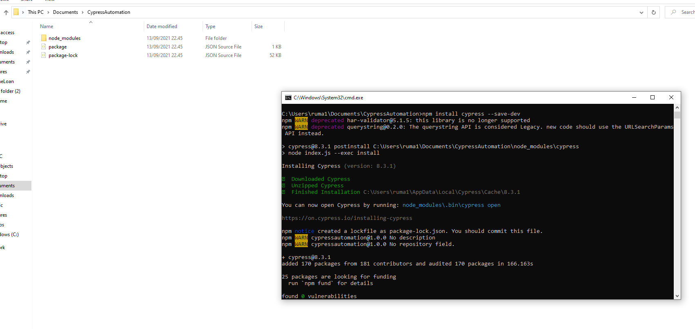
Opening cypress Test runner:

Run Command node_modules\.bin\cypress open

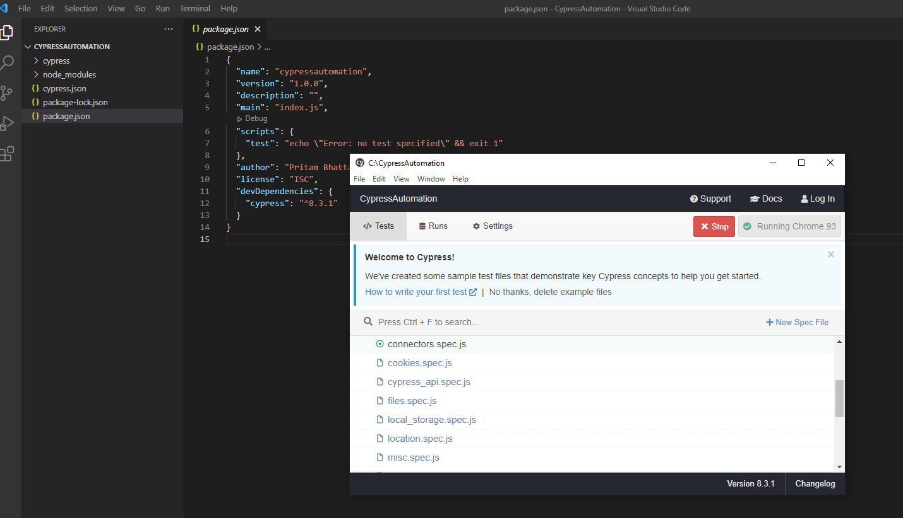
Running test from command promt:

node_modules\.bin\cypress run

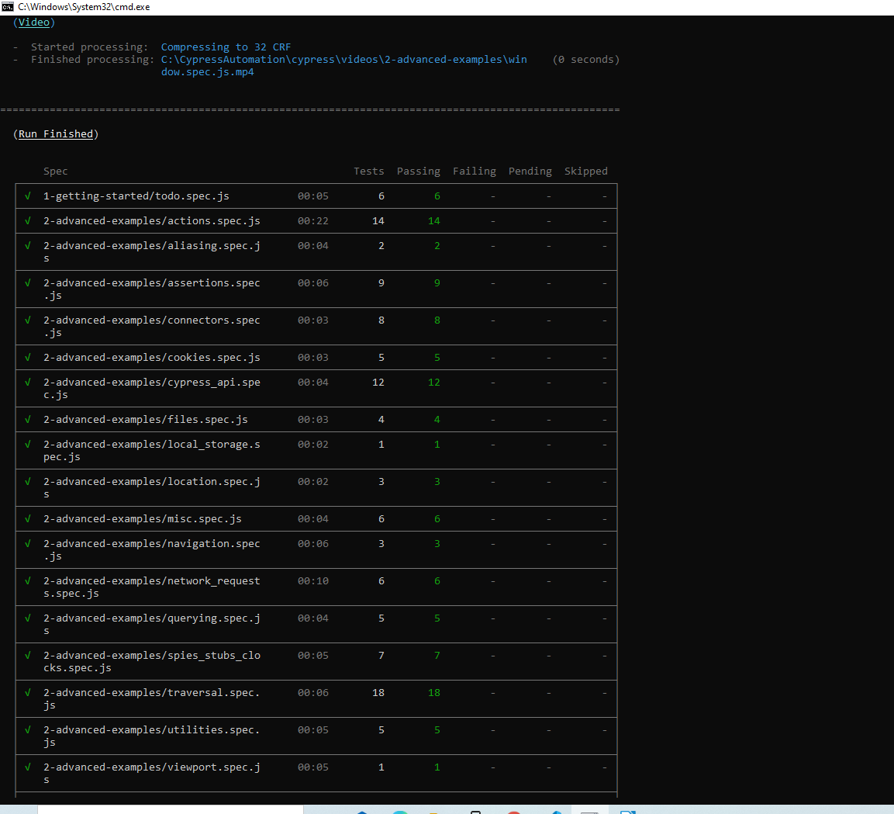
Using Cypress dashboard:

Go to Test Runner window → Runs tab→ Login Cypress dashboard services with Github account

generate project:

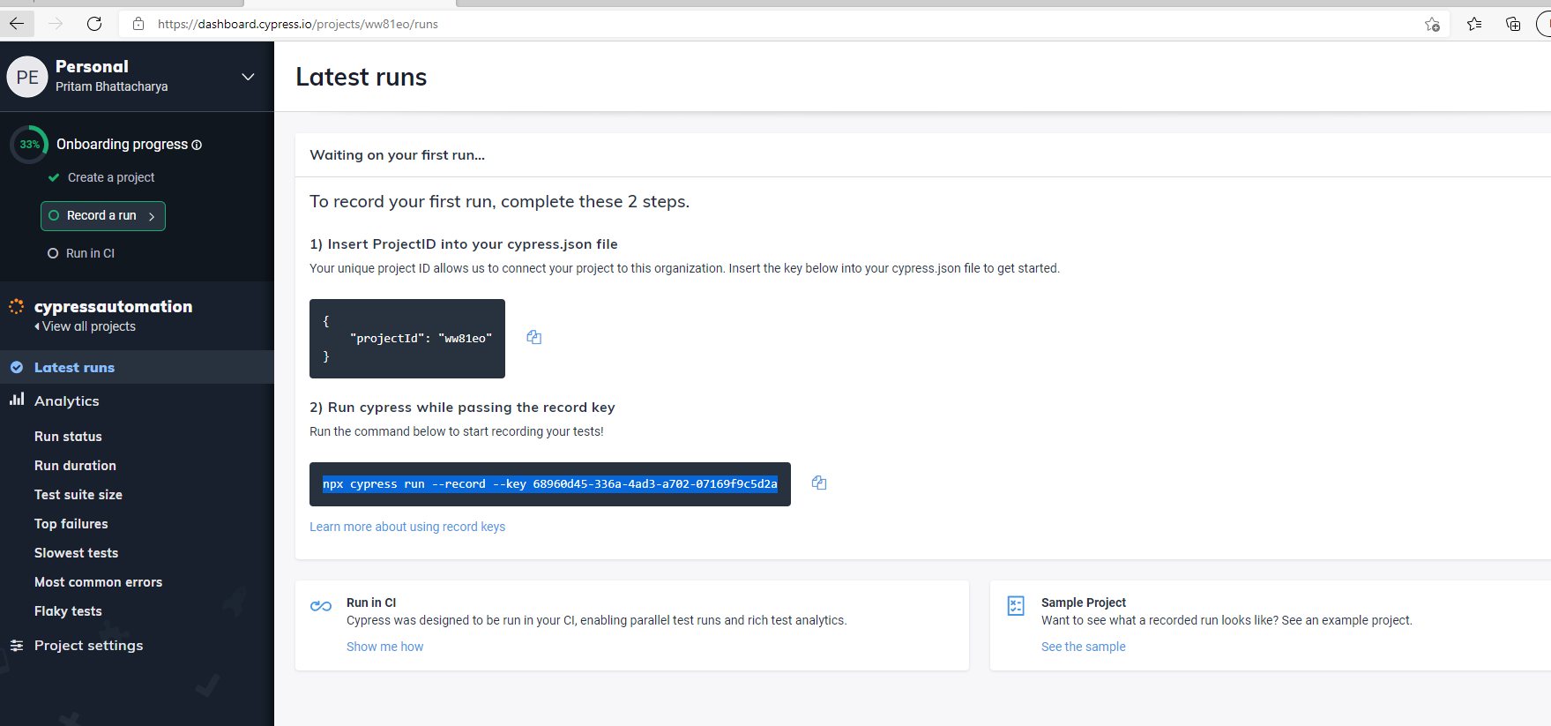
Running again with dashboard services implemented:

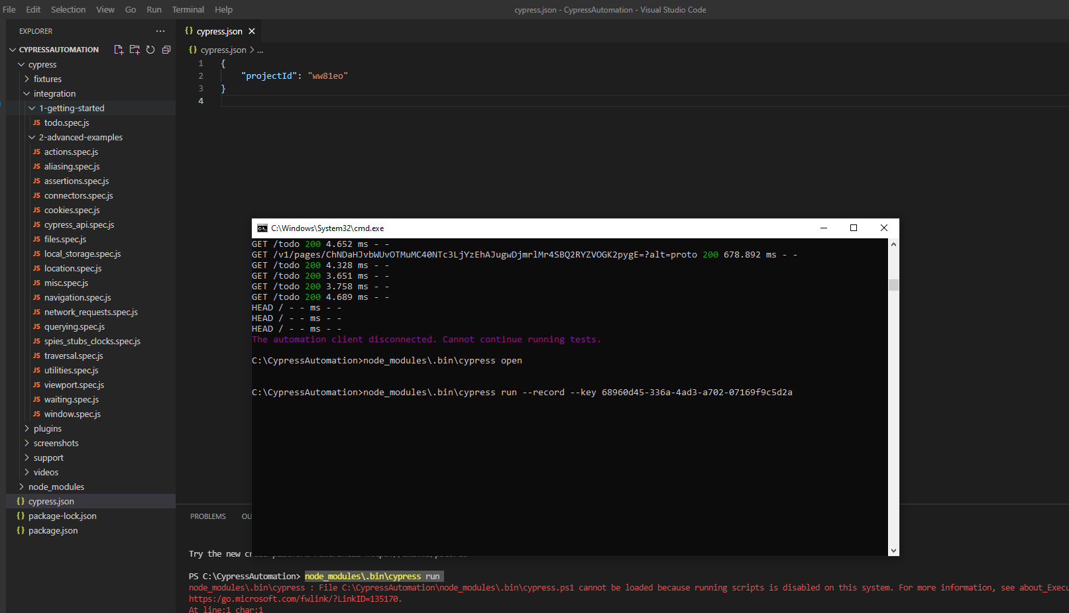
Live execution details from Cypress dashboard:

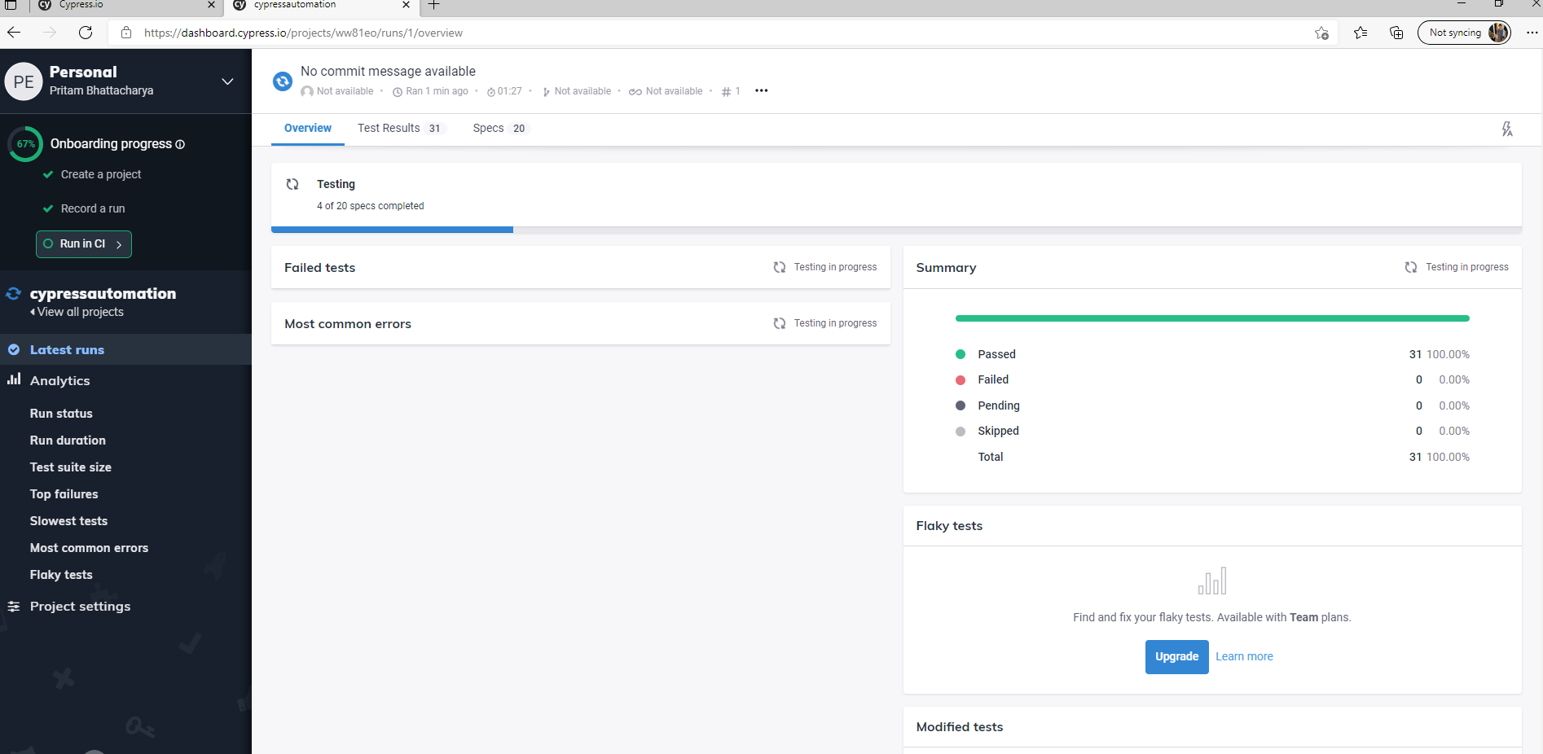
After completion of test:

Check details of execution and videos

