MCMS4251 (Internet Technologies)
CIA Examination
(Total: 20 Marks)
INSTRUCTION:
Q1 SHOULD BE ATTEMPTED BY STUDENTS WHOSE ROLL NUMBERS ARE BETWEEN 501-515
Q2 SHOULD BE ATTEMPTED BY STUDENTS WHOSE ROLL NUMBERS ARE BETWEEN 516-534
Q3 SHOULD BE ATTEMPTED BY STUDENTS WHOSE ROLL NUMBERS ARE BETWEEN 535-556
Q4 SHOULD BE ATTEMPTED BY STUDENTS WHOSE ROLL NUMBERS ARE BETWEEN 557-573

- Using HTML and JS design a BILLING SYSTEM FOR A BOOK STORE. The application will have the names of the Books along with the prices in a label, with a text box to accept the number of each books taken. Keep condition of allowing a 25% discount if the Bill amount crosses Rs. 5000 or more, else a discount of 10% will be applied. The entire application should be made in such a way so that the user can run it with keyboard only, implementing Tabindex, keypress and access keys. The form should have at least the names of 10 books on the form. On Clicking/Activating the Button “BILL AMOUNT” the amount of the bill will be displayed in a label.

- Design the following Calculator using HTML and JS:
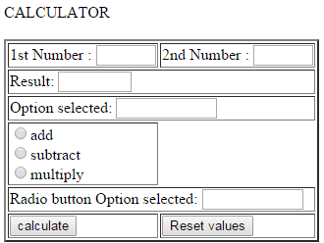

- Create a form using HTML accepting the details of a student having the
following fields:
Name (text box), Guardians Name (Text Box), Address (Text area), Gender (Radio button), Contact Number (10-digit format), Course(s) Applied for. (Check Box). Display the data filled up through the form in another HTML file using PHP.

- Using HTML and JS design a RESTAURANT BILLING SYSTEM. The application will have the names of the food items along with the prices in a label, with a text box to accept the number of each items taken. Keep condition of allowing a 10% discount if the Bill amount crosses Rs. 2000 or more. The entire application should be made in such a way so that the user can run it with keyboard only, implementing Tabindex, keypress and access keys. The form should have at least 12 items on the menu. On Clicking/Activating the Button “BILL AMOUNT” the amount of the bill will be displayed in a label.

