Indian institute of engineering science and technology, shibpur

CERTIFICATION

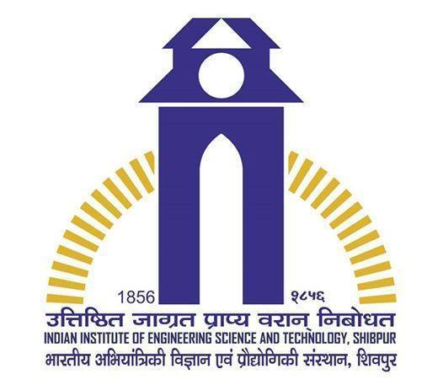

This is to certify that Debomit Dey(510516002), Prerna Raghuwanshi(510516057), Pritam Barua(510516042), Chandrapaul Khan(510516080) have successfully completed mini project on :

1. Automatic Text Summarization
2. Relation between two words.
3. Creating spell checker and finding most relevant answer for a query.
4. Finding related word from text documentation.

Under the guidance of Prof. Jaya Sil

Date – 7/5/2018 Signature